
MSc Public Health and Social Care in Practice
Module: Social Epidemiology and Public Health Development
Module code: LCHS7000
Assessment Title: “Age and Health Inequalities: Long-term Management and Community Reintegration of the Elderly in the UK”
Lecturer: Itse Olaoye
Student Name: MD RIMON MIAH
Student Number: 2509982
Word Count: 2602
Submission Deadline: 1st May 2026

Table of Contents
Task 1: Social Epidemiological Analysis 1
1. Introduction 1
2. Background and Facts of a Context 1
2.1 Higher rates of mental illness: 1
2.2 Low healthcare access rates: 1
2.3 Death rates of the aged group: 2
2.4 Social Isolation/Loneliness: 2
2.5 Poverty in Later Life: 2
2.6 Housing Issues: 3
3. National Response to Lessen Health Inequalities 3
3.1 The Core20PLUS5 Approach (Adults) 3
3.2 Fit for the Future: 10 Year Health Plan 4
4. Organisations involved in supporting the elderly 4
5. Conclusion 5
Task 2: Epidemiological Analysis 6
1. Introduction 6
2. Public health measures: The 3 P’s: 6
3. Important Determinants and Risk Factors: 7
4. Identification of At-Risk Groups: Epidemiological Studies and HNA: 7
5. Monitoring and Surveillance Systems: 8
6. Public Health Impact: Short- and Long-Term Outcomes 8
7. Health Intervention Suggestion: "Heart of the Community": 8
8. Advantages and disadvantages of the epidemiological approach: 9
9. Conclusion 9
Reference: 10

Contents of Figures
Figure 1: Core20PLUS5 Approach 3
Figure 2: Age UK 4
Figure 3: Three Ps of Public Health 7

Task 1: Social Epidemiological Analysis

1. Introduction
This report focuses on the elderly population in the UK, specifically those aged 65 and above. A complex interplay of biological vulnerability, socioeconomic disadvantage and barriers to systemic services makes this group at a high risk of health inequalities. Based on a report by the Office of National Statistics (2025), the UK is experiencing an ageing population whereby more than 11 million individuals are 65 years and above. Although longevity is a victory of communal well-being, this is not distributed evenly, as those in the lowest deciles in the distribution have a larger share of the rest of their lives in poor well-being than those in the wealthiest decile (Health Foundation, 2024). The cumulative life-course disadvantages (poor housing, lifetime income, and lack of equal access to preventative care) underlie this "health gap" that leads to a shift between healthy ageing and frailty.

2. Background and Facts of a Context

2.1 Higher rates of mental illness:
- Statistics and Risk Factors: It is estimated that around 14% of the older adults in the UK have the symptoms of common mental health disorders, including depression and anxiety (Age UK, 2025). This risk is particularly greater to those in the most deprived regions, with the prevalence of clinical depression possibly being twice as high as in the least deprived regions (NHS England, 2024).
- Inequality Drivers: Risk Factors: The grief of bereavement, physical chronic pain, and the so-called diagnostic overshadowing of mental health being viewed as an inescapable aspect of ageing are all risk factors.
- Solutions: Co-located "Primary Care Networks" (PCNs) have been found to be effective in early intervention and less stigmatising in geriatric psychiatry by co-locating mental health practitioners in GP surgeries (Goleman, 2024).

2.2 Low healthcare access rates:
- Statistics and Risk Factors: There is a high clinical need in the elderly population of rural or impoverished urban 'cold spots' with major barriers. According to the recent statistics, digital exclusion or transport poverty is one of the issues that 1 in every 5 older adults experience when seeking elective care within target timeframes (Age UK, 2025).
- Inequality Drivers: The inversion of care law is still common, with individuals with the highest health care needs not having access to high-quality services. The 2.5 million over-75s who do not use the internet often face discrimination from most digital-first appointment systems (Office for National Statistics, 2024).
- Solutions: Hybrid models of services that preserve the traditional routes of telephone and face-to-face communication, as well as digital ones, are needed to even the access (UKHSA, 2024).

2.3 Death rates of the aged group:
- Statistics and Risk Factors: Geography is sharply split in terms of mortality rates. In certain areas of Blackpool, men have almost 10 years less life expectancy in comparison to Westminster (Office for National Statistics, 2025). Moreover, old age groups in the underinsulated houses are the most disproportionately affected by excess winter deaths.
- Inequality Drivers: The high mortality is connected with the high rates of multi-morbidity – living with 2 or more chronic conditions is 60% more likely in deprived communities (Health Foundation, 2024).
- Solutions: NHS targeted vaccination programmes (flu and COVID-19) and prescriptions for the so-called 'Warm Home' can be used to alleviate the risks of mortality due to the environment (WHO, 2025).

2.4 Social Isolation/Loneliness:
- Statistics and Risk Factors: Approximately a quarter of UK adults (70 and above) report feeling lonely (often or always or some of the time) (Office for National Statistics, 2025). The clinical risk of premature mortality has been shown to increase by 26% in loneliness and is akin to 15 cigarettes a day (Age UK, 2025).
- Drivers of Inequality: Structural elements such as the shutdown of community centers, a decline in bus routes, and the digital divide (or lack of access to technology) do not allow elderly people to stay connected.
- Solutions: Social prescribing, where the GPs refer the patients to the community groups instead of prescribing them medications, is an important national policy to replenish social capital (NHS England, 2024).

2.5 Poverty in Later Life:
- Statistic and Risk Factor: In the UK, a significant number of pensioners (around 2.1 million) are living in poverty, which is a higher number compared to the past years because of the high cost of living (Age UK, 2025). The heat or eat dilemma is a day-to-day challenge for people in the lowest income decile.
- Inequality Drivers: When the rates of inflation are high, uptake of pension credit and the dependency on fixed incomes adversely affect those who do not own any assets privately or a home.
- Solutions: To ensure a minimum standard of living, it is necessary to have automatic enrolment in pension credit and the so-called 'triple lock' policy (GOV.UK, 2025).

2.6 Housing Issues:
- Statistics and Risk Factors: It is estimated that there are 1.3 million older households who inhabit non-decent homes and are either damp, cold or hazardous (Age UK, 2025). Poor housing increases the number of falls, as they are the number one cause of emergency hospital admissions among the over-65s.
- Inequality Drivers: The instability and poor maintenance are most likely to put older renters in the private market at greater risk than they would be with homeowners.
- Solutions: The "Disabled Facilities Grant" (DFG) can be used to make the home safer (with additions such as grab rails and ramps) to enable people to remain at home (GOV.UK, 2024).

3. National Response to Lessen Health Inequalities

3.1 The Core20PLUS5 Approach (Adults)
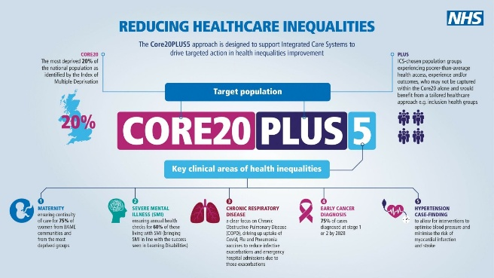
Figure 1: Core20PLUS5 Approach
Source: england.nhs.uk
The NHS England Core20PLUS5 is a flagship national strategy, which should be used to minimise healthcare inequalities. It focuses on the 20% of the population that is the most deprived – the Core20 and the specific groups PLUS, e.g., the elderly with multiple long-term conditions. The programme intends to bridge the gap in mortality between the richest and poorest older adults by targeting five clinical areas, such as early cancer diagnosis and hypertension (NHS England, 2024).

3.2 Fit for the Future: 10 Year Health Plan
This government policy, which was introduced in 2025, moves the NHS away from a definition of a community, rather than a hospital, and illness, rather than prevention. In the case of the elderly, this involves the implementation of the so-called 'Neighbourhood Health Centres' offering integrated care in the vicinity of the home that will alleviate stressful experiences of visiting the hospital and make sure that the impact of social determinants such as housing and nutrition is tackled along with clinical needs (GOV.UK, 2025).

4. Organisations involved in supporting the elderly
Age UK
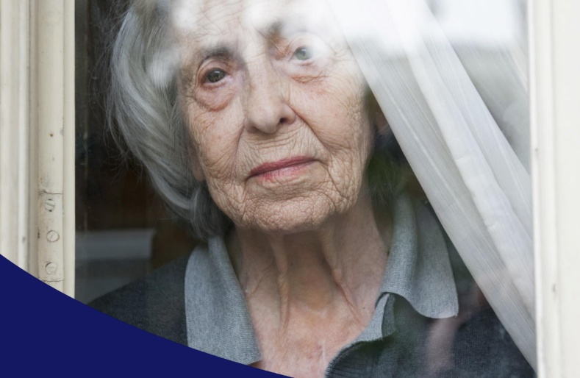
Age UK, the first national charity, aims to assist older people. Its broader use is to lobby intensively to change policies (including energy price caps) and offer a national evidence base via its State of Health and Care reports to shine light on social injustices against the aged (Age UK, 2025).
Figure 2: Age UK
Source: (Age UK, 2025)
- Charity Support: It offers a free national advice line, Silver Line befriending, and local exercise classes to fight physical deterioration.
- Aims: The organisation aims at ensuring that all the older people are given a chance to live an accomplished later life. It does original research into poverty among older adults and digital exclusion to impact government expenditure (Age UK, 2025).

5. Conclusion
The elderly population in the UK does not necessarily experience health inequalities, but it is a consequence of the accumulation of socioeconomic differences in the past. This report has determined that even though the clinical problems such as mental illness and high death rates are very serious and cannot be overlooked, they cannot exist without the social problems such as poverty, isolation and poor housing. The introduction of the national response, including the Core 20PLUS5 and the 10-Year Health Plan, is one of the major steps to a systemic change. Nevertheless, more effort is needed to sustain charities such as Age UK to fill the policy-lived experience divide in the experience of the most vulnerable older citizens in the UK.

Task 2: Epidemiological Analysis

1. Introduction
This report is about cardiovascular disease (CVD) as a leading non-communicable disease (NCD) among the elderly people in the London Borough of Tower Hamlets as a regional epidemiologist of North East London. CVD is a collection of diseases of the heart and blood vessels such as hypertension, coronary heart disease and stroke. In addition to the clinical burden, CVD has social and cultural impacts that may result in a loss of independence, strain on the carers, and social isolation of the elderly (WHO, 2024). Health literacy disparities across various boroughs such as Tower Hamlets can be culturally driven and create a delay in diagnosing and appropriately managing risk factors.
CVD is the most common cause of death worldwide, with an estimated number of 17.9 million deaths every year (WHO, 2024). CVD is the leading cause of death in the UK, estimated to have between 160,000 and 170,000 deaths annually (British Heart Foundation, 2025). Although it is prevalent in the whole country, it is more severe in Tower Hamlets, with the prevalence of circulatory diseases being much higher than the average of London due to a higher prevalence of hypertension in the deprived deciles than in more affluent wards (Public Health Outcomes Framework, 2025).

2. Public health measures: The 3 P’s:
Public health measures to be used to manage the impact of cardiovascular disease (CVD) in Tower Hamlets are strategically placed under the 3 Ps, namely prevention, promotion and protection. Prevention is concerned with clinical intervention, namely, secondary prevention in the form of high-uptake screening of people aged 40–74 with the help of the NHS Health Check programme to detect early signs of hypertension and high cholesterol levels before they build up into acute events (UKHSA, 2024). The complement to this is the health promotion, an example of which is the "Tower Hamlets Healthy Borough" programme; here the culturally specific message needs to be used in the Sylheti and Bengali languages in order to address the needs of local demographics, actively promoting physical exercise and smoking cessation among community members of older age (Tower Hamlets Council, 2025). Lastly, Protection changes the priorities to structural and environmental protection, including the extension of the Ultra Low Emission Zone (ULEZ) to minimise the levels of particulate matter (PM2.5), a key initiator of cardiovascular discomfort in the particularly susceptible elderly group (Greater London Authority, 2024). These pillars combine to create an extensive framework to decrease morbidity and mortality due to CVD on the local level.
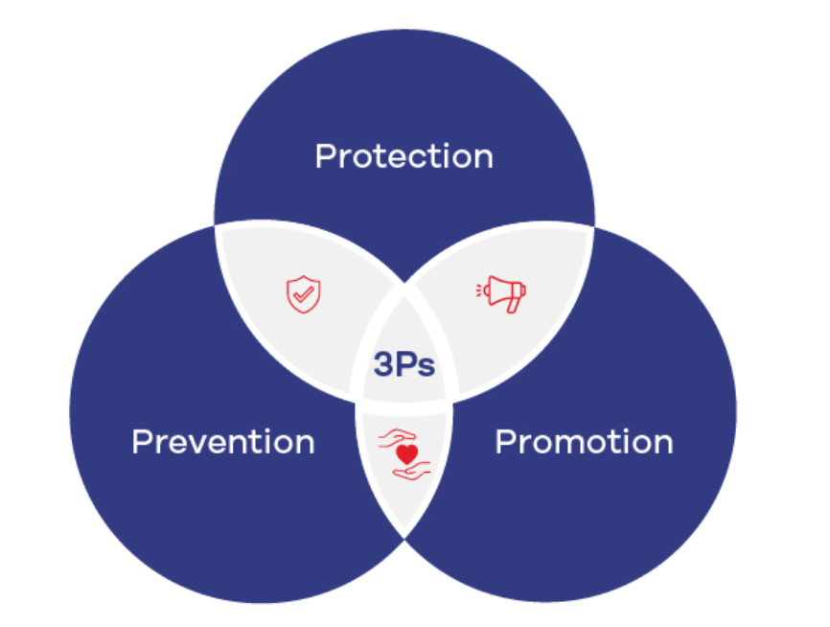
Figure 3: Three Ps of Public Health
Source: ubas.edu.pk

3. Important Determinants and Risk Factors:
The causes of CVD among this cohort are complex. Risk factors that are biological in nature are increasing age, type 2 diabetes and hyperlipidaemia. Wider determinants of health, however, exacerbate these. In Tower Hamlets, the income deprivation rates are high, and as a result, most of the elderly population in the area resides in the so-called food deserts, where fresh and low-sodium foods are relatively costly as compared to processed and high-calorie foods (Health Foundation, 2024). Moreover, disadvantages of the structure, including low air quality and inadequate housing, are the causes of chronic stress that raises blood pressure, one of the main causes of CVD (Marmot et al., 2021).

4. Identification of At-Risk Groups: Epidemiological Studies and HNA:
With a Health Needs Assessment (HNA) and longitudinal cohort study, such as the Whitehall II study, we have determined that the at-risk group in Tower Hamlets is not primarily determined by age but rather by age and ethnicity. Epidemiological research shows that the elderly males in the borough who are of South Asian descent are half as likely to develop coronary heart disease in comparison with their white counterparts of the same age (British Heart Foundation, 2025). There is a risk group that is not apparent in the HNA: elderly women living alone in social housing, as most of them tend to experience obstacles on the way to primary care because of poor mobility and language barriers (Office for National Statistics, 2025).

5. Monitoring and Surveillance Systems:
In its effort to keep track of the prevalence rates of cardiovascular disease (CVD) in the borough, Tower Hamlets uses a multi-layered model that combines the passive, active, and digital surveillance systems. Passive surveillance is mainly enabled with the help of the Quality and Outcomes Framework (QOF) that gathers routine data about general practitioner registers systematically to track the rates of hypertension and stroke among the local population (NHS Digital, 2024). This approach is complemented by active surveillance through the UKHSA, through its "Sentinel Surveillance" systems, which actively surveil emergency department admissions related to acute myocardial infarction; through this, epidemiologists are able to identify spikes in cardiac events in real-time, which is usually due to environmental changes such as extreme cold snaps (UKHSA, 2024). Moreover, online surveillance applications, including the so-called Public Health Fingertips, can present interactive dashboards with which the local health authorities can compare the CVD mortality and morbidity rates in Tower Hamlets with the national and regional rates (Office for Health Improvement and Disparities, 2025). These systems collectively provide a robust data infrastructure that enables swift responses to public health events and facilitates long-term planning.

6. Public Health Impact: Short- and Long-Term Outcomes
Through epidemiology, we are able to make projections of the devastating effect of unchecked CVD. High incidence in the short-term results in pressure on Barts Health NHS Trust, which is manifested by an increase in the number of emergency admissions, as well as the waiting list of surgical patients. The implication in the long run is a disability burden. Each fatal stroke in Tower Hamlets is accompanied by four others, who are left with serious disabilities, and they need long-term social care (King’s Fund, 2024). This traps families in a poverty/poor health cycle, as savings are used up for care, and inequalities in health are further ingrained in the region.

7. Health Intervention Suggestion: "Heart of the Community":
Design of Intervention: A community-based mobile cardiovascular screening and literacy hub. This programme will send mobile vans to the local markets (e.g., Whitechapel Market) to offer blood pressure checks, BMI tests and instant referrals to GPs.
Assessment: The effects will be assessed based on a randomised control trial (RCT) in various wards. A 10% rise in the rates of hypertension diagnosis within 12 months and a decreased number of CVD-related emergency admissions in the intervention group as compared to the control group will be considered a success (NICE, 2024).

8. Advantages and disadvantages of the epidemiological approach:
The advantage of this strategy is that it is evidence-based and precise; resources are allocated where they are most required rather than being evenly distributed throughout the city. Nevertheless, the main limitation is the selection bias of the surveillance information, as the most marginalised (e.g., undocumented migrants or the most remote) may not be reflected on the GP registers and the actual prevalence will be underestimated (Marmot, 2023). Longitudinal studies are also vulnerable to attrition bias, as the sickest respondents may opt out of the study and the data may be biased towards a healthy survivor effect.

9. Conclusion
The epidemiological prism that is necessary in the management of CVD in the elderly population of Tower Hamlets is one that considers the disease in the context of social causes that lie behind its clinical manifestations. Incorporating the 3 P's, a robust surveillance system, and community-specific interventions can alleviate the harsh inequalities experienced by this borough. Although there are some constraints in the data collection process, strategic exploitation of HNA and specific interventions can provide a potential opportunity to enhance heart conditions and lower the mortality gap in East London.

Reference:
Age UK (2025) The State of Health and Care of Older People in England 2025. [Online]. Available: https://www.ageuk.org.uk/reports-2025 (Accessed: 24 April 2026).
Department of Health and Social Care (2025) Fit for the Future: The 10 Year Health Plan for England. [Online]. Available: https://www.gov.uk/government/publications/10-year-health-plan (Accessed: 24 April 2026).
Goleman, D. (2024) The Psychology of Ageing and Mental Health. 2nd edn. London: Academic Press.
Health Foundation (2024) Our ageing population: Long-term conditions and the NHS. [Online]. Available: https://www.health.org.uk/reports/ageing-population-2024 (Accessed: 24 April 2026).
NHS England (2024) Core20PLUS5 (adults) – An approach to reducing healthcare inequalities. [Online]. Available: https://www.england.nhs.uk/about/equality/core20plus5/ (Accessed: 24 April 2026).
Office for National Statistics (2025) Voices of our ageing population: Living longer lives. [Online]. Available: https://www.ons.gov.uk/peoplepopulationandcommunity/ageing/2025 (Accessed: 24 April 2026).
Office for National Statistics (2025) Public opinions and social trends, Great Britain: January 2025. [Online]. Available: https://www.ons.gov.uk/wellbeing/bulletins/2025 (Accessed: 24 April 2026).
UK Health Security Agency (UKHSA) (2024) Health Disparities Report: Seasonal Risks for the Elderly. [Online]. Available: https://www.gov.uk/ukhsa/disparities-2024 (Accessed: 24 April 2026).
World Health Organization (WHO) (2025) World Report on Ageing and Health. Geneva: WHO Press.
Age UK (2025) The State of Health and Care of Older People in England 2025. [Online]. Available at: https://www.ageuk.org.uk/reports-2025 (Accessed: 24 April 2026).
British Heart Foundation (2025) UK CVD Statistics Factsheet. [Online]. Available at: https://www.bhf.org.uk/stats-2025 (Accessed: 24 April 2026).
Department of Health and Social Care (2025) Fit for the Future: The 10 Year Health Plan for England. [Online]. Available at: https://www.gov.uk/government/publications/10-year-health-plan (Accessed: 24 April 2026).
Greater London Authority (2024) Air Quality and Cardiovascular Health in Inner London. [Online]. Available at: https://www.london.gov.uk/reports/air-quality-2024 (Accessed: 24 April 2026).
Health Foundation (2024) Our ageing population: Long-term conditions and the NHS. [Online]. Available at: https://www.health.org.uk/reports/ageing-population-2024 (Accessed: 24 April 2026).
King’s Fund (2024) The Rise of Multi-morbidity in Deprived Urban Areas. [Online]. Available at: https://www.kingsfund.org.uk/publications/multimorbidity-2024 (Accessed: 24 April 2026).
Marmot, M. (2023) Social Justice and the Health Gap. London: Bloomsbury.
Marmot, M., Allen, J., Goldblatt, P. and Morrison, J. (2021) Build Back Fairer: The COVID-19 Marmot Review. London: Institute of Health Equity.
NHS Digital (2024) Quality and Outcomes Framework (QOF) – 2023-24 Results. [Online]. Available at: https://digital.nhs.uk/data-and-information/publications/statistical/quality-and-outcomes-framework (Accessed: 24 April 2026).
NHS England (2024) Core20PLUS5 (adults) – An approach to reducing healthcare inequalities. [Online]. Available at: https://www.england.nhs.uk/about/equality/core20plus5/ (Accessed: 24 April 2026).
NICE (2024) Cardiovascular disease: risk assessment and reduction, including lipid modification. [NG238]. London: NICE.
Office for Health Improvement and Disparities (2025) Public Health Fingertips: Cardiovascular Disease Profile. [Online]. Available at: https://fingertips.phe.org.uk/profile/cardiovascular-disease (Accessed: 24 April 2026).
Office for National Statistics (2025) Voices of our ageing population: Living longer lives. [Online]. Available at: https://www.ons.gov.uk/peoplepopulationandcommunity/ageing/2025 (Accessed: 24 April 2026).
Office for National Statistics (2025) Health state life expectancy by local area, UK: 2022 to 2024. [Online]. Available at: https://www.ons.gov.uk/health-expectancy-2025 (Accessed: 24 April 2026).
Public Health Outcomes Framework (2025) Tower Hamlets Borough Health Profile. London: OHID.
Tower Hamlets Council (2025) Joint Strategic Needs Assessment (JSNA): Cardiovascular Disease. [Online]. Available at: https://www.towerhamlets.gov.uk/jsna-cvd (Accessed: 24 April 2026).
UK Health Security Agency (UKHSA) (2024) Health Disparities Report: Seasonal Risks for the Elderly. [Online]. Available at: https://www.gov.uk/ukhsa/disparities-2024 (Accessed: 24 April 2026).
UK Health Security Agency (UKHSA) (2024) Surveillance of Non-Communicable Diseases in Urban Environments. [Online]. Available at: https://www.gov.uk/ukhsa/ncd-surveillance (Accessed: 24 April 2026).
World Health Organization (WHO) (2024) Cardiovascular diseases (CVDs) Factsheet. [Online]. Available at: https://www.who.int/news-room/fact-sheets/detail/cardiovascular-diseases-(cvds) (Accessed: 24 April 2026).
Unilever (2024) Annual Report on Nutrition and Health Trends. [Online]. Available at: https://www.unilever.com/reports/2024 (Accessed: 24 April 2026).
Public Health Wales (2024) Epidemiological methods in modern practice. Cardiff: PHW.
Journal of Public Health (2023) ‘Socioeconomic status and heart disease: A 10-year study’, 45(2), pp. 112-120.
Lancet Public Health (2024) ‘Global trends in hypertension: 2020-2025 review’, 9(3), pp. e145-e156.

