A critical analysis of the relationship between teacher subject knowledge and effective learning and teaching in the primary school

Word Count:
Introduction
In this essay I will begin by discussing the literature that surrounds teacher subject knowledge (SK) for effective learning and teaching in the primary school. I will then analyse and evaluate my SK and its impact on effective primary teaching on Professional Teaching Experience (PTE) while on my initial school placement. Throughout this essay the placement school name, pupils and staff are reported as anonymous to maintain confidentiality, supporting British Educational Research Association (BERA, 2018) Ethical Guidelines for Educational Research.

I am undertaking PTE1 in a large English medium primary school on the outskirts of Swansea. The school caters for 328 pupils, aged from three to eleven years old. Most pupils have English as a first language and some children come from an ethnic minority background. Approximately 28% of pupils are entitled to free school meals and approximately 23% of pupils have additional learning needs (School Guide, 2018). I was placed in the upper Key Stage 2 department, which catered for children in year groups 4, 5 and 6, with 85 pupils (41 male, 44 female) in total. Pupils are shared between three experienced teachers. The class teaching staff are assisted by one teaching assistant.

SK for effective teaching

SK signifies a teachers’ specific knowledge surrounding one subject (Metzler and Woessmann, 2010). There has been growing evidence to suggest that for effective teaching to occur in primary schools, good teacher SK is essential (Ko, Sammons and Bakkum, 2016). Rosenshine (2012) suggests that excellent SK is a key characteristic of effective teaching. However, numerous studies have recognised additional variables that can impact pupil attainment such as teacher motivation, pupil motivation, school characteristics and pupil existing SK (Metzler and Woessmann, 2010; Coe, Aloisi and Higgins, 2014).

Ofsted (2009) reviewed the importance of good SK for high-quality teaching. Ofsted (2009) discovered that teachers with low SK overlooked misconceptions and errors in children’s understanding (Ofsted, 2009). Similarly, Estyn (2014) reported that specifically in mathematics, teachers with low SK failed to address pupils’ numerical misconceptions and pupils became confused. In some lessons, teachers offered incorrect strategies to manipulate numbers and in other lessons teachers struggled to explain numerical concepts and processes clearly (Estyn, 2014). Pupils in these lessons made limited progress, this was evident in primary and secondary schools (Estyn, 2014). Furthermore, Estyn (2014) acknowledged that when teachers had low SK, children were not questioned or encouraged to feedback information and high achieving children were not challenged. Ofsted (2009) concluded that general pedagogical teaching skills (e.g. classroom management and instructional support) can make up for gaps in teacher SK.

The above findings coincide with research by Murphy (2010). Murphy (2010) discovered that specifically, student teachers with low mathematical SK lacked confidence in their ability to provide clear explanations. Whereas, student teacher’s with high mathematical SK supplied pupils with clear, accurate demonstrations and related mathematical problem to real-life situations. Nicaise, Gibney and Crane (2000) found that when SK was related to real-life situations (authentic learning) pupil’s gained confidence in their learning capabilities and developed problem solving skills. However, Murphy’s (2010) research was obtained using interview style questions. When teachers are interviewed, teachers may interpret the same question differently which may elicit a varied response. Furthermore, an interview style environment does not provide a true representation of the pedagogical skills a teacher may use for effective teaching in a classroom. Additionally, due to the small sample size of Murphy’s (2010) study it is difficult for results to be generalised.

Questioning is an effective instructional teaching act that develops elements of the instructional core (teacher, student and content; Taba, Levine and Elzey, 1964; Cohen, Raudenbush and Ball, 2003). When the elements of the instructional core interact, pupil engagement and achievement increase (Walsh and Sattes, 2011). Rosenshine (2012) identified that teachers who possess good SK ask questions, provide comprehensive explanations and check pupils understanding as they progress through a topic. Rosenshine (2012) found that mathematics teachers with good SK spend an increased duration (23 minutes) in lessons questioning, compared to teachers with little mathematical SK (11 minutes). Similarly, Whitby (1993) identified that when teachers asked more questions in science, pupils understanding of the topic increased. Nevertheless, research by Rosenshine (2012) and Whitby (1993) was obtained using an observational technique. Observational methods are subjective; therefore, it is difficult to draw conclusions from these results (Coe et al. 2014). Shulman (1986) suggests that teachers need to understand SK in different ways to transfer their SK to children through clear illustrations, explanations, demonstrations and questioning. Hill, Rowen and Ball (2005) supports Shulman (1986) by suggesting that teacher effectiveness is not just based on teacher SK but on their knowledge of ‘how to teach’.

Khwaja (2006) recognised that teacher SK is “the most severe obstacle” to improving pupil outcome in primary science. Metzler and Woessmann (2010) found that good teacher SK had a positive impact on pupil achievement. However, due to the small sample size of Metzler and Woessmann (2010) study, this outcome cannot be generalised across the overall primary population. Furthermore, previous research (Whitby, 1993; Brown and Simon, 1996) recognised that science achievement in primary aged children was linked to teacher’s confidence in their own SK. Bennett and Turner-Bissett (1993) found similar results when teaching music to 7-11-year olds. Brown and Simon (1996) recognised that if teachers have confidence in their SK, they utilise an open style of questioning, drawing on from ideas formed by children. Open divergent questions encourage pupils to justify and add reasoning to their responses (Hayes, 2006). This encourages children to develop their higher-order thinking (Lee and Kenzie, 2012) relating to Bloom’s Taxonomy (Bloom, 1956). Higher-order thinking supports children in retaining information (Tofade, Elsner and Haines, 2013).

SK and pedagogical knowledge

In contrast to previous research, evidence suggests that if teachers have strong SK, effective teaching in primary school is not guaranteed (Khwaja, 2006). Khwaja (2006) concluded that teacher SK is important, however effective teachers must understand how content is delivered in a way that children can learn to help them progress. Furthermore, Carré and Ernest (1993) found no difference in effective teaching of mathematics between teachers with high and low mathematical SK (Carré and Ernest, 1993). Similarly, Hill et al. (2005) moved on from claims that effective teaching was gained through good teacher SK. Hill et al. (2005) discovered that effective teaching was evident through delivering confident teaching based on fundamental pedagogical knowledge. Hill et al. (2005) found that SK and pedagogy in mathematics was positively related to pupil achievement. Results from Hill et al. (2005) are considered reliable as cause and effect of SK and pedagogy were explored over prolonged time (longitudinal and qualitative study). Furthermore, due to the large sample size of the study (115 elementary schools), results obtained by Hill et al. (2005) can be generalised to a primary school population.

Pedagogical content knowledge (PCK)

Shulman (1987) developed the idea that effective teaching was constructed on more than good SK alone. Shulman (1987) recognised that effective teaching was grounded by the knowledge and understanding surrounding ‘how to teach’. Shulman (1987) proposed that to be an effective teacher it is essential to have an in-depth understanding of seven categories that form the knowledge base for teaching (Figure 1; Appendix A).
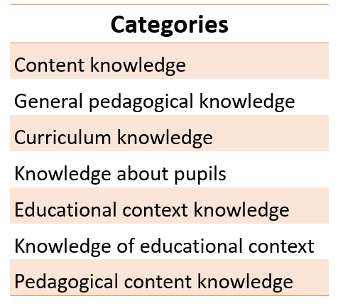
Figure 1 - Seven categories that form the knowledge base for teaching (Shulman, 1987).
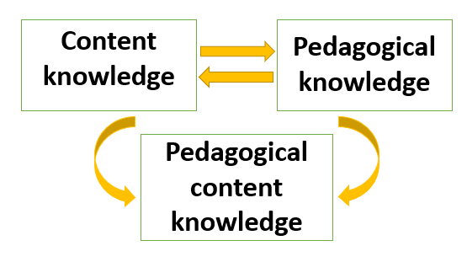
Shulman (1987) focused on the notion of “pedagogical content knowledge” (Figure 2), constructed by knowledge that incorporates content knowledge (knowledge of a specific subject) and pedagogical knowledge (relevant to execute the specific subject).
Figure 2 - PCK formed through the interaction of content knowledge and pedagogical knowledge (Shulman, 1987).

Shulman (1987) reported that when pedagogy and content combine (PCK) specific problems, subjects or issues can be ordered, displayed and adapted to cater for a variation of pupil interests and learning abilities. PCK draws attention on understanding how different children learn based on their age, misconceptions, ability and prior knowledge (Shulman, 1986).

Shulman (1986) defined PCK as “the knowledge needed to make subject matter accessible to students”. Shulman (1987) believed that effective teachers had the PCK necessary to convert subject content to be taught to pupils so that it could be easily grasped. To make subject matter accessible, it is necessary to identify pupils’ conceptions and misconceptions about the subject and have knowledge of teaching strategies (Ball, Themes and Phelps, 2008). Therefore, teachers need to have good SK to address errors in pupils understanding. However, an expert level of SK is not necessary (Lee et al. 2007). Nevertheless, teachers need to be free from errors in their own SK to identify misconceptions in pupils SK (Kathirveloo, Puteh and Matematik, 2014). Baumert et al. (2010) and Coe et al. (2014) suggested that pupil attainment was enhanced by teacher SK and a teacher understanding of how pupils grasp subject content (PCK), specifically in mathematics. However, research that demonstrates a link between SK and PCK consists of a small sample size, therefore it is difficult to draw conclusions for a given population based on findings (Cochran-Smith and Zeichner, 2005).

Research has demonstrated (Voss, Kunter and Baumert, 2011; Kunter et al. 2013) that general pedagogical knowledge alone is as important as SK and PCK to be an effective teacher. Baumert et al. (2010) supports this finding by demonstrating when SK is controlled, not considering general pedagogy, pupil achievement does not improve. Evidently, previous research has only considered formal qualifications as proof of SK and fails to consider everyday knowledge that people retain from leaving school, such as informal learning opportunities gained through experience (Kleickmann et al. 2013). Therefore, there is limited research surrounding how professional development and experiences develop SK (Cochran-Smith and Zeichner, 2005). Nevertheless, conclusions can be drawn from Baumert et al. (2010) findings as a direct assessment method was used. Direct assessment is a reliable method of assessing findings as results directly reflect the assessed outcome.

Based on the above findings, research suggests that pedagogy needs to be accounted for to determine effective teaching (Coe et al. 2014). However, it is challenging to relate good pedagogy to teaching effectiveness, as what is considered good pedagogy differs from teacher to teacher (Coe et al. 2014). Husbands and Pearce (2012) claimed that ‘effective pedagogies give serious consideration to pupil voice’. However, this was not related to pupil attainment and little evidence supports this (Coe et al. 2014). Additional research suggests that effective teachers apply pedagogy through providing opportunities for pupils to build upon prior knowledge (Hattie and Yates, 2014). An effective teacher will integrate the pupil’s previous knowledge into a lesson in the introduction of a new topic; they will make links between content to place meaning behind new information (Tay, 2018). However, pupils will have differentiated access to prior knowledge, therefore teachers have the pedagogical challenge to involve each pupil in readdressing prior knowledge and evaluate the quality of existing knowledge through assessment (Tay, 2018).

The knowledge Quartet

Shulman (1987) identified that PCK is demonstrated through planning and teaching meaningful illustrations, example and demonstrations in a way that others can comprehend with ease. PCK also demonstrates how to adapt learning to suit a range of abilities (Shulman, 1987). Rowland, Huckstep and Thwaites (2003) developed the understanding that PCK needs to become visible in planning and teaching with focus on the subject matter of the lesson. Drawing on the above considerations, Rowland et al. (2003) devised The Knowledge Quartet (TKQ) as a framework to reflect and develop teaching and teacher knowledge and to apply this knowledge within practical teaching in the classroom.
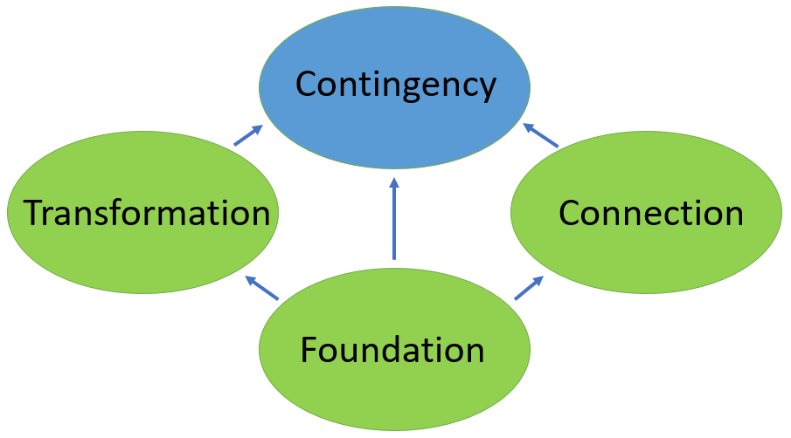
TKQ consists of four dimensions (Figure 3): foundation, transformation, connection and contingency (Rowland et al. 2003).
Figure 3- The four dimensions of The Knowledge Quartet (Rowland et al. 2003).

Foundation

The foundation dimension of TKQ draws on the beliefs, knowledge and understanding a trainee teacher develops when they are studying in university, to transfer to their role within a primary school classroom (Rowland et al. 2003). During the foundation stage of TKQ student teachers gain an understanding of different national curriculum subjects and gain knowledge surrounding how to teach the learning of these subjects in a classroom (Rowland et al. 2003).

While on PTE1, the key stage 2 theme for the school term was the Egyptians. In each area of learning, I would set out to develop the pupil’s knowledge and understanding of the Egyptians. The lesson I have chosen to reflect on was aimed at the languages, literacy and communication area of learning as suggested by Donaldson (2015). The lesson involved pupils identifying the key features of a newspaper report and then constructing a newspaper report based on the discovery of Tutankhamun’s Tomb.

When planning the subject content for this lesson, despite researching articles on the discovery of King Tut’s Tomb, I had little confidence in my understanding of the topic. When it came to teach this lesson, it was apparent that I had a limited foundation knowledge of the Egyptians. My low foundation knowledge was evident in my low level of support, feedback and challenge I could present to the pupils. This limited the quality of information the children could include in their reports (Coe et al. 2014). Rosenshine (2012) identified that if teachers have limited foundation knowledge, it restricts the level of support and feedback a teacher can provide, specifically when helping pupils recognise errors in their work and gaps in their understanding. Furthermore, teachers’ confidence in their SK is reflected in children’s responses to topic questions (Brown and Simon, 1996). In contrast, I exhibited good foundation knowledge in relation to the national curriculum requirements for structuring and organising a newspaper report based on the features displayed in appendix B. Exhibiting high confidence in my SK of newspaper features enabled me to sufficiently scaffold pupils learning and through higher order questioning, children were encouraged to expand and apply reasoning to their answers (Hayes, 2006).

In my future teaching, I will display characteristics such as passion, motivation and enthusiasm, evident to override poor teacher SK and help pupils achieve their full potential (Hattie, 2012). I will apply the pedagogical technique of scaffolding within the classroom to help pupils progress with their learning (James and Pollard, 2011). Scaffolding occurs when a pupil is assisted by a more knowledgeable other (MKO) to complete a task (Scott, 2008). Extensive research suggests that scaffolding in a primary school is ‘adult driven’ as much of the time the teacher is recognised at the MKO (Verenikina, 2008). However, I intend to place the focus on pupils scaffolding their peers learning through working collaboratively in small groups and pairs. Scaffolding supports a social constructivist approach to learning (Weegar and Pacis, 2012) and will help children to become ‘creative contributors’ (Donaldson, 2015). Donaldson (2015) suggests that peer support when learning (cooperative learning) enhances problem solving, motivation and achievement in children (Quinn, 2006). Furthermore, when children work with peers, they are taking responsibility for their own learning and develop as ‘ambitious, capable learners’ (Donaldson, 2015). I will also encourage children to use digital sites to further scaffold their knowledge and understanding of the discovery of King Tut’s Tomb (Wood, Bruner and Ross, 1976). By doing so, I will be supporting the cross-curricular responsibility that teachers must embed digital competence in the same way that the literacy and numeracy framework suggests (Donaldson, 2015). Furthermore, I will ensure that I gain an in-depth understanding of the class topic. By doing so I will have a good understanding of any pre-misconceptions that pupils may encounter during the lesson, therefore errors can be addressed in a prompt manner.

Transformation

The transformation dimension of TKQ arises when a teacher applies their knowledge gained in the foundation stage to inform their planning and teaching of lessons in a classroom. Shulmans (1987) research informs this stage as here the teacher transforms the SK they hold into ways children can access this knowledge to learn. Teachers transfer their SK to children through practical examples, demonstrations and explanations that can be adapted to suit a variety of ages and learning ability levels (Shulman, 1986).

On the third week of my teaching placement I introduced the topic of ratio to a middle ability group of year 4 and 5 children. Ratio comes under the mathematics and numeracy area of learning (Donaldson, 2015). I began demonstrating the concept of ratio using method 2 (Figure 4). However, I struggled to explain and demonstrate this instructional method of calculating a ratio of a quantity to pupils in a concise way so that pupils could grasp the concept. Rapidly, I reverted to an alternative method of calculating the ratio of a quantity using practical pictorial representations (Method 1; Figure 4). I hadn’t planned to use a pictorial demonstrating in my teaching. When I reverted to the pictorial method, pupils understood the concept. When reflecting on the lesson, if I hadn’t of had previous experience demonstrating ratio using the pictorial method, I would have struggled to teach pupils the topic of ratio using the planned method (Method 2; Figure 4).

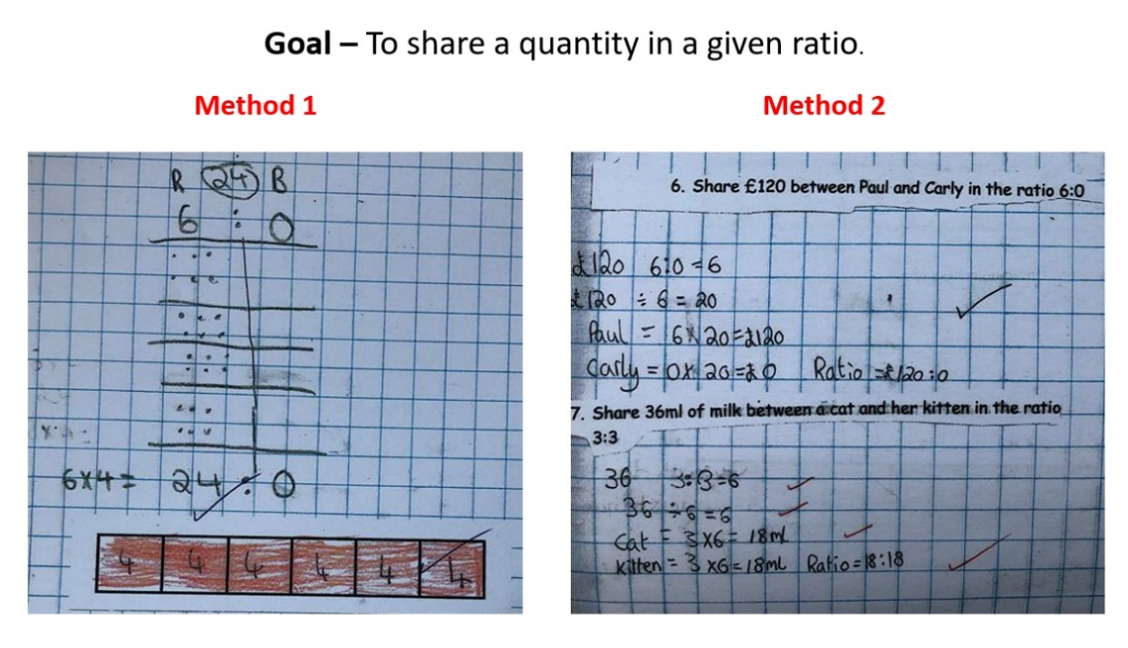
Evidence suggests that I understood the mathematical elements of the topic of ratio well enough to personally grasp the concept, however, I lacked in PCK to originally transform my SK into an explanation that children could easily learn (Coskun and Bostan, 2018). Evidence suggests that if I had a strong foundation of mathematical SK, I would have planned and applied the pictorial method of demonstrating ratio originally to help pupils grasp the concept to avoid confusion (Coskun and Bostan, 2018). Nevertheless, by eventually modifying my method of explanation, I exhibited an improved use of PCK by adapting my demonstrations to suit the diverse ability needs of the pupils, therefore making the subject content more accessible.
Figure 4 – Two different demonstration examples used in the lesson to explain, how to share a quantity in a given ratio.

Within my future teaching, I will develop my overall PCK through hands on practical teaching experiences in a range of classroom settings. By doing so I can adopt a range of instructional strategies and gain a better understanding as to how I can demonstrate class tasks that promote optimal learning (Coe et al. 2014). Additionally, when introducing a new topic, I will plan alternative practical demonstrations that could involve mental arithmetic, individual and group work and interactive learning utilising Information Communication Technology (ICT). Although some research suggests that ICT can lead to poor concentration and delay language development in children (Healy, 2003). ICT supports children in developing problem solving and critical thinking skills that can be transferred into different environments (Donaldson, 2015). By utilising ICT within a mathematics lesson, it supports the application of digital competence across the curriculum (Donaldson, 2015). Additionally, I will be considering the diverse needs of learners and recognising that children learn through accessing information using different approaches (Shulman, 1987). By encouraging children to adopt a range of strategies to approach mathematical problems it will help children to apply this knowledge in a range of real-life settings, facilitating an environment that encourages children to become ‘ambitious, capable learners’ (Donaldson, 2015).

Furthermore, when carrying out demonstrations in the classroom, I will ensure that I present information to pupils in small manageable stages (Rosenshine, 2012). I will model the task for pupils, guide pupils through the practice, supervise and support pupils through worked examples, check understanding (address any misconceptions) and then recap information where necessary (Rosenshine, 2012). Although this method of instruction will take time, research demonstrates that effective teachers take more time guiding and presenting new content to children. By doing so, children can learn information with ease (Rosenshine, 2012).

Connection

The connection stage of TKQ involves the combination of planning and teaching over a series of lessons. During this stage a teacher will order a sequence of tasks and learning activities between and within lessons. The teacher will transfer knowledge to pupils in a logical progressive way (Rowland et al. 2003).

The learning event I am going to focus on is contained within the mathematics and numeracy area of learning (Donaldson, 2015). The learning objective for lesson 1 was to identify the 12hour time on digital and analogue clocks. The learning objective of lesson 2 was to identify the 24h time on digital and analogue clocks. The lessons displayed clear progression. However, when starting lesson 2, I failed to clearly demonstrate the connections between 12hour and 24hour clocks and failed to relate the skills applied to a practical real-life context. This meant that children did not understand the links between the 12hour and 24hour clocks (evident in Appendix C. Therefore, when it came to pupils solving the time conversion task, children had great difficulty in understanding how to convert the 12h time into the 24h time (Figure 5). I had to go from pupil to pupil to explain the connection.

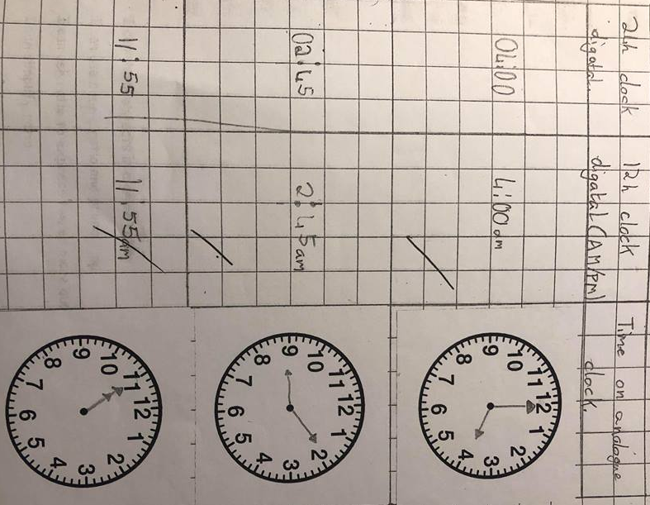
Hiebert and Carpenter (1992) recognised “it is essential to make connections in mathematics if one intends to develop mathematical understanding”. Rosenshine (2012) stated that children learn though connecting the understanding of new information to existing knowledge. However, within a primary school class pupils existing knowledge varies greatly. Therefore, a teacher should seek to determine pupils existing SK through assessment (Tay, 2018). Following this, my future practice will support the process of pupils making connections between new and existing mathematical knowledge. I will draw on pupil’s previous knowledge to identify gaps in existing knowledge and focus on misconceptions that may impact future learning (Shulman, 1987). Donaldson (2015) states that teachers should provide opportunities for children to connect new concepts to prior knowledge, so children can transfer their existing skills and understanding to new situations. Furthermore, I will support pupils in applying new knowledge to real-life context. When children apply skills to a real-life context it supports them in becoming ‘ambitious, capable learners’ (Donaldson, 2015).
Figure 5 – Lesson 2 outcome to convert between the 12h and 24h clocks.

Contingency

The contingency stage of TKQ consists of classroom actions that are unpredictable and can’t be planned for (Rowland et al. 2003). During the contingency stage, teachers can diverge from the planned lesson and respond to children’s questions and curiosities. The contingency stage follows a constructivist approach to learning by encouraging children’s input into lessons and supporting their desire to grow in knowledge and understanding.

The contingency stage of TKQ was displayed as I was teaching within the science and technology area of learning (Donaldson, 2015). Within a science lesson, pupils were set out to label and draw scientific diagrams of the human eye. Once complete, children were instructed to research and record the functions of the features of the human eye. One pupil asked, ‘why are some animals are colour blind?’. This was an interesting question which sparked interest on the topic with other pupils in the class. Other pupils asked, ‘why do some people have brown eyes?’. Although not linked to the lesson objectives, these queries were still relevant to the topic of the eye.

Rowaland and Zazkis (2013) proposed that increased SK enables teachers to take advantage of divergent situations. Increased SK increases a teacher’s ability to plan for pupils’ responses (Rowland et al. 2009) and “think on one’s feet” (Rowland and Turner, 2007). However, Warburton (2015) found that high SK does not necessary impact a teacher’s ability to respond to unpredictable situations. This is due to high anxiety levels linked to low perceived confidence in existing SK limiting a teacher’s ability to listen (Brown and Wragg, 1993).

Even though the questions asked by pupils were beyond my SK, children’s ideas should be responded to, to satisfying their curiosity (Rowland et al. 2003). Hurst (2016) identified that contingent events encourage children to reflect critically, draw key ideas together and solve problems. If contingent events are ignored to reduce the lesson from being pushed off track this could have a negative impact on the pupils moral and negatively impact their learning. Therefore, to overcome this contingent event, rather than ignoring the questions from the pupils, I assisted pupils in relating the unexpected events back to the intended subject matter. I created a classroom environment that welcomed the unexpected and related subject matter to the real-world context (Foster, 2014). I suggested to pupils that after their existing work had been completed, they were able to use the iPads and internet to research their query individually or in groups and present their findings back to the class. Chin and Osborne (2008) found that pupils felt ‘happy’ and ‘excited’ when given the opportunity to research their own questions. By encouraging pupils to use technology to research and explain their own ideas and interests it will help children to become ‘ambitious, capable learners’ (Donaldoson, 2015). By giving children the opportunity to present their findings back to the class it develops strands of the LNF by developing their communication, oracy and presenting skills (Donaldson, 2015). This supports the cross-curricular responsibilities of developing literacy and digital competence across the curriculum (Donaldson, 2015).

Conclusion

In conclusion, SK is key contributor of effective teaching and is linked to pupil’s attainment (Rosenshine, 2012). However, SK has a greater impact on pupils’ achievement when interacting with a teacher’s general pedagogical knowledge (Baumert et al. 2010). Through having a solid grasp of pedagogical knowledge, teachers can organise SK to help children learn and access information with ease (Hill et al. 2005), through the concept of PCK (Shulman, 1987). PCK is essential for effective teaching and develops the understanding of transforming knowledge in a way that can be grasped by a variety of pupils (Shulman, 1987). TKQ is an ideal framework to allow PCK to be evident in planning and teaching for effective teaching to occur (Rowland et al. 2003). The TKQ has allowed me to review my own PCK to inform my future teaching. Within my future practice, I will have a strong SK foundation so that I can provide the best level of support, feedback and confidence when addressing any misconceptions that could limit pupils understanding and attainment. I will encourage the execution of social interaction within the class to intensify pupil’s development and learning. I will utilise practical and visual interactive demonstrations relating to a real-life context when introducing a new topic as this method has shown to elicited pupils learning and their ability to access new information. Furthermore, within my future teaching, I will use my pedagogical understanding of how children learn to ensure children can connect to prior knowledge to help organise new information and add meaning subject content (Tay, 2018). I will ensure that children’s unexpected ideas and questions that spark curiosity in their thinking are addressed with enthusiasm and support.

Key references

- Ball, D.L., Thames, M.H. and Phelps, G. (2008) ‘Content knowledge for teaching. What makes in special?’, Journal of Teacher Education, 59(5), pp. 389-407.
- Baumert, J., Kunter, M., Blum, W., Brunner, M., Voss, T., Jordan, A., Klusmann, U., Krauss, S., Neubrand, M. and Tsai, Y. (2010) ‘Teachers’ mathematical knowledge, cognitive activation in the classroom, and student progress’, American Educational Research Journal, 47(1), pp. 133-180.
- Bennett, N. and Turner- Bissett, R. (1993) ‘Knowledge Bases and Teaching Performances’, in Bennett, N. and Carré, C. (ed.) Learning to Teach. London: Routledge.
- BERA (2018) Ethical Guidelines for Educational Research. Available at: https://www.bera.ac.uk/researchers-resources/publications/ethical-guidelines-for-educational-research-2018 (Accessed: 27th December 2018).
- Bloom, B.S. (1956) Taxonomy of Educational Objectives: The Classification of Educational Goals: Handbook 1: Cognitive Domain. New York: David McKay Co Inc.
- Brown, G. and Wragg, E.C. (1993) Questioning. London: Routledge.
- Brown, M. and Simon, S. (1996) cited in Osborne, J. and Simon, S. (1996) ‘Primary Science: Past and Future Directions’, Studies in Science Education, 26, pp. 99-147.
- Carré, C. and Ernest, P. (1993) ‘Performance in subject-matter knowledge in mathematics’, in Bennett, N and Carré, C. (ed.) Learning to Teach. London: Routledge.
- Chin, C. and Osborne, J. (2008) Students’ questions: a potential resource for teaching and learning science. Available at: https://www.tandfonline.com/doi/full/10.1080/03057260701828101 (Accessed: 8th January 2019).
- Cochran-Smith, M. and Zeichner, K.M. (2005) Teacher education. The report of the AERA Panel on Research and Teacher Education. Mahwah, NJ: Lawrence Erlbaum.
- Coe, R., Aloisi, C. and Higgins, S. (2014) What Makes Great Teaching? Review of the Underpinning Research. Available at: https://www.suttontrust.com/wp-content/uploads/2014/10/What-makes-great-teaching-FINAL-4.11.14-1.pdf (Accessed: 9th January 2019).
- Cohen, D., Raudenbush, S. and Ball, D.L. (2003) ‘Resources, instruction, and research’, Educational Evaluation and Policy Analysis, 25(2), pp. 1–24.
- Coskun, S.D. and Bostan, M.I. (2018) ‘The Analysis of a Novice Primary Teachers’ Mathematical Knowledge in Teaching: Area Measurement’, International Journal for Mathematics Teaching and Learning, 19(1), pp. 1-21.
- Donaldson, G. (2015) Successful Futures. Available at: file:///C:/Users/Hannah/Downloads/Donaldson%20Report%20-%20Successful%20Futures%20-%20Independent%20Review%20of%20Curriculum%20and%20Assessment%20Arrangements%20in%20Wales%20(2).pdf (Accessed: 10th December 2018).
- Estyn (2014) Numeracy in key stages 2 and 3: an interim report. Available at: https://dera.ioe.ac.uk/21390/1/Numeracy_in_key_stages_2_and_3_an_interim_report_-_November_2014.pdf (Accessed: 29th December 2018).
- Foster, C. (2014) Exploiting unexpected situations in the mathematics classroom. Available at: https://core.ac.uk/download/pdf/81517855.pdf (Accessed: 9th January 2019).
- Hattie, J. (2012) Visible learning for teachers: Maximizing impact on learning. New York, NY, US: Routledge/Taylor & Francis Group.
- Hattie, J. and Yates, G. (2014) Visible learning and the science of how we learn. London, UK: Routledge.
- Hayes, D. (2006) Inspiring Primary Teaching: Insights into excellent primary practice. Exeter: Learning matters Ltd.
- Hiebert, J. and Carpenter, T. (1992) ‘Learning and teaching with understanding’, in Grouws, D.A. (ed.) Handbook of Research on Mathematics Teaching and Learning. New York: Macmillan.
- Hill, H.C., Rowen, B. and Ball, D.L. (2005) ‘Effects of Teachers’ Mathematical Knowledge for Teaching on Student Achievement’, American Educational Research Journal, 42(2), pp. 371-406.
- Hurst, C. (2016) Provoking contingent moments: Knowledge for ‘powerful teaching’ at the horizon. Available at: https://www.tandfonline.com/doi/abs/10.1080/00131881.2016.1262213 (Accessed: 8th January 2019).
- Husbands, C. and Pearce, J. (2012) What makes great pedagogy? Nine claims from research. Available at: https://assets.publishing.service.gov.uk/government/uploads/system/uploads/attachment_data/file/329746/what-makes-great-pedagogy-nine-claims-from-research.pdf (Accessed: 28th December 2018).
- James, M. and Pollard, A. (2011) ‘TLRP’s ten principles for effective pedagogy: rationale, development, evidence, argument and impact’, Research Papers in Education, 26(3), pp. 275-328.
- Kathirveloo, P., Puteh, M. and Matematik, S. (2014) Effective Teaching: Pedagogical Content Knowledge. Available at: https://www.researchgate.net/publication/303940850_Effective_Teaching_Pedagogical_Content_Knowledge (Accessed: 8th January 2018).
- Khwaja, C. (2006) The role of subject knowledge in the effective teaching of primary science. Available at: https://www.researchgate.net/publication/26598047_The_Role_of_Subject_Knowledge_in_the_Effective_Teaching_of_Primary_Science (Accessed: 2nd January 2019).
- Kleickmann, T., Richter, D., Kunter, M., Elsner, J., Besser, M., Krauss, S. and Baumert, J. (2013) ‘Teachers’ Content Knowledge and Pedagogical Content Knowledge: The role of structural differences in Teacher Education’, Journal of Teacher Education, 64, pp. 90-106.
- Ko, J., Sammons, P. and Bakkum, L. (2016) Effective Teaching. Available at: https://www.educationdevelopmenttrust.com/~/media/EDT/Reports/Research/2015/r-effective-teaching.pdf (Accessed: 2nd January 2019).
- Kunter, M., Klusmann, U., Baumert, J., Richter, D., Voss, T. and Hachfeld, A. (2013) ‘Professional competence of teachers: Effects on instructional quality and student development’, Journal of Educational Psychology, 105(3), pp. 805–820.
- Lee, E., Brown, M.N., Luft, J.A. and Roehrig, G.H. (2007) ‘Assessing beginning secondary science teachers’ PCK: Pilot year results’, School Science and Mathematics, 107, pp. 52-60.
- Lee, Y. and Kinzie, M. (2012) ‘Teacher question and student response with regard to cognition and language use’, Instructional Science, 40(6), pp. 857–874.
- Ma, L. (1999) Knowing and teaching elementary mathematics: Teachers' understanding of fundamental mathematics in China and the United States. Mahwah, N.J: Lawrence Erlbaum Associates.
- Metzler, J. and Woessmann, L. (2010) The Impact of Teacher Subject Knowledge on Student Achievement: Evidence from Within-Teacher Within-Student Variation. Available at: http://ftp.iza.org/dp4999.pdf (Accessed: 28th December 2018).
- Murphy, C. (2010) The role of subject knowledge in primary student teachers’ approaches to teaching the topic of area. Available at: http://ife.ens-lyon.fr/publications/edition-electronique/cerme6/wg10-14-murphy.pdf (Accessed: 29th December 2018).
- Nicaise, M., Gibney, T. and Crane, M. (2000) ‘Toward an Understanding of Authentic Learning: Student Perceptions of an Authentic Classroom’, Journal of Science Education and Technology, 9(1), pp. 80.
- Ofsted (2009) Improving primary teachers’ subject knowledge across the curriculum. Available at: https://dera.ioe.ac.uk/305/1/Improving%20primary%20teachers%20subject%20knowledge%20across%20the%20curriculum.pdf (Accessed: 28th December 2018).
- Healy, J.M. (2003) ‘Cybertots: Technology and the Preschool Child’, in Olfman, S. (ed.) In All Work and no Play: How Educational Reforms are Harming Our Preschoolers. Westport: Praeger Publishers.
- Quinn, P. (2006) Cooperative Learning and Student Motivation. Available at: https://digitalcommons.brockport.edu/cgi/viewcontent.cgi?article=1295&context=ehd_theses (Accessed: 10th January 2019).
- Rosenshine, B. (2012) ‘Principles of instruction: Research based strategies that all teachers should know’, American Educator, 36(1), pp. 12–19.
- Rowland, T. and Turner, F. (2007) ‘Developing and Using the ‘Knowledge Quartet’: A Framework for the Observation of Mathematics Teaching’, The Mathematics Educator, 10, pp. 107-123.
- Rowland, T., Huckstep, P. and Thwaites, A. (2003) The Knowledge Quartet. Available at: file:///C:/Users/Hannah/Downloads/Introducing%20Knowledge%20Quartet.pdf (Accessed: 28th December 2018).
- Rowland, T. and Zazkis, R. (2013) ‘Contingency in the mathematics classroom: Opportunities taken, and opportunities missed’, Canadian Journal of Science, Mathematics and Technology Education, 13, pp. 137–153.
- Rowland, T., Turner, F., Thwaites, A. and Huckstep, P. (2009) Developing primary mathematics teaching: Reflecting on practice with the Knowledge Quartet. London: Sage.
- School Guide (2018) Gorseinon Primary School. Available at: https://www.schoolguide.co.uk/schools/gorseinon-primary-school-swansea (Accessed: 27th December 2018).
- Scott, D. (2008) Critical Essays on Major Curriculum Theorists. Abingdon: Routledge.
- Shulman, L.S. (1986) ‘Those who understand: Knowledge growth in teaching, Educational Researcher’, 15(2), pp. 4-14.
- Shulman, L.S. (1987) ‘Knowledge and teaching: Foundations of the new reform’, Harvard Educational Review, 57(1), pp. 1-22.
- Taba, H., Levine, S. and Elzey, F. (1964) Thinking in Elementary School Children. Research Project. San Francisco: San Francisco State College.
- Tay, C. (2018) A good star: The pedagogical challenge of engaging prior knowledge for all pupils. Available at: https://impact.chartered.college/article/tay-pedagogical-challenge-engaging-prior-knowledge/ (Accessed: 5th January 2019).
- Tofade, T., Elsner, J. and Haines, S.T. (2013) ‘Best Practice Strategies for Effective Use of Questions as a Teaching tool’, The American Journal of Pharmaceutical Education, 77(7), pp. 155.
- Voss, T., Kunter, M. and Baumert, J. (2011) ‘Assessing teacher candidates’ general pedagogical/psychological knowledge: Test construction and validation’, Journal of Educational Psychology, 103(4), pp. 952–969.
- Walsh, J.A. and Sattes, B.D. (2011) Thinking through Quality Questioning- Deepening student engagement. California: Corwin A SAGE Company.
- Warburton, R.K. (2015) Learning through teaching: factors influencing teachers’ mathematics knowledge. Available at: http://etheses.whiterose.ac.uk/11886/1/R%20Warburton%20Final%20thesis%202016.pdf (Accessed: 8th January 2018).
- Weegar, M.A. and Pacis, D. (2012) A Comparison of Two Theories of Learning - Behaviorism and Constructivism as applied to Face-to-Face and Online Learning. Available at: https://www.g-casa.com/conferences/manila/papers/Weegar.pdf (Accessed: 10th October 2018).
- Whitby, V. (1993) ‘Questioning techniques used in primary science’, Primary Science Review, 30, pp. 6-8.
- Wood, D., Bruner, J. and Ross, G. (1976) ‘The role of tutoring in problem solving’, Journal of Child Psychology and Child Psychiatry, 17, pp. 89−100.
- Verenikina, I. (2008) Scaffolding and learning: its role in nurturing new learning. Available at: https://ro.uow.edu.au/cgi/viewcontent.cgi?referer=https://www.google.co.uk/&httpsredir=1&article=1043&context=edupapers (Accessed: 6th January 2019).

Appendices

Appendix A

Shulman’s seven categories of teacher knowledge, with description (Shulman, 1987).

Categories | Description
Content knowledge | Knowledge of a specific subject
General pedagogical knowledge | Strategies and principles such as organisation of pupils and class management (e.g. group or individual work/ behaviour management techniques)
Curriculum knowledge | Knowledge of the national curriculum guidelines that act as tools for teaching
Knowledge about pupils | Knowledge of individual pupils. For example, pupils’ motivations and cognitive capabilities
Educational context knowledge | Knowledge of how the classroom operates. Knowledge of the school community.
Knowledge of educational ends | Knowledge of the values and purpose of education.
Pedagogical content knowledge | The integration of subject specific content knowledge and the pedagogical knowledge specific to teaching a specific subject.

Appendix B

An extract taken from a resource where key stage 2 pupils had to identify the features of a newspaper report. Based on the newspaper report features, pupils then began to write a newspaper report on the discovery of King Tut’s tomb.
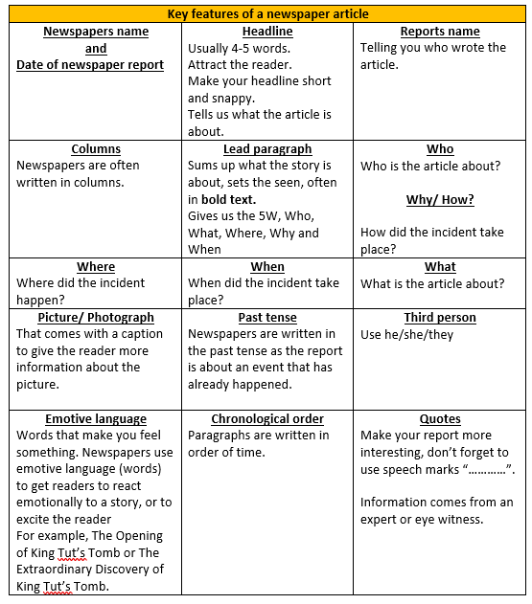

Appendix C


