Map Images / Backdrop Maps

Google Earth Satellite as a backdrop

Sometimes we need a base map - a good one to use and import into Q GIS and to help you find where you are is the Google satellite imagery. Because this operates on a coordinate system, we can import it as an xyz file type.
Found here in the browser:

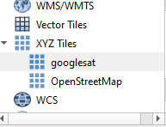

Right click on the XYZ tile and what we're attempting to do is load a connexion to the Google satellite imagery. Copy and paste the URL but you can see below into the connexion details and click OK.
https://www.google.cn/maps/vt/lyrs=s@189&gl=cn&x={x}&y={y}&z={z}
Give the new connection a name. As you can see, I have just simply called it Google sat and you should now see that you have a new XYZ add tile appearing underneath the browser set. Simply drag and drop this into the central map area.

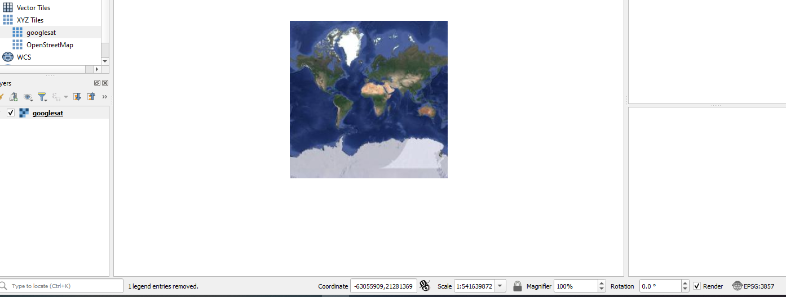

CRS - coordinate reference system

Things to note:
At the very bottom of the screen, you can see something that indicates the coordinates of where your cursor is on the map, the scale of the map and the zooming in rotation and so on. As a default you will see that the coordinate system is in a decimal system. We want to change this and make this map appear in a more traditional lon / lat coordinate system.
To do that right at the far right hand side of at the QGIS page you will see a little world type icon /projection indicator - click on this and once the window opens choose the WGS84 coordinate referencing system once you click OK you will notice the information in the coordinate box at the bottom changes to a more traditional or longitude latitude degrees and minutes display.
Move your cursor around the map to somewhere where you are familiar with and you should notice that the coordinates displayed provide the correct references and look similar to something that you may have collected off a GPS system.

