The Assistant Director – Oliver Goulstone

Introduction
With the opportunity to perform in the role of AD (Assistant Director) with the Third Year Acting project alongside Will, it gave me the chance to put into practice many of the techniques and methods learned from my first year of study. The prospect of working alongside a professional working Director was particularly exciting to both observe and collaborate, with a vast number of lessons to learn and reflect upon. Before beginning the process, I set out these six objectives that I wanted to concentrate on and answer myself in conclusion:

- To increase overall knowledge of the management and running of a company through the entire production method.
- To continue to build my language of communication with both the actors and the creative team.
- To observe and understand the process of the professional Director I will be assisting.
- To continually critique my contribution to the overall production and reflect upon my progression.
- To manage expectations of my creative vision not always being accepted by the director.
- To overall enjoy and build on my passion and understanding of the creative process and craft.

Role of the Assistant Director
'Great theatre is never the result of a single individual's efforts' (Parker) as discussed in previous work the process of any production is a collaboration between numerous creatives working in their respective roles. Many projects will not have an Assistant Director as part of that creative team, and so when that role is filled it is up to them to complement the Director in their vision and do and be many things.
Reading and having a thorough understanding of the play at hand is of course essential, with personal ideas and concepts noted to increase that overall familiarity with the chosen piece. 'This could entail pre-rehearsal research on the context of the play' (Girvan) creating documents that research into particular themes or address words or language that may not be common knowledge within the company. Knowing as much as possible within the space when confronted with questions or issues will only go further to increasing trust and working relationships within the rehearsal room.
'The AD might read through the script with the director, offering suggestions and insights into interpretation and concepts for staging the show.' (Parker)
With the Assistant Director needing to work closely with the Director and understand their visions entirely it should be vital they meet pre-production to either read through the piece or at least have a detailed conversation about thoughts of the work. 'It'll give you a chance to find out exactly what their ideas for the production are' (Judd, 2012). We discuss the importance of director to actor often with the use of language and sharing the creative process, the same must be said for the director to AD. This would be imperative in production meetings that the AD must attend that dialogues of the project are consistent and on track to sustain clarity of the end goal.
The AD will possibly be a part of the casting decisions and less so on the decision of production team members, with whom the AD must have a strong working relationship. Especially the work between AD and SM (Stage Manager) who will regularly communicate and work together in the rehearsal room.
Within the rehearsal space the AD will run warm-ups, keeps notes on directions and alterations, run the rehearsal when the Director is absent, or on breakout spaces, read in for absent actors, and whenever possible be the go-to person for questions from the production team members and actors. Often when the rehearsal period is finished the AD will remain for the performances to ensure smooth running and conduct any alterations that may have to be made and keep the actors on track.

‘Later in the process the AD might conduct line runs of the play, or rehearse the understudies… the Ads role is that od dogsbody in terms of directing… they learn and observe experienced directors at work.
(Foreman, 2009, Pg.26)

'The AD is a jack-of-all-trades' (Parker) or can do their very best to achieve the director's vision as we've stated and to be a sponge of information. And 'you will feel much more comfortable entering the room on Day One if you have prepared well' (Judd, 2012) being sure of your preparation and role within the fabric of the company.

'Loveplay' & Pre-Production Prep
‘It’s a portmanteau play: a series of short vignettes providing a showcase… it too often feels a little formulaic, written to order, and by the head and not the heart.’
(Aspen, 2022)
Dan Jones of 'The Other Room' was invited to direct the production and we were very excited to work with him on his selected piece 'Loveplay' (Buffini, 2006) a play centred around 'the quest…for love and sex.' (Billington, 2001) On receiving the script I read it several times to collect my thoughts and understanding of the play and what it means to me and a contemporary audience. My initial feeling for the production was slick and simple with a focus on imaginative costume design to ensure quick changes and a fast pace. With prior knowledge that our show would be performed in the 'Y Llyfwan', I imagined the set to be smaller and more dynamic, to create fast scene changes that moved with the time travel and signified the period in history. Not so much in its physicality but its shift shaping set-pieces 'The Curious Incident of the God in the Night' (National Theatre, 2013) would highlight that train of thought.
On our first meeting with Dan, Will and I were asked to complete a production handbook which could be used as a reference for the actors with questions towards historical periods or unknown words/phrases, these two documents can be found in appendix 1 & 2, precisely what Girvan discussed in my research. Although extremely beneficial for increasing our knowledge and understanding of the play, these documents were not available to the cast as they had to conduct their research as part of their course development and assessment.
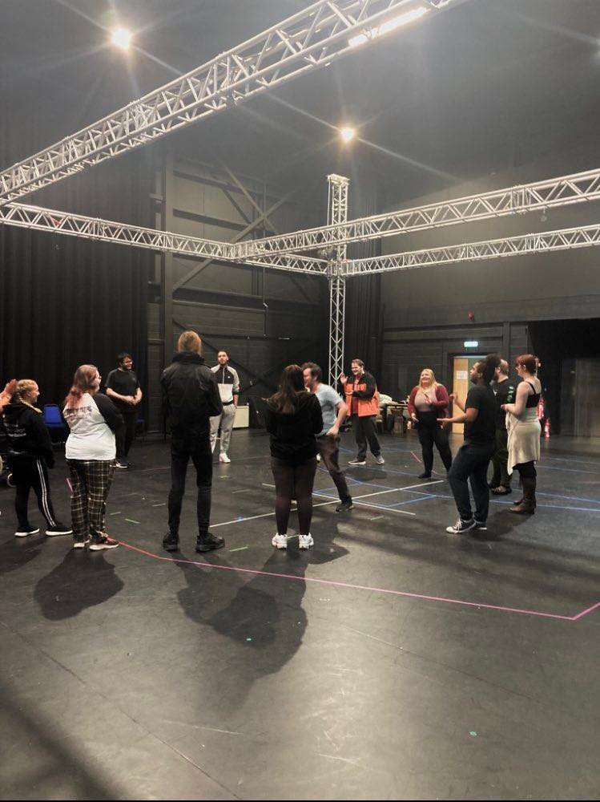
It was made clear by Dan that we would be leading warm ups, breakout rehearsal sessions (focused on transition and leading the Friday sessions when he would be absent.
What was missing in pre-production prep, which I believe both Will and I would've benefitted from, was a sit down with Dan on our own. This would've allowed us to be able to question his aims and desires for the performance and to establish how he likes to work in the room, this would've made my later tasks, with directing the transitions between scenes, easier as I would've been able to go into the room knowing what was wanted from them and how to elevate the performance in keeping with Dan's vision.
This initial lost meeting set a precedent of Dan only communicating with us when things needed to be fixed in the production. What would've been valuable would-be explanations of decisions Dan was happy with; why they fitted the play and how they executed his vision. For us to have a springboard to work off in our independent tasks. Not only would it have benefitted my work in this production but it would be appreciated in furthering my overall knowledge of directing.

Auditions & Interviews
In an ideal world, an audition would be able to go on for half an hour, 'what I never do is hold… actors are given ten minutes to recite a couple of lines.' (Alfreds, 2007, Pg.153) However, because of time constraints and such a large cast, our audition process could only last 10 minutes per actor. Initially, after each audition, I provided Dan with critique and opinion on the actor's performance, but as time went on, I realised what would perhaps be more beneficial to Dan would be providing that prior knowledge of how that actor works and their attitude and determination in the rehearsal room to aid in giving him a better picture.
The next stage of the audition process was a company workshop, where actors were tried in different combinations, but all at the same time, with Dan, Will and I flitting between the groups. This made it hard to focus on the details of the pieces and provide any constructive criticism if that was needed at this stage. Will and I shadowed dan for this section, watching his process, it felt directionless and unplanned Mike Alfreds talks about the 'Bluffer' in which the director has 'made himself vulnerable' (Alfreds, 2007, Pg.333) and this session fitted that example. This led to an extra audition session in which actors were taken out of the main room in smaller groups to read scene by scene for final castings to be decided. Vital time is possibly wasted due to a lack of management. Appendix 3 is my casting in comparison to Dan's.
On the other side of things, we were able to sit in on the Design & Production students in their interviews for positions within the company. It was fascinating to see such preparation and determination from the majority of them, and showing a much detailed and thorough understanding of the piece than many of the actors in their audition.
Rehearsal Process
The first rehearsal is always to a degree the blind leading the blind… formal speeches… show models… make jokes… playing a game.’
(Brook, 2008, Pg.118)
As sated it was expected of us to run warmups and what ever break out rehearsal sessions were needed, for the majority of the main rehearsal we were present in the room working closely with the SM (Stage Manager) Cara Peploe to make notes of the rehearsals and contribute to the rehearsal and show reports. I will outline the first day’s rehearsal that was the broad structure to the majority of the process with Dan.
Overall, the way Dan conducted himself with actors in rehearsal was engaging and pleasurable to observe, in many ways similar to how I try to carry out rehearsals, up on his feet listening and discovering with the actors. He does though offer less as a director in contrast to myself I believe I offer too much at times, not leaving as much responsibility to the actor. The issue is we had no table work before the actors were up on their feet with Dan, no thorough conversation or discovery of any real sort.
In that first rehearsal, the cast list was announced and then a read-through of the play, with brief breaks between scenes and limited discussion. Asking eighteen people for any thoughts and expecting them all to jump seldom happened and by the latter scenes, the breaks were even shorter. And then in the afternoon, we started blocking Scene 1 (Buffini, 2006, Pg.303) with Lowri and Romario.
When I think of my process within the constraints of this rehearsal period, I would have spent at least two to three days working through eventing and character biographs, creating the world, discussing the play's timeline 'an immersion in the material' (Alfreds, 2007 Pg.142). Explaining to the company my thoughts on the themes and expectations of the production, and more importantly theirs. Discovering together what Moira Buffini is writing about and how we can translate our interpretation. My opinion now on reflection would be (especially with this group of actors) moving onto the studio to spend extra time on those early discoveries before getting up on our feet.
Immediately Dan is asking for ideas from Lowri and Romario in regards to their character objectives and how they conduct themselves within the scene, and it's clear to see they have no ideas, 'actors need time to build their characters' (Mitchell, 2009. Pg115). Or they're searching hard trying to appease Dan and show they have the ability when in truth they don't have any real idea because they have been given their respective characters only a couple of hours prior.
They were expected to give results immediately 'making decisions as soon as is reasonable' (Alfreds, 2007, Pg.142) and it seemed as if Dan wasn't as prepared with the script as he was, or that he hadn't any real plan of where the scene was going (Alfreds, 2007, Pg.333) In my reflection I would hope to know and be prepared more so in that rehearsal. I think there should always be time for table work, the work I did with a group of Third-Year actors last year with only six days of rehearsal before presenting the finished work, we still made time to sit down and discuss before getting on our feet. In my recent production of 'Knapps Last Tape' (Beckett, 2006) we spent perhaps ninety per cent of the rehearsal process at the table, when we got up on our feet all the intentions and thoughts were there.
It gives a positive energy to the room, actors are happy and feel they are progressing and being productive, young actors in particular can't at times understand the precursor work to block, and see it as a waste of time. It feels easy to produce results immediately. They find a comical moment, or an effective moment in that playfulness on their feet and stick with it, not pushing on not staying 'open to possibilities' (Alfreds, 2007, Pg.142).
Lowri and Romario in front of the entire company that day struggled to understand the environment they were in, and it made them look extremely poor at understanding the direction. Trying to absorb so much information quickly caused them to not remember what side of the stage to enter, or whether to run walk and so on. The actors were given the proper foundations and so 'the building will not stand up correctly' (Mitchell, 2009, Pg.115)
As an aspiring director, it has given me deep reflection to ensure I create the most helpful and stable environment in my rehearsal room. One of my objectives is to build on my language and communication within the room, and it was clear from the points above that environment was wrong for those actors. 'Patience and long-term thinking' (Mitchel, 2009, Pg.115) as a director are vital in general communication and also in creating a culture and theatre for a company on the same page.

Transitions & Warmups
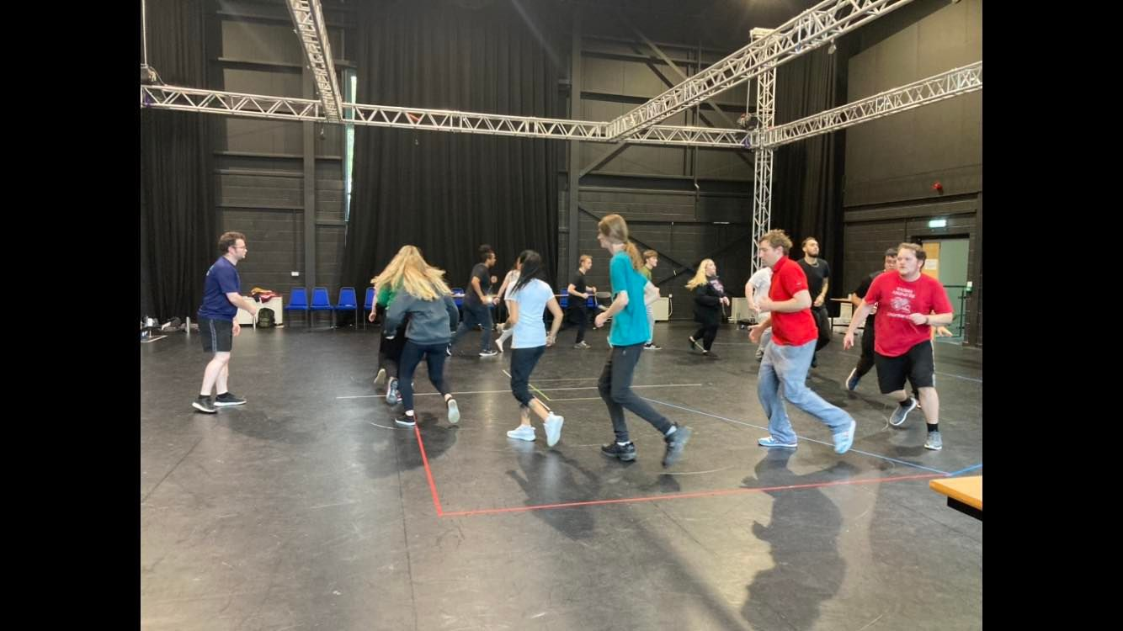
Each transition needed to signify the period the story was moving to and from in its journey from AD79 to the present day. As well as the constant features of love, sex, and Tinder which needed to be constantly sowed into the piece to continue Dan's realisation of the search for love.
We would break off with the actors available for each transition and have those guidelines as mentioned to create from scratch work to show back to Dan. Often they would look at the periods in history for half an hour or so, decide what was relevant then begin to create. It was difficult at times as we were encouraged not to guide the actors too much, and to ensure they were devising work of their own for their process.
Every morning we would lead the warmups, Will and I together, often separately, but both engaged in the room. Warmups are vital always to ensure the company is engaged and ready to work, 'a great way to take the temperature out of the room' (Joseph, 2020) some actors more so than others. Some actors will never seem engaged with a warm-up, Jake and Maddy are actors who are engaged but their body language often radiates laziness or lack of focus.
In the Friday session in particular when we often ran transitions or created new work, we wanted the company to be focused and warmed up. The first Friday I would say it took us the entire day to begin to produce work as the actors were so worried about getting things wrong. Realising there was that block I decided to introduce two improvisational exercises I learnt from my acting experiences called 'Anywho who…' and 'The Box Game' which forced the actors to say the first thing that came into their heads in a bid to 'encourage creativity, quick thinking, and communication skills.' (Smart, 2021) By the final weeks, these warmup exercises were no longer feared by the majority of the company, and I'm certain contributed to their increased creativity and bravery in the room.
The transitions did indeed improve, initially more so than lack of creativity it was the presenting back of work to Dan where performance levels would drop, and I believe this was due to a lack of their personal belief, but also trust in me. The first couple of times they showed work back I was visibly frustrated, and I should've tried to 'hold my nerve… better for everyone involved' (Mitchell, 2009, Pg.124) and I didn't, a point Dan picked up and was fed back to me.
It became clear that I had to be braver in myself and lead the room with certain decisions which may have not been right and fitted the fabric of the piece, but that showed imagination. Two examples would be the transition from Scene 5 (Buffini, Pg.331) to Scene 6 (Pg.340) various examples of work were shown to Dan without him being satisfied, I created an improvisation piece of work that had different methods of payment being presented to a prostitute that was turned down until we got to contemporary card payments. I had them improvise lines and have some real fun, they were unsure if Dan would appreciate it and when we went into the main room, I gave a pep talk and they committed. The final transition was very much what they created, just with music instead of the improvisational lines. The same can be said for Scene 7 (Pg.344) to Scene 8 (Pg.353) where we created a steam train and interjected 'Love Train' by The O'Jays (Philadelphia International Records, 2022) the cast found it funny but believed Dan wouldn't buy it, and it was in the final production. By overcoming my fears of failure, the company did so also by being adventurous in their work.
Sound
Within the production team, we were without a sound designer and technician, meaning the responsibility of the production's soundtrack was down to Dan, Will and me to compose. I have had past experiences in creating soundtracks to complement theatrical phenomena such as 'Blood Brothers' (Russell, 2014) and most recently 'Agatha Crusty and the Village Hall murders' (David Spicer Productions, n.d). As learnt previously Dan appreciates independence in creativity, so I went ahead and sourced an array of sound material to complement the scenes as well as the transitions.
Several days before the tech rehearsal began Dan, Will and I met together in the space and sourced the sound effects, backing music, atmospheric music and images for the AV. This complements the statement made earlier made about an assistant director being happy to assume other roles.

Friday Sessions & Scene Work
Every Friday up until the last couple of weeks Will and I would take the days rehearsal. To be efficient with our use of time, especially in the earlier weeks we would split, with Will and I sharing the scenes out and going off to rehearse.
These sessions were beneficial in that we could be left to our own devices to run and build on the scenes, giving what advice we can and guidance when needed. On the other hand, we had to be careful not to overreach with our direction not to contradict what Dan had created in the room. There were several times I had an offering, for it to go against the original blocking, and very honestly, I retracted that offering and moved ahead. As a creative thought, one is always looking to improve the overall clarity of each scene.
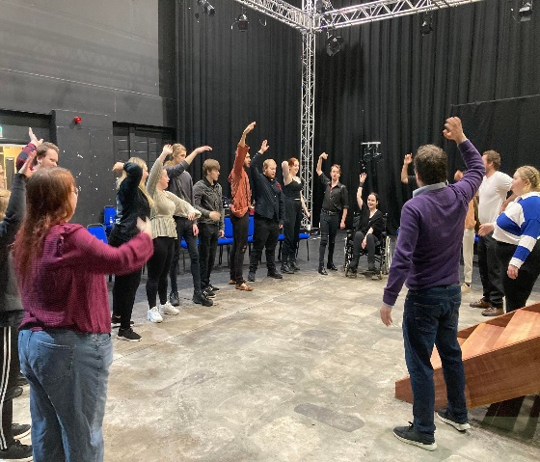
Scene 6 (Buffini, Pg.340) which included Matthew, Molly, and Beth was a challenge in getting them to understand the stakes of the situation they found their characters. Matthew's character, Mr Quilley, was trying to hide his infidelity to his wife, Millie. The scene read as Mr Quilley thinking on his feet and creating secrets to hide the affair ‘Yes I was helping Miss Tilley put some toys away.’ (Buffini, Pg.342) Matthew couldn't grasp the idea that spontaneous imagination would get him out of trouble, and the scene was resultingly flat. I made them carry out an improvisational game in which Millie enters the space and changes her opening line, Matthew and Molly would then have to improvise their responding lines. Naturally, it caused laughter and some embarrassment, but after a few goes they delivered the lines in the fashion we were aiming for.
Throughout the length of the rehearsal period, Scene 6 improved gradually, progress being made each time it was visited. Scene 7 (Pg.344) was the opposite and caused a different sort of issue, which on reflection I'm still frustrated with, but unsure still if I should have intervened more from my position as an AD.
James and Ed are both capable actors, James played the flamboyant artist comfortable with himself and sexuality, and his old school friend De Vere a priest and not comfortable with sexuality played by Ed. Arguably the finest scene within 'Loveplay' there is so much to unpack about sexuality, religion, conformance, and acceptance, and holds up when it was written twenty years ago and more so today. In a world where homosexuality is still illegal in many countries, and taboo more so, with legal marriage in the UK only recently passed (Chakrabarti, 2014) it is a mammoth task to portray its potential.
A great scene with solid writing comes alive in its basic form when read with some conviction, but it can always be built on Ian McKellen performing in Hamlet again after 50 years is still reimagining his role (Wood, 2020). It started in such a solid place that there was never time put aside to build on the intentions and motivations of the given characters. High praise Dan for their work, and myself, and I think they thought the job was done. But when questions of ‘how small is the apartment… condition it is in’ (Kiely, 2016, Pg.72) they were still unsure.
It's up to Dan the director to decide how far he wants to build on a scene, and what he wants it to say in conjunction with the entire piece, but I found myself fighting to improve it. I continually gave advice, highlighted areas of character to discuss, and questioned the tone of his intentions. I wanted Ed particularly to alter his tone, not play it all on one level. To live in the moment, to be different each time that situation happens. It was clear Ed was 'frightened of revealing himself' (Alfreds, 2007, Pg.323) and struggled to let himself go. James was so sure of himself and having had positive guidance from the director not wanting to be tested on it by myself as an AD, I had to let it go. On reflection, I think I should have taken the initiative and done table work with them, as that is what was needed in my opinion, but I would have needed to be in line with Dan's thoughts. I came to the conclusion it was one of those times where I had to sit back and leave the thought to 'burn in your own imagination' as it 'would be of no help to anyone in that specific moment.' (Judd, 2012)
Scene 10 (Pg.361) I spent an immense amount of time on and was challenged by Dan to get it up to speed, as it lacked overall the pace and energy it really should have had. As it came closer to the opening night Dan knew it needed a major amount of work but he did not have the time to do so, benefit of having an AD to take them to another room and work on it.
We ran the scene multiple times and I watched each actor closely, one at a time through each run and zoned in on their physicality, ensuring they were making character decisions and understanding them, which took a high level of time but I tried to 'make small steps, not giant leaps' (Mitchell, 2009, Pg115). Molly and Cydney in particular struggled with the opening segment of the scene to illustrate the character's objectives and intentions, I gave numerous suggestions and had to act out some bits just to give them the idea, but more so the confidence to do it. In that context, I believe I made the right decision to help heavily in their discoveries. If time had been spent through table work at the beginning of the process in determining the events of the scenes, the character's objectives, and so on then they would have had the tools to have not just found what we did in the room last minute, but also have gone further along in their realisations of respective characters. I gave them research to look into Alan Ayckbourn's short play 'Between Mouthfuls' (Ayckbourn, 1977) as a reference to their work.

Tech Week
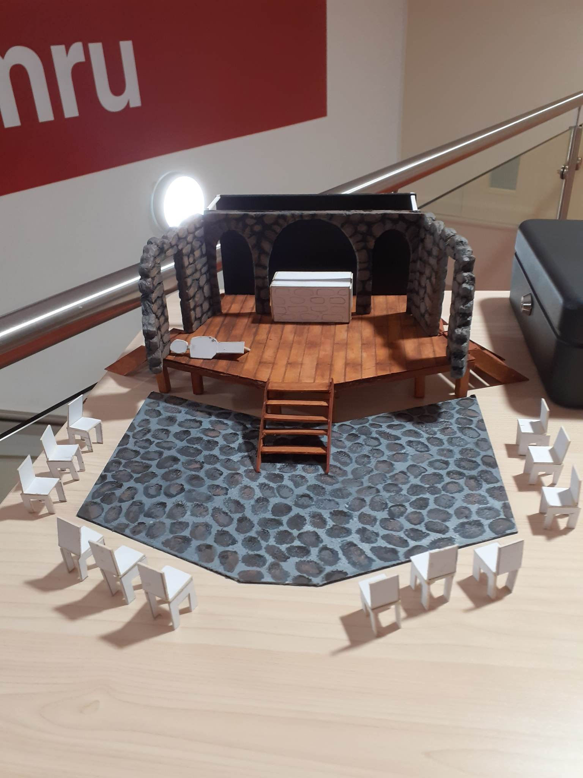
For the duration of the technical rehearsals, we were asked by Dan to sit in the audience seating, in particular on the sides (as these were the seats with the most restricted sight lines) to ensure the production w visible and working efficiently. We were encouraged to flag up any issues that arose and to help to orchestrate transitions and movement of props and scenery to keep the piece flowing. Scenes 5 and 6 in particular needed precise placement of the set to hide nudity and sexual moments on stage from the audience.
It was an opportunity missed as we weren't able to sit with the production team and go through the process and see how Dan translates his visions across to them in a working process. It would have been extremely beneficial to have seen how they all work, and more importantly to have observed Dave Rocks on lighting. With him being such an experienced technician and designer, he could have unloaded a major amount of information and advice on creating that lighting environment. It's only after the fact that I have reflected on these technical rehearsals and regret not taking initiative and learning from Dave more.

Show Week/Feedback/Notes
After the opening weekend of the show Dan departed and left Will and I in charge of ensuring the actors and production team were telling the same sorry and being discipline din what was constructed in the rehearsal period. Ensuring the company was on time and ready, and most importantly given feedback and notes after every performance.
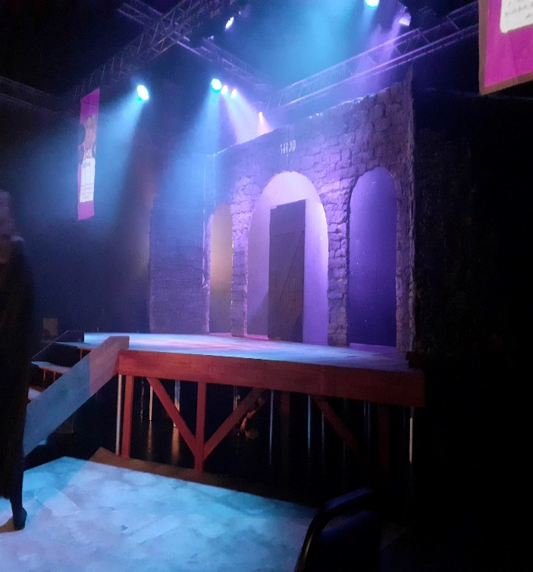
It is important in feedback and notes after each performance to keep instructions ‘specific and concrete’ (Mitchell, 2009, Pg.128) that Dan has constructed in the room. As an AD it's important to be as consistent with that method of communication and to ensure that you are consistent throughout, with two ADs as well as Dan there were three different creatives giving notes, so it was important not to contradict one another and remain true to Dan's vision.
Giving everyone notes and sharing your time with all actors is difficult to achieve, some actors will need more than others, but all need to feel their performance is being scrutinised and you've given them the tools and assistance they require. At times I'm sure I did not give Bea enough notes, not that she didn't need them, but more so there were more pressing issues that needed attention. This is of course unfair to her development perhaps, but within the time constraints of a moving production moments such as that will occur. On the other hand, I conceivably gave Beth too many notes.

Conclusion
Shadowing Dan allowed me to observe Production Meetings and how the director conducts the many plates he has to spin. It benefited me mostly from the positivity he has towards ideas and the welcoming of offers from the room. The lack of communication at times left me unsure of what to do in rehearsals, and the lack of trust in my suggestions at times meant I took a backward step and removed myself from the decision-making with the production team at times. I hugely regret on reflection my lack of communication with the production team, whilst it was efficient, I should have asked more questions about their work for my benefit and their assistance. I was always available to answer questions or to find the answers, but I should have been more inquisitive. I should have asked more questions in the technical week and been more selfish of my progression.
Will and I worked efficiently together and showed levels of communication in which we could share a rehearsal room in the future, as assistants or directors to one another. In terms of the actors, it was all about building trust and using my experience to lead them through sticky situations. Once they had validation from Dan that the scenes work, the work they were doing with me started working, or the transition fitting in they listened more and more as we progressed. It's about me as a director being braver and not 'being liked by the actor' (Mitchell, 2009, Pg119) for all to achieve.
When I reflect on my observations of Dan's process it seems I'm negative towards his approach, but in critiquing his work I can find constructive feedback in how I conduct myself and my rehearsal room. Dan's way of working is extremely different to mine, but he is a professional creative and his process works for him, he achieved what he set out to with the actors, although his full vision of the finalised production was never realised. The ending of the show for example seemed rushed and not thought out. I have to tell myself not to be a 'Bluffer', to come into every rehearsal room prepared, and organised, but also to accept the mistake and not knowing some things. The way Dan works with actors I take great satisfaction in embracing, and not that I agree with much of his method he has 'without a shadow of a doubt influenced' (Judd, 2012) my method of work and process.
Initially, I gave very little to the process, I at times felt like a passenger with no clear communication coming from Dan for long period. Such is the role of an AD, I had to use my initiative to create soundtracks and set lists, to give actors small offerings when I could, and to encourage and critique their performances in line with the consistency of the production goals. I learnt to DO and NOT ASK, to be brave and put my neck on the line to improve overall the actor's abilities. I struggled throughout to come to grips with Dan's overall vision of the play, which halted at times my communication and assistance with the production team, but I understood the character's intentions and what Dan wanted from his actors. There were several scenes such as Scenes 3, 6, 7, &10 that I put a lot of effort into, but I never stopped advising every member of the cast when needed or asked. Will and I both were both regularly available for conversation and quiet words, as the majority of actors towards the end came and asked for extra sessions and unplanned rehearsals to assist their performance, and we always said yes.
It was clear to me before I started the production that an AD was not to be vocal in the room, but there to take notes, answer questions and assist in the director's overall vision. At times I wanted to spurt out a suggestion and early on in the process, I suggested privately an offering to Dan which was not in line with his thinking and left me in an 'uncomfortable and embarrassing position' (Judd, 2012). I only spoke to Dan when I felt there was a certain need for it and I could back up my thoughts, sometimes he used those ideas, and sometimes he didn't. I'm not precious in my ideas being used or accepted, I just want to assist the director.
I thoroughly enjoyed the overall process, being a part of a team creating theatre is very much an ambition of mine to be involved with at a professional level, and the experience of this project underlined that. In my reflection I've tried to hold the directing account instead of blaming the actors, I've tried to put that on myself as well as Dan, and want to pick up in future projects where I left off here, being brave and communicating clearly. Communicate more with the production team. Most importantly ensure that if in the role of an AD again to sit down with the director and ensure I am certain of my role and job in the room, and that communication is precise not estimated.

Appendix 1
Classical Age – Roman rule of Britain  AD 43 – 410 | Classical antiquity (also the classical era, classical period or classical age) is the period of cultural history between the 8th century BC and the 6th century AD centred on the Mediterranean Sea, comprising the interlocking civilizations of ancient Greece and ancient Rome known as the Greco-Roman world. It is the period in which both Greek and Roman societies flourished and wielded huge influence throughout much of Europe, North Africa, and Western Asia.
Dark Age – Anglo Saxon rule of Britain  AD 500 - 1066 | Migration period, also called Dark Ages or Early Middle Ages, the early medieval period of western European history—specifically, the time (476–800 CE) when there was no Roman (or Holy Roman) emperor in the West or, more generally, the period between about 500 and 1000, which was marked by frequent warfare and a virtual disappearance of urban life.
New Millennium – Norman rule of Britain  AD 1066 - 1154 | The Normans were the next group of people to rule England after the Anglo-Saxons. They built some of our most well-known castles, such as Windsor Castle and the Tower of London.  The Normans came from northern France, and invaded England in 1066 after King Edward the Confessor died without leaving an heir to the throne. They eventually defeated the Anglo-Saxons at the Battle of Hastings, when King Harold II was killed. The Normans ruled England for about 300 years.
The Renaissance – Elizabethan Age  14th – 17th Century | The Renaissance was a fervent period of European cultural, artistic, political and economic “rebirth” following the Middle Ages. Generally described as taking place from the 14th century to the 17th century, the Renaissance promoted the rediscovery of classical philosophy, literature and art.  William Shakespeare, Leonardo da Vinci, Michelangelo
The Enlightenment – Georgian Britain  17th & 18th Centuries | The Enlightenment – the great ‘Age of Reason’ – is defined as the period of rigorous scientific, political and philosophical discourse that characterised European society during the ‘long’ 18th century: from the late 17th century to the ending of the Napoleonic Wars in 1815. This was a period of huge change in thought and reason. Centuries of custom and tradition were brushed aside in favour of exploration, individualism, tolerance and scientific endeavour, which, in tandem with developments in industry and politics, witnessed the emergence of the ‘modern world’.

The Romantic Age - Georgian Britain  1798 – 1837 (Perhaps up to 1850) | The Romantic Period began roughly around 1798 and lasted until 1837. The political and economic atmosphere at the time heavily influenced this period, with many writers finding inspiration from the French Revolution.  Romanticism can be seen as a rejection of the precepts of order, calm, harmony, balance, idealization, and rationality that typified Classicism in general and late 18th-century Neoclassicism in particular. It was also to some extent a reaction against the Enlightenment and against 18th-century rationalism and physical materialism in general
The Age of Empire – Victorian Britain  1820 – 1914  See also:  THE AGE OF EMPIRE is a book by Eric Hobsbawm about the strange death of the nineteenth century, the world made by and for liberal middle classes in the name of universal progress and civilisation. | Victorian era, in British history, the period between approximately 1820 and 1914, corresponding roughly but not exactly to the period of Queen Victoria’s reign (1837–1901) and characterized by a class-based society, a growing number of people able to vote, a growing state and economy, and Britain’s status as the most powerful empire in the world.  During the Victorian period, Britain was a powerful nation with a rich culture. It had a stable government, a growing state, and an expanding franchise. It also controlled a large empire, and it was wealthy, in part because of its degree of industrialization and its imperial holdings and in spite of the fact that three-fourths or more of its population was working-class.
The Age of Austerity – Interwar Britain  1920s- 1930s  Post War Britain – Austerity measures and rationing ran for decades after the end of World War Two.  1945-1979 | Through the 1920s, Britain's economy was already struggling to pay for the effects of World War I. Then, in 1929, the US stock market crashed. World trade slumped, prices fell, credit dried up, and many countries protected their domestic market by taxing foreign imports. The value of British exports halved, plunging its industrial areas into poverty: by the end of 1930, unemployment more than doubled to 20 per cent. Public spending was cut and taxes raised, but this depressed the economy and cost even more jobs. Finally in 1931 the pound was devalued by 25 per cent, helping exporters by making their goods cheaper abroad, and helping to start the recovery. Through the 1930s, poverty and unemployment blighted large areas of Wales and northern England. Around London, however, some parts of the economy thrived: the suburbs enjoyed a building boom, helped by cheap interest rates.  Austerity in its simplest form is government efforts to reduce national debt through tax increases and spending cuts. Seeing people spend more with less help coming back from the state. Austerity measures were taking through the 2010’s by the Conservative Government.
The Age of Innocence – Post War Britain  The Swinging Sixties  1960 | The Swinging Sixties was a youth-driven cultural revolution that took place in the United Kingdom during the mid-to-late 1960s, emphasising modernity and fun-loving hedonism, with Swinging London as its centre. It saw a flourishing in art, music and fashion, and was symbolised by the city's "pop and fashion exports  The 1960s saw the end to an Age of Innocence as free love and the hippy movement aided in a musical environment fighting the system saw young and old broaden their horizons.  The Beatles, Rolling Stones, Jimi Hendrix, Bob Dylan, Janis Joplin, Dusty Springfield.

Appendix 2
LOVEPLAY by Moira Buffini
Rehearsal research document.

SCENE ONE
Dorcas (Dor-kuss) | The meaning of Dorcas is Gazelle – a disciple of Christ.
Marcus | Marcus is a masculine given name of Ancient Roman origin.
Latrine | A toilet, especially one in a camp or barracks.
Garrison | A group of troops stationed in a particular location, often to guard/defend. Usually in a city, town, fort, castle, ship or similar site.
Slug on salt | A popular phrase “salt kills slugs” – otherwise known as ‘osmosis’, salt kills slugs by causing the water to leave its body.
Wool | The spread of the roman empire introduced wool to Britain.
Money for nothing | Dire straits song – rock star excess and the easy life it brings compared with real work.
SCENE TWO
Anglo-Saxons | The Anglo-Saxons came from Scandinavia and Germany. They settled in Britain between AD 410 and AD 1066.
Crux | A puzzling or difficult problem.
Supernatural force | A force and power that resides in supernatural beings such as gods and spirits.
SCENE THREE
Novice | One who is new to/inexperienced in a job or situation.
Acquiesces | Accept something without protest reluctantly.
Cloistered | Kept away from the outside world/sheltered.
Incandescence | Glowing light with intense heat.
Canker | An ulcerous condition or disease of a human or animal. Abscess/sore/infection etc.
St Bridget | Saint Bridget of Sweden, canonized (declared a saint) in 1391.
SCENE FOUR
Sublime | Of very great excellence or beauty.
Malcontent | A person who is discontented, disgusted or dissatisfied. Usually quite rebellious.
Betroth’d (betrothed) | A person that someone has promised to marry.
Bastard | A person of unmarried parents
Sulphorous | (in this context) hot tempered.
Green (and frenzied) | (in this context) jealousy/greed/envy.
Alabaster | A mineral or rock that is white and soft. Generally used to symbolize transparency and purity, considered as the protective stone especially for those who are innocent at heart.
Borne | Carried or moved by a particular thing.
Black mood | Represents evil, darkness, night and despair. A very unhappy feeling.
Insipid | Lacking interest or lacking flavour/taste.
Milksop | A person who is indecisive and lacks courage.
Sissy | A timid or cowardly man.
Ephermal | Something of no lasting significance.
Conjucated verbs | Change the verb in order for the sentence to make sense.
Innovative | Something/someone that introduces new methods, original and creatively thinking.
Purgatory | Mental anguish or suffering, a feeling of being stuck.
Adolescent | A young person in the process of developing from a child into an adult (teenager).
Lumpen | Misshapen and ugly.
Denouement | A final part of a play/film/narrative that are drawn together and matters are explained or resolved.
Millstone | A heavy burden.
Impotent | Unable to orgasm – something weak and useless.
Prig | Someone who behaves as if they are superior to others.
Transcendent | Exceeding usual limits.
Mundane | Very dull, lacks interest.
Pretence | A false display of feelings, attitudes or intentions.
SCENE FIVE
Relic | A person or item that has survived from an earlier time.
Mirth | Amusement.
Artisan | A worker in a skilled trade, usually one that involves making things by hand (textiles/ceramics etc)
Tyranny | Cruel and oppressive.
Mewling | High pitch crying noise (can be used about animals or babies)
Infirmity | The state of being weak physically or mentally – typically used when talking about older people as their bodies weaken.
Empirically | Something that relies on observation/experimentation or experience rather than theory
Plenitude | An abundance – lots of.
Nebulous | Something that is not clear – lacks form/shape/isn’t content.
SCENE SIX
Governess | Usually a woman employed to teach children in a private household – now would be called a private tutor.
Tresses | A long lock of a woman’s hair.
Beneficiary | A person who has advantage of something (for example a trust, will or life insurance).
Extricating | Freeing themselves or someone from a constraint of difficulty.
SCENE SEVEN
De Vere | Someone of intelligence and a great lover.
Buttermere | A lake of untouched purity.
Consign | Deliver / send.
Bohemian | A socially unconventional person, especially one who is involved in the arts.
Oblivion | The state of being unaware or unconscious.
Hermit | A reclusive or solitary person.
Tincture | A medicine that consists of a combination of alcohol and small amount of drug.
Opium | A reddish-brown heavy-scented addictive drug – side effects consist of sleepiness, emotional detachment and relaxation.
Antiquity | Something of great age.
Satan | The devil.
Lucifer | Was an angel of god who turned against his creator and was exiled from heavens.
Benediction | The state of being blessed.
Blaspheme | To speak in an offensive manner that shows no respect for God or religion.
SCENE EIGHT
Austerity | Difficult economic conditions.
SCENE NINE
A squat | A building occupied by people living in it without the legal right to do so.
Emancipation | The fact or process of being set free from legal, social or political restrictions – freeing/release/freedom.
Bourgeois | Member of the middle class, typically with reference to its perceived materialistic values or conventional attitudes.
Corporate pigs | People involved in big business. Usually spoken about negatively.
SCENE TEN
Inca | An ancient tribe from Peru.
Inca burial | The incas believed that life continued after death therefore would bury the deceased in really awkward and uncomfortable ways.
Juvenile | Childish or immature.
Glib | Can’t be confident in speeches/statements.
Convulsed | To make sudden, violent or uncontrollable movements.
Urologist | A doctor who specializes in the study or treatment of the function and disorders of the urinary system.
Urinary tract | The series of channels by which the urine passes from the renal pelvis out of the body.
Catheter | A flexible tube inserted through a narrow opening into a body cavity, particularly the bladder, for removing fluid.
Nom de plume | A name that a writer uses instead of their real name.
Terrapin | A small type of turtle.
Spanish inquisition | A Christian organisation in Spain that brutally tortures and killed non-religious people.
Stigmata | A mark of disgrace associated with a particular circumstance, quality or person.

Appendix 3
Character | Dan’s Choice | My Choice
Marcus | Romario | Romario
Dorcas | Lowri | Lowri
Eric | Harley | Matthew
Herek | Liam | Liam
Deric | Reece | Reece
Gilda | Beth | Beth
Hilda | Bea | Charla
Matilda | Charla | Bea
Helen | Bea | Maddy
Llewellyn | Thomas | Harley
Trevelyn | James | James
Roxanne | Maddy | Jade
Man | Romario | Romario
Marianne | Jade | Dom
Miss Tilly | Molly | Jade
Mr Quilley | Matthew | Thom
Millie | Beth | Beth
De Vere | James | James
Buttermere | Ed | Jake
Joy | Dom | Ed
Boy | Ed | Dom
Flynn | Dom | Lowri
Quinn | Thom | Thom

Lynne | Jade | Jade
Gwyn | Reece | Harley
Brigitta | Charla | Charla
Rita | Cydney | Cydney
Anita | Molly | Molly
Dieter | Matt | Reece
Peter | Jake | Jake

References:
Ayckbourn. A (1977) Confusions London: Redburn Productions Ltd
Alfreds. M (2007) Different Every Night London: Nick Hern Books LTD
Aspen. M (2022) Come Again Loveplay Available at: https://markaspen.com/2022/03/27/loveplay/ (Accessed: 10/10/22)
Beckett. S (2006) The Complete Dramatic Works Croydon: Faber and Faber Limited
Billington. M (2001) Two thousand years in 90 minutes Available at: https://www.theguardian.com/stage/2001/mar/07/theatre.artsfeatures (Accessed: 15/12/22)
Brook. P (2008) The Empty Space 4th edition London: Penguin Books LTD
Buffini. M (2006) Moira Buffini Plays 1 London: Faber and Faber Limited
Chakrabarti. R (2014) Gay marriage legalised at midnight in England and Wales Available at: https://www.bbc.co.uk/news/av/uk-26782081 (Accessed: 16/12/22)
David Spicer Productions (n.d) Agatha Crusty and the Village Hall Murders Available at: https://www.davidspicer.com.au/shows/agatha-crusty-and-village-hall-murders (Accessed: 16/12/22)

Foreman. G (2009) A Practical Guide To Working In Theatre London: A & C Black Publisher Ltd

Girvan. G (n.d) ‘SO WHAT DOES AN ASSISTANT DIRECTOR ACTUALLY DO?’ Available at: What does an Assistant Director do | Blog | Royal Shakespeare Company (rsc.org.uk) (Accessed: 13/12/22)
Joseph. L (2020) Theatre Games and Warm-Ups Available at: https://blog.stageagent.com/theatre-games-and-warm-ups/ (Accessed: 07/01/23)
Judd. C (2012) SO, WHAT DOES THE ASSISTANT DIRECTOR ACTUALLY DO? Available at: https://www.watermill.org.uk/blog/index.php/so-what-does-the-assistant-director-actually-do/ (Accessed: 04/01/23)
Kiley. D (2016) How to Read a Play, Script Analysis for Directors London: Routledge
Mitchell. K (2009) The Directors Craft, A Handbook for the Theatre London: Routledge
National Theatre (2013) The Curious Incident of the Dog in the Night-Time - working on the spectrum Available at: https://www.youtube.com/watch?v=k2bV75ITXJw&t=3s (Accessed: 02/01/23)
Parker. M (n.d) Assistant Director and Theatre Duties Available at: https://woman.thenest.com/assistant-director-theatre-duties-14989.html (Accessed: 15/12/22)
Philadelphia International Records (2022) The O'Jays - Love Train (Official Soul Train Video) Available at: (123) The O'Jays - Love Train (Official Soul Train Video) - YouTube (Accessed: 10/01/23)
Russell. W (2014) Blood Brothers Oxford: Oxford University Press
Smart. J (2021) 22 great improv games for better collaboration (and fun!) Available at: https://www.sessionlab.com/blog/improv-games/ (Accessed: 07/01/23)
Wood. A (2020) Ian McKellen to play Hamlet in new production that begins rehearsals on Monday Available at: https://www.whatsonstage.com/london-theatre/news/ian-mckellen-hamlet-rehearsals-covid_51848.html (Accessed: 08/01/23)

Bibliography:
Abercromby. M (2017) Directing Exercises Available at: https://www.stagemilk.com/directing-exercises/ (Accessed: 15/12/22)
Acquah. N (2018) Emotional Safety in the Rehearsal Room Available at: http://exeuntmagazine.com/features/emotional-safety-rehearsal-room/ (Accessed: 18/11/22)
Akbar. A (2022) Handbagged review – sparks fly at the Queen’s audiences with the Iron Lady Available at: https://www.theguardian.com/stage/2022/sep/15/handbagged-review-sparks-fly-at-the-queens-audiences-with-the-iron-lady (Accessed: 10/10/22)
Appstate (n.d) Assistant Director Available at: https://theatreanddance.appstate.edu/script-and-rehearsal/assistant-director (Accessed: 10/10/22)
Apperson. L (1998) Stage Managing & Theatre Etiquette A Basic Guide Chicago: Ivan R. Dee
Backstage Staff (2022) The Best Acting Warmup Exercises Available at: https://www.backstage.com/magazine/article/vocal-physical-actor-warmup-guide-74817/ (Accessed: 15/12/22)
Backwater. J (2012) The Importance Of Rehearsal In Improv Available at: https://www.themaydays.co.uk/the-importance-of-rehearsal-in-improv/ (Accessed: 08/01/23)
Bradley. Karen K (2009) Rudolf Laban Oxon: Routledge
Braun. E (1992) The Director and the Stage from Naturalism to Grotowski 4th Edition England: Clays Ltd, St Ives Plc
Braun. E (1995) Meyerhold- A Revolution in Theatre Second Edition London: Methuen
Britannica (2022) Victoria Era Available at: https://www.britannica.com/event/Victorian-era (Accessed: 10/10/22)
Chekhov, M (2002) To the Actor on the technique of acting Abingdon, Oxon: Routledge
DeKoven. L (2006) Changing Direction Oxford: Elsevier
Feeney. P (n.d) 1966: When Britain was the envy of the world Available at: https://www.thehistorypress.co.uk/articles/1966-when-britain-was-the-envy-of-the-world/ (Accessed: 10/10/22)
Forum Theatre (2022) The Role Of The Assistant Director In Theatre Available at: https://forum-theatre.com/what-is-the-role-of-assistant-director-in-theatre/ (Accessed: 15/12/23)
Forward. S (2014) The Romantics Available at: https://www.bl.uk/romantics-and-victorians/articles/the-romantics (Accessed: 10/10/22)
Get into Theatre (n.d) What does an Assistant Director do? Available at: https://getintotheatre.org/blog/what-does-an-assistant-director-do (Accessed: 15/12/22)
Hagen. U (1991) A Challenge for the Actor New York: Scribner
Hall. Ann C (2008) Making the Stage Essays on the Changing Concept of Theatre, Drama, and Performance Newcastle: Cambridge Scholars Publishing
Harris. J (2015) Ian McKellen talks about his first Beauty and the Beast rehearsal Available at: https://www.digitalspy.com/movies/a642092/ian-mckellen-talks-about-his-first-beauty-and-the-beast-rehearsal/ (Accessed: 08/02/23)
Hirshon. K (n.d) The First Rehearsal Read-Through: Yay or Nay? Available at: https://www.theatrefolk.com/blog/first-rehearsal-read-yay-nay/ (Accessed: 08/01/23)
Hope-Jones. E (2018) Boundaries, Respect and Communication Available at: http://www.create-hub.com/comment/discomfort-in-the-rehearsal-room/ (Accessed:15/12/22)
Innes. C (2000) A Sourcebook on Naturalist Theatre London: Routledge
Jarus. O & Szalay. J (2022) The Renaissance: The 'Rebirth' of science & culture Available at: https://www.livescience.com/55230-renaissance.html (Accessed: 10/10/22)
Johnson. B (n.d) The Romans in England Available at: https://www.historic-uk.com/HistoryUK/HistoryofEngland/The-Romans-in-England/ (Accessed: 10/10/22)
Johnson. B (n.d) The Norman Conquest Available at: https://www.historic-uk.com/HistoryUK/HistoryofEngland/The-Norman-Conquest/ (Accessed: 10/10/22)
Kane. S (2001) Complete Plays London: Methuen Publishing Ltd
Kobylka. L (2018) Theatre Review: ABBEDAM’s “Loveplay” Available at: https://thegatewayonline.ca/2018/11/theatre-review-abbedam-loveplay/ (Accessed: 10/10/22)
Larew D. (1984) A Doll’s House Available at https://library.ndsu.edu/exhibits/donlarew/DollsHouse.html (Accessed: 18/11/22)
Marty. P (2019) Contemporary Stage Directors, Conversations on Craft London: Methuen Publishing Ltd
MasterClass (2021) 7 Acting Warmups, Games, and Techniques for Actors Available at: https://www.masterclass.com/articles/7-acting-warmups-games-and-techniques-for-actors (Accessed: 15/12/22)
McCaffery. M (1993) Directing a Play Revised Edition. London: Phaidon Press LTD
Malloy. K.E (2015) The Art of Theatrical Design Elements of visual composition, methods, and practice Abingdon: Routledge
Morgan. N & Saxtone. J (1989) Teaching Drama… A mind of many wonders London: Nelson Thornes Ltd
Middleton. S (2022) The Crisis of Democracy in Interwar Britain Available at: https://www.cambridge.org/core/journals/historical-journal/article/abs/crisis-of-democracy-in-interwar-britain/CABA463FF77B3B90C236B013D36A0BCF (Accessed: 10/10/22)
Mitter. S & Shevtsova. M (2005) Fifty Key Theatre Directors Abingdon: Routledge
Oddey. A (1996) Devising Theatre a Practical and Theatrical Handbook London: Routledge
Omaweng. C (2022) Loveplay at The Questors Theatre | Review Available at: https://www.londontheatre1.com/reviews/loveplay-at-the-questors-theatre-review/ (Accessed: 10/10/22)
Oppenheim. L (1994) Directing Beckett USA: The University of Michigan Press
Peithman. S & Offen. N (1999) Guide to Directing Portsmouth: Heinemann
Pickering. K & Woolgar. M (2009) theatre studies Basingstoke: Palgrave Macmillan
Prentki. T & Abraham. N (2021) The Applied Theatre Reader 2nd Edition Abingdon: Routledge
Priestley. J, B (1989) An Inspector Calls Oxford: William Heinemann Ltd
Pickles. M (2014) The Oxford academic helping actors to perform Shakespeare without rehearsing Available at: https://www.ox.ac.uk/news/arts-blog/oxford-academic-helping-actors-perform-shakespeare-without-rehearsing (Accessed: 08/01/23)
Rambaran-Olm. M & Wade. E (2021) The Many Myths of the Term ‘Anglo-Saxon’ Available at: https://www.smithsonianmag.com/history/many-myths-term-anglo-saxon-180978169/ (Accessed: 10/10/22)
Remembrance of Things Past (2021) James Gandolfini on 'God of Carnage' Play Available at: (123) James Gandolfini on 'God of Carnage' Play - YouTube (Accessed: 20/10/22)
Robinson. J (2015) Ian McKellen’s Surprisingly Touching Report on His First Beauty and the Beast Rehearsal Available at: https://www.vanityfair.com/hollywood/2015/04/ian-mckellen-beauty-and-the-beast-rehearsal (Accessed: 08/01/23)
Stanford Encyclopaedia of Philosophy (2017) Enlightenment Available at: https://plato.stanford.edu/entries/enlightenment/ (Accessed: 10/10/22)
Sierz. A (2014) In-yer-face-theatre London: Faber & Faber
Smith. M (1994) Women Playwrights The Best Plays of 1993 Vermont: Smith & Kraus, Inc.
Takelessons (2021) 7 Acting Warm-Ups & Games to do Before an Audition Available at: https://takelessons.com/blog/acting-warm-up-games (Accessed: 15/12/22)
Teambuilding (2022) 15 Improv Games, Exercises & Activities for Adults in 2022 Available at: 15 Improv Games, Exercises & Activities for Adults in 2022 (teambuilding.com) (Accessed: 15/12/22)
Collis. R (2020) How To Successfully Put On A Theatre Play Together In 13 Steps Available at: https://www.ticketsource.co.uk/blog/how-to-successfully-put-on-a-theatre-play (Accessed: 08/01/23)
Tufnell. M & Crickmay. C (2001) BODY SPACE IMAGE Notes Towards Improvisation and Performance Alton, Hampshire: Dance Books Ltd
Williams. Z (2021) Moira Buffini: ‘My friends who work in telly say, “Why do you do theatre? It’s so elitist”’ Available at: https://www.theguardian.com/stage/2021/nov/15/moira-buffini-my-friends-who-work-in-telly-say-why-do-you-do-theatre-its-so-elitist (Accessed: 10/10/22)

