Managing Projects in the Organisation

Lecturer: Rebecca Francis-Davies
Student name: Flavius-Florin Filimon
Student number: 2208335

Blog 1: Project management lifecycle

What is a project management?
Project management involves overseeing a project from its inception to its completion, ensuring its successful execution. Project management encompasses five distinct phases:

- Initiating phase (Clarifying the business requirement, establishing overarching expectations and resource allocations, and initiating the identification of potential stakeholders involved in the project).
- The planning phase (Involve specifying the project scope, time frames, resources, and hazards, as well as determining the anticipated methodologies for project communications, quality, and management of external purchases of products and services).
- The execution phase (Involves three main tasks: forming and overseeing the project team, engaging and overseeing project stakeholders, and carrying out the project plans).
- Monitoring and controlling phase (Monitoring performance and implementing appropriate steps to guarantee successful implementation of project plans and attainment of desired outcomes).
- Closing phase (The end of all project activity) (Portny and Portny, 2022).

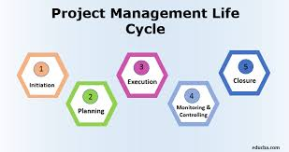

What makes a project successful?

Strategic planning, efficient organisation, diligent monitoring, and effective control of all project parts are project management. It also requires inspiring everyone to work safely to meet the project's goals within the timetable, budget, and performance criteria. Project performance, especially in the short term, is the focus of project management.
Meeting time, cost, and quality criteria determines project success (Radujković and Sjekavica, 2017).

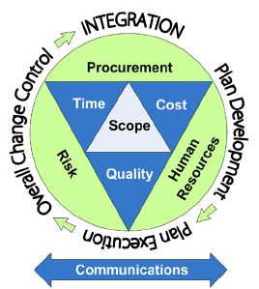

Reference list:
Portny, J.L. and Portny, S.E. (2022). Project management for dummies. John Wiley & Sons.
Radujković, M. and Sjekavica, M. (2017). Project management success factors. Procedia engineering, 196, pp.607-615.

Blog 2: Iron triangle

Understanding the Iron Triangle
The Iron Triangle, also known as the Triple Constraint or the Project Management Triangle, is a key idea that defines the criteria for project success. The Iron Triangle is a conceptual framework that represents the fundamental criteria used to define project success. It assesses if the project is delivered within the specified parameters of time, cost, and scope.
The project must be completed within the specified deadline, while staying within the allocated money, and meeting the agreed-upon standards of quality, performance, or scope. The Iron Triangle has established itself as the benchmark for regularly evaluating project performance (Pollack et al., 2018).

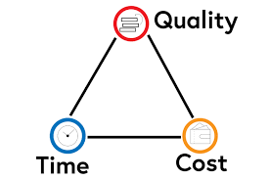

Iron triangle benefits:

- Risk mitigation: Knowing the iron triangle helps project managers make proactive decisions and reduce risks by identifying fixed restrictions and flexibility.
- Adaptability: Knowing the project management triangle's set restrictions helps project managers handle sudden scope, timetable, and budget changes.
- Help in decision-making: The iron triangle helps project managers balance scope, time, and money to meet goals.

Iron triangle limitations:

- Limited flexibility: The model assumes that changing one constraint always affects the others, which may not be true in practice.
- Stakeholder expectations: The iron triangle may overlook stakeholder expectations and satisfaction, which are vital to project success.
- Long-term planning issues: The iron triangle may not be as effective at resource planning and management for larger, long-term projects. (Whyte, 2022).

Watch this video:

What is the Iron Triangle? Time, Cost, Quality, Scope? - YouTube

Reference list:

Pollack, J., Helm, J. and Adler, D. (2018). What is the Iron Triangle, and how has it changed?.International journal of managing projects in business, 11(2), pp.527-547.

Whyte, C. M. (2022). The project management triangle and how it benefits your team. [Online]
Available at: https://blog.farmerswife.com/what-is-the-project-management-triangle
[Accessed 01 June 2024].

Blog 3: GANTT CHART
WHAT IS A GANTT CHART AND HOW CAN BE USED IN A PROJECT?

The Gantt Chart, named after Henry Gantt, is a highly utilised tool in contemporary project management for the purpose of planning and overseeing projects. A Gantt chart, also referred to as a bar chart, is a visual representation that illustrates the duration, start, and finish time of each task using bars on a time scale. Providing ample information about the actions in a brief time frame makes it easy to comprehend. The Gantt chart employs milestones to denote the
completion of progress in the project. The Gantt chart utilises milestones to signify the completion of certain points in a project timeline, serving as an indicator of progress within the project (Krcheva et al., 2023).

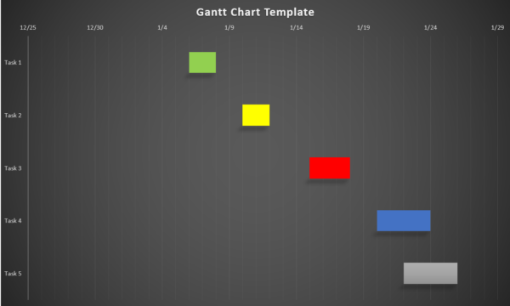

Advantages and disadvantages of using Gantt Chart in Project Management

Gantt charts are important tools for managing projects, and they have many uses and benefits. They show complicated project plans in a way that is easy to understand and lets you compare real performance to baselines. These charts make it easy to see the project's scope, schedule, and how tasks rely on each other. They also help with allocating resources.
However, some team members may find it hard to understand Gantt charts, and not all software has all the tools that you need. Simpler tools, like job lists or kanban boards, might be enough for small teams or projects that only last a short time. The linear design of Gantt charts can also make them less useful for agile projects (projectmanager.com, 2024).

Reference list:

Krcheva, V., Dzidrov, M., Srebrenkoska, S. and Krstev, D. (2023). Gantt chart as a project management tool that represents a clutch hub manufacturing process. Balkan Journal of Applied Mathematics and Informatics (BJAMI), 6(2), pp.67-78.

projectmanager.com. (2024). What Is a Gantt Chart? (Examples & Templates). [Online]
Available at: https://www.projectmanager.com/guides/gantt-chart
[Accessed May 20 2024].

Blog 4: Stakeholder analysis in Project management

Definition and importance of Stakeholder Analysis

Stakeholder analysis is a crucial process in project management that involves identifying and assessing the individuals, groups, or organizations that can impact or be impacted by a project.
Project stakeholders are the people involved in a project who will either be affected or have an interest in it. Neglecting to interact with them may directly affect the projects results. Stakeholder analysis aids in determining the needs and expectations of the project's stakeholders. It makes it possible to identify important stakeholders, those who support the project and those who might be against it. (Varvasovszky and Brugha, 2000).
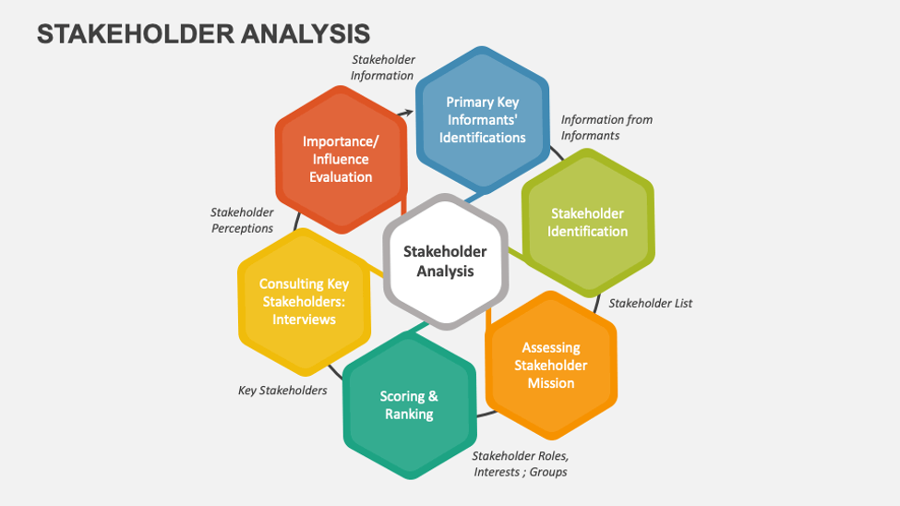

Steps to Conduct Stakeholder Analysis:

Identify Stakeholders: List all individuals or groups affected by the project or who have a vested interest in its success or failure. This includes internal stakeholders (team members, leadership) and external stakeholders (customers, investors).
Assess Stakeholders: Evaluate their level of interest and influence. Tools like the Power/Interest Grid can help visualize stakeholder relationships and inform communication strategies.
Prioritize Stakeholders: Classify stakeholders based on their impact and influence. This helps in allocating time and resources effectively.
Engage Stakeholders: Develop strategies for stakeholder engagement. This might include regular updates, consultation meetings, and collaboration efforts (Schmeer, 1999).

Reference list:

Varvasovszky, Z. and Brugha, R. (2000). A stakeholder analysis. Health policy and planning, 15(3), pp.338-345.
Schmeer, K. (1999). Stakeholder analysis guidelines. Policy toolkit for strengthening health sector reform, 1, pp.1-35.

Blog 5: Risk Analysis: A Crucial Step in Project Management

In the world of project management, risk analysis is a vital process that can make or break a project's success. It involves identifying, analyzing, and evaluating potential threats and opportunities that could impact project objectives (Widianti et al., 2018).
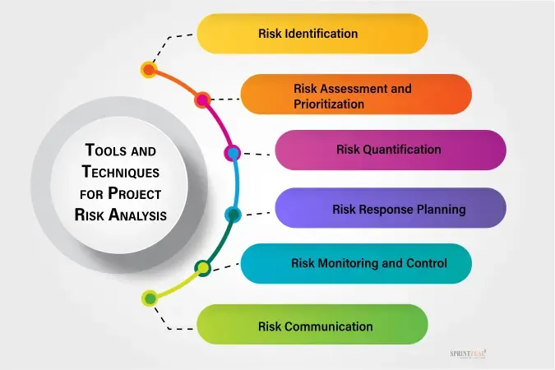

Key steps to follow when creating a risk analysis:
Identify potential risks: Brainstorm with your team to identify all possible risks that could impact the projects.
Collect and analyze data: Gather relevant information to estimate the likelihood and potential impact of each identified risk.
Assess risk probability and impact: Evaluate how likely each risk is to occur and what its consequences would be if it did materialize. This often involves using tools like risk matrices or probability/consequence matrices.
Prioritize risks: Based on the probability and impact assessments, prioritize the risks to focus on those that pose the greatest threat to the project.
Develop risk response strategies: Create plans to address each significant risk, either to prevent it from occurring or to mitigate its impact if it does happen.
Monitor and review risks: Continuously monitor identified risks and scan for new ones throughout the project lifecycle. Regularly review and update the risk analysis as the project progresses and circumstances change.
Communicate with stakeholders: Keep all relevant stakeholders informed about significant risks and mitigation strategies.

Reference list:

Health and Safety Executive.(2024). Five steps to risk assessment. [Online]
Available at: https://www.midsussex.gov.uk/media/1820/5-steps-to-risk-assessment-lealfet.pdf
[Accessed 02 June 2024].
Widianti, U.D., Harihayati, T. and Sufaatin, S. (2018). August. Risk project management analysis. In IOP Conference Series: Materials Science and Engineering (Vol. 407, No. 1, p. 012087). IOP Publishing.

