Task 1: Locating Sources
Identify and locate three different sources (a report, a journal article, and a website) related to the question
“What employability skills do business graduates need to succeed in the modern workplace?”
Show how you used keywords, search terms, and Boolean operators to find them, and explain how you know which type of source each one is and why it is appropriate for the research question.

Source Type & Why It Is Appropriate | URL/DOI | What search engine did you use? Google/Online Library/Library AI Assistant | Keywords/Boolean Operators Used
Article | https://librarysearch.uwtsd.ac.uk/permalink/44WHELF_UWTSD/1bmis16/cdi_proquest_journals_3223677404 | Library | Employment skills AND student
Article | https://librarysearch.uwtsd.ac.uk/permalink/44WHELF_UWTSD/1bmis16/cdi_proquest_journals_3223677404 | Library | Employment skills  AND student
Article | https://librarysearch.uwtsd.ac.uk/permalink/44WHELF_UWTSD/1bmis16/cdi_proquest_journals_3223677404 | Library | Employment skills AND student

Task 2: Evaluating Information (CRAAP Test)
Your colleague has forwarded you a source from a peer reviewed journal, and they are not sure whether it is appropriate to use and has asked for your help. Your task is to evaluate the source by using the CRAAP Test to assess its appropriateness.
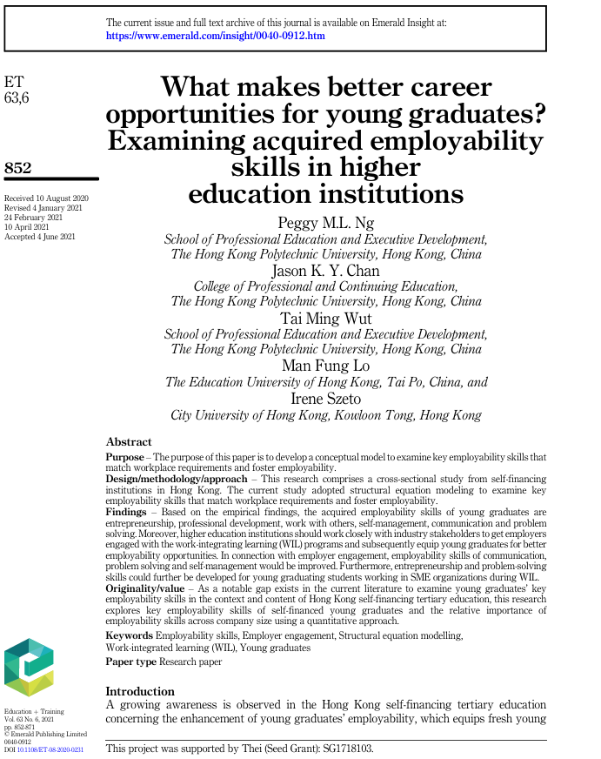

CRAAP Test
Currency | 2021  Reasonably current as it was in the last 5 years.
Relevance | Yes as it examines what the key employability skills are in the workplace.
Authority | Peggy ML. NG  Jason K. Y. Chan  Tai Ming Wut  Man Fung Lo  Irene Szeto
Accuracy | Yes it was peer reviewed as it was supported by Thei(Seed Grant):SG1718103 and published by Emerald Publishing Limited
Purpose | Yes it clearly states its purpose which is to develop a conceptual model to examine key employability skills that match workplace requirements and foster employability.

Task 3: Source Analysis
Your manager has provided you with a short extract from a source and has asked you to analyse the source by Identifying one strength, one weakness, and providing a brief explanation of the strength and weakness identified.
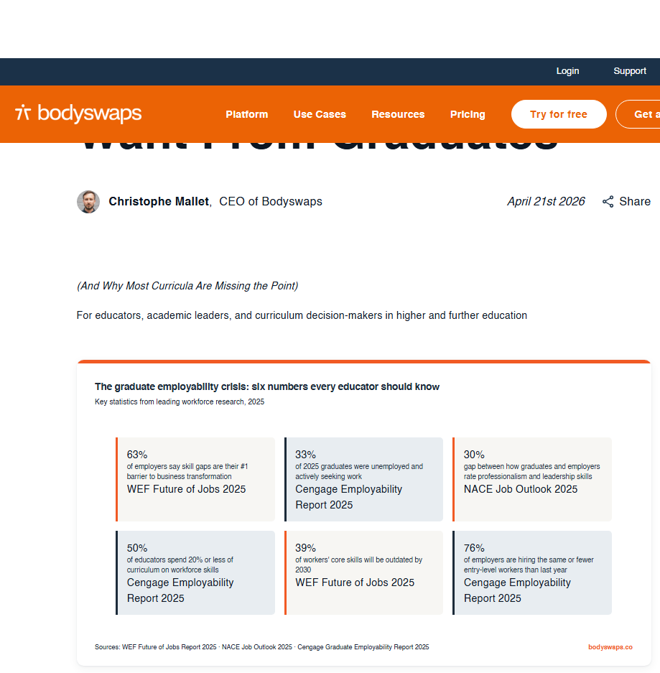
.

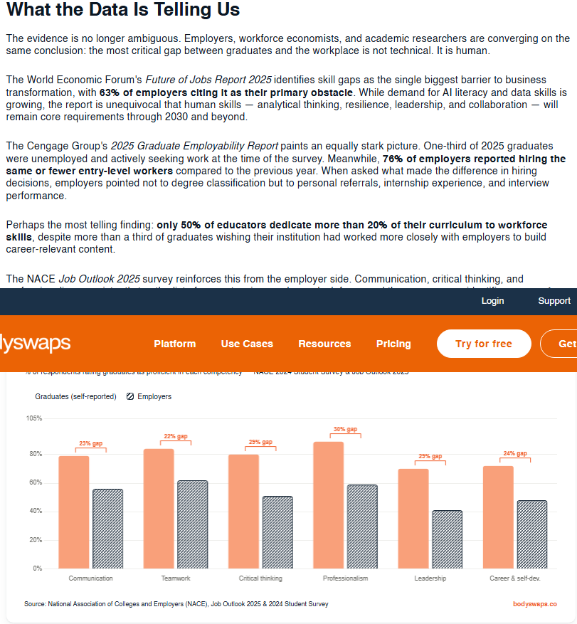

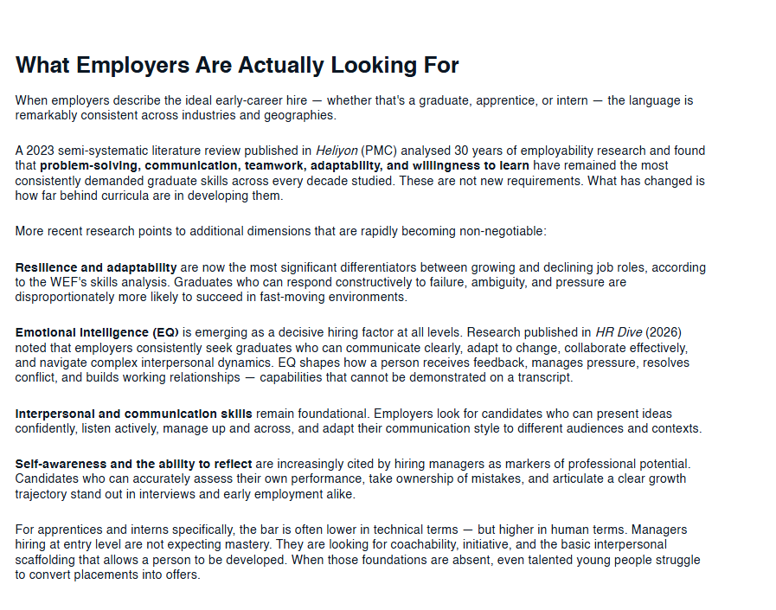

Please click the link, if you wish to read the article online.
What Employers Actually Want From Graduates

Strength of the Source:

It was written and published on April 21st 2026 which shows us that it very recent data.

And further data included is from 2025 which is still recent.

Weakness of the Source:

We don’t know if the data is accurate as it hasn’t give us any indication that it has been peer reviewed or where the figures are from.

