Student number – 1908502

BA hons Illustration

Word count – 1432

Tutors. – Jon Pugh & Martin Bush

Ways of perceiving

My curation of an imagined exhibition

“Great minds think alike”

The exhibition that I have imagined and curated will influence those who find it difficult to express

their feelings and emotions verbally.

Focusing mainly on those who struggle with mental and physical disabilities such as depression,

ADHD, Bipolar, Autism, Down syndrome, Cerebal palsy and many others who struggle with various

other disabilities.

Expressing feelings of emotions through Art in any form, can offer those who struggle with

communication and learning difficulties, by expressing their thoughts and feelings creatively. This is

a self-revealing approach for both adults and children with these barriers and difficulties.

Creativity can be an inspiring way for anyone with mental and physical disabilities.

Expressing emotions through art can be therapeutic and decrease any tensions or frustrations that

may have built up over time.

This way of engagement will explore their imagination to help them express what is troubling their

minds in a way that they can’t express verbally in person.

Some research suggests that just the presence of art can play a vital part in boosting mental health.

You don’t need to have a special talent to participate in self expression.

Top 5 benefits of art therapy

- Art relieves stress by providing a distraction from normal day life.

- Art helps to encourage creative thinking.

- Art helps to boost self-esteem and offer accomplishment.

- Art encourages brain activity.

- Art improves overall quality of life in dementia patients.

Although there are a lot of medical and financial support out there for those with disabilities, I

don’t think there is enough encouragement to inspire or motivate those who feel

disadvantaged or even disheartened because the fear of being rejected and stereotyped.

The idea of this event is to show that you are not alone and to believe in yourself.

To give you a sense of self worth.

Anyone, regardless wether you have the talent to draw exceptional or not, can explore

expressiveness through art.

The outcome from this event is to communicate, that it doesn’t matter who you are or what you are

capable of, art is accessible to anyone and it can be an alternative way to express feelings freely in a

way you may feel difficult to express verbally.

More than ever now, this is topic of discussion everywhere and that more awareness is needed

over this stigma.

There are many various charities offering support, such as fund raising, discussions, counselling.

However, there is very little action supporting Cognitive behavioural therapy.

Such as activities or events showing practical activities on how to approach differently towards

coping with emotions and mental or physical positivity.

That’s is where I believe art therapy could made a massive impact on self belief and help with

Expression and positive attitude.

Location of my exhibition/event

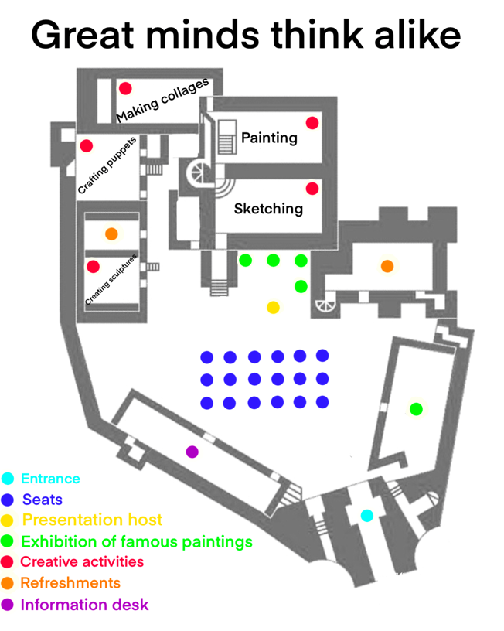

Figure 1 : castle event plan (Map of the layout)

My exhibition “great minds think alike”, will take place in the famous historical Oystermouth castle,

situated down Swansea’s mumbles.

This will be the perfect setting for such an exhibition.

Oystermouth Castle was built presumably by William De Londres.

His son Maurice de Londres was known to have been lord of Oystermouth in 1151.

The castle is open and airy with many different rooms to accommodate the various arts and

crafts for those to express and enjoy. The aim is to get everyone as involved as possible.

The idea is to help those with disabilities to feel comfortable, not enclosed or to feel Claustrophobic.

Many who struggle with mental disabilities have a fear of being isolated or Being stuck enclosed,

where there is no where to escape if they need too.

This can cause unnecessary stress and episodes to which they can’t control.

The castle is perfect. It has no roof due to its derelict history, it’s almost like your out in the open

but inside a castle.

As you walk through the entrance you’ll see a wide open garden area where there will be a

seating and standing area, where a short introduction of the exhibition will take place.

The presentation will express the meaning of the exhibition, where there will be a gallery display of

the famous art paintings.

The presentation will reveal the amazing art work of the famous artists and a brief discussion about

the reasons behind the inspiration for their work.

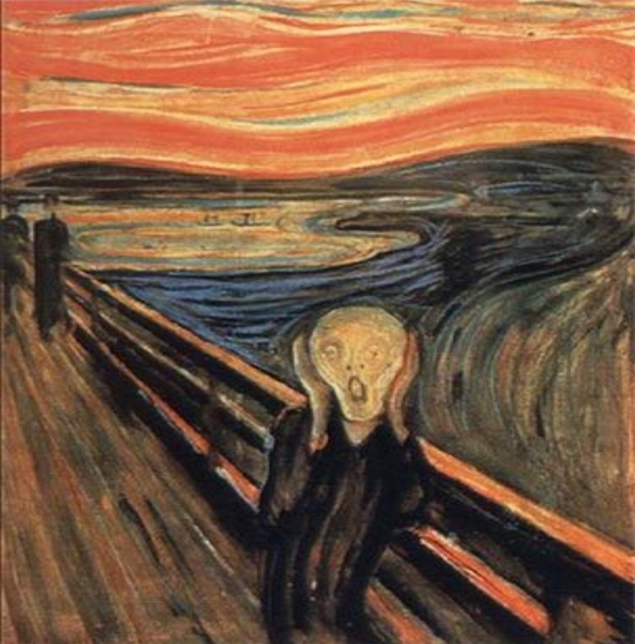

Figure 2 : The scream ( Edvard Munch, 1892 )

I have decided on four famous paintings to be exhibited in my event that are provide a powerful

message behind the reasons why art therapy is effective.

Edvard Munch ( Norwegian painter ) created The scream back in 1892.

The Scream is iconic. Munch created this painting in his manic phase where he expressed a

feeling of anxiety and despair.

Munch created four versions of The Scream, two in paint and two in pastels.

Two of the painted versions have been stolen throughout their life time but have been recovered.

One of the pastel versions is the fourth highest paid for painting at a public auction.

Munch expressed in his diary : One evening I was walking along a path, the city was on one side and

the fjord below. I felt tired and ill. I stopped and looked out over the fjord, the sun was setting and

the clouds turning blood red. I sensed a scream passing through nature; it seemed to me that I

heard the scream. I painted this picture, painted the clouds as actual blood. The colour shrieked.

This became the scream.

1879 Munch enrolled in technical college to study engineering, excelling in physics, chemistry and

math, he learned scale and perspective drawing, unfortunately his frequent illnesses interrupted his

studies.

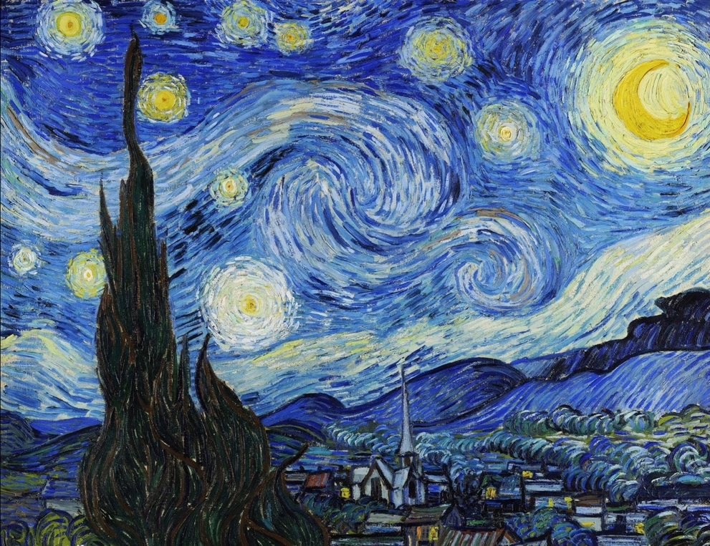

Figure 3 : Starry night ( Vincent Van Gogh ) 1889

Vincent Van Gogh ( Dutch post – impressionist painter ) created Starry night back in 1889.

Gogh was renowned for his mental health issues, being labelled as the ‘crazy artist’.

He suffered with many mental health symptoms from his bipolar disorder, causing him to have

hallucinations, paranoia, epilepsy. He lacked confidence and was highly emotional.

As a result of his illness he cut off his own ear with a razor blade.

Due to his episode of hysteria, he spent some time in St-Paul-De Mausole Asylum, this

is where he created one of his most known pieces of art ‘Starry night’.

Gogh’s art work reflects his emotional pain, he used his creative imagination to help

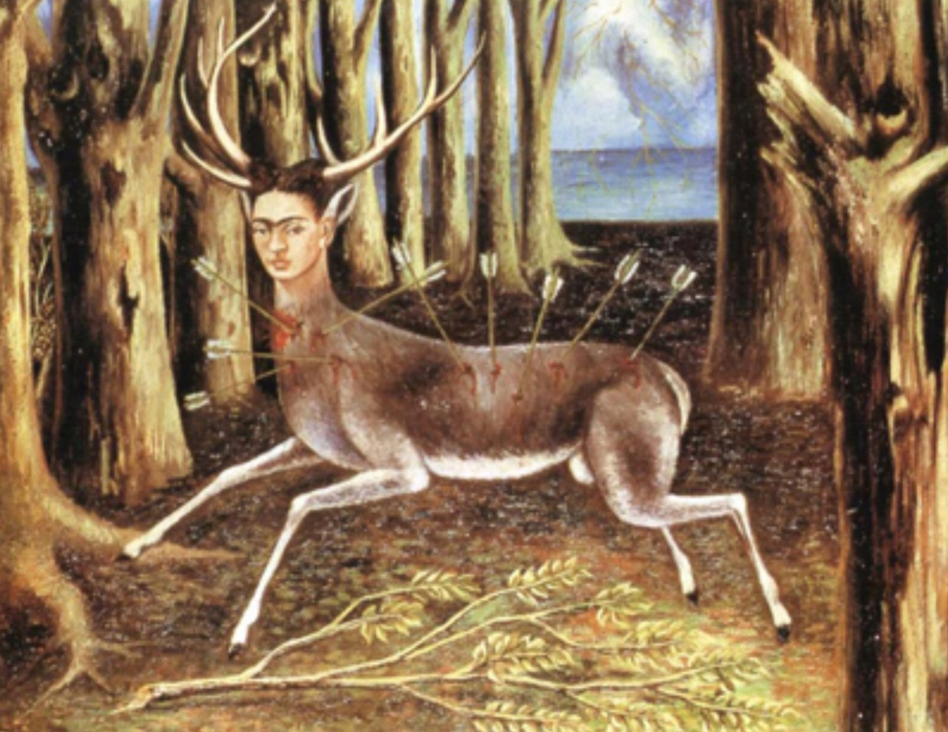
cope with his emotions and mental health.

Figure 4 : The wounded deer ( Frida Kahlo ) 1946

Frida Kahlo ( Mexican painter ) created The Wounded deer, back in 1942.

Kahlo suffered with Polio when she was a child, she nearly died in a bus accident where she suffered

multiple injuries. she spent most of her time recovering in a full body cast, although her medical

school dreams became impossible to fulfil due to her horrific injuries, she rediscovered her passion

for art where she spent her long days bed bound painting portraits.

Her Mexican heritage, her pre-Columbia’s and catholic beliefs was a massive inspiration behind most

of her work.

Her work was very expressive and mixed between fantasy, naivety and fascination with violence and

death.

Kahlo’s paintings expressed a lot to do with pain, hurt and guilt.

She spent most of her life in hospitals, painting was a way for her to express and find a sense of

Freedom, being that she was disabled she had no other way to escape the disabilities she had mobility

freely.
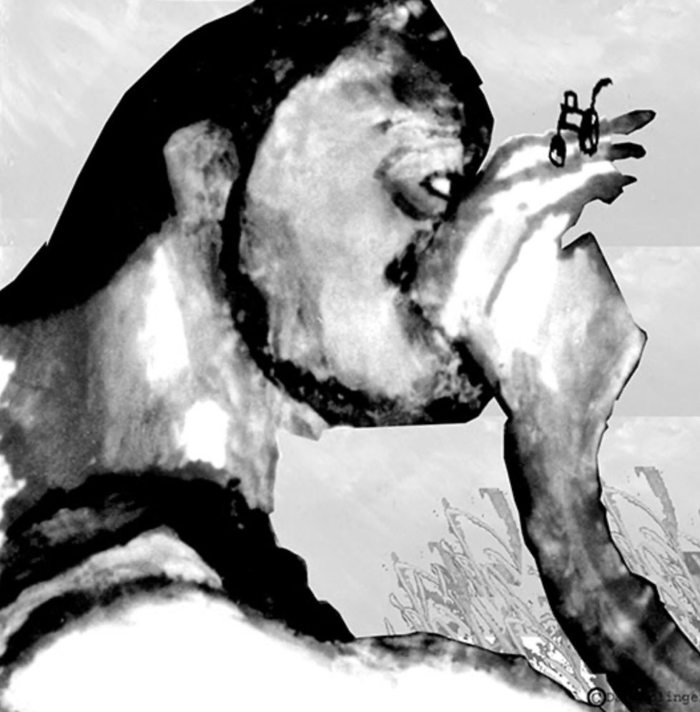

Figure 5 : My precious ( Dan Keplinger ) 2008

Dan Keplinger ( American artist and Motivational speaker ) created My precious in 2008, more

recently than the other art work exhibited in this event.

Keplinger has spastic and athetoid Cerebral Palsy.

As a child in school his teacher encouraged him to express himself through art.

Keplinger simply gets given the tools he needs, to have art express what he needs to say.

He paints with a brush attached to his head with a headband and a stick.

“Painting canvas becomes my voice” – Dan Keplinger.

In an interview with Alexandra Wang, where she had asked various questions relating

to Keplinger’s disabilities and how to motivate or inspire others, she asks him “ how can art be a

place of passion for people with cerebral palsy?”, Keplinger’s response was very moving and

inspiring “art is its own language, there are no rights or wrongs. The idea is to have freedom of

expression. Nobody can take that away from you. Art is a place to express your true feelings, no

matter what.” – Madamactivist.wordpress, 2019.

Bibliography

Jonas, A., 1886. Oystermouth castle. Notes and Queries, s7-I(16), pp.309-309.

En.wikipedia.org. 2020. Oystermouth Castle. [online] Available at: <https://en.wikipedia.org/wiki/Oystermouth_Castle> [Accessed 12 May 2020].

Ro.wikipedia.org. 2020. Pablo Picasso. [online] Available at: <https://ro.wikipedia.org/wiki/Pablo_Picasso> [Accessed 12 May 2020].

Disability Horizons. 2020. Disabled Icons: Painter Frida Kahlo And Pushing Boundaries | Disability Horizons. [online] Available at: <http://disabilityhorizons.com/2015/12/disabled-icons-painter-frida-kahlo-and-pushing-boundaries/> [Accessed 12 May 2020].

Team, P., 2020. 5 Word-Famous Artists That Had Disabilities: Michelangelo, Goya, Klee.... [online] Passionate People by Invacare. Available at: <https://www.passionatepeople.invacare.eu.com/5-world-famous-artists-disabilities/> [Accessed 12 May 2020].

VisitWales. 2020. Castles And Heritage. [online] Available at: <https://www.visitwales.com/things-do/attractions/castles-heritage> [Accessed 12 May 2020].

Mars Hill University. 2020. Art Therapy - Mars Hill University. [online] Available at: <https://www.mhu.edu/academics/majors-and-minors/art-therapy/> [Accessed 12 May 2020].

Edvardmunch.org. 2020. Art Analysis: Meaning Of The Scream By Edvard Munch. [online] Available at: <https://www.edvardmunch.org/link.jsp> [Accessed 12 May 2020].

Cohen, A., 2020. 7 Things You Didn’T Know About Edvard Munch. [online] Artsy. Available at: <https://www.artsy.net/article/artsy-editorial-7-things-edvard-munch> [Accessed 12 May 2020].

Kinggimp.com. 2020. Dan Keplinger, Artist. [online] Available at: <http://kinggimp.com/index.html> [Accessed 12 May 2020].

Encyclopedia Britannica. 2020. The Starry Night | History, Description, & Facts. [online] Available at: <https://www.britannica.com/topic/The-Starry-Night> [Accessed 12 May 2020].

