Lois Davies – 1504981
BA Surface Pattern Design

Word Count 1484
Julia Lockheart

Realization of Fashion / Gwireddu Ffasiwn
An exhibition evidencing the harmful impact of fast-fashion clothing on the environment, comparing synthetic and natural materials in a space, and showing how we can change our ways to prevent destroying the earth. In this essay there will be a detailed description of the exhibition, including the meaning behind it and why it is in that space, as well as supporting theories and artists which inspired this exhibition.
Mae dillad yn bwysig iawn i bobl ac mae o wastad mynd i fod. Gwnaed dillad yn wreiddiol filoedd o flynyddoedd yn ôl ar gyfer cadw yn dwym a’r tywydd, erbyn heddiw, mae ymddangosiad y dilledyn wedi dod yr un mor bwysig â’r swyddogaeth. Mae pobol yn teimlo bod angen prynu dillad yn gyson i gadw fyny a’r tueddiadau parhaus, yn ogystal â defnyddio dillad i fynegi ei hunain, ac i adlewyrchu ar bwy ydyn nhw fel person. Mae damcaniaethwr Luckins yn dadlau fod “in a post-modern consumer society, it can be argued that the pursuit of fashionable dress is motivated by an individual’s desire either to appear distinctive or to conform” (2010).
Mae dillad a ffasiwn yn mor bwysig i bobl mae pawb yn ddall i’r ffaith fod o hefyd yn nafi’r byd wrth ddefnyddio defnyddiau synthetig a llifynnau gwenwynig (Independent, 2018). Mae’r arddangosfa yma yn dangos y niwed mae ffasiwn gyflym yn cael ar yr amgylchedd wrth edrych ar pum gwmni dillad gwahanol, yn ogystal ag awgrymu ffyrdd gwell o gynhyrchu dillad syn diniwed i’r blaned.
The exhibition starts 20th of June first day of spring. It is set in Epping Forest, which is located between Kent and London, the reason behind this is because it is on the greenbelt which was made for controlling urban growth (London Green Belt Council), which relates to the growth of fast fashion production. 5 mannequins stand side by side, approximately 1 meter apart from each other, the mannequins are made of wood which was inspired by the artist Tim Davies, who returned a mahogany floor from Wales to Belize and laid it in the rainforest – the mahogany floor was placed back to where it started its life and will over time “years from now, nurture a young mahogany tree” said by Barcott (2004).
Mae’r arddangosfa yn agor dwywaith, unwaith am wythnos, ac yna am wythnos arall deng mlynedd yn ddiweddarach. Mae hyn yn rhoi cyfle i’r gynulleidfa ddychwelyd i weld canlyniad yr arddangosfa ar ôl deng mlynedd, i weld y darn wedi gorffen, ac i gymryd y neges mewn a oedd wedi cymryd blynyddoedd i’w chyflawni. Ysbrydolwyd y defnydd o amser yn yr arddangosfa hon gan y cerflunydd David Nash, a’i ddarn ‘Ash Dome’ (gweler ffigwr 1) le mae’n gynnwys coed a wnaeth e ei blannu ei hun. Daeth y darn yma yn boblogaidd 40 mlynedd yn hwyrach, a daeth y neges tu ôl i'w waith yn ymwybodol wrth ddefnyddio amser a natur. (Jobson, 2016).
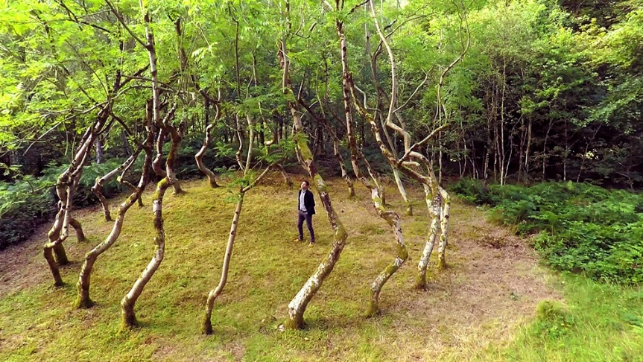

Ffigwr 1 - Ash Dome, (Nash, 2016)

Five of these mannequins have garments on them from five different fast fashion brands, including River Island, Missguided, Asos, H&M and Bershka. There is a reason behind why these brands are in the exhibition, 4 of these garments has garments made of synthetic material, a type of material frequently used by big brands as they are cheaper, easier and faster to make. Synthetic materials, like polyester, which is the most popular fibre used in fast fashion, harms the planet in many ways. Not only it pollutes the water, but it also takes between 20-200 years to decompose in the environment, noted by Uren (2018) as he discusses the material polyester. This is one of the biggest issues with fast fashion, as it takes this many year to decompose it also releases harmful greenhouse gases including methane which adds on to the list of problems.
Bydd un manicin gyda dilledyn o’r cwmni H&M wedi cael ei greu allan o gotwm organig. Mae cotwm yn ddefnydd naturiol sydd ddim yn niweidiol i’r amgylchedd ac sy’n cymryd rhwng 1-5 mis i bydru (Delaney, 2013). Y rheswm mai dilledyn H&M sydd allan o gotwm yw oherwydd mae’r brand yn “committed to sourcing sustainable or recycled materials in its clothing by 2030” meddai Bauck sy’n sôn am frandiau ffasiwn gyflym cynaliadwy (2017). Felly, ar ôl dod 'nôl deng mlynedd yn hwyrach, mae’r gynulleidfa yn weld eu hun pa ddillad sydd dal yno a pa ddillad sydd wedi pydru, gan dangos y niwed mae defnydd synthetig a’i gymharu â deunyddiau naturiol.
Kate Fletcher who discusses sustainable fashion and textiles talks about the impact of a garment depending on what material is used, and also discusses which materials are most sustainable for fashion “today- organic, Fair Trade and rapidly renewable fibres continue to lead populist ideas about sustainability innovation” (Fletcher, 2014) evidencing that using natural materials is something that should be considered to have sustainable fashion, this is seen in the exhibition with H&M’s garment which is made of cotton. Fletcher goes on discussing where materials are dumped after being thrown away and what impact it has in a landfill “Where textiles and clothing are sent to landfill, these products contribute to overall environmental impact of these sites… Synthetic textile materials with long decay times prolong these impacts”(Fletcher, 2014) her proof and theory of how long synthetics take to decay in an environment, proves that returning to the exhibition 10 years later and seeing the result of the garments has an impact on the audience, which is what the curator wants, for the audience to see how long lasting and harmful man made materials can be.
Gan fod un o’r dilledyn wedi cael ei wneud gan gotwm naturiol, mae’n awgrymu fod yna ateb i’r broblem a gall fod yn fwy addas a ddiniwed i’r amgylchedd. Mae defnyddio defnydd organig a naturiol fel cotwm, gwlân a sidan yn opsiwn llawer mwy cynaliadwy. Mae Fletcher yn credu mai defnyddio defnydd naturiol yw’r ffordd ymlaen ar gyfer ffasiwn gynaliadwy:
The strategy of materials diversity involves replacing some of the dominant or high-impact fibres with alternative including low-chemical and organic cotton, hemp, lyocell, wool and PLA. This would help us pursue multiple strategies to tackle sustainable problems (Fletcher, 2014).
Mae’r gofod le mae’r arddangosfa yn digwydd yn rhan bwysig iawn. Mae pobol yn medru cysylltu gyda lle neu ofod ac mae’n medru gwneud i bobl deimlo rhyw fath o ffordd, a dyna pam cynhelir yr arddangosfa yn y goedwig. Mae bod yng nghanol natur yn beth dda iawn i’ch iechyd a gydag effaith gadarnhaol at bobol. Mae bod yn yr amgylchedd naturiol, fel y goedwig, yn gwneud i chi deimlo’n well yn emosiynol, yn lleihau straen a phryder ac yn gwella’ch hwyliau (Kane,2018).
As the space of the exhibition has such positive and calming impact on people, the curator decided this will have more of an impact on them, as they visit the mannequins and see the remains of the synthetic garments 10 years later, this will make the audience uncomfortable as they can see the impact of man-made materials, making them feel selfish, guilty, and self-hatred, which contrasts with the feeling that nature gives us. Artist Andy Goldsowrthy also inspired the space the exhibition is held in, as he collaborates with nature in his work, he feels like the space is key “The energy and space around a material are as important as the energy and space within” (Goldsworthy, 1990).
Dyma ddarlun o'r arddangosfa ei hun (Ffigwr 2). Gallwch weld mae yna lwybr yn mynd trwy’r goedwig sy'n cymryd chi at yr arddangosfa ei hun. Cyn gweld y 5 manicin, gallwch weld bwrdd gwybodaeth sydd yn esbonio effaith ffasiwn gyflym ar yr amgylchedd, ac yn esbonio'r arddangosfa. Mae’n yn sôn am ffeithiau a ffigurau sydd i wneud ar resymau tu ôl i'r neges, yn ogystal â'r dyddiad pryd fydd o'n agor eto i'r gynulleidfa dod yn ôl. Ar y bwrdd gwybodaeth bydd yn dweud bod croeso i bawb dynnu lluniau, o’r dillad, natur, a’r bobol, ar ôl 10 mlynedd gallent ddod 'nôl a thynnu rhagor o luniau er mwyn cymharu, mae hyn yn gwneud hi’n fwy personol i’r gynulleidfa.

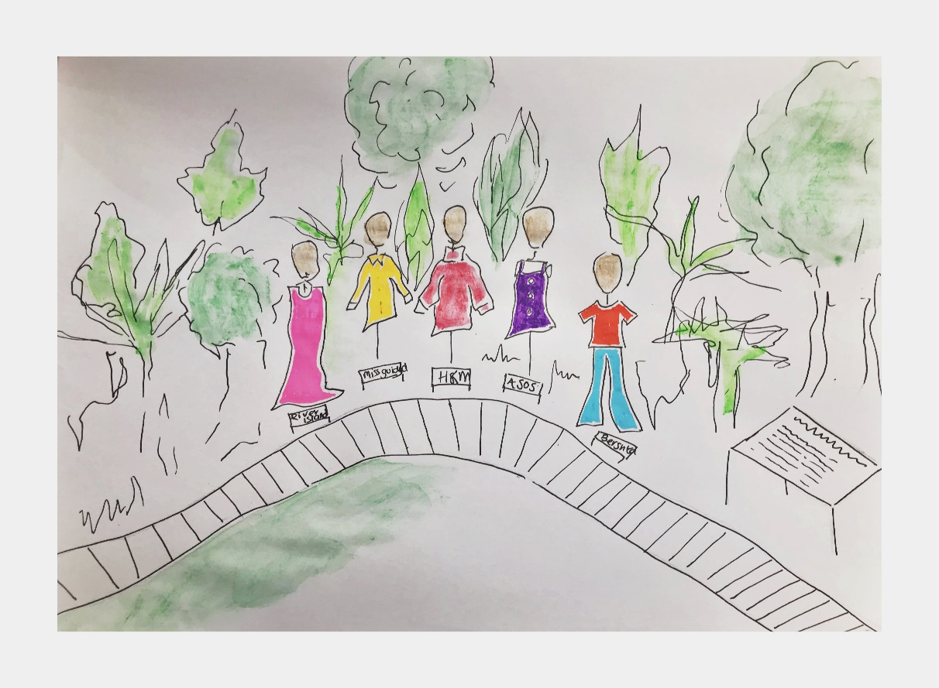

Ffigwr 2 - Darlun o’r Arddangosfa (Davies, 2019)

This exhibition is a realization. A realization of problems the people and the planet face today. Environmental issues are becoming a bigger problem, with the peoples need for more and more from this planet, it is also destroying it. Extreme weather, rising sea levels, and extinction of animals, are just some of the problems that is caused by global warming, the biggest issue facing the planet caused by humans. This exhibition has been designed and thought through so it can impact on the audience. The location, the space, the objects in the exhibition all mean something to the audience, and hopefully seeing the impact we have on the environment will inspire people to try and make changes to save our beautiful planet.

Bibliography
Barcott,B. (2004) ‘Art; And you though art in New York was a jungle’, The New York Times, 9th of May. Available at: https://www.nytimes.com/2004/05/09/arts/art-and-you-thought-art-in-new-york-was-a-jungle.html (Accessed: 4th April 2019).
Bauck, W. (2017) ‘Fashionista’, The Fashion industry emits as much greenhouse gas as all of Russia, 22nd of September. Available at: https://fashionista.com/2017/09/fashion-industry-greenhouse-gas-climate-change-sustainability (Accessed:6th April 2019)
Davies, L. 2019 Darlun o’r arddangosfa [pen on paper].
Delaney, P. (2013) ‘Down 2 Earth Materials’, how long does it take for some everyday items to decompose, 14th February. Available at: https://www.down2earthmaterials.ie/2013/02/14/decompose/ (Accessed: 6th April 2019)
Fletcher, K. (2014) Sustainable Fashion and Textiles Design Journeys 2nd Ed. London u.a. Routledge.
Goldsowrthy, A. (1990) Andy Goldsworthy: a collaboration with nature. New York: H.N. Abrams
Independent (2018) The Environmental costs of fast fashion. Available at: https://www.independent.co.uk/life-style/fashion/environment-costs-fast-fashion-pollution-waste-sustainability-a8139386.html (Accessed: 4th April 2019).
Jobson, C. (2016) ‘Colossal’, Ash Dome: A Secret Tree Artwork in Wales Planted by David Nash in 1977, 9th of May. Available at: https://www.thisiscolossal.com/2016/05/ash-dome-david-dash/ (Accessed: 7th April 2019).
Kane, S. (2018) ’10 ways nature helps your well-being’ PsychCentral [blog] 8 July. Available at: https://psychcentral.com/blog/10-ways-nature-helps-your-well-being/ (Accessed: 15th April 2019).
London Green Belt Council (2019) Available at: https://londongreenbeltcouncil.org.uk/about-londons-green-belt/ (Accessed: 4th April 2019)
Luckins, K. (2010) Fashion Re-consumption: Developing a sustainable fashion consumption practice influenced by sustainability and consumption theory. VDM Verlag Dr.Muller.
Uren, A. (2018) ‘Good on You’, Material Guide: How sustainable is Polyester?, 7th Of September. Available at: https://goodonyou.eco/material-guide-polyester-2/ (Accessed:5th April 2019)

