3/24/2025
University of Wales Trinity Saint David
London campus
E-Portfolio Link:
Module Name: Learning In the Digital Era
Module Code: ACCA 4025

Student Name: Maksym Berkyta
Student ID: 2518672
Group: 1

Lecturer’s Name: Koushik Modak

LDE Assignment 1
E-Portfolio
Table of Contents
Introduction 2
Main Body 2
Task 1: Essential Academic and Employment Skills for the future career Path 2
Task 1 (a): Report on Essential Academic and Employment Skills 2
Task 1 (b): Evaluation of Task 1 (a) based on Similarity report 2
Task 2: Collaborative Mind Map and Individual Poster 2
Mind Map (Collaborative) 2
Poster (Individual) 2
Task 3: Virtual Collaboration and RefWorks 2
Report on Virtual Collaboration 2
Step-by-step process of using RefWorks with visuals 2
Task 4: E-Portfolio Creation and Evaluation 2
Task 4 (a): E-Portfolio Creation 2
Task 4 (b): Illustrative Review of E-Portfolio tool Selection 2
Conclusion 2
References 2
Task 1 References: 2
Task 3 References: 2

Introduction

Main Body

Task 1: Essential Academic and Employment Skills for the future career Path

Task 1 (a): Report on Essential Academic and Employment Skills
Academic skills (research, referencing, writing).
In today's world, it is required for students to combine academic and work skills in order to prepare for their future careers. The skills provide one with great ways of studying more effectively, working well in a team, and facing new challenges. Acquiring the correct skills ensures that finding employment and career advancement at the workplace becomes very easy. The report outlines the most crucial skills that students need for development in relation to their future paths.One major academic skill involves managing time. Students are usually flooded with homework, group projects, and studying. Time management ensures they stay organized and do not suffer from stress. Another crucial academic skill involves critical thinking. This includes carefully assessing information for clarity and wisdom in making appropriate decisions. Critical thinking applies to every subject and enables students to solve problems intelligently. Research skills are also crucial, as students have to locate appropriate, accurate information and cite their sources appropriately. Job skills are also very important for a future career. A major skill for a job is communication. This involves being able to write clearly, speak confidently, and also listen to others. It allows people to work well and effectively with others; this avoids misunderstandings. Another skill in the workplace is teamwork because most places require working together and supporting one another. Being able to work with different kinds of people raises someone's chances of succeeding at their job. Another helpful ability is problem-solving. When problems occur within the job, employers seek to find workers who can handle themselves quietly, analyze a situation, and come up with practical solutions. Flexibility is important today, too: technology keeps on updating, and workplaces change too, so people have to be ready for different situations and learn something new. Finally, self-management helps workers stay responsible, perform on time, and sustain motivation without reminders. Conclusion: It has thus been established that academic and job skills are equally important for a solid future career path. In fact, these employability skills of time management, communication, teamwork, and problem-solving bring confidence and prepare them for real-life challenges. Developing these skills early will afford students a better chance of success both at school and at work.

Task 1 (b): Evaluation of Task 1 (a) based on Similarity report

Task 2: Collaborative Mind Map and Individual Poster

Mind Map (Collaborative)

Mind Map Link: https://lucid.app/lucidspark/4490324e-2e8d-4d9f-ba52-27410bcd7290/edit?viewport_loc=-3025%2C-326%2C3783%2C1723%2C0_0&invitationId=inv_4c80dbeb-1840-4905-b78a-9419b622cdd9
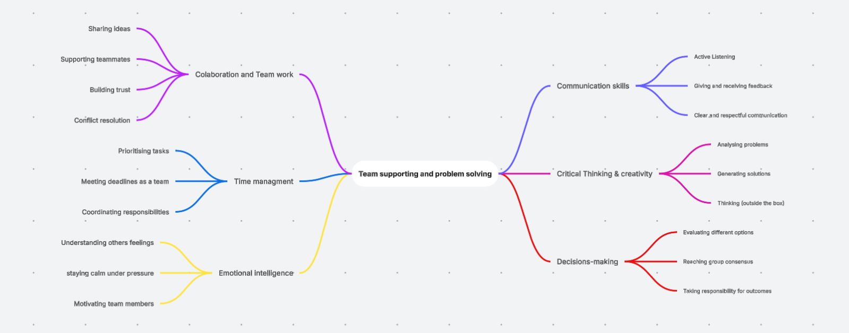

Poster (Individual)
Poster Link:
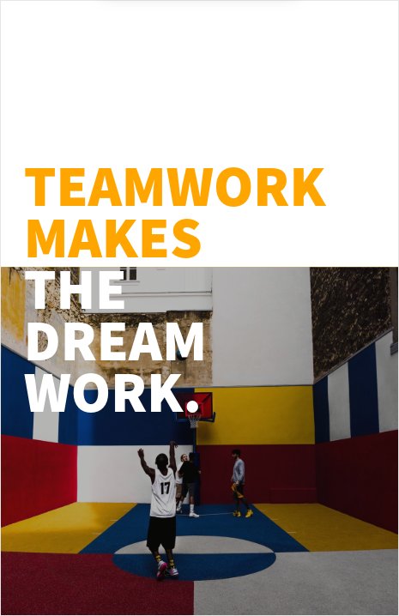

Task 3: Virtual Collaboration and RefWorks

Report on Virtual Collaboration

Step-by-step process of using RefWorks with visuals

Task 4: E-Portfolio Creation and Evaluation

Task 4 (a): E-Portfolio Creation

Task 4 (b): Illustrative Review of E-Portfolio tool Selection

Conclusion

References

Task 1 References:

Task 3 References:

