Op-Amp Build
SamanthaJade Williams
2205436
Workshop Skills - ACDA4022
Electrical and Electronic Engineering

Table of Contents:
- Introduction
- Virtual Circuit Design
- Virtual Circuit Testing
- Breadboard Design
- Breadboard Testing
- PCB Design

Introduction
The overall aim of this task was to first design and then produce an operational amplifier circuit. This type of circuit is more commonly referred to as an op-amp circuit. This op-amp needed to have a gain of three in order for this task to be successful. In order to achieve this, there were several design stages. Each came with their accompanied testing stages. This testing was done at each stage to ensure that the circuit had full functionality at each stage of the task. This was necessary to prevent any mistakes from being missed and to ensure the circuit was correct before moving forward to the next stage. For each stage of the design process, a different format was used. For example, the first design was done digitally through the use of proteus. The second design was done on a breadboard planning sheet before being built on the breadboard. The third and final design for this project was done using Easy-PC before being printed, which provided us with the final PCB to solder the components onto.
Virtual Circuit Design
The first of the design stages was the digital circuit design. This particular design was completed using Proteus. In this stage, the schematic diagram for the circuit was first drawn up on Proteus. This schematic diagram consisted of a 10kΩ resistor, a 20kΩ resistor, two 100kΩ resistors, three 1uF capacitors, an op-amp, a ground, and a 12V voltage source. Once this was built, the signal generator and oscilloscope were both connected to the circuit in order to complete the testing from the first testing stage. This is shown below in table 1.
Figure 1: Schematic of a non-inverting amplifier with a gain of 3.
Virtual Circuit Testing
For the first of the testing stages, the signal generator was set to 2V peak-to-peak. The output voltages at each frequency were then carefully measured and recorded in a table of results as shown in table 1. this was done by measuring the peak-to-peak voltage of the output voltage with some assistance form the cursors available on the oscilloscope on Proteus. Using the formula for gain, shown below as formula 1, the gain was calculated by dividing the input voltages by the output voltages for each set of results. Table 1 also contains a column for all of these calculated results for gain at each frequency. These results for gain were then made into a graph against the frequency. This was done using a logarithmic scale for the horizontal axis showing the frequency. This is the graph which is shown in figure 2. Using both the results table which is shown in table 1 and the graph that is shown in figure 2, it is clear that the schematic diagram is accurately drawn and that the circuit clearly has full functionality as the highest calculated value for gain is found to be 3dB.
$$A=\frac{V_{in}}{V_{out}}$$
Formula 1: Gain.
Frequency (Hz) | $V_{in}$ | $V_{out}$ | Gain (dB)
10 | 2 | 3.46 | 1.73
20 | 2 | 4.8 | 2.4
50 | 2 | 5.76 | 2.88
100 | 2 | 5.92 | 2.96
200 | 2 | 5.98 | 2.99
500 | 2 | 6 | 3
1000 | 2 | 6 | 3
2000 | 2 | 6 | 3
5000 | 2 | 6 | 3
10000 | 2 | 6 | 3
20000 | 2 | 6 | 3
50000 | 2 | 5.76 | 2.88
100000 | 2 | 3.1 | 1.55
200000 | 2 | 1.574 | 0.787
Table 1: Table of results for Proteus testing.
Figure 2: Gain/Frequency graph showing results from Table 1.
Breadboard Design
The second design stage of this task was that of the breadboard prototype. To start this stage, a breadboard planning sheet was used in order to design and plan the layout of the components and wires that would be necessary to build the full circuit beforehand. Breadboard planning sheets are used to save time in the design stage as it is time consuming to assemble and disassemble circuits repeatedly to check if the connections will work. The breadboard planning sheet which was produced for this task is shown below in figure 3. this breadboard planning sheet includes all of the components listed in the components list shown in table 2 as well as any additional wires connecting the components. The resistors and capacitors are each labelled for easier identification ready to build the breadboard circuit.
Figure 3: Breadboard planning sheet.
After the planning sheet for the breadboard was completed, the components and wires were then gathered in order to be ready to build the breadboard. The breadboard was then populated using the components shown in table 2 as well as the additional wires previously mentioned which are also shown in figure 4. Shown in figure 4 is the fully assembled complete breadboard circuit without any testing equipment. Each component shown in figure 4 is labelled with a number directly corresponding with the components listed in table 2. This was done in order to make the components far easier to identify in the image. The breadboard connections labelled in table 2 as 9 and 10 respectively, are used to connect the breadboard itself to the ground or 0V which is the black wire and the 12V voltage source which is the green wire. These wires show where to connect each part of the testing equipment, which consists of the signal generator, the oscilloscope, and lastly the DC power supply to the breadboard circuit.
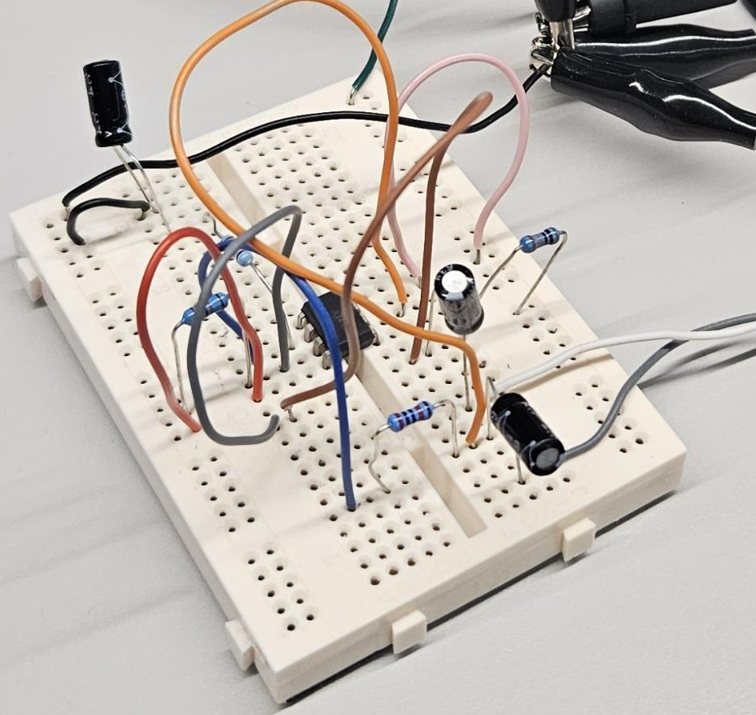
10
9
8
7
6
5
4
3
2
1
Figure 4: Breadboard connections.
 | Component
1 | LM741 Op-Amp
2 | R3 - 20kΩ
3 | R1 - 100kΩ
4 | R4 - 10kΩ
5 | R2 - 100kΩ
6 | C1 - 1uF
7 | C2 - 1uF
8 | C3 - 1uF
9 | 0V (Ground) wire
10 | +12V wire
Table 2: Components for breadboard build.
Breadboard Testing
As is shown in figure 5 it is the testing equipment required for the breadboard circuit. As stated above, this equipment consists of a signal generator, an oscilloscope, and a DC power supply. In order to correctly test the breadboard circuit, the DC power supply is to be set to 12V, and the signal generator is to be set to 2V peak-to-peak. The oscilloscope was then used to accurately measure the output voltage. This was done by measuring the peak-to-peak voltage of the output voltage with the assistance of the cursors available on the oscilloscope. On the oscilloscope itself, channel A is used to represent the input voltage in the circuit, and channel B is used to represent the output voltage in the circuit. The frequency is then adjusted to each value by use of the signal generator and the output voltage is accurately measured and noted at each value. The results from the testing are then all put into a table of results, shown in table 3, which can then be further used to calculate the gain at each frequency. These calculated results are then also put into table 3 with the other measured results obtained. The results for gain are then also made into a graph with frequency as is shown in figure 6, which also uses a logarithmic scale on the horizontal axis.
Figure 5: Oscilloscope, signal generator and DC power supply.
Frequency (Hz) | $$V_{in}$$ | $$V_{out}$$ | Gain (dB)
10 | 2.12 | 6.04 | 2.85
20 | 2.12 | 6.08 | 2.87
50 | 2.12 | 6.12 | 2.89
100 | 2.12 | 6.12 | 2.89
200 | 2.12 | 6.12 | 2.89
500 | 2.12 | 6.12 | 2.89
1000 | 2.12 | 6.12 | 2.89
2000 | 2.12 | 6.12 | 2.89
5000 | 2.12 | 6.12 | 2.89
10000 | 2.12 | 6.12 | 2.89
20000 | 2.12 | 6.12 | 2.89
50000 | 2.12 | 4.72 | 2.23
100000 | 2.12 | 2.4 | 1.13
200000 | 2.12 | 1.2 | 0.57
Table 3: Results table for breadboard testing.
Figure 6: Gain/frequency graph for breadboard tests.
PCB Design
The third and final stage of this task was that of the final PCB design which was drawn on Easy-PC. For this particular stage, a project with two types of files was made. These files were the schematic diagram and the PCB design both drawn on Easy-PC. The schematic diagram for the circuit was drawn before the PCB design. This was to input the correct components into the list referred to as the “components bin” shown in figure 7, which was able to be transferred onto the PCB design file. This schematic diagram is clearly shown in figure 8 and is almost the same as the schematic diagram shown in figure 1. The difference between the schematic diagram in figure 1 and the schematic diagram in figure 8 is that on figure 1 it shows the testing equipment and on figure 8 it shows the connector pins instead. By using the schematic diagram in figure 8 and the components list in table 2, the PCB design can then be drawn with the appropriate connections and component. These components were also found in the components bin, which is shown in figure 7. This is done in order to reduce the overall size of the PCB. The primary aim was to reduce the size of the PCB to below 26 x 26 mm, however, the final size of the PCB design was 26.67 x 29.21 mm which is shown in the final design for the PCB, as shown in figure 9. If the PCB were to be made any smaller than this, the component placement would have unfortunately overlapped. Shown in figure 9 is the completed PCB design, and figure 10 shows a 3D rendition of the PCB design. This was used to ensure the components placement was in fact correct and that the components did not overlap with each other. Once the component placement was at last finalised, the PCB was sent to be printed.
Figure 7: Components bin on Easy-PC.
Figure 8: Schematic diagram for op-amp on EasyPC.
Figure 9: PCB design on EasyPC.
Figure 10: 3D view of PCB on EasyPC.
The physical PCB is shown in figure 11 below, before any of the components had been soldered onto the PCB itself. The components were then taken from the breadboard prototype before being soldered directly onto the PCB in order for the testing to be done to ensure that the PCB is indeed fully functional. The components were soldered onto the PCB in height order starting with the shortest. The resistors were the first to be soldered onto the PCB, followed by the op-amp, then the capacitors, and finally the connector pins. The untested PCB is shown in figure 12. The testing was done to ensure the circuit was fully operational. The testing consisted of connecting the PCB to the oscilloscope, the signal generator, and the DC power supply using the connector pins labelled on the PCB as PL1, PL2, and PL3. The output voltage is then carefully tested to ensure full functionality which is shown on the oscilloscope shown in figure 13. Figure 13 also shows that the input voltage was 2V peak to peak and the output voltage was 6V peak to peak meaning that the gain was in fact 3dB.
Figure 11: Physical PCB.
Figure 12: Populated PCB.
Figure 13: Testing connections for PCB.

