
Adriana Roman (2007914)
lecturer: dr Ping wu
Blog 1
Blog 2
Poster
MSc Public Health and Social Care in Practice LCHS7007
Population Health and Digital Health Promotion
Task 1

Blog 1: Existing Digital Technology


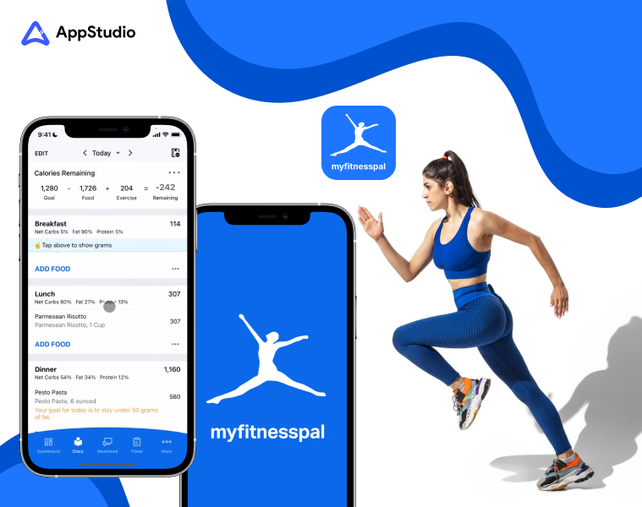
Source: (AppStudio, 2025)
The World Health Organisation (WHO, 2025) reports that global obesity rates have tripled since 1975, with around 650 million adults categorised as obese. Obesity markedly elevates the risk of long-term conditions such as cardiovascular disease, type 2 diabetes, as well as particular cancers.

Obesity is now recognised as a critical global public health issue, presenting significant challenges to health systems across the globe (Kopelman, 2000).

Why OBESITY is a concern?
The concerning obesity rates originate from inactive lifestyles, poor dietary practices, and insufficient knowledge about balanced nutrition. The worldwide financial effects of obesity are projected to exceed $4 trillion per year by 2035 (World Obesity Federation, 2023). Such statistics underscore the imperative for meaningful public health interventions.
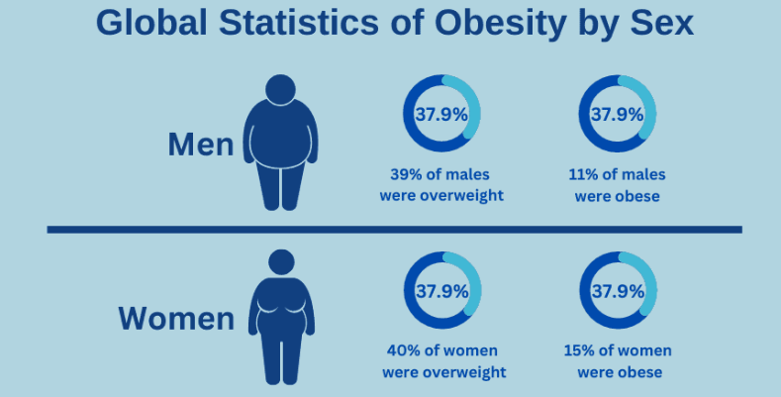
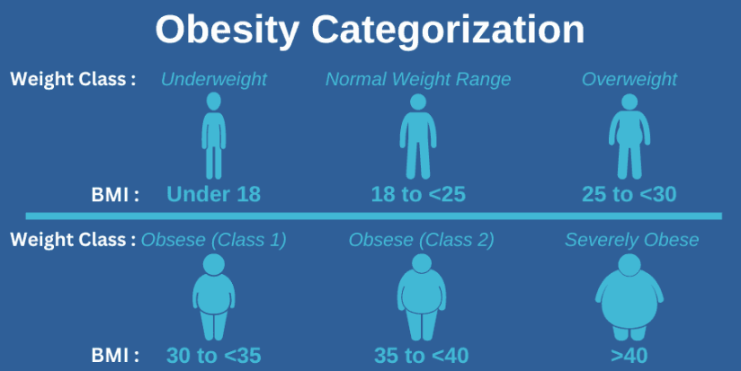
Source: (Renew Bariatrics, 2024)

Current Digital Intervention
A notable digital health technology tackling obesity is MyFitnessPal, a calorie-tracking and dietary management application utilised by millions globally.

MyFitnessPal enables users to record nutritional intake, manage nutritional data, track exercise, and establish individualised weight-loss plans
!!! Explore the App !!!: https://www.myfitnesspal.com/
Effectiveness of the App
Recent studies demonstrate that digital interventions such as MyFitnessPal can markedly improve weight loss results. A randomised controlled trial released by Banal et al., (2024) indicated that participants experienced nearly double the weight loss relative to conventional diet tracking methods.

The Impact of MyFitnessPal in Health Promotion

Advantages | Disadvantages
Easy to use interface and accessibility  The simple design of MyFitnessPal makes it highly accessible, even for those with minimal technological proficiency. The simple process of recording foods, activities, and monitoring progress guarantees substantial user compliance The availability of mobile support enables users to obtain assistance at any time, integrating easily into their daily routines, thereby improving the likelihood of continued engagement.  Efficient self-regulation and increased responsibility  Consistent monitoring via MyFitnessPal improves personal accountability, allowing users to understand dietary patterns, identify negative eating behaviours, and deliberately modify their habits.  Extensive database enabling informed dietary decisions  The extensive nutritional database, including millions of foods, especially restaurant dishes and barcode scanning capabilities, enables users to make informed dietary choices. It improves nutritional awareness by offering prompt feedback on caloric intake and macronutrient composition, thereby significantly impacting healthier dietary practices. | Excessive dependence on self-reporting, resulting in inaccuracies  The precision of MyFitnessPal is heavily reliant upon users' honesty and accuracy in recording their food intake. Portion sizes may be underestimated or overlooked, resulting in discrepancies between actual and reported caloric consumption. This misreporting may obstruct progress assessment, encourage undue confidence, or cause frustration if anticipated outcomes fail to manifest.  Reduced effectiveness in the absence of extra behavioural change methods  MyFitnessPal primarily emphasises calorie counting and nutritional tracking; however, sustainable weight management frequently necessitates more profound behavioural modifications, emotional support, and motivation that extend beyond simple numerical feedback. In the absence of integrated psychological and motivational support, the application alone may insufficiently resolve fundamental issues such as emotional eating, loss of motivation, or stress-induced dietary behaviours.
References:
AppStudio, 2025. App Development. [Online] Available at: https://www.dev-new.appstudio.ca/blog/how-does-myfitnesspal-work-as-canadas-most-popular-fitness-app/ [Accessed 20 March 2025].
Banal, M. G. et al., 2024. MyFitnessPal smartphone application: relative validity and intercoder reliability among dietitians in assessing energy and macronutrient intakes of selected Filipino adults with obesity. BMJ Nutrition, Prevention & Health, 7(1), pp. 54-60.
Bariatrics, R., 2024. Obesity Statistics & Facts: Causes, Complications & Treatments. [Online] Available at: https://renewbariatrics.com/obesity-statistics/ [Accessed 20 March 2025].
Federation, W. O., 2023. World Obesity Atlas 2023. [Online] Available at: chrome-extension://efaidnbmnnnibpcajpcglclefindmkaj/https://data.worldobesity.org/publications/WOF-Obesity-Atlas-V5.pdf [Accessed 20 March 2025].
Kopelman, P. G., 2000. Obesity as a medical problem. Nature briefing, pp. 635-643.
WHO, 2025. World Health Organization, Obesity and overweight. [Online] Available at: https://www.who.int/news-room/fact-sheets/detail/obesity-and-overweight
[Accessed 20 March 2025].

Addressing Shortfalls: To alleviate these issues, the incorporation of automated tracking via wearable devices may reduce inaccuracies in self-reporting.
Integrating MyFitnessPal with behaviour modification programs, sessions with coaches, or online psychological assistance platforms may substantially improve long-term results

Task 1

Blog 2: My Designed Digital Technology


NutriFit App

Source: (Medicine, 2025)

Revolutionizing Obesity Management through AI and Gamification
Obesity is a significant global health issue, substantially contributing to chronic diseases like diabetes, cardiovascular conditions, and several cancers.
The World Health Organisation (WHO, 2025) reports that obesity results in more than 4 million fatalities worldwide annually. The escalating prevalence, combined with growing healthcare demands, requires innovative and sustainable solutions.

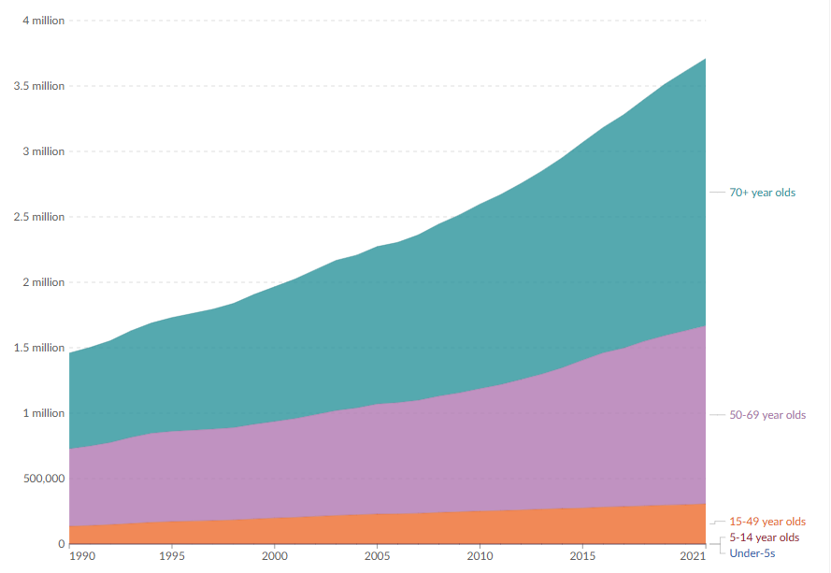

Figure: Deaths from obesity, by age, worldwide, between 1990 to 2021. Source: (Data, 2025)
The NutriFit App is a complex digital health application designed to combat obesity through an original integration of artificial intelligence (AI), gamification, and customised behaviour modification strategies.
In contrast to conventional fitness applications, the NutriFit App incorporates advanced technology, including customised meal-planning algorithms, virtual reality (VR) exercise sessions, real-time biometric surveillance, and interactive gamified physical activities to improve user motivation and engagement.

How NutriFit App Addresses Obesity?
The NutriFit App utilises AI algorithms to assess user dietary habits, nutritional preferences, metabolic rates, and fitness levels to provide tailored dietary recommendations. Users obtain customised daily meal suggestions optimised for nutritional equilibrium, caloric regulation, and dietary variety. Gamified elements, including challenges, achievement badges, social leaderboards, and reward systems, promote continuous user engagement and commitment to physical activity.
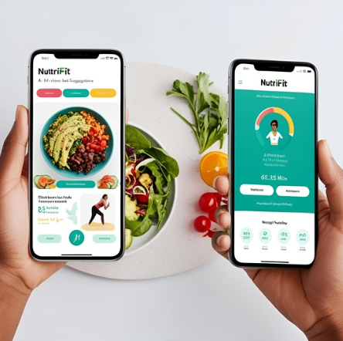
The application integrates VR fitness modules, facilitating realistic workout experiences at home and addressing obstacles such as gym intimidation and a lack of enjoyment in exercise. Real-time health monitoring through wearable integration enhances user support by delivering immediate feedback, fostering accountability, and reinforcing beneficial lifestyle decisions.

More information about Obesity can be found by accessing the link below

https://www.nhs.uk/conditions/obesity/
Source: (NHS, 2025)

Figure: AI generate image of NutriFit App using Canva
Advantages | Disadvantages
- Improved Engagement through Gamification  NutriFit’s gamified framework encourages sustained utilisation through rewards, competition, and acknowledgement, markedly improving compliance with healthier practices.  - Customised Interventions for Durable Change  The application offers tailored dietary and exercise regimens modified in real-time, promoting lasting behavioural modifications and long-term health enhancements, as opposed to transient dietary trends.  - Real-Time Monitoring for Better Accountability  Instant feedback from integrated wearable devices allows users to monitor progress and maintain motivation, thereby promoting increased self-awareness and responsibility in health management. | - Technology Dependence and Accessibility  NutriFit's dependence on smartphones and advanced technology may accidentally marginalise elderly individuals or those with limited digital literacy, thereby reinforcing digital inequalities.  - The pervasive implementation of gamification poses a risk of fostering user dependency on external rewards, which may diminish the internal drive essential for permanent lifestyle modifications in the absence of ongoing digital stimuli.  - Substantial Development and Maintenance Expenses  Advanced functions, including AI-driven personalisation and virtual reality technology, incur considerable initial development costs and continuous operational expenditures, which may restrict broad affordability and accessibility.
Addressing Shortfalls
To improve inclusivity, NutriFit App could implement simplified, intuitive user interfaces tailored for elderly and technologically challenged users. Extensive tutorial videos, user manuals, and offline support resources could further reduce accessibility obstacles. Moreover, incorporating community-oriented offline group activities can enhance internal drive and diminish reliance on digital interactions, thereby cultivating greater personal commitment and social support. Ultimately, forming strategic alliances with healthcare providers or public health organisations could reduce financial burdens, improving affordability and increasing accessibility.

References:
Canva, 2025. Magic Media. [Online] Available at: eyJFIjp7IkE_IjoiViIsIkEiOiJ1cGxvYWRfZDY4Yzk3NDAtYmVlMC00YzQwLTgxMjUtNWMzMDlhMTNkMjM5IiwiQiI6IkIifSwiRyI6eyJCIjp0cnVlLCJWIjp0cnVlfX0 [Accessed 21 March 2025].
Data, O. W. i., 2025. Deaths from obesity, by age, World, 1990 to 2021. [Online]
Available at: https://ourworldindata.org/grapher/deaths-from-obesity-by-age?time=earliest..2021 [Accessed 21 March 2025].
Medicine, J. H., 2025. Obesity Prevention. [Online]
Available at: https://www.hopkinsmedicine.org/health/conditions-and-diseases/obesity/preventing-obesity [Accessed 21 March 2025].
NHS, 2025. Obesity Overview. [Online] Available at: https://www.nhs.uk/conditions/obesity/ [Accessed 21 March 2025].
WHO, 2025. World Health Organization, Obesity and overweight. [Online]
Available at: https://www.who.int/news-room/fact-sheets/detail/obesity-and-overweight [Accessed 20 March 2025].

TASK 2 - POSTER

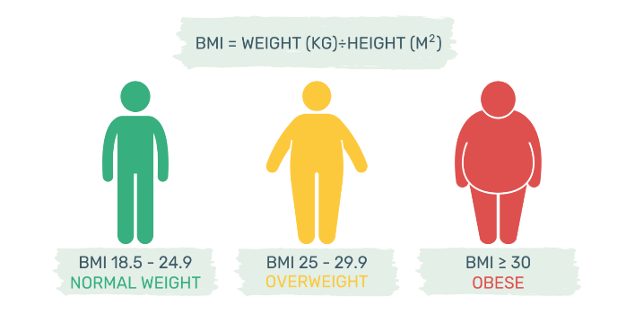
2. Health Promotion values and principles
Health promotion underscores empowerment, equity, inclusivity, participation, and evidence-based methodologies (Rootman, 2001). NutriFit embodies these principles by enabling individuals to make informed dietary decisions through tailored nutritional information, thereby augmenting self-efficacy. Accessibility promotes equity by providing the app at no cost or at a low price, thereby reaching various socioeconomic groups. The user-friendly design guarantees inclusivity, catering to individuals with diverse levels of technological proficiency. NutriFit encourages active involvement by utilising feedback systems and community engagement, incorporating evidence-based dietary guidelines to guarantee scientifically validated interventions.

NutriFit App Promoting Healthy Weight through Digital Innovation
- Background
Obesity represents a major global health issue, impacting more than 650 million adults globally (WHO, 2025). It elevates the risk of chronic conditions including diabetes, cardiovascular diseases, and specific cancers. Effective public health interventions are essential. Conventional interventions encompass nutritional guidance, encouragement of physical activity, and educational initiatives (Schmitz & Jeffrey, 2000). Recent digital interventions have arisen, encompassing smartphone applications dedicated to calorie monitoring and nutritional management. The NutriFit App is a mobile nutritional tracking platform that assists users in weight management through AI-generated meal recommendations, exercise monitoring, and immediate feedback to promote healthier lifestyle decisions.

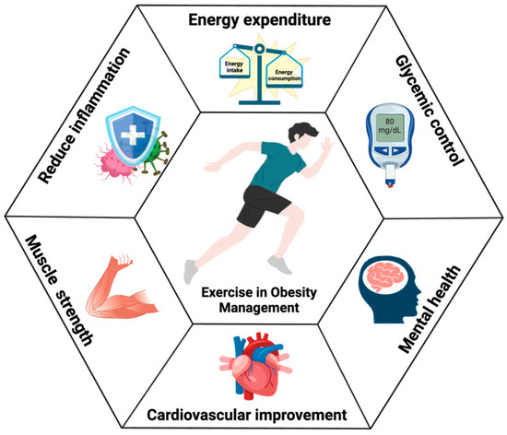
References
Canva, 2025. Magic Media. [Online] Available at: eyJFIjp7IkE_IjoiViIsIkEiOiJ1cGxvYWRfZDY4Yzk3NDAtYmVlMC00YzQwLTgxMjUtNWMzMDlhMTNkMjM5IiwiQiI6IkIifSwiRyI6eyJCIjp0cnVlL CJWIjp0cnVlfX0 [Accessed 21 March 2025].
Mastellos, N. et al., 2014. Transtheoretical model stages of change for dietary and physical exercise modification in weight loss management for overweight and obese adults. Cochrane Database of Systematic reviews, Issue 2.
Rootman, I., 2001. Evaluation in Health Promotion: Principles and Perspectives. 92 ed. Denmark: World Health Organisation.
Schmitz, M. K. H. & Jeffery, R. W., 2000. PUBLIC HEALTH INTERVENTIONS FOR THE PREVENTION AND TREATMENT OF OBESITY. Medical Clinics of North America, 84(2), pp. 491-512.
Sonntag, M., 2024. Beyond the Scale: Understanding Obesity for Medical Students. [Online] Available at: https://pan-int.org/nutrition-insights/beyond-the-scale-understanding-obesity-for-medical-students [Accessed 22 March 2025].
WHO, 2025. Obesity and overweight. [Online] Available at: https://www.who.int/en/news-room/fact-sheets/detail/obesity-and-overweight [Accessed 22 March 2025].
Zhang, Y., Wang, R., Liu, T. & Wang, R., 2024. Exercise as a Therapeutic Strategy for Obesity: Central and Peripheral Mechanisms. Metabolites, 14(11), p. 589.

Figure: AI generate image of NutriFit App using Canva
5. Conclusion
The integration of the NutriFit App into public health strategies could significantly impact policies that promote digital health solutions, encouraging wider adoption within healthcare systems. NutriFit can be incorporated into public health programs and initiatives, enhancing nutritional literacy and promoting awareness of healthy behaviours. The application offers research opportunities to assess the efficacy of digital interventions, user engagement strategies, and digital disparities. Identifying factors influencing compliance and long-term effects could guide future interventions, improving the overall effectiveness.

Source: (Zhang, et al., 2024)
3. Behavioral change theory
The Transtheoretical Model (Stages of Change) serves as the foundation for NutriFit's digital intervention. This theory suggests that individuals advance through five stages: pre-contemplation, contemplation, preparation, action, and maintenance (Mastellos, et al., 2014). NutriFit customises its features to assist users throughout these phases. During the pre-contemplation and contemplation stages, NutriFit offers educational materials to enhance awareness regarding the risks of obesity and the advantages of weight management. NutriFit integrates realistic dietary objectives and daily meal monitoring during the preparation and action phases, enhancing user confidence. By aligning these application features with the Transtheoretical Model, NutriFit effectively promotes durable behavioural transformation towards healthier lifestyles.

Source: (Sonntag, 2024)
4. Expected Outcome
The utilisation of the Transtheoretical Model via the NutriFit App is anticipated to markedly improve user motivation and compliance with healthy eating practices, leading to effective weight management and diminished obesity prevalence. Users are expected to acquire greater nutritional knowledge, heightened self-efficacy, and increased awareness of their health behaviours. Long-term outcomes include a lower prevalence of obesity-related health conditions and a reduction in healthcare expenses.

