

Student name: Alexandra Lidia Chilianu
Student ID: 2118366
Module Code: BMSW401
Programme: Academic and Employability skills
Assignment Title: Academic Report task 1
What are the most effective ways to motivate staff?
Task- Reflection report
Lectures name: Md Nazmul Hasan

introduction 2
The concept of motivation 3
Herzberg Theory 3
Ways of Motivating employees 5
Conclusion 6
References 6

introduction
Motivation can be a tricky business and often the best ways to motivate an employee is one they are not expecting. Did you know the best time to give employee a performance review is when they have just been hired. Statistically more effective than any time of the year.so if you're considering a review, it makes sense to take advantage of this opportunity and make a high point of employee first month. One thing that got you into this job?’ pay attention. The survey organisation ‘. The centre for creative leadership conducted a study which showed that staff feel more motivated by rewards and recognition than threats like firing employees. We can see that the easiest way to motivate staff can be as simple as a quarterly bonus or a private health care or something even bigger that will keep them in the business.
Herzberg (1959) defined employee motivation as performing work related action because they like to work itself and therefore being intrinsically motivated. In today's workplaces there are several job level satisfactions some of these include:
Workplace culture: it is very important than an organisation has a positive culture where employee remain the same motivated to produce high quality outputs to stay competitive in their industry. An organisation where employees are allowed to contribute their own ideas and feel as though they heard will follow for higher level of employee satisfaction.

The concept of motivation
The concept of employee motivation is relatively new in management and organisational psychology field. The concept of employee motivation gained attention during 1960s when researchers and academics started to study why employees behave as they do in organisations. The emergence of the concept of employee motivation also coincided with the emergence of Human Resource Management as a distinct unit within organisation (Jonhson & scholes,2009.) motivation is believed to be associated with the phenomenon of this phenomena is observed in human, non-human and artificial intelligence systems. With over time, this emotional state can evolve into (MIT). There are several factors that motivate individuals to pursue certain goals. Such as necessity and opportunity, task (prestige), fear, desire, etc.
Motivation can take place at the level of both the individual level and the organisational level. Individual motivation is defined as an urge to pursue certain goals or pursue certain choices. The individual meets a need to change or improve oneself and how it is defined by other individuals. Theoretical models are also useful in explaining why people decide to stop working on a particular job (or why they leave their job)
why managers need to motivate employees?” (Herzberg, 1959) This theory is based on Frederick Herzberg's two-factor theory of motivation. This theory states that there are two factors that an analyst can use to motivate employers or employees at work. First, the task factor refers to the employee's need for and interest in his/her job and he feels a sense of achievement when he/she performs well. Second, the individual factor refers to other aspects of a person's life out of work that impact his/her productivity at work. For example, if the employee does not feel valued or respected in his/her job, then he/she will have low morale and less motivation at work. It is important for managers to create an environment where employees can make a difference. The job design theory says that the way employees' jobs are designed can have a significant impact on their motivation. The task attractiveness and job design are very closely related to each other. In fact, task attractiveness is more of a subset of job design.

Herzberg Theory
Herberg (1959) introduced a well-known motivation theory, which is the two-factor Theory, that identified factors that are related to job satisfaction. Firstly, the theory shows what motivates us at work. Secondly, it shows the relationship between these factors and our job satisfaction. Thirdly it helps companies understand and provide them with a better environment for them to be happy.it is an interesting theory and effective in motivating employees. However, it has several limitations such as the difficult measurement of job satisfaction, non-existence of a sensitive instrument to be able to measure the factors under this theory.
Table 1 Herzberg factors (2016)

Motivators | Hygiene
- Achievement  - Recognition  - Work itself  - Responsibility  - Advancement  - Growth | - Company policy  - Supervision  - Relationship with the boss  - Work condition  - Relationship with the peers  - Security
Most of us accept a simple fact that if your workplace is working well then you feel happy and well paid. However, explanation of this relationship between well-being and work performance have remained somewhat elusive despite decades of discussion and study

Intrint & Extrinsic Motivation
Intrinct motivation is based on external motivator relates to the consequences of action (Staw & Ross,2006). According to Staw and Ross (2006) intrinsic motivation creates a good job fit. whereas extrinsic motivation consisting of external factors of reward and punishment rather than intrinsic factors such as achievements and curiosity and exploration
Motivated individuals are such as their expectations and goals. Some of these factors are to maintain the level of motivation and are committed towards a goal. Employee motivation is the key element to help a business grow as an organisation grows it needs to demonstrate its goals in the real world.
Studies have shown that employees who are treated valued individuals perform better at their jobs and are more loyal to the company.

Firstly, employees are motivated by psychological needs such as food,air,water and shelter. The more the employee's hierarchy Maslow states that once an individual has met their physiological needs, they will then be motivated by social needs. The hierarchy states that if these social needs are not met, there will be frustration and dissatisfaction.
The following is an excerpt from the article "Maslow's Hierarchy of Needs": Cognitive theory: Maslow's Need Hierarchy Theory suggests that when one is engaged in a task that is self-rewarding or fulfilling, one might think of new or innovative ways to solve a problem. This theory states that once an individual has met their physiological needs, they will then be motivated by social needs. The hierarchy states that if these social needs are not met, there will be frustration and dissatisfaction.
Aims to develop higher order values or qualities in an individual because safety, love, respect and trust is needed before any developmental or creative stage can take place. Successful development requires the ability to have high order thinking skills.
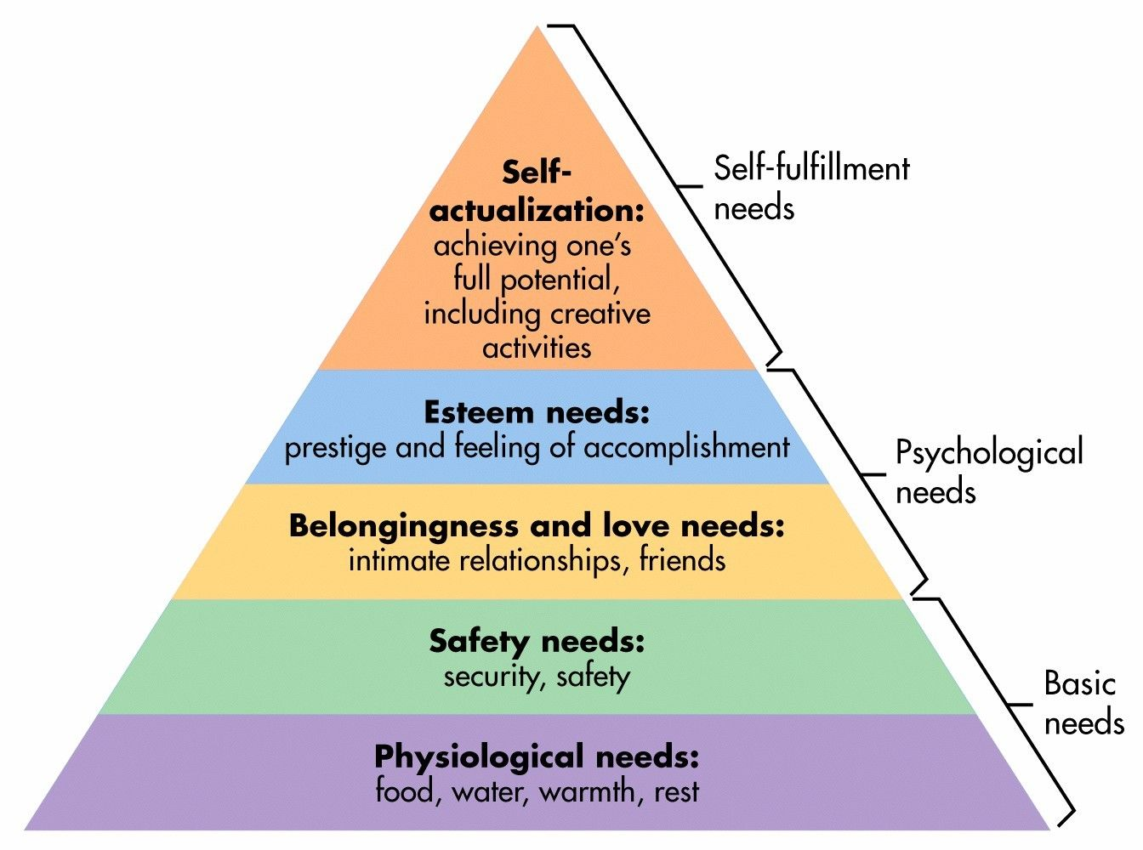

Ways of Motivating employees
Here is a list of top ways of motivating employees:
- Offer meaningful pay rises or a bonus employees know when you appreciate their good work by rewarding financially for it.
Employees know when you are appreciating good work when you want to encourage them. they will know your saying thank you and they will appreciate good work and make them want to do more. Encourage employees to express themselves to create freedom. Nothing is more motivating than making a difference in an organisation

- Offer flexible work schedules. Who wants to feel like that their job robs their personal time? fitting work into a busy schedule can help employee get more done and make them feel motivated by it.
- Encourage employee expression through company events. Let employees get to know co-workers, fellow managers, and senior staff as well let them share similar interest and hobbies.
- Offer rewards for good performance for example employee who are effective as their job but not recognised for that employee will feel unappreciated.
- Encourage employee feedback So many business owners dislike the idea of employee feedback but it’s so important, but they think it’s a waste of time as they simply don’t have the time to read them all

Conclusion
It can be concluded that motivation is crucial to the performance and productivity of employees in an organisation. Without motivation, companies will never succeed. Motivation also helps organisations achieve their success. The last paragraph should summarise the rest of the article, bringing it all together. In this case, you should state that motivation is vital to an organisation's performance and productivity, as well as its overall success.

References
https://www.zimbio.com/Paul+Scholes/pictures/pro/2009?Page=2

https://www.coursehero.com/file/p518cjg/Herzbergs-model-or-the-two-factor-theory-states-that-there-are-certain-factors/

https://www.vocabulary.com/dictionary/theory

https://www.merriam-webster.com/dictionary/place

https://www.indeed.com/career-advice/career-development/benefits-of-flexible-work-schedules

https://www.coursehero.com/file/p518cjg/Herzbergs-model-or-the-two-factor-theory-states-that-there-are-certain-factors/

https://www.gmc-uk.org/-/media/documents/guidance-for-appraisers---pms-45189197.pdf

https://www.merriam-webster.com/dictionary/business

