Research Project Proposal

Topic- What are the current challenges that the hospitality industry is facing that are affecting business performance:
A case study of Hotel Hilton

Student name: Marius Hurmuzache
Student number: 2125248
Module title: Personnel resourcing and Development
Module code: BMIH5005
Lecturer’s Names: Emma Roberts
Executive Summary

The current challenges of the hospital industry emerged and developed through the recent factors of Brexit and Covid 19. Most of hospital business faces certain losses and difficulties to perform. Certain challenges harm the effective business process of the hospital industry. From the perspective of the challenging factors, there is a shortage of employees and management issues. The further case study of Hotel Hilton gives fine examples related to those issues and provides recommendations to mitigate them.

Table of Contents
1. Introduction 4
1.1 Topic Background 4
1.2 Hotel Overview 4
1.3 Aims 5
1.4 Objectives 5
1.5 Rationale 5
1.6 Research questions 5
2. Literature Review 6
2.1 Introduction 6
2.2 Theoretical Overview of business management 6
2.3 Issues being faced by the hospitality industry 7
2.4 Significance of risk management in the hospitality sector 8
2.5 Current affairs affecting recruitment and Retention in the Industry 8
2.6 Factors that would enable retention in the Industry 9
2.7 Potential Solutions for the identified issues 9
2.8 Literature Summary 10
2.9 Literature Gap 10
2.10 Conceptual Framework 10
3. Research Methodology 11
3.1 Research Philosophy 11
3.2 Research Approach 11
3.3 Research Strategy 11
3.4 Research design 11
3.5 Data collection method 11
3.6 Data Analysis Method 12
3.7 Ethical Consideration 12
3.8 Research Schedule 12
4. Conclusion 13
5. References 14

1. Introduction

1.1 Topic Background
The main challenges in the hospitality industry are emerging as the negative impact of Covid 19 and the Brexit effect. Most of the company in this sector faces the same kind of challenges in providing the services. The main challenges regarding staff shortage, poor management system and lack of employee training. Hotel Hilton faces the same kind of difficulties which reduce the effectiveness of their services. After certain emerging problems regarding political and environmental issues, most of the hotel industries lost their customer retention and issues related to employee recruitment. In this research, the main objective is to identify the current challenges and the way for mitigating them (Instituteofcustomerservice.com, 2023).

1.2 Hotel Overview
Hotel Hilton is emerging and developing as a big hospitality chain across the UK and expanding worldwide. In the UK, Hilton Hotel was established in 1963. The Hilton Group plc. Emerged and developed its hospitality chain across the globe (Hilton.com, 2023). There are more than 7,646 active employees and promotes 18 brands. Hotel Hilton developed their hospitality industry and provided their services for business travellers mainly across the UK. As a leading hospitality company, Hilton promotes their brands and maintains their reputation through their services.

Figure 1: Official Logo of Hotel Hilton
(Source: Hilton.com, 2023)

1.3 Aims
This research aims to identify the challenges regarding the hospitality business which affect business performance. For example, Hotel Hilton is a fine example which defines current challenging factors.

1.4 Objectives
- To identify the affecting challenges that occurred in the current situation of the hospitality business.
- To evaluate the issues faced by the hospital industry.
- To analyse the significance of risk management in the hospitality sector
- To recommend the measures of the factors that would enable retention in the hospital Industry.

1.5 Rationale
The current issues in the hospitality industry developing and growing specifically after the pandemic and Brexit incident. There are relevant factors and theories based on the management of the hospitality industry. From the current day perspective, it is important to gain a clear concept of the affecting factors of the hospitality business. Hotel Hilton gives fine examples related to the issues and challenges.

1.6 Research questions
RQ1. How to identify the affecting challenges that occurred in the current situation of the hospital business?
RQ2. How to evaluate the issues faced by the hospital industry?
RQ3. How to analyse the significance of risk management in the hospitality sector?
RQ4. What are the recommended measures of the factors that would enable retention in the hospital Industry?

2. Literature Review

2.1 Introduction
The present era has been marked by various challenges approaching several sectors and the hospitality industry has been suffering through the same. There are other factors as well which has greatly impacted the industry on an aggregate basis among which COVID-19 and Brexit are prominent. Moreover, the main areas of the industry such as accommodations and food and beverage have lasted with the impact and are struggling to sustain their business. For instance, the hotel Hilton is going through a similar condition and the management is trying to cope with the uncertainties coming towards the business.

2.2 Theoretical Overview of business management
The theories that have helped the business in bringing change and facing the current challenges are contingency management and human relations theory.

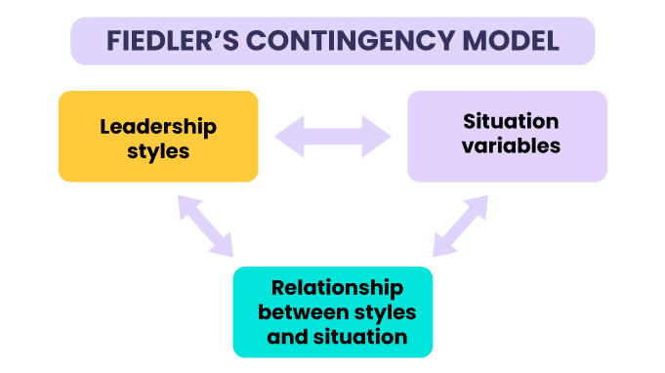
Figure 2: Contingency theory
(Source: vantagecircle.com, 2023)
As stated by McAdam et al., (2019, p.195) the contingency theory focuses on the application of the right leadership style in the right situation. This relates to the efficiency of a leader who needs to act as per the situation. In the present scenario, the hotels need to idealise according to the prevailing condition in the environment so that they could deal with the issues effectively. Among all the four types, the path-goal theory of contingency would be fruitful in approach.

Figure 3: Human relations theory
(Source: nanoglobals.com, 2023)
Human relations theory is said to be the most important one as it strives for worker satisfaction aspect, both formally and informally leading to the enhancement of morale and motivation. The prominent issue being dealt with inside the organisation could have a positive effect on the application of such a theory. Hence, the industry is emphasising applying these theoretical procedures in the industry to curb the effects.

2.3 Issues being faced by the hospitality industry.
There are numerous issues which could be presented at a time, but the most crucial ones are described as follows.
Staff shortage: As opined by Gandini, (2019, p.1039) the hospitality industry is suffering a major shortage in the number of staff and workers. There are increased redundancies and high stress levels in work which has led to this situation. The issue has created problems in the working culture as well.
Lack of training: The employees need to be trained while conducting operations. The training polishes skills and knowledge and increases work efficiency. The hospitality industry has set aback in this aspect and thus the productivity got declined.
Poor Management: Management includes other functions like planning organising, staffing and controlling. However, these shall work in coordination with each other. The management techniques are poor in some of the sectors, and it has generated hurdles for several organisations operating in the industry.
Operational nuances: The operational areas such as the food and beverage department, reservations and marketing, housekeeping, maintenance and front office shall be managed in operations. There exist some nuances in operations which has been the generation of issues.

2.4 Significance of risk management in the hospitality sector
As depicted by Hole, (2019, p.10) risk management is the process of identifying, assessing and controlling risks. However, these risks could be of several types like financial, technological and operational. The importance of risk management is described below.
Calculating the impact of natural disasters: Industries are largely impacted by natural disasters. The process of risk management helps organisations to estimate the impact of coming natural disasters on business functions.
Informed decision-making: Since the potential threats and risks are identified priorly, there is informed decision-making. Also, there is an anticipation of accidents and breaches. So, the decisions are taken based on the study.
Proactive and reactive approaches: There are proactive and reactive assumptions and functions in organisations. These are a product of risk management as the company may decide on how to react to a particular situation.
A risk assessment by employees: Risk management enables the employees to identify, analyse and measure the risks that may affect the company in future. The hospitality industry has benefitted along with it.

2.5 Current affairs affecting recruitment and Retention in the Industry
Current affairs like Brexit and COVID-19 are the sources which have affected the working of the hospitality industry specifically hotels. The suffering has been related to a lack of workforce. Their underlying impact on recruitment and retention is stated below.
Loss in number of workers: As described by Li and Singal, (2019, p.124) the workers are leaving their jobs and are finding other sources of income. COVID-19 led to lower salaries and no pay to the workers and for this reason, they have been leaving the organisation. The data shows that the percentage of employment in the workforce has gone significantly down.
Increase in vacancies: As workers and employees are leaving their jobs, the vacancies in various job positions have increased. The organisations are keeping their salary structure high to attract workers so that they could fill the vacant positions.
Increased turnover of employees: Turnover in employees means the person wanting to change their workplace or go for a different job opportunity. This has also been an impact of Brexit since the UK approved its dismissal from the EU and hence the policies changed.
Production Shortage: As there are many vacant positions and increased employee turnarounds, the productivity of the industry has been lowered. This has been recorded as the most drastic effect of these current affairs on the industry in totality.

2.6 Factors that would enable retention in the industry.
Acknowledgement at work: The hospitality industry shall practice providing acknowledgement to the workers, staff and employees. This would make the employees more informed on what they must perform and when. Also, it would generate confidence in known facts.
Providing meaningful benefits: As coined by Kansakar et al., (2019, p.60) meaningful benefits mean important recognition to those working tirelessly and honestly. The industry shall practice giving the workers a sense of value in their performance. This shall prevail in retention in the working environment so that the number of turnarounds decreases.
Mission and values alignment: As opined by Osei et al., (2020, p.479) retention shall improve with proper alignment of mission and values in the organisation. The industry must focus on establishing a great connection between the mission and value statement of work culture.

2.7 Potential Solutions for the identified issues
Developing the employee recruitment process: Developing the recruitment process helps to gain fluency and transparency. Maintaining a clear inspection of the recruitment process helps to emerge the factors related to the management in the hospitality industry.
Enhance the skills of employees: Developing skill enhancement helps to reduce the Staff shortage problem. Enhancing the skills of the employees to mitigate the problems related to recruitment.

2.8 Literature Summary
The literature review contains a piece of detailed information on the hospitality industry and the underlying challenges faced by them. The regarded issues and their impacts are discussed further. Measures to control such impacts and resolve issues are stated descriptively. The overall view concludes with a desirable approach to studying the issues identified.

2.9 Literature Gap
In this chapter, the main discussion is about the factors, issues and significance of management problems in the hotel industry. There are also some scopes which can define further research on practical examples of management problems in the hospitality industry.

2.10 Conceptual Framework
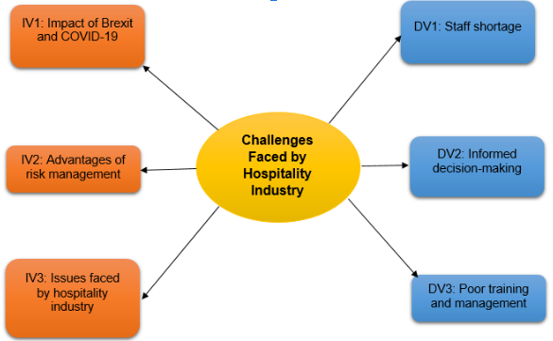
Figure 4: Conceptual Framework
(Source: Developed by the learner)

3. Research Methodology

3.1 Research Philosophy
The research philosophy developed a clear concept for the formulation of further research. There are four types of research philosophies including, interpretivism, positivism, pragmatism and realism. In this research, the interpretivism philosophy would be applicable which defines the current challenges in the hospital industry (Mahuika and Mahuika 2020, p.370).

3.2 Research Approach
The main motive of the research approach is developing the whole structure of the research process. There are three types of approaches including deductive and inductive. In this research, an inductive approach would be applicable. The inductive approach helps to navigate to collect the required data related to the issues of the hospitality business (Hoque et al., 2020, p.54).

3.3 Research Strategy
The research strategy developed the blueprint for the research progress. There are two types of research strategies presented including qualitative and quantitative. In this research, the qualitative strategy helps to analyse the collected data related to the issues of the hospitality business (Aldiabat and Navenec, 2018, p.250).

3.4 Research design
The research design navigates the whole research process in a formative way. There are two types of research designs including exploratory and explanatory. While in this research process, an explanatory design would be applicable. The explanatory design helps to explain data collected from secondary sources (Gruber 2019, p.720).

3.5 Data collection method
The method of data collection helps to develop the research progress. While there are two types of data collection methods including primary and secondary methods, in this research secondary data collection method would be applicable. The secondary data are based on the articles, journals and case studies of Hotel Hilton facing challenges which affected the business performance.

3.6 Data Analysis Method
The method of data analysis helps to process the research work. There are two types of data analysis methods existed, thematic and descriptive. In this research, thematic analysis helps to narrate the factors collected from secondary sources. The analysation of the challenges regarding the hospital industry developed further research.

3.7 Ethical Consideration
The research is developed on secondary data. All the data was collected from authentic sources of journals, articles, books and case studies. The data collection process maintains the Data Protection Act 2018 (Legislation.gov.uk, 2023). All the collected data was ethical and valid from reliable secondary sources.

3.8 Research Schedule

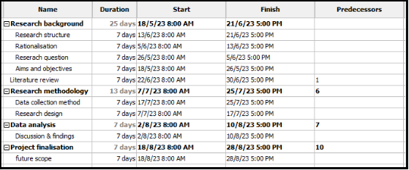
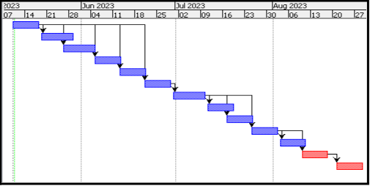
Figure 4: Gantt chart
(Source: Developed by the learner)

4. Conclusion
The research is developing the factors related to the challenges of the hospital industry. With the negative impact of the Covid-19 and Brexit, most of the hospitality industry faces issues related to management problems and staff retention issues. In this research process, the overall discussion is all about the factors affecting the hospitality business. The case study of Hilton would be helpful to analyse the significant factors of current challenges in the hospitality business.

5. References
Websites
Hilton.com, 2023 Available at: https://www.hilton.com/en/locations/united-kingdom (Accessed on 10th May 2023)
Instituteofcustomerservice.com, 2023 Available at: www.instituteofcustomerservice.com ((Accessed on 10th May 2023)
Legislation.gov.uk, 2023 Available at: https://www.legislation.gov.uk/ukpga/2018/12/contents/enacted (Accessed on 9th May 2023)
nanoglobals.com, 2023 Available at: https://nanoglobals.com/assets/images/header-human-relations-theory.jpg (Accessed on May 10th 2023)
vantagecircle.com, 2023 Available at: https://blog.vantagecircle.com/content/images/2021/07/FIEDLER-S-CONTINGENCY-MODEL.png (Accessed on May 10th 2023)

Journals
Aldiabat, K.M. and Le Navenec, C.L., 2018. Data saturation: The mysterious step in grounded theory methodology. The qualitative report, 23(1), pp.245-261. https://search.proquest.com/openview/48f13c7ceef16d6e82e54ca0917c13ec/1?pq-origsite=gscholar&cbl=55152
Gandini, A., 2019. Labour process theory and the gig economy. Human relations, 72(6), pp.1039-1056. https://doi.org/10.1177/0018726718790002
Gruber, A., Scanlon, T., van der Schalie, R., Wagner, W. and Dorigo, W., 2019. Evolution of the ESA CCI Soil Moisture climate data records and their underlying merging methodology. Earth System Science Data, 11(2), pp.717-739. https://essd.copernicus.org/articles/11/717/2019/
Hole, Y., 2019. Challenges and solutions to the development of the tourism and hospitality industry in India. African Journal of Hospitality, Tourism and Leisure, 8(3), pp.1-11. https://www.ajhtl.com/uploads/7/1/6/3/7163688/article_67_vol_8_3__2019.pdf
Hoque, A., Shikha, F.A., Hasanat, M.W., Arif, I. and Hamid, A.B.A., 2020. The effect of Coronavirus (COVID-19) on the tourism industry in China. Asian Journal of Multidisciplinary Studies, 3(1), pp.52-58. https://www.asianjournal.org/online/index.php/ajms/article/view/213
Kansakar, P., Munir, A. and Shabani, N., 2019. Technology in the hospitality industry: Prospects and challenges. IEEE Consumer Electronics Magazine, 8(3), pp.60-65. https://ieeexplore.ieee.org/abstract/document/8684803/
Li, Y. and Singal, M., 2019. Capital structure in the hospitality industry: The role of the asset-light and fee-oriented strategy. Tourism Management, 70, pp.124-133. https://doi.org/10.1016/j.tourman.2018.08.004
Mahuika, N. and Mahuika, R., 2020. Wānanga as a research methodology. ALTERNATIVE: An international journal of indigenous peoples, 16(4), pp.369-377. https://journals.sagepub.com/doi/pdf/10.1177/1177180120968580
McAdam, R., Miller, K. and McSorley, C., 2019. Towards a contingency theory perspective of quality management in enabling strategic alignment. International Journal of Production Economics, 207, pp.195-209. https://doi.org/10.1016/j.ijpe.2016.07.003
Osei, B.A., Ragavan, N.A. and Mensah, H.K., 2020. Prospects of the fourth industrial revolution for the hospitality industry: a literature review. Journal of Hospitality and Tourism Technology, 11(3), pp.479-494. https://doi.org/10.1108/JHTT-08-2019-0107

