DS 1 Template

My Screenshots/Photos
- Please add 4–6 screenshots or photos of your digital life.
- You can use your phone or laptop.
- For each screenshot, write one or two sentences explaining what it shows.

Screenshot/Photo 1
Smart phone

A smart phones it’s a very helpful tool, we can use with out notice, I use for my alarm In this morning, and to get my coffee on click and collet. We can see the massive improvident an long the time on the Smart phones in the world. I was rase in small village where just 3 houses had a land line, everything was very hard in terms of communications.

Screenshot/Photo 2
Cash

We can see the physical cash disappearing from almost everywhere, and the digital cash are taking the place, no one want to load money for safe reason and we are all on the digital banks and app.

Screenshot/Photo 3
School
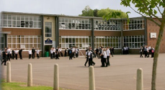
Before we use to do all the leaning on the book from physical library, which later one was replace with a digital library, same happed with the assignment before we use to do all in paper, its was such a good change to be honest everything became more easy, like today I’m here doing my assignment in a all digital version.

Screenshot/Photo 4
Smart home
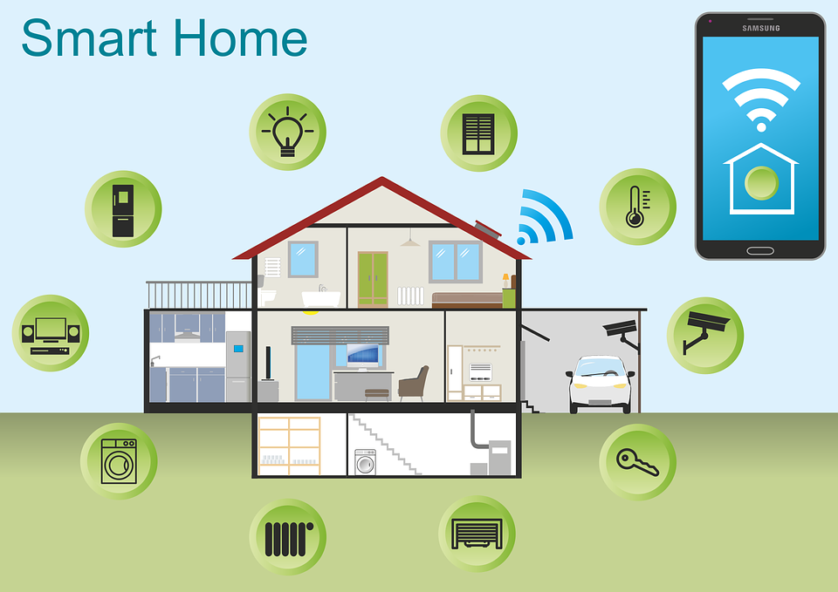
My family house back home, is a smart home, everything is digital from the turning the lights to locks the gates from the main entrance, the house was designed for give my gramma all the support that she needs as she became old there things that’s she’s not able to do, the digital change a and give her the freedom again.

Screenshot/Photo 5
Flight ticket
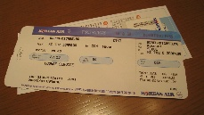
Back on 2013 when my mun decide that I would move from Brazil to come and live with her, my gramma had to a travel agency and buy my ticket and take us almost 1 week to receive my ticket, now we can see a big change, you can just buy the ticket from your phone inside your house, you can plan an entire holiday while sitting at home.

Screenshot/Photo 6
Cars
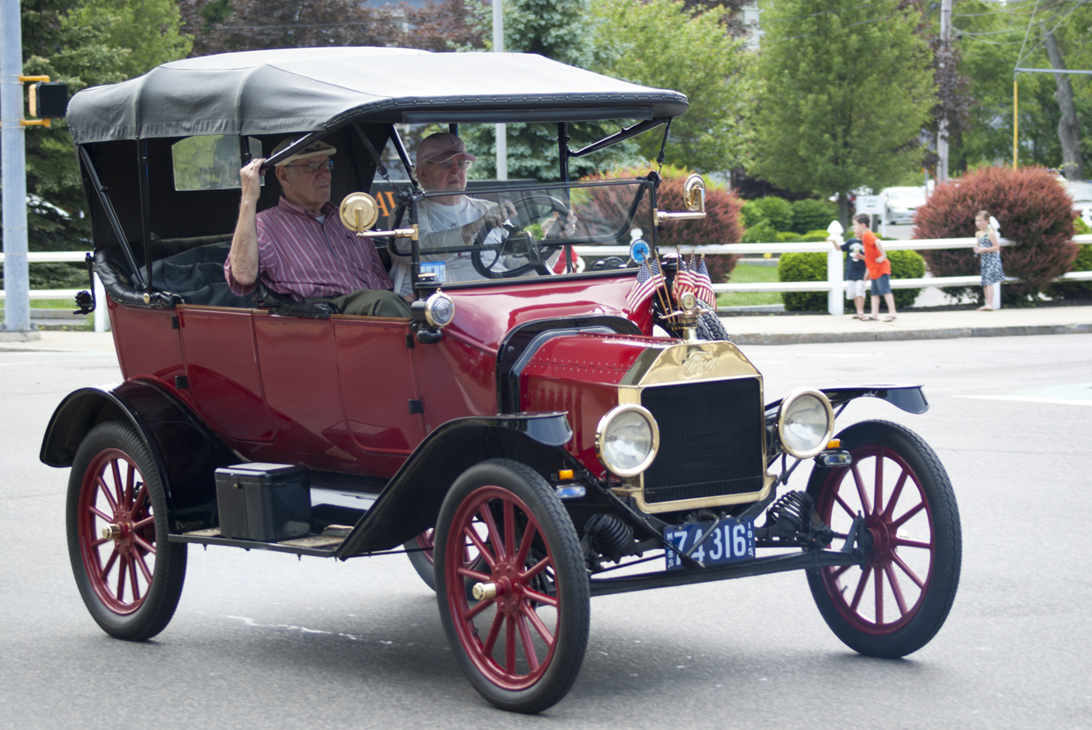
A few months ago, I trade my old car for a newer one , I went from a 2009 model to a 2020, on this 11 years gap there’s a lot changes, my new one has power windows and a big screen with a car play , and many features that I haven’t figured out how to use yet.

My Short Reflection
- Write 5–8 simple sentences about your digital life.
- You can use the sentence starters below if helpful.
I use digital tools to study, for work and to communicate with other people, I often use my phone, computer and the internet, sometimes I find it to use some digital tools like computer because I don’t have much confidence, I want to improve my computer skills and learn new thigs, sometimes I feel so nervous when using technology. I hope this modulo will help mw to improve my digital skills and became more confident. Digital skills are important for me because they will help me with my studies and my career, and let me able to compete in the job field,

Sentence starters
- I use digital tools to …
- I feel confident when I …
- I want to improve …
- I often use these tools: …
- I sometimes feel nervous about …
- I hope this module will help me …
- Digital skills are important for me because …
You can write more if you want.

Submission Checklist
Before you submit, please check:
​​​ ☐ I added 4–6 screenshots
☐ I wrote short sentences for each screenshot
☐ I wrote my short reflection
☐ My work is my own
☐ My file opens correctly
​​☐ My file opens correctly

