

Programme: Master of Business Administration

Module: Strategic Management

Module Code: LCMB7003

Assignment Title: Assessment: Individual Report- Patagonia

Lecturer’s Name: Amare Desta

Name and ID of the Student: Naitik Kantibhai Sheladiya 2430954

Submission Date: 22 December 2025

Executive Summary
The report highlights an overview of Patagonia’s history and its position as an environmentally and socially responsible outdoor clothing manufacturer. In addition, it discusses the way Patagonia views India as a viable market for future growth due to continued economic development, increasing popularity of adventure tourism activities, and growing demand for eco-friendly products in India. The report identifies Patagonia’s strengths in understanding consumer behaviour and in aligning itself with relevant organisations. The report has also evaluated its strategic capabilities. Key analytical tools were identified in this report, as well as Joint Ventures as the best option for entering this new market. Finally, a detailed and actionable growth strategy that incorporates the above analytical insights was developed for Patagonia.

Table of Contents
Introduction 3
1. Chosen organisation and Target Market 4
1.1 Organisational background of Patagonia 4
1.2 Target market 4
1.3 Rationale for the decision 6
2. Comprehensive Strategic Analysis 7
2.1 Macro-Environmental Analysis 7
2.2 Industry/Competitive Analysis (FFM) 8
2.3 Performance analysis (SWOT) 10
2.4 Insights and Strategic Implications 11
3. Strategy Development and Formulation 12
3.1 Strategic Direction and Rationale 12
3.2 Strategic Model 12
3.3 Market Entry Mode 14
3.4 Competitive positioning-Porter’s Generic Strategies 17
3.5 Strategic Fit and Capability Assessment: VRIO Framework 18
3.6 Strategy Implementation Components 19
3.7 Risk analysis and mitigation 20
4. Performance Evaluation 22
4.1 Balanced Scorecard Framework 22
4.2 Triple Bottom Line (TBL) Integration 23
4.3 Monitoring and Mechanisms of Governance 24
Conclusion 26
References 27
Appendix: PESTLE Analysis 34

Introduction
Patagonia is a U.S.-based company that manufactures outdoor apparel, sportswear and gear. The company began in 1973, resulting from Yvon Chouinard’s creation of a small manufacturer of climbing gear (Patagonia, 2025). At present, Patagonia operates in nearly 45 countries and has over 100 retail locations worldwide (Collins, 2025).
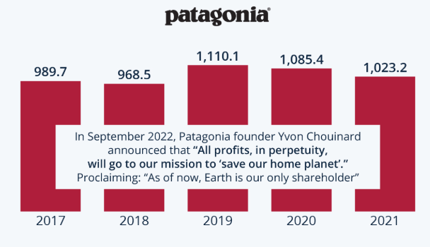
Figure 1: Annual revenue of Patagonia
(Source: Armstrong, 2022)
They are producing approximately $1,023.2 million of global revenue in 2021, which indicates that they have a strong position within the premium outdoor clothing and gear market (Armstrong, 2022). Through a “business to protect the planet” business philosophy, Patagonia directs its product development and business decisions in pursuit of an environmentally friendly future. Patagonia operates in a very competitive marketplace with respect to brands offering outdoor lifestyle clothing (Patagonia, 2025). However, the company’s commitment to being environmentally responsible, practising fair labour standards and using top-grade materials keeps Patagonia ahead of its competitors (Patagonia, 2025b). Additionally, as global markets continue to change due to advancements in technology, climate change, and evolving consumer preferences, Patagonia must remain flexible and adaptive to changes within the marketplace. Patagonia sees an attractive opportunity for international expansion into the growing Indian marketplace. People of India have a growing interest in outdoor recreation and travel, and 87% of them plan for eco-conscious holidays (TravelWorld.com, 2025). Patagonia intends to enter the Indian marketplace through either flagship stores, or partnerships or internet sales. However, considering the strategic implementation plan, Patagonia will develop its brand as an established and credible outdoor lifestyle clothing company.

1. Chosen organisation and Target Market

1.1 Organisational background of Patagonia
Patagonia is an American retailer and private company that designs and manufactures outdoor clothing and equipment, and it was originally founded in 1973 by Yvon Chouinard (Patagonia, 2025a). The foundation of Patagonia began with a climbing gear company that eventually expanded into producing high-quality gear for multiple sporting activities including climbing, hiking, skiing, and surfing or trail running. At present, the company is based in Ventura, California and has approximately 3,600 employees throughout the World (Alonso, 2023). Patagonia has created a strong reputation based on its commitment to environmental and social responsibility. Patagonia’s business mission is to use the potential for business to protect the planet and support product development, supplier choices, and community programme development (Patagonia, 2025b). I believe Patagonia is different from many of its competitors because of its long-term focus and commitment to sustainability. I have found that its consistent behaviour of supporting environmental projects and encouraging responsible utilisation of products creates a high degree of trust with its customer base and leads to greater brand loyalty.

1.2 Target market
Based on numerous indicators suggesting cultural, demographic, economic, and environmental development of India, as well as its strategic intent within BRICs, it is clear India represents an attractive new international geographic expansion opportunity for Patagonia (India Briefing, 2025).
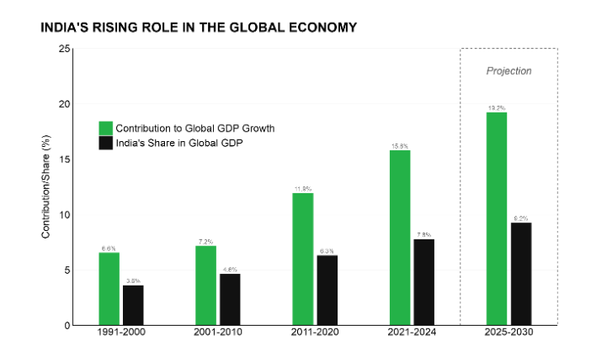
Figure 2: The economic growth rate of India
(Source: Finger, 2025)
India has sustained an average economic growth rate of above 6% per year for the past three decades (Finger, 2025). India’s GDP has reached $3.75 trillion in the year of 2023 and became the world’s fifth-largest economy according to recent Global Economic Reports (Tripathy, 2023).
The factors contributing to the increase in consumer demand in India are directly related to increased levels of the middle class, and rising discretionary lifestyle products such as adventure clothing and travel gear, and sustainability-based products (Ravi, 2025). These have resulted in an increase in domestic experiential tourist travel, while enhancing it by government promotion of domestic adventure-based tourism and a growing number of young Indians seeking out adventure and travel experiences (Ravi, 2025).
Patagonia’s key product offerings including jackets, backpacks, hiking apparel and outdoor technical apparel fit within the natural demand created by these emerging trends in India. However, the urban consumers are also becoming increasingly fitness-oriented with the expansion of gym culture, running clubs, and travel clubs in major Indian Metro areas, including Mumbai, Bengaluru, Delhi NCR, Pune, and Hyderabad. These urban hubs represent Patagonia’s target customer base, where consumers will pay more for quality and durability, and performance-driven products that fit within their premium lifestyles. The results of recent Retail and Consumer Research studies show that over 60% of Indian consumers prefer to shop with environmentally responsible brands, while around 70% of Millennial are willing to spend additional money on environmentally sustainable products (The Times of India, 2022). In addition, the Indian government has established numerous national sustainability initiatives, which will further raise consumer awareness of responsible consumption. Therefore, even though India is a price-sensitive economy, it is moving away from being price-sensitive and towards aligning itself with Patagonia’s core values.
In the context of Patagonia’s core values aligning with the developing purchasing habits of consumers in an emerging economy, India represents a great market opportunity for Patagonia. Patagonia has been named one of the foremost sustainable outdoor manufacturers and has over $1,023.2 million of global revenue, a number of employees, and operates in 40+ countries (Sundheim, 2023). Patagonia’s commitment to sustainability, ethical supply chain practices, creating durable products and offering product repair programs distinguishes Patagonia from all other apparel brands globally. Therefore, these core values make Patagonia ideally positioned to take advantage of a growing Indian consumer base that is increasingly gravitating toward sustainability and quality (Patagonia, 2025b). However, based on the Dynamic Capabilities Theory, the company is sufficiently positioned to enter the Indian market. According to this theory, a company’s ability to recognise new opportunities, capitalise on them and identify the best way to mobilise its resources to maximise its competitive advantage is critical to its long-term success (Hutchinson, 2024). Patagonia has a long history of demonstrating strong dynamic capabilities. Therefore, it identified an early demand for sustainable outdoor products, capitalised on them with its global expansion and effectively repositioned its operations to limit its environmental impact. Additionally, through aggressive product innovation, Patagonia can quickly adapt to changing customer needs and expectations. A new market in India represents a new growth opportunity for Patagonia (Hutchinson, 2024).

1.3 Rationale for the decision
The expansion decision by Patagonia is further supported by the Institutional Theory. Companies tend to perform better in international markets when their organisational values fit with the cultural and societal norms within the host country (EBSCO, 2025). For example, in India, there is currently an increased emphasis on developing environmental laws, increasing awareness of green tourism and encouraging companies to adhere to sustainability reporting (Shah, 2022). In the same way, urban-dwelling consumers are now beginning to develop a preference for responsible fashion brands. The values of Patagonia fit well with these current institutional developments, making it likely that Patagonia will be both accepted and have a successful future in India (Holtström, Bjellerup and Eriksson, 2019). In addition, it has become apparent to me that the “planet-first” philosophy of Patagonia correlates well with increasing focus of India on protecting the planet effectively.
The Consumer Behaviour Theory also provides strong justification for the expansion strategy of Patagonia. The most important aspect of this theory is the movement from functional consumption to expressive consumption among consumers in India (Thangavelu, 2025). Furthermore, consumers in India are deciding which brands to purchase based upon the values, lifestyles and identities that they wish to project. Patagonia has built a brand identity using storytelling, advocating on behalf of important issues and marketing based on its mission (Thangavelu, 2025). Through utilising this platform, Patagonia has built emotional loyalty with consumers, which is vital when attempting to establish a foothold in a competitive retail market such as that of India.

2. Comprehensive Strategic Analysis

2.1 Macro-Environmental Analysis
PESTLE analysis
Political Factors
Governments encourage local tourism, eco-tourism, and rural employment, and enhance the development of the outdoor apparel industry. A large role is played by state investments in adventure tourism infrastructure and safety regulations. For instance, as per the Ministry of Tourism (2024), India generated 76.17 million jobs in the tourism sector in 2022-23, which demonstrates how the public expenditure on outdoor goods affects the demand.
Economic Factors
The increase in disposable income and the development of the middle class stimulate the consumption of high-quality outdoor brands. Reports by Credence Research (2024) indicated the market size of outdoor equipment in India at USD 978.45M in 2023, which has a strong growth rate, yet untapped potential. However, Pricing and profit margins are influenced by import duty fluctuations, currency fluctuations and retail prices.
Social Factors
The social changes, such as increased attention to fitness, wellness, nature travel, precondition the fact that younger urban millennial and Gen Z prefer trekking, camping and micro-adventures (Ravi, 2025). This increases the sales of specialised clothing, hydration devices and portable foods.
Technological Factors
Market reach and product differentiation have been increased through e-commerce, wearables, material science and food preservation technology. D2C brands can grow rapidly using digital platforms because there are 900 million internet users in 2024 (DD News, 2025). Competitiveness is still being improved through lightweight fabrics, modular gear and freeze-dry nutrition.
Legal Factors
The regulation of outdoor products includes the GST categories, the safety standards, and the FSSAI food safety regulations of adventure foods (The Times of India, 2024). The sports goods are subject to GST slabs, which are dependent on the HSN code and price, which affect the cost structure.
Environmental Factors
Climate change influences the patterns of outdoor activities. The average temperature in India had increased by 0.9 degree Celsius over the past ten years (PTI, 2025). The brands are becoming more environmentally friendly with the use of sustainable materials and eco-friendly packaging.

2.2 Industry/Competitive Analysis (FFM)
Porter’s five forces
Threat of New Entrants
The risk of new entrants is medium. Clothing and other equipment can be accessible to small companies, which get their products locally or from third-party vendors. However, technical skills, good supply chains and quality standards, particularly for equipment and food, elevate the entry barriers. According to Deb (2024), the outdoor gear market was USD 978.45 million in 2023, and major players are more likely to win over amateurs.
Supplier Bargaining Power
The power of suppliers is moderate to high, depending on the product. Global price changes affect technical fabrics, imported components and raw materials. From the reports by Tandon (2025), it has been found that the rise in domestic production and big retailers such as Decathlon are already sourcing much in India.
Bargaining Power of Buyers
Buyer power is high as Indian consumers reach brands both in the offline stores and online. Sensitivity to price and the high number of options, particularly in non-premium segments, allow consumers to change brands at will. According to Custom Market Insights (2025) reports, the Indian sports apparel market is expected to reach USD 696.45 million in 2025, which highlights the competition in the market. This is a constraint of premium pricing due to the abundance of alternatives.
Threat of Substitutes
The threat of substitutes is medium. Amateurs can substitute special outdoor apparel with everyday sportswear, low-end athleisure/casual wear, and general snacks can substitute ready-made outdoor food. However, durable and safety-conscious products are required by serious outdoor enthusiasts, which make substitutes ineffective in the high-end segments (Ravi, 2025). Therefore, the lower end of the market is the one that is mostly impacted through substitution.
Competitive Rivalry
Rivalry is high. The Indian market has international, domestic, mass-market and niche players, emerging D2C brands. Major competitor Decathlon has 132 stores on its own in 55 cities (PTI, 2025). As numerous brands compete with each other based on price, range, distribution and reach, competition is tightening the margins and compelling continuous innovation and value differentiation.
Outdoor and sportswear in the Indian market is quite competitive. It is therefore easy to start a business with just basic products but difficult to venture in the development of advanced outdoor gears, due to the skills required and the supply chains involved, as a result making it difficult to venture through the industry (IMARC Group, 2024). Supplier power is moderate and high since changes in the price of fabrics and materials may influence costs. Buyers possess a high power due to the numerous alternatives available in both stores and online. Substitutes largely influence the low-end of the market, where individuals will select less expensive sportswear as opposed to outdoor clothing. The competition is very stiff as numerous international and local brands struggle to dominate the market (Sannino, 2023).

2.3 Performance analysis (SWOT)
Strengths
All over the world, Patagonia is famous for its emphasis on the planet, products with long-lasting and fair treatment. It gains the trust of customers through the utilisation of good materials and through prudent purchasing. The company will provide repair services and the origin of its items as well, which is also a distinguishable characteristic of the company compared to many of its competitors (Sundheim, 2023). Its long-term objectives assist it in maintaining its customers all over.
Weaknesses
Its prices are too high, thus restricting its accessibility in price-sensitive markets such as India. The company does not have much experience in the varied Indian retail scene. It is a set of very stringent sustainability regulations, which can be expensive and difficult to scale (Vaishanav, 2024).
Opportunities
Outdoor activities, fitness, and eco-friendly products are also liked by India. It has a large youth population and an increasing middle-income population that has embraced quality and responsible brands. Internet shopping is also expanding at a rapid rate, which provides Patagonia with an opportunity to access customers with ease (Sharma, 2025). An alliance with a local company can enable the company to penetrate the market easily.
Threats
India has a high level of competition, as there are both international and local brands of outdoor and sportswear. Customers possess power because of the presence of a variety of options. Inequality in sportswear may reduce the demand for high-quality products (Sharma, 2025). Competition in the market can also drive prices and margins down.

2.4 Insights and Strategic Implications
PESTLE analysis
Effectiveness: The PESTLE framework aids business in understanding the external environment by analysing political, economic, social, technological, legal and environmental factors. The report published by CIPD (2022) showed that it assists businesses in providing contextual information and identifying the opportunities and threats at an early stage. This is beneficial for the brand to form strategies, risks, and be better prepared to handle any changes in laws, market trends, technology and regulation. PESTLE is quite simple to analyse and apply to organisations, even without experience.
Limitations: PESTLE is simple, but it fails to evaluate some delicate interrelations, interdependencies or factors that might have critical importance on business. The analysis is dynamic and time-based. According to the report published by Tele Analysis (2023), it can be a lengthy process for a business to form strategies because consumer preferences are changing rapidly. The brand consumes resources and needs reliable data with up-to-date information in different fields.
Porter’s Five Forces analysis
Effectiveness: The Five Forces analysis presents a more industry-level overview of competition, and helps companies to influence the supplier power, buyer power, reduce threat of new entrants, threat of substitutes and pre-existing competitive rivalry over profitability. Danao and Watts (2024) suggested that it helps in making strategic decisions. The information on the areas of the strongest competitive forces assists companies in pricing, market selection, and positioning themselves to take advantage of the weaknesses of an industry. It is a rather simple and flexible model, it can be utilised in most industries and in most cases. An internal-capability model analyses how to construct a broader strategic picture. It assists stakeholders in identifying opportunities and threats at an early stage. These factors contribute to risk management and long-term plans to business.
Limitations: The Porter’s five forces model has subjective appraisals. It provides a fixed or static image of the industry conditions. However, there are significant changes in areas such as technological growth, globalisation, and regulations. Rusith (2022) showed that the model is purely industry-based, leaving out the factors at the company level, such as capabilities, culture, and resources, which may create difficulties for the company.

3. Strategy Development and Formulation

3.1 Strategic Direction and Rationale
The reason Patagonia chose to expand into India is that its residents are more concerned with outdoor activities, fitness and environmentally friendly lifestyles. They are entering a new market where their existing products are compatible with what people desire. This decision is encouraged by the youthfulness of India and the increasing demand for green brands (Sundheim, 2023). The reason why Patagonia decided on a joint venture is that it provides local knowledge, risk-sharing, and assists in maintaining sustainability standards. This is going to build a physical, tangible presence in India and simplify the challenges of cultural and legal differences.

3.2 Strategic Model
Ansoff Matrix

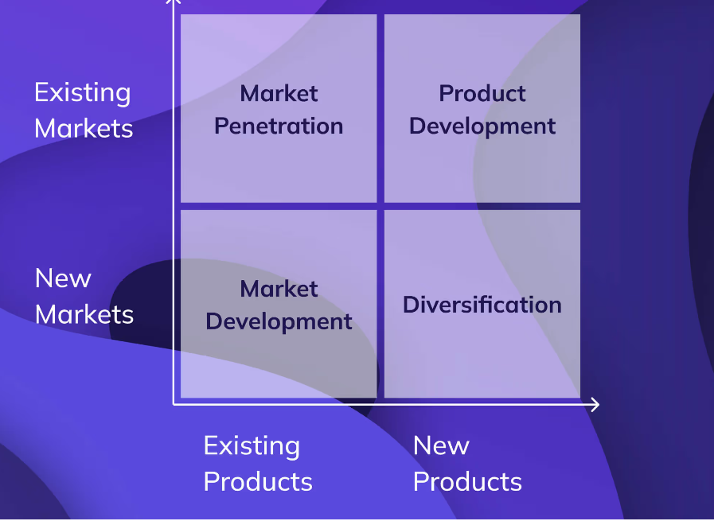
Figure 3: Ansoff Matrix
(Source: Wright, 2022)
The Ansoff Matrix is a strategic framework that provides direction to organisations as they seek to develop strategies to accomplish the highest growth rate possible. The matrix consists of four different categories, including Market Penetration, Market Development, Product Development and Diversification. The Ansoff Matrix provides the basis upon which to develop a market entry strategy for Patagonia’s expansion into India by utilising the appropriate category (Wright, 2022).
Market Penetration: Market Penetration primarily focuses on selling existing products within existing markets. Currently, Patagonia sells products in more than 40 countries and generates approximately $1.5 billion annually from its retail operations. For example, currently in the United States, Patagonia’s outdoor jackets, backpack have a very large and loyal customer base, and increasing the sales volume of those products would require Patagonia to either create new advertising campaigns to reach additional customers or improve distribution channels.
Product Development: It focuses primarily on developing new products for existing markets. As an example, Patagonia has developed a programme called “Worn Wear” through which customers can have their previous purchases repaired. They can also use more recycled materials to manufacture their existing products, and both of these methods are examples of how Patagonia continues to grow in the existing markets where it currently operates. Patagonia may ultimately design and sell products in the Indian market that are country-specific, such as heat-resistant fabrics that are appropriate for the hot temperatures found in many areas of India.
Diversification: It means creating new products for new markets is a very high-risk action, as it is uncertain that the new market is willing to buy newly developed products. However, the time-frame for diversification could be long-term, which is not recommended as a way to enter the market initially. Patagonia is a high-end brand, and developing brand-new product lines before understanding the Indian market can pose a high financial risk.
Market Development: Patagonia’s optimal strategy is to enter a new market where they already have a product line. It can be stated that India can double its retail market to nearly $1.9 trillion by 2030 (Deloitte, 2025). There has been a significant amount of growth in the outdoor recreation sector, with some areas experiencing more than 20% growth annually in adventure tourism (The Times of India, 2022). The country has a very young population that is predominantly under the age of 35, and it is estimated that just over 60% of the urban consumer population prefers to purchase from eco-friendly brands (The Times of India, 2022). These facts indicate a very significant potential for Patagonia in the Indian market with its eco-friendly range of products. However, Market Development can be an effective way for Patagonia to enter into the Indian market by using its established, high-quality and sustainable products and placing them directly into that market.

3.3 Market Entry Mode
International strategies
International strategies that Patagonia used in businesses, such as promoting localisation, forming distribution strategy, considering product adaptation and price adaptation. The internationalisation strategy of Patagonia combines both global integration and local responsiveness. This includes a transnational and hybrid strategy in the I-R context. Le and Liao (2018) stated that a theoretical overview of I-R framework highlights the fact that there are several factors, which influence business performance. This includes technological development, supplier relationships and environmental dynamics. In the global integration context, the company has a process of maintaining a uniform brand based on sustainability, high-quality products and ethical supply-chain practices.
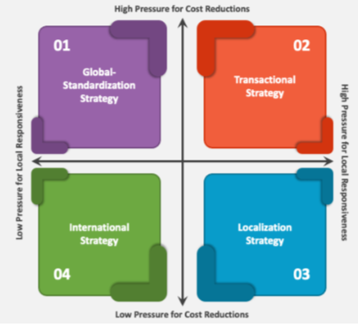
Figure 4: Global Integration Local-Responsiveness (I-R) framework
(Source: Le and Liao, 2018)
The brand shaped its sustainability strategy by using recycled materials, working with the circular economy, maintaining supply-chain transparency, and arranging global sustainability programs in all markets.
Market Entry Mode Strategy
In terms of Patagonia to protect their values as a company that emphasises sustainability when entering India, an approach must be developed that supports entrance into such a large, varied and diverse market. I have explored all of the major options for entering India, including Export, Licensing, Franchising and others. However, I think that a Joint Venture (JV) would be the best option for Patagonia to enter India (Hargrave, 2024). At present, India is one of the fastest-growing consumer markets in the world, including a fast-growing online retail market, which has grown to $75 billion in 2024 and it is expected to grow $260 billion by 2030 (Deloitte, 2025).
In addition to this, there are over 850 million internet users in India, making India the largest online consumer market in the world (The Economic Times, 2025). Combining physical retail expansion with the rapid growth of online sales makes India an attractive opportunity for Patagonia. I believe that entering the Indian market independently would present a significant risk to Patagonia, given the local knowledge and experience required to build relationships with various stakeholders, including customers, distribution channels, and retail policies (Hargrave, 2024). Building a successful JV with an existing retailer in India that has established relationships with consumers, distribution channels, and retail policies in India would offer Patagonia a significant competitive advantage.
The concept of Joint Venture allows Patagonia to co-own and manage the company with an organisation that is experienced in the Premium Retail or the Outdoor Lifestyle Sector in India. The advantages include access to a pre-built network of suppliers, logistics partners and retailer locations (Patagonia, 2025c). In addition, through knowledge of the local laws and compliance process, an Indian partner will provide an easier way for Patagonia to navigate the complex regulatory environment of India. The third advantage includes the establishment of consumer preferences within India, as they vary greatly between regions. This is more easily understood through a JV than through franchise or export channels (Ken Research, 2019). For example, Higher Income Level Areas such as Bengaluru, Mumbai and Delhi NCR have a greater inclination toward purchasing products associated with outdoor activities, while lower income areas generally focus on affordability (Ken Research, 2019). Through my experiences, I found that a JV is a more flexible and effective means of gathering this data than exploring other options like franchise or exporter. As a franchise, Patagonia would have reduced control over their sustainability efforts and exporting alone will not provide adequate opportunities for them to develop the deep community relationships, for which they are known. Patagonia will thus maintain control over all decisions regarding sustainability standards, the quality of products sold, the communication of brand messages and the consumer experience in its stores and outlet locations (Hargrave, 2024).
These two cities are home to large populations of young urban professionals, outdoor recreation lovers, and environmentally conscious shoppers. A significant number of surveys conducted in India indicate that over 60% of urban dwellers will buy products from environmentally responsible companies. In the same way, 70% of millennial will spend more for eco-friendly products. This is strongly aligned with Patagonia’s stated mission and product lines (Livemint, 2022).

3.4 Competitive positioning-Porter’s Generic Strategies
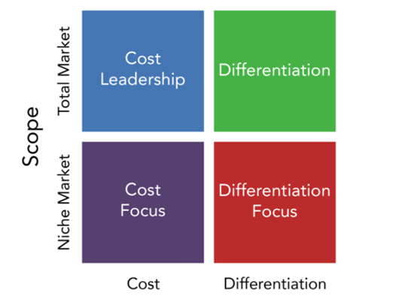
Figure 5: Porter’s Generic Strategies
(Source: Lumen, 2025)
The generic strategies of Porter can be applied to explain the position of Patagonia in India. These are cost leadership, differentiation and focus strategy. In the case of Patagonia, differentiation is the most appropriate, but with some focused differentiation (Lumen, 2025). In India, Patagonia will not be able to compete with low prices due to the eco-friendly, high-quality products. At the time, when it has a premium image, it would be damaging it with a low-cost strategy. Most Indian customers seek low prices, and reducing the prices would make Patagonia weaker as a brand. However, Patagonia has an opportunity to combine selling durable, ethically made products and a powerful planet-first message and make a change (Lumen, 2025). These concepts are increasing in Indian cities, particularly among the young professionals and nature-conscious customers. The repair service of Patagonia, its use of recycled materials and open supply chain make it unlike other brands. Focused differentiation is also something that Patagonia can employ. That is to say, it is focused on a particular group, and not all. There are numerous individuals in India, but Patagonia will target high-end shoppers in such cities as Bengaluru, Mumbai and Delhi NCR (Laja, 2023). These consumers are quality-conscious, sustainability-conscious and outdoor sports enthusiasts who are willing to spend extra on durable and sustainable, and responsible products. Through targeting this group, Patagonia will be able to maintain a good position and not compete with large, low-price brands (Laja, 2023). Its fair labour and clean environment promotions, campaign against climate scientifically attract Indian customers who believe in ethics. Its status can be enhanced by opening workshops, repair days and sustainability lessons in stores. Such concepts leverage the strengths of such a company and access the required customers.

3.5 Strategic Fit and Capability Assessment: VRIO Framework
Resource / Capability | Valuable | Rare | Inimitable | Organised to Capture Value | Outcome
Strong sustainability mission and brand identity | Yes | Yes | Yes | Yes | Sustained Competitive Advantage
High-quality durable products | Yes | No | No | Yes | Temporary Competitive Advantage
Ethical and transparent supply chain | Yes | Yes | Yes | Yes | Sustained Competitive Advantage
Global experience in outdoor markets | Yes | No | No | Yes | Temporary Advantage
Repair programmes (Worn Wear) | Yes | Yes | Yes | Yes | Sustained Competitive Advantage
Table 1: VRIO analysis
(Source: Self-Created)
However, VRIO evaluation reveals that Patagonia possesses some powerful strengths that will enable it to penetrate India. Its prioritisation of sustainability, ethical supply chain and repair initiatives are both valuable, rare, and difficult to imitate by competitors. Patagonia has also been structured to exploit these strengths, which have provided it with a sustainable competitive advantage (The Strategy Institute, 2024). Not completely rare in high-end markets, high-quality products can be used to add additional value. The global experience can be beneficial to Patagonia but it can only be a temporary advantage as competitors can also acquire similar experience after some time. On balance, all the key sustainability assets of Patagonia are aligned with the requirements of the Indian market.

3.6 Strategy Implementation Components
There are specific steps to consider in implementing Patagonia market entry strategy in India, which will enable successful operation, excellent brand building and smooth expansion in the long term. The initial one is to form a joint-venture alliance (Patagonia Ventures, 2023). Patagonia should choose a local partner, which they trust and is familiar with the high end retailing market and local regulations. Contracts specifying ownership, responsibilities and sustainability benchmarks and store operations will be signed by both parties. This ensures that the firm ventures into India with joint risk and domestic backup. The second one is the establishment of the flagship store. The joint-venture team must select a location in Bengaluru or Mumbai, since the areas have young and environmentally conscious consumers (The Strategy Institute, 2024). The designs of the store must align with the international brand of Patagonia, with plain layouts, informative layouts, and sustainability messaging. It also must have a repair shop called Worn Wear, which will demonstrate the culture of repair that Patagonia has portrayed. The personnel should be trained on the products, values of sustainability, and customer service (The Strategy Institute, 2024).
The third thing is to develop a good internet presence. Patagonia and its partner must introduce a site focused on India and collaborate with other big online marketplaces. The number of digital consumers in India is immense. Hence, web-based sales will enable Patagonia to reach consumers nationwide. The digital marketing must narrate the effectiveness, emphasise on the environmental values, and demonstrate the advantages of durable products. The fourth step is to plan supply chain and logistics (Heinrich, 2025). The joint venture must monitor the sales, client comments, store traffic, and online interaction. Periodic reviews will indicate areas of strengths and areas, which need upgrading. Combined, all these steps form a viable and workable strategy of Patagonia in India.

3.7 Risk analysis and mitigation
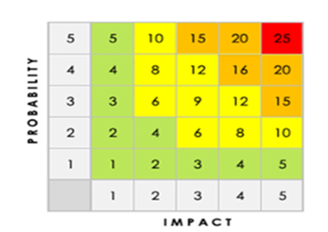
Figure 6: Risk Register Colour Code
(Source: Hall, 2019)
Risk | Description | Category | Likelihood | Consequence | Impact (L×C) / Priority | Response
Regulatory delays | Difficulty meeting Indian import, retail and sustainability rules | Legal / Compliance | High | Store launch delays, extra costs | High (5×5) | Use local legal advisors and JV partner to manage compliance (Romain Dambre et al., 2025)
Supply chain disruption | Dependence on imported materials and long lead times | Operational | Medium | Stock shortages, slower sales | Medium (3×4) | Build local supplier network
Price sensitivity | Consumers choosing cheaper alternatives | Market | High | Lower sales in early stages | High (5×4) | Target premium cities
Strong competition | Many global and local brands active in India | Competitive | High | Reduced market share | High (5×5) | Focus on sustainability, repair services and niche positioning (Romain Dambre et al., 2025)
Table 2: Risk assessment table
Patagonia’s entry into the market faces multiple risks related to regulations, supply networks, rivalry and customer habits. Being aware of these risks enables the company to develop countermeasures. India has state-specific regulations, inconsistent retail norms and complicated import protocols. This heightens the likelihood of hold-ups. Supply chain difficulties might arise from reliance on imported materials or interruptions in logistics. Competition is intense in India, from brands providing more affordable options (Laja, 2023). Additionally there is a risk that luxury pricing might not appeal to every consumer segment.

4. Performance Evaluation

4.1 Balanced Scorecard Framework
Perspective | Strategic Objective | Goals | KPIs | Targets
Financial | Establish profitable and scalable Indian operations | Achieve sustainable revenue and margin levels within 3 years | Annual revenue from India  Gross margin  Cost-to-sales ratio | USD$50–70 million revenue by Year 3  45% gross margin  Reduce cost-to-sales to below 18%
Customer | Increase brand acceptance, loyalty and market presence | Build a strong eco-conscious customer base in urban metros | Customer satisfaction score  Repeat purchase rate  Brand awareness index | CSAT of 85%  40% repeat purchase  25% brand awareness in major metros by Year 2
Internal Processes | Strengthen operational efficiency and supply-chain reliability | Ensure timely product availability and compliance | Inventory turnover  Local sourcing ratio  Compliance audits | 6 inventory turns annually  25% local sourcing by Year 3  100% compliance audit clearance
Learning and Growth | Build organisational capabilities to support Indian expansion | Develop sustainability expertise and employee competencies | Employee training hours  Sustainability innovation projects | 40 hours annual training  3 sustainability-driven projects/year  85% retention
Table 3: Balanced scorecard for Patagonia
(Source: Self-Created)
The Balanced Scorecard provides Patagonia with a definite means of monitoring its performance in India by correlating financial objectives with customer objectives, work process objectives, and learning objectives with the mission of the company’s sustainability. In the money section, there is a long-term profit-making opportunity in a market that is fast expanding yet price-sensitive. The customer aspect is quite essential as the Indian population is getting eco-friendly and 60-70% of them prefer brands, which are environmentally conscious (The Economic Times, 2025). The main figures such as revenue and gross profit are what enable Patagonia to maintain their high-end perception at the same time, keeping watch on the expenses involved in their complex chain of supply and government tax on imports.
Measuring the level of customer-happiness, repeat-shopping, and brand recognition will help Patagonia understand whether its promise of durable products, environmental practices, and transparency is successful. This would suit the middle-class of the city and those who enjoy adventure tours.

4.2 Triple Bottom Line (TBL) Integration
Application of the Triple Bottom Line to evaluate the KPIs
Application of the Triple Bottom line (TBL) enables Patagonia to view the impact of its entry into India through the prism of people, planet, and money. The TBL framework considers the People, Planet and Profit components, while Patagonia can remain responsible in its aims of growing. The numbers used by Patagonia to determine the happy customer levels, the number of hours that employees spend under training and the number of employees who remain within the company serve the social component of the TBL. In context to customer satisfaction, it will indicate that the company is selling good, fair products that are liked by the Indian shoppers (Alsyani et al., 2020). Employee retention and training figures enable Patagonia to establish a stable, strong and fair working force in India. This is important when individuals are concerned about poor working conditions. These measures allow Patagonia to monitor its process of bettering the lives of its workers and customers.
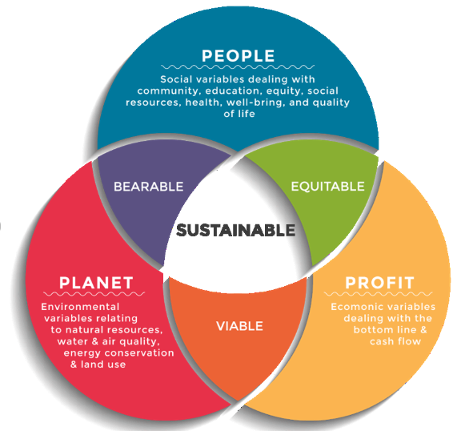
Figure 7: Triple Bottom line model
(Source: Dalibozhko and Krakovetskaya, 2018)
The ratio of local suppliers, the new green initiatives, and the audits of regulations are all examples of environmental statistics that enable Patagonia to fulfil its long-standing green commitments. The materials are more local and sustainable, which reduces environmental emissions associated with long commuting and promotes the cyclical economy. Consistent checks of the rules ensure that Patagonia is in compliance with waste and packaging regulations (Patagonia, 2022). The emerging initiatives assist Patagonia in producing eco-friendly garments that are kept to suit the climate of India. The indicators such as sales quotas, profit margins, cost and sales reveal the sustainability of the expansion. Earning money ethically will enable Patagonia to remain competitive in one of the markets that are conscious about price without affecting its high-end brand. These figures ensure that the business has a long-term survival without damaging people or the environment.

4.3 Monitoring and Mechanisms of Governance
Effective oversight and robust governance are crucial for Patagonia’s launch in India. As the company intends to enter via a Joint Venture, both parties need to establish guidelines regarding decision-making, reporting and performance monitoring. A Joint Venture Steering Committee can be formed to supervise the progress. This committee should consist of leaders, from both Patagonia and the Indian partner. They will convene routinely to assess sales outcomes, customer feedback, supply chain efficiency and financial statements (Hargrave, 2024). Basic dashboards serve to monitor metrics, like foot traffic, e-commerce revenue repair service usage and customer satisfaction ratings. Patagonia also needs to oversee adherence to sustainability and ethical criteria. Frequent inspections must be conducted to verify that suppliers adhere to Patagonia’s labor protocols. Staff training programs should be conducted regularly to maintain consistency in the brand’s message (Hargrave, 2024). Governance should additionally involve tracking risks. A risk register may be revised quarterly to review concerns, like shifts, market rivalry or supply chain interruptions (Sundheim, 2023). Clear communication channels between both partners will support transparent and quick decision-making. Good governance will help Patagonia respond to problems early, adjust strategies when needed and maintain its strong brand reputation in India.

Conclusion
The evaluation showed that Patagonia’s strong corporate culture around sustainability and a strong brand image in the global marketplace correspond with the increasing trend towards practices in India. In addition, through analysis, it was determined that India has created favourable economic, social and environmental conditions for a successful expansion of Patagonia’s brand into India. The evaluation demonstrates Patagonia’s unique strengths combined with the evolving consumer purchasing behaviour in India. Based on the analysis, Joint Venture has been identified as the optimal market entry strategy for Patagonia to establish its brand success in India. In summary, the expansion strategy provides Patagonia with a well-defined pathway to enter the Indian market successfully.

References
Alonso, T. (2023) How Patagonia Became the Benchmark in Sustainable Clothing, Cascade. Available at: https://www.cascade.app/studies/patagonia-strategy-study (Accessed: 28 November 2025).
Alsyani, M.K., Al Homaidi, E.A., Qaid, M.M., Khaled, A.S.D. and Almugari, F. (2020) ‘Factors influencing consumer satisfaction Toward Online Shopping, a Special Reference to India Context’, International Journal of Procurement Management, 1(1), p. 1. Available at: https://doi.org/10.1504/ijpm.2020.10036953.
Armstrong, M. (2022) Infographic: The Size of the Company ‘Given Away’ to Save the Planet, Statista Daily Data. Statista. Available at: https://www.statista.com/chart/28257/patagonia-inc-revenue-company-db/?srsltid=AfmBOoqQe1NfO0TCSRfYyh2-oeaNpkhr_kcq_f06l1xF0ddFmf9k_sxq (Accessed: 28 November 2025).
CIPD (2022) PESTLE analysis, CIPD. Available at: https://www.cipd.org/globalassets/media/knowledge/knowledge-hub/factsheets/pestle-analysis-factsheet_20221230T092611.pdf (Accessed: 28 November 2025).
Collins, G. (2025) Patagonia: Committed to Creating Long-Lasting Products, Manufacturingdigital.com. Bizclik Media Ltd. Available at: https://manufacturingdigital.com/news/patagonias-supply-chain-manufacturing-sustainability (Accessed: 28 November 2025).
Credence Research (2024) India Outdoor Gears and Equipment Market - Demand, Size and Competitive Analysis, Credence Research. Available at: https://www.credenceresearch.com/report/india-outdoor-gears-and-equipment-market (Accessed: 28 November 2025).
Custom Market Insights (2025) Web Series Reviews, Custom Market Insights. Available at: https://www.custommarketinsights.com/report/india-sports-apparel-market/? (Accessed: 28 November 2025).
Dalibozhko, A. and Krakovetskaya, I. (2018) (PDF) Youth entrepreneurial projects for the sustainable development of global community: evidence from Enactus program, ResearchGate. Available at: https://www.researchgate.net/publication/329185478_Youth_entrepreneurial_projects_for_the_sustainable_development_of_global_community_evidence_from_Enactus_program (Accessed: 28 November 2025).
Danao, M. and Watts, R. (2024) Porter’s five forces: Definition & how to use the model, Forbes. Forbes Media LLC. Available at: https://www.forbes.com/advisor/business/porters-five-forces/ (Accessed: 28 November 2025).
DD News (2025) Internet users to surpass 900 million in India this year, AI a game changer, Ddnews.gov.in. Available at: https://ddnews.gov.in/en/internet-users-to-surpass-900-million-in-india-this-year-ai-a-game-changer/ (Accessed: 28 November 2025).
Deb, R.K. (2024) India Outdoor Gears and Equipment Market, Credence Research Inc. Available at: https://www.credenceresearch.com/report/india-outdoor-gears-and-equipment-market? (Accessed: 28 November 2025).
Deloitte (2025) India’s US$1.06 trillion retail sector is set to reach $1.93 trillion by 2030 per Deloitte–FICCI report, Deloitte. Available at: https://www.deloitte.com/in/en/about/press-room/india-s-us-1-06-trillion-retail-sector-is-set-to-reach-1-93-trillion-by-2030.html (Accessed: 28 November 2025).
EBSCO (2025) Institutional Theory | Research Starters | EBSCO Research, EBSCO. Available at: https://www.ebsco.com/research-starters/sociology/institutional-theory (Accessed: 28 November 2025).
Finger, H. (2025) India’s Path To Becoming One of the World’s Largest Economies | Econofact, Econofact | Key facts and incisive analysis to the national debate on economic and social policies. Available at: https://econofact.org/indias-path-to-becoming-one-of-the-worlds-largest-economies (Accessed: 28 November 2025).
Hall, C. (2019) The objective of this article This article is to give you some of my views on ISO27001/information risk management and my recommendations on what a risk register could contain. It is not the intention of this article to give you a methodology/process for undertaking risk assessments., Linkedin.com. Available at: https://www.linkedin.com/pulse/iso27001-risk-management-what-register-could-contain-chris-hall/ (Accessed: 8 December 2025).
Hargrave , M. (2024) Joint venture (JV): What is it and why do companies form one?, Investopedia. Available at: https://www.investopedia.com/terms/j/jointventure.asp (Accessed: 28 November 2025).
Heinrich, A. (2025) How to Measure Marketing Effectiveness, Business Insights Blog. Available at: https://online.hbs.edu/blog/post/how-to-measure-marketing-effectiveness (Accessed: 8 December 2025).
Holtström, J., Bjellerup, C. and Eriksson, J. (2019) ‘Business model development for sustainable apparel consumption’, Journal of Strategy and Management, 12(4), pp. 481–504. Available at: https://doi.org/10.1108/jsma-01-2019-0015.
Hutchinson, J. (2024) Dynamic capabilities (organizational theory) | EBSCO, EBSCO Information Services, Inc. | www.ebsco.com. Available at: https://www.ebsco.com/research-starters/business-and-management/dynamic-capabilities-organizational-theory (Accessed: 28 November 2025).
IMARC Group (2024) India Sportswear Market Size, Share, Growth and Industry Report, Imarcgroup.com. Available at: https://www.imarcgroup.com/india-sportswear-market (Accessed: 8 December 2025).
India Briefing (2025) India’s Trade and Development with BRICS: Analysis and Opportunities - India Guide | Doing Business in India, www.india-briefing.com. Available at: https://www.india-briefing.com/doing-business-guide/india/trade-relationships/india-s-trade-and-development-with-brics-analysis-and-opportunities (Accessed: 28 November 2025).
Ken Research (2019) India Luxury Retail Market | 2019 – 2030 | Ken Research, Kenresearch.com. Available at: https://www.kenresearch.com/india-luxury-retail-and-premium-brands-market (Accessed: 28 November 2025).
Laja, P. (2023) Differentiation Strategy: What It Is, Why It’s Critical, and How to Get It Right, CXL. Available at: https://cxl.com/blog/differentiation-strategy/ (Accessed: 8 December 2025).
Le, U.-M. and Liao, T.-S. (2018) ‘A Dynamic View of Global Integration and Local Responsiveness Framework’, International Journal of Emerging Research in Management and Technology, 6(8), pp. 58–66. Available at: https://doi.org/10.23956/ijermt.v6i8.119.
Livemint (2022) Over 60% willing to spend more on sustainable brands, mint. Available at: https://www.livemint.com/industry/retail/over-60-of-indian-shoppers-willing-to-spend-more-on-sustainable-brands-11654238219450.html (Accessed: 28 November 2025).
Lumen (2025) Strategy Formulation | Human Resources Management, courses.lumenlearning.com. Available at: https://courses.lumenlearning.com/wm-humanresourcesmgmt/chapter/strategy-formulation/ (Accessed: 8 December 2025).
Ministry of Tourism (2024) Tourism Expansion in India (Ministry of Tourism), pp. 1–5. Available at: https://static.pib.gov.in/WriteReadData/specificdocs/documents/2024/dec/doc20241216472801.pdf (Accessed: 28 November 2025).
Patagonia (2022) Patagonia Customer Service & Help Center, Patagonia.com. Available at: https://help.patagonia.com/s/article/Packaging-Materials-and-How-to-Properly-Recycle-Them (Accessed: 28 November 2025).
Patagonia (2025a) Company History, Patagonia. Available at: https://www.patagonia.com/company-history/ (Accessed: 28 November 2025).
Patagonia (2025b) Our Footprint, Patagonia. Available at: https://www.patagonia.com/our-footprint/ (Accessed: 28 November 2025).
Patagonia (2025c) Working With Factories, Patagonia. Available at: https://www.patagonia.com/our-footprint/working-with-factories.html (Accessed: 28 November 2026).
Patagonia Ventures (2023) Patagonia Ventures, Patagonia Ventures. Available at: https://www.patagoniaventures.com/ (Accessed: 8 December 2025).
PTI (2025a) Decathlon India eyes nearly $1 bn sales in next 5 years with double-digit growth, The Economic Times. Economic Times. Available at: https://economictimes.indiatimes.com/industry/services/retail/decathlon-india-eyes-nearly-1-bn-sales-in-next-5-years-with-double-digit-growth/articleshow/123071889.cms?from=mdr& (Accessed: 28 November 2025).
PTI (2025b) India’s average temperature rose by 0.9 degrees C in last decade: study, The Times of India. The Times Of India. Available at: https://timesofindia.indiatimes.com/home/environment/global-warming/indias-average-temperature-rose-by-0-9-degrees-c-in-last-decade-study/articleshow/125488956.cms (Accessed: 28 November 2025).
Ravi, S. (2025) Examine the growth of India’s middle class and its impact on consumer spending., CXO Digitalpulse. CXODightalPulse. Available at: https://www.cxodigitalpulse.com/examine-the-growth-of-indias-middle-class-and-its-impact-on-consumer-spending/ (Accessed: 28 November 2025).
Romain Dambre, Litowitz, D., Morscheiser, R., Bray, R., Brown, M., Jebb, B., Betker, J., Livneh, K., Rivlin, K., Marsh, B., Black, E.W., Brumfield, N.A. and Delbaum, J.K. (2025) Key considerations for forming and operating a joint venture in the U.S., Lexology. A&O Shearman. Available at: https://www.lexology.com/library/detail.aspx?g=e4d50077-afcf-448a-b2cd-4f1b3cf3a63a (Accessed: 8 December 2025).
Rusith (2022) Porter’s Five Forces: Advantages and Disadvantages, Learn Business Concepts. Available at: https://learnbusinessconcepts.com/advantages-and-disadvantages-of-porters-five-forces/ (Accessed: 28 November 2025).
Sannino, G. (2023) How do International Brands Compare to Local Brands?, Medium. Available at: https://medium.com/@seocopy/how-do-international-brands-compare-to-local-brands-b5b3869d9f4 (Accessed: 8 December 2025).
Shah, M. (2022) ‘View: Making India a green tourism destination is a step towards sustainability targets’, The Economic Times, 27 September. Available at: https://m.economictimes.com/industry/services/travel/view-making-india-a-green-tourism-destination-is-a-step-towards-sustainability-targets/articleshow/94475022.cms (Accessed: 28 November 2025).
Sharma, S. (2025) Sustainable Fitness Why Outdoor Gym Equipment is Eco-Friendly, Meerut Gym. Available at: https://www.meerutgym.com/blog/sustainable-fitness-why-outdoor-gym-equipment-is-eco-friendly (Accessed: 8 December 2025).
Sundheim, D. (2023) How Patagonia Became The Most Reputable Brand In The United States, Forbes. Available at: https://www.forbes.com/sites/dougsundheim/2023/12/12/how-patagonia-became-the-most-reputable-brand-in-the-united-states/ (Accessed: 28 November 2025).
Sundheim, D. (2023) How Patagonia Became The Most Reputable Brand In The United States, Forbes. Available at: https://www.forbes.com/sites/dougsundheim/2023/12/12/how-patagonia-became-the-most-reputable-brand-in-the-united-states/ (Accessed: 8 December 2025).
Tandon, S. (2025) Decathlon plans $3 billion of sourcing from India by 2030, mint. Available at: https://www.livemint.com/companies/decathlon-india-sourcing-plans-footwear-fitness-equipment-sports-products-cricket-bats-manufacturing-capabilities-11753791000988.html (Accessed: 28 November 2025).
Tele Analysis (2023) The Power and Limits of PESTLE Analysis , www.teleanalysis.com. Available at: https://teleanalysis.com/the-power-and-limits-of-pestle-analysis/ (Accessed: 28 November 2025).
Thangavelu, P. (2025) The Success of Patagonia’s Marketing Strategy, Investopedia. Available at: https://www.investopedia.com/articles/personal-finance/070715/success-patagonias-marketing-strategy.asp (Accessed: 28 November 2025).
The Economic Times (2025) Only 20-25% of India’s 850 mn internet users shop online, shows untapped potential: McKinsey Report, The Economic Times. Economic Times. Available at: https://m.economictimes.com/industry/services/retail/only-20-25-of-indias-850-mn-internet-users-shop-online-shows-untapped-potential-mckinsey-report/articleshow/122944287.cms (Accessed: 28 November 2025).
The Strategy Institute (2024) VRIO Framework: Unlocking Competitive Edge for Your Business, Thestrategyinstitute.org. Available at: https://www.thestrategyinstitute.org/insights/vrio-framework-unlocking-competitive-edge-for-your-business (Accessed: 8 December 2025).
The Times of India (2022) 60% in India willing to pay a premium for sustainability products, reveals survey - Times of India, The Times of India. Available at: https://timesofindia.indiatimes.com/business/india-business/60-in-india-willing-to-pay-a-premium-for-sustainability-products-reveals-survey/articleshow/92030126.cms (Accessed: 28 November 2025).
The Times of India (2024) ‘All about FSSAI’s new rules for packaged foods and how it will impact the market’, The Times of India, 8 July. Available at: https://timesofindia.indiatimes.com/life-style/food-news/all-about-fssais-new-rules-for-packaged-foods-and-how-it-will-impact-the-market/articleshow/111574793.cms (Accessed: 28 November 2025).
TravelWorld.com (2025) 87% of Indian tourists plan eco-conscious holidays in 2025: Booking.com, ETTravelWorld.com. ETTravelWorld. Available at: https://travel.economictimes.indiatimes.com/news/research-and-statistics/research/majority-of-indian-travellers-embrace-sustainable-tourism-in-2025/121619054 (Accessed: 28 November 2025).
Tripathy, D. (2023) ‘India’s GDP swells to $3.75 trillion as it topples other biggies’, The Economic Times, 12 June. Available at: https://economictimes.indiatimes.com/news/economy/indicators/indias-gdp-swells-to-3-75-trillion-as-it-topples-other-biggies/articleshow/100929191.cms?from=mdr (Accessed: 28 November 2025).
Vaishanav, Ni. (2024) Zero Gravity Communications, Zero Gravity Communications. Available at: https://zerogravitycommunications.com/changing-consumer-behavior-in-india-price-meets-digital/ (Accessed: 8 December 2025).
Wright, T. (2022) The Ansoff Matrix Helps Organizations To Grow, Cascade. Available at: https://www.cascade.app/blog/the-ansoff-matrix-helps-organizations-grow (Accessed: 28 November 2025).

Appendix: PESTLE Analysis
PESTLE Factors | Alignment | Details
Political | Positive | Tourism job creation; infrastructure support
Economic | Positive | USD 978.45m market value; rising incomes
Social | Positive | 2,509.63m domestic tourists; adventure interest
Technological | Positive | 886m internet users; innovation in materials
Legal | Both | GST slabs; compliance requirements
Environmental | Negative | +0.7°C temperature rise; climate risk
Table 4: PESTLE Analysis
(Source: Self-Created)

