Aday Cejas Torres P150999

Creative Computer Games Design
Module Code: M6X01791
Final Wordcount 5427
ESports and Online Gaming
Can we consider it an actual sport?
Contents
Introduction 2
What is a Sport? And a Game? 4
Definition of “Sport” 4
Definition of “Game 6
Chess as a Sport 6
What turns a game into eSport? 9
Those who rise the industry 11
The old days of competitive and multiplayer videogames 12
GameSpy, Mplayer and Heat.Net 13
Electronic Sports 13
A fast-growing sector 14
What countries consider eSports videogames as actual sports? 15
South Korea 16
China 16
France 16
Sweden 17
Russia 17
The IOC and the eSports 17
Is it therefore a lack of standardised rules stopping officially recognition of esports as a sport? 19
Conclusion 20
Image Bibliography 22
Bibliography 23

Abstract
This document aims to clarify in an objective and contrasted way if eSports or competitive videogames can be considered today as actual sports, for which the following topics will be treated in depth to reach said result:
-Similarities between games, video games and a very common sport: the characteristics of the game, videogame and sport are contrasted to see the similarities between them and finally clarify whether competitive videogames have enough features to be treated as sports.
-Other non-digital games that are considered Esports: his part of the document will highlight the characteristics that these games have to be considered sports even without the need to be a physical activity.
-The characteristics that turn a videogame into a sport: in this section we will talk about the Esports and will list the characteristics that differentiate it from other games and turn it into a supposed electronic sport.
-The beginning of competitive gaming: this section will be treated as before the multiplayer gameplay was possible, clarifying the reason why it was not yet known worldwide until the API support and the pioneers of this industry arrived
-What countries consider eSports videogames as actual sports? Some countries already consider games as a job and a professional sport. Therefore, this countries have created son institutions to regulate eSports more.
-The IOC and the eSports: one of the most important associations worldwide has recognized recently that competitive organized videogames are sports. Although they are far from becoming Olympic games since most of them involve violence.
-Conclusion: competitive videogames can be considered sport. Every videogame properly organized with a big audience can become a sport if they contain certain characteristics.

Introduction
Competing is an inherent act of the human being. Man competes even before having the notion of being a man. We are born to survive, to fight.

The first video games were far removed from what we know today as electronic sports, but from its conception, until the end, they were based on a challenge, the search for a goal: to beat a score or reach the end of a phase. In the early years of videogames, the first tournaments were held, locally and without great prizes, fame or glory.

Over time, the improved games, the use of two players competing with each other, reached the Internet and the fight lasted at all times against rivals from around the world. Video games became the hobby par excellence of young people and the competition was professionalized with dedicated associations, spectators, clubs and prizes.

Now the videogames that fill stadiums and move millions are a sport, a regulated competition with sponsors, periodic events, a community of people who like to see and miles of young people who struggle every day to be the best. For them it is not a simple video game.

The world of eSports or electronic sports is awakening more and more interest. Teams, players, fans and companies are making the phenomenon of electronic sports grow, but do we really know what an eSport is?
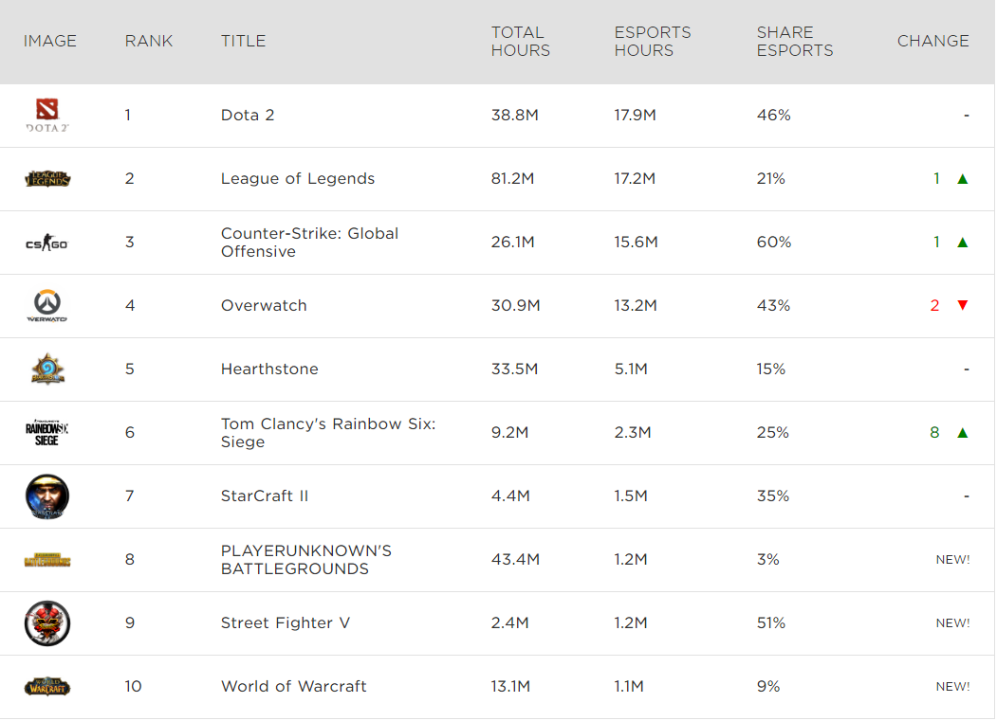
“The global eSports audience will reach 380 million this year, made up of 165 million dedicated eSports fans and 215 million occasional viewers” Alex Gray Senior Writer, Formative Content

What is a Sport? And a Game?
Before we can consider video games as a sport we have to go back and take a look at the roots of some of the definitions that most directly concern this topic. What is a sport? And a game?
Definition of “Sport”
Sport is a regulated activity, usually of a competitive nature, that can improve the physical condition of the person who practices it, and also has properties that differentiate it from the game. The Royal Spanish Academy, in its Dictionary of the Spanish language, defines sport as a "physical activity, exercised as a game or competition, whose practice involves training and compliance with standards"; also, in a second meaning, broader, such as "recreation, hobby, pleasure, fun or physical exercise, usually in the open air". On the other hand, the European Charter of sport defines it as: “All forms of physical activities that, through organized participation or not, aim at the expression or improvement of the physical and mental condition, the development of social relations or the obtaining of results in competition at all levels ". Institutionally, for an activity to be considered a sport, it must be supported by administrative and control structures that are responsible for regulating it (sports organizations). The British Wikipedia from also has its own definition from SportAccord.
According to the British Wikipedia and the Council of Europe, “a sport includes all forms of competitive physical activity or games which, through casual or organised participation, aim to use, maintain or improve physical ability and skills while providing enjoyment to participants, and in some cases, entertainment for spectators”. The British definition also defends that there are several types of sports involving the participation of several participants either individually against all others, by teams or competing as individuals against another player. In some sports such as car or motorcycle races, the participants face each other individually, simultaneously against the other participants, with a single winner. In others however, the contest or match is disputed between two sides and each side tries to exceed the other. A number of contests may be arranged in a tournament producing a champion. Many sports leagues make an annual champion by arranging games in a regular sports season, followed in some cases by playoffs.

However, the fact that any activity is not institutionally recognized as a sport does not prevent it from being so. Popularly, as it happens with rural sports or with alternative sports. Most definitions of sport define it as "physical activity", but there are activities of low or no physical exercise that are considered as sports by associations such as the IOC (International Olympic Committee), for example chess, or sports shooting, as it is thought that the concentration and mental abilities necessary to excel in them require a good physical form. On the contrary, there are strenuous physical activities that are not a sport, because they do not comply with other elements of the definition. Likewise, according to the International Olympic Committee, the practice of sport is a human right, and one of the fundamental principles of Olympism is that "every person must have the opportunity to practice sport without discrimination of any kind and within the Olympic spirit, which requires mutual understanding, solidarity and a spirit of friendship and fair play”.

Definition of “Game”
On the other hand, we have other definitions that most affect the subject "game." According to the Collins Dictionary a “game is an activity or sport usually involving skill, knowledge, or chance, in which you follow fixed rules and try to win against an opponent or to solve a puzzle”. As we can see, the very definition of the game refers to itself as a sport, so the link and similarities between these two definitions are undeniable, and this same source defends or defines games or game as an organized event in which competitions in several sports take place or even organized sports activities.
Also, if we take a look at definitions from other countries, we can find even more concordance between these two words. According to the Spanish Wikipedia a game is “a Physical or mental recreational activity in which two or more people compete by submitting to rules in order to provide entertainment or fun” and The DOSB (national sports organization of Germany) expresses in its preamble: “The exercise of sport must have to its own end a specific motor activity depending on the kind of sport. This specific motor activity does not exist especially for mental games”, apart from this also refers to that these games exercise some ability or skill, and this is something that we will mention later as one of the requirements that a videogame must have in order to become part of the competitive gaming industry and thus become an ESport.

Chess as a Sport
Once the two most directly linked words with the Esports are clarified, the relationship between games and sports is unchangeable. That is why if we take a look at another game considered a sport in most of the world, we might be able to find a lot of similarities to the eSports. In this case the game under analysis will be chess. Chess is a non-physical activity or game which is considered as a sport in more than 100 countries, one of those countries in which it is not considered a sport is UK, but before going into more detail in the reasons why This game is not considered a sport in the United Kingdom, what characteristics make chess into sport?

- It is competitive. The goal is to win. Chess involves a relentless fight against an opponent in chess the concentration and total focus means everything. Therefore, a failure as small as losing focus in a small fraction of time or a slight distraction can cause you to lose. This is something that in few games and sports happens and such is the impact and the importance of the concentration that the players must remain in a constant alert in a prolonged amount of time.

- It has a structure. The world championship has been organized since 1886 and continues to have a great tradition. Chess competitions are organized at all levels: schools, universities, cities, leagues, junior, senior, European, world, etc. In Spain, for example, there are about 30,000 federated: a number close to the number of people federated in Rugby
and only in England are more than six million people registered each year playing chess according to YouGov.
- It actually requires physical aptitude. The maximum mental condition requires being in good physical condition. Players must fully concentrate for many hours and for many days in official tournaments. As tension increases, blood pressure, pulse and respiration rates increase. The competitors for the world championships have nutritionists and physical trainers since they might expend even a week competing in a tournament which makes a good nutrition a crucial factor.
- It has a code of behavior. Mobile phones are prohibited for example. There is an anti-doping policy. And the rules of chess are complex and rigorous just like in any other sport.
- Olympic recognition. Chess has been recognized as a sport by the International Olympic Committee since 2000. It was one of the events at the Asian Games in 2006 in Doha and again in Guangzhou in 2010. It is also being considered for inclusion in the Pan American Games. Russia is trying to incorporate chess into the Winter Olympics. In addition, they have also tried to put in the Olympic games of Tokyo 20120 although they have been rejected.
- Chess is recognised as a sport in many European countries. Chess is recognized as a sport in 24 of the 28-member states of the European Union. The exceptions are the United Kingdom, Ireland, Belgium and Sweden. In Sweden, chess is likely to be included soon.

- Global game. Chess is played around the world regardless of age, race, sex, income or language. Blind people and people with physical disabilities play chess. Even people with advanced psychological illnesses play chess.
- Mental component All sports have a mental component. In short, competitive sports can be interpreted as strategy games that differ only in their physical manifestation.
- Player classification system. The player classification system was developed for chess in 1960 (the ELO system: mathematical method, based on statistical calculation, to calculate the relative ability of sports players such as chess) and has been adopted by many other worldwide recognized sports, including American football, baseball, basketball, hockey, korfball, rugby and golf. It is a very reliable system to measure the level of the players.

Once mentioned all the reasons why chess is considered a sport activity in many countries, especially European, you can see the similarities that this game has with many of those already officially recognized as sports by many of the official sports institutions such as are the International Olympic Committee or the European Sport Charter.
But even keeping so many aspects in common this popular activity is still unrecognized in the UK as a sport. Why isn’t Chess recognized as a sport in the United Kingdom? According to the ECF (English Chess Federation), Dominic Lawson one of the reasons why chess is not recognised as a sport in the UK is because it’s not perceived as part of the British culture. In the other hand, according to Miss Crouch Although the sports councils are currently reviewing elements of the recognition process, they do not intend to move away from the Council of Europe's definition of a sport "As chess is not a physical activity, it is not under consideration for recognition as a sport."
These two reasons seem to be the two most important reasons why chess is not even considered a sport in the UK along with the fact that it is difficult to get funding for the tournaments and support from brands that want to become the publishers of the clubs and players.

What turns a game into eSport?
Now that we have reviewed what factors turn a mental game into a sport in many areas of the world, let's compare it with competitive video games.
The eSports are, first of all, video games. But they have a series of 'unwritten' rules that differentiate them from the rest. So, if we want to know if we are facing an eSport or not, we should look at some specific aspects.
We could define eSports as the sports area of ​​video games, where people develop and train both physically and mentally with the aim of acquiring skills that allow them to compete professionally with other players. All games qualified as eSports meet a series of requirements 'unofficial' but recognized worldwide.
The first one is that all players must be on equal terms. This implies that the game is truly Free to Play. In other words, free from the dynamic Pay 2 Win in which players who invest more money are more likely to win the game. Thus, the weapon that will give the victory will be only the ability of the competitors.
And we say competitors because this is another premise; all eSport must have a competitive component that promotes the desire to excel. The excitement involved in the competition manages to create huge communities of players, another of the needs of eSports. Of course, all eSport videogames must allow direct confrontation between two or more participants either online or in person.

These games must incorporate constant updates to solve the balance problems that may arise (for example: a champion in League of Legends is winning all the games for being too strong). Caring for the operation of the game and readjusting different parameters is necessary for the game to evolve and not be monotonous by including new characters, mechanics or game modes. Therefore, all the games that aspire to be part of this industry fix, balance the content and add new patches, usually monthly or bimonthly so that the game in question is constantly developing and changing, see games like League of Legends (previously mentioned), Rainbow Six Siege, Smite, Counter Strike, Dota 2 and an extensive etc.
It could be able to be played locally but is often played online. These videogames match or “games” normally arouse the expectation among users, who become viewers through streaming platforms such as the famous Twitch.
But perhaps the most important thing for a game to be considered eSport is that it has a serious and regulated competitive league. Around an eSport must be created leagues and competitions organized by sponsors or companies from which the media echo. The best examples, the Superliga Orange (Orange Super Ligue, the Spanish Ligue), the ESL Masters Spain or the LCS EU, among others.

Those who rise the industry
Behind the competitive scene of an eSport videogame are a large number of people that make it possible to operate and profuse. We are referring to the agents that intervene in the electronic sports industry.
First of all we find, of course, each of clubs and professional teams. Clubs are nothing more than sets of teams dedicated to different games that come together under the same name. Their objective is to develop a good brand image by reaping achievements and, in some cases, winning even more competitions than those concerning football or basketball. And this is the reason why even some of the teams from the Champions League or the NBA are jumping unto the eSports to achieve glory also in this field. Another fundamental piece is the publishers, which are none other than the eSports videogame developers. Blizzard (Overwatch, Hearthstone), Valve (Counter-Strike, Dota 2) or Riot Games (League of Legends), among others, are responsible for supporting the game and introducing updates and constant updates. Also, in this bag enter the companies organizing events and competitive leagues.
Finally, we distinguish the bilateral agents or sponsors. That is, the brands. They are called bilateral because they sponsor both the teams themselves and the companies that organize the competitive tournaments. A fundamental support for the eSports industry has become what it is today.

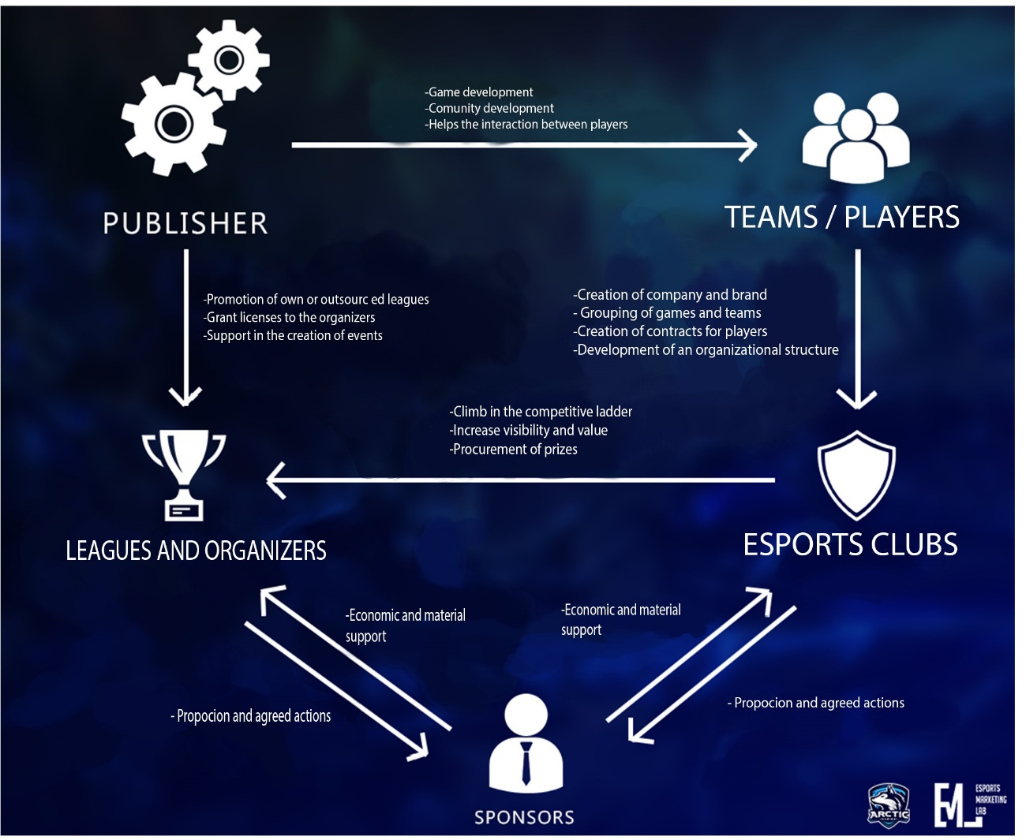
“Introduction to Esports” By Alvaro Lloret
Marketing & Sponsorship Executive | Esports Specialist at MKTG Spain
Translation by Aday Cejas Torres

The old days of competitive and multiplayer videogames
Even before all the above was possible, even before competitive games were dubbed as eSports, other, more crude methods were used to make a competitive video game community possible.
Competitive gaming is a global phenomenon that anyone can join. All you need is free time, a gaming computer, and a reliable internet connection. If you've got the drive and the dedication, you can join the best of the best. Plus, if you want it badly enough, you can make a living playing your favourite video games. However, competitive gaming and multiplayer gaming in general were not always the plug-and-play experiences they are now. Services like Heat.net, MPlayer (multiplatform media player), WON (World Opponent Network) and GameSpy paved the way, leading to the powerful, yet simple matchmaking and communications we enjoy on modern gaming platforms (all the names mentioned above refer to software’s for online videogames).
Before Steam, GOG, and dedicated matchmaking APIs (matchmaking API is a set of functions that enable users to find other users to play), things were a lot more frustrating. At the OS (Operative system) level, you had to make sure the right protocols were installed and configured correctly. Once you found the appropriate settings that allowed you to connect to anyone with a game, you would then have to contend with dial-up internet. After finally getting into a game, it was time to connect to your friend's game, typically by direct connection to their computer via UDP. Then, if you both managed to set your computers up correctly, you could play a game. To add to the frustration of this process were the plethora of driver issues, incompatible hardware, and the fact that every game had its particular way of handling multiplayer connections.

GameSpy, Mplayer and Heat.Net
By the late nineties, several services were emerging that would take some of the frustration out of playing online and allow for the competitive scene to develop. Mplayer and GameSpy were two of the first companies to offer a middleman solution for online PC multiplayer. Both launched in 1996 and initially centred around offering a way for players to find Quake servers. However, they quickly expanded to providing online services for many popular PC games of the era.
SegaSoft launched Heat.net in 1998 as a competitor to GameSpy and Mplayer, but focused more on community features, including one of the first competitive gaming leagues. HeatCIGL (College Internet Game League) involved students from over 1,000 colleges competing in Unreal Tournament and Quake II for a $5,000 grand prize. HeatCIGL was a forefather of today’s competitive gaming teams, and even though Heat.net and HeatCIGL shut down on October 31, 2000, they were pioneers of the competitive gaming world, and we can still see their influence today

Electronic Sports
Now that’s its clear what a game should have to be considered an electronic sport but, is it right to call them sports? Some make it clear: they are full-fledged sports. Despite this, the debate on the matter is quite controversial.

This arises from the erroneous conception that there must be a merely physical effort for something to be considered a sport. However, chess, poker or billiards are activities recognized as sports in many counties where the mental factor makes a difference.

In fact, professional eSports players maintain strict physical and psychological training. Apart from exercising body and mind, usually spend most of the time living together and even come to maintain certain diets.
Governments like the German or the American recognize professional gamers as athletes or, rather, cyber athletes. Even Olympic Committees, like the Korean one, have granted eSports the rank of Olympic sport.
And is that eSports require a sacrifice similar to any other sport. Professional gamers dispense many aspects of their private lives and leisure to be able to give what it takes to succeed and win victories with their teams.

A fast-growing sector
We cannot deny that the eSports sector is growing at dizzying levels. A study published in November by Newzoo (the global leader in games and esports analytics) showed the enormous economic growth that this industry is experiencing. Two months after the end of the year revealed that the volume of revenue was already 34% more than in 2016. And is that electronic sports have moved about 660 million dollars in 2017.
Two months after the end of the year Newzoo revealed that the volume of revenues was already 34% more than in 2016. Electronic sports have moved close to 660 million dollars in 2017.
These results seem to increase as the months pass, and Newzoo predicts that by 2020, electronic sports will generate a volume of revenues of close to 1.5 billion dollars.
(All the percentage data above was taken from “2016 GLOBAL ESPORTS MARKET REPORT” by Newzoo.

What countries consider eSports videogames as actual sports?
That eSports are increasingly a booming phenomenon is a fact. With millions of spectators following the competitions and tournaments, with the final of the League of Legends World Cup seen by 36 million people, with players signing millionaire contracts and with brands and companies entering to sponsor teams, the regulation of this sector is an issue that It is beginning to take more into account in more and more countries. Many countries have already taken the decision, through their regulatory bodies, to elevate eSports to the category of sport, so that they can be contemplated through the same legislations as traditional sports. Countries such as Taiwan, Austria, or Malaysia, among many others, are some of the nations that already have regulation for electronic sports.

South Korea
The Korean case is the paradigmatic one. Electronic sports are a phenomenon that paralyzes the country and the skills can be seen even through traditional television. It is no wonder then that the Korean government decides to support e-sports and the creation of the Korean Electronic Sports Association (KeSPA), which regularly engages in this activity and the rights of professional players. In 2014, the University of South Korea also became the sport as sport, sports in sport, sports and flexibility in the schedule. Soccer or basketball.

China
China has also been among the first to join the regulation of electronic sports. Together with the Chinese eSports Association (ACE), the government created in the KeaHoarl association, a project dedicated to supporting the industry and players. In this way, people who want to dedicate themselves to the professional competition of eSports find in KeaHoarl a point where they can learn and develop as players, receiving classes and training by professionals. In addition, this association also aims to change the perception of Chinese society on eSports, since there are still many prejudices that make taking the life of a professional electronic sports player not an easy decision.

For its part, the ACE (Association of Chinese Esports) and its subsidiaries are responsible for regulating the competition and may even fine or prohibit participation in competitions of Chinese players if they have missed any regulations.

France
The neighbouring country has taken important steps at the beginning of this year to professionalize electronic sports through the creation of a body called France eSports. According to the French Minister Axelle Lemaire, this institution will act as a body representing the interests of the sector in its relations with the French government and will be a member of the National Olympic Committee. The creation of France eSports also allows regulation of the rights of French professional players, framing their activity within the French Labour Code and thus protecting competitors against abusive clauses. Of course, the actual effectiveness of France eSports is still subject to the approval of the so-called Numerical Law. Meanwhile, the organization will operate as a representation and pressure group in the struggle to recognize eSports.

Sweden
The Nordic country is in a situation similar to South Korea. The world of e-sports has been well received in a country where indoor sports are very common. Public television collaborates regularly with eSports events, broadcasting tournaments and matches, and private media also closely follow this activity.
The last step of Sweden has been to implement, on an experimental basis, subjects in its public schools related to electronic sports. Swedish students will receive three hours of classes a week, where theoretical and practical content will be mixed, and they will have the opportunity to participate in their own competitions.

Russia
The Russian Federation has been one of the last countries to join the recognition of eSports. On June 2016, the Russian Minister of Sports has issued an order to give the same level of recognition to electronic sports as to traditional ones. The "Sports for PC", the denomination they receive there, were already semi-official for a couple of years, but with this order their official status is beyond doubt. Once again, this will allow Russian players to have greater protection of their rights and facilities when traveling to participate in different competitions

The IOC and the eSports
As we can see above, the fame of these competitive video games is in a growing state which is getting the acceptance of this activity as an official sport, but the countries are not the only ones that are beginning to show interest in eSports.
Through a statement, the International Olympic Committee has established, for the first time in history, that video games, best known in the sports field as eSports, are considered sports. The players' struggle to demonstrate that the virtual world was just as competitive as other reals has had its prize. The IOC drew up a statement in which it made its decision effective and urged the federations to agree to even have an Olympic presence:
“eSports are growing a lot, especially among young people from different countries, and can be a platform compatible with the Olympic Movement. The competition in eSports can be considered a 'sporting activity', and players prepare and train with an intensity that can be compared to that of athletes of traditional sports. In order to be recognized as a sport by the IOC, the content of eSports must not infringe Olympic values. A greater recognition by the IOC necessarily implies that there is an organization that guarantees that the rules of the Olympic movement (anti-doping, betting, manipulation, etc.) are complied with” (Owen S. Good 2017)
As the IOC mentions, even if they consider eSports to be true sports, they still have to fulfill certain types of conditions so that they can be included in the same Olympic Games. In order for the IOC to recognize them as a sport, the content of the eSports must not infringe the Olympic values. Also, A greater recognition by the IOC implies the existence of an organization that guarantees that the rules of the Olympic Movement (anti-doping, gambling, cheating, etc.) are complied with.

This is clearly a small step for eSports to be recognized as something else than just games. The IOC states that eSports can indeed be treated in a certain way as a sport, or as a "sports activity", to be exact. However, the existence of the two main requirements complicates the complete acceptance and arrival at the Olympic Games. Soccer and basketball, yes; shooters and MOBA, no; Sports video games such as FIFA, PES or NBA 2K could fall within the requirements by not infringing the Olympic values. Others would have to be eliminated from the equation, such as League of Legends, CS: GO, Call of Duty, etc. Any videogame that has some violence would not be considered an Olympic sport. It also seems complicated that publishers accept the creation of a federation (national or international) that writes some rules over their own products. However, if all the conditions were ever met, the IOC has opened the door for eSports to reach the Olympic Games

Is it therefore a lack of standardised rules stopping officially recognition of esports as a sport?
Institutionally, for an activity to be considered a sport, it must be supported by administrative and control structures that are responsible for regulating it as we have seen (sports organizations). The fact that any activity is not institutionally recognized as a sport does not prevent it from being so.
Most of the definitions defend that sports in general refer to physical activities, however there are some associations that consider activities of little or no type of physical activity as sports, for example chess or sports shooting, since the concentration and mental ability in these types of activities play a fundamental role as it is thought that the concentration and mental abilities necessary to excel in them require a good physical form.
However, no type of institution like the IOC or the Sport Council decides what is and what is not a sport. Each organization has its own definition of what each of them considers as a sport. The Sports Council for example defends that for an activity to be considered as a sport it must have some kind of physical effort or human physical skill.

“Sport means all forms of physical activity which, through casual or organised participation, aim at expressing or improving physical fitness and mental well-being, forming social relationships or obtaining results in competition at all levels.”

Conclusion

The differences between the different official associations of sport like the international Olympic committee, the sports council, The European Charter of Sports, The National Sports Organization of Germany, and the rest of them, make clear that there is no official definition worldwide recognized. Some associations defend that physical activity is a compulsory requirement for an activity to be considered as a sport while others assure that activities with a great use of intelligence and mental ability can be considered as a sport, but for that they need to be organized and controlled by institutions. In addition, the fact that certain activities or games are not recognized as sports by any of these associations or by any of them at all does not stop an activity of being so. The fame and the world success are what seems to make certain activities happen to be recognized as a sport, this is the case of the two examples that we have studied in this document, chess or the eSports themselves. The fact that has led them to receive some type of recognition by the associations is the recognition and worldwide interest in these activities. In the case of the latter, the eSports, it is clear that they move a big amount of money in many industries already mentioned (stream platforms, bets, sponsors, brands, etc.) what seems to have been the attention of these associations among other things. In addition to this last, another reason why competitive videogames are beginning to make a dent in the world of professional and recognized sports is the organization they have in teams and tournaments, and the amount of audience they attract.
In addition, it is undeniable that they promote the sporting spirit, and this can be seen reflected in the type of training they use, being very similar to those performed by professionals in other sports, dedicating their lives entirely to what they do, with long and hard workouts, those that require a balanced diet and a healthy body. In the tournament, a healthy rivalry among can take place and the great events that take place to celebrate their tournaments reflect the seriousness with which brands and teams take this industry, besides investing a lot of time, money and effort into it.
It is because of all this that we can finally say that videogames are a sport, one that is still in the process of development since it does not even have anti-doping regulations in the majority of games, among other things, but in the end it It's about an industry that is still growing and becoming popular with young people and new generations with the help of even some countries and organizations.

Image Bibliography
Gray, A. (2018). The global eSports audience will reach 380 million this year, made up of 165 million dedicated eSports fans and 215 million occasional viewers.. [image] Available at: https://www.weforum.org/agenda/2018/07/the-explosive-growth-of-esports/ [Accessed 27 Oct. 2018].

Giner Lloret, Á. (2018). “Introduction to Esports”. [image] Available at: https://www.linkedin.com/in/alvaroginerlloret/?originalSubdomain=es [Accessed 30 Oct. 2018].

Bibliography
Jurre Pannekeet (2018) Newzoo: Global Esports Economy Will Reach $905.6 Million in 2018 as Brand Investment Grows by 48% | Newzoo. [Online] Accessible at:https://newzoo.com/insights/articles/newzoo-global-esports-economy-will-reach-905-6-million-2018-brand-investment-grows-48/
En.wikipedia.org. (2018). Swedish Chess Federation. [online] Available at: https://en.wikipedia.org/wiki/Swedish_Chess_Federation [Accessed 01 Oct. 2018].
Es.wikipedia.org. (2018). Juego. [online] Available at: https://es.wikipedia.org/wiki/Juego [Accessed 1 Oct. 2018].
Es.wikipedia.org. (2018). Deporte. [online] Available at: https://es.wikipedia.org/wiki/Deporte [Accessed 1 Oct. 2018].
En.wikipedia.org. (2018). Sport. [online] Available at: https://en.wikipedia.org/wiki/Sport [Accessed 2 Oct. 2018].
Collinsdictionary.com. (2018). Game definition and meaning | Collins English Dictionary. [online] Available at: https://www.collinsdictionary.com/dictionary/english/game [Accessed 2 Oct. 2018].
Elvar, P. (2018). Deporte - Instituto Internacional de Ciencias del Ejercicio Físico y Salud. [online] Grupo Sobre Entrenamiento (G-SE). Available at: https://g-se.com/deporte-bp-W57cfb26e3aef1 [Accessed 3 Oct. 2018].
LoL Esports. (2018). FLASHBACK | 2018 Worlds Finals Recap. [online] Available at: https://eu.lolesports.com/en/articles/flashback-2018-worlds-finals-recap [Accessed 8 Oct. 2018].
McConnell, K. (2018). Olympic Movement esports and gaming communities meet at the Esports Forum - Olympic News. [online] International Olympic Committee. Available at: https://www.olympic.org/news/olympic-movement-esports-and-gaming-communities-meet-at-the-esports-forum [Accessed 8 Oct. 2018].
Newzoo. (2018). Newzoo's 2018 Global Esports Market Report | Light. [online] Available at: https://newzoo.com/insights/trend-reports/global-esports-market-report-2018-light/ [Accessed 11 Oct. 2018].
Samson, V. (2018). ¿Llegará el ajedrez a ser deporte olímpico?. [online] Noticias de ajedrez. Available at: https://es.chessbase.com/post/ajedrez-deporte-olimpico-si-o-no-2017 [Accessed 11 Oct. 2018].
Mundo Deportivo. (2018). Tokio 2020 presenta los 26 nuevos deportes aspirantes a ser olímpicos. [online] Available at: https://www.mundodeportivo.com/juegos-olimpicos/20150612/20440560257/tokio-presenta-los-nuevos-deportes-aspirantes-a-ser-olimpicos.html [Accessed 12 Oct. 2018].
MARCA.com. (2018). Otros deportes: Tokio 2020 presenta los 26 nuevos deportes aspirantes a ser olimpicos - MARCA.com. [online] Available at: https://www.marca.com/2015/06/12/mas_deportes/otros_deportes/1434102498.html [Accessed 15 Oct. 2018].
Dennys, H. (2012). AGON releases new chess player statistics from YouGov. [online] World Chess Federation. Available at: https://www.fide.com/component/content/article/1-fide-news/6376-agon-releases-new- [Accessed 15 Oct. 2018].
News, L. and News, S. (2018). Chess' inclusion in 2020 Tokyo Olympics would be great, says India's Viswanathan Anand ahead of Olympiad - Firstpost. [online] Firstpost. Available at: https://www.firstpost.com/sports/chess-inclusion-in-2020-tokyo-olympics-would-be-great-says-indias-viswanathan-anand-ahead-of-olympiad-5230231.html [Accessed 19 Oct. 2018].
Daniel Santoro, O. (2010). ¿Es el ajedrez un deporte?. [online] Isde.com.ar. Available at: http://www.isde.com.ar/ojs/index.php/isdesportsmagazine/article/viewFile/38/48 [Accessed 20 Oct. 2018].

Dinic, M. (2017). Poll in UK and US: Most people don’t see chess as a sport. [online] Medium. Available at: https://medium.com/@BCMChess/poll-in-uk-and-us-most-people-dont-see-chess-as-a-sport-575aa97e63f5 [Accessed 20 Oct. 2018].

Chess.com. (2017). How Many Chess Players Are There In The World?. [online] Available at: https://www.chess.com/article/view/how-many-chess-players-are-there-in-the-world [Accessed 25 Oct. 2018].

Löffler, S., Marsh, S. and Wandowicz, K. (2018). Chess and Society | London Chess Conference 2018. [online] Londonchessconference.com. Available at: https://londonchessconference.com/category/chess-and-society/ [Accessed 11 Dec. 2018].
Chess News. (2007). Chess and Nutrition – how to feed a chess grandmaster. [online] Available at: https://en.chessbase.com/post/che-and-nutrition-how-to-feed-a-che-grandmaster [Accessed 28 Oct. 2018].

NEWZOO ESPORTS. (2016). 2016 GLOBAL ESPORTS MARKET REPORT. [online] Available at: http://resources.newzoo.com/hubfs/NEWZOO_Free_2016_Esports_Market_Report.pdf) [Accessed 12 Nov. 2018].

Anon, (2018). Hier ist Facebook. [online] Available at: https://www.dosb.de/ueber-uns/#akkordeon-12384 [Accessed 11 Nov 2018].
Miller, J. (2016). Biochemistry in chess.. [online] Omics International. Available at: https://www.omicsonline.org/open-access/biochemistry-and-psychology-of-chess-and-classical- [Accessed 31 Oct. 2018].

Omicsonline.org. (2015). Journal of Sports Medicine & Doping Studies. [online] Available at: https://www.omicsonline.org/open-access/biochemistry-and-psychology-of-chess-and-classical-physical-exercise-concurring-or-conflicting-evidence-2161-0673-1000158.pdf [Accessed 1 Nov. 2018].

Markushin, Y. (2010). Chess diet: eat or play?. [online] Thechessworld.com. Available at: https://thechessworld.com/articles/healthpsycology/chess-diet-eat-or-play/ [Accessed 2 Nov. 2018].

Muñoz, D. (2018). Cambios en la normativa FIDE - El árbitro podrá cachearte. [online] TheZugzwangBlog. Available at: https://thezugzwangblog.com/cambios-en-la-normativa-fide/ [Accessed 4 Nov. 2018].

Ross, D. (2007). Arpad Elo y el sistema de puntuación Elo. [online] Noticias de ajedrez. Available at: https://es.chessbase.com/post/arpad-elo-y-el-sistema-de-puntuacin-elo [Accessed 4 Nov. 2018].

Chessgraphs.com. (2018). ChessGraphs.com - Lookup, graph and compare chess ratings - FIDE, USCF, or URS - for any player. [online] Available at: https://www.chessgraphs.com/ [Accessed 5 Nov. 2018].

Eloratings.net. (2018). World Football Elo Ratings. [online] Available at: http://www.eloratings.net/ [Accessed 7 Nov. 2018].

Liquipedia StarCraft 2 Wiki. (2018). Korea e-Sports Association. [online] Available at: https://liquipedia.net/starcraft2/Korea_e-Sports_Association [Accessed 7 Nov. 2018].
Database.esportsobserver.com. (2018). TEO Professional. [online] Available at: http://database.esportsobserver.com/company/korea-e-sports-association-kespa [Accessed 7 Nov. 2018].
Korea.net. (2012). South Korea, the Mecca of e-Sports : Korea.net : The official website of the Republic of Korea. [online] Available at: http://www.korea.net/NewsFocus/Sci-Tech/view?articleId=100629 [Accessed 10 Nov. 2018].

DOTALAND.net. (2013). ACE Alliance’s King makes statement. [online] Available at: https://dotaland.net/2013/08/30/ace-alliances-king-makes-statement/ [Accessed 10 Nov. 2018].

Parte, R. (2017). Association for Chinese esports Archives - TalkEsport. [online] TalkEsport. Available at: https://www.talkesport.com/tag/association-for-chinese-esports/ [Accessed 13 Nov. 2018].
Peña, E. (2013). Nace KeaHoarl, un paso más para los eSports chinos - MeriStation. [online] MeriStation. Available at: https://as.com/meristation/2014/03/25/noticias/1395760440_129688.html [Accessed 13 Nov. 2018].
Mythili, S. (2017). ACE (Association for Chinese Esports) bans former Wings players for life. [online] Dire Dota. Available at: https://diredota.com/2017/05/17/ace-association-chinese-esports-bans-former-wings-players-life/ [Accessed 20 Nov. 2018].
Bergerot, B. (2017). France Esports, la CCI du Pays d’Arles et Stakrn organisent la première journée professionnelle Esport & Formations - France Esports. [online] France Esports. Available at: https://www.france-esports.org/france-esports-la-cci-du-pays-darles-et-stakrn-organisent-la-premiere-journee-professionnelle-esport-formations/ [Accessed 20 Nov. 2018].
Barberá, A. (2017). La regulación de los eSports en Francia. [online] IUSPORT: EL OTRO LADO DEL DEPORTE. Available at: https://iusport.com/art/44457/la-regulacion-de-los-esports-en-francia- [Accessed 20 Nov. 2018].
Ruiz Bobillo, A. (2017). Francia avanza en la regulación de los esports. [online] AS.com. Available at: https://as.com/esports/2017/05/12/mas_esports/1494583195_005361.html [Accessed 20 Nov. 2018].
Thelocal.se. (2018). Five reasons Sweden is so good at eSports. [online] Available at: https://www.thelocal.se/20180808/five-reasons-sweden-is-so-good-at-esports [Accessed 24 Dec. 2018].
Sportni.net. (n.d.). What is a Sport? - Sport NI. [online] Available at: http://www.sportni.net/performance/governing-bodies/recognition/what-is-a-sport/ [Accessed 26 Nov. 2018].

Esports.xataka.com. (2016). La espantada de tres grandes equipos a pocos días del comienzo de la DreamLeague. [online] Available at: https://esports.xataka.com/dota-2/la-espantada-de-tres-grandes-equipos-a-falta-de-cinco-dias-para-el-comienzo-de-la-dreamleague [Accessed 24 Nov. 2018].
Polygon. (2017). Olympic committee lays out expectations for esports’ inclusion. [online] Available at: https://www.polygon.com/2017/10/29/16566528/olympics-ioc-statement-esports [Accessed 25 Nov. 2018].
Red Bull. (2018). The Gaming Industry - Lecture & Panel Discussion. [online] Available at: https://www.redbull.com/se-en/gaming-industry-ewknd [Accessed 26 Nov. 2018].
Moosa, T. (2017). eSports are real sports. It’s time for the Olympic video games | Tauriq Moosa. [online] the Guardian. Available at: https://www.theguardian.com/commentisfree/2017/aug/11/esports-olympic-video-games-ioc-gaming [Accessed 26 Nov. 2018].
Gosu Gamers. (2015). eSports como asignatura en institutos de Suecia. [online] Available at: http://www.gamingesports.com/actualidad-esports/masesports/esports-como-asignatura-en-institutos-de-suecia/ [Accessed 26 Nov. 2018].
Staaf, L. (2015). Certain Swedish high schools add 3 hours of eSports classes a week. [online] Gosugamers.net. Available at: https://www.gosugamers.net/news/32120-certain-swedish-high-schools-add-3-hours-of-esports-classes-a-week [Accessed 26 Nov. 2018].
Anton, M. (2015). Los adolescentes suecos podrán estudiar una asignatura sobre deportes electrónicos. [online] cuatro.com. Available at: https://www.cuatro.com/blogs/vig/suecia-asignatura-eSports-deportes-electronicos-videojuegos_6_2033415003.html [Accessed 28 Nov. 2018].
Anon, (2018). [online] Available at: https://www.linkedin.com/company/russian-esports-federation/ [Accessed 28 Nov. 2018].
Cooke, S. (2018). Russia’s Minister of Sport recognises esports at St. Petersburg Economic Forum. [online] Esports Insider. Available at: https://esportsinsider.com/2018/05/russias-minister-of-sport-recognises-esports-at-st-petersburg-economic-forum/ [Accessed 29 Nov. 2018].
Stubbs, M. (2018). How Epicenter transformed the Moscow esports scene. [online] Redbull.com. Available at: https://www.redbull.com/sg-en/moscow-esports-scene-epicenter-interview [Accessed 30 Nov. 2018].

