Database Assignment – ACCA4023
Benjamin Bramwell - 2225602
I have created tables using Microsoft Access to store data in regards to Northern Light Pvt LTD needs and requirements. In the employees table, I have created the necessary fields and columns required.
Here is the Employees table I have created. 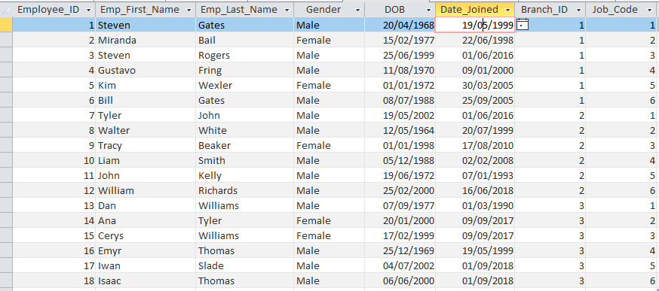
As you can see, I have created a field for the Employee Id, their first and last name, gender, Date of Birth, Date joined, what branch they work at and what their job role is. This table contains all the necessary data to be linked to the other tables within the database.
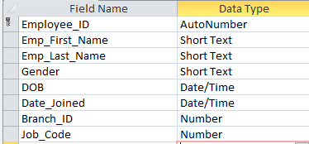Here you can also see that I have set each field type correctly within the Employees table.

Below is the Branch Table I have created.
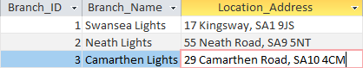 Here is the branch Table. It contains the necessary fields, such as an ID, location and name. This table links to the employee table through the foreign key – primary key relationship with the Branch_ID column.
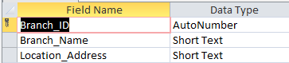Here you can see I have set each field type correctly within the Branch Table

Below is the JobsDetails table I have created.
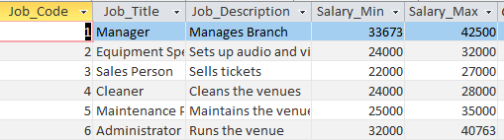 Here is the Job_Details table, this links to the employee table via the foreign key – primary key relationship with the Job_Code column. This table contains the necessary fields, such as: An ID, Job Title, Job Description, and also a salary range.
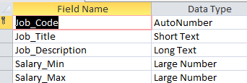Here you can see I have set each field type correctly withing the Job_Details table.
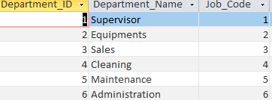Here is the departments table I have created. This table is linked to the Job_Details table via the Job_Code column. This table contains a column for the ID, a column for the department and also a column for the Job Code which links the job to the correct department.
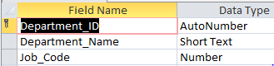Here you can see that I have set each field type correctly within the Departments table in the database.

Here is the customer Table I have created. This table tracks the customer’s names, their location and also assigns them an ID to track them.
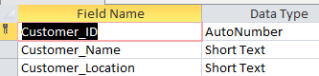Here you can see that in the Customers table within the database, I have set each field type correctly to store the correct type of Data

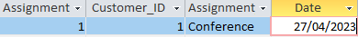Here is the Assignments table. This table tracks which customer wants what type of product from Northern Lights. This table stores the type of product, gives it a unique ID and also links it to a Customer’s ID, which allows us to see what customer wants what product and the date they require it.
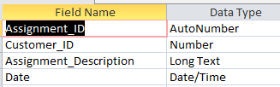Here you can see that within the Assignments table in my database, I have set each field type to the correct type in order to store the required data correctly.
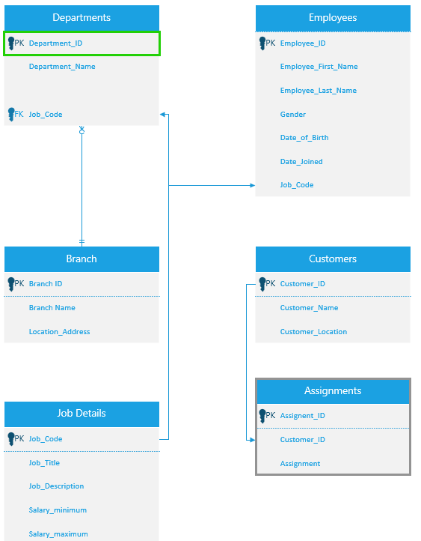Here is the Relationships Table created within Microsoft Visio, this shows the different tables, their fields and what particular field links the tables

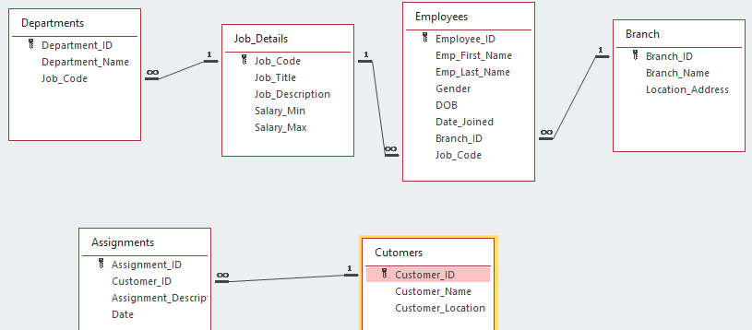This is the relationships between all the tables, as you can see they are linked appropriately and have been linked by the correct column in each tab

