
Assessment 1
Title: Report on Amul

Name: Aayushy Pradipkumar Patel
Student ID: 2503361
Module Name: International Business Concepts
Module Code: LCMB7034
Lecturer’s Name: Gladius Kulothungan
Word Count: 5077

Term 2

Table of Contents
Section 1 3
1. Introduction to the report 3
2. Industry and country overview 3
a. Introduction of the dairy industry in India 3
b. Size, scope, and economic importance 4
c. Major domestic and multinational firms within the dairy industry 5
3. Application of Porter’s Diamond Model to critically analyse the global competitiveness of the dairy industry 6
4. Amul operates in India, and a critical analysis of factors impacting the company's operations in India 9
5. Conclusion 17
Section 2: Reflection 18
References 22

Section 1

1. Introduction to the report
The report aims to critically evaluate international business concepts of Amul, a popular Indian dairy company owned by the Gujarat Cooperative Milk Marketing Federation (GCMMF). The report will provide a detailed description of the Indian dairy industry to provide an overview of the market environment of the dairy sector. Describing the market size, scope, and economic significance of this industry will offer insights about this sector as well as the company. It will be followed by the identification of the local and multinational firms within this industry, which will help in evaluating the positioning of the key competitors. It will lead to a comparison of the strategies, performance, market segments, and positioning of each brand. Porter’s Diamond Model will be applied to examine the global competitiveness of the Indian dairy industry. Amul, being a major foreign company, will be evaluated to comprehend the factors that contribute to its success.

2. Industry and country overview

a. Introduction of the dairy industry in India
The chosen industry is dairy and the country is India, as the Indian dairy sector is the cornerstone of the national economy. It contributes approximately 5% to the country's GDP and supports over 80 million dairy farmers (PIB, 2025). As per the reports of 2025-2026, India has a concrete position as the largest milk producer in the world, accounting for 23-25% of global output. Key statistics have revealed that the milk production volume in India is estimated to be 248 million tonnes in FY 2024-25 (Mohan, 2025). The industry has been able to maintain its robust annual growth rate of nearly 4-6% to significantly outpace the global average. The availability of milk in India has risen to 485 g/day, which exceeds the global average of 322 g (FNB News, 2025).
The Indian dairy sector is characterised by a unique Cooperative Model, used by leading Indian brands like Amul and Nandini. These two companies are reportedly managing over 60% of the organised milk market of India (PIB, 2025). Conversely, the industry is largely fragmented as it involves millions of small-scale farmers. The major growth drivers of this market are urbanisation, rising per-capita income, and the shift towards value-added products (VAPs). The VAPs include cheese, paneer, and yogurt that work as major catalysts, and this particular segment is growing at 10-12% annually (FNB News, 2025). Therefore, the government has allocated approximately ₹7,544 Crore to the Animal Husbandry, Dairying, and the Ministry of Fisheries in the Budget 2025-26 (Indian Dairy Association, 2025).

b. Size, scope, and economic importance
The dairy industry of India has evolved into an international powerhouse that serves as the largest agricultural commodity in this country. This sector has transitioned into a surplus-driven economic engine from a deficiency-led sector that can be defined by its social impact and massive scale (Parzonko et al. 2024).
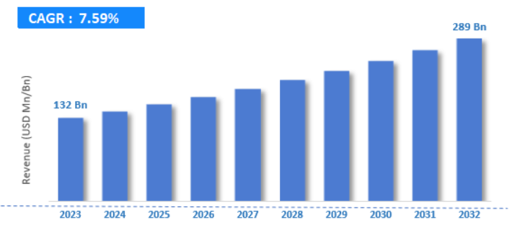
Figure 1: Indian dairy market size 2023-2032
(Source: Zion Market Research, 2026)
Figure 1 expresses the market size of the Indian dairy sector, showing an evaluation of $132 billion in 2023 (Zion Market Research, 2026). It is expected to reach $289 billion by 2032 with a CAGR of 7.59% between 2024 and 2032. As the leading global milk producer, the estimated output of the sector was around 24-25% of the total global milk production (PIB, 2025). The market value of the organised milk market is nearly ₹21.3 trillion in 2025, which is projected to reach ₹57 trillion by 2033 with a CAGR of 12%.
From the point of view of economic scope and structure, this sector alone contributes to 25-30% of the total agricultural GDP and 5% of the Indian national GDP (PIB, 2025). The Indian organised sector handles nearly one-third of the marketable surplus. A huge corporation network of 241 district unions and 22 federations leads this sector. They ensure that 80% of the consumer price is provided to the farmers due to the usage of the cooperative model. In terms of product diversification, the liquid milk market dominates with around 62% market share, and it is expanding the industry's scope into VAPs.
Dairy products are regarded as a "shock absorber" for the rural economy as they provide a daily and stable income stream, rather than a seasonal crop nature. The Indian dairy sector supports approximately 80 million rural households, and for marginal farmers, dairy contributes to 30% of their total household earnings (NDDB, 2022). From the viewpoint of employment and gender empowerment, the Indian dairy workforce constitutes of 70% women workers. This industry works as a key driver of female financial independence, as there are over 48,000 dairy cooperative societies led by women (PIB, 2025). Milk, being one of the primary sources of protein, is consumed by a large vegetarian population, and this industry is addressing vital social issues like malnutrition to support public health goals.

c. Major domestic and multinational firms within the dairy industry
Major firms in the Indian dairy industry are Amul (GCMMF), leading the market with an annual turnover of $7 billion, followed by regional powerhouses like Nandini (KMF) and Mother Dairy (Rupera, 2025). Besides, there are private and multinational players like Heritage Foods and Hatsun Agro, along with Britannia and Nestlé India.
Company | Strategy | Market segment | Performance/ positioning
Amul | Mass-market penetration using a robust cooperative network | Mass market | This company holds the highest volume, being the market leader.
Nestlé | Health-focused innovation and premiumisation | Urban or premium | Positioned as a global wellness and nutrition leader with high margins.
Parag Milk | Focus on farm-to-table and value-added niche brands | Premium or niche | Leader of the cheese segment and targets high-income urbanites.
Hatsun Agro | Vertical integration and aggressive retail expansion | Southern India | Strong regional dominance, being the largest private dairy, and having cold-chain efficiency (Patvardhan et al. 2026).
Mother Dairy | “Democratizing’ protein-rich dairy and multi-category expansion. | National with the strongest position in the North | Aims to exceed a revenue of ₹20,000 crore by FY26 with a push into high-protein variants and value-based products like curd and paneer.
Table 1: Relative positioning and strategy of key dairy firms in India
(Source: Influenced by Patvardhan et al. 2026)
Table 1 compares the positioning of key companies in the Indian dairy market based on their strategies, market segments, and positioning.

3. Application of Porter’s Diamond Model to critically analyse the global competitiveness of the dairy industry
The analysis of the global competitiveness of the Indian dairy industry needs to consider its status beyond the world's largest producer. The Diamond Model helps in identifying if India is dominating sustainable competitive advantages or being a functional scale.
1. Factor conditions
The factor conditions of India are a combination of significant structural challenges and immense natural resources.
Basic factors: Bovine population in India is the largest among all global countries, and the tropical and sub-tropical climate allows the country to produce a wide range of dairy breeds (Toksoy and Karamelikli, 2026). The country also produces a large amount of milk globally, which accounts for over 230 million tonnes annually, offering a massive raw material base.
Advanced factors: The dairy industry faces challenges in this context as the National Dairy Development Board (NDDB) has enhanced artificial insemination and genetic breeding (NDDB, 2026). However, the industry is still struggling with the inconsistent electricity and fragmented “cold chain” in rural areas. This sector is thus rapidly adopting milk-testing IoT devices and digital payment systems at village collection centres. It represents an escalating created advantage in data-driven procurement.
2. Demand conditions
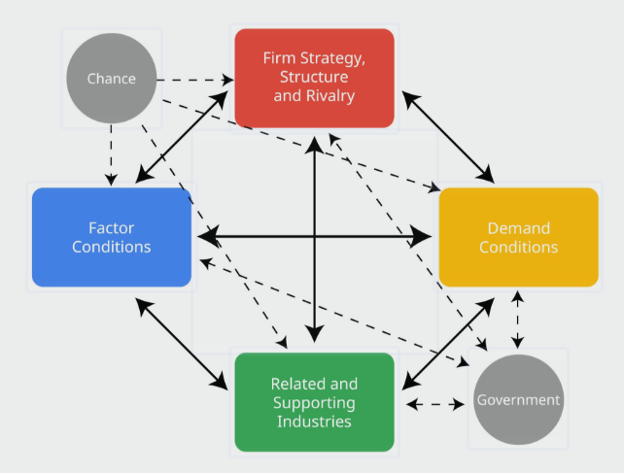
Figure 2: Four attributes of a nation to create a competitive advantage
(Source: Influenced by Constantin et al. 2022)
Figure 2 presents the major attributes of a country to obtain a competitive edge, as the nature of the home market acts as a key driver for innovation.
Sophisticated buyers: In global dairy markets like the EU, consumers prefer high standards of organic certification, animal welfare, and traceability (Constantin et al. 2022). This creates domestic pressure and forces the dairy industry and firms to innovate in “clean label” processing and sustainable farming.
Anticipating global trends: Though the domestic market of New Zealand is small, it is highly sensitive to the nutritional needs of the Asian market (Worku et al. 2024). This market develops specialised products, such as milk powders at home and high-protein infant formulas, to gain a first-mover advantage globally.
3. Related and supporting industries
The world dairy industry is dependent on a cluster of other supporting sectors. For instance, the existence of specialised feed manufacturers, veterinary services, and dairy processing equipment engineering ensures that dairy producers obtain immediate access to high-quality inputs (Bankova and Tsvetanova, 2024). Besides, this industry also collaborates with research bodies and agricultural universities, like Teagasc in Ireland. It assists in ensuring that the current research in dairy and soil science processes rapid commercialisation to develop a self-reinforcing cycle of efficiency.
4.Firm strategy, structure, and rivalry
International success of companies is determined by the way that firms organise themselves and the intensity of the local competitors. Many global dairy leaders, such as Arla and Fonterra, use the Cooperative Model or structure (Toksoy and Karamelikli, 2026). This structure perfectly aligns with farmers' needs with the processors and allows them to invest strategically for the long term, which might be avoided by a purely profit-driven model. In terms of domestic rivalry, intense competition for supermarket shelf space and milk supply forces local competitors to enhance operational efficiency (Constantin et al. 2022). Hence, such pressure in the home markets to match global standards prepares them to compete in the global markets.
The Diamond Model has government policy and chance events as supporting factors. For instance, government policies can impact the above four determinants both positively and negatively by acting as a catalyst (Militaru et al. 2025). It improves national competitiveness, and chance events can be regarded as uncontrollable events, such as wars, pandemics, and scientific breakthroughs. Such events might disrupt the dairy industry and reshape the competitive edge.
Government policy and chance events for the global dairy industry
Porter’s model identifies two external variables beyond the four major pillars that affect the diamond. In the Indian dairy industry context, government policies act as catalysts. The government has introduced initiatives like the National Programme for Dairy Development (NPDD), which is shifting its focus from mere production to quality-driven exports (DAHD, 2026). This initiative provides subsidies for the technical training and “cold chain” infrastructure. The Indian government is also attempting to turn basic factors, like raw milk volume, into advanced factors, like high-value exports and processing.
On another note, chance events represent global shifts, such as sudden outbreaks of Bovine diseases or milk price fluctuations. It also tests the diamond's resilience and the ability of India to sustain biosecurity protocol during these events, which can determine its reliability as an international trade partner (Lehene et al. 2024).
The systemic interaction
The actual strength of a country lies in its interconnectivity of the following points:
a) Factor-demand link: Indian consumers currently demand more health-conscious and sophisticated products, and it forces them to invest more in advanced factors, like organic testing and cold-storage IoT (Militaru et al. 2025).
b) Strategy-related industries link: The Cooperative Model or Firm Strategy develops a more stable ecosystem for supporting industries like Tech and Feed to thrive.
The analysis of Porter’s Diamond Model shows that the dairy industry of India is presently at a crossroads, and it needs to move beyond being functional by leveraging its cooperative structure and domestic rivalry.

4. Amul operates in India, and a critical analysis of factors impacting the company's operations in India
The global competitiveness of Amul can be evaluated along with its operational success as a popular dairy firm in India. It is an Indian dairy cooperative, and the PESTLE framework can be applied to understand market attractiveness in India. This framework will highlight how the company, as a domestic cooperative, has been able to outpace other relevant global MNCs.
a) The Amul Model and firm strategy
The success of Amul is deeply rooted in its unique organisational structure as it is a three-tier cooperative, unlike other traditional profit-driven firms. The application of this structure at Amul has ensured that its “Strategy and Structure” is aligned with the major producers, the farmers (Amul, 2026). Amul provided 80% of every rupee earned to its farmers to create a “self-reinforcing cycle of efficiency”. Thus, farmers remain loyal to this brand that rival companies or foreign MNCs find difficult to replicate.
b) PESTLE analysis to understand market attractiveness
PESTLE factors | Description | Impact
Political | - Alignment with government missions like “Atmanirbhar Bharat” (Insights IAS, 2025).  - Political resistance to lowering import duties on dairy  - The impact of the India-US Trade discussion | High
Economic | - Constantly increasing fodder and fuel costs  - The market size of the Indian dairy market is expected to be $31.95 billion in 2026 (Mordor Intelligence, 2026)  - Impact on the company's financial performance by Indian quick-commerce platforms | High
Social | - The high demand for milk as a sacred commodity  - The requirement of milk in ethical and religious events  - Participation of 70% women workers in this industry (IMARC Group, 2026) | High
Technological | - Technological integration to improve milk quality  - Increasing usage of IoT, robotic milking, and digital apps  - Omni-channel distribution | Moderate
Legal | - Strict regulations by the FSSAI Act 2006 (FSSAI, 2023)  - 7% of produced milk raises safety concerns  - FSSAI replacing MMPO 1992 | Moderate-High
Environmental | - Increased investment in cow-dung-to-CNG plants (Bhat and Infascelli, 2025)  - Carbon footprint related to the bovine population  - Investment in heat-resistant livestock | Moderate
Table 2: PESTLE of India
Table 2 provides a brief overview of the political, economic, social, technological, legal, and environmental landscape of India. It helps in comprehending how these factors increase the market attractiveness of this region for Amul.
Political: The “Sovereign” advantage
Amul has significant government support as its mission aligns with the “Atmanirbhar Bharat” (Self-Reliant India) and “Make in India” missions of the government (Insights IAS, 2025). However, India has political resistance to lowering import duties on dairy, especially in FTA negotiations with Australia or the EU. It acts as a protective power for Amul and prevents the domestic market from being saturated with subsidised foreign milk. State-run unions create a political tension for cooperative models like Amul (Joshi, 2023). Regional conflicts can impose challenges for Amul's expansion in Karnataka over its market share and local identity.
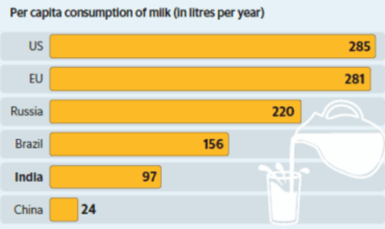
Figure 3: Per capita milk consumption by country
(Source: Insights IAS, 2025)
Figure 3 shows that per capita consumption of milk is 97 litres per year, whereas the US consumes nearly three times more milk compared to India (Insights IAS, 2025). The India-US trade discussion led India to refuse to open its dairy sector, citing risks to farmers in terms of their livelihoods.
Economic: Volume and pricing power
The Indian business landscape is affected by the escalating fodder and fuel costs. Yet, the economic scale of Amul allows the brand to absorb price shocks better than small competitive companies (PIB, 2025). Besides, the disposable income of India is growing with the rise of the Indian middle class, which is shifting the trend of “loose milk” to packaged and branded milk products. Amul has a diversified portfolio with chocolates, cheese, and organic pulses to capture the increasing “wallet share”.
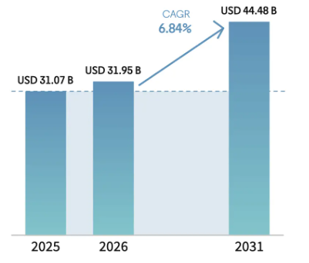
Figure 4: Overview of the Indian dairy market
(Source: Mordor Intelligence, 2026)
The Indian dairy market size has expanded to $31.95 billion in 2026 from $31.07 billion in 2025, registering a 6.84% CAGR growth from 2026 to 2031 (Mordor Intelligence, 2026). However, Amul has competitors from quick-commerce platforms like Zepto and Blinkit, which have ignited demand for short-shelf-life products, impacting the financial return of Amul.
Social and cultural: The "Taste of India."
Culturally, milk is considered a pure and sacred commodity in India, and Amul has decades-long branding as “The Taste of India”. This brand positioning has created a new level of cultural capital for the company that works as a huge barrier for foreign brands to enter the market (Amul, 2026). On the other hand, Amul strictly adhered to vegetarian-friendly processing that satisfies the religious and ethical requirements of the majority of Indian consumers. The sacred status of this commodity in India makes the market highly attractive, along with its dietary significance. Dairy cooperatives often have a broader social role that promotes healthcare in rural areas. This particular sector of India has been initiated to empower Indian women, as the entire workforce includes 70% of women workers (IMARC Group, 2026). Besides, this sector is also important in India to bring the small and neglected farmers into the mainstream economy.
Technological: Digital Dairy
The Indian dairy market is transforming through technological integration to improve quality and increase productivity. The trends of robotic milking, IoT, and usage of digital apps are increasing (IBEF, 2021). Similarly, high-efficiency embryo transfer and artificial insemination techniques are being used to enhance livestock genetics. Amul has incorporated “Advanced Factors” to replace “Basic Factors” and maintain the success of the brand. The brand has installed Automatic Milk Collection System (AMCS) units in many villages (Joshi, 2023). This has offered the company real-time data on the quality and fat content of milk to ensure spoilage reduction and transparency. In terms of e-commerce integration, Amul has significantly adopted omni-channel distribution and ensured that its products are available on major “quick commerce” platforms in the urban centres.
Legal: Food safety and quality
The Food Safety and Standards Authority of India (FSSAI) Act 2006 has strengthened regulations on milk production and adulteration. FSSAI covered several areas like food standards, packaging, additives, and labelling to prevent adulteration (FSSAI, 2023). The dairy sector of India is facing the dual challenge of safety in quality control, as approximately 7% of milk samples have projected safety concerns, which makes this market less attractive (Smart Food Safe, 2025). Amul has a vertically integrated supply chain, which has allowed for superior traceability as compared to the unorganised sector. Similarly, Milk and Milk Products Order (MMPO) 1992 is largely replaced by FSSAI and regulated through its principles to make process capacity and hygiene relevant (IMARC Group, 2026). Cold chain management also imposes threats in terms of milk quality and critical safety challenges, especially controlling pathogens like Salmonellaand Listeria.
Environmental: The ESG challenge
From the Circular Economy lens, Amul has heavily invested in its cow-dung-to-CNG plants (Bhat and Infascelli, 2025). This has provided another revenue stream for Indian farmers and helped address the environmental pressure to reduce the carbon footprint of the bovine population. However, the dairy industry of India causes significant methane emissions by nearly 25% from the herd, heat stress during milk production, and water scarcity (EDF, 2025). This creates pressure on farms to adopt renewable energy and implement efficient manure management. Yet, the government has initiated large investments in heat-resistant livestock breeds for long-term sustainability, which makes this industry attractive. Besides, growth in sustainable products, policy support for Green Tech, and cold chain infrastructure are other potential factors of market attractiveness in this industry (Militaru et al. 2025). In this way, the Indian dairy industry is gradually establishing a decentralized farming system.
Critical evaluation of the success factors
While Amul is dominating the dairy industry of India, it has continued its success, which can be derived from the PESTLE analysis. The Amul Model can be critically assessed to understand where the success factors stand in this domestic cooperative (Gumel and Bardai, 2023). These factors have helped the brand in defending its territory against the international FMCG giants like Danone and Nestlé. The operations of Amul are successful as it leverages its "National Diamond", which is challenging for other brands to replicate. India's largest bovine population is its biggest strength, which is considered a "Basic Factor" (IBEF, 2021). Amul has turned it into an "Advanced Factor" to establish a three-tier cooperative structure. Hence, it is able to offer farmers high-quality feed, veterinary services, and artificial insemination.
Indian consumers are becoming more sophisticated regarding the purity of milk and freshness, yet remain price-sensitive. The branding of Amul as “The Taste of India” is aligned with the cultural values of this country (Saleh et al. 2025). Moreover, the success of Amul relies on other related and supporting industries, as the brand has fostered a huge network of specialised cold-storage providers and logistics. The company has also developed an “Amul Pulse” distribution system to ensure that even small stores in rural areas receive a fresh supply of milk daily.
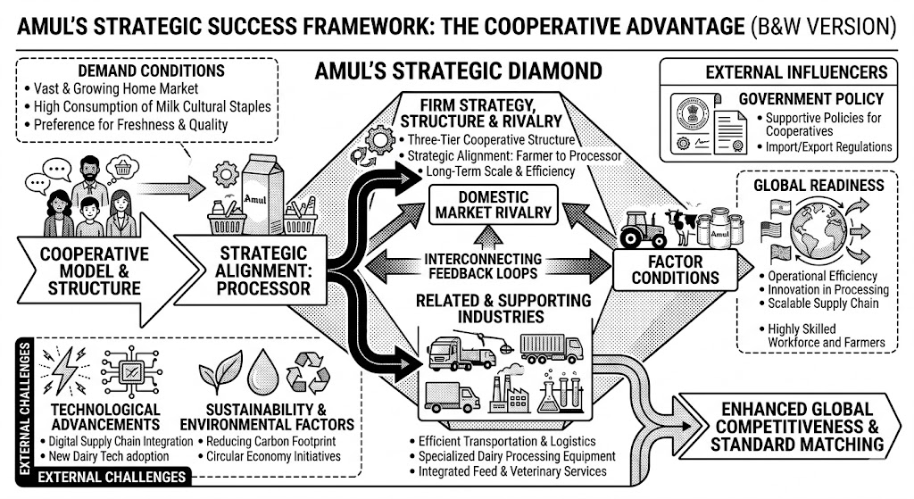
Figure 5: Amul’s success strategy
(Source: Influenced by Agrawal and Ashraf, 2023)
The overall success strategy of Amul has been projected through Figure 5 to determine the efficiency of its strategic choices. The strategy works because the brand successfully balances consumer-first innovation with farmer-first values (Agrawal and Ashraf, 2023). Unlike other global FMCG giants, Amul thrives by being deeply rooted in the cooperative movement of India. Yet the brand remains culturally iconic and digitally relevant, and this dual focus ensures that the brand has long-term loyalty and is resilient against competitors (Patel et al. 2025). Thus, it increases the strategic value while creating a positive impact on consumers and farmers, which contributes to the success of the company. The key success factors of Amul have been mentioned below.
1. Strong cooperative network
More than 3.6 million farmers are part of the cooperative model used by Amul, and over 11,000 village societies have ensured their grassroots participation (Sahoo and Jena, 2022). Farmers are considered to be both stakeholders and suppliers that create a sustainable ecosystem. This model has also guaranteed fair income distribution and brand loyalty by milk producers, which adds value to its success.
2. Iconic branding and marketing
The Amul Girl Mascot is the most iconic and recognisable advertising element in India. The campaigns of this brand are witty, topical, and culturally relevant, which keep Amul a part of everyday conversations (Sachan et al. 2022). The brand has also generated emotional loyalty among Indian consumers with its slogans that make the company resonate with the Indian population.
3. Innovation and quality products
Amul is consistent in delivering best-in-class dairy products, like butter, cheese, milk, and ice cream. Its focus on innovation has been projected through the launch of lactose-free milk, prebiotic curd, and premium chocolates (Pallathadka et al. 2022). Such innovative and high-quality products have ensured reliability and trust in the brand among Indian consumers.
4. Affordable pricing
Amul products are priced to be easily accessible to all income groups of India, and the inclusive brand identity has been strengthened with this affordability (Sahoo and Jena, 2022). Besides, the value-for-money positioning of the brand has assured a massive adoption across rural and urban markets.
5. Farmers' empowerment and sustainability
Indian farmers related to Amul milk production have better income options and are protected against middleman exploitation (Sachan et al. 2022). Amul has increased its investment in sustainable practices, such as feed quality, animal health, and rural development. This has helped in empowering and strengthening both brand equity and social impact.
Potential risks to success
Despite the dominance of Amul in the Indian dairy market, two primary factors can threaten its operations in the future.
1. Intense rivalry: Tech-enabled dairy startups like Country Delight are emerging in the Indian market that provides “farm-to-table” premium milk (Wang et al. 2026). Such products have a higher price point and are difficult for Amul to maintain its dominance in the segment of “sophisticated buyer” of Tier-1 cities.
2. Diminishing returns in factor conditions: The yield per animal is significantly lower in India than in the US and New Zealand, despite having the largest bovine population (Sharifi et al. 2022). Amul can struggle with supply-side problems as the demand is rising without Amul investing more in the Advanced Factors.

5. Conclusion
The critical analysis of the Indian dairy sector and a particular focus on Amul shows that the brand has become a purpose-driven cooperative strategy. It has moved beyond a profit-centric MNC model by leveraging the Factor Conditions of India. The country holds the largest bovine population in the world, which has been converted into Advanced Factors by Amul through the creation of a three-tier supply chain and nearly an impenetrable “National Diamond”. However, Amul is facing a critical inflection point as it is moving forward, whereas the political social alignment has remained a formidable barrier for foreign competitors in this market. The brand needs to focus more on yield productivity and environmental sustainability due to the rising demand of Indian consumers. A transition towards a circular economy can help Amul in evolving into a high-value international nutrition leader from a functional-scale milk producer. Therefore, Amul has been identified as a brand that must balance cutting-edge technological innovation with traditional grassroots ethos.

Section 2: Reflection
The reflection has followed Gibbs Reflective Cycle to assess the research and analysis process of the global competitiveness of the dairy industry. It has also considered the strategic success of Amul in the Indian dairy market to prepare this section of the assignment.
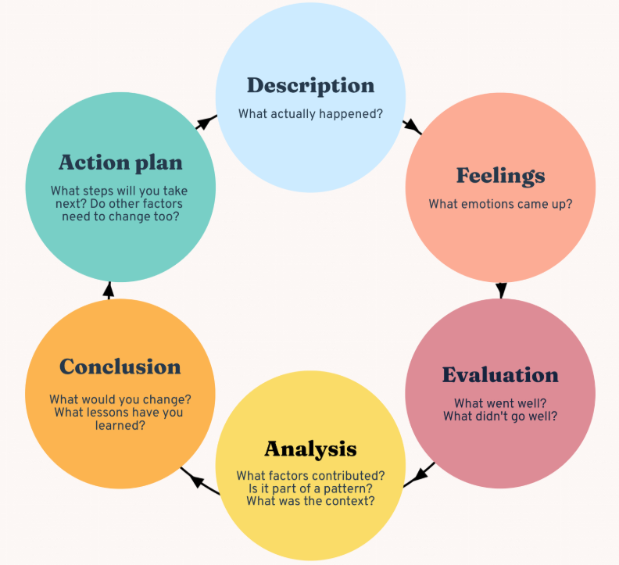
Figure 6: Gibbs Reflective Cycle
(Source: Influenced by Spiteri. 2025)
Figure 6 presents the six different stages of the Gibbs model, which works as a structured framework utilised to learn from experience. The six stages of this framework involve description, feelings, evaluation, analysis, conclusion, and action plan (Spiteri. 2025). The application of this model can provide a deeper and critical understanding of the research process that I have conducted.
Description
I have performed the tasks that required multi-dimensional analysis of the Indian dairy sector. I have used Porter’s Diamond Model and PESTLE analysis to understand the operations of Amul in India. I have begun the research process with a secondary research phase and targeted academic databases (Amir et al. 2023). I have also regarded various authentic industry reports, such as Mordor Intelligence and IMARC Group, to gather informative quantitative data. I have specifically collected statistical information regarding milk production in India along with qualitative data regarding the “Amul Model” (Ocampo et al. 2025). I have applied a transition phase to map such findings into the selected strategic frameworks. As a result, I have synthesised insights to form a structured report and supported it by including visual diagrams to illustrate the cooperative's competitive edge.
Feelings
I felt an initial academic pressure at the beginning because I had found the Diamond Model to be complex. Though the four pillars of this model are distinct, their interconnectivity is challenging to articulate without being repetitive (Nurlatifah et al. 2023). However, I have tried to uncover the sheer scale of social impact that Amul creates to support millions of small-scale Indian farmers. It has also shifted my perspective from a pure clinical business performance analysis to one that represents genuine interest (Ahmadpour et al. 2025). I also felt a sense of discovery when I realised that the success of Amul is not just the outcome of market mechanisms, but a unique socio-political alignment to defy the traditional logic applied in the Western MNCs. I feel that after completing the research, the academic language and presentation of data could have been more enhanced, which requires more practice.
Evaluation
I have used the Diamond Model, which has allowed me to go beyond the functional scale or the description of the company. It has assisted me in conducting a “sustainable advantage” analysis that considers quality and system (Aneeis Hashim et al. 2023). Moreover, I have highlighted the success strategies of Amul with diagrams that positively forced me to simplify complex ideas into a single comprehensible format. It has also clarified my understanding of the “Farmer-to-Processor” alignment.
On the other hand, finding updated and consistent data is on “Advanced Factors", such as particular IoT penetration in rural areas, was difficult. I have found many sources to prioritise aggregate production, instead of technological specifics, which has made it more challenging for me (Amir et al. 2023). I have specifically noticed that, as Amul is a nationally popular choice of Indian consumers, the majority of the available information is celebratory. Hence, it was difficult for me to identify genuine external challenges and maintain a critical stance.
Analysis
The entire research process has highlighted a fundamental oppression between the international management of global standards and the local context. I have applied Porter’s Diamond model, which has revealed that the competitive advantages of India are presently Factor-Driven in terms of land and cattle (Ezezika and Johnston, 2023). Furthermore, the country is trying to become innovation-driven, as the analysis has projected that the firm strategy of Amul uses a cooperative model. I have observed it to work as a strategic buffer, and it protects the dairy market from economic volatility. However, it can often cripple the private dairy firms, yet the PESTLE analysis has underscored the effectiveness of the emerging markets (Hassani Nia et al. 2026). India is also an emerging market, and the political and social pillars are more influential than the economic ones. Thus, I have noted that Amul's success is the outcome of being a social enterprise, which is disguised as a market leader.
Conclusion
While reflecting on the report, I can realise that I have initially underestimated the significance of the "related and supporting industries" pillars. I have primarily focused on Indian consumers and farmers who are related to Amul. Yet the research shows that the veterinary services and cold chain are the invisible threads holding the entire diamond together (Dunne et al. 2024). I would have spent more time and effort investing in the circular economy initiatives of Amul, relevant in the earlier process. In addition, I would have considered the environmental pillar more while analysing insights from the PESTLE analysis. The economic and legal constraints are becoming more crucial, rather than just a moral one, which requires an establishment of their connection to environmental factors (Sherwood et al. 2025). Henceforth, I could have tried to offer different perspectives and approached other points of view to justify the strategic decisions of Amul and its success.
Action plan
In similar future assignments that involve international business strategy, I will plan to implement an earlier stakeholder mapping. For instance, I will identify supporting industries in detail in the beginning of the research phase and ensure that a more balanced Diamond Model is administered (Spiteri, 2025). I will actively search for critical perspectives and dissident reports to counter the positive bias, which is frequently found within national or corporate success stories. I will also include diagrams during the research that can be visually more appealing and comprehensive of the business strategies. I believe that such modifications will help in maintaining the logical flow throughout the research that I intend (Sherwood et al. 2025). I will also proactively work on my data presentation skills in the future to represent the analytical knowledge in a more synchronised way.

References
Agrawal, S. and Ashraf, G.Y., (2023)‘A Study on Consumer Buying Pattern Towards Amul Milk’,International Journal of Advanced Research in Science, Communication and Technology (IJARSCT), 3(5), pp.501-511. Available at: DOI: 10.48175/IJARSCT-11676
Ahmadpour, N., Shariati, A. and Moghadam, M.P., (2025)‘Effect of narrative writing based on Gibbs’ reflective model on the empathy and communication skills of nursing students’,BMC Medical Education, 25(1), p.10. Available at: https://doi.org/10.1186/s12909-024-06593-7
Amir, H., Permatananda, P.A.N.K., Cahyani, D.D., Langelo, W., Rosita, R., Sajodin, S., Noprianty, R., Astuti, A., Suhari, S., Wahyuningsih, S. and Kusumawati, P.D., (2023)‘Enhancing skill conceptualization, critical thinking, and nursing knowledge through reflective case discussions: a systematic review’,Journal of medicine and life, 16(6), p.851. Available at: DOI 10.25122/jml-2023-0042
Amul (2026). The Taste of India. Available at:https://amul.com/m/about-us (Accessed: 28 March 2026)
Aneeis Hashim, S.N., Yaacob, A., Suryani, I., Mohd Asraf, R., Bahador, Z. and Supian, N., (2023)‘Exploring the Use of Gibbs’ Reflective Model in enhancing in-Service ESL teachers’ reflective writing’,Arab World English Journal (AWEJ) Volume, 14. Available at: https://papers.ssrn.com/sol3/Delivery.cfm?abstractid=4497558
Bankova, Y. and Tsvetanova, T., (2024)‘The Diamond Model of Porter to Measure Rural Regions' Competitiveness: A Case from Bulgaria’,Annals of the University Dunarea de Jos of Galati: Fascicle: I, Economics & Applied Informatics, 30(3). Available at:https://www.researchgate.net/profile/Tsvetelina-Tsvetanova-2/publication/388310777_The_Diamond_Model_of_Porter_to_Measure_Rural_Regions'_Competitiveness_A_Case_from_Bulgaria/links/67bd73fcf5cb8f70d5bea78b/The-Diamond-Model-of-Porter-to-Measure-Rural-Regions-Competitiveness-A-Case-from-Bulgaria.pdf
Bhat, R. and Infascelli, F., (2025)‘The Path to Sustainable Dairy Industry: Addressing Challenges and Embracing Opportunities.’,Sustainability, 17(9), p.3766. Available at: https://doi.org/10.3390/su17093766
Constantin, M., Sacală, M.D., Dinu, M., Piștalu, M., Pătărlăgeanu, S.R. and Munteanu, I.D., (2022)‘Vegetable trade flows and chain competitiveness linkage analysis based on spatial panel econometric modelling and Porter’s Diamond Model’,Agronomy, 12(2), p.411. Available at:https://doi.org/10.3390/agronomy12020411
DAHD (2026). National Programme for Dairy Development. Available at:https://dahd.gov.in/schemes/programmes/npdd (Accessed: 28 March 2026)
Dunne, M., Penman, M. and Nisbet, G., (2024)‘Exploring the outcomes of a reflective teaching strategy with students: A feasibility study’,International journal of speech-language pathology, 26(4), pp.532-543. Available at: https://doi.org/10.1080/17549507.2023.2223373
EDF (2025). India’s dairy industry: A market opportunity for climate adaptation to protect people and livelihoods. Available at:https://blogs.edf.org/climate411/2025/12/18/indias-dairy-industry-a-market-opportunity-for-climate-adaptation-to-protect-people-and-livelihoods/#:~:text=Dairy%20livestock%20produce%20methane%2C%20a,partners%20like%20PepsiCo%20and%20ADM. (Accessed: 28 March 2026)
Ezezika, O. and Johnston, N., (2023)‘Development and implementation of a reflective writing assignment for undergraduate students in a large public health biology course’,Pedagogy in Health Promotion, 9(2), pp.101-115. Available at: DOI: 10.1177/23733799211069993
FNB News (2025) India’s livestock & dairy sector gets fresh momentum on National Milk Day 2025, new data, infrastructure & awards rolled out. Available at:https://www.fnbnews.com/Top-News/indias-livestock--dairy-sector-gets-fresh-momentum-on-national-milk-day-2025-new-data-infrastructure--awards-rolled-out-85403#:~:text=During%20his%20address%2C%20the%20minister,and%20focused%20support%20for%20farmers. (Accessed: 16 March 2026)
FSSAI (2023). FOOD PRODUCT STANDARDS. Available at:https://www.fssai.gov.in/upload/uploadfiles/files/Chapter%202_1%20(Dairy%20products%20and%20analogues).pdf#:~:text=Hygiene.%20%2D%20(a)%20The%20products%20shall%20be,specified%20in%20Appendix%20'B'%20of%20these%20regulations. (Accessed: 28 March 2026)
Gumel, B.I. and Bardai, B.B., (2023)‘A review of critical success factors influencing the success of SMEs’, SEISENSE Business Review, 3(1). Available at: https://ssrn.com/abstract=4492176
Hassani Nia, N., Karami, S., Shahraki, F. and Kohan, M., (2026)‘Structured reflective sessions enhance knowledge and clinical skills in operating room technology students: a Solomon four-group study’,BMC Medical Education, 26(1), p.121. Available at: https://doi.org/10.1186/s12909-025-08431-w
IBEF (2021). Digitalisation of India's Dairy Farming. Available at:https://www.ibef.org/blogs/digitalisation-of-india-s-dairy-farming#:~:text=Another%20company%2C%20Stellapps%20Technologies%20(Stellapps,chain%20is%20better%20decision%2Dmaking. (Accessed: 28 March 2026)
IMARC Group (2026). Dairy Industry in India Size, Share, Trends and Forecast by Product and Region, 2026-2034. Available at:https://www.imarcgroup.com/dairy-industry-in-india (Accessed: 28 March 2026)
Indian Dairy Association (2025)A Bird’s Eye View on Union Budget and its Impact on Indian Dairy Sector. Available at:https://indiandairyassociation.org/Presidents-Desk.aspx?ino=NTk%3D#:~:text=A%20Bird's%20Eye%20View%20on,and%20expand%20its%20capabilities%20effectively [Accessed: 16 March 2026]
Insights IAS (2025). Indian Dairy Sector. Available at:https://www.insightsonindia.com/2025/09/16/indian-dairy-sector/ (Accessed: 28 March 2026)
Joshi, R., (2023). The politics of milk wars. Business India. Available at:https://businessindia.co/magazine/focus/the-politics-of-milk-wars#:~:text=Third%2C%20the%20government%20resorts%20to,grounds%20of%20sub%2Dnational%20pride. (Accessed: 28 March 2026)
Lehene, C.F., Jaradat, M. and Nistor, R.L., (2024)‘An interdisciplinary and multilevel analysis of local economy determinants and their impact on Firm Performance—Considering Porter’s Diamond model, clusters, and industry’,Systems, 12(3), p.82. Available at: https://doi.org/10.3390/systems12030082
Militaru, A.M.G., Kurt, A. and Gumus, M., (2025)‘Analysis of national strategic innovation objectives using adapted Porter’s diamond model: a comparison of Romania and Türkiye’,Competitiveness Review: An International Business Journal, 35(1), pp.100-118. Available at: https://doi.org/10.1108/CR-10-2023-0260
Mohan, V., 2025. India records increase in milk, egg meat, and wool production in 2024-25. Available at:https://timesofindia.indiatimes.com/business/india-business/india-records-increase-in-milk-egg-meat-and-wool-production-in-2024-25/articleshow/125595677.cms (Accessed: 16 March 2026)
Mordor Intelligence (2026). INDIA DAIRY MARKET SIZE & SHARE ANALYSIS - GROWTH TRENDS AND FORECAST (2026 - 2031). Available at:https://www.mordorintelligence.com/industry-reports/india-dairy-market#:~:text=India%20Dairy%20Market%20Analysis%20by,%2C%20and%20high%2Dprotein%20cheese. (Accessed: 28 March 2026)
NDDB (2022)Address by Shri Meenesh Shah, Chairman, NDDB at Int'l Conference Dairying for Sustainability and Nutritional Security IDA TN Chapter 14 October, 2022. Available at:https://www.nddb.coop/about/speech/Int_conference_dairying#:~:text=Talking%20about%20dairy%20sector%2C%20today,production%20of%20all%20European%20countries. [Accessed: 16 March 2026]
NDDB (2026)Dairy Knowledge Portal. Available at:https://www.nddb.coop/resources/dkportal [Accessed: 16 March 2026]
Nurlatifah, L., Purnawarman, P. and Sukyadi, D., (2023, December)‘The implementation of reflective assessment using Gibbs’ reflective cycle in assessing students’ writing skill’, In AIP Conference Proceedings (Vol. 2621, No. 1, p. 070006). AIP Publishing LLC. Available at: https://doi.org/10.1063/5.0143375
Ocampo, F.A., McIntyre, B.G., Massey, D. and Saunders, R., (2025)‘Nursing student reflections on a research internship: A reflective discussion following the Gibbs' reflective cycle’,Nurse education today, 145, p.106481. Available at: https://doi.org/10.1016/j.nedt.2024.106481
Pallathadka, H., Pallathadka, L.K., Devi, S.K. and Singh, S.K., (2022)‘Reasons for the success story of Amul: An empirical study of customers’ opinions’,Integrated Journal for Research in Arts and Humanities, 2(6), pp.252-259. Available at: https://doi.org/10.55544/ijrah.2.6.34
Parzonko, A., Parzonko, A.J. and Bórawski, P., (2024)‘Economic Competitiveness of Dairy Farms from the Top Milk-Producing Countries in the EU: Assessment in 2014–2021’,Agriculture, 14(1), p.123. Available at: https://doi.org/10.3390/agriculture14010123
Patel, D., Parmar, K. and Vidani, J., (2025)‘To Study on Consumer Awareness Towards all the Products of Amul in Ahmedabad City’,Kalpari Journal of Business and Economics, 2(1), pp.51-70. Available at: https://doi.org/10.55927/kalpari.v2i1.13767
Patvardhan, N., Rathi, C. and Chopra, A., (2026)‘The Indian Dairy Market: Forecast, Risk and Strategic Roadmap to 2030’,Research on World Agricultural Economy, pp.90-116. Available at: https://doi.org/10.36956/rwae.v7i1.2527
PIB (2025)India’s Dairy Sector. Available at:https://www.pib.gov.in/PressReleasePage.aspx?PRID=2172546&reg=3&lang=2 (Accessed: 16 March 2026)
Rupera, P., (2025)Amul brand is now nearly $11 billion co-operative entity. Available at:https://timesofindia.indiatimes.com/city/vadodara/amul-brand-now-nearly-11-billion-co-operative/articleshow/119880134.cms (Accessed: 16 March 2026)
Sachan, R., Singh, S.V., Shukla, Y. and Raichur, V., (2022)‘AMUL’S COVID-19 LOCKDOWN STRATEGY TO BEAT ITS COMPETITORS’,Short Cases For Managing Organizational Change, 1. Available at: https://sbm.nmims.edu/docs/2024/Short-Cases-for-Managing-Organizational-Change.pdf#page=11
Sahoo, K. and Jena, L.K., (2022)‘Story of milk mantra: Growth and sustenance in a complex emerging market’,Business Perspectives and Research, 10(3), pp.396-414. Available at: DOI: 10.1177/22785337211024928 journals.sagepub.com/home/bpr
Saleh, A., Hilletofth, P. and Fobbe, L., (2025)‘Unraveling critical success factors of local food supply chains: a systematic literature review’,Journal of Business & Industrial Marketing, 40(13), pp.103-123. Available at: https://www.emerald.com/jbim/article-pdf/40/13/103/9873754/jbim-01-2024-0027.pdf
Sharifi, F., Vahdatzad, M.A., Barghi, B. and Azadeh-Fard, N., (2022)‘Identifying and ranking risks using combined FMEA-TOPSIS method for new product development in the dairy industry and offering mitigation strategies: case study of Ramak Company’,International Journal of System Assurance Engineering and Management, 13(5), pp.2790-2807. Available at: https://link.springer.com/article/10.1007/s13198-022-01672-8
Sherwood, G., Cherian, U.K., Horton-Deutsch, S., Kitzmiller, R. and Smith-Miller, C., (2025)‘Reflective practices: meaningful recognition for healthy work environments’,Nursing Management, 32(6). Available at: https://www.researchgate.net/profile/Cheryl-Smith-Miller/publication/323347750_Reflective_practices_Meaningful_recognition_for_healthy_work_environments/links/62b38ea089e4f1160c930d9a/Reflective-practices-Meaningful-recognition-for-healthy-work-environments.pdf
Smart Food Safe (2025). Dairy Industry Under the Lens: Food Safety Risks & Remedies. Available at:https://smartfoodsafe.com/dairy-food-safety-challenges-solutions/ (Accessed: 28 March 2026)
Spiteri, D., (2025)‘The hall of mirrors: reflecting on pre-service teachers’ reflections’,Teachers and Teaching, 31(1), pp.52-69. Available at: https://www.tandfonline.com/action/showCitFormats?doi=10.1080/13540602.2024.2320147
Toksoy, T. and Karamelikli, H., (2026)‘Empirical Analysis of The Competitiveness of High-Tech Export Goods Based on Porter's Diamond Model’,Fiscaoeconomia, 10(1), pp.1-20. Available at:
Wang, M., Islam, S. and Yang, W., (2026)‘Supply chain risks in the dairy industry’,Benchmarking: An International Journal, 33(3), pp.965-986. Available at: https://discovery.ucl.ac.uk/id/eprint/10201353/1/Wang_Dairy%20Supply%20Chain%20Risk%202024_MW.pdf
Worku, M.A., Debela, K.L. and Mudde, H.L., (2024)‘Do existing competitiveness models comprehensively assess the competitiveness context of the contemporary agribusiness sector? A systematic review’,Cogent Business & Management, 11(1), p.2389466. Available at: https://www.tandfonline.com/action/showCitFormats?doi=10.1080/23311975.2024.2389466
Zion Market Research (2026)India Dairy Market Size, Share, Growth, Analysis, Trends, Forecasts, 2032. Available at:https://www.zionmarketresearch.com/report/india-dairy-market [Accessed: 16 March 2026]

