University of Wales trinity saint David
Wales institute of science and art



Material Selection Report & GD&T Drawings
Engineering Design and Materials ACHA4001

Cameron Andrews
2300898
19/04/2024
Contents
1 Introduction 2
2 Chapter 1 – Component Design Specification 3
3 Chapter 2 – Material Selection 5
4 Chapter 3 – Manufacturing Process Selection 7
5 References 10

Introduction

During this assignment I will be producing one technical GD&T drawing based on a piston head that has been provided. I will then be making a technical report based on a road vehicle about an engine component of my choice. During this report a comprehensive design specification will be done considering aspects like the environment it is used in, material cost and maintenance. Also be detailing the materials used and the method of using it.

Chapter 1 – Component Design Specification
Component of choice is a head for a Honda civic d14.
Features
The main features of a Honda civic d series head will be the SOHC design that they all come with, this sets D series apart from most Honda engines as they only have one camshaft instead of two. For this to be achieved the head will have to be designed to only fit one camshaft. Some D series heads come with VTEC further making the importance of the head being manufactured correctly. To also go with the manufacturing of the cylinder head d series are 16 valves meaning they have 4 valves per cylinder 2 intake and 2 exhaust so not only will the head have to be the correct size for one camshaft it will also have to have enough space for 16 valves. The cylinder head also has features like the intake manifold being attached to it and the fuel rail. So, while manufacturing it must account for the studs and correct mounting sections. Most heads are also made from aluminium to help reduce the overall weight.
What does the product need to have to meet the requirements.
For the cylinder head to meet its needs it will need to be machined with precision as it will allow the surface to be correctly sealed, have precise tolerances for valve clearance and correct oil and cooling ports machined into the head. Without this the head wouldn’t be able to do its job effectively. The construction of the cylinder head needs to be strong and lightweight so the materials used will need to withstand heat and force and at the same time be lightweight.
Weight targets
Weight targets when making a Honda civic d series cylinder head will be to do with performance. During the process of making, it will need to be as lightweight as you can make it while holding its structural rigidity and keeping it strong against heat and keeping it sturdy from damage. The average weight for a Honda civic cylinder head is around 20 to 40 pounds.
Price to manufacture.
As this car is a road car the price to manufacture must be low due to mass production of the engine and the car itself. The d series engine is not just used in the Honda civic but also used in many other Honda cars. By it being inexpensive it can easily be made and installed onto many cars.
Price to retail
The same will go for the price to retail due to the car being a road car and not a race car the price for retail will have to be affordable to the everyday person, due to it needing repairs or replacing throughout the years. If it was too expensive people won’t buy the car. (parts, 2024)
Using websites like this one you can see that the price to buy retail will go from anyone between £150-£250.
Environmental Considerations
When it comes to environmental consideration the type of materials will need consideration due to the waste lifespan, using materials like aluminium can reduce the overall footprint used. Plus, the manufacturing process of the cylinder head is an important process to consider when it comes to environmental considerations. Also, the cylinder head is in the engine bay attacked to the engine block a place that gets hot, this will mean that the cylinder head itself will need to be able to withstand high temperatures.
Customer needs | Business needs | Component needs
Low cost | Cheap to manufacture | Less than £300
Easy to operate | Simple to produce and fix | Simple design and easily mounted
Safe and reliable | Needs to be legislations | Meet safety standards and environmental standards
Well-made cylinder head | Low weight, cheap design | Meet a weight target that doesn’t hinder durability
Easily fixed/ Replaced | Able to find parts or make them | Common materials with an easy manufacturing process
Working Cylinder Head | Affordable component | Resistance to Heat, strong and lightweight
Easy to work on | Lightweight Component | Around 20 to 40 pounds

Chapter 2 – Material Selection
 | Main Feature | Weight | Cost | Environmental Effect | Easily manufactured? | Heat resistance
Aluminium | Lightweight and has good thermal efficiency | Between 20 -30 pounds as a cylinder head | Once’s can be a few hundred massed produced can be in the thousands | Has excellent heat dissipation and thermal efficiency and aluminium is easily recyclable | Yes, easier than cast irons | Aluminium keeps its structural strength when faced with temperatures of 200-300*C which is what you want.
Cast iron | Cast iron cylinder heads are known to be strong and durable | Average weight of a cast iron cylinder head is 50-60 pounds | Cast iron is cheap and easily obtained making it a cheaper option than most materials | Cast iron doesn’t have the best heat dissipation as it has good heat retention properties. This material is also highly recyclable | They are known to be a more difficult design process than other metals | Cast iron is known for having good heat retention against heat
Alloy Steel | Alloy steel is known for being exceptionally strong and have good heat resistance | On average alloy steel is heavier than most material but lighter than cast iron usually around 30-40 pounds | Alloy steel is usually more expensive that materials like aluminium but cheaper than the higher-level metals. | The waste process on Alloy steel is a lot harder has it can’t easily be recycled like other material and the process is more expensive. And it can also handle the heat produced from the environment it is in | Manufacturing alloy steel cylinder heads can be challenging and require high levels of skill | Alloy steel is excellent at handle high temperatures a lot better than most materials.
Copper | The main feature of a copper cylinder head would be the great thermal conductivity that the copper has making heat transfer from hot spots easier. | Copper cylinder heads are a lot denser than most other metals therefore makes it a lot heavier around 50-100 pounds | Copper is an expensive material compared to the others making it the most expensive option. | Copper can handle the levels of heat within the engine bay has it has great thermal conductivity and it is also highly recyclable | Manufacturing copper heads is a lot more challenging than cast iron or aluminium heads. | Copper has a great thermal conductivity and a high melting point making it great for the higher temperatures
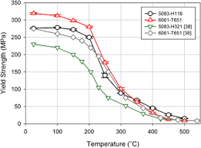
(Summers, 2015)

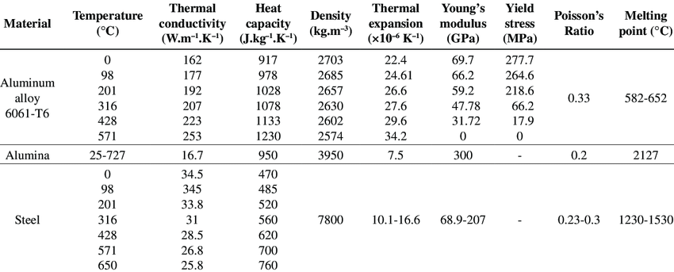
(Maina, 2018)

Overall, after looking at this table and the images provided, you can determine that Aluminium heads would be the better choice for a Honda civic cylinder head as it meet more of the design specification needs. For example, the overall weight and cost is ideal for a road vehicle and great for performance plus the manufacturing side is easy making it cheaper and better option for mass production. Copper is a definite no for this type of cylinder head, and it is way too expensive for a mass-produced component and the weight and process make it unviable for the needs of the cylinder head.

Chapter 3 – Manufacturing Process Selection
Aluminium cylinder heads can be made many ways, some more complicated than others and some being more effective too. Ways you can manufacture cylinder heads out of aluminium are:
- Sand casting.
- Die casting.
- Lost foam casting
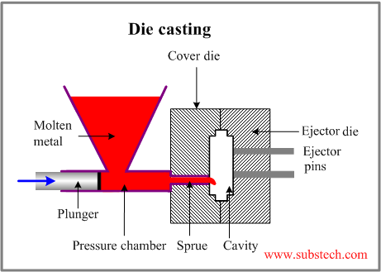
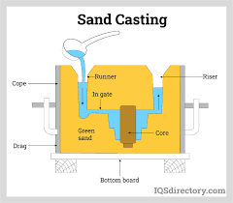
Sand casting is the process of making a Mold from sand mixed with a binder and then making a pattern. It is then placed in a moulding box and sand gets packed around it to create to shape. The next step is Pouring. This is when the Mold is ready molten aluminium then gets poured into the shape using a gating system and then taking shape of the pattern. Once it has been cooled the Mold is taken off and the cylinder head is left there to be cleaned up. Machining is required to then meet the final dimensions of the shape as the Mold is a rough design. And to achieve the desired finish. Then assembly is next if required or if it’s being sold as it is then its off to the final stop of quality control. Here is where they check the component to make sure it is 100% before sending it off (IQS, n.d.).
Die casting is the process of injecting molten aluminium into a metal Mold instead of a sand Mold under high pressure. This method is great for producing a cylinder head with complex shapes or integrated designs. (Ryobi, n.d.)
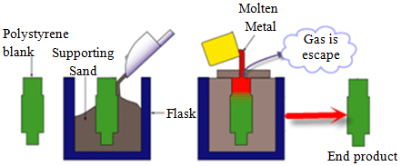
Lost Foam casting is when you use a foam pattern of the cylinder head and then coat it with a refractory material and then placed in a sand Mold. Molten aluminium is then used and melt the foam replacing it with the aluminium (TFG, n.d.).
Overall to produce an aluminium cylinder head I would use the die casting method. This is due to the high production efficiency that it yields this means that you can easily mass produce a lot of aluminium cylinder heads with good accuracy too. This is exactly what the design specification needs. You also get a tight tolerance on die casting great for the valves and cam and the overall time and cost is lower than most processes. Downside to using this method is there is a high initial cost of tools and materials but as this component is going to be mass produced its worth the money.
(Subs, n.d.)
(Tibba, 2014)

Chapter 5 – Conclusion
In conclusion after doing research into the different types of materials that can be used in making a cylinder head and doing research into some methods of producing the cylinder head. The best overall material to use is aluminium and the best method to use is die casting. This is all down to the design specification for making a Honda civic cylinder head. The design specification says it needs to be durable and lightweight. It also must withstand heat due to its environment and it needs to be cost effective as its going on a road car. Aluminium fits all of these, its overall weight in a cylinder head is the lowest out of all the other materials yet it still performance around the temperature required and is still strong. It is also cheap to manufacture and die casting is used in mass production and can easily make a large quantity of cylinder heads when needed. Making repairs and retail purchases cheap and affordable. As both these materials and method meet the design specification, they are the best choice for a Honda civic cylinder head.

References
IQS, n.d. IQSdirectory. [Online]
Available at: https://www.iqsdirectory.com/articles/die-casting/sand-casting.html#:~:text=Sand%20casting%20is%20a%20manufacturing,broken%20away%20and%20shaken%20out
[Accessed 19 april 2024].
Maina, M. R., 2018. Reserach Gate. [Online]
Available at: https://www.researchgate.net/figure/Physical-properties-of-copper-C1020_tbl1_329159652
[Accessed 19 april 2024].
parts, B. c., 2024. Buy car parts. [Online]
Available at: https://www.buycarparts.co.uk/cylinder-head/honda/civic-vi-coupe-ej-em1
[Accessed 19th april 2024].
Ryobi, n.d. Ryobi Group. [Online]
Available at: https://www.ryobi-group.co.jp/en/glance/02.html#:~:text=Die%20casting%20is%20a%20metal,of%20aluminum%2C%20magnesium%20and%20zinc
[Accessed 19 april 2024].
Subs, n.d. SubsTech. [Online]
Available at: https://www.substech.com/dokuwiki/doku.php?id=die_casting
[Accessed 19 april 2024].
Summers, P. C. Y. R., 2015. Firesceincereviews. [Online]
Available at: https://firesciencereviews.springeropen.com/articles/10.1186/s40038-015-0007-5
[Accessed 19 april 2024].
TFG, n.d. ThefederalgroupUSA. [Online]
Available at: https://www.tfgusa.com/capabilities/lost-foam-casting/#:~:text=Lost%20foam%20casting%20is%20a,process%20similar%20to%20injection%20molding
[Accessed 19 april 2024].
Tibba, G. S., 2014. ReserchGate. [Online]
Available at: https://www.researchgate.net/figure/Outline-of-lost-foam-casting-process_fig4_275713286
[Accessed 19 april 2024].

