

BSc (Hons) Professional Police Practice

LEVEL 5 - 40 Credits

Workbook title: Competency Based Workbook 3 (PCDA)

(SOUTH WALES POLICE, GWENT POLICE AND UWTSD)

Learner name: Michael ODriscoll

Learner’s University Registration Number: 1922495

FACULTY OF BUSINESS AND MANAGEMENT
PUBLIC SERVICE PROGRAMME

Module title: Professional Police Practice 2 (PCDA) BMPP5000D

Workbook Guidance

Please read these notes carefully; they provide essential information.

What is the workbook for?

The purpose of this workbook is to enable learners to demonstrate and provide evidence of how they meet the learning outcomes set by the College of Policing, for the BSc programme. Essentially, you are being asked to outline your experiential learning based upon your theoretical understanding in a range of operational situations.

- Wellbeing and Resilience
- Decision-making and Discretion
- Vulnerability and Risk
- Public Protection
- Maintaining Professional Standards
- Leadership and Team-working
- Policing the roads
- Information and intelligence
- Conducting Investigations

You may wish to use the same incidents as you’ve outlined in the Occupational Competence Portfolio.

How should the workbook be presented?

Blank electronic copies can be found on Moodle of this workbook. You must submit this document electronically therefore it is important that you save your work regularly and upload the final typed version through Turnitin on Moodle.

Word count policy can be found in chapter 7 of the Academic Quality under section 7.7 (this applies to presenting work above and under the specified word count).
(https://www.uwtsd.ac.uk/media/uwtsd-website/content-assets/documents/academic-office/aqh-chapters/chapters---en/Chapter_07_Assessment_Taught_Programmes_Pages_72-79-UPDATED-05-11-2019.pdf)

Reflective practice is a core aspect for your workbooks and although there is a variety of useful resources on Moodle, there is one particular book, that is specifically based on reflective practice in policing, here is a link to one chapter from Selina Copley’s Reflective Practice for Policing Students:
https://moodle.uwtsd.ac.uk/pluginfile.php/298870/mod_resource/content/1/Reflective%20Practice%20for%20Policing%20Students%20-%20Selina%20Copley%20Chapter5.pdf

How is the workbook assessed?

Advice and support about the completion of this workbook will be provided by university staff as part of your initial training day. Your tutor constable and in-force training staff will not be involved in assessing or marking your workbook after it has been submitted.

Dates of workbook submission will be made available during the initial training day and posted on Moodle.

Once submitted your workbook will be assessed and marked independently.

Confidentiality

It is important that no individual can be identified either directly or indirectly from the information in the workbook. Therefore, you must:

- adhere to guidance in the Student Handbook about unfair practice and plagiarism.
- not identify individuals including witnesses, victims or offenders by name.
- not write information that enables any individual to be identified indirectly through the description you provide. This includes references to names, colleagues, places (including hospitals, schools, town, villages, streets) specific incidents which were high profile and could be identified due to past publicity, other professionals or any other personal information including medical or other conditions.
- take personal responsibility for adhering to confidentiality rules.
- not include any dates of any incidents or anything that specifically identifies an actual incident.

NOTE

Your workbook will be submitted electronically via Turnitin on Moodle. Guidance on this is in the Student Handbook.

Remember that the workbook is YOUR responsibility you must not rely on the assessor or anyone else to pick up any confidentiality breaches as this is your work and you must accept full responsibility for confidentiality. Meeting all the confidentiality requirements is very important.

Dyslexia and other special circumstances

If you have any condition that you feel may affect your ability to deal with any part of the programme, please see the Student Handbook for further guidance. The University has a Student Services Unit that may be able to help but it is the learner’s individual responsibility to contact them.

Guidance:

- Your workbook must contain the items specified in the table below (clearly identified and in the order given);
- You should use this particular document to insert your text / answer within each section of this workbook;
- You should upload your completed document as a saved pdf file of this workbook; if this is not possible then a Worddoc file is acceptable. Do not send a scanned file from a photocopier, an apple.dot file or a Microsoft publisher file as Turnitin will not be able to assess them, despite you being able to upload them.

Contents

Workbook | Area of Professional Practice | Word count
Task 1 | Wellbeing and Resilience | 1250
Task 2 | Decision-making and Discretion  Vulnerability and Risk  Public Protection | 1750
Task 3 | Maintaining Professional Standards  Leadership and Team-working | 1750
Task 4 | Policing the roads  Information and intelligence  Conducting investigations | 1750
Task 5 | Individual Learning Plan | 1500 equivalent
 | Total | 8000
 | Bibliography

Task 1

Relevant areas of the National Policing Curriculum:
Wellbeing and Resilience

Having achieved Independent Patrol Status, reflect on the impact of organisation culture within policing on your wellbeing and resilience (organisation change, retaining personal values in a wider organisational culture).

Consider the risks of conforming to organisational culture.

Illustrate your strategies for maintaining wellbeing and resilience.

1250 words (+/- 10%: include your actual word count at the end of each section)

ANSWER:

Introduction

Now that I have achieved Independent patrol status I have been asked to reflect on the impact of organisational culture within policing on my wellbeing and resilience. I have been asked to consider the risks of conforming to organisational culture and to illustrate the strategies I have developed to maintain my own wellbeing and resilience.

To complete this task I intend to begin by demonstrating my understanding of the term organisational culture.

According MSG management Study Guide,

“The term “Organisation culture” refers to the values and beliefs of an organization. The principles, ideologies as well as policies followed by an organization form its culture. It is the culture of the workplace which decides the way individuals interact with each other and behave with people outside the company.” Juneja, P. (2015).

I also intend to utilise models such as “Burtons Reflective Tool” and “Gibbs model of Reflection 1998” to help structure my answer.

Main Body

Upon reflection of my time as a Police Constable I have noted all officers have an astonishing volume of workload and are under continuous intense pressure which includes not only paperwork but also attending emergency and general calls to assist that public. Most often they will required to stay past the end of their shift to ensure that their workload is manageable.

From my own personal reflection and observation the workload and continuous pressure drains the resilience of an Officer and can often develop a negative unmotivated mind-set. This culture of unmotivated and demolished officers has been identified by an article by the Evening Standard,

“The Police Federation, which represents rank and file officers in England and Wales, said its members are becoming increasingly demoralised, with the way police are treated being the biggest contributor. While 60.2% of officers said their personal morale was low - nearly 5% more than last year - there was also an increase in the number planning to leave the service either as soon as possible or within the next two years (12.3% compared to 11.8%).” Collier, H. (2017).

Working within this environment can be a challenge, although I empathise and I understand that my fellow officers may feel this way my own personal values mean that I will not allow the workload and negative aspect of police culture to affect my own frame of my mind and positive outlook.

I have found that the combination of learning a new role and the pressure of independent status and personal workload as well as continually ensuring that other Officers depolarized mind sets do not affect my attitude to my role, has proved to test my resilience on a daily basis more so than any other job I have had including working as a Prison Officer. The challenge of retaining my own personal values within a wider culture of demoralised, stressed and frustrated officers has been very challenge in itself.

I have identified an example of organisational culture within the police service which I have observed as above. I have considered the risks of conforming to such cultures. Conformity has been defined as follows by Very well mind,

“Conformity involves changing your behaviours in order to "fit in" or "go along" with the people around you. In some cases, this social influence might involve agreeing with or acting like the majority of people in a specific group, or it might involve behaving in a particular way in order to be perceived as "normal" by the group.” Cherry, K. (2020).

The risks of conforming to such negative aspects of police culture is the fact that you as an individual become a part of a wider problem.
By conforming to negative police culture I would be lose my integrity. By allowing my own personal principles to be compromised I would not be acting in the publics interests. This would therefore mean that I failed to maintain the professional standards and expectations of The Code of Ethics. The College of Policing outlines the Nine Policing principles as a part of the Codes of Ethics

“The policing principles originate from the Principles of Public Life developed by the Committee on Standards in Public Life in 1995. The Code of Ethics includes the principles of ‘fairness’ and ‘respect’ as research has shown these to be crucial to maintaining and enhancing public confidence in policing.

Accountability – You are answerable for your decisions, actions and omissions

Fairness – You treat people fairly

Honesty – You are truthful and trustworthy

Integrity – You always do the right thing

Leadership – You lead by good example

Objectivity – You make choices on evidence and your best professional judgement

Openness – You are open and transparent in your actions and decisions

Respect – You treat everyone with respect

Selflessness – You act in the public interest” Policing (2014).

I have developed strategies for maintaining my wellbeing and resilience for example,

An important aspect of my wellbeing is ensuring that I maintain a high level of physical fitness, therefore a strategy that I have developed is to prioritise my fitness. By staying committed to my fitness it has not only allowed me to stay fit but also affects my mental wellbeing in a very positive way. An article by Help Guide outlines the benefits of physical training on ones wellbeing,

“Regular exercise can have a profoundly positive impact on depression, anxiety, and ADHD. It also relieves stress, improves memory, helps you sleep better, and boosts your overall mood. And you don’t have to be a fitness fanatic to reap the benefits. Research indicates that modest amounts of exercise can make a real difference. No matter your age or fitness level, you can learn to use exercise as a powerful tool to deal with mental health problems, improve your energy and outlook, and get more out of life.” Robinson, L., Segal, J. and Smith, M. (2019).

Another strategy that I utilise to maintain my wellbeing and resilience is always having a Positive mind set, which is something that I already had before becoming an officer, the benefits of such a frame of mind have been explained in an article by Very well Being,

“Resilience refers to our ability to cope with problems. Resilient people are able to face a crisis or trauma with strength and resolve. Rather than falling apart in the face of such stress, they have the ability to carry on and eventually overcome such adversity.
It may come as no surprise to learn that positive thinking can play a major role in resilience. When dealing with a challenge, optimists typically look at what they can do to fix the problem. Instead of giving up hope, they marshal their resources and are willing to ask others for help.” Cherry, K. (2012).

Conclusion / Summary

Upon reflection of answering this task I have identified certain negative aspects of Police organisational culture.

I feel that it is an officer’s personal responsibility to maintain their own personal standards when dealing with negative culture within the police service. Doing this has naturally tested my resilience and wellbeing.

Upon evaluation of my experience I would say that my resilience being tested as it has since becoming an officer and maintaining a positive frame of mind and upholding my integrity has been a rewarding one as I have realised how committed I am in relation to being true to my own standards and professionalism.

When I analysis my experience I have observe that an officer will not intentionally conform to negative aspects of police organisational culture. It is a process in which their resilience is gradually broken down by overwhelming workloads and constant pressure.

To conclude based on reflection of my answer to this task, going forward I will refer to the principles of Betaris Box, and do all that I can to support my colleagues and hope that my strong positive frame of mind and attitude affects their attitudes for the better. Betaris box theory is explained by toolshero as follows,

“The foundation of the Betari Box pertains to the idea that human behaviour influences one’s own attitudes. One person signals and interprets the behaviour of another and that forms the start of the cycle. After all, people act based on other people’s behaviour; it influences the actions the other takes. This, in turn, influences that person again.

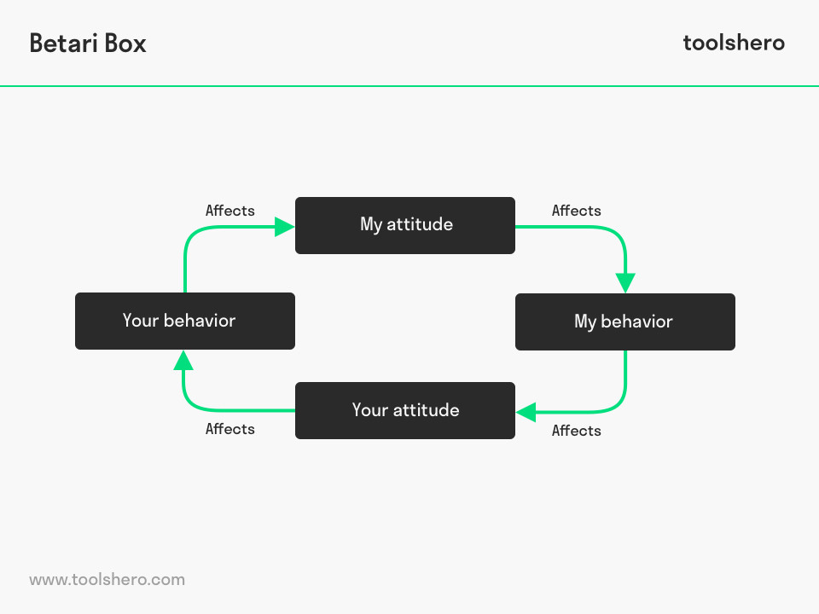 Mulder, P. (2018).

Task 2

Relevant areas of the National Policing Curriculum:
Decision-making and Discretion, Vulnerability and Risk, Public Protection.

You must choose an incident, for example a domestic related incident, and reflect on how you made decisions in complex and unpredictable circumstances using dynamic risk assessment.

Give a brief description of the problem including social and legislative contexts and any relevant cultural, ethnicity and language issues.

Evaluate decisions made during the incident and your use (or otherwise) of the National Decision Model. Explain the rationale behind your decisions and your considerations when recording details of the incident. Consider your ethical approach to the decision. Outline the consequences of your decision making.

1750 words (+/- 10%: include your actual word count at the end of each section)

ANSWER:

Introduction

I have been tasked to choose an incident that I have dealt with and reflect on how I made decisions in complex and unpredictable circumstances using dynamic risk assessment.

I intend to give a brief description of the problem including social and legislative context and any cultural, ethnicity and language issues.

I intend to evaluate decisions made during the incident and my use of the National Decision Model. I will explain the rationale behind my decisions and my considerations when recording details of the incident. I intend to consider my ethical approach to my decision and to outline the consequences of my decision making.

To complete this task I intend I use Gibbs Reflective Cycle as I discuss an incident of Domestic Violence that I have dealt with during my time within the Police Service.

To begin to answer this task I will define what is meant by a dynamic risk assessment, HASpod defines Dynamic Risk assessment as follows,

“A dynamic risk assessment is a process of assessing risk in developing and changing situations. You might not always be able to know the exact level of risk ahead of time. Dynamic risk assessment is often used to continually assess to allow for unknown risks and handling uncertainty.” Haspod . (2019)

A brief description of the problem is as follows. When I had achieved independent patrol status I was single crewed on duty and a call came through of a report of a domestic incident in which a female had reported that her husband had assaulted her and that this had been going on for many months.

Besides the initial information that I received I had no other details. When I arrived at the address the door was ajar I knocked loudly but there no answer, I opened and went inside. The home belonged to an Asian family a mother father and teenage boy. The mother and son were sat at the top of the stairs they appeared to be scared and the mother had what appeared to a black eye.

Once I made sure that the mother and son were ok I asked where the husband was they explained that he was in the kitchen and was furious and was a violent person.

This incident was a complex and unpredictable situation. I did not have any detailed intelligence and had to use the information that I had to create a dynamic risk assessment. I did so and decided to enter the kitchen, however due to the further information the mother and son gave me when they disclosed that the husband had a violent personality my continued dynamic risk assessment increased the threat level to my safety and therefore I requested a further unit as I was single crewed.

I entered the kitchen and the husband was sat at the table, he was not aggressive but the first thing that he said was that it was his wife and his home and that they were his property and he had the right to do as saw fit in relation to what he described as disciplining his wife. He openly admitted punching her and stated that he had done nothing wrong because she was his property.

I asked why he thought of her as his property he simply stated that in his house it was his rules and that his wife had become “too westernised”. From his communication I perceived that he genuinely felt that it was his right to assault his wife based on the basis that she belonged to him. I made a note of what he has just said as a significant statement. This would be example of a relevant cultural issue.

Despite the husbands personal view that he had done nothing wrong. He was arrested for domestic related assault.

Further units arrived and the male was taken to custody. The female instantly said to me that she did not want her husband arrested and that she would not support police action as she needed to be loyal to her husband as it was her duty and became defensive in her communication to me.

I returned to the address to carry out outstanding actions required of my investigation. I spoke with the female and reassured her that I an independent investigator. I believe that my calm and professional approach gave her the confidence to give a supporting statement in relation to the assault.

The rational of my decision to go and speak to the female in person rather than on the phone was to reassure her that the police were there to support her, this is a good example of how my attitude affected her attitude towards the police and helped to break down obvious barriers. It is a good example of The Betari Box Theory, as explained by Mindtools,

“The Betari Box, is a simple model that can help us to understand the impact that our attitudes and behaviours have on the attitudes and behaviours of the people around us.”

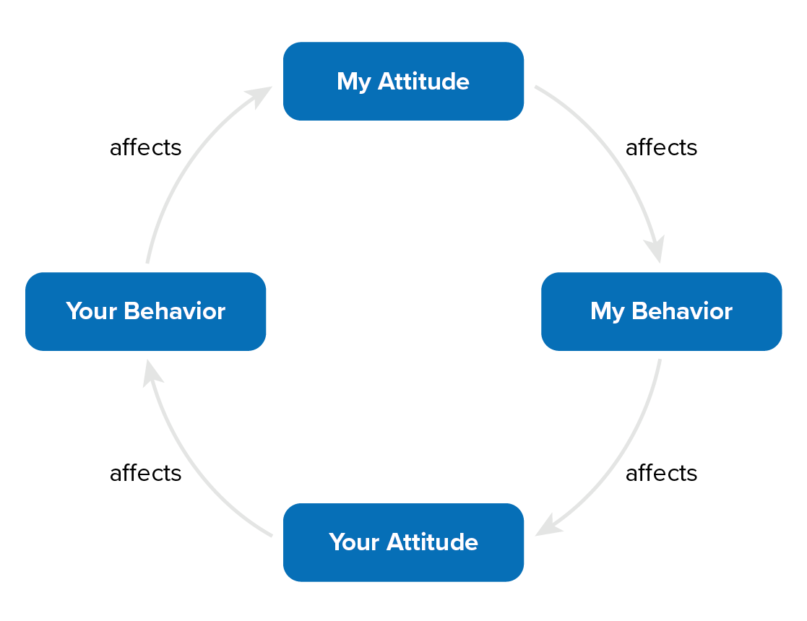 Mindtools . (2014).

This incident was complex as there was obvious relevant cultural issues and safeguarding concerns for vulnerable individuals. In regards to cultural issues in this incident I had to ensure that I took an ethical approach to my decision making. For example, my personal believe and perspective in regards to how I treat my wife were completely different to the husbands. Such differences are an example of why policing a multicultural society can face difficulties,

“A lack of cultural sensitivity, real or perceived, may lead to unintended consequences and violence. Failure to adequately address the challenges of policing in a multicultural society can, result in misunderstandings between groups and alienation” NJJ. National Institution of Justice. (2003).

Main body

Throughout this incident I made my decisions based on the structure of the National Decision Model framework and the continued Dynamic Risk Dynamic. This would ensure that all my decisions were based on the principles of The Codes Of ethics and made ethically, especially considering that there were obvious relevant cultural differences held by both the husband and wife.

The National Decision Model gave me structure to be able to make my decisions, The College of policing describe the model as follows,

“The NDM puts the Code of Ethics at the heart of all police decision making. This distinguishes the NDM from other decision-making models and recognises the need for all police decisions to be consistent with the principles and standards of behaviour set out in the Code of Ethics

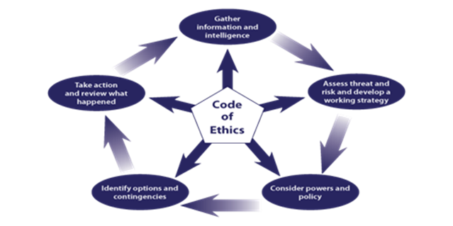
College Of Policing . (2014).

When I evaluate my decisions I feel that it was the correct decision to enter the address single crewed due to ensuring the safety of everyone involved in the incident and to stop any further possible escalation. Upon reflection If I was to deal with a similar situation I would call for further units sooner.

I believe that that my use of a dynamic risk assessment was very effective in relation to assisting me with making a decision based on changing circumstances.

My powers and policies were considered and I made the correct decision to arrest the husband for Domestic Related assault.

Whilst dealing with the incident I identified my options and contingencies, I considered extra units and evaluated whether to enter the kitchen alone to speak with the husband or await more officers.

In relation to taking action, I made the decision to arrest the male confidently, and I feel that this was the correct decision.

Upon review of the incident I have identified where I can improve if I was to deal with a similar incident that would be to request further units sooner.

As a consequence of my decisions the male was placed under arrest and taken from the home, he had been given bail conditions after he was released to not attend the family home, so his wife and son would be safeguarding, As a result of the detailed Public Protection Notice Report that I shared the female spoke with women’s Aid and Live fear free charity. A support structure was developed for her and her son.

Conclusion

Upon reflection of this incident I believe that cultural differences played a part in the dynamics of the relationship between the wife and husband. It actually challenged my own views, on account that I could not comprehend that a person would think of their wife as a belonging which gave them the right to hit them, The fact that the male expressed that his wife had become too westernised and the wife would not support police action made this incident complex as there was safeguarding concerns for the family.

When I look on the incident I believe that my patient and calm approach to the female broke down barriers and gave her confidence to give a statement to the police, which she had initially refused to do.

I had the complex task of dealing with the incident as a Police Officer this incident was an excellent experience to develop from due to so many factors playing a part in the incident.

I recognised that other cultures and individuals have different views of marriage to myself, for example considering your spouse to be a belonging and presuming the right to assault them.

The National Decision Model is centred around the principles of The Code Of Ethics and this ensured that I remained professional calm and objective. The codes of ethics is explained by the college of policing as follows,

“The main components of the Code are sets of principles and standards of professional behaviour.

Policing principles

• Accountability
• Honesty and integrity
• Fairness
• Honesty
• Integrity
• Leadership
• Objectivity
• Openness
• Respect
• Selflessness

Standards of professional behaviour

• Authority, respect and courtesy
• Equality and diversity
• Use of force
• Orders and instructions
• Duties and responsibilities
• Confidentiality
• Fitness for work
• Conduct
Challenging and reporting improper conduct

College Of Policing . (2014).

Task 3

Relevant areas of the National Policing Curriculum:
Maintaining Professional Standards, Leadership and Team-working

Evaluate theories of team dynamics as a means of developing team cohesion (reasons why some teams cannot function, theories and models relating to team dynamics, ways to improve team cohesion).

Consider why inter-personal conflict can occur within a team and outline what strategies can be adopted to enhance individual and team performance.

Consider how team dynamics within the police service can result in failing to comply with professional standards requirements (Code of Ethics, policies, procedures, protocols or legislation).

1750 words (+/- 10%: include your actual word count at the end of each section)

ANSWER:

Introduction

I have been given the task to evaluate theories of team dynamics as a means of developing team cohesion (reasons why some teams cannot function, theories and models relating to team dynamics, ways to improve team cohesion).

I have also been tasked to consider why inter-personal conflict can occur within a team and outline what strategies can be adopted to enhance individual and team performance.

I have been asked to consider how team dynamics within the police service can result in failing to comply with professional standards requirements (Code of Ethics, policies, procedures, protocols or legislation).

To begin this task I will demonstrate firstly what is meant by the term team dynamics. According to team technology team dynamics is described as,

“Team dynamics are the unconscious, psychological forces that influence the direction of a team’s behaviour and performance. Team dynamics are created by the nature of the team’s work, the personalities within the team, and their working relationships with other people, and the environment in which the team works.
Team dynamics can be good - for example, when they improve overall team performance and/or get the best out of individual team members. They can also be bad - for example, when they cause unproductive conflict, demotivation, and prevent the team from achieving its goals.” Team Technology. (2022).
To answer this task my understanding of the concept of team cohesion needs to be evidenced. Therefore, to demonstrate my understanding I would refer to the definition of team cohesion from Russel Tobin website,

“Team cohesion happens when a team remains united while working to achieve a common goal. Being a cohesive team means that not only are group goals met but everyone feels like they have contributed to the overall success of the group. Individuals on a cohesive team tend to focus more on the entire group rather than their individual selves and are more motivated to work towards the team goal.” Russell Tobin. (2020).

Main Body

There are many theories and models which offer strategies to develop team cohesion. Because of these considerations a team requires time to develop cohesion and gel.

This is best explained by referring to Tuckman's Model for Nurturing a Team to High Performance,

“Stage 1. Forming. This first stage involves the bringing together of a group of individuals to form a team.

Stage 2. Storming. During this second stage, where team members feel more able to express and question opinions, you will see more evidence of internal conflict.

Stage 3. Norming. Once your team has reached the third stage of its development the members focus on resolving differences so that the mission and goals can be clearly defined

Stage 4 – Performing. Now your team has reached the final stage of its development and can now bring real benefits to you and the organization. Your team members are now competent.

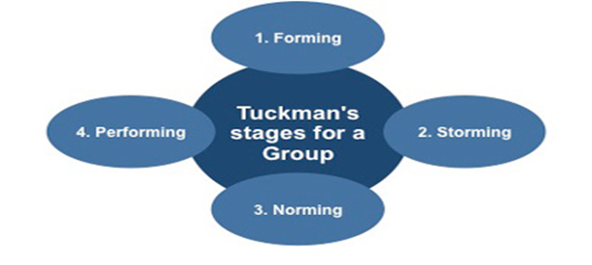Free management books . ().

Within the Police service an officer is almost always a member of a team. During my probation I have been a member of three teams, my original team at Kingsway’s whilst in my initial training period and two response teams. I have also worked with many different teams in different areas during overtime shift and cancelled rest days.

Based on that experience I will evaluate Tuckmans Theory.

In relation to stage one from my experience this was true when I was integrated into the team I had very positive expectations.

I recognise stage two from the perspective of the fact I identified different personality types and naturally adapted, but can understand the concept that this is the stage where conflict of personalities could develop.

Stage three of Tuckmans Model is particularly relatable from own experience as this is the stage I believe my natural leadership began to be demonstrated within the dynamic of the team. The team had accepted me into their group dynamic from building trust and respect whilst in stage 1 and 2.

Stage 4 I can relate to also as I felt a part of the team and worked extremely well as a group knowing and understanding each other’s strengths.

This task has asked me to consider why interpersonal conflict can occur within a team and to outline what strategies can be adopted to enhance individual and team performance. I will begin by presenting an example definition of what is meant by interpersonal conflict,

“Interpersonal conflict is any type of conflict that involves two or more people. In the workplace, interpersonal conflict in the workplace is defined as a person or group of people who interfere with another person’s attempts at achieving goals or completing assignments. Resolving this form of conflict in the workplace can help repair working relationships, boost morale and increase customer satisfaction.” Indeed. (2021).

It can occur within a team this can be several reasons for example, It is human nature that when a group of individuals are put into a team that within that team there will different personalities, that the team members will be from different backgrounds and have different points of views and outlooks towards the workplace and life in general. Because of this fact it is fair to state that often there can be natural personality clashes based on those differences. For example one person’s work ethic may be more driven than another team members and thus a conflict can occur. This example can be best described by healthline,

“People have very different personalities, values, expectations, and attitudes toward problem-solving. When you work or interact with someone who doesn’t share your opinions or goals, conflict can result. Conflict isn’t always serious, though. Nor is it always negative. Learning how to recognize and work through interpersonal conflict in productive, healthy ways is an important skill” crystal Raypole . (2020)

Interpersonal conflict can be managed and resolved by using the strategy of demonstrating a mature and professional approach to open communication and by treating the other person with respect and courtesy. Just because two individuals have a difference viewpoint or opinion it does not automatically mean that it has to end in conflict. As described by healthline,
“When conflict inevitably happens, respectful communication is key. You may not always agree with everyone, and that’s just fine. Polite words and an open mind can help you resolve — or come to terms with — differences more effectively.” crystal Raypole . (2020)

Interpersonal conflict can in fact present the opportunity of self-development by listening and trying to understand another perspective with patience and professionalism, as described by healthline,

“Managing conflict doesn’t necessarily mean preventing conflict. Different opinions and perspectives can provide opportunities to better understand how other people feel and relate to them on a deeper level.” crystal Raypole . (2020)

I am to consider how team dynamics within the Police Service can result in failing to comply with professional standards requirements (Code of Ethics, policies, procedures, protocols or legislation). As a Police Constable you are held to high standard of accountability from the public, your supervisors and colleagues. You are expected to demonstrate authority, respect and courtesy and the highest level of professionalism is expected.

The code of ethics defines the standards that are expected from the police. It is foundation of what a police officer should represent. The college of policing explain that the code is based on 9 policing principles and 10 standards of Professional Behaviour,

“The main components of the Code are sets of principles and standards of professional behaviour.

Policing principles

• Accountability
• Fairness
• Honesty
• Integrity
• Leadership
• Objectivity
• Openness
• Respect
• Selflessness

Standards of professional behaviour

• Honesty and integrity
• Authority, respect and courtesy
• Equality and diversity
• Use of force
• Orders and instructions
• Duties and responsibilities
• Confidentiality
• Fitness for work
• Challenging and reporting improper conduct
College of Policing. (2014).

It is important to approach a difference of opinion or clash of personality within your team as a Police officer with diplomacy and professionalism. However, one must remember that if another Officer is behaving inappropriately and not adhering to The Code of Ethics it is your responsibility to challenge them and report improper conduct if required.

If no one for fills this obligation, not only would that officers behaviour go unchallenged but you as an individual will not meet the standards that are expected of you as an Officer by The Code of Ethics.

Summary

To summarise team dynamics within the context of the Police service I would suggest that team cohesion is essential in order to ensure that the public are provided with the service that they deserve and that service is delivered to the highest level of professionalism.

However, the reality of policing through my own experience is without doubt a very intense stressful and dangerous vocation. Due to the pressure that teams are under often personality clashes can occur.

As a member of the Police service one is at an advantage on account that no matter the conflict may concern as Police Officers we all share the same goal which is serve to the public and we all follow The Code of Ethics, therefore with open, courteous, respectful and professional communication individuals can express their opinions and even develop from a personal and professional perspective by listening and acknowledging another point of view even if they do not agree with it.

Interpersonal conflict within the context of being a member of a team within the Police service can occur. But by following the Betaris Box Theory disagreements and difference of opinions will not result in consult, Betari Box is explained by, Mindtools.

“The Betari Box is a simple model that can help us to understand the impact that our attitudes and behaviours have on the attitudes and behaviours of the people around us around us around us around us.

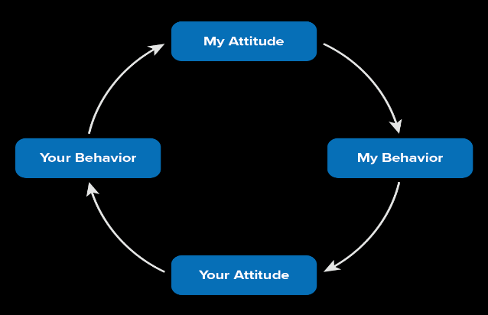 Mindtools. (2020).
Conclusion

It is important for officers to challenge and report improper conduct. If an officer does not they will also be falling short of the standards that are expected from The Codes of Ethics.

Task 4
Relevant areas of the National Policing Curriculum:
Policing the roads, information and intelligence and conducting investigations.

Explain how information and intelligence can be used in the disruption of the more prevalent criminal activity (e.g. drug smuggling, human trafficking, child sexual exploitation, counterfeit goods, organised crime groups and ‘county lines’) by effective policing of the roads.

Outline how ANPR can be used as investigative resource when disrupting criminal activity.

1750 words (+/- 10%: include your actual word count at the end of each section)

ANSWER:

Introduction

I have asked to explain how different information and intelligence can be used in the disruption of the more prevalent criminal activity (e.g. drug smuggling, human trafficking, child sexual exploitation, counterfeit goods, organised crime groups and ‘county lines’) by effective policing of the roads.

I have also been asked to outline how ANPR (Automatic Number Plate Recognition) can be used as an investigative resource when disrupting criminal activity.

In order to answer this task I will begin by demonstrating my understanding of what information and intelligence means within the police service and how they are different from each other. According to nafn.gov.uk Data and intelligence Services intelligence is explained as follows,

“Information that has undergone an evaluation process to assess its worth, Intelligence is graded by using the 3x5x2 aspect of the National Intelligence Model. The use of the 3x5x2 grading system should mean uniformity to all pieces of intelligence”
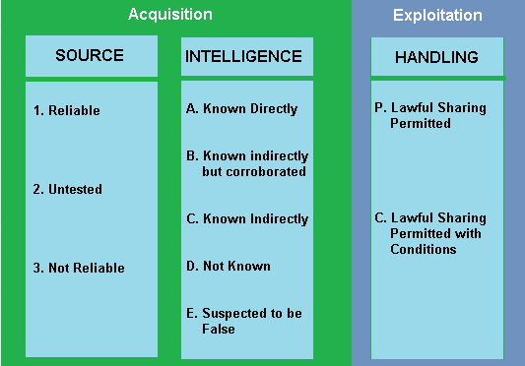 nafn.gov.uk (n.d.).

Information however, is explained by Cyware as follows,

“In the simplest terms, information relates to raw, unverified and unevaluated data gathered from numerous source, while, intelligence refers to processed, evaluated and perspective-driven data that is gathered from trusted sources.” Labs, C. (2021).

As part of my introduction I also intend to demonstrate my understanding of what is ANPR. Automatic Number Plate Recognition. According to Police.uk,

“ANPR (Automatic Number Plate Recognition) technology to help detect, deter and disrupt criminal activity at a local, force, regional and national level. This includes travelling criminals (those using the road network to avoid being caught), organised crime groups and terrorists.
ANPR provides lines of enquiry and evidence in the investigation of crime and is used by forces throughout England, Wales, Scotland and Northern Ireland. As a vehicle passes an ANPR camera, its registration number is read and instantly checked against database records of vehicles of interest.” Metropolitan Police. (2021).

How an ANPR system works is best described by Fluxposure,

“ANPR camera technology takes a snapshot of a vehicle’s number plate and then converts that image into machine-encoded text – this is known as optical character recognition. The vehicle registration is then cross-checked with whichever database is being used by the ANPR operator for their specific requirements.

Police ANPR for example, reads a vehicle’s registration number as it passes a number plate recognition camera and is instantly checked against database records of ‘vehicles of interest’. Using this information, police officers can then intercept any vehicles red-flagged by the system, check it for evidence and, where necessary, make arrests” fluxposure . (2021).

For this task I intend to expand in more detail how information and intelligence through effective roads policing and ANPR Automatic Number Plate Recognition can disrupt the criminal activities of County Lines.

Main body

County lines is a form of criminal activity that utilise the road networks of the UK. The National Crime Agency define county lines as follows,

“County Lines is where illegal drugs are transported from one area to another, often across police and local authority boundaries (although not exclusively), usually by children or vulnerable people who are coerced into it by gangs. The ‘County Line’ is the mobile phone line used to take the orders of drugs. Importing areas (areas where the drugs are taken to) are reporting increased levels of violence and weapons-related crimes as a result of this trend.” National Crime Agency. (2018).

Information and intelligence can disrupt this criminal activity. For example, when officers submit intelligence reports from local knowledge it will assist in building a wider picture of county lines activity. For example if a vehicle that is known to be involved in county lines from one area is travelling via the road networks to another area and there is intelligence on that vehicle then traffic officers will be able to access that information/ intelligence from mobile ANPR systems from their vehicles. Intelligence reports are defined by the college of police as follows,

“The intelligence report (IR) is used to submit and evaluate information, and to manage dissemination of intelligence. It protects the source and contributes to an audit trail of the intelligence” College of Policing. (2022).

ANPR Automatic Number Plate Recognition disrupts county lines criminal activity from the perspective that the cameras are placed all over the motorways of the United Kingdoms. Therefore, even if a driver of a vehicle involved in county lines activity is aware where an ANRP is situated they may take longer routes to avoid them and by definition this itself is disrupting their criminal activity. For example there are around 1.000 ANPR camera throughout England, as described by Fluxposure,

“Highways England operates around 1,100 ANPR cameras across approximately 500 sites on motorways and trunk roads.” fluxposure . (2021).

ANRP Automatic Number Plate Recognition cameras are also available in certain mobile police vehicles which means that even if a vehicle intentionally changes their route whilst transporting drugs from one area to another, then they still are vulnerable to mobile police vehicle patrols that will identify intelligence on their vehicles. Dorset Police for example possess 18 vehicle- based ANPR systems, as described by Fluxposure,

“Not every police vehicle is mounted with an ANPR camera. Exact figures of how many police vehicles have ANPR systems installed is not readily available for all regions. That said, some police forces do disclose this information on their websites. Dorset Police for example, possess 18 vehicle-based ANPR systems.” fluxposure . (2021).

Although ANRP can be an effective way to disrupt criminal activity of county lines, it does have weaknesses. For example, as discussed if criminals are aware of the location of an ANRP they can simply divert to another route. Furthermore, criminals can simply use fake number plates on the vehicles that they use as they transport the drugs between county lines.

In regards to mobile ANRPs as discussed and referenced above not all police vehicles have them to utilise.

I have also considered the sheer volume of traffic on the roads of the United Kingdom will make intercepting and managing these vehicle difficult.

Summary

Through my research I have learnt that criminal activity such as county lines will utilise the road network, this is best described by The Department of Transport,

“An efficient road network is essential to a thriving economy. Nearly 80% of domestic freight in the UK is transported by road. Unfortunately, what works for commerce also works for criminals. Whether it is the illegal trafficking of people, drugs or other contraband, the road network will be used by criminals in the furtherance of their socially damaging enterprises. Offenders will use the road network to facilitate the commission of crimes including smuggling and cargo theft, county lines, exploitation, facilitating burglary and crimes of violence. Local police forces, the National Crime Agency, Border force and other enforcement agencies are focused on detecting and prosecuting these offenders.” Department of Transport. (2020).

It is therefore a duty of the police service to ensure that such criminal activity is monitored and that as much information / intelligence as is possible is developed and shared. This intelligence enables the police service to develop effective tactics to disrupt crimes such county lines through gaining knowledge of routes that vehicles involved in such crimes may take, the type of vehicles that may be used and the times that they are most likely to be on the roads. For this reason ANPR. Automatic Number Plate Recognition is a key investigative resource when disrupting criminal activity.

When an Officer is dealing with an incident relating to a vehicle that they suspect could be involved with crimes such as county lines and drug smuggling they will structure their approach to dealing with the vehicle and its occupants based on the National Decision Model. The first element of the National Decision Model is to gather Information and intelligence. The information must be accurate and sanitised accordingly as to evaluate its reliability. This is because they will use this part of the model to develop a risk assessment and working strategy. The College of policing explain the NDM as follows,

“The National Decision Model (NDM) is suitable for all decisions and should be used by everyone in policing. It can be applied:

To spontaneous incidents or planned operations
By an individual or team of people
To both operational and non-operational situations.

Decision makers can use the NDM to structure a rationale of what they did during an incident and why.”

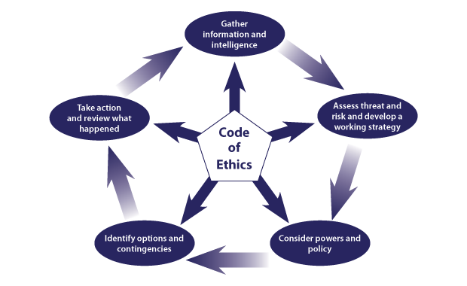

College of Policing. (2022).

Conclusion

To conclude information and intelligence that is submitted from police officers will help to build a wider picture of county lines criminal activity and so contribute towards disrupting their enterprise. However, this information must be accurate and sanitised via the 3x5x2 grading system. This information and intelligence forms the initial stage of the National Decision Model which an officer will be using to guide their approach to dealing with a vehicle that may be involved in county lines.

Roads Policing contribute towards disrupting county lines criminal activity via both static and mobile ANPR systems. It does this by forcing drivers of vehicles to take different routes to avoid the cameras (if they are aware of their location). It collects valuable information for mobile police units to intercept such vehicle.

Even if vehicles are aware of the locations of ANPR cameras, they are still vulnerable to mobile police vehicles intercepting them.

ANPR has both strengths and weaknesses that I have discussed through this task. But providing the system is used ethically it without doubt is important as investigative resource when disrupting criminal activity.

Task 5
Individual Learning Plan

The second learning outcome identified in the accompanying module descriptor (BMPP 5000D) asks that you create an individual learning plan to meet your identified needs through reflection upon your continuing practice. This shows confidence in your ability to manage your own learning in response to evolving circumstances in the workplace.

This task differs from the PDPs that you have completed in your previous workbooks in that this learning plan allows you to assess what level you believe you are in key knowledge, skills and experience against where you believe you (and the force) consider you should be – now and in the coming 6 to 12 months of your placement. This should then be used to target future development need.

1500 words equivalent. Please note that this is not the actual number of words used in completing the table, the count reflects the thought and research behind it.

It will count towards the overall equivalent word count of 8000 words expected from this module.

ANSWER:

Knowledge, Skills and Experience Assessment

 | REQUIRED |  |  | RATING |  |  | DEVELOPMENT NEED
KNOWLEDGE  My key Knowledge is of medium average to good overall. I rarely need to ask my experienced colleagues knowledge based questions, but I would like to improve,  I would say I was at a score of 7 | Low  1-4 | Med  5-7  7 | High  8-10 | Low  1-4 | Med  5-7 | High  8-10  8 | I would to improve my key knowledge but manage my own expectations. Often knowledge comes with time and experience. But I would like to see my knowledge increase to the lower end high as this will prove personal progression  I would like to develop to a score of 8.
SKILLS  I think that my skill is of high medium range,  I am continuing to improve and feel that on a day to day basis I can reply on my skillset to effectively deal with everyday call and more complex calls. I often carry out a tour of duty single crewed and fell that most of the time I do not need to check decisions with my supervisor.  I would give myself a score of medium 7. | Low  1-4 | Med  5-7  7 | High  8-10 | Low  1-4 | Med  5-7 | High  8-10  9 | I would like to improve this area as enjoy to develop at a fairly fast pace.  For example I hope to complete my blue light course and also my taser course as soon as possible which will increase my skill level.  I intend to put focus on this area so that I can achieve an ambitious score for 9.
EXPERIENCE  I feel that I have been fortunate with my placement of station. Fairwater provides a steady call volume of a variety of different calls, from DV, Public order and driving offences to name a few examples.  I am also keen in regards to overtime so have had the opportunity to work at different areas of Cardiff and with different officers, I have had the opportunity to observe different policing styles and worked with experienced and inexperienced officers.  I am familiar with the process of custody, the hub, and have attended BCU days for protest and large events I have also regular completed Cardiff after Dark shifts.  I would say I am a score of Medium 7. | Low  1-4 | Med  5-7  7 | High  8-10 | Low  1-4 | Med  5-7 | High  8-10  9 | I am always eager to develop however I understand that this time. I intend to increase my experience by continuing to accept overtime and enjoy my attachment placements.  I would like to develop to a score of 9.

Bibliography
The bibliography should only include sources referenced within the workbook using the Harvard referencing system. Information about referencing in written assignments and how to avoid plagiarism can be found on Moodle. It is important that you are aware of the importance of ensuring that the work submitted is your original work.
ANPR cameras: what are they and what do they do?. Available: https://www.adrianflux.co.uk/blog/2021/04/what-are-anpr-cameras.html. Last accessed 04/01/2022.
Automatic Number Plate Recognition . Available: https://www.met.police.uk/advice/advice-and-information/rs/road-safety/automatic-number-plate-recognition-anpr/. Last accessed 04/01/2022.
Benefits of Positive Thinking for Body and Mind. [online] Verywell Mind. Available at: https://www.verywellmind.com/benefits-of-positive-thinking-2794767 [Accessed 23 Dec. 2021].
Betari Box Linking Attitude and Behaviour. Available: https://www.mindtools.com/pages/article/newCS_82.htm. Last accessed 02/01/2022.

Bruce Tuckman's 'Stages for a Group'. Available: http://www.free-management-ebooks.com/faqld/development-02.htm. Last accessed 02/01/2022.

Code of Ethics . Available: https://assets.college.police.uk/s3fs-public/2021-02/code_of_ethics_summary.pdf. Last accessed 02/01/2002.

Conformity and Behavior. [online] Verywell Mind. Available at: https://www.verywellmind.com/what-is-conformity-2795889 [Accessed 23 Dec. 2021].

County lines . Available: https://www.nationalcrimeagency.gov.uk/what-we-do/crime-threats/drug-trafficking/county-lines. Last accessed 04/01/2022.

Dealing With Interpersonal Conflict at Work. Available: https://www.indeed.com/career-advice/career-development/interpersonalconflict#:~:text=Workplace%20conflicts%20arise%20whenever%20two,personality%20clashes%20or%20poor%20communication.. Last accessed 02/01/2022.

Definition Of Team Dynamics. Available: https://www.teamtechnology.co.uk/team/dynamics/definition/. Last accessed 02/01/2021.

Edgar Schein Model of Organization Culture. [online] Managementstudyguide.com. Available at: https://www.managementstudyguide.com/edgar-schein-model.htm [Accessed 23 Dec. 2021].

How to Handle Interpersonal Conflict Like a Pro. Available: https://www.healthline.com/health/interpersonal-conflict. Last accessed 02/01/2022.

Intelligence management . Available: https://www.app.college.police.uk/app-content/intelligence-management/intelligence-report/. Last accessed 04/01.2022.

Intelligence Management 3 x 5 x 2. [Online] nafn.gov.uk. Available at: https://www.local.gov.uk/sites/default/files/documents/Intelligence%20Management%20Training.pdf [Accessed 3 Jan. 2022].

National Decision Model. [online] www.app.college.police.uk. Available at: https://www.app.college.police.uk/app-content/national-decision-model/the-national-decision-model/#policing-principles [Accessed 23 Dec. 2021].

National Decision Model. Available: https://www.app.college.police.uk/wp-content/uploads/2014/12/NEW-National-decision-model1.png. Last accessed 02/01.2022.

National Decision Model . Available: https://www.app.college.police.uk/app-content/national-decision-model/the-national-decision-model/. Last accessed 04/01/2022.

Policing a Multicultural Society. Available: https://nij.ojp.gov/library/publications/policing-multicultural-society. Last accessed 02/01/2022.

Police officers “suffering from low morale and feel undervalued.” [online] www.standard.co.uk. Available at: https://www.standard.co.uk/news/uk/more-police-officers-suffering-from-low-morale-and-feeling-undervalued-survey-finds-a3622491.html [Accessed 23 Dec. 2021]

Roads Policing Review. Call for evidence. Available: https://assets.publishing.service.gov.uk/government/uploads/system/uploads/attachment_data/file/899574/roads-policing-review-call-for-evidence.pdf. Last accessed 04/01/2022.

Robinson, L., Segal, J. and Smith, M. (2019). The mental health benefits of exercise: The exercise prescription for depression, anxiety, and stress. [online] Help Guide. Available at: https://www.helpguide.org/articles/healthy-living/the-mental-health-benefits-of-exercise.htm accessed 23/12/2021

Team cohesion in the workplace . Available: https://www.russelltobin.com/culture/team-cohesion-in-the-workplace/. Last accessed 02/01/2022.

The Code of Ethics – Summary July 2014. Available: https://assets.college.police.uk/s3fs-public/2021-02/code_of_ethics_summary.pdf. Last accessed 02/01/2022.

The Dynamic Risk Assessment And When To Use It. Available: https://www.haspod.com/blog/paperwork/what-is-dynamic-risk-assessment. Last accessed 02/01/2022.

What is the difference between Information and Intelligence | Cyware | Educational Guides. [online] Cyware Labs. Available at: https://cyware.com/educational-guides/cyber-situational-awareness/what-is-the-difference-between-information-and-intelligence-f4d3 [Accessed 3 Jan. 2022].

