

Should UK Police Forces stop Pursuing vehicles?

Luke Morgan
2124732
BSc (Hons) Professional Policing Practice
October 2024
Word Count: 8000

Acknowledgments
I would like to thank Jane Davies, Sarah Jones, Rhiannon Sandy, Kelly Andrews and my Supervisor, Samantha Wilson for their time and support throughout the course of the dissertation process.
I would also specifically like to thank my parents, friends and colleagues for their support during my time on this course. Their assistance and guidance has been nothing short of exemplary and I thank each and every one of you for everything you have done for me.

Declaration

This work has not previously been accepted in substance for any degree and is not being concurrently submitted in candidature for any degree.
Signed: L.Morgan
Date: 07.10.2024

STATEMENT 1
This dissertation is being submitted in partial fulfilment of the requirements for the degree of BA.
Signed: L.Morgan
Date: 07.10.2024

STATEMENT 2
This dissertation is the result of my own independent work/investigation, except where otherwise stated.
Other sources are acknowledged by footnotes giving explicit references. A bibliography is appended.
Signed: L.Morgan
Date: 07.10.2024

STATEMENT 3
I hereby give consent for my dissertation, if accepted, to be available for photocopying and for interlibrary loan, and for the title and summary to be made available to outside organisations.
Signed: L.Morgan
Date: 07.10.2024

STATEMENT 4
I hereby give consent for my dissertation, if accepted, to be available on the university’s IT system to those who have consent to use the system.
Signed: L.Morgan
Date: 07.10.2024

Abstract
The aim of this dissertation is to investigate Police Pursuit within the modern way of policing to understand and explore what factors may lead to a pursuit and what current police officers think. The researcher has carried out an in-depth and varied analysis of existing academic literature in relation to police pursuits, Public and professional opinion and any data found about the topic.

To gain further insight into pursuit decision-making, pursuit management and first-hand experiences a research project was undertaking. This project provides practical perspectives on the key factors influencing officers' choices to initiate, continue, or terminate pursuits. The literature present and accessible has guided the development of research project questions, targeting crucial themes such as risk assessment, opinion, and public safety considerations.

The findings support much of the literature discussed in Chapter Two, identifying several core themes in relation to police pursuits: the prioritization of public safety, real-time decision-making, and public perception. Each of these plays a critical role in shaping the outcome of pursuits, with officers consistently highlighting the importance of situational awareness and proportionality in their actions.

Following each chapter through to completion, the dissertation achieved the aim of answering the headed question: “Should UK Police forces stop Pursuing vehicles?” with the answer having relevant research and literature to ascertain and effectively obtain information to answer the question.

Table of Contents
Chapter 1 – Introduction……………………………………………………………………………………………………………………6
  - Background………………………………………………………………………………………………………………………………...6
  - Aim and objectives………………….…………………………………………………………………………………………………..6
  - Research Rationale…………………………………………………………...............................................................7
  - Structure……………………………………………………………………………………………………………………………………..7
  - Conclusion……………………………………………………………………………………………………………………………………..7
Chapter 2 – Literature review…………………………………………………………………………………………………….………8
  - Practice and Policies……………………………………………………………………………………………………………………8
  - Causation Factors…………………………………………..……………………………………………………………………..…...9
  - External Factors of Police Pursuits.................................................................................................10
  - Effects of Pursuits on Officers…………………………………………………………………………………………………...11
  - Reports on Pursuits by Independent Bodies………………………………………………………………………………12
  - Conclusion…………………………………………………………………………………………………………………………………12

Chapter 3 – Methodology………………………………………………………………………………………………………………..13
3.1 Research…………………………………………………………………………………………………………………………….………13
3.2 Types of Questions and framework………………………………………………………………………………….………..14
3.3 Ethical Considerations…………………………………………………………………………………………….………………….15
3.4 Conclusion…………………………………………………………………………………………………………………….…………..15

Chapter 4 – Analysis of results……………………………………………………………………………………………..………….16
4.1 Theme one………………………………………………………………………………………………………………..……………….16
4.2 Theme two………………………………………………………………………………………………………………..……………….17
4.3 Limitations………………………………………………………………………………………………………………..……………….17
4.4 Results of findings……………………………………………………......………………………………….……………………….17
4.5 Conclusion……………………………………………………………………..……………………….…………………………………18

Chapter 5 – Conclusion and recommendations……………………………………………………………………………….19
5.1 Aims and objectives…………………………………………………………………………………………………………………..19
5.2 Findings……………………………………………………………………………………………………………………………………..20
5.3 Recommendations…………………………………………………………………….……………………………………………….21
5.4 Limitations of the dissertation……………………………………………………………………………………………………22
5.5 Conclusion…………………………………………………………………………….……………………………………………………22

Bibliography…………………………………………………………………………………………………………………………………….23
Appendixes………………………………………………………………………………………………………………………………………26
Appendix A – Questionnaire Sheet Blank…………………………………………………………………………………………26
Appendix B – Research Project Questionnaire sheet answers from participants…………….…………………29

List of figures
Figure 2.2.1 - Diagram of statistics on reported vehicle offences (Clark, 2022)……………….………………….9
Figure 3.2.1 - Differences of Open ended and closed questions (Rosala, 2024………………………………….14
Figure 4.1 – Age ranges from participants of Research…………………………………………………………………….16
Chapter 1 – Introduction
The purpose of this dissertation is to critically investigate modern day policing requirements in relation to Roads Policing and specifically Police pursuits and to provide an answer to the question “Should UK Police Forces Stop pursuing Vehicles?” This chapter of the dissertation provides a look at the background of the study and explores why research is important.
1.1 Background
Police pursuits have long been a critical aspect of modern day policing over recent years particularly in situations where suspects attempt to evade arrest by fleeing in vehicles. These often involve significant risks, not only to the officers and suspects but also to the public, making them a controversial practice in modern policing. Balancing the need to apprehend suspects with the responsibility to ensure public safety has led to intense debate around the appropriateness, risks, and benefits of pursuits. The rise of public scrutiny and the influence of the media have further complicated this issue, with some high-profile cases ending in tragic consequences, thereby fuelling calls for stricter pursuit policies and on occasions the stopping of pursuits
Policies around pursuits typically focus on assessing the risks involved, including the severity of the offence, road conditions, traffic density, and the behaviour of the suspect. However, the effectiveness of these policies and the decision-making processes officers use during pursuits remain key areas of concern, as pursuits often escalate quickly and unpredictably.
With present information and literature it is clear that there is a need to delve into, discuss and conduct further research to establish stronger foundations into this topic and provide further data to enhance the ability to discuss the incident and in turn answer the question of this dissertation.

1.2 Aims and objectives
The aim of the research project within this dissertation is to obtain and collate information relating to the first-hand experience and opinion of Police officers who have dealings with Police Pursuits. The aim of this dissertation is to evaluate and critically analyse academic literature presently available to compare and establish any areas of change, any areas where research is needed and this in turn will also allow for conclusions and recommendations to be drawn up in relation to this question.
- To analyse current and previous academic literature accessible in relation to Modern day policing and taking a specific look at Pursuits
- Conduct effect research into research methods and make the appropriate informed decision on which method will be used within the research project
- To conduct primary research and further conduct a critical analysis into the generated information and data to further understanding in the field and gain insight into officers opinions
- Provide recommendations regarding any relevant information discovered or key issues that have arisen and require auctioning

1.3 Research rationale
The research within the project of this dissertation unfortunately comes from a place of sadness and increase in the number of police related accidents, fatalities and failures to adhere to policy and procedures. This has resulted in an increased amount of coverage from media outlets, governing bodies and police forces themselves discussing matters. This has evoked a need for further analysis and research into the topic, namely police pursuit, and to enhance and progress the literature, research and conclusions.

1.4 Structure
In order to effectively achieve and complete the objectives and aims of this dissertation, individual chapters will take the reader through a composed and clear discussion of the relevant areas of the topic. Chapter two of the dissertation will look to analyse and critically evaluate present accessible academic literature into the topic of police pursuits and looking specifically at areas such as Officer training, Reviewing of pursuits and public perception.
Chapter three will review and analyse various research techniques and methodologies looking at the benefits of them and what areas may be open to critique. This will allow for an effective primary research approach to have the desired outcome.
Chapter four will then take the data and information obtained from this research project, propose any identified themes and drawn conclusions from detailed analysis of the information.
Finally, bringing the dissertation to a conclusion is Chapter five which looks to address and encompass all objectives, to effectively analysis the conducted research and make informed recommendations based on the observations.

1.5 Conclusion
This is the first chapter of the dissertation and has now effectively produced and presented the context to the dissertation and research proposal regarding the topic of Modern day policing looking specifically at Police Pursuits. The following chapter now takes the forefront and leads into a critical analysis of identified and relevant accessible academic literature that is available for viewing and reading.

Chapter 2 – Literature Review

This chapter of the dissertation will delve into the varying aspects which surround a police pursuit, looking specifically at the training given, different dangers associated with a pursuit; and discussing what information is present in the public domain regarding pursuits from bodies such as the Independent Office for Police Conduct (IOPC) to name just one. Not only will this chapter consist of discussion but also comparison and analysis in order to effectively and efficiently answer the question headed of this dissertation.
Furthermore, this chapter aims to answer the objectives within this dissertation which is to gather research and information surrounding different United Kingdom (UK) Police forces and to analyses critically the information gathered. This chapter is divide into six sections of individual subjects. Section one provides an overview of the practice and policy of police pursuits; Section two looks at factors for the causation or reasons that police pursuits develop; Section three looks at an overview of external factors of police pursuits; Section four looks at the effect of police pursuits on officers and what they encounter; Section five will detail reports made by independent Bodies such as the IOPC.

2.1 Practices and Policies
A police pursuit is defined in the “Authorised Professional Practice” (APP) by the College of Policing when “A police driver is deemed to be in pursuit when a driver/motorcyclist indicates by their actions or continuance of their manner of driving/riding that; they have no intention of stopping for the police, and; the police driver believes that the driver of the subject vehicle is aware of the requirement to stop and decides to continue behind the subject vehicle with a view to either reporting its progress or stopping it” (College Of Policing, 2013). Through the APP, this is the standardised practice which governs UK police officers in their duties.
The pursuit of vehicles by Police Forces is an extreme event whereby risk is high and the possibility of damage, injury or fatalities are possible outcomes of such an incident (Christie, 2020). The decision to pursue a vehicle by a police officer must be taken with due diligence and that officer must have the correct skills and training in order to undertake such a significant decision. As per the College of Policing website “Drivers must be qualified within the terms of current National Police Chiefs’ Council (NPCC) approved national training standards”. This qualification being “Initial Phase Pursuit” or “Tactical Phase Trained” for those involved (College Of Policing, 2013). Even given this, it is not a straight forward process based solely on an officer’s skillset and there are several variables that have an attributing factor towards a pursuit’s initiation and outcome such as age of the pursuing officer, their ability to manage their adrenaline and stress reflexes during such an intense incident. This means that these rules for pursuits are effective however there are external issues associated which can bring on risk or issues within incidents of these nature (Wade, 2014).
This literature highlights the intricate and necessary policies that are incorporated into any and all police pursuits. It also highlights a need to obtain a more personal understanding of what this all means and the impacts it has on the officers involved and attempts to achieve this be within the research project chapter

2.2 Causation Factors
The causation factor in why a pursuit begins is something specific to each individual incident of a pursuit however there is almost always one factor as to why a person does not stop for police. Looking specifically at one aspect of reasons which may cause a pursuit is vehicle crime. According to recent statistics from year 2022 to 2023 there was an increase in the number of vehicle theft offences in England and Wales (Clark, 2022)
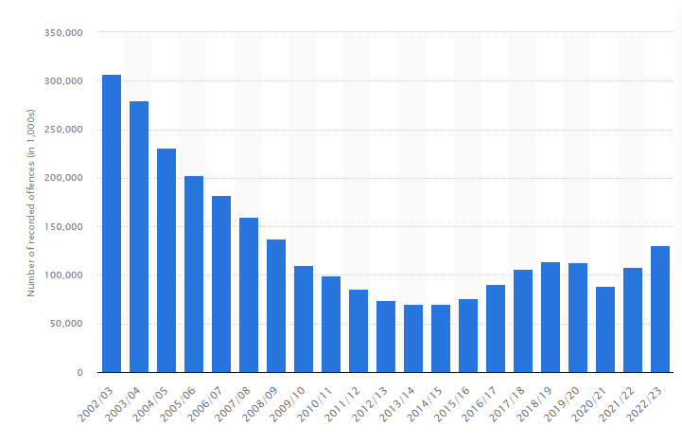
Figure 2.2.1 - Diagram of statistics on reported vehicle offences (Clark, 2022)
As seen in this diagram in relation to vehicle theft offences, there was an increase in reported offences from the year 2022 to 2023. However looking this over a broader period of time there has been a significant decrease in reported offences from year 2002 to 2023.

To compare this statistic to police pursuits, a Freedom of Information request published on the West Yorkshire Police Website shows the number of pursuits each year starting in 2018 finishing in 2023 (North Yorkshire Police, 2023)


Figure 2.2.2 - Statistics provided by North Yorkshire Police of number pursuits per year (North Yorkshire Police, 2023)
While crime statistics fluctuate annually, there is often a correlation between higher crime reports and an increase in police pursuits. However, from 2022 to 2023, despite an increase in reported offences, the number of pursuits declined. It's important to note that the crime data reflects UK-wide figures, whereas the pursuit data pertains to a specific police force. This difference suggests that varying crime levels across police forces may impact the number of pursuits. As highlighted, this literature relates to specific police forces and as such there is a necessity to research a wider range of police forces to gain further understanding for which at present there is not present.

2.3 – External Factors of Police Pursuits
Something to be aware of when discussing this topic are the factors which affect operational policing. Police pursuits require specially trained police officers to be able to effectively manage and conclude a pursuit. Not only does this require the right training (College Of Policing, 2013) but there must also be a sufficient number of officers present. And in today’s policing world, numbers of officers are dwindling. A report from the Home Office, showed that “4668 officers resigned between April 2022 and March 2023”. This shows a 32% increase in officers leaving Forces across England and Wales compared the previous year (West Midlands Police Federation, 2023, P.1-2).This drastic loss in numbers of officers is a pivotal shift in the way in which modern day policing is undertaken and its effectiveness. With increase in the number of reports made to police, the deployment of officers to reports is less efficient and done in a timely manner which will in turn create less availability for police to undertake pursuits and to have the desired outcomes (Dearden, 2018)
There are also other factors which play into the operational undertaking of Police Pursuits. Media coverage and public perception are an instrumental factor in the way police undertake various day to day duties. Over recent years media coverage of the police has been substantially negative through various incidents of poor or inappropriate behaviour to which officers have been subjected to investigation or further disciplinary action. Cases such the of the murder of Sarah Everard by at the time serving metropolitan police officer Wayne Couzens and the coverage it had in the media had a significant effect on the public’s perception of the police and the downturn in trust and confidence (Metropolitan Police, 2024).
Public trust and confidence is directly affected through media coverage, a tracked report from the IOPC in regards to public perception shows that direct publication through media reports, stories or publications have caused confidence in the police to decrease in turn negativity has increased to its highest level post January (Independent Office for Police Conduct, 2023). Phoebe Netto furthers this issue surrounding media coverage by stating “Securing positive media coverage is an excellent way to establish credibility” (Netto, 2014). This factor may play into the mind-set of police officers and as such has the possibility to effect officers not wanting to be put into the Media’s light by undertaking such things as a pursuit whereby things can go wrong. This is something that will be highlighted within research conducted to establish any plausibility in this.
The clear lack of public trust is seen through the rising outcries from members of the public for change within the criminal justice system. The “Northern Police Monitoring Project” are a community based group that aims to “Challenge police violence, brutality and racism”. One aspect of the group’s aims is to create significant change to the APP guidelines to which police work under within the UK. Looking specific at their goals, they wish to make a change within UK policing that police pursuit are not considered or even undertaken for offences considered “Nonviolent” or “Minor traffic violations” (Northern Police Monitoring Project, 2024)
This literature does show that a proportion of the public do believe that higher scrutiny and more in depth decision making needs to be undertake when a pursuit occurs. One could view this and see that it ties into the information as this scrutiny increases the likely hood of officers engaging in or continuing a pursuit may decrease. This area of scrutiny is something which I aim to understand and obtain through research by asking officers for their first hand opinions and experiences.
Following on from this topic of increased scrutiny, this is something which the UK government along with various agencies and bodies over the last several years have attempted to delve deeper into to make any necessary changes and uphold public confidence. In September 2017, Right Honourable Nick Hurd, Minister of State for Policing and the Fire service, announced a Home Office lead review into the policies, procedures, law and guidance surrounding police pursuits. The reasoning for the review was to identify areas of improvement, lacking areas surrounding the legal framework and once completed making remarks into what can be changed or improved within this area of policing with the findings published in 2018 (Hurd, 2018).
UK police forces are adapting and welcoming this change in scrutiny and shift in public perception by becoming more transparent and forthcoming with information and statistics. To name but a few, Surrey and Sussex police have released a publicly accessible document which details their pursuit policies, stating the training involved and as well as the practical workings of a pursuit and those involved (Surrey Police and Sussex Police, 2024). However, intense scrutiny may not always achieve the intended outcomes. Instead, it can lead individuals or organizations to prioritize actions that seek approval from their audience, rather than addressing the underlying issues, potentially resulting in performative measures rather than meaningful change (Sutton and Galunic, 1995). In the context of policing, particularly Roads Policing, research indicates that police pursuits can be influenced by the need for public approval or validation. Decisions surrounding pursuits may be shaped by prevailing public sentiment, with officers potentially altering their actions based on whether public opinion supports or opposes such measures at the time

2.4 – Effects of Pursuits on Officers
The very nature of a police pursuit is a dangerous and high risk chain of events. Police pursuits occur within the public space and area that they should feel totally and utterly safe. Then taking a person or persons who wish to evade police creates an ever-changing and complex situation that needs to be safely managed. As such the officers involved begin to work towards extreme levels of intensity and the effects can be physically and mentally impactive. A report from the University of Nottingham details the intricacies and differences in the way in which “novice, response” and “pursuit” drivers react to different hazards and their perceptions. The discussions post research shows an interesting but somewhat expected correlation that police officers have a greater level of horizontal scanning and perception whereas novice drivers are more adapt to scanning vertically. This is possibly associated with the training police officers receive to scan in a different manner for hazards. (Crundall et al., 2003). This report gives clear substance and clarity to the question of the dissertation and strengthens the arguments in favour of police pursuits.
Similarly, police officers appear to be able to respond to a higher number of hazards and register a greater number of stimuli during pursuits and police driving which is something beneficial and gives confidence to the public that those officers engaged in pursuits and going to be able to spot and hopefully negate and avoid hazards at an increased rate. On the contrary, the research and evidence synthesised appears to suggest that police officers still produce similar hazard ratings that novice drivers produce. (Crundall et al., 2003)

2.5 – Reports on Pursuits by Independent Bodies
Following on from specifically looking at pursuits and their outcomes, the IOPC continue to release data in regards to “Deaths following police contact”, the most recent available data is from the year 2022 to 2023. The data collated shows that in this time period, there were “28 fatalities from 26 road related traffic incidents (RTIs)”. This showed a decrease by 12 from the previous but the most interesting piece of data shows that “20 of the 28 fatalities arose from 18 police pursuit related incidents” (Independent Office for Police Conduct, 2023). This data presents an interesting suggestion as to the level and amount of fatalities occurring from Police pursuits. Out of a 365 day period, 18 police pursuits resulted in at least 1 fatality. Contextually, from previous data North Yorkshire police engaged in 57 pursuits during this time period so as to look at this figure and contextualise it to the amount of pursuits across the entire UK, the probability and likely hood of a fatality occurring from a police pursuit appears to be very minimal.
Further research and data collection are evidently needed to explore this perception more fully, current findings suggest that police pursuits, though inherently risky, are managed in a way that minimizes the risk of fatalities as much as possible. This highlights the careful balancing of public safety with the necessity of pursuits, affirming the importance of ongoing evaluation and refinement of pursuit protocols and highlights the need for continued and further research to clarify and identify information to sustain the level of police pursuits.

2.6 - Conclusion
To conclude this chapter, the literature explored shows the complex and multifaceted nature of police pursuits, offering insights into their development, legal frameworks, decision-making processes, and the role of public perception. Police pursuits remain an essential yet controversial tool in law enforcement, necessitating a careful balance between apprehending suspects and safeguarding public safety. Despite the inherent risks, advancements in pursuit policies, training, and technology have helped reduce the likelihood of fatalities and other adverse outcomes.
The analysis of the literature highlights that public opinion plays a significant role in shaping pursuit policies, with officers and agencies often under pressure to respond to societal expectations. However, the need for validation and approval from the public can sometimes result in performative actions rather than evidence-based strategies, which may compromise the effectiveness of pursuit management. It is crucial that police forces prioritize data-driven decision-making and continual assessment of pursuit policies.
In response to the literature shown, future research for which I will conduct will focus on further data collection, especially on the impact of emerging technologies and alternative pursuit strategies, to ensure the ongoing evolution of safer and more efficient police pursuit practices.

Chapter 3 – Methodology
This chapter of the dissertation aims to focus on the Research Methodology examining what research is available, the different forms of research and what ultimately will be used to the answer the overarching question this dissertation is centred on. This chapter will cover forms of research, Ethical considerations, types of questioning and framework.

3.1 Research
Research and its methodology benefit from taking insight into the topic and its information prior to performing new research as once done this allows for directed and informed research. There are several forms of research which provide their own insights and correlations from the data which is produced (Pearlstein , 2010)
There are two main forms of research which have considered for research within this dissertation, these being Qualitative and Quantitative. Qualitative research studies centre on the ability for comparison and interpretation of the data produced in the forms of Interviews, records, surveys or more. This styling of research allows for a slightly more anecdotal and complex data field to be published which provides significantly more insight into the experiences of those involved. Quantitative research produces information and data over time based forms and the data collected is viewed in a numerical or statistical form. This approach to research is far more structured and analytical producing data which is far more generalised and is used against other research studies due to its objective and clear findings (Oxbridge Essays, 2023); however cognisance must be given to that this may not always be the case.
The research that is set out to be conducted in this dissertation takes the form of Qualitative research. This has been chosen after meticulous review for several reasons. Qualitative form research provides a significantly deeper insight into the personal side of those involved in the research. The data and information extracted can be analysed, compared and interpreted at a level much broader than Quantitative research. In addition, qualitative research allows for participants to be open ended with their answers which provides the researcher with experience based data as well understanding the thoughts and feelings of participants. Something which cannot be extracted from Quantitative research (Tenny, Brannan and Brannan, 2022)
Further to this, consideration has been made to what the outcome of this dissertation is and the expected results. This dissertation puts the focal point of real first-hand experience at its core to be able to effectively answer the headed question. This can only be aided through such qualitative research. This has been seen in research conducted by the National Health Service (NHS) whereby a report made for public viewing informs them how qualitative research allows the organisation to gain deeper understanding of patients thoughts and feelings alongside gathering persons together to be able to share a similar viewpoint or opinion to benefit the research and its data produced (NHS England, 2017).

3.2 Types of Questions and Framework
The research undertaken in this dissertation will utilise Primary source research as opposed to Secondary. Primary research consist of obtaining information or data which comes directly from either a person or source such as texts or documents. Whilst Secondary research is discussions, opinion or interpretation of already produce primary research (University of Massachusetts Boston, 2019). The literature within this dissertation has provided insight and foundations into the direction of the research project, what is currently available and what is sought to enhance the outcome.
With this information available Primary research will be conducted for this research project. This will consist of a questionnaire based form of research whereby the participants are expected to answer several short but open ended questions in as little or as much detail as they feel appropriate. The answers in hope, will be broad and varying in length and experience. This is to ensure a rich field of information to extract and further review as part of the subsequent analysis.
Open ended questions as opposed to closed questions are akin to this form of research due to their inherent ability to produce answers or information which is of larger or more in depth nature. These questions allow the reader to think critically and formulate answers which allow the research to further develop and analyse the information and preclude any correlations found (Weller et al., 2018)
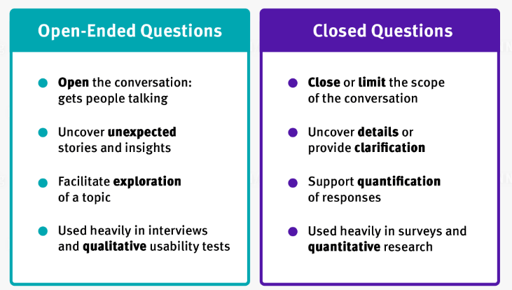

Figure 3.2.1 - Differences of Open ended and closed questions (Rosala, 2024)

3.3 Ethical Considerations
Whilst conducting this research due diligence must be given to what is being asked of the participants and it must be kept at the forefront any ethical considerations to be made. There will be include within the questionnaire a disclosure that persons do not have to provide any personal details, can answer anonymously and that they do not have to answer questions they are not comfortable with. This is to not only ensure there is clear consent in regards to participation but also that there is no associated risk to the participants in the form of any data leaks or identification. There will be clear ethical considerations given within this research task ensuring that there is transparency in relation to what is expected, what will happen and when will the findings be released (Sherry, 2024)
Researchers are obliged to consider this through the scope of the Data Protection Act 2018 which governs and ensures controlled and effective management and processing of personal data obtained and the subsequent usage. Further to this, scrutiny will be applied to the management and storing of data post research. This will be done through secure processing utilising secure and encrypted devices to ensure any and all data is not lost, damaged or found to negate any form of risk or identification of persons involved (UK Government, 2018).
The overarching aim of this research methodology is to obtain first-hand information regarding personal experiences and opinion on modern day policing from a Roads Policing Perspective. Utilising a questionnaire based format in order to promote a response within the questions which is personal but expressive encapsulating experience, opinion and emotional bundled together. This is turn will ensure an effective answer to section 1 of the research objectives of this dissertation.

3.4 Conclusion
This current chapter is completed in hopes that there will be sufficient information to undertake calculate comparison and discussion around the topic and consider any findings or correlations. This research forms a large basis of the answer to the question of this dissertation and as such will be conducted in a timely manner with a heavy focus on the standard of questions, format and subsequent data compiling.
A blank questionnaire sheet can be found in Appendix A
This chapter has outlined the research methods chosen to address the dissertation's central question. The selected approach will guide data collection and analysis, forming the basis for the findings in the following chapters.

Chapter 4 – Analysis of results
This chapter follows on from the previous which detailed the various ways to conduct primary research, the benefits and considerations to be taken whilst conducting the research. This will now present the results and findings from the primary research focusing on police pursuits. This chapter will explore the chosen method to conduct this research, exploring key themes identified from analysing the results and drawing a conclusion from it. This research attempts to obtain and understand first-hand information, data and experience to fill the gaps seen in previous chapters whereby there is a lack of officer opinion and information.
The research method chosen was a questionnaire style survey in which participants were provided with a list of questions to answer at their leisure. The questionnaire was sent out to several individuals within the policing context and those in receipt were asked to answer as many questions as possible. Specifically to obtain relevant answers, the questionnaire was sent out directly to Roads Policing Teams and former Roads Policing Officers to attempt to garner their information, knowledge and experience.
Further to this, the questionnaire favours more open questions in order to allow broader and detailed answers from the participants. But there are also closed questions which asks for much more specific answers which still allow for themes and conclusions to be made based on the generated results.

Figure 4.1 – Age ranges from participants of Research
The questionnaire was answered either in part of full by fifteen (15) individual participants, of different occupations within policing different genders and different age ranges as seen in “Figure 4.1”

4.1 Theme one
A key early identified them that has arisen from this research is the perspectives from the participants on Public Safety. When asked a question regarding main risk factors involved in a Police pursuits, 80%, Being Twelve out of fifteen participants, directly stated that “Members of the public” or “Innocent bystanders” were their main risk taking into consideration if they were in a police pursuit. This goes to shows that officers place a strong emphasis on the safety of the general public when making decisions even during intense situations like pursuits. This clear focus and ability to recognise the danger for the public aligns with police force ethics and policies that maintain and ensuring public safety is paramount.

4.2 Theme two
Another core theme identified from the research in the previous chapter is that officers are in consensus that Police Pursuits are a dangerous part of policing but are necessary. Several participants have clearly identified that Police Pursuits are an inherently dangerous and risky situation that officers and members of the public are exposed to. One participant wrote “there is risk involved, members of the public sometimes get caught up in the middle of these incidents and sometimes when things go wrong people can get hurt”. What can be seen from participant’s answers is that police pursuits are something that officers stand behind and support with the right training, policy and procedure. Fourteen out of the fifteen participants agreed that Police Pursuits should continue to happen.

4.3 Limitations
The research conducted within the previous chapter and the generated information data from within this chapter is effective in answering this dissertation in a clear and concise way. However consideration must be given as to what the limitations and weak areas of the research are as part of transparency and personal understanding.
There are only fifteen participants within this research project. This is assisted by the fact that persons with varying ages, experience and roles have engaged but it is still an extremely small glimpse into a national policing factor. Couple this with having only five females participating, there is a possible lack of representation for which could be amended with a larger scaled project and direction to ascertaining female participants.
Something else to consider in this project whilst looking at the other chapters within this dissertation are that this project has been answered by current of formed police officers, but there is no participants from governing bodies such as the IOPC which could add a further amount of information from another side of the argument which would enhance this chapters effectiveness.

4.4 Results of findings
This research project has generated a sufficient amount of information that can be collated into data and themes. From this, it is evident that police officers both current and former believe that Police pursuits are a necessary part of policing but it is very dangerous. The element of a pursuit has to have the appropriate means to an end and as well as having appropriate grounds to continue and the research shows that officers are cognisant to the idea that risk is a constant factor that cannot be completely removed.
What is also shown is that officers take the IOPC to be harshly criticising of Police Pursuits and this appears to undermine the excellent work Roads Policing officers or suitably trained officers’ work that is carried out each day? It is shown within the research that as an independent body the IOPC helps to provide guidance and advice as well as giving reprimands for those who work outside of their remit, however there is that mixed bag of feelings varying between officers and their own personal experiences.
4.5 Conclusion
This research project has provided a first-hand insight into police experience and knowledge. From analysing the generated information and data that the current research and literature is in line with what some officers believe and experience. Officers conduct mentally and physically challenging rules and when engaging in pursuits their abilities are tested and the situation becomes heightened. The training that officers receive is adapted and specific to their roles and it evident that the training is necessary for continued success but also for progression to limit and mitigate risks within an officer risk assessment.
This research project has effectively addressed research objectives One, Three and Four by successfully obtaining first hand detail and experiences from Police officers and information surrounding Police training, experience and opinion.
This chapter has presented the findings of the research project from first-hand primary collection. This now ensured a clear and smooth transition into the next chapter which will aims to provide recommendations and effectively conclude this dissertation.

Chapter 5 – Conclusion and recommendations
The previous four chapters of this dissertation have enabled a guided and informed delve into the various areas and projects. This includes the introduction, research project, planning and analysis phases, with the most recent chapter exploring the primary research project of first-hand officer experience and opinion with an end goal of collating the data.
This chapter aims to conclude the dissertation in relation to the chosen topic after conducting effective analysis of literature and engaging in primary research. This chapter also aims to undertake the final piece of the dissertation which is to produce and provide recommendations in relation to Police Pursuits in Modern day policing.

5.1 Aims and objectives
The chapters proceeding this have established the basis to achieve and complete the aims and objectives of this dissertation.
- To analyse current and previous academic literature accessible in relation to Modern day policing and taking a specific look at Pursuits

An extensive and in depth analysis of academic literature has been conducted within chapter two, looking at an array of literature, review of the material and making conclusions

- Conduct effect research into research methods and make the appropriate informed decision on which method will be used within the research project

The array of research methods, including various frameworks have been explored within chapter three of this dissertation

- To conduct primary research and further conduct a critical analysis into the generated information and data to further understanding in the field and gain insight into officers opinions

Primary research has been conducted utilising the review of chapter three which allowed an informed decision to be made which was a questionnaire aimed at obtaining detailed and broad answers from participants.

- Provide recommendations regarding any relevant information discovered or key issues that have arisen and require auctioning

This objective is to be completed within this chapter of the dissertation.

5.2 Findings
This dissertation has explored the intricate nature and complexities of Roads policing taking a considered and direct approach to Police pursuits focusing on the Research of pursuits, Public perception, Public safety and officer opinion. The literature available and accessible at present time shows Police officers who undertake Police pursuits have to work to extremely higher levels of physical and mental pressures compared to other officers. The training standards for police pursuits are maintained at a high level and the real life factors of pursuits show the ability of the officers to manage stress and adrenaline levels.
The findings indicate that while pursuits are often necessary, their inherent risks demand careful regulation and continual assessment. Officers’ ability to terminate pursuits when the danger becomes too high is crucial, and this decision-making process must be informed by both training and technological support. Public perception also plays a significant role, with the public generally supporting pursuits for serious crimes but expressing concerns about the safety risks, especially for minor offences.
Further findings suggest that crime rates involving vehicles and the number of pursuits vary from year to year and is further not only from academic literature but also the primary research conducted. Officers are acutely aware that causation factors of pursuits relate to persons being involved in crime such as driving stolen vehicles. The primary research further indicates that pursuits will develop from criminality and those aware of crimes and their involvement which goes to show a strong argument for answering the questions of this dissertation as Police pursuits should continue.
Finally, from critically analysing literature and primary research it is evident that Public perception is a substantial external factor which directly affects Police pursuits. Independent bodies such as the IOPC have an effect on police officers and police pursuits. Through reading the literature and conducting primary research it can see that officers are satisfied to be reviewed and critiqued to improve and ensure public safety. However there is a clear fine line that officers feel is crossed and undermines their work.
The literature and primary research have allowed for effective analysis and shows that police pursuits are determined by risk and at times have increased risk to the public but it something that the public feel is necessary during certain circumstances.

5.3 Recommendations
The following recommendations have been made on the basis of the previous chapters in this dissertation and the decision is drawn from the reviewing of findings made whilst assessing the literature and conducting primary research.
Firstly, the training programmes utilised in the modern day need to continue to improve in any area of Police pursuits regardless of how big or small. Training for officers to be involved in police pursuits must remain up to date with modern day practices and public image. The training should involve real life based scenarios in public settings to bring to the forefront public safety and the factors taken into a Risk assessed decision process. Due to the effects on officers, training must also focus on physical and mental challenges for officers involved as this will ensure there is no decrease in hazard scanning or perception, inability to manage stress and risk assess.
The primary research further backs this recommendation as several participants answered that they would only feel comfortable to pursue a vehicle if they had sufficient training with annual refreshers.
Secondly, Reviews and Investigations into police pursuits need to balance realistic expectations of officer’s involved and public image. It is seen through the literature and the research project that when Independent bodies such as the IOPC conduct investigations into police pursuits officers tend to take a two sided approach. Some will understand the investigation and accept the findings whereas some will rebut the findings as they are deemed overly critical. This fine line needs to be maintained and bodies such as the IOPC should review and critique police officers involved in pursuits but there should be clear consideration given to the real life nature and heightened nature of these incidents.
Thirdly, a recommendation is to be made that given the lack of academic literature which focuses on officer opinion and experience more needs to be undertaken to improve the knowledge base for further discussions.
Finally, the primary research project within this dissertation has identified a clear and objective recommendation which is that Police Pursuit despite the risk, perception and sometimes unwanted outcomes they should continue to be engaged as they combat the crime and persons who create such problems for society that they need to be addressed and dealt with in this matter.

5.4 Limitations of the dissertation
The dissertation itself although broad and substantial is limited through the nature of its own size and topic. Due to firstly the level of dissertation there is a reduced ability to develop areas of literature, research or analysis due to restrictions on individual sections and their respective word counts.
Not only this, but in this case, the topic of Police Pursuits is a very publicly based topic whereby if it were able, public research and real life involvement would bring forward a new layer of information and data for analysis. The ability to go on real life working days with officers involved in pursuits would also create new areas of discussion and analysis however we have to be realistic about what our goals are and what can be achieved in this topic space.
Finally, there is a clear lack of academically based real life literature to base evaluations off within this dissertation. It has been evident some literature is not what some would call up to date or completed within the modern time which can cause a disconnect between what we are seeing and what we are reading. Further to this, the lack of literature in relation to police pursuits means there is a heavier reliance on subjective based information which can mean a lower source of reliability and when this becomes clear during different chapters of the dissertation it has allowed for a more challenging analysis of the information.

5.5 Conclusion
This dissertation has undertaken several aims, objectives and chapters throughout its duration and has produced a plethora of different sets of data, varying forms of analysis and in the end recommendations and findings. This dissertation and research project have been successful in providing the reader with a substantial amount of information and data and has achieved its aims and objectives. This dissertation in turn has allowed the reader to make an informed answer to the headed question of “Should UK Police Forces stop pursuing vehicles?”.
Through careful and considerate primary research and further analysis this dissertation has been able to explore and understand the intricate ways of Modern Day roads policing and Police Pursuits. Clear viewpoints of officers, present and past, have been explored and allowed for well-rounded analysis’ to be made.
It is worth noting that the literature and research within this dissertation is not finite to what is accessible. There will be and should be more first-hand research being conducted and generated within the coming years to further this topic. This would provide not only benefit for officers involved in pursuits but the members of the public who have to bear witness to the incidents during their day to day lives.

Bibliography

Reference list
Christie, N. (2020). Managing the safety of police pursuits: A mixed method case study of the Metropolitan Police Service, London. [Report] Amsterdam: Elsevier Ltd, pp.1–15. Available at: https://librarysearch.uwtsd.ac.uk/discovery/ [Accessed 7 May 2024].
Clark, D. (2022). Motor vehicle theft in England and Wales 2020. [Report] Statista. Available at: https://www.statista.com/statistics/303551/motor-vehicle-theft-in-england-and-wales/ [Accessed 14 Jun. 2024].
College of Policing (2013). Police pursuits. [Online] College of Policing. Available at: https://www.college.police.uk/app/roads-policing/police-pursuits [Accessed 7 May 2024].
Crundall, D., Chapman, P., Phelps, N. and Underwood, G. (2003). Eye Movements and Hazard Perception in Police Pursuit and Emergency Response Driving. Journal of Experimental Psychology: Applied, [online] 9(3), pp.163–174. Available at: https://librarysearch.uwtsd.ac.uk/discovery/fulldisplay?docid=cdi_proquest_miscellaneous_71288163&context=PC&vid=44WHELF_UWTSD:44WHELF_UWTSD_VU1&lang=en&search_scope=MyInst_and_CI&adaptor=Primo%20Central&tab=Everything&query=any,contains,police%20pursuit&offset=10 [Accessed 16 Jun. 2024].
Dearden, L. (2018). Number of police officers in England and Wales hits record low. [online] The Independent. Available at: https://www.independent.co.uk/news/uk/crime/crime-rises-statistics-england-wales-police-officer-numbers-record-low-government-tories-labour-cuts-funding-a8178631.html [Accessed 14 Jun. 2024].
Hurd , R.H.N. (2018). The law, guidance and training governing police pursuits: government response (accessible version). [Online] GOV.UK. Available at: https://www.gov.uk/government/consultations/police-pursuits/outcome/the-law-guidance-and-training-governing-police-pursuits-government-response-accessible-version [Accessed 15 Jun. 2024].
Independent Office for Police Conduct (2023a). IOPC Public Perceptions Tracker Summary Report. [Online] Independent Office for Police Conduct, pp.1–47. Available at: https://www.policeconduct.gov.uk/sites/default/files/documents/IOPC-public-perceptions-tracker-report-2022-23.pdf [Accessed 14 Jun. 2024].

Independent Office for Police Conduct (2023b). IOPC publishes figures on deaths during or following police contact for 2022/23 | Independent Office for Police Conduct (IOPC). [Online] www.policeconduct.gov.uk. Available at: https://www.policeconduct.gov.uk/news/iopc-publishes-figures-deaths-during-or-following-police-contact-202223#:~:text=This%20year%20there%20were%2028 [Accessed 17 Jun. 2024].
Metropolitan Police (2024). Our response to issues raised by the crimes of Wayne Couzens. [Online] Metropolitan Police. Available at: https://www.met.police.uk/notices/met/our-response-to-issues-raised-by-the-crimes-of-wayne-couzens/ [Accessed 14 Jun. 2024].
Netto, P. (2014). Positive media coverage is a powerful marketing tool. [Online] Pure Public Relations. Available at: https://www.purepublicrelations.com.au/media-coverage-can-benefit-business/ [Accessed 14 Jun. 2024].
NHS England (2017). Building greater insight through qualitative research. [Online] p.2. Available at: https://www.england.nhs.uk/wp-content/uploads/2017/04/bitesize-guide-qualitative-research.pdf [Accessed 29 Jun. 2024].
Northern Police Monitoring Project (2024). NPMP | Northern Police Monitoring Project. [Online] Northern Police Monitoring Project. Available at: http://npolicemonitor.co.uk/ [Accessed 14 Jun. 2024].
North Yorkshire Police (2023). FOI Police pursuits 2004-2021 (0652-2022/23). [Online] North Yorkshire Police. Available at: https://www.northyorkshire.police.uk/foi-ai/north-yorkshire-police/foi-disclosure-2021-22/july-2023/foi-police-pursuits-2004-2021-0652-202223/ [Accessed 14 Jun. 2024].
Oxbridge Essays (2023). Different Types of Research Methodologies in Research. [Online] Oxbridge Essays. Available at: https://www.oxbridgeessays.com/blog/different-types-of-research-methodology-in-research/ [Accessed 29 Jun. 2024].
Pearlstein , R. (2010). The many forms of research. [EBook] TheManyFormsofResearch, International Society for Performance Improvement, pp.1–4. Available at: https://research-ebsco-com.ezproxy.uwtsd.ac.uk/c/onvpsy/viewer/pdf/c7lpywbe4r?route=details [Accessed 29 Jun. 2024].
Rosala, M. (2024). Open-Ended vs. Closed-Ended Questions in User Research. [Online] Nielsen Norman Group. Available at: https://www.nngroup.com/articles/open-ended-questions/ [Accessed 29 Jun. 2024].
Sherry, S. (2024). Complying with the Data Protection Act as an academic researcher. [Online] www.bath.ac.uk. Available at: https://www.bath.ac.uk/guides/complying-with-the-data-protection-act-as-an-academic-researcher/#:~:text=Ensure%20compliance%20with%20the%20six [Accessed 29 Jun. 2024].
Surrey Police and Sussex Police (2024). Pursuit Policy (Surrey and Sussex) (617/2024). [Online] Sussex Police, pp.1–4. Available at: https://www.sussex.police.uk/SysSiteAssets/foi-media/sussex/policies/pursuit-policy-surrey-and-sussex-617.pdf [Accessed 16 Jun. 2024].
Sutton, R. and Galunic, D. (1995). Consequences of public scrutiny for leaders and their organizations. [Online] pp.1–62. Available at: https://flora.insead.edu/fichiersti_wp/Inseadwp1995/95-79.pdf [Accessed 16 Jun. 2024].
Tenny, S., Brannan, J. and Brannan, G. (2022). Qualitative study. [Online] National Library of Medicine. Florida: StatPearls Publishing. Available at: https://www.ncbi.nlm.nih.gov/books/NBK470395/ [Accessed 29 Jun. 2024].
UK Government (2018). Data Protection Act 2018. [Online] www.legislation.gov.uk. Available at: https://www.legislation.gov.uk/ukpga/2018/12/section/1 [Accessed 29 Jun. 2024].
University of Massachusetts Boston (2019). Research guides: Primary sources: A research guide: Primary vs. secondary. [Online] Libguides.com. Available at: https://umb.libguides.com/PrimarySources/secondary [Accessed 29 Jun. 2024].
Wade, L.M. (2014). High-Risk Pursuit Classification: A Categorical Analysis of Variables from Georgia Police Pursuits. [Online] Sage Journals, Los Angeles: Los Angeles, CA: SAGE Publications, pp.278–292. Available at: https://journals-sagepub-com.ezproxy.uwtsd.ac.uk/doi/full/10.1177/0887403413516000 [Accessed 2 Oct. 2024].
Weller, S.C., Vickers, B., Bernard, H.R., Blackburn, A.M., Borgatti, S., Gravlee, C.C. and Johnson, J.C. (2018). Open-ended interview questions and saturation. [Online] Available at: https://librarysearch.uwtsd.ac.uk/discovery/fulldisplay?docid=cdi_plos_journals_2062792914&context=PC&vid=44WHELF_UWTSD:44WHELF_UWTSD_VU1&lang=en&search_scope=MyInst_and_CI&adaptor=Primo%20Central&tab=Everything&query=any,contains,Open%20ended%20questions&offset=0 [Accessed 29 Jun. 2024].
West Midlands Police Federation (2023). Officers leaving police service in record numbers. [Online] www.polfed.org. Available at: https://www.polfed.org/westmids/news-and-events/2023/officers-leaving-police-service-in-record-numbers/#:~:text=The%20figures%20reveal%20a%20total [Accessed 14 Jun. 2024].

Appendices
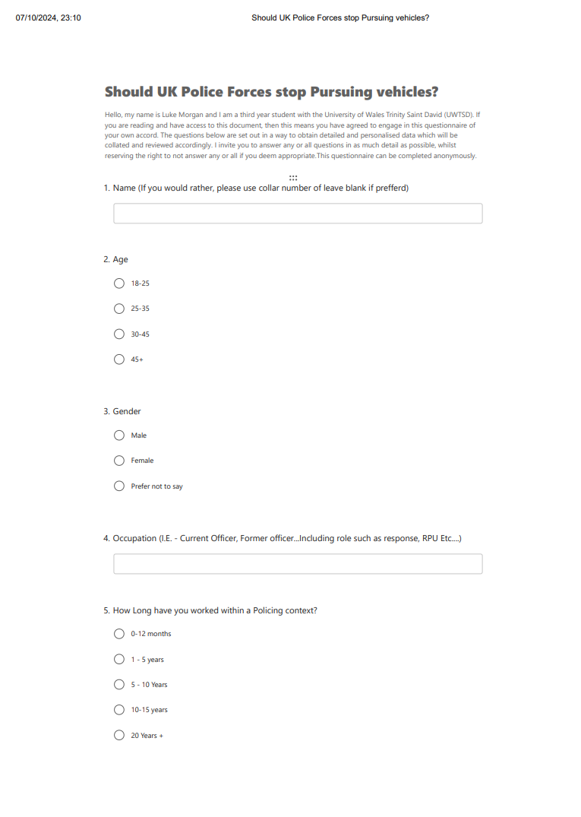
Appendix A – Questionnaire Sheet Blank
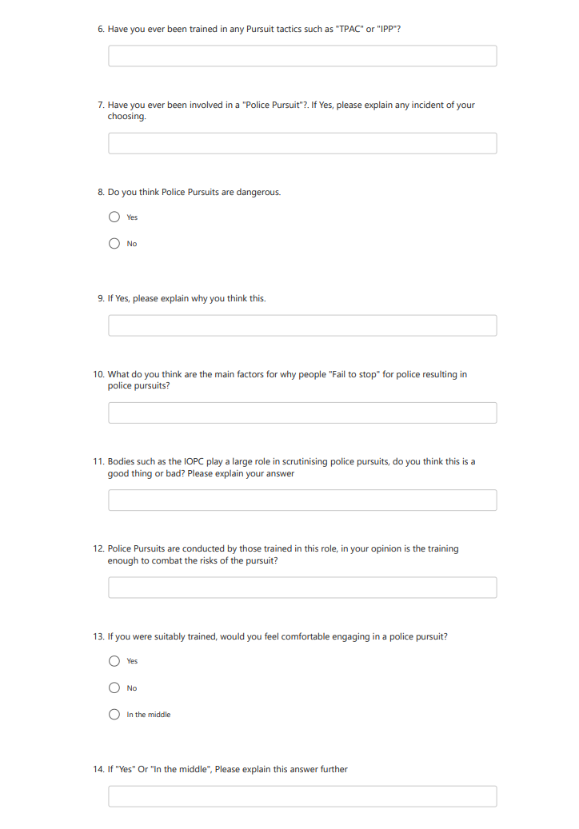
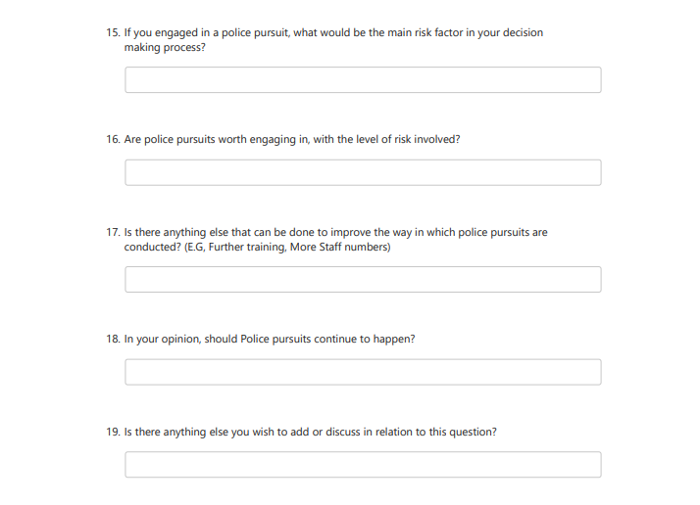

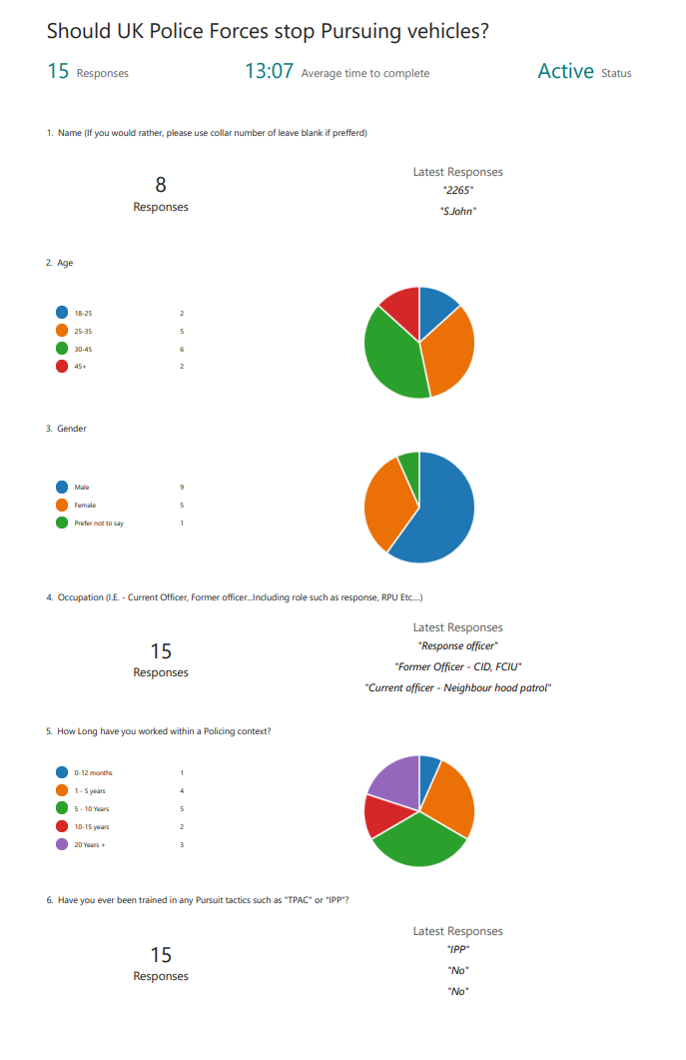
Appendix B – Questionnaire Sheet answers from Participants


