LCBB 5004

UNIVERSITY TRINITY SAINT DAVID – LONDON

Assignment 1

Lecturer: Dr Charles Oham

Student id: 1815969
Student name: Alina iamandi

Table of content:

Task 1
Introduction………….…………………………………………………………………3
Summary…………………………..…………...………………………………………3
Conclusion………………...……………………………………………………………5
Task 2
Introduction………………………………………………………..………………………..…6
Report….……………………………….……………...………………………………………6
Conclusion……………………………………………………………………………………13
References……………………………………………………………………………………14

Task 1
Introduction
A company needs an official who is responsible for hiring the employees in the organisation. The HR is the human resource recruitment official who is responsible for the hiring and selection of the employees in the company. The HR of M&S plans and coordinates the working structure and the culture of the employees (LEARN, 2016).
Summary
An interactive set of standards which aims at guiding and navigating those who serve in the human resource, whose goal is ultimately to develop the working structure of the organisation is the CIPD map. The whole map draws out the goals and the achievements that the HR need to top in for the purpose of the work with full confidence and the working of the human resource official. This process teaches confidence and the energy to work for the company. If separated, the CIPD map constitutes the following factors (Beatty and Queen’s, 2019),
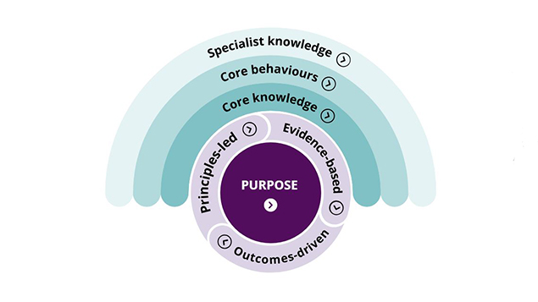
Figure 1: CIPD profession map
(Source: Webber, 2020)
Core knowledge: It is important for the M&S to patrol the working of the company and the correct application of then CIPD map to the company, to do not fall back from other company comparatively. The HR, according to the core knowledge should be very much capable and versatile that will let the individual to work in the organisation peacefully and with pride. Apart from this, the individual should also be well experienced with the digital technology and the virtual space that is mandated to gel up the work culture of the company. The digital means are preferred now days to work in the company. The HR acts as a bridge between the working of the employees and the company (Davies, 2017).
Core behaviours: An HR is someone who holds knowledge regarding the working of the learning values and the work structure of the company. The HR professional is also concerned with the ethics and the regulations that is required to be performed and maintained by the employees of the organisation according to the core behaviours. The HR professional is concerned for making the understandings of the company and regulates the feedback of the company that is received for the good working of the company (Tosey and Marshall, 2017).
Specialist knowledge: According to the specialist knowledge, the working of the employees, experience of the employees is examined. The relation of the employees with the company and the co-workers determines the nature of the employees. The learning and development of the people for the working of the company is important as there are rewards also which are provided to the employees in the form of compensation. The development and design of the M&S plays an important role according to the CIPD map. Also, the analytics and the working of the people is important for the maintenance of the engagement of the employees in the M&S (Anderson, 2017).

Conclusion
The CIPD map and the HGR professional, the M&S HR acts as a link between the company and the recruitment of the employees who will truthfully and trustworthily serve the company that will in turn help the M&S in earning profits and goodwill in the long run.

Task 2

Introduction
M&S is a famous brand that deals with the clothing, food, and several other supplies. Firstly, the report deals with the functions and the activities that the HR is responsible to deliver. Secondly, the process of improvement with the current employer and the working pattern will be investigated. The M&S runs with an employee count of more than 10,000 and with 32 million satisfied customers (Marksandspencer.com. 2020).

The organisational objectives of the M&S are the objectives and the goals that the company aims to achieve within a specific time and working method. The objectives of the organisation are required for the purpose of the allocation of resources of the company and the assistance in the completion of the work by the employees. The aim that is planned to be achieved by the company can be short or long-term objectives. The team and the groups of managers and leaders help in the achievement of the goals and the working of the company is regulated by the working structure of the organisation. The various objectives of the company are mentioned underneath (Owusu and Mardani, 2020),
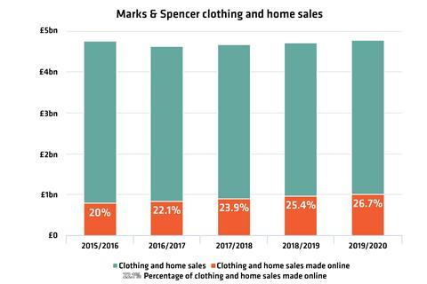
Figure 2: Sales structure of the M&S, UK (Source: Mark, 2020)
Planning: The planning by the HR is the set up and writing out of the plan consisting of the working structure that involves the planning and structuring of the working of the company. The planning is mainly done by the HR of the company by grouping out the managers and the competent people those who are involved in the work of the company. The working of the company so, is very important when a plan is developed. A plan planned by the managers and the workers of the company who manages to plan the rules and regulations that will be followed while doing the work. The planning sector is important that carries out the working of the company and helps in navigating a path towards the goals and aims of the company (Geertman and Stillwell, 2020).
The whole planning team should constitute a team and group of people where the company plan about the various working of the organisation. The planning and the decision of the working of the people is required to work and the process of change in the company. The planning process elevates the spirit of the employees and the working structure of the M&S is also upgraded if a good planning team is set up (Wan, et al., 2017).
Recruitment: The recruitment is a healthy and structured process where the HR professional conducts the process of interviewing, recruitment, selection in various modes to the candidates. The process of recruitment of the people of the company is important as it supplies the company with talented and hardworking people those who work in the company. It is the responsibility of the leaders and the HR to recruit the candidates based on the size of the company. The overflow or the increase in the number of the workers in the company can be disadvantageous for the functioning of the company. The recruitment involves the identification of staffs of the company and the requirement of filling the same. The recruitment goals constitute the employment of the right and competent people in the company who will prove to be an asset for the working of the company (al Habibi, 2019).
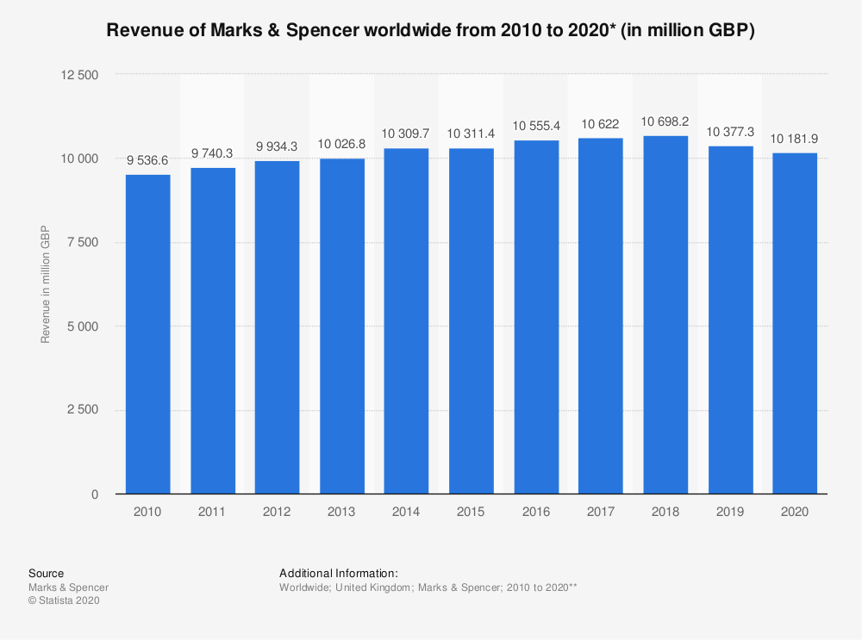
Figure 3: Revenue of M&S, UK (Source: Statista, 2020)
In M&S the recruiter can find out the several modifications and inventions that will let the selection of the employees in a peaceful and a good manner. These modification helps in the minimisation of the time involved in the process of interview and selection of the candidates for work. Finding the right people at the right time and for the tight position is very essential as it involves the working of the company in a good way and the ability of the future needs of the company (Jones and Comfort, 2020).
Selection: The selection is the stage of the recruiters that involves the final selection of the employees who will work in the company. The final selection of the employees will be required for the process of the recruitment. The selection of the employees in M&S passes through the few stages as mentioned underneath (Bocciarelli, et al., 2017),
Job announcement: The announcement of the job is done for the purpose of the working of that will allow apply in the position of the job mentioned. The announcement of the job is required for the purpose of the announcement of the job (Miah, 2017).
Applications review: The applications and the resumes of the candidates are reviewed by the leaders and managers of the company. The review of the applications is required for the purpose of the fulfilment of the goals and the people who are appointed should be vested with responsibilities (Taylor, 2019).
Final selection: The final selection of the application is required after the interview process and the selection procedure is important for the people to work and serve the basis in the company. A candidate is finally selected after the completion of all the procedures and the rules that are required to be followed (al Habibi, 2019).
Testing: This stage involves conducting the test and the examination of the employees for the purpose of the observation that is done on the employees after the formalities are over (Fakhimi, et al., 2017).
Making an offer: The offer for employment is required for the purpose of the final call to the selected individuals to join the company and the working of the newly selected employees will be conducted from that point of time (Butler and Hammer, 2020).

An organisation needs to continuously evolve to work with the structure and culture of the employees and this helps in the synchronisation of the factors of M&S. The workings of the employees are very crucial for the maintenance of the working structure of the company. The several ways in which M&S is evolving are:
Working timing: The working structure has gone over a lot of changes in M&S. Previously, there was bit of rigidity in the working structure which has recently become much more lose. This working structure has proved to be very effective and good for the working of the company. The working structure of the company is required for the purpose of the control of the employees in the company. The structure change has happened due to the change and modification of the managers and the leaders. This has also changed the way the company sees the working of the employees. In the current situation, there are ways in which the official of the M&S supports the working of the employees in the organisation (Wulfert, et al., 2019).
Facilities for work from home: With time, there are changes in the facilities of the working of the people in the company. The change in the facilities include work from home facility for the employees those who will be unable to serve the company during the tough times or due to any other reason. Along with it, there are facilities of providing laptops and systems at home itself, offering that the employees can conduct their tasks peacefully without any hesitation. If there are such employees cannot work from home every day of the week then, the employees can take an alternative day for work from home and the other days the individual can serve from the office (Janda, et al., 2016)
Restructuring the roles: The roles and the tasks of the companies need to be shuffled by the employers and the leaders of the company and the restructuring of roles refers to the shuffling of roles and positions of work between the employees. For example, the manager of the M&S can be restructured or move to other higher position in the working group. Similarly, the caretaker of the M&S store can be shifted to the position of store. The restructuring of the employees helps in the motivation and boosting the energy levels that will lead the working of the company. This helps in the assistance of the working of the people of the company. The working structure of restructuring gives a fresh look to the whole working structure. So, restructuring of M&S has helped with the working of the company in various ways (Yu, et al., 2019).
Covid 19 safety measures: In this grave pandemic situation, the working of the M&S needs to be taken care of, and health and safety of the workers is also required to be taken care of. The working of the employees in the pandemic situation itself involves a lot of risk. The working of the employees needs to be taken care of by the checking on the temperature of the employees, sanitising the store and the workplace every day. Apart from this, the temperature check and regular care of the immunity of the employees is very much required. M&S should every employee to use masks and face shields while working.

Conclusion
Combining the whole working style, the HR of M&S must take care of the recruitment, selection and planning that will let the working of the M&S get a new charm. In the pandemic situation there are some strict steps that are taken by the M&S that will assist and protect the working of the staffs employed in M&S.

Reference List

Anderson, V., 2017. HRD standards and standardization: where now for human resource development? Human Resource Development International, 20(4), pp.327-345.
Beatty, C.A., and Queen’s, I.R.C., 2019. From HR Practitioner to HR Leader: Competencies Required. Queen’s University Industrial Relations Centre (IRC).
Bocciarelli, P., D'Ambrogio, A., Paglia, E., Panetti, T., Giglio, A. and Plinio, V., 2017, November. A Cloud-based Service-oriented Architecture for Business Process Modeling And Simulation. In CIISE (pp. 87-93).
Butler, P. and Hammer, A., 2020. Pay progression in routinised service sector work: navigating the internal labour market in a fast-food multinational company. Industrial Relations Journal, 51(4), pp.351-371.
Davies, J., 2017. CIPD's profession for the future project and its implications for the HRD curriculum in UK universities.
Fakhimi, M., Stergioulas, L.K. and Mustafee, N., 2017, December. Modelling for sustainable development using the triple-bottom line: Methods, challenges, and the need for hybrid M&S. In 2017 Winter, Simulation Conference (WSC) (pp. 632-643). IEEE.
Geertman, S. and Stillwell, J., 2020. Planning support science: Developments and challenges. Environment and Planning B: Urban Analytics and City Science, 47(8), pp.1326-1342.
Habibi, B., 2019. HR practices of Marks & Spencer, Selfridges, Primark, and Sainsbury’s (Doctoral dissertation, University of Science & Technology).
Janda, K.B., Bright, S., Patrick, J., Wilkinson, S. and Dixon, T.J., 2016. The evolution of green leases: towards inter-organizational environmental governance. Building Research & Information, 44(5-6), pp.660-674.
Jones, P. and Comfort, D., 2020. Customer Engagement: Storytelling and the UK's Leading Retailers. In Handbook of Research on Contemporary Consumerism (pp. 57-71). IGI Global.
LEARN, W.C.T.M., 2016. THE MENTORING ACROSS PROFESSIONS (MaP) PROJECT.
Marks, R., 2020. M&S: Product Is Key to Achieving Online Goals. [online] Retail Week. Available at: <https://www.retail-week.com/analysis/mands-product-is-key-to-achieving-online-goals/7027386.article?authent=1> [Accessed 30 November 2020].
Marksandspencer.com. 2020. Welcome to Marks & Spencer. [online] Available at: <https://www.marksandspencer.com/> [Accessed 30 November 2020].
Miah, J., 2017. An Analysis of Human Resource Management Practices of New age Group (Doctoral dissertation, Daffodil International University).
Owusu, E. and Mardani, M., 2020. Towards Achieving Organisational Objectives: The Role of Effective Communication. Journal of English Language Teaching and Applied Linguistics, 2(4), pp.17-25.
Statista. 2020. M&S: Revenue 2019 | Statista. [online] Available at: <https://www.statista.com/statistics/413349/group-revenue-marks-and-spencer-mands/> [Accessed 10 December 2020].
Taylor, A., 2019. An exploratory study of the relationship between job insecurity and employee engagement focusing on temporary employees in the retailing industry in the United Kingdom| Case study: Marks and Spencer Group plc.
Tosey, P. and Marshall, J., 2017. The demise of inquiry based HRD programmes in the UK: Implications for the field. Human Resource Development International, 20(5), pp.393-402.
Wan, S., Li, D., Gao, J., Roy, R. and Tong, Y., 2017. Process and knowledge management in a collaborative maintenance planning system for high value machine tools. Computers in Industry, 84, pp.14-24.
Webber, J., 2020. CIPD Unveils New HR Profession Map at Annual Conference - Personnel Today. [online] Personnel Today. Available at: <https://www.personneltoday.com/hr/cipd-unveils-new-hr-profession-map-at-annual-conference/> [Accessed 27 November 2020].
Wulfert, T., Betzing, J.H. and Becker, J., 2019. Eliciting Customer Preferences for Shopping Companion Apps: A Service Quality Approach.
Yu, M., Cao, D., and Tan, J.Y., 2019. CSR-consumption paradox: examination of UK apparel companies. Journal of Fashion Marketing and Management: An International Journal.

