The Pet Place
Executive summary:
The pet place limited is a business that provides boarding for pets with multiple unique selling points resulting in its potential success. With luxurious quarters ready for your pets stay, as well as its ‘all pets welcome’ quality further encouraging people to visit. This is a business plan deciphering all aspects to consider when starting this business for example, financing, competition, market etc.

Introduction:
I as an individual have a keen interest in animals and a strong ambition to run my own successful business. Combining the two together, I have envisioned a unique, profitable successful company taking care of pets from any area whilst the owners are away. Carefully considering all aspects for creating a business for example financial and marketing, as well as strategies such as pricing and revenue to maximise profits to further invest back into the company or possibly expand. Ensuring owners of the safety and wellbeing of their pets and having a calm friendly image.
My sister and I have decided to commence on this affordable new venture, presenting the area with a unique and useful business very beneficial for pet owners. Providing a hotel-like service and the option for regular updates on your pet such as photos/videos etc. The pet stop caters for all kinds of pets, with bookings in advance to prepare for their stay.
This is a business partnership formed and managed by myself, Lydia Muir, and sister Summer Williams after recently experiencing a struggle with temporarily accommodating our cat whilst away on holiday. Noticing a potential gap in the market we began researching. In full dedication to this business, we both decided to quit our jobs to become full time managers of the pet stop, minimising the costs of potential staff. With our own personal savings of £8000 each, as well as a business loan of £8000, projections for the business are positive.

Legal:
There are 3 main reasons why the Pet Place Limited is a limited company, the main being, that it is separate from the owners minimising personal liability therefore the business is accountable not us.
Another being lower tax rates at 25% allowing us the opportunity to grow as a business and potentially expand in the future. The added ‘limited’ to our name gives off a professional status- and this is how we as a company would like to appear to both our customers and competing companies.
The pet place is a name chosen by myself and Summer Williams, with research done we decided upon this name as most similar names are being used by other competitors and we feel it best fits our business. As well as this our chosen website address being www.the petplace.uk.com showing further promotion of our business alongside Facebook and twitter.
Due to the health and safety in the workplace act we will adopt health and safety regulations, have correct workplace facilities and create policies for ourselves and potential future staff Alongside emergency medical supplies for our pets if needed.
After receiving our licence from Carmarthenshire County council for boarding animals, my business partner and I are legally fully qualified to run this business alongside our CV’s, both containing Level 3 qualifications in Canine care, Behaviour, and welfare.

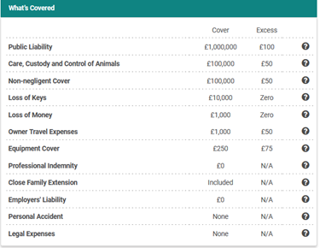
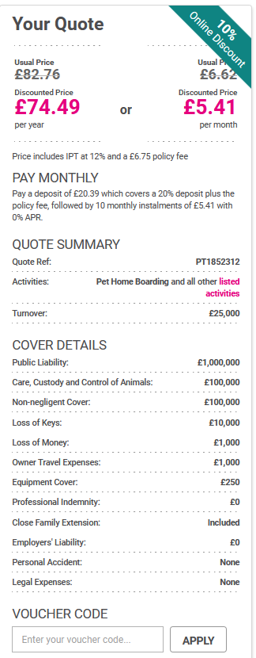
Alongside our newly purchased public liability insurance- protecting the business from injury or damaging claims, myself and business partner Summer Williams are legally prepared to venture out and become part of the market.

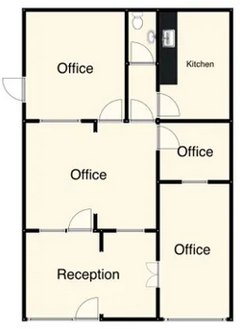
Financial information:
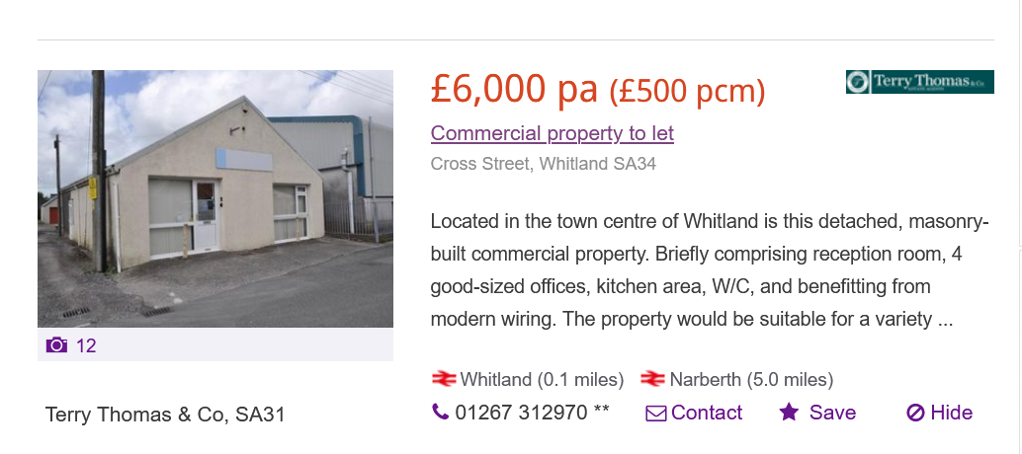
After careful consideration, we decided upon this property located in Whitland centre. As we both live in Carmarthen the commute is convenient and affordable.
This property is affordable and very much within our budget alongside a variety of rooms allowing space and accessibility. This also allows us to achieve our goal to cater for all types of pets highlighting the uniqueness of the business.
 | Per Night | Weekend | Per Week
Dogs | £15 | £35 | £70
Cats | £10 | £25 | £50
Reptiles | £9 | £21 | £50
Rodents | £5 | £12 | £30
Rabbits | £5 | £12 | £30
Birds | £9 | £21 | £50
Other | Please contact for further information

Price list

The price list is per night with a slight increased cost at weekends, but we do offer a discounted price per week. We anticipate that there will be more customers that want pet accommodation at weekends as people tend to take short weekend breaks, we also anticipate to reach optimum maximum capacity during the summer months when customers tend to go on holidays and need accommodation for their beloved pets.
Our maximum capacity is 75 living quarters which compromise of 40 dog kennels, 20 cat quarters, reptile room which caters for both snakes and lizards in suitable exotic habitats, small animal room caters for rabbits, guinea pigs, hamsters, gerbils, chinchillas, hedgehogs amongst many others. The Pet Place generates a monthly income which will increase over 12 months.
Our monthly expenditure is £4780.00, therefore our income will need to be equivalent in order to break even, which means we have to occupy at least 14% of the living quarters. In month one we anticipate a small loss, but by month 3 we anticipate that The Pet Place will start to see a small profit increasing monthly.
Following research into fellow competitors in the local area our pricing is in line with the current market, but with our unique selling point we aim to profit, build, and expand our client base on our reputation of high-quality standards and luxury.
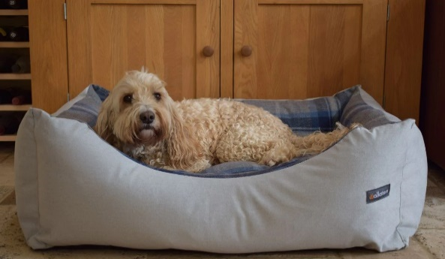
Start Up Costs include Refurbishment which is done by a local trades team RTJ Renovations who have quoted us a total of £6000 which include construction of pet living quarters, materials, and labour.
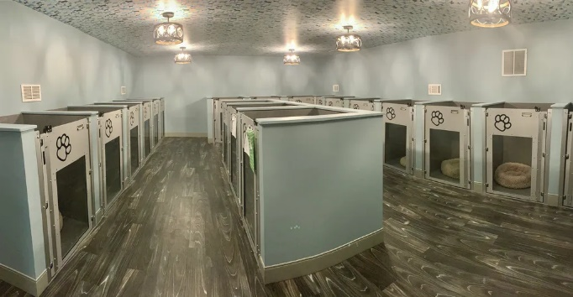
We as a business aim do differ from other businesses by having the highest possible living standards for your pet. Substituting cages for refurnished dog/cat bed-rooms seemed like the most fitting option. Being pet lovers we think its cruel and unfair to house animals in cages for extensive periods of time, we strive to make The Pet Place as homely for our guests as possible.

The Pet Place Ltd would like to have a smart upper-class image and staff will be of a very smart appearance dressing in appropriate uniform, promoting cleanliness and hygiene. We have sourced a supplier online and are able to acquire 10 shirts and trousers for £150.
Bathing service | Dog walking service | Updates on pets
Additional services we offer.
These are additional services we offer as a business when looking after your pet with each being optional at the customer’s request.
We can also offer specialised diet requirements and the option to bring your pets habitat or anything that may make their stay more homely and comfortable and relaxing for your pets stay.

Marketing:
To promote The Pet Place Limited, we have taken our advertisement to social media platforms such as Facebook and twitter alongside our own newly designed website which is further promoted online. There will be a virtual tour, where customers can view all of our facilities and our dedicated pet living quarters. As a business have also designed and printed flyers to hand out in parks and on beaches on account of our target audience being pet owners. These flyers are also in local shops around the area. We aim for the highest standard bedding for optimal comfort for your pets of all which are displayed on our social media platforms and website.
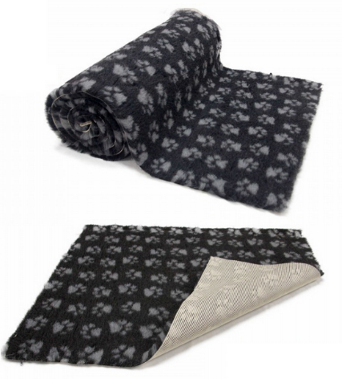
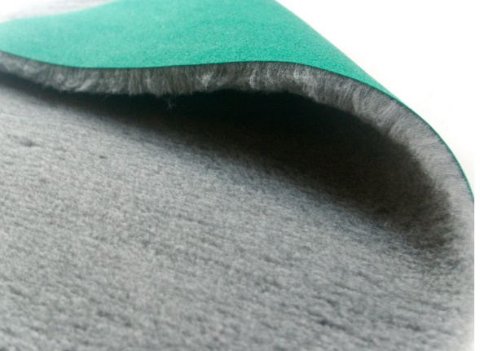
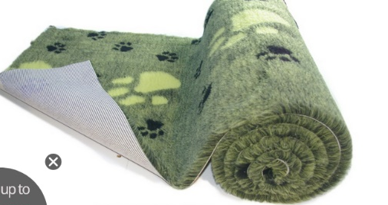

With a growing number of followers and friends on the 2 platforms, our small business is slowly building its name and getting recognised with over 180 likes on our most recent marketing post. With strategic planning implemented, future advertising goals can be met throughout social media to expand the business image.
Analysing other competitors environment, we realised dog walking wasn’t enough. After some negotiation the local farmer was more than happy to accommodate us one of his boarder-secure fields for our dogs. A perfect deal as the field sits closely behind our business. With running space to hands our dogs are guaranteed a happy stay.
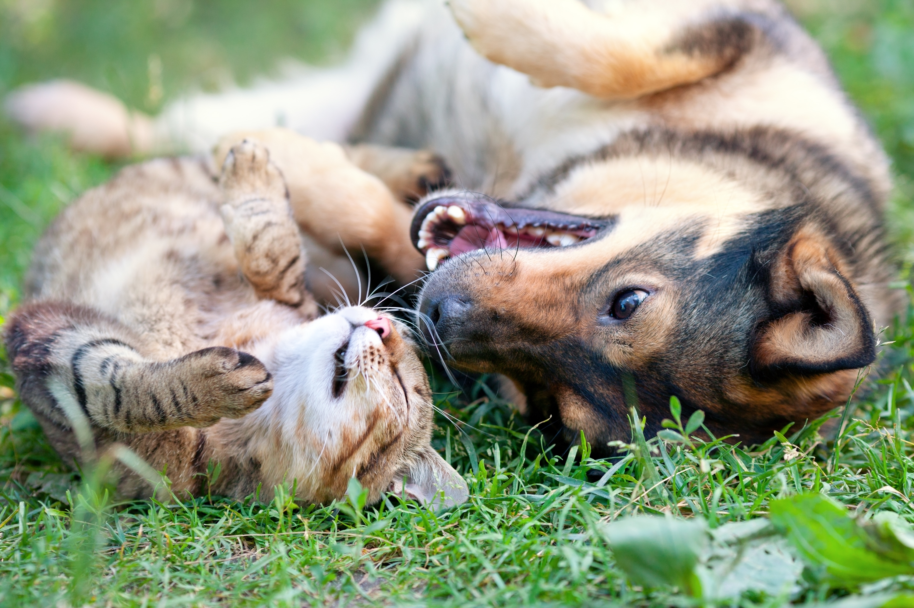

Unique selling point
What makes this business unique to other competitors is that we cater for a wide range of pets and is not subjected to just one or two. With advancement bookings on our website or over the phone, we can prepare for their stay and deliver the best service. Having equipment at the ready for pets with different habitats for example Lizards and Snakes and additional leftover savings of £2000 to further invest if needed highlighting the importance of booking in advance. As well as this we provide a service where the customer can receive regular updates of their pet through photos/ videos if they wish at no additional cost. This Is also promoted throughout our advertisement platforms. With our newly refurbished rooms designed for each individual pet, The Pet Place looks more than accommodating.
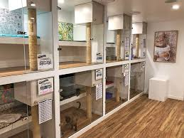
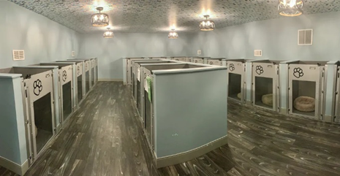

Competitor analysis
With a variety of competitors across Carmarthenshire most of which are home-run sole proprietorships for example
The Muddy Paws Pet Services – located in Swansea catering for dogs
Contended cats boarding cattery- located In Whitland catering for cats
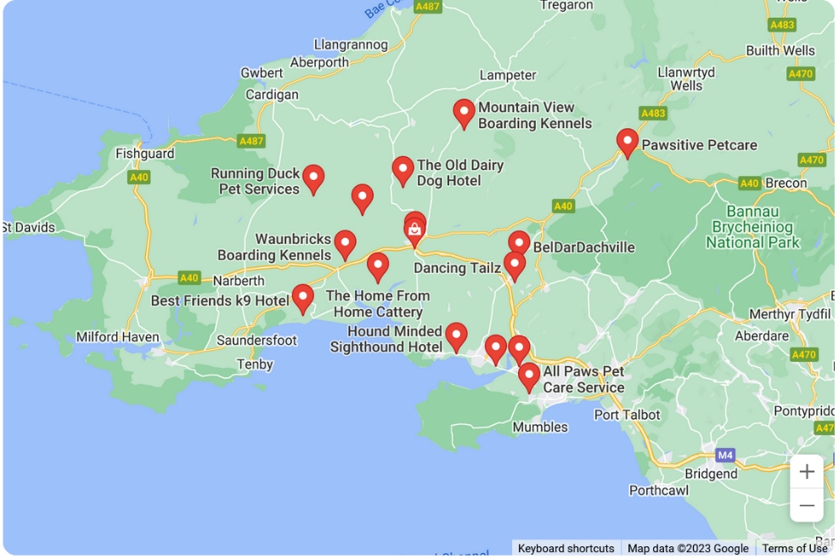
There are a handful of potential threats, with many businesses in this market around Carmarthenshire servicing dogs and cats, however we have both struggled to find a business that caters for other pets and all pets.
This image is a rough area map of all the businesses servicing pets. Under further research we discovered that to be successful we must apply our unique selling point (caters for all pets) to stand out from the competition and attract customers.

Assessing all competitors, my sister and I agreed upon three potential threats in the area:

Best Friends K9 Hotel – located in Pendine, Carmarthen.
Waunbricks Boarding Kennels – located in St Clears, Carmarthen.
Maesylan Boarding kennels – located in St Clears, Carmarthen.

These three businesses all have 5-star ratings and reviews, two of which have been open for a number of years, attracting a loyal customer base. All three are located near Whitland where our business partnership is located. They each have free running space for their pets with adequate living facilities all at low cost. Utilizing our unique selling point, my business partner and I are not concerned by these competing businesses as our brand image differs from theirs.

Pest analysis:

Political | Economic | Social | Technological
Environmental  Ecological  Tax rates  Wages  Legislation  Health and safety  Political stability | Interest rates  Inflation  Recession  Taxes | Lifestyles  Religion and beliefs  Social classes  Views and opinions  Average disposable income level | Other pet services  Advertisement  Competitors

Swot analysis:

Strengths | Weaknessess | Opportunities | Threats
Field for dogs  Bathing service  Experienced staff  Regular updates  Different from competitors – unique selling point | Inexperienced business owners  Competition  Low budget  No business links.  Low recognition-as a new business | Profit  Expand in the future.  More staff  Work chosen hours.  Running our own successful business | Competition  Recession/inflation-products more expensive  Not making a profit  Possibility of losing money

Market segment:

The Pet Place is a business that strives to attract the attention of pet owners from all areas, taking the attention off other competing businesses by using advertisement to promote our unique selling points and business overall. Knowing our target audience are pet owners, its important our advertisement platforms reach the right people. With placed flyers in pet- focused companies e.g., pets at home, vets etc and also distributing them in locations such as local parks and beaches. To further emphasis The Pet Stop’s key selling point, displayed on our flyers are photos of the variety of pets we cater for alongside their temporary homes to attract a variety of customers.

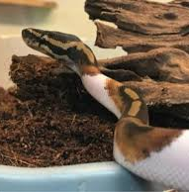
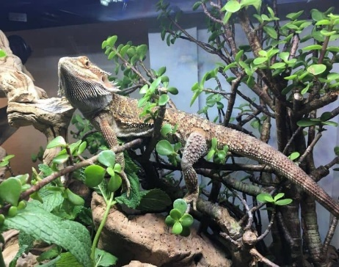
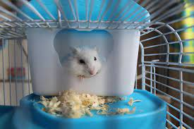


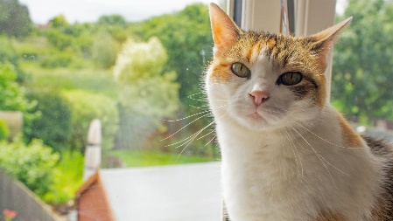
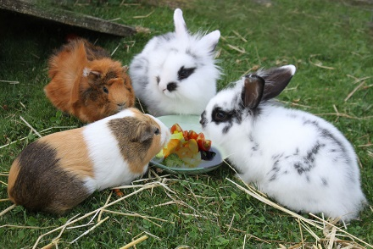

Having multiple suitable habitats at the ready is a key selling point for our business alongside its diverse image. Dividing my potential customer base into groups based on the type of animal they have, it’s important to show advertisement for all, targeting all possible customers.

Market size:

To start off, we are targeting people in the community and Carmarthenshire as there are competing businesses. To make locals aware of our business and its qualities, and to gain the best reputation as fast as possible.

“47 percent of all household in Wales own at least one pet” ‘RSPCA, 2023.’

This is almost half of the people in Wales, suggesting that competing businesses have a strong customer base. Evaluating each competitor, myself and business partner cannot locate any other business that caters for anything other than dogs and cats.
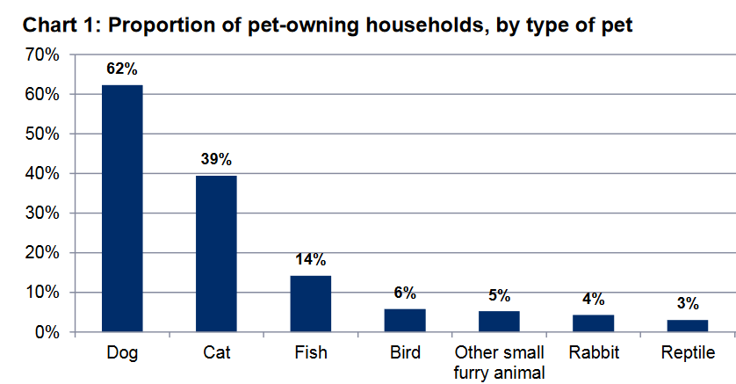

This is a graph taken from a National survey for Wales on pet welfare and states the proportion of pet- owning households by type of pet. Published in 2017, numbers since then have been steadily increasing.

With our unique selling point, we are expected to have a variety of pet types, looking at this graph there Is roughly 32% of pets in Wales that is neither dog nor cat. As it was published in 2017, we can expect this percentage to have increased a little.

From this we can expect a wide range of pets as well as being the only business that caters for all types.

Objectives:
In the future we hope to expand out business and hopefully create a chain company, we aim to double profits eventually, so we can further invest back into our company. Investing profits into bigger accommodating buildings when considering expansion and recruiting more staff to run them.

References:
https://cpdonline.co.uk/knowledge-base/business/legal-structure-of-a-business/
https://www.zoopla.co.uk/to-rent/commercial/details/64692431/?search_identifier=624c57ea44cf6741ff75b557175ee42d
https://www.businessnewsdaily.com/4686-how-to-start-a-business.html
https://www.investopedia.com/terms/m/marketing.asp
https://www.investopedia.com/terms/m/marketsegmentation.asp
https://www.gov.wales/sites/default/files/statistics-and-research/2019-03/national-survey-wales-pet-welfare-2014-15.pdf
https://pestleanalysis.com/political-factors-affecting-business/
https://pestleanalysis.com/economic-factors-affecting-business/
https://secure.protectivity.com/pet-business-insurance/Benefits?quoteRef=Pp6UdFkLoFDP5qAOkWe8qQ2

https://www.gov.uk/find-licences/animal-boarding-establishment-licence-wales-scotland

