Task 1: Locating Sources
Identify and locate three different sources (a report, a journal article, and a website) related to the question
“What employability skills do business graduates need to succeed in the modern workplace?”
Show how you used keywords, search terms, and Boolean operators to find them, and explain how you know which type of source each one is and why it is appropriate for the research question.

Source Type & Why It Is Appropriate | URL/DOI | What search engine did you use? Google/Online Library/Library AI Assistant | Keywords/Boolean Operators Used
Journal Article | https://librarysearch.uwtsd.ac.uk/permalink/44WHELF_UWTSD/oc9jb5/cdi_unpaywall_primary_10_18267_j_efaj_214 | Online Library | Employability skills AND Successful graduates

Task 2: Evaluating Information (CRAAP Test)
Your colleague has forwarded you a source from a peer reviewed journal, and they are not sure whether it is appropriate to use and has asked for your help. Your task is to evaluate the source by using the CRAAP Test to assess its appropriateness.
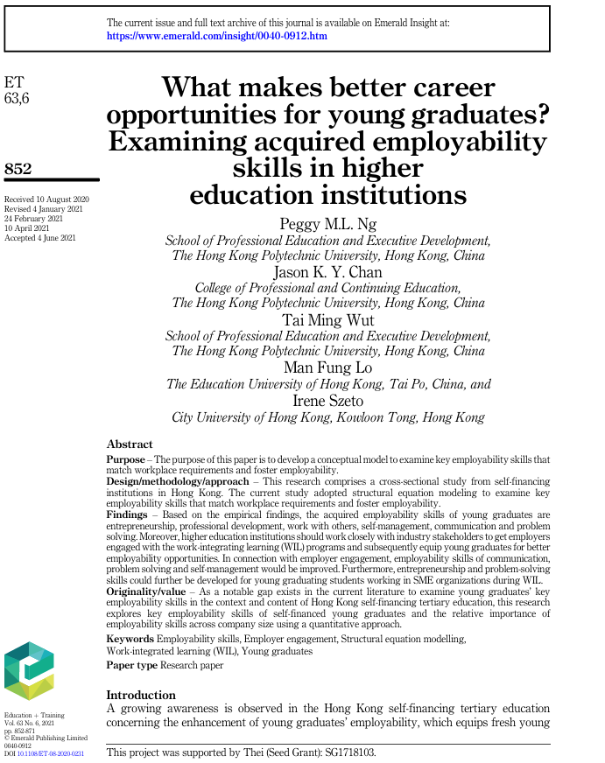

CRAAP Test
Currency | The timelines of this article were accepted on June 4th, 2021. Which also means that they are in date and reliable as the article was published way after 2016.
Relevance | This article is relevant because we want to know what makes career opportunities better for graduates? In this article it shares that on the findings the employability skills of young graduates are entrepreneurship, professional development, work with others etc. It shows that programs subsequently equip graduates for better employability opportunities.
Authority | The source of the info is from Emerald + Training.
Accuracy
Purpose | The purpose of this paper is to develop a conceptual model to examine employability skills, that match the workplace requirements and to foster employability.

Task 3: Source Analysis
Your manager has provided you with a short extract from a source and has asked you to analyse the source by Identifying one strength, one weakness, and providing a brief explanation of the strength and weakness identified.
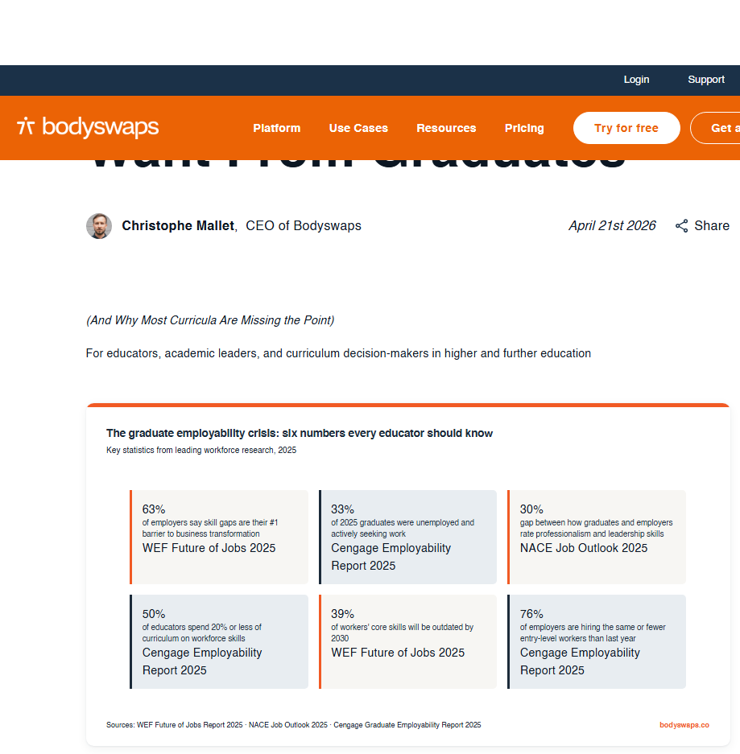
.

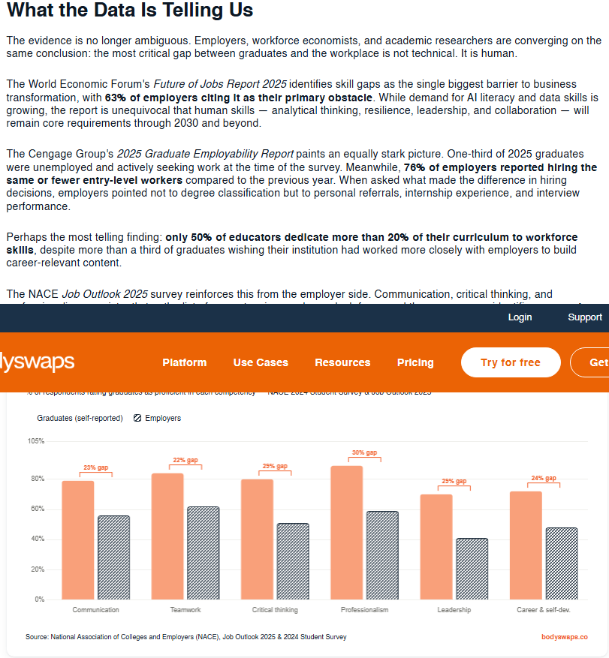

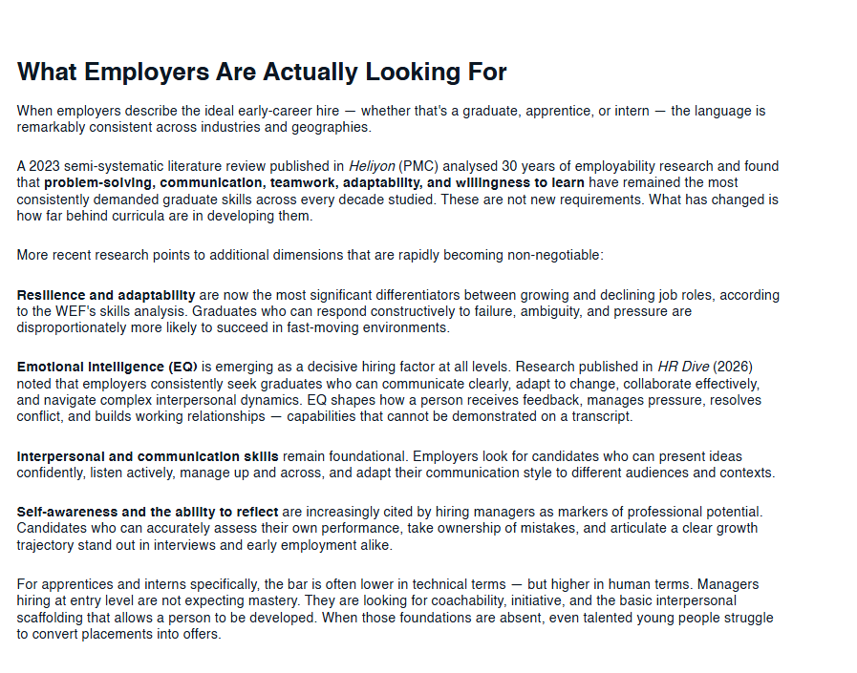

Please click the link, if you wish to read the article online.
What Employers Actually Want From Graduates

Strength of the Source:

Weakness of the Source:

