Title Page

Working culture and its impact on organisational efficiency
BMSW5105
Shajan Ali
Student ID- 1814853
Lecturer- Eric Osei
Date- 10/11/2020

Table of Contents
Task 1: Report 1
Introduction 1
Analysis of the macro-environment influencing Culture of Sainsbury's 1
PESTEL Analysis of Sainsbury's 1
Porter’s 5 Force Analysis of Sainsbury's 3
Analysis of the culture of Sainsbury's 4
McKenzie’s 7S in understanding culture 5
Barriers to the effective functioning of Sainsbury’s culture 6
Effects of globalisation on the culture of Sainsbury's 7
Recommendations 9
Conclusion 9
References 10

List of Figures
Figure 1: PESTEL analysis of Sainsbury's 2
Figure 2: Porter's Five force 3
Figure 3: McKinsey 7-S Model 5
Figure 4: Sainsbury's General Supermarket Structure 6
Figure 5: Barriers to effective functioning 7
Figure 6: Effects on external parties 8
Figure 7: Effects of Globalisation on employees 9
List of Tables
Table 1: Positive and negative impacts of globalisation on Sainsbury’s culture 7

Introduction
Workplace culture is the basic attributes of the workplace which is applied regularly in business settings. The developed culture has a higher impact on the efficiency of organisational activities. For understanding workplace culture, macro environmental analysis is common which influences and changes organisational culture (Booth and Melling, 2017). Besides, in effective functioning in the organisation, different factors act as barriers. Globalisation is also playing an influential role in the workplace culture and impacting the efficiency of functions. For understanding the industrial cultural macro-environment, PESTEL and Porter’s 5 forces are used largely. These factors affect the cultural environment of the workplace. The organisational culture of Sainsbury’s will be analysed using 7S of McKenzie. Besides, the influence of globalisation from different perspectives will be focused.

Task 1: Analysis of the macro-environment influencing Culture of Sainsbury's
Sainsbury's is one of the biggest supermarket chains in the UK competing with a huge number of businesses. 1500 supermarket stores of the company have led the company to become the largest retail stores. The company has been operating from 1869 which is nearly more than 151 years old (Sainsburys.co.uk, 2020). Different types of products and services are offered by the company such as groceries, supermarket items, fuel, café, banking and so on. The company have a higher net income in 2019 which is £219 million with around 120000 employee bases. The company have developed their own culture of business which has affected the operation of the business. For understanding the macro environment which influences the culture and operations, can use PESTEL analysis and Porter’s 5 Forces.

1.1 PESTEL Analysis of Sainsbury's
PESTEL analysis of Sainsbury's can help in understanding their macro-environmental culture based on six specific factors. These factors are-
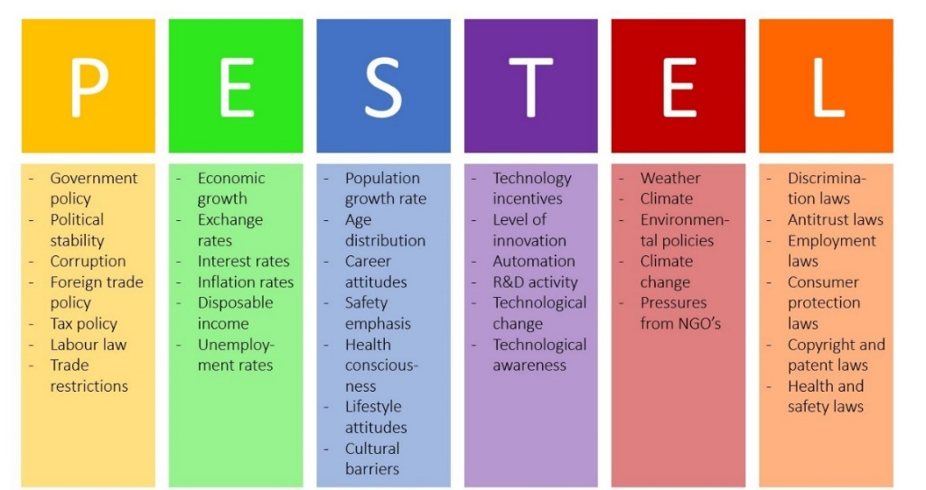
Figure 1: PESTEL analysis of Sainsbury's
Source: (Griffin et al., 2018)
Political Factors: Sainsbury’s culture and operation have a greater impact on different political factors. The governmental policies such as Brexit issue have a greater effect on the business operation of the company. The changes in tax pattern, business policies, restrictions from Brexit and benefits from such policies of government affects the business culture and operational efficiency of the company (Martin, 2019). The political stability of the UK government which is very stable positively affected the business of Sainsbury’s. Lower level corruption in the UK business environment has created the scope of business growth in the country which helps the company in increasing the business base. Positive foreign trade policy and labour law have created the scope of business of Sainsbury’s. As a result, the political factors in the culture and operation of Sainsbury’s have a greater effect on the current culture and business operational efficiency of the company.
Economic Factors: The economic growth of the UK has a positive impact on the business culture of Sainsbury's. UK has 1.3% annual GDP growth and as a developed country the economic activities are strong enough to spread business operation. The exchange rate of Pound Sterling compares to other currencies have a positive vibe on internal business. As a result, being a supermarket chain gets the benefit of positive exchange rate policies. Currently, the country has 1.2% inflation rate with 3.9% unemployment rate (Satryo, 2019). Overall, the economic factors of the UK have helped to develop a positive business culture for Sainsbury's.
Social Factors: The social factors of the UK have helped to develop a good business culture which leads to the operational efficiency of Sainsbury’s. The average population growth rate in the developed country and the average age of people which is the young generation has created an environment for higher demand for innovative and new types of business. Supermarkets of the company are ensuring these social factors to maintain the business demand. The career attitudes of people are very professional where it helps to improve business growth in the country. The emphasis on safety and health consciousness of the people seeks products and services which are healthy for them. Ensuring those products and services in the supermarkets of Sainsbury’s, have developed a strong culture. Besides, the life-style attitudes of people living in the country helped develop acceptance of supermarket-based retail business of Sainsbury’s.
Technological Factors: The technological factors of UK business industry have effects on the operational culture and efficiency of Sainsbury’s. The technological incentives and scope of using developed technologies in the supermarkets of Sainsbury have established a strong culture. Besides, the level of innovation and automation in the business sector has helped Sainsbury’s to develop their business operational efficiency and establish a strong technology-based business culture (Beattie, Fearnley and Hines, 2019). The company has research and development activities which help to increase more technological factors in the business operations. The changes in technology and applying those changes in the supermarkets of the company have positive impacts on the business culture.
Environmental Factors: The UK has a very stable environment for business based on the country’s weather and climate. Besides, the retail business has less restriction based on environmental policies enforced in the UK. However, the concern of the company towards the environment has developed a strong culture which has positive impacts on their customers also.
Legal Factors: Legal factors is the most important factors affects in business culture and operational activities. The enforced legal restrictions by the UK government have to strictly maintain by Sainsbury for operating their business. Besides, the consumer protection laws, health and safety-related laws need to implement properly in the daily business of Sainsbury’s.
In this manner, different factors of the macro-environment influence the culture of the company.

1.2 Porter’s 5 Force Analysis of Sainsbury's
The culture of Sainsbury’s has been affected by another type of micro-environmental factors which is their level of business competition. For analysing the competitive business environment of Sainsbury’s, Porter’s Five Force Model has been used in this section.
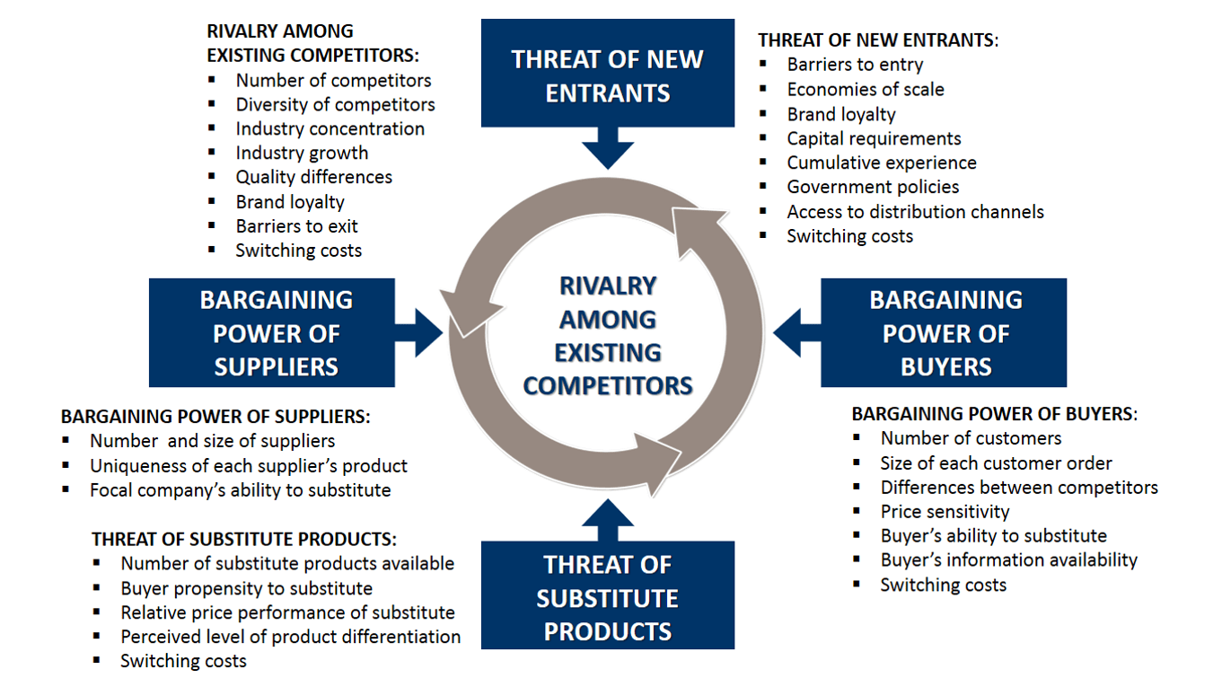
Figure 2: Porter's five force
Source: (Ball, Geringer, McNett and Minor, 2018)
The competitive environment of Sainsbury’s depends on five specific forces which decide how competitive the business environment or culture is in the industry. Besides, it also helps to shows the effectiveness of business culture and its operational efficiency.
Threats of New Entrants: Sainsbury’s is operating in the retail industry of the UK where there are a large number of new entrants and existing competition among the businesses. However, there are fewer barriers to entry as a developed and free economy. Considering the fact, Sainsbury’s have economic of scale benefit where the business has been able to spread their business more. Besides, higher brand loyalty of Sainsbury’s decreased the threats of new entrants in the industry. Lower capital requirements and positive governmental policies have increased the number of new entrants which increases the threats of new entrants for Sainsbury’s.
Threats of Substitute Products: The higher alternatives of substitute products in the retail industry of the UK increased the threats of Sainsbury’s. However, the company is increasing and diversifying the product portfolio to reduce such threats. The buyer’s propensity to the substitute products has a greater impact on Sainsbury's business activities. The number of substitute products in the industry and price of the substitute products has a closer relationship with the Sainsbury’s business demand (Graham, 2017). Besides, if the switching costs are higher, the business has fewer threats of substitute products.
Bargaining Power of Buyers: The bargaining power of buyers in the retail industry of the UK is very lower. Through the number of customers of Sainsbury’s is higher in number but the organisation is selling fixed price products. The differences in price between competitors is very lower where the power of buyer is lower. Besides, the buyer has a lower ability to substitute and that cause lower power of buyers.
Bargaining Power of Suppliers: The higher number of suppliers in the retail industry and the big size of suppliers lead to the lower bargaining power of suppliers. However, the uniqueness of the suppliers sometimes increases the bargaining power of suppliers. Besides, the company have a higher ability to substitute the supplier’s products. Sainsbury’s has effectiveness with the bargaining power of suppliers.
Rivalry among Existing Competitors: The existing competitor's rivalry has a greater effect on the Sainsbury’s business culture. The higher number of competitors in the retail industry with Sainsbury’s have an impact on the level of competition. Besides, the lower diversity of the competitors compare to Sainsbury’s is reducing the existing culture. The increased growth of industry and quality differences impacts on the existing competition (Bower, 2020). However, Sainsbury has developed a loyal customer base within a strong culture.
In this manner, the culture of Sainsbury has affected their business operational efficiency.

Task 2: Analysis of the culture of Sainsbury's
The culture of Sainsbury’s has impacts on daily functioning. As culture leads to the way of operating business, analysis of the culture of the organisation will provide a basic insight into the functioning of culture. For the understanding of the culture, McKenzie’s 7 S model has been applied in the analysis.

2.1 McKenzie’s 7S in understanding culture
According to McKenzie’s 7S, business organisations can be divided into 7 specified areas. The areas can be hard and soft which help to understand the importance of the areas in the analysis of the culture.
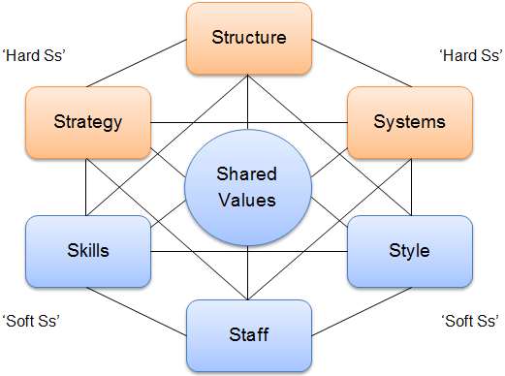
Figure 3: McKinsey 7-S Model
Source: (Trompenaars and Hampden-Turner, 2019)
Hard Ss: Sainsbury’s culture can be effectively analysed based on the areas of the model. In the case of hard S of the model, the strategy of Sainsbury’s is the first area. Sainsbury's have a very good business strategy to grasp the UK retail market. The first position in the retail market has to attain by the company for which has developed a strong business strategy. The organisation have been set goals to increase their number of supermarkets and business portfolio. The growth of the company has been promoted in the strategy. Based on the culture, the company has developed a strategy to ensure stable growth of the business. Another hard S is the structure of the company. The supermarket chain uses a simple organisational structure which has been their culture from the beginning. Departments and teams are structured and organised properly with every necessary skill.
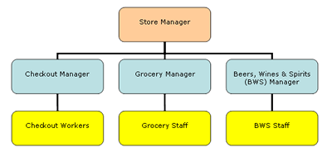
Figure 4: Sainsbury's General Supermarket Structure
Source: (Dinçer, Hacioğlu and Yuksel, 2018)
In the supermarkets, at least 10 teams work collaboratively according to the hierarchy structure of the company. The system of Sainsbury is another hard S area where the organisation applies simple procedures in their daily activities. In the system, the supermarket has an automated information system with the scheduling of works. These increased the effectiveness of the culture and increase efficiency. Based on the hard S of the company, can understand the culture of Sainsbury where structure, system and strategy of the company are enforcing operational efficiency.
Soft Ss: Shared value is the soft areas which is the core value of the company. Sainsbury’s have culture where they have focused on valuing humans of every religions, culture and race. Theses non-discriminatory practices in the value of the company’s culture with ethical practices increase work motivation for staffs. Besides, the cultural emancipation based on the shared positive values increases the effectiveness of corporate culture. Besides, the adopted participative leadership style in every supermarket of the company increased the success of the company. Sainsbury’s has been able to develop a strong culture and effective leadership helps to get its operation more efficient. In general, Sainsbury’s have recognition for staffing in the industry. The company have higher retention ration of their employees and they recognised the capabilities of staffs and employees. Besides, the supermarket giant has a dependence on the skills of their employees. Overall, the culture of the company is very strong in the perspective of business success and satisfaction of employees. Based on the culture, the business has higher effectiveness on its operational activities.

2.2 Barriers to the effective functioning of Sainsbury’s culture
Analysis of the culture of Sainsbury’s has found that different factors act as barriers to the effective functioning of the organisation. Effective functioning depends largely on the culture of the organisation. The cultural effectiveness promotes the organisational activities to successfully manage. The barriers which affect the functioning of Sainsbury’s culture is shown in the following-

Figure 5: Barriers to effective functioning
Source: (Fleenor and Raven, 2019)
In effective function, the structural problem of the company which is based on the culture affects a lot. The structure of the company has problems in different situations such as supermarket structure are same in every place wherein someplace, the structures require to modify for effective functioning. The use of participative leadership in the supermarket chain increases the time of decision making which affects the effective functioning or business activities. However, the higher number of employees in participative leadership and management increases the conflicts among the employees. Thus, results in a reduced level of functioning in the company. Lack of skills of employees or staffs in different activities and necessary for training and development affects the overall level functioning in the company. Sainsbury’s have some problems related to power and control where every supermarket store is controlled from one place. This leads to affect the functions of the company. Besides, the management of the company has a gap as supermarkets are numerous and managing all in the same line is not possible (Martin, 2018). Using supermarket-based management for every store differs their functional abilities. Another most important barriers are the shared goals which cannot properly enable and affects the functioning of Sainsbury’s culture.

Task 3: Effects of globalisation on the culture of Sainsbury's
Globalisation has affected every business sector in the world and Sainsbury’s is not except the list in the UK retail sector. It has both positive and negative impacts on the culture of Sainsbury’s. Besides the company, external parties of the company and employees are affected by increased globalisation. Effect of globalisation on the Sainsbury’s culture is-
Table 1: Positive and negative impacts of globalisation on Sainsbury’s culture
Positive Effect of Globalisation in Sainsbury’s culture | Negative Effect of Globalisation in Sainsbury’s culture
Sainsbury’s has been able to grasp the free trade facility as a result of Globalisation. | Increase in the competitive business environment due to globalisation increase the internal business competition of Sainsbury’s.
Globalisation increases the business facility which represents the growth of the company. | Business loss due to higher competition in the international business environment.
Sainsbury’s can get access to economical and quality products from different countries. | Globalisation has negative impacts on the supply chain management of the business.
The company are accessing skilled and developed talents from outside countries. | Globalisation is forcing change to the culture of business which is changing rapidly due to technological adaptation in the supermarket.
The company can gain access to greater knowledge of business activities due to globalisation (Hassi and Storti, 2019). | The company is getting the barriers in trade such as VAT in some countries.
The use of technologies and improved devices increases the efficiency of business activities.
Increasing cultural diversity impacts the internal working condition of the company.
Besides the effect on Sainsbury’s, globalisation affects the external parties of the company. The effect on the external parties’ are-

Figure 6: Effects on external parties
Source: (Hill, 2018)
The external parties such as customers, general people and suppliers of the company have effects due to globalisation. It has increased economic activities by increasing the business growth of Sainsbury’s. However, it has impacted the overall economic activities. The customer of the company has access to several alternatives due to increased globalisation. Besides, international demand for the products increases the overall customer demand. The relationship with the customers also can be positively influenced by improved services by the supermarket chain. The higher availability of the suppliers impacts the relationship with the suppliers. Besides, the increased globalisation affects the employees of the company. These effects on the employees of the company are shown in the following-

Figure 7: Effects of Globalisation on employees
Source: (Beam and McFadden, 2019)
Globalisation affects the income level of employees which increases the satisfaction of employees. Based on globalisation, employees have a higher scope of getting a variety of jobs. The working conditions for the employees has been improving due to globalisation. The earnings have an impact on the living standards of the employees. However, the employees of Sainsbury’s have these effects which are increasing and enriching the culture of the company.

Recommendations
Based on the analysis of Sainsbury’s culture on its operational activities, found the organisational effectiveness in some aspects and loopholes in other areas. Some recommendation would reduce the loophole of the culture as given in the following-
- Sainsbury’s should focus on developing an integrated culture for all the stores and apply modifications based on the suitability in different places.
- The company must implement actions to reduce their current level of competitions such as diversifying its products portfolio.
- Improved and technologically developed methods should be applied in the supermarkets so that increase the effectiveness in functioning.
- The company should retain its culture so that the culture leads to the growth of the business.
- Supply products in line with the needs of the specific geographical community.

Conclusion
Sainsbury’s has an effective workplace culture which has effects on organisational efficiency. The analysis of the culture using 7S shows that the business is a long-term strategy with an effective structure and many other aspects which affects the functioning of the organisation. According to my research of an employee at a Coventry branch, it suggests that employees are following the core principles of Sainsburys strategy. The employees are motivated by the style of management which is based on friendly interactions with colleagues, regular feedback, rewards and praises. Sainsburys unique core value is that they value humans of every religion, culture and race.The business has greater effects of globalisation which are beneficial for the company. The workplace culture has also positive effects on the external parties and employees of the business.

References
Ball, D., Geringer, J., McNett, J. and Minor, M., 2018. International Business. New York, NY: McGraw-Hill/Irwin.
Beam, B. and McFadden, J., 2019. Employee Benefits. La Crosse, WI: Dearborn.
Beattie, V., Fearnley, S. and Hines, T., 2019. Perceptions of factors affecting audit quality in the post-SOX UK regulatory environment. Accounting and Business Research, 43(1), pp.56-81.
Booth, A. and Melling, J., 2017. Managing the Modern Workplace. Florence: Taylor and Francis.
Bower, J., 2020. Varieties of capitalism, competition policy and the UK alcoholic beverages industry. Business History, pp.1-20.
Dinçer, H., Hacioğlu, U. and Yuksel, S., 2018. Strategic Design and Innovative Thinking In Business Operations. Cham, Switzerland: Springer.
Fleenor, C. and Raven, P., 2019. Barriers to Effective E-Business in Developing Countries. International Business & Economics Research Journal (IBER), 1(4).
Graham, C., 2017. Competition Law and UK Retail Banking. SSRN Electronic Journal,
Griffin, R., Ebert, R., Starke, F., Dracopoulos, G. and Lang, M., 2018. Business. Toronto: Pearson Canada.
Hassi, A. and Storti, G., 2019. The interplay between the convoluting forces of culture and globalisation. J. for Global Business Advancement, 10(3), p.261.
Hill, J., 2018. International Business. Los Angeles: SAGE.
Martin, M., 2018. Business Efficiency for Dummies. Hoboken, NJ: Wiley.
Martin, S., 2019. Culture and Brexit: A Catastrophic Partnership. Journal of Intercultural Management and Ethics, 2(3), pp.19-24.
Sainsburys.co.uk, 2020. [online] Sainsburys.co.uk. Available at: <https://www.sainsburys.co.uk/> [Accessed 19 October 2020].
Satryo, C., 2019. Free Trade Intervention: Political-Economic Intervention on Global Business Environment. Asia Pacific Management and Business Application, 007(01), pp.31-44.
Trompenaars, F. and Hampden-Turner, C., 2019. Riding the Waves of Culture. London: Nicholas Brealey Publishing.

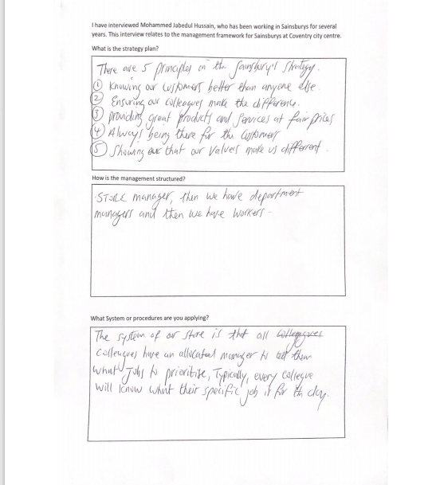
Appendix



