ASSIGNMENT:
SWANSEA FORESHORE ICE-CREAM PARLOUR

AUTHOR:
MERYL LYNNE JONES

STUDENT NUMBER:
1810816

DATE:
18/02/2019

Contents

OVERVIEW: 3

SECTION ONE 4
DESK TOP STUDY 4
WALK OVER INSPECTION 10

SECTION TWO 15
INSTRUCTION TO SPECIALIST SITE INVESTIGATORS 15

SECTION THREE 22

SECTION FOUR 28
(i) External wall, window and door intersections to the ice-cream parlour 28
(ii) The roof weathering and structure, of the restaurant & kitchen areas 30
(iii) The Ground Floor’s construction, detailing and junctions with external walls. 34
(iv) Site set up and plant 36

REFERENCES 38

APPENDIX A 40

OVERVIEW:

A ‘design & build’ opportunity has arisen, to construct a low-rise building, located on Swansea fore-shore, between the Civic Centre (formerly known as County Hall) and the Marriott Hotel.
The building is to incorporate a restaurant, café bar, ice-cream parlour, staff welfare facilities and a manager’s self-contained apartment.
I, as the junior construction professional / technician of a firm that is local to the site, will carry out the following, to assist my seniors with their tender submission:
- Desk top study of the site
- Walk-over inspection of the site
- Recommendations for more detailed site investigations from other professionals / sources
- Determine the most appropriate foundation and sub structure for the building, based on my preliminary findings
- Detail the suggested choice of materials and methods for
- External wall, window & door intersections to the ice-cream parlour
- The roof weathering & structure of the restaurant & kitchen areas
- Construction of the ground floor
- Site set up and plant typically required to carry out the work safely

SECTION ONE

DESK TOP STUDY

SITE LOCATION:
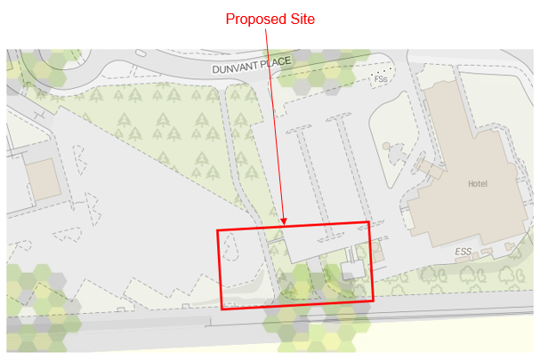
Picture 1.1 (Land Registry, 2019)

Picture 1.1 shows the proposed site location, via the Land Registry portal.
The Land Registry portal is a vital tool for confirming land ownership.
A Title Register document (which shows who the proprietor is along with any restrictions & charges) and Title Plan document (a plan outlining the boundaries of the title) can easily be obtained from this Government organisation, for a small fee per document (typically £3 each).
Any areas of land within the site which are declared as ‘unregistered’ may cause issues or delays for any plans proposed for the site due to the lack of ownership detail.

Proposed Site
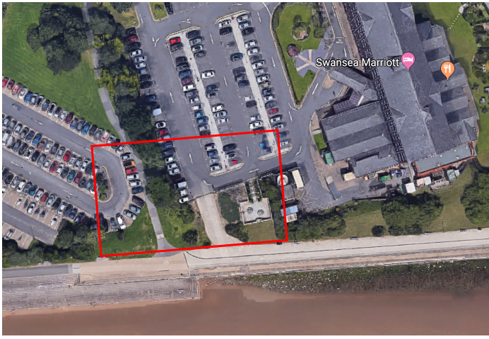
Picture 1.2 (Google Maps, 2019)

Picture 1.2 shows a satellite view of the site.
Such a view allows you to observe at a glance, what is currently surrounding the site such as walkways, sand, trees, commercial buildings and car parks.

Whilst Pictures 1.1 & 1.2 show the site location, the map and images used are ‘current day’. It would be pertinent to look into the historical maps of the site, as this would give essential information to past uses, buildings and structures. Historical data would also show any alteration to the coastline due to environmental factors.
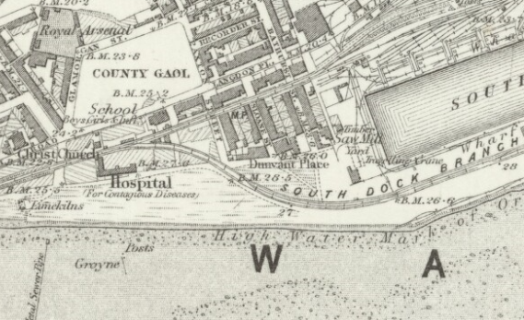
Picture 1.3 (National Library of Scotland, 1884)
Picture 1.3 shows the historical map of the area where the proposed site is located. This map was published in 1884, following surveys carried out in 1876 to 1877. The area shows that there was a hospital for contagious diseases and a railway track.

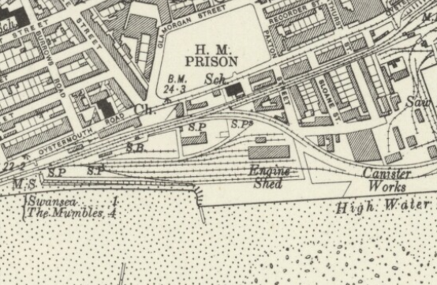Picture 1.4 (National Library of Scotland, 1921)
Picture 1.4 shows the historical map of the area where the proposed site is located. This map was published in 1921, following surveys carried out in 1913 to 1914. Comparing the area with the map in Picture 1.3, it now shows that the hospital for contagious diseases is no longer in existence, and the railway tracks have changed due to the area now housing an engine shed and other ‘end of track’ areas.

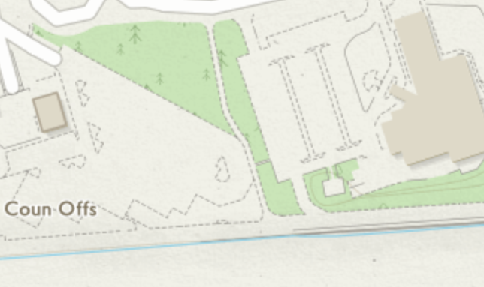
Picture 1.5 (Ordnance Survey, 2019)
Picture 1.5 shows the current Ordnance Survey Map of the area.

As the proposed site sits near the coastline; the wind & rain factors, plus flooding likelihood will need to be investigated. This will assist with deciding the building’s choice of materials.

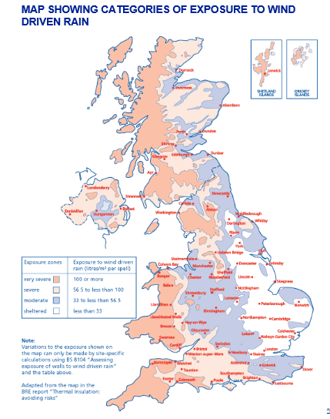
Picture 1.6 (NHBC, 2010)
Picture 1.6 shows the UK’s exposure to wind driven rain. The key shows that the darker red/pink areas have ‘very severe’ exposure to wind driven rain. Swansea is in that coloured zone.

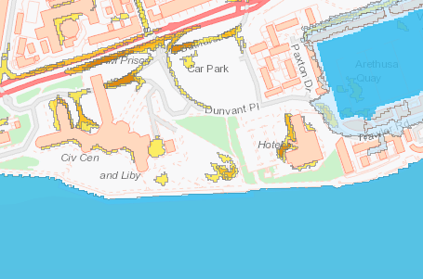
Picture 1.7 (National Resources Wales, 2019)
Picture 1.7 shows the flood risk zones for the site’s area.
The blue indicates areas of sea and the yellow indicates surface water flooding.
There appears to be a significant amount of surface water flooding in the proposed site’s area.

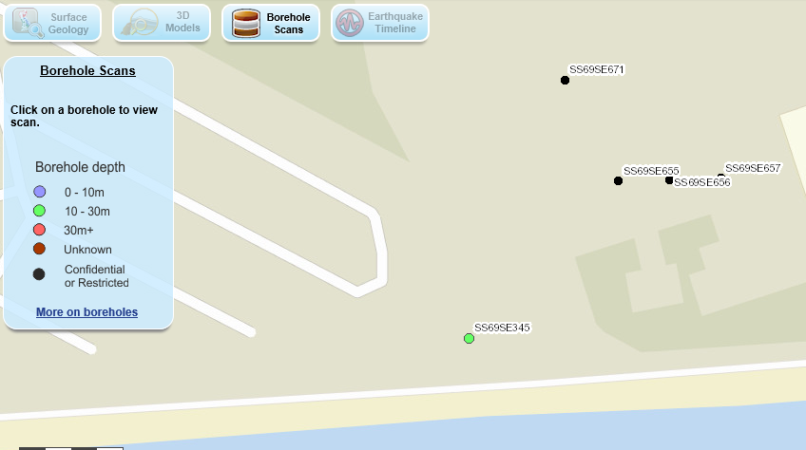
Picture 1.8 (British Geological Survey, 2019)
Picture 1.8 shows the recorded boreholes on / around the proposed site. Such data will give detail on the sub surface strata, which in turn will enable a decision with regard to which foundation type to use. There is existence of a borehole in the area of the proposed site (Ref SS69SE345). Appendix A shows this borehole’s report.
Additional desk top searches can include past planning applications for the existing buildings and applications that were cancelled / declined. Documents relating to each planning case, are available to view via the Local Authority’s planning portal and in person if unable to use the internet.

WALK OVER INSPECTION

The walk over inspection of the site was carried out 27th January 2019. The weather conditions were windy, cold, cloudy and showers.
By carrying out a walk over survey, it enables identification of any potential hazards or difficulties of the build that may not be identifiable from the desk top investigations.
The following photos were taken, which show the existing elements on the proposed site:
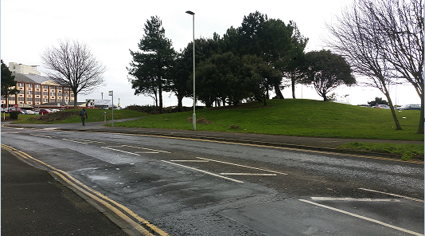
Picture 1.9 (Jones, 2019)
This is the northern side of the proposed site. This shows raised ground levels
and mature trees.

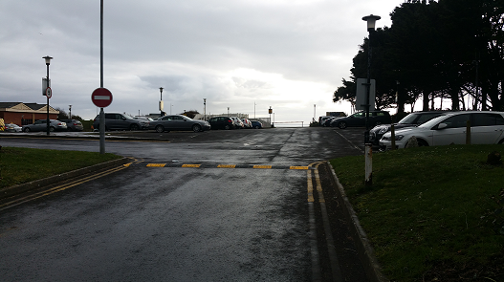
Picture 1.10 (Jones, 2019)
This is the Marriott’s car park.

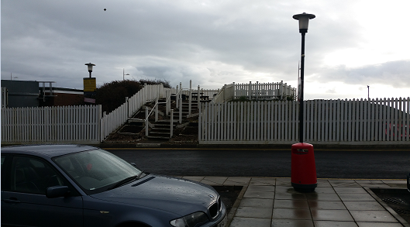
Picture 1.11 (Jones, 2019)
This is the Marriott’s viewing platform off the car park, which sits adjacent to
the coastal walkway for views over Swansea Bay. It sits on raised ground.

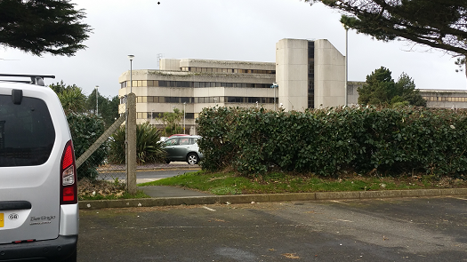
Picture 1.12 (Jones, 2019)
This is the path from the Marriott’s car park to the public pathway.

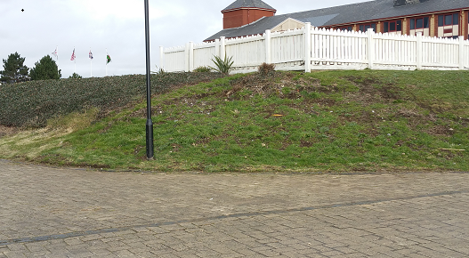
Picture 1.13 (Jones, 2019)
This is the Marriott’s viewing platform (showing the Southern side).
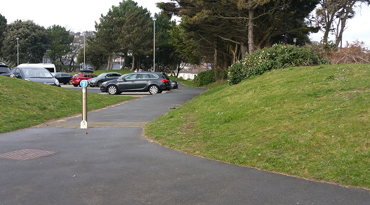
Picture 1.14 (Jones, 2019)
This is the public pathway between the Civic Centre & Marriott (Civic Centre
car park on the left). Raised ground levels are present on both sides.

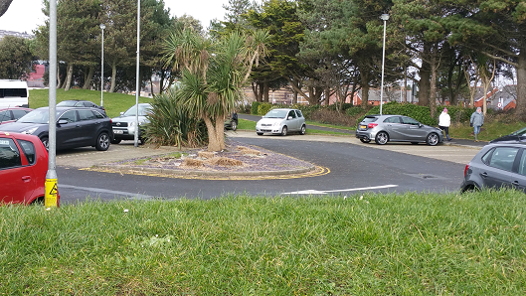
Picture 1.15 (Jones, 2019)
This is the Civic Centre car park showing the area which is the North West
Corner point of the proposed site.

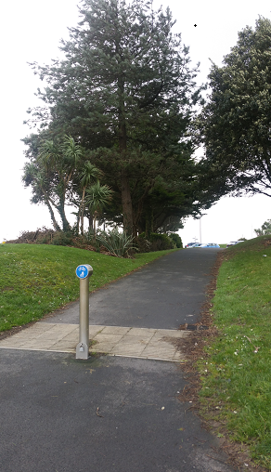
Picture 1.16 (Jones, 2019)
This is the public pathway between the Civic Centre & Marriott (Civic Centre
car park to the right). Raised ground levels are present on both sides.

My observations of this site are:
- Public Right of Way between the Civic Centre & Marriott’s car parks
- Public Right of Way along the sea front on the coastal walkway (foot path & cycle path)
- Mature trees and shrubs
- Raised ground levels (appear to be man-made)
- Drainage manholes
- Whole area exposed to coastal weather (wind, rain, sea water spray)

SECTION TWO

INSTRUCTION TO SPECIALIST SITE INVESTIGATORS

Some of the site investigations necessary, are not achievable from a desk top study or site walk over alone. ‘Competent persons / Companies’ must be instructed in order to fulfil all currently unknown aspects of the proposed site.
Such requests would typically include:
- Boreholes to ascertain the geology of the land which will provide knowledge of the strata
- Trial pits to identify the sub soil’s profile
- Soil & rock survey to ascertain the characteristics of the soil and determine if there is any contamination plus the strength & durability of the rock
- Utilities search to identify the location of existing services mainly gas, electric, water, sewer and telephone lines
- Topographic Survey to identify the elevations of the site
- Coal mining survey because South Wales is a coal mining area, as per my local knowledge of the area
- Radon Gas survey to identify if any protective measures are required to prevent the gas entering the new building
- Ecology Survey to determine if there are any protected species in the area
Instructing the ‘Competent Persons / Companies’ must be in writing and the request must be specific. Being specific avoids ambiguity, time wasting, unnecessary costs and unnecessary / irrelevant information.
Before instruction, a decision needs to be made regarding the location of the building on the proposed site.
Based on the preliminary findings, I recommend the building be located to the east of the site where the Marriott’s viewing platform and path which accesses the coastal public walkway, are currently situated. The building is to be set back from the public walkway, to allow for an external seating area and queuing area for the restaurant & ice cream parlour customers. Intended site location sketch overleaf:
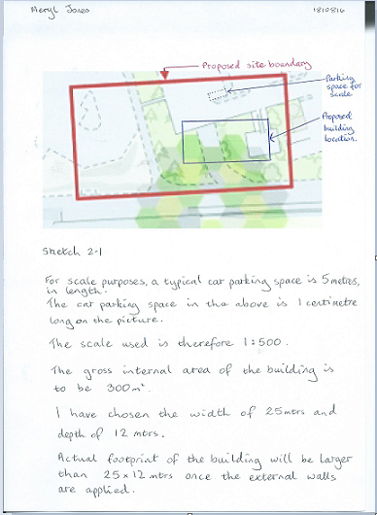
Sketch 2.1

By having the building located to the Marriott’s side, it will not impede on the public footpath which joins Dunvant Place and the public coastal walkway.
The very centre of the proposed site, will have a reference relating to the UK’s National Grid Map, where there will be an ‘easting’ reference and a ‘northing’ reference. Such references will need to be given to the companies who carry out the following surveys:
- Utilities
- Coal mining
- Radon gas
The reference to be given for the proposed site is:
265395 Easting
192291 Northing
The companies will work from this map point, to a radius which would cover the whole of the proposed site.

The companies who need to carry out physical surveys, such as:
- Boreholes
- Trial pits
- Soil survey
- Rock Survey
would need plans / drawings indicating exactly where their investigation needs to be carried out / extracted from, along with grid map references too.
For boreholes, I would request one in each corner of where the exterior of the building would be positioned, as indicated in the following sketch overleaf:
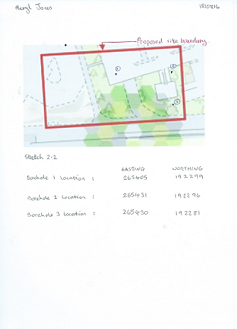
Sketch 2.2 Borehole Locations

The proposed building has a gross internal area (GIA) of 300m² hence why the boreholes would need to be made in places where the foundations would be situated (ie. just outside of the GIA’s footprint as the interior & exterior walls would ‘perimeter’ the GIA).
You will note that no request has been made for the South West corner. This is due to a previous borehole report in that location. See Appendix A.

For a trial pit, I would request one at each side of the building, as indicated in the following sketch overleaf:

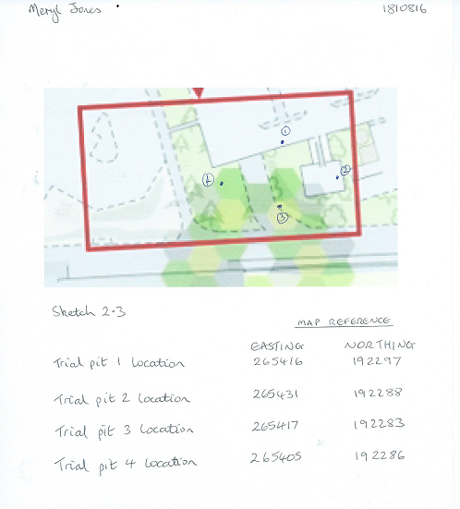
Sketch 2.3 Trial Pit Locations

The soil and rock surveys could be amalgamated with the borehole / trial pit investigations. As there was formerly a hospital for contagious diseases to the west of the site, the soil investigation will identify any contamination. As there was a former locomotive engine shed to the east of the site, the soil survey will identify any residual waste from the shed’s activities, such as fuel and ashes.

The company carrying out a topographic survey, will require the site location plan because they need to know where the site’s boundaries are.

The company carrying out the ecological survey will require the site location plan as they will identify any protected species in that specific area, along with the surrounding area.

SECTION THREE

Choosing the right foundation and sub structure, will be derived from the site investigation findings, teamed with the size & type of building to be erected.
As a rule of thumb, the higher / heavier the building, the deeper / stronger the foundations should be.
The building proposed is a 3 storey, with commercial & residential elements meaning its load will be heavier than a typical 2 or 3 storey residential home. The borehole findings from a past investigation in the area, showed that the strata is soft sandy clay, deepening to varying types of clay (See Appendix A).
Based on the building height, load and strata composition, I would recommend foundation and sub-structure of:

REINFORCED CONCRETE FRICTION PILES & RING BEAM

I have recommended this foundation type as the cohesive soil types (identified in the borehole in Appendix A) will grip the sides of the piles with friction. This can be likened to when stepping into deep, wet mud in wellington boots, it can prove difficult to pull the boot out because the friction of the matter prevents removal.
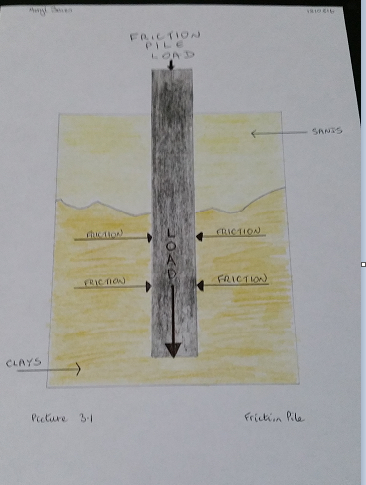
Picture 3.1 Friction Pile

As there are surrounding buildings, the vibration from ‘hammering’ in pre-cast piles will not be appropriate. Therefore, the piles would need to be replacement piles where the concrete replaces the matter that has been augured. This means the concrete for the piles & beam are best applied in-situ.

The ring beam will even out the stresses of the building’s load as the beam is a continuous ring, attached to each pile.

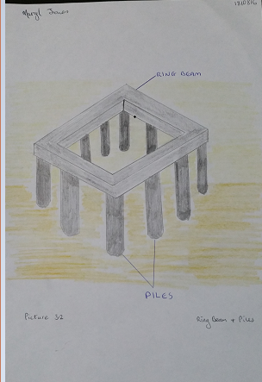
Picture 3.2 Ring Beam

The ring beam will also be an in-situ placement. It will have steel reinforcement to give added strength and durability because the proposed building is of a commercial nature, meaning heavier usage than a typical low rise domestic dwelling.

The walls of the proposed building are block and block for strength and durability. A cross section of the pile foundations, ring beam and block walls is overleaf:

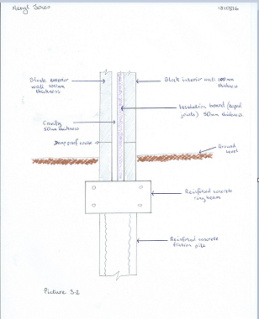
Picture 3.3 Substructure cross section
(Chudley R, 2016)

SECTION FOUR

- External wall, window and door intersections to the ice-cream parlour.

Lintels are a strong, continuous ‘bar type’ material, which are placed above an opening in a wall for windows / doors. By having a lintel present, the load above the opening, will be spread evenly down to the foundations, without putting strain on the opening.
Lintels can be of a timber, steel or concrete material.
For strength, durability and sustainability, I would recommend a heavy duty steel lintel, as seen in the sketch overleaf:

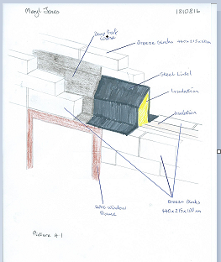
Picture 4.1 Steel Lintel
(IG Steel Lintels, 2019)

The ice cream parlour will have a lot of openings in the walls because it will need a wide / double door for customers, a serving hatch for external customers for a take-away ice cream and wall to ceiling windows to maximise the coastal view.

As mentioned previously, the internal and external walls will be breeze block. The external wall’s finish will be a polymer render as this is less prone to cracking and doesn’t require painting.
(Brinkley, 2017)

The lintel, which will be fixed to the internal and external wall, will span the whole length of the window / door frame, plus an overlap each side. Overlap length is dependent on the width of the opening.
Building Regulations 2010 (Wales) BS EN 845-2: 2003
(Welsh Government, 2017)

The roof weathering and structure, of the restaurant & kitchen areas

The ground floor’s roof area of 12.5 x 12 metres (being the ground floor’s area remaining, after first & second floor have been erected) is to be covered with the appropriate roofing materials.
I recommend a flat roof, of ‘warm deck’ construction to meet with Part L of the Building Regulations for new buildings. The following sketch overleaf shows a warm deck construction:
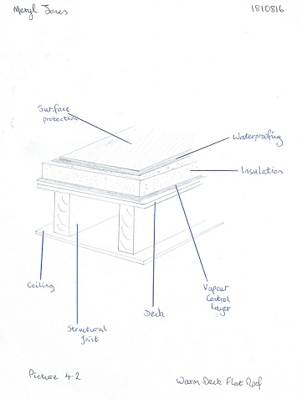
Picture 4.2 Warm Deck Flat Roof
(The National Federation of Roofing Contractors Limited, 2015)

The surface protection of the flat roof should be Ethylene Propylene Diene Monomer (EPDM) for its durability and plainer / smoother finish plus ease of application as it is supplied in rolls.
British Standard 6229 & 8217 relate to this part of a building.
To avoid ponding of water on the flat roof, which will weaken the structure, it must be constructed at an angle (typically 10⁰) for water to drain off into an appropriate drainage system. The fall should be a minimum of 1:40 with a finished fall of 1:80 to ensure water drains off.
(Bauder, 2019)
For commercial buildings, a ‘flat roof vertical drain’ is often preferred as they are more aesthetically pleasing and the internal pipes don’t freeze. A flat roof drain is an opening in strategic locations on the roof, to allow water to drain away, through a filtered trap as indicated in the sketch overleaf:

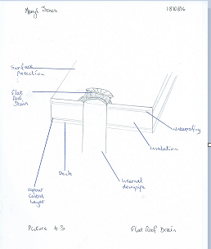
Picture 4.3 Flat Roof Drain

However, it would be pertinent to find out from the client if they want to consider installing any photovoltaic systems which would take advantage of the building’s location to incorporate sustainability in its design. The flat roof drainage may need to be reconsidered if such a system were to be installed.

The Ground Floor’s construction, detailing and junctions with external walls.

Commercial buildings will have heavier traffic than domestic, so durability is needed. I recommend a concrete slab floor with under slab insulation, as indicated in the sketch overleaf:

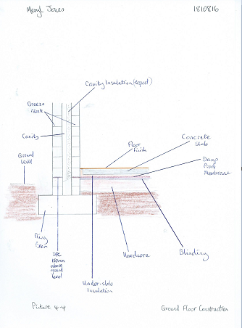
Picture 4.4 Ground Floor Construction

Site set up and plant

Site set up on any project, no matter what size, is extremely important. The safety and welfare of staff, contractors and the general public – basically, everyone. Risks must be eliminated / reduced wherever possible.
Securing a site is necessary, using appropriate hoarding around the perimeter of the site, with lockable entrance gates. This particular site would need very strong hoarding that would withstand high winds as the site is exposed to the coast. Hoarding would need to display the clear signs such as ‘work in progress’, ‘hard hats to be worn at all times’, ‘all visitors to report to site office’ and so on dependent on the rules decided for the site.
The public footpaths that currently sit within the site’s boundaries will need to be re-routed to a safe and accessible route.
For staff on site, whether they are principle contractor, sub-contractor or client/visitor, welfare facilities must be provided. Such facilities must be appropriately located and have access to services of drinking water and electric. Schedule 2 of the Construction Design & Management Regulations sets out the minimum requirements.
There must be a site office and storage facilities, which usually come in the form of porta-cabins or containers. The site office will be located near the entrance gates so that all entrees can obtain appropriate safety gear before entering any further. All entrees need to ‘sign in’ in the visitor’s book.
An assembly point for any emergencies must be designated and an appropriate warning sound such as a siren or alarm bell which will be loud enough to be heard over any construction plant noise. It must be tested once a week.
Parking for staff and visitors must be located to an area which will not interfere with the build and it’s construction plant.

Typical plant that will be required for this build is:
- Borehole rig to carry out the 3 boreholes required
- Excavator to level the ground
- Dumper truck to remove excavated waste
- Forklift truck to transport materials from storage to build location
- Piling machine
- Cranes to lift items into place such as large glazed units
- Delivery trucks for materials

REFERENCES

Bauder, 2019. Falls and Drainage. [Online]
Available at: https://www.bauder.co.uk/technical-centre/technical-literature/design-guides/flat-roof-design-considerations/falls-and-drainage
[Accessed 10 02 2019].
Brinkley, M., 2017. Choosing Render for your Home. [Online]
Available at: https://www.homebuilding.co.uk/choosing-render/
[Accessed 09 02 2019].
British Geological Survey, 2019. Geology of Britain Viewer. [Online]
Available at: http://mapapps.bgs.ac.uk/geologyofbritain/home.html
[Accessed 26 01 2019].
Chudley R, G. R., 2016. Building Construction Handbook. Eleventh ed. Abingdon: Routledge.
Google Maps, 2019. Google Maps. [Online]
Available at: https://www.google.co.uk/maps/@51.6133488,-3.945343,151m/data=!3m1!1e3
[Accessed 22 01 2019].
IG Steel Lintels, 2019. 100mm Inner Leaf Lintel. [Online]
Available at: https://iglintels.com/lintels/standard-lintels/100mm-inner-leaf-100mm-outer-leaf-lintels/
[Accessed 10 02 2019].
Jones, M., 2019. Site Walk Over Inspection. Swansea: s.n.
Land Registry, 2019. Map Search. [Online]
Available at: https://eservices.landregistry.gov.uk/mapsearch/addressSearch
[Accessed 22 01 2019].
National Library of Scotland, 1884. Glamorgan XXIV. [Online]
Available at: https://maps.nls.uk/view/102342508
[Accessed 26 01 2019].
National Library of Scotland, 1921. Glamorgan XXIV. [Online]
Available at: https://maps.nls.uk/view/102342505
[Accessed 26 01 2019].
National Resources Wales, 2019. Geocortex Viewer for HTML5. [Online]
Available at: https://maps.cyfoethnaturiolcymru.gov.uk/Html5Viewer/Index.html?configBase=https://maps.cyfoethnaturiolcymru.gov.uk/Geocortex/Essentials/REST/sites/Flood_Risk/viewers/Flood_Risk/virtualdirectory/Resources/Config/Default&layerTheme=0
[Accessed 26 01 2019].
NHBC, 2010. NHBC Standards 2010. [Online]
Available at: http://nhbccampaigns.co.uk/landingpages/techzone/previous_versions/2010/Part6/section1/appendix.htm#61A2
[Accessed 26 01 2019].
Ordnance Survey, 2019. O S Maps. [Online]
Available at: https://osmaps.ordnancesurvey.co.uk/51.61341,-3.94549,18
[Accessed 26 01 2019].
The National Federation of Roofing Contractors Limited, 2015. [Online]
Available at: https://www.nfrc.co.uk/docs/default-source/form-protected-documents/homeowners/householders-guide-to-flat-roofing-2015.pdf
[Accessed 10 02 2019].
Welsh Government, 2017. Building Regs Approved Document. [Online]
Available at: https://gov.wales/docs/desh/publications/170403building-regs-approved-document-a-structure-en.pdf
[Accessed 10 02 2019].

APPENDIX A

BOREHOLE REPORT

(British Geological Survey, 2019)

3 PAGES



