Competitive Dynamics of China’s Smartphone Industry: A Strategic Analysis of Apple’s Operations Using Porter’s Diamond Model and PESTLE Framework

Student name:
Student ID:
Table of content:
SECTION 1 – INTERNATIONAL INDUSTRY REPORT 3
1. Introduction 3
2. Overview of the Industry and the Country 3
2.1 Overview of China’s Smartphone Industry 3
2.2 Economic Significance of the Industry 5
2.3 Competitive Positioning and Major Firms 6
3. Diamond Model Analysis by Porter 8
3.1 Factor Conditions 9
3.2 Demand Conditions 9
3.3 Related and Supporting Industries 10
3.4 Firm Strategy, Structure, and Rivalry 10
4. Apple’s Operations and Market Attractiveness in China 11
4.1 Overview of Apple in China 11
4.2 Political Environment (PESTLE) 12
4.3 Economic Environment 13
4.4 Legal and Regulatory Environment 14
4.5 Cultural Factors 15
4.6 Strategic Opportunities and Strategic Risks 16
5. Conclusion 17
SECTION 2 – REFLECTIVE ACCOUNT 18
6. Reflective Account Gibbs Reflective Cycle 18
6.1 Description 18
6.2 Feelings 19
6.3 Evaluation 19
6.4 Analysis 20
6.5 Conclusion 20
6.6 Action Plan 20
Reference list 22

SECTION 1 – INTERNATIONAL INDUSTRY REPORT

1. Introduction
China is among the most powerful markets in the smartphone industry across the world, as it is the largest manufacturing hub in the world, in addition to being the largest consumer market of mobile devices (Coe and Yang, 2021). The market is featured by the high competitiveness of local technology companies, Huawei and Xiaomi, and foreign brands like Apple. In this sector, multinationals play a very large role in determining innovation, supply chains, and global technological standards. This report evaluates the competitive nature of smartphone companies in China and critically examines the activities of Apple in the Chinese market. The analysis implements the Diamond Model of Porter to evaluate the national competitive advantage and a PESTLE model to evaluate the political, economic, legal, and cultural elements that affect the success of Apple in China.

2. Overview of the Industry and the Country

2.1 Overview of China’s Smartphone Industry
The Chinese smartphone is one of the most powerful sectors of the world's consumer electronics industry (Jiang and Murmann, 2022). The nation operates as the biggest smartphone production centre as well as a massive consumer market of the globe. China has achieved a very advanced smartphone ecosystem in the last ten years, owing to technological advancement, well-established local brands, and massive production and manufacturing facilities. The industry is typified by a fast technological growth, especially in the aspects of 5G connectivity, the implementation of artificial intelligence, and new camera technologies that have greatly boosted consumer expectations of new models of smartphones.
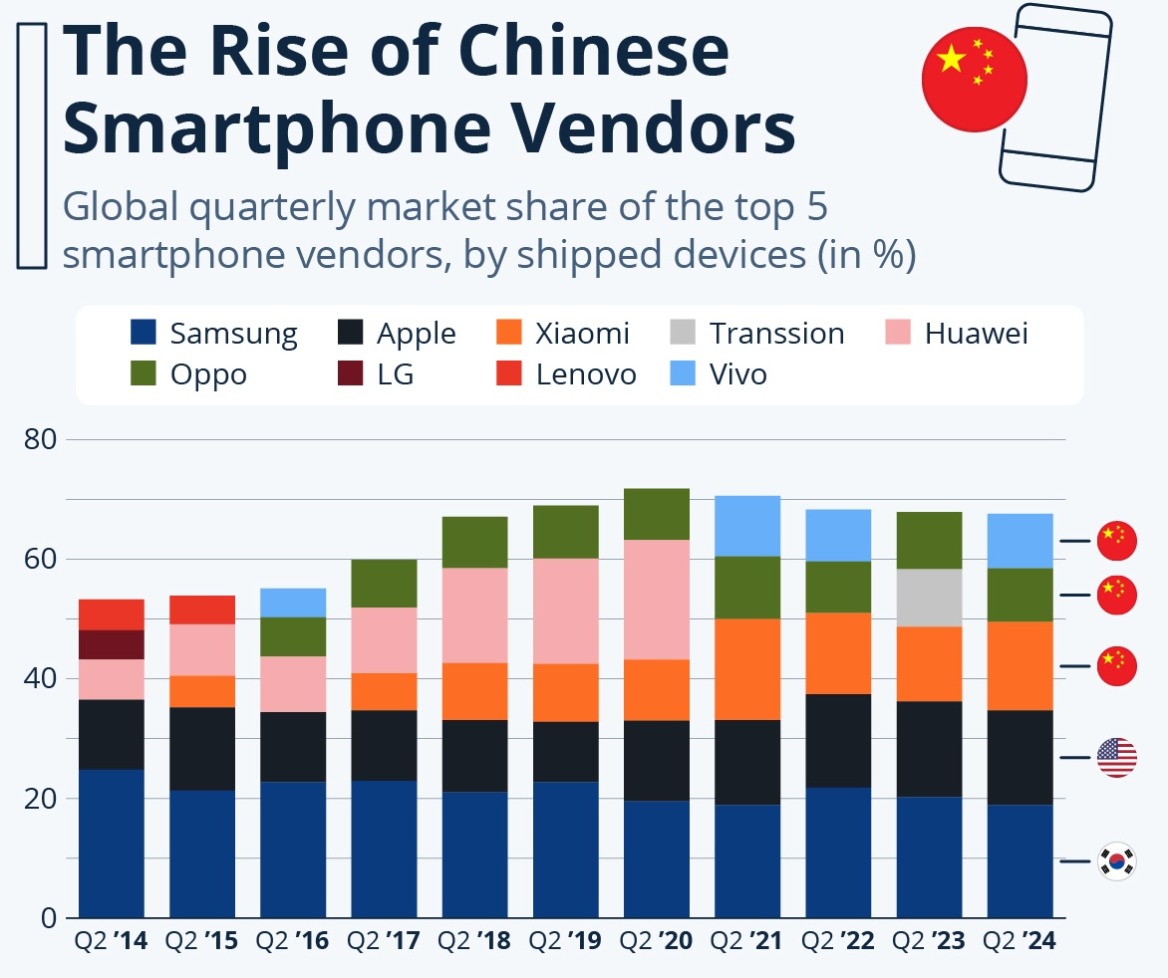
Figure 1: Global Smartphone Market Share by Manufacturer
Source: selfmade
China contributes a significant percentage of the worldwide smartphone market, as the country has developed an electronics manufacturing industry and has an integrated supply chain. Some cities like Shenzhen are now central hubs in the network of smartphone manufacturing in the world, with many of the manufacturers, component suppliers, and research centers located there (Ma et al., 2024). It is estimated by the industry that China manufactures over half of the total smartphones in the world, which serve both the domestic and international markets. Large-scale availability of labour, well-developed logistics networks, and a high level of government support of high-technology industries support this manufacturing advantage. Nevertheless, despite dominating smartphone production in the world, the dominance is being gradually impacted by the rising labour costs and the gradual offshoring of the electronics manufacturing industry to the lower cost economies including Vietnam and India.
The Chinese smartphone market is also typified by stiff rivalry between the local companies and multinational companies. The mid-range and the budget segments are dominated by major domestic manufacturers, including Huawei, Xiaomi, and OPPO, whereas the high-end devices are more or less Apple and local high-end models (Jabr, 2023). The high pace of the development of 5G technology has only increased the expansion of the market, with Chinese consumers being very open to new technologies and updating their devices regularly. Consumer reliance on smartphones is further supported by high levels of smartphone penetration rates and well-developed digital ecosystems such as mobile payments, e-commerce platforms, and the like, which contribute to consumer reliance on smartphones within Chinese society.

2.2 Economic Significance of the Industry
The smartphone business is a vital part of the overall technology sector in China, and it also has an impact on the economic growth of the nation. It is a constituent of the electronics manufacturing business in China, one of the largest export businesses in the domestic economy (Wang et al., 2023). As a significant part of the high-technological exports of the country, smartphones and other electronic gadgets not only promote economic development but also the competitiveness of international trade.
Another significant area of economic impact of the industry is the creation of millions of people working in smartphone production, the production of components, software creation and distribution, and logistics. International companies like Foxconn, which act as global contract manufacturers, have large plants in China where most smartphones are made on behalf of international brands (Hao and Bu, 2022). These production ecosystems offer a wide employment spectrum and enhance the reputation of China as a key node in the electronic supply system of the world.
One of the most significant technological centers in the world, called by some as the China Silicon Valley of hardware, has risen in Shenzhen. The area is home to a high concentration of component vendors, semiconductor firms, display firms, and assembly factories, which, together, are in support of smartphone manufacturing. This combined supply system enables companies that are doing business in China to receive reduced costs of production, less time for innovation, and effective product development processes.
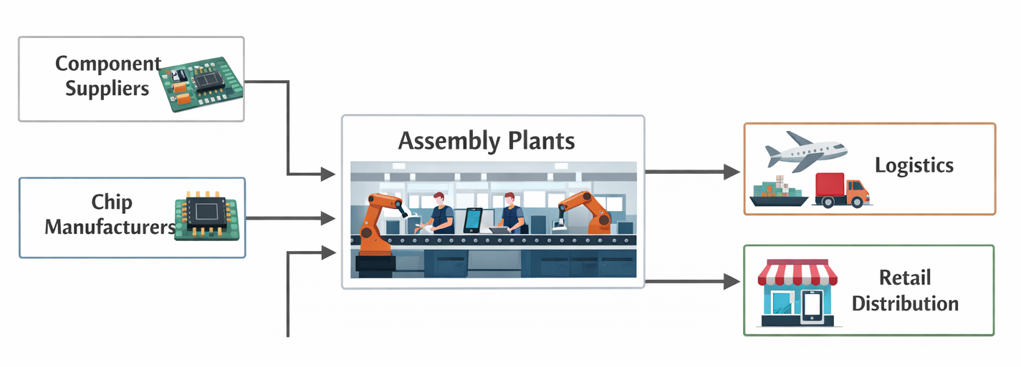
Figure 2: Smartphone Production Ecosystem in China
Source: selfmade

2.3 Competitive Positioning and Major Firms
The smartphone industry in China is also very competitive, with local and multinational companies competing in various segments of the market. The major firms are Apple, Huawei, Xiaomi, OPPO, and Samsung Electronics. These companies adopt different competitive theories in capturing the market share.
Company | Strategy | Market Segment | Competitive Advantage
Apple | Premium differentiation strategy focusing on high-end design, ecosystem integration and brand prestige | Premium / High-income consumers | Strong brand loyalty, integrated ecosystem (iOS, iCloud, App Store), advanced chip technology
Huawei | Innovation-driven strategy with strong investment in R&D and proprietary technologies | Premium and upper mid-range | Advanced camera technology, strong domestic brand reputation, development of proprietary chipsets and software
Xiaomi | Cost leadership combined with online sales model and rapid product launches | Mid-range and budget | Competitive pricing, strong online ecosystem, large domestic consumer base
OPPO | Product differentiation focusing on camera technology and design innovation | Mid-range and upper mid-range | Strong offline retail network, advanced camera and charging technology
Samsung Electronics | Broad product diversification strategy across multiple price segments | Premium and mid-range | Advanced display technology, global brand recognition, strong R&D capabilities

The innovation in combination with a friendly price is the main strategy of domestic manufacturers like Huawei and Xiaomi, which allows them to conquer the middle-range smartphones market (Wu et al., 2022). Their plans are characterised by quick product development, powerful online distribution systems, and connection with the Chinese digital ecosystem. Apple, on the contrary, pursues a premium differentiation strategy and focuses on the high-income buyer who is interested in brand reputation and product design and integration into the Apple ecosystem of devices and services.
Samsung Electronics competes with a diverse product offering, which covers premium and mid-range products. Its share in China has been eroded by the local brands' competition. In general, the Chinese smartphone market has been characterized by a fast rate of innovations, intense brand rivalry, and price differentiation within the various classes of consumers.

3. Diamond Model Analysis by Porter
The Diamond Model of Porter offers a manageable model used in the analysis of national competitive advantages that have helped China to become a dominant player in the smartphone industry (LU, 2025). This model analyzes four interrelated determinants, which are factor conditions, demand conditions, related and supporting industries, and firm strategy, structure, and rivalry, in explaining how national environments can affect industrial competitiveness.All these determinants in the case of China form a most favourable ecosystem for smartphone manufacturing and innovation.
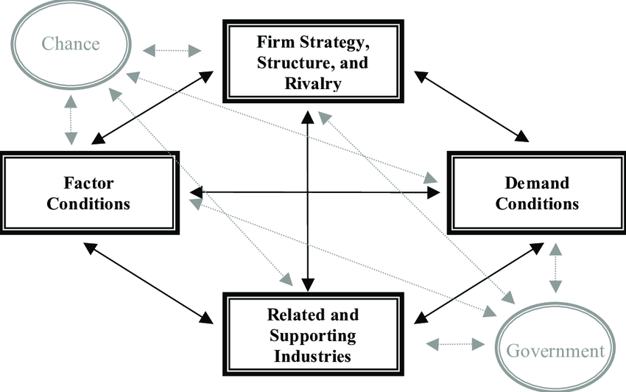
Figure 3: Porter’s Diamond Model of National Competitive Advantage
Source: selfmade

3.1 Factor Conditions
China has good factor conditions that place it in a great position to gain a competitive edge in the manufacture of smartphones. The number of skilled and large labour force that is specialised in electronics production and engineering is one of the most critical factors. China has built a lot of technical skills in the last twenty years in the sectors of electronics assembly, fabrication of components, and the design of products (Zhang, Fan and He, 2023). This labor force is facilitated by a well-developed manufacturing system, which incorporates modern production sectors, developed logistic systems, and large industrial parks. These factor conditions are enhanced even more by technology clusters like Shenzhen. Shenzhen is currently one of the most significant hardware innovation centres in the world, as a number of technology firms, component vendors, and contract manufacturers can be found. Companies that are located in this cluster have the advantage of sharing knowledge, quick prototyping, and being very near to their suppliers. In this regard, the Chinese government has been able to invest heavily in research and development by investing in national initiatives to enhance its technological power. These investments have aided the development of local companies like Huawei and Xiaomi to compete favorably with international firms like Apple (Pereira et al., 2022). However, China has a significant dependency on manufacturing advantages that can be dangerous in the long term as the world supply chains keep diversifying out of China because of geopolitical tensions and economic restructuring.

3.2 Demand Conditions
The competitiveness of the industry is also largely enhanced by the demand conditions in China. China boasts of a huge consumer base of Smartphones in the world with hundreds of millions of smartphone users. The high domestic population will provide a significant customer base, and this customer base will spur the constant development of the products and technological advancement. The overall receptiveness of the Chinese consumers to new technologies and the regular changes of the devices they use stimulates companies to launch new models and features in a very fast stream (Tao et al., 2026).
The other significant factor of demand conditions is that the adoption of new advanced technology, like 5G-enabled smartphones, is being adopted rapidly. China has put a lot of money into 5G infrastructure, resulting in extensive high-speed mobile network coverage. This makes the consumers insist on smartphones with better connectivity, performance, and new features. Simultaneously, a large number of consumers are still price-sensitive, and this makes manufacturers manufacture technologically advanced devices at competitive prices.

3.3 Related and Supporting Industries
The availability of well-developed related and supporting industries also adds strength to the smartphone industry in China. China has a huge network of component producers such as semiconductor manufacturers, battery makers, and display technology companies. These corporations create a wholly comprehensive supply chain, which facilitates the production of smartphones on a large scale (Biberman, 2022).
An example would be that companies like BOE Technology are the providers of high-tech display panels, but there are also many manufacturers of batteries and components in the Chinese electronics clusters. The fact that these suppliers are close to one another means that smartphone producers can cut down on production expenses, shorten the development process, and respond quickly to changes in the market. Such supplier-manufacturer and logistical chain integration gives a boost to the efficiency and competitiveness of the smartphone industry of China.

3.4 Firm Strategy, Structure, and Rivalry
The last aspect of Porter's Five Forces is strategy in the firm, structure, and rivalry, and this is of massive importance in the Chinese smartphone market. The level of competition between local and global companies is extremely high, which results in innovation going on very fast and the release of new products very frequently (Porter, 2023). The Huawei, Xiaomi, and OPPO companies are actively competing in various market segments using pricing strategies, technological innovation, and marketing campaigns.
This stiff competition makes companies keep on enhancing the quality of their products, adding new functionalities and competitive pricing mechanisms. Most Chinese manufacturers are aiming to provide high specifications at reduced prices, whereas the high-end brands like Apple are competing with product differentiation, design, and ecosystem integration. Consequently, the competitive nature of the Chinese market contributes to technological growth and market dynamism, which enhances the competitiveness of the smartphone industry in the country at the global level. Although the high level of domestic competition stimulates a fast rate of innovation, it also reduces the profit margins and compels business firms to pursue aggressive pricing policies that can ultimately decrease the industry profitability over the long term.

4. Apple’s Operations and Market Attractiveness in China

4.1 Overview of Apple in China
In the late 2000s, Apple decided to enter the Chinese market when the consumer electronics industry in China started to grow fast with the growth of incomes and the development of the internet. The introduction of the iPhone into China saw a huge milestone in placing Apple among the most competitive international brands in the high-end smartphone market in the country. Over the years, China has grown to form one of the most strategically important markets to Apple as a large consumer market and as a part of the global manufacturing network of the company (Lin, 2024).
The first approach used in China was to establish brand status by opening flagship retail stores in large cities like Beijing and Shanghai, and at the same time, form joint ventures with large telecommunication companies to distribute iPhones. These efforts positioned the iPhone as a high-end and aspirational product in the eyes of the Chinese consumers. During the first decades of growth, Apple was enjoying its booming growth with more and more middle-class consumers willing to use smartphones that are of superior quality, smart in features, and with good brand recognition.
The dynamics of market shares in China have been changing greatly in the last decade, with the emergence of domestic smartphone producers at an alarmingly quick pace. Firms like Huawei, Xiaomi, and OPPO have come up with very competitive smartphones at relatively lower prices that have won big shares in the markets. The fierce rivalry in the Chinese smartphone market has not stopped Apple from being a major player in the premium market segment. Apple operates under a premium differentiation strategy, which focuses on product quality, ecosystem integration, and brand reputation instead of direct competition based on price (Shabdanov, 2023).
The other important detail of Apple's Chinese presence is that it has extensive dependence on the Chinese manufacturing infrastructure. Most iPhones are manufactured in China, as Foxconn and Pegatron are the two contract manufacturers. Such manufacturing integration enables Apple to enjoy the advanced electronics supply chain in China, a skilled labor force, and effective logistics networks in the manufacturing. China thus straddles two aspects of the Apple global strategy: it is a key sales market and a core production centre of the Apple global supply chain.
But the market dynamics and geopolitical tensions in China are gradually defining the role of Apple in the country. The rise of well-established domestic competition and changes in the regulatory environment have offered both opportunities and challenges to Apple (Paweł Bryła and Shokir Abdusattarov, 2025). Although the company still enjoys a high brand loyalty amongst the high-income consumers, to remain competitive in the long term, the company will need to operate in the Chinese market amidst intricate political, economic, legal, and cultural dynamics.
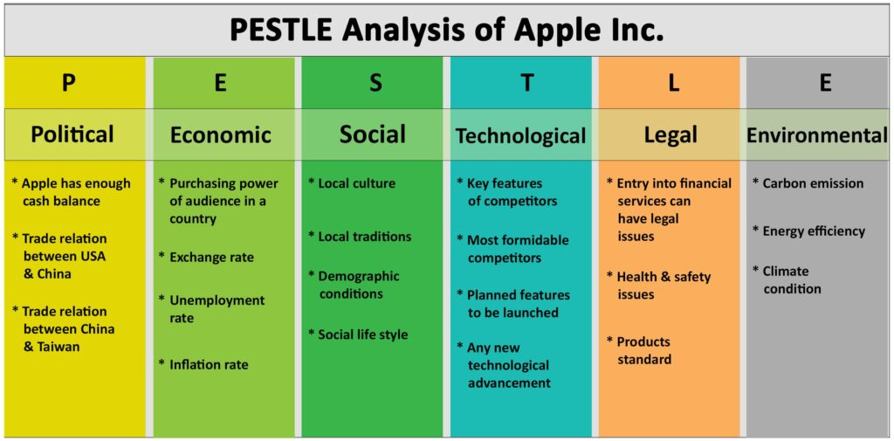
Figure 4: PESTLE Framework for Analysing Apple’s Market Environment in China
Source: selfmade

4.2 Political Environment (PESTLE)
The political climate plays an important part in determining the conditions under which multinational technology firms operate in China. The Chinese government has had robust control of the technology industry with policies that seek to promote local innovation at the cost of having control over digital infrastructure and data security. In the case of Apple, these policies pose strategic constraints as well as regulatory requirements.
The other major political aspect that is influencing the operations of Apple is the bigger geopolitical conflict between the United States and China (Schindler and Rolf, 2024). The recent years have seen technology emerge as one of the key concerns in the trade relations between the two countries. The export control, technology prohibitions, and national security issues have added to the complexity of regulations for international technology companies. The larger geopolitical environment has raised the level of uncertainty with regard to international technology supply chains, although Apple has not experienced the same degree of limitations as other enterprises.
Apple is also affected by government regulations in the area of data security and the governance of digital space in China (Shtub and Gal, 2022). The technology companies have to abide by stringent cybersecurity legislation and localisation of data by Chinese authorities. Such regulations compel businesses to save some levels of data in China and collaborate with government control systems. The need to comply with these requirements may pose operational problems to multinational firms that will have to strike a balance between the regulatory requirements and the international privacy standards. This obliges multinational technology companies like Apple to strike a delicate balance between regulation and Chinese laws and international data privacy and corporate governance standards.
Moreover, the industrial policies in China are becoming more focused on the self-sufficiency of China technologically and the creation of local technology firms. Chinese Smartphone local brands have been empowered by the government to compete better in the local market (Coe and Yang, 2021). This political focus on the national development of technology can have an indirect impact on the market conditions of foreign firms like Apple, which have to compete with firmly sponsored local competitors.
On the whole, the political environment in China provides a challenging operating environment where Apple has to balance regulatory compliance, geopolitical risks, and strategic relations with the local stakeholders.

4.3 Economic Environment
The economic environment in China has been a primary factor that has contributed to the demand for smartphones and has influenced the opportunities that Apple has in the market (Lin, 2024). China has undergone an impressive economic growth over the last 20 years, which has seen a significant rise in household income, as well as the size of the middle market. With the increase in the level of disposable income, most consumers can now afford to buy high-quality electronic gadgets like iPhones.
The expansion of the middle-income market in China has formed a huge and desirable consumer segment of high-quality smartphones. The purchase decision-making process of urban consumers, especially, is more likely to emphasize the quality of the products, brand image, and technological advancement. Apple has been able to effectively leverage this trend by positioning its products as high-end devices that have better design, performance, and software integration.
Nevertheless, the situation in the economic environment also brings some difficulties to the premium pricing strategy of Apple (Nagle, Müller and Gruyaert, 2023). The majority of Chinese consumers are still price-conscious and might shift to cheaper products provided by local companies. Other companies like Xiaomi have managed to acquire considerable market share by providing high-performance smartphones at affordable prices. Consequently, Apple has to trust in robust brand differentiation and integration of the ecosystem to provide the justification for the increased cost of its devices.
Consumer buying behaviour in China can also be impacted by economic changes. The demand for high-priced smartphones can decrease during the slowdown of economic growth or a decrease in consumer confidence. In this case, Apple will risk even more competition with general middle-range equipment that could also possess similar features at a reduced price.
Despite such hurdles, China is among the most key revenue markets for Apple because of its high population and the quickly developing consumer electronics industry. The long-term opportunity of premium technology products is still present in the country due to its current urbanisation, digital transformation, and growing middle-class population.

4.4 Legal and Regulatory Environment
The other factor that is of critical concern to the operation of Apple in China is the legal and regulatory environment. The foreign technology firms in China have to abide by a complicated system of laws that regulate intellectual property, digital security, data protection, and competition in the market (Shtub and Gal, 2022).
Multinational firms that have been in operation in China have historically been concerned with respect to intellectual property protection. Though in recent years, China has tightened its intellectual property laws, some areas still have difficulties with their enforcement. In the case of technology-based companies like Apple, it is necessary to safeguard proprietary designs, software systems, and technological inventions to have a competitive edge.
The technology companies are also subject to certain requirements under the Chinese laws on cybersecurity and data governance (Borgogno and Michele Savini Zangrandi, 2024). The regulations demand that firms abide by stringent rules of data storage, information security, and user privacy. As an illustration, Apple has been forced to change some of its operational habits because of the localisation of the data requirements of the Chinese. The laws ensure that the Chinese data of users is stored in the servers in China, where data control and regulatory measures might be a matter of concern.
Besides cybersecurity laws, Apple has to adhere to the local technological standards and digital ecosystem laws as well. The Chinese government has imposed regulatory control on mobile applications, digital payment, and online services. This means that Apple should make sure that its services and platforms are simply functioning within the framework instituted by the Chinese regulators.
To foreign companies, answering to these legal necessities may become a complex form of operation and strategic risk. The long-term viability of both the Chinese and the foreign multinationals in the technology sector can be affected by compliance costs, uncertainty in the regulation, and possible alteration of the policy.

4.5 Cultural Factors
The cultural aspects are significant in influencing consumer behaviour and brand perceptions in the smartphone market in China (Deng, 2025). The Chinese are very keen on the quality of products, innovation, and brand name when choosing smartphones. To a lot of consumers, the possession of a high-end smartphone is not just a utilitarian one but also an indication of their social status and identity.
In this regard, Apple has managed to market the iPhone as a status symbol to a large number of Chinese buyers. The brand is said to have good quality, advanced technology, and international prestige. The perception has also helped in creating a high brand loyalty among some groups of the Chinese people, especially urban professionals and young people.
Nevertheless, the situation in China is changing with respect to cultural dynamics. Patriotic consumption has also been on the increase in recent years, in which certain consumers choose to patronize local brands of technology. Businesses like Huawei have taken advantage of this trend by fostering innovation in technology in the country and tapping into the consumer pride in home products (Wang et al., 2024).
The Chinese smartphone brands have equally managed to be competitive in product design, performance, and innovation. The perceived difference between international and local brands has reduced as local brands have been upgrading product quality and technological prowess. This means that to keep its high-end status in the Chinese market, Apple should continuously strengthen its brand value by introducing innovation, design, integration, and ecosystem into its brand.

4.6 Strategic Opportunities and Strategic Risks
The market still presents a considerable strategic opportunity to Apple despite the difficulties of doing business in China. The first opportunity is the fact that the premium smartphone market is still growing. With the growing consumer incomes and the digital life gaining more and more popularity, the demand for high-performance smartphones is projected to be high (Madhavi Dachawar et al., 2025). The company finds itself in a good position to tap this high demand due to Apple's reputation for quality products and innovation.
The integrated product and service ecosystem at Apple is another important opportunity. The iPhone, iPad, Mac, and Apple Watch are all made to complement each other using the Apple software ecosystem. Such a combination provides an effective lock-in effect on the ecosystem to compete with other suppliers of products and services, making consumers stay inside the product ecosystem of Apple after adopting several devices.
Some threats can, however, influence the long-term status of Apple in China. The relations between China and the United States are based on geopolitics and are considered to be one of the primary issues since policy shifts or trade restrictions may affect the technology supply chains (Oup.com, 2026). Also, the emergence of other local rivals like Huawei and Xiaomi that have been rapidly expanding is further escalating the competition in the mid-range and high-end smartphone markets.
Another strategic risk that is posed by supply chains to Apple is supply chain concentration. Since a good percentage of the Apple manufacturing business has shifted to China, a regulatory shift, labour or world crises can affect the manufacturing capacity. To this, Apple has started to diversify part of its supply network to other nations, even though it has remained a major manufacturer in China.
Finally, China is still a crucial market and a complicated strategic environment for Apple. The company will be successful in the long run solely because it will manage to balance premium brand positioning against the local market forces and changing political, economic, and regulatory environments. Therefore, the competitiveness of Apple in the long term in China will not only depend on the product innovation but also on its geopolitical risk management through strategic management of geopolitics, regulatory pressures and the growing competition by local brands that are technologically advanced.

5. Conclusion
With a well-built manufacturing strength, huge technology networks, and a very well-knit electronics supply chain, China has built one of the most competitive and dynamic smartphone businesses in the world. The use of the Diamond Model of Porter has indicated that China has favourable factor conditions, such as the availability of skilled labour, good manufacturing infrastructure, and high government investment in technological development (LU, 2025). Moreover, the vast local market, the high rate of use of 5G technology, and supporting industries have also increased the competitiveness of the country in smartphone production worldwide. The fierce competition between local companies like Huawei, Xiaomi, and OPPO further led to constant innovations and technological development in the industry.
In this competitive environment, the differentiation of its products and integration with the ecosystem have given Apple a robust strategic stance. China has been the most important to Apple as a key source of revenue as well as a centre point of its global manufacturing system. Nevertheless, the company is experiencing numerous threats such as growing competition from local brands, regulatory interference, and political instabilities between China and the United States.
Nevertheless, despite the risks, Apple still has substantial opportunities in the fast-growing premium smartphone industry in China. The sustainability of the company in the Chinese market in the long term is determined by its capacity to sustain technological innovations, respond to the dynamics of the local markets, and cope with the uncertainties of politics and economic situations.

SECTION 2 – REFLECTIVE ACCOUNT

6. Reflective Account Gibbs Reflective Cycle

6.1 Description
This reflective report investigates the procedure involved in the research, analysis, and writing of the international industry report on the smartphone industry of China and the activities of Apple in the Chinese market. The research process has started by identifying an appropriate country-industry combination that would present adequate publicly available data to analyze. The smartphone market of China was chosen because it is important globally, today it is technologically innovating, and has the presence of strong multinational and domestic companies.
To conduct the research, one had to gather information in a range of academic and industry sources, which could be journal publications, industry reports, technology news platforms, and company publications. As part of the market trend analysis, competition, and technological innovation in the smartphone industry, secondary data was the main source of data to be analysed. These sources assisted in determining the major industry participants like Huawei and Xiaomi, and understanding their competitive strategies in the Chinese market.
In order to organize the analysis, two important international business frameworks were chosen: Porter's Diamond Model and the PESTLE framework. The Diamond Model of Porter was employed to analyze the national competitive advantage of China in terms of smartphone production, whereas the PESTLE framework was used to analyze political, economic, legal, and cultural forces that affect Apple's operations in China. The frameworks used offered a systematic methodology in the analysis of complex matters in international business and enabled the report to combine theoretical matters with the industry trends on the ground.

6.2 Feelings
The topic seemed to be complicated at the initial stage of the research process because of the size of the Chinese smartphone industry and the numerous companies that are working in the market. Firstly, the researcher had difficulty deciding on the most relevant and reliable sources to be used in academic analysis. The high rate of technological development in the smartphone market and industry also led to the need to work with recent data to make sure that the analysis was relevant.
With the course of the research, however, confidence was gained in analyzing international business environments. The strategic comparison of the competition between the global and domestic brands of smartphones facilitated the process of exploring the ways in which multinational companies work within the institutional and cultural settings. The knowledge of the competitive practices of businesses like Apple and Huawei was also helpful in understanding how companies can change their strategies to fit the local market.
All in all, the research process turned out to be more entertaining due to the fact that the linkages between theoretical foundations and practical business strategies became more apparent.

6.3 Evaluation
The availability of numerous and reliable resources to construct a holistic picture of the smartphone segment in China was one of the strengths of the research process. The academic literature and the industry report enabled the analysis to include the theoretical and practical market developments. The introduction of traditional frameworks, like the Diamond Model provided by Porter and PESTLE analysis, also served to organize the report logically and provide the analysis with consideration of the main factors that international business operations depend on.
Nevertheless, there are also a few limitations, which were met in the course of research. The difficulty was also getting as detailed or proprietary market information as some industry reports would be available only through paid subscriptions. This forced some of the statistics to be calculated based on publicly available summaries, but not complete datasets. Also, the technology industry is highly dynamic, and thus market share and industry dynamics may shift quickly, thus impacting the long-run validity of some of the findings.
Regardless of these restrictions, the general research process provided adequate information to carry out a critical analysis of the industry and the strategic position of Apple in the Chinese market.

6.4 Analysis
The discussion process in the assignment has drawn attention to the significance of international business frameworks in interpreting complex industries in the world. The Diamond Model offered by Porter came in handy, especially in the explanation of the effects of national environments on the competitiveness of industries. It was through this paradigm that it emerged that the smartphone industry in China is favoured by a blend of good manufacturing infrastructure, huge domestic demand, and massive supply chain networks.
The PESTLE framework also proved useful in understanding how the external environmental factors influence multinational companies in foreign markets. As an illustration, the study of political and legal variables showed that government policies and political tensions can influence the strategic choices of technology firms. Economic and cultural aspects also depicted the impact of consumer behaviour and purchasing power on the positioning of the product and its success in the market.
The assignment thus supported the relevance of interweaving theoretical models with the actual analysis of the industry so as to be in a position to comprehend the global competition and multinational business strategies.

6.5 Conclusion
This reflection revealed that the research of international business must be systematic and critical in the analysis of the theoretical framework and information in the industry. The assignment enhanced the knowledge of how global industries can be managed in complicated political, economic, and cultural contexts. It also emphasized the use of systematic analytical models to make sense of international business strategies.

6.6 Action Plan
There are a number of areas that can be enhanced in future research projects to improve the quality of analysis. To begin with, more focus will be made on the access to the wider scope of academic journal articles to enhance the theoretical underpinning of the study. Secondly, better data analysis will be acquired to be able to analyze market statistics more successfully and apply quantitative evidence to academic arguments.
Further, the research will be conducted in the future to strengthen the critical analysis skills based on the comparison of various points of view in academic literature. Through further enhancement of these research and analytical capabilities, one will be able to create a more in-depth and informative analysis of the international business settings later on in academic and professional practice.

Reference list
Biberman, J. (2022). Manufacturing the Digital Revolution: Building a Sustainable Supply Chain for ICT-Driven Development in India. [online] www.econstor.eu. Available at: https://www.econstor.eu/handle/10419/250912 [Accessed 17 Mar. 2026].
Borgogno, O. and Michele Savini Zangrandi (2024). Chinese Data Governance and Trade Policy: From Cyber Sovereignty to the Quest for Digital Hegemony? Journal of Contemporary China, pp.1–25. doi:https://doi.org/10.1080/10670564.2023.2299961.
Coe, N.M. and Yang, C. (2021). Mobile Gaming Production Networks, Platform Business Groups, and the Market Power of China’s Tencent. Annals of the American Association of Geographers, [online] 112(2), pp.1–24. doi:https://doi.org/10.1080/24694452.2021.1933887.
Deng, K. (2025). Cultural Decoding of the Global Smartphone Brand Market Landscape: A Cross-cultural Comparative Study of Consumer Preference Formation. Sociology & Social Policy, 2(2), pp.72–75. doi:https://doi.org/10.26855/ssp.2025.09.006 [Accessed 16 Mar. 2026].
Hao, D. and Bu, N. (2022). The Broad and Pivotal Roles of Taiwanese Electronics Industry in the Global Electronics Supply Chain: A Case Study of Foxconn and TSMC. Advances in Theory and Practice of Emerging Markets, pp.161–196.
Jabr, F. (2023). John A. Long - Publications List. Publicationslist.org, 14(6).
Jiang, H. and Murmann, J.P. (2022). The Rise of China’s Digital Economy: An Overview. Management and Organization Review, [online] 18(4), pp.790–802. doi:https://doi.org/10.1017/mor.2022.32 [Accessed 17 Mar. 2026].
Lin, G. (2024). Apple Inc. and Its Electronic Devices: An Exploration of Their Impact on China’ s Technology Market and Strategies for Adaptation. Finance & Economics, [online] 1(6). doi:https://doi.org/10.61173/v3ywy327.
LU, M. (2025). A Comparative Analysis of Digitalization Initiatives in Key Southeast Asia Countries: A Porters Diamond Model Perspective. Snu.ac.kr. [online] doi:https://doi.org/000000191676 [Accessed 15 Mar. 2026].
Ma, S., Ding, J., Huang, Z. and Guo, R. (2024). Evaluation of the urban industrial coupling strategy based on the global production networks theory: A case study of the smart phone industry in the Guangdong-Hong Kong-Macao Greater Bay Area. PLoS ONE, 19(4), pp.e0300588–e0300588. doi:https://doi.org/10.1371/journal.pone.0300588 [Accessed 16 Mar. 2026].
Madhavi Dachawar, Iyer, L., Ritika Moolya and Nirali Sancheti (2025). Technological Advancements and Market Segmentation in the Smartphone Industry: an Analytical Study. 2022 4th International Conference on Inventive Research in Computing Applications (ICIRCA), [online] pp.1–12. doi:https://doi.org/10.1109/icirca65293.2025.11089810.
Nagle, T.T., Müller, G. and Gruyaert, E. (2023). The Strategy and Tactics of Pricing. Routledge. doi:https://doi.org/10.4324/9781003179566 [Accessed 16 Mar. 2026].
Oup.com. (2026). Welcome To Zscaler Directory Authentication. [online] Available at: https://academic.oup.com/joeg/advance-article-abstract/doi/10.1093/jeg/lbaf033/8223510 [Accessed 17 Mar. 2026].
Paweł Bryła and Shokir Abdusattarov (2025). Apple’s Strategy Success Factors and Challenges in Europe: A Case Study of Apple’s Business Model and International Marketing. Annales Universitatis Mariae Curie-Skłodowska, sectio H – Oeconomia, [online] 59(5), pp.7–30. doi:https://doi.org/10.17951/h.2025.59.5.7-30.
Pereira, V., Temouri, Y., Shen, K.N., Xie, X. and Tarba, S. (2022). Exploring multilevel innovative ecosystems and the strategies of EMNEs through disruptive global expansions – The case of a Chinese MNE. Journal of Business Research, 138, pp.92–107. doi:https://doi.org/10.1016/j.jbusres.2021.08.070 [Accessed 17 Mar. 2026].
Porter, M.E. (2023). Changing Patterns of International Competition. International Strategic Management, pp.61–86. doi:https://doi.org/10.4324/9781315058993-8.
Schindler, S. and Rolf, S. (2024). Geostrategic globalization: US–China rivalry, corporate strategy, and the new global economy. Globalizations, [online] pp.1–18. doi:https://doi.org/10.1080/14747731.2024.2434306.
Shabdanov, B. (2023). Strategic Analysis Report on Apple Inc. [online] Available at: https://jei.uni-ruse.bg/Issue-2023/Shabdanov-JEI-article-2023.pdf.
Shtub, T.G. and Gal, M.S. (2022). The Competitive Effects of China’s Legal Data Regime. Journal of Competition Law & Economics, [online] 18(4), pp.936–970. doi:https://doi.org/10.1093/joclec/nhac007.
Tao, C., Xu, Z., Zhu, J. and Xu, Y. (2026). Empowering entrepreneurs: the impact of digital technology innovation on overcoming managerial myopia in Chinese enterprises. International Entrepreneurship and Management Journal, 22(1). doi:https://doi.org/10.1007/s11365-025-01134-0.
Wang, C., Chen, M., Wang, Q., Fang, Y. and Qiu, L. (2024). New product development paradigm from the perspective of consumer innovation: A case study of Huawei’s integrated product development. Journal of innovation & knowledge/Journal of innovation and knowledge, 9(2), pp.100482–100482. doi:https://doi.org/10.1016/j.jik.2024.100482 [Accessed 17 Mar. 2026].
Wang, Q. 1, Chen, S. 2, Wang, Y. 3 1 S. of E., Finance, S.C.U. of T., protected, email, School of International Education, S.C.U. of T., Finance, S.C.U. of T., Economics, email protected] 3 S. of and Management, S.C.N.U. (2023). An Empirical Study on the Impact of Digital Economy Innovation Development on the Export Quality of Chinese Electromechanical Products. ProQuest, [online] p.16908. doi:https://doi.org/10.3390/su152416908.
Wu, Y.-S., Tonsukchai, G., Chatpokponjaroon, P., Wu, C.-Y. and Molina, M.F.D. (2022). Ahead of the curve: the strategic analysis of Samsung. dspace.fcu.edu.tw, [online] 1(1). Available at: http://dspace.fcu.edu.tw/handle/2376/4770 [Accessed 16 Mar. 2026].
Zhang, X., Fan, X. and He, M. (2023). Analysis on the effects of global supply chain reconfiguration on China’s high-end equipment manufacturing industry. International Journal of Physical Distribution & Logistics Management, 54(1). doi:https://doi.org/10.1108/ijpdlm-11-2022-0346.

