Rick Turner (2520197)
09/07/2026

Changemakers: Creativity and Value Creation
ACCA5033
Assignment 2: Practical and Professional Development

Sickness-Management Decision Support Tool

Contents
Introduction 2
1 – Practical Development / Implementation 2
2 – Enterprise and Innovation 6
3 – Project reflection 10
4 – Conclusion 12
5 - References 12
6 – Appendix 14

Introduction
This report is a documentation of progress in relation to the creation of a bespoke sickness management tool created for Heddlu Dyfed Powys Police. It covers a range of topics in relation to the development of the program, focusing on stakeholder and peer feedback with a view of improving the proof of concept that has already been developed. Critical analysis of feedback, practical implementation and overall reflection on skill development and positive social impact will be explored.

1 – Practical Development / Implementation

Feedback
To obtain feedback on the project idea, MS forms was used to capture qualitative data from a range of peers and potential users of the program. The survey received and 80% response rate from participants. See Appendix A for results.
Generally, the feedback received was positive however there were some key observations made which may assist in development of the program.
The largest area of concern for respondents was around the program’s use of policy to make decisions. The respondents identified concerns that the program may use out of date policy which would impact on the output delivered. In addition, there was concern that while this system is currently being developed for use in one organisation that expansion into other areas would require re-work of the program to adopt varying policies from differing organisations.
In view of the feedback, changes will be made to the program to check if the criteria is correct and up to date before allowing the user to proceed. If the program is rolled out to other organisations then the administrator will be able to set their own criteria.

Implementation
Following feedback additions have been made to the program code to check criteria. The additional code is displayed below:
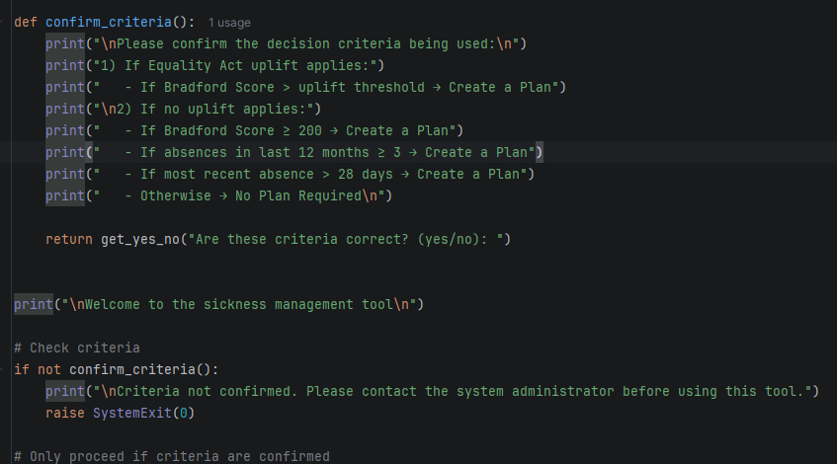
The following screenshot is an output which shows the program running the new code. The main point of feedback received was that there were concerns around the validity of the criteria being used in the program. By clearly displaying the criteria being used and prompting the user to validate it this removes the issue of invalid data sources being to provide outcomes.
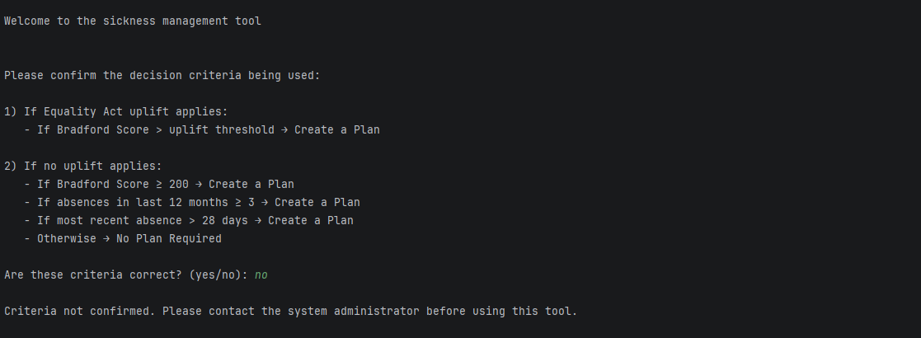
As displayed above, if there is an issue with criteria being used the user is prompted to contact the administrator and does not allow them to use the program as this would produce false outcomes.

The following screenshots display the outputs from user testing. User testing provides valuable feedback which is critical in the development and improvement cycle. This compliments agile methodology and forms part of sprint cycles. [1] [2]

Below screenshot displays the program providing a correct output when no triggers are hit.
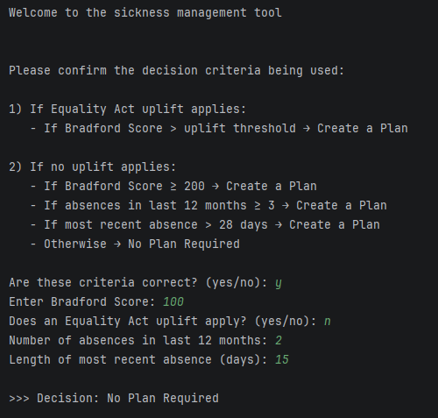
The output below displays the decision when the Bradford score only trigger is hit and the equality act doesn’t apply.
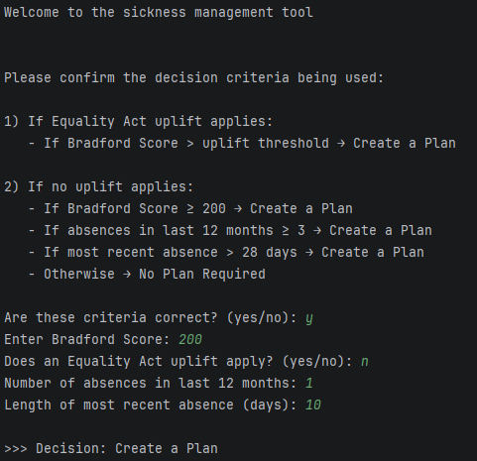
Finally, the below screenshot displays the difference in the output when the same criteria as above is input by the user but an uplift under the equality act applies. The output is different which is a correct decision based on the policy.
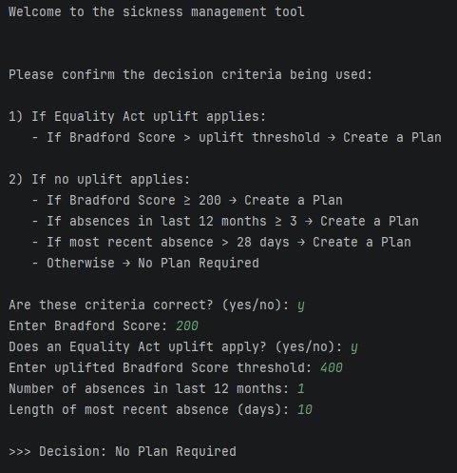

Troubleshooting
Through testing, it was identified in the first iteration of the program that data validation was required to stop users inputting data that would produce incorrect outputs. As an example, negative numbers are not possible in the Bradford Score however the program allowed users to enter them based on the code displayed below:
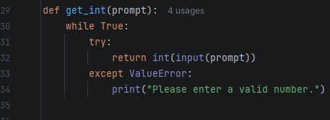
Some minor alterations were made to enhance the validation of this data as displayed in the following code:
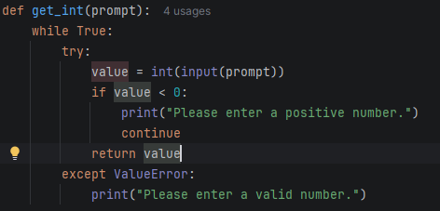

2 – Enterprise and Innovation

Innovation
As the program is initially designed for use within a policing environment, there are a number of pre-determined constraints and requirements for use of third party software.
The program is developed on PyCharm using the Python programming language. This programming language is commonly used by data engineers in the target organisation and is also used widely for programming. This will allow for IT professionals to understand and tailor the program to their needs if required. The Agile methodology is used to assist with the development of the program. The initial Proof of Concept program was released to the user for testing which allowed for users to pilot the program and provide feedback for enhancements.

The program would be launched as an internal web application which would be accessible as part of the overall sickness management system. The organisation currently uses a large variety of Microsoft solutions and on this basis, the use of MS Intune would be the platform for deployment of the software. This has been selected due to the benefits associated with deploying/managing software in the organisation. The organisation has hundreds of users across a large geographical area and includes home workers. One of the main benefits is that program can be rolled out remotely to all users.
Moving into the maintenance phase, Intune will also support the ongoing remote support of the system, inclusive of updates and troubleshooting. There is also the option of limiting the program to only be used by supervisory positions based on their grouping.

If the program is successful there is scope to expand it to cover more aspects of the sickness management process. This could include providing advice on how to manage specific absences such as psychological, musculoskeletal etc. In addition, there is the possibility of incorporating AI into the program which may further improve the UI. This would required stringent testing owing to the constraints of using AI policing.

PESTLE analysis
PESTLE Analysis of Microsoft
P – Political Factors
- Microsoft operates in over 190 countries globally and therefore has a wide variety of political factors to consider when operating. [1] As a United States owned company, political tension between the US and other countries such as China inevitably has a significant impact. Taiwan produces the majority of high-end computer chips globally and therefore China/Taiwan and US relations are likely to be impactive on MS capability. [2]
- MS has been subject to global mistrust issues and changing political landscape, such as the Trump-Vance administration, will influence the organisation. The Federal Trade Commission, under Trump-Vance, began investigating MS cloud and AI operations in 2024. A US company being investigated by it’s own country will likely be monitored closely by other countries and be impactive. [3]
E – Economic Factors
- Tariffs imposed on countries such as China will impact production costs to Microsoft.
- Exchange-rate fluctuations can impact revenue because a substantial proportion of Microsoft's sales are generated outside the United States. [4]
S – Social Factors
- Growing demand for remote/hybrid work and collaboration tools supports adoption of Microsoft products such as Teams.
- Public concerns about data privacy, misinformation, cybersecurity, and job displacement caused by AI may affect consumer trust and product adoption. [5]
T – Technological Factors
- Rapid advancements in AI, cloud computing and cybersecurity create both opportunities and competitive pressures. [6]
- Cybersecurity remains a critical priority, reflected in Microsoft's Secure Future Initiative and ongoing investments in security technologies. [6]
L – Legal Factors
- Microsoft must comply with data protection regulation, competition law, cybersecurity, consumer rights, and AI governance.
- MS faces risks associated with antitrust allegations, monopolisation and AI product deployment. [5] [3]
E – Environmental Factors
- There is an increasing pressure for companies to have initiatives to reduce their carbon footprint. By 2030, Microsoft aims to becoming carbon negative and achieve zero waste. [7]

3 – Project reflection

Practical feedback
Further feedback was gained following the adjustments to the program. While there were less responses on this occasion the feedback gained was generally positive. The responses are available in Appendix B.
All respondents stated they felt a web based platform would be a suitable solution. This will require further development but is achievable.
In addition, there was a generally positive feeling towards the efficacy of the program and how it would achieve the project aim.
Respondents did commonly identify that the User interface (UI) could be improved which would improve the User experience (UX). This is an area that will require additional work. A review of 20 peer-reviewed studies show that a well designed UI greatly increases the UX and these are both significant factors in software success. [8]

Progress diary
Throughout the lifecycle of the project, progress sheets have been used to monitor progress and set actions. This is a useful audit system to identify where actions have been identified and completed or rolled on to the following week. The progress reports worked well in identifying that bugs in the system would need be resolved and allowed focus to be made on resolving these issues. While the UI issues were identified there was insufficient time to resolve these issues. This was then further highlighted through the feedback forms as an area where stakeholders felt the program was lacking. This could have been resolved at an earlier stage which would have likely improved the overall customer feedback. Progress sheets are available in appendix C.

Skills
A number of skills have been developed during the lifespan of this project. Hard skills such as the use of a Gantt chart proved invaluable in managing various aspects of the development. The ability to visualise, track progress and understand the potential impact on timelines is a skill that will be useful in future project management. Learning how to use MS forms has been useful in providing the skills to obtain feedback in an electronic format. It allows the capture of both quantitative and qualitative data and is an easy, quick way of obtaining valuable feedback.
Understanding the benefits and drawbacks of various project management methodologies, such as Waterfall and Agile, allowed for the most appropriate use of methodology in successfully managing the project. Having an understanding of these techniques will allow for future projects to managed using a methodology which is suitable for the project and will likely improve success and customer satisfaction.
Further development of soft skills has been undertaking during this project. The ability to communicate verbally and via written correspondence with peers and stakeholders will not only improve the confidence of the project manager but in turn will enhance customer confidence in managing projects in future.

Positive social impact
While the project aim is to improve overall sickness management for the organisation there are inherently positive social impacts as a biproduct. By enhancing the support provided to employees overall health and wellbeing is more likely to improve owing to earlier managerial intervention. This not only improves the employee health and wellbeing but will also assist with keeping people in work. As the project is initially designed to rolled out in the police service, having employees in the workplace with suitable support, more often will contribute to more effective running of public services, especially when this is considered for the impact on operational, front line policing.

4 – Conclusion
The development of the sickness management tool has provided opportunity for a number of both hard and soft skills to be learnt. While the implementation of the tool may not be a realistic option in it’s current state, valuable learning has been gained in obtaining feedback, critical analysis, problem solving and stakeholder engagement. The project demonstrates that innovation, creativity and forward thinking can provide opportunities for solutions to problems. In addition, while all projects may not be successful, it can highlight that there is an appetite to resolve issues which may lead to further interest to explore other opportunities.

5- References

[1] | S. Firmenich, A. Garrido, J. Grigera, J. M. Rivero and G. Rossi, “Usability improvement through A/B testing and refactoring,” Software Quality Journal, vol. 27, pp. 203-240, 2019.
[2] | F. Salman, B. Baluch and Z. A. Bakar, “A model for classificaiton usability testing practically from the Agile methodology aspect,” Society of Visual Informatics; JOIV : international journal on informatics visualization , vol. 9, pp. 81-89, 2025.
[3] | M. Copilot, Private Communication, 2026.
[4] | J. Kochumon and J. C.A, “Taiwan’s Silicon Shield Balancer in the Taiwan-US-China Triangularity,” vol. 43, pp. 23-36, 2026.
[5] | D. Ullman, “Microsoft Faces Renewed Antitrust Scrutiny Amid Changing Political Winds,” SAMexpert, 22 03 2025. [Online]. Available: https://samexpert.com/microsoft-antitrust-pressure/. [Accessed 28 07 2026].
[6] | Bullfincher, 2025. [Online]. Available: https://bullfincher.io/companies/microsoft-corporation/revenue-by-geography. [Accessed 28 07 2026].
[7] | “US FTC ramps up scrutiny of Microsoft over AI, cloud practices, questions rivals, Bloomberg reports,” Reuters, 13 02 2026. [Online]. Available: https://www.reuters.com/legal/litigation/us-ftc-ramps-up-scrutiny-microsoft-over-ai-cloud-practices-questions-rivals-2026-02-13/. [Accessed 28 07 2026].
[8] | S. Nadella, “MS Annual Report,” Microsoft, 2024.
[9] | M. Nakagawa, “MS Environmental Sustainability Report,” Microsoft, 2026.
[10] | M. O. A. M. K. S. J. C. M. R. D. G. Olimverio, “User Interface and User Experience Design on Software Usability: A Literature Review,” in Innovations in information and decision sciences, 2026, pp. 246-256.

6 – Appendix

Appendix A
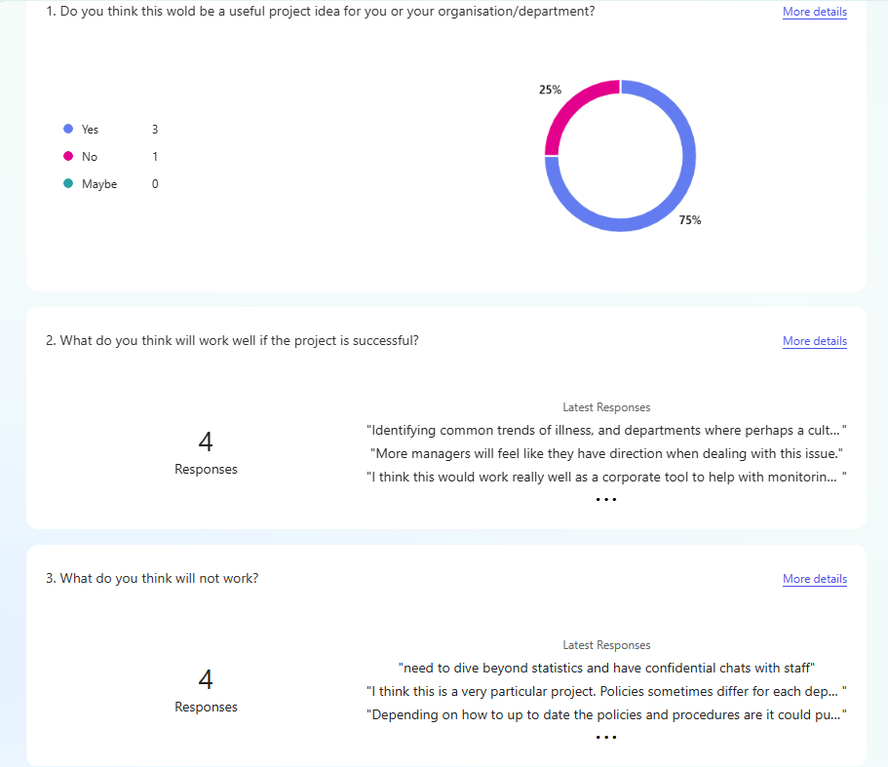
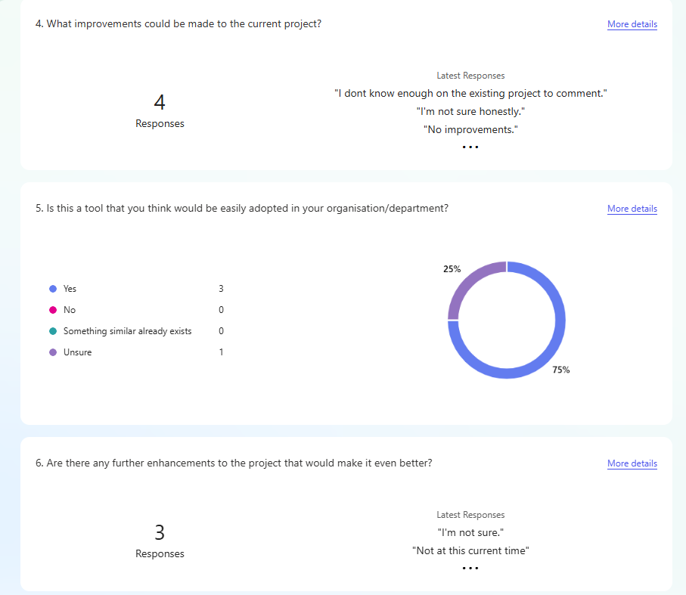

Appendix B

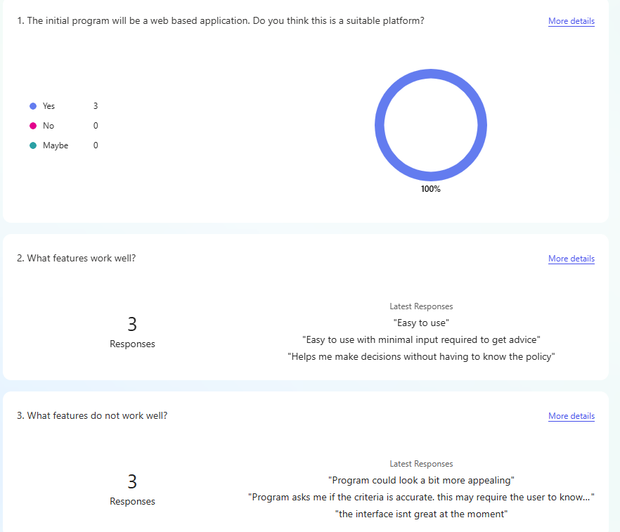
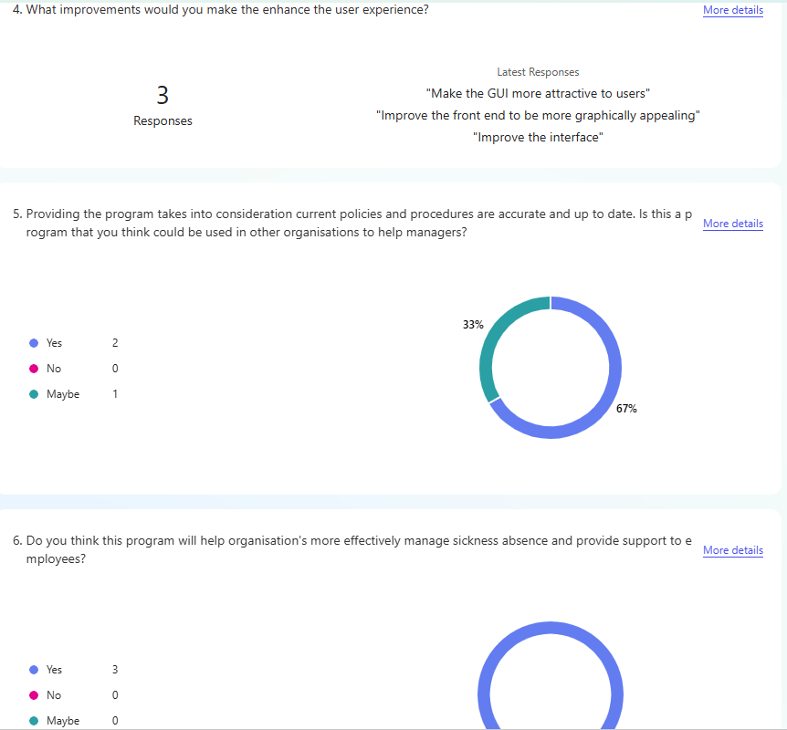

Appendix C


