

Abstract
Group Project Portfolio
Ordnance Munitions and Explosives Apprenticeship (HNC L4) ACDA5022
Ashley Pidgeon
This Portfolio Report shows the research and design process in the creation of a firework display by the AWE Home Team. It shows how the team created a 3-minute firework display with a theme that represented OME, the university (UWTSD) and education with the fireworks being fired from the quayside near the IQ building to an audience in the IQ campus. The display would come within the £10000 budget and complied with all legal limitations and regulations for safety and logistics as well as all ‘Fall-Out’ (airborne display debris) being assessed, and any associated safety issues addressed. Environmental effects were considered and documented including such things but not limited to disposal, site contamination and air pollution.
Table of Contents
Abstract 0
Table of Figures 3
1.1 Introduction 4
1.2 The Brief 4
2.1 The Teams 4
2.2 Team Roles 4
2.2 Team Meeting 1 5
3.1 What are Fireworks? 5
3.2 Firework Anatomy 6
3.3 Firework Chemistry 7
3.4 UWTSD Colours 7
4.1 Team Meeting 2 8
5.1 Systems Engineering 9
5.2 Stakeholder Influence Map 9
5.3 Left Shifting 10
5.4 Holistic Requirements Model 10
6.1 Types of Fireworks and Firework Effects 11
6.2 Firework Categories 14
6.3 Environmental Impact 15
6.4 Alternates to Traditional Fireworks 15
7.1 Team Meetings 3 to 6 16
8.1 Risk Assessment 17
8.2 Trials 18
8.3 ShellCalc 18
8.4 Site Layout 19
8.5 Contingency and Emergency Plans 21
9.1 The Display Simulation 22
9.2 Firework Display Purchase Order 24
9.3 Display Layout and Equipment 25
9.4 Transport 25
9.5 Storage 26
9.6 Misfire/Dud Procedure 27
10.1 Conclusions and Observations 27
11.1 Appendix 28
31
12.1 References 33

Table of Figures
Figure 1 Assignment of Roles to Team Members 9
Figure 2 Group Focused Tasks 9
Figure 3 Anatomy of a Firework 10
Figure 4 Firework Chemistry 11
Figure 5 UWTSD Crest 11
Figure 6 Minutes from Second Team Meeting 12
Figure 7 Stakeholder Influence Map 13
Figure 8 Stakeholder Groups 14
Figure 9 Holistic Requirements Model 15
Figure 10 ADR Firework Type Definitions 17
Figure 11 Firework Effects 18
Figure 12 Category 4 Fireworks 18
Figure 13 The Forever Dog Poster 20
Figure 14 Firework Risk Assessment 21
Figure 15 Regulation 6 of The Explosive Regulations 2014 21
Figure 16 Height Trial 22
Figure 17 ShellCalc 22
Figure 18 Display Site A 23
Figure 19 Display Site Layout 23
Figure 20 Site B 24
Figure 21 Site C 24
Figure 22 Contingency and Emergency Plans 25
Figure 23 Information for local residents and businesses 26
Figure 24 Blue and Yellow Fountains 27
Figure 25 Blue and Yellow Atom Shells with Ring Effect 27
Figure 26 Yellow Shells 27
Figure 27 Heart Shell with Ring Effect 28
Figure 28 Yellow Comets and Mines 28
Figure 29 Firework Purchase Order 28
Figure 30 Firing Site Layout 29
Figure 31 Quick Match and Cobra Module 29
Figure 32 ADR 2023 UN Groups 30
Figure 33 Section 5.4.1.2.1 and 7.5.5.2.1 of ADR2023 30
Figure 34 Clean Up Operation List 31
Figure 35 Environmental Impact Assessment 32
Figure 36 Team Meeting 3 33
Figure 37 Team Meeting 4 34
Figure 38 Team Meeting 5 35
Figure 39 Team Meeting 6 36

1.1 Introduction
For this portfolio report a task was set to apply a systematic understanding of the scientific principles behind Ordnance Munitions and Explosives (OME) design and to critically analyse and select appropriate OME to produce a given effect, in this instance fireworks. The cohort was split into small design teams to engage in the solving of the design task.

1.2 The Brief
The brief of the design task was to create a centrepiece firework display for the graduation of the first OME Level 4 Apprentices. The parameters of the task being:
- The display theme needed to represent OME, the university and education.
- The fireworks were to be fired from the quayside near the IQ building.
- The audience to be in and around the IQ campus.
- A duration of at least 30 seconds was required (excluding any time to effect) though up to two minutes was desirable.
- The materials budget for the fireworks display was £2000 per minute of the display or a maximum of £10000 total.
- The display shall not break any legal limitations/regulations.
- ‘Fall-Out’ (airborne display debris) should be assessed and any associated safety issues addressed.
- Logistics and safety plans would be required.
- Environmental effects were to be considered and documented including such things but not limited to disposal, site contamination and air pollution.

The teams were instructed to consider the design of the desired effects, any synchronisation to music, the effects criticality to safety as well as the criticality to function elements. The task should not be limited to the display alone but include transportation, display set up, initiation of the fireworks and display and the clean-up and disposal action after the performance.

2.1 The Teams
As previously mentioned, the cohort was split into teams, these being AWE Home Team, AWE France + QinetiQ and DSTL, the author’s team being AWE Home Team. Once the cohort had been split into teams, the AWE Home Team decided to set up periodical meetings to discuss the individual contributions and progress that they had made. The minutes of these meetings can be seen in Appendix.

2.2 Team Roles
During the brief for this task, it was suggested that the team should agree on defined roles for the individuals of the team so as to be able to demonstrate the individual contributions. Examples of these roles are given below:
- Research & Development / Design
- Test and Evaluation
- Safety
- Manufacturing
- Breakdown and Disposal (Including waste disposal.)

2.2 Team Meeting 1
In the first of the team meetings, the first action was decided to be to allocate the team members their roles and areas to focus on going forward, this can be seen in the slide in the meeting minutes in Figure 1. The role assigned to the author was that of Logistics (Storage and Transport) and will be the main focus of this report.
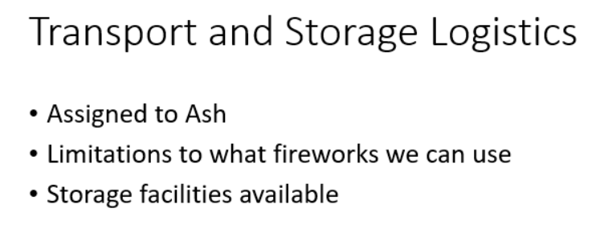
Figure 1 Assignment of Roles to Team Members
Due to the fact that there only being four members of the AWE Home Team, it was decided that at this stage the individual roles were to be broken down into the following:
- Systems Engineering/Research
- Test, Evaluation and Advertisement
- Safety
- Logistics (Storage and Transport)

Manufacture was not considered as a role as the fireworks being used were to be off the shelf, professional use fireworks and the development of new fireworks was not required. Design would be undertaken by the team as a whole.
Figure 2 again taken from the first team meeting minutes, shows the suggested items of focus for the group to be looked at before the next team meeting.
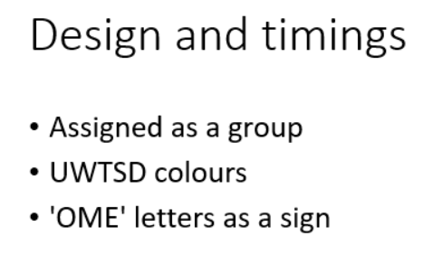
Figure 2 Group Focused Tasks

3.1 What are Fireworks?
Fireworks are regulated in the United Kingdom by regulations including, but not limited to, ADR 2023 [1], Explosive Regulations 2014 [2], and The Pyrotechnic Articles (Safety) Regulations 2010 [3].
The Explosive Regulations 2014 and ADR 2023 describe fireworks as “the explosive articles assigned in accordance with the United Nations Recommendations any of the U.N. nos. 0333 to 0337” [1] [2] and The Pyrotechnic Articles (Safety) Regulations describes fireworks as “a pyrotechnic article intended for entertainment purposes” [3].
These descriptions allowed for a better understanding of the requirements for the display going into the design phase. These regulations also guided the author into focusing on the rules for transportation and storage of the fireworks for the display as well as allowing for direction of which fireworks to use as well as the importance of entertainment to crowd.

3.2 Firework Anatomy
Although firework manufacture is not a role that was considered by the team, it is important to understand how fireworks work, their anatomy and how this effects the design.
When looking at the anatomy of fireworks, they can be broken down into the component parts seen in Figure 3 [4].
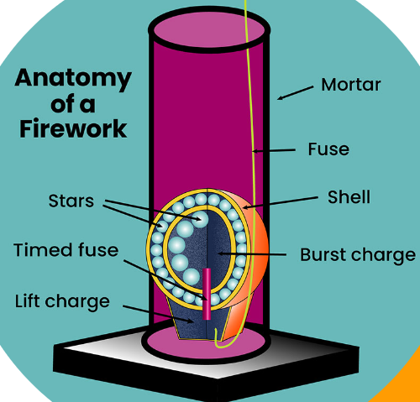
Figure 3 Anatomy of a Firework
- The Mortar is normally a cylindrical tube that holds the shell until it is launched.
- The Shell often comes in the form of a paper sphere with two halves packed with stars designed to produce the desired effect in the sky. The bottom of the shell contains a lift charge that launches the shell from the mortar.
- The fuse is used to ignite the lift charge.
- The Lift Charge, usually made from black powder is ignited to launch the shell out of the mortar into the sky.
- The Timed fuse activates the burst charge within the firework.
- The Burst charge is located at the centre of the shell and ignites the stars within the firework.
- Stars are small pellets made of chemicals, such as powdered metal salts. When ignited, they create the firework’s desired sound and light effects.

3.3 Firework Chemistry
To create the colours, lights, and sound for fireworks the small pellets or stars made of chemicals such as powdered metal salts are burnt. Containing the gas created by these burning chemicals creates the distinctive sound of fireworks. Collision explains out that “The various colours we see arise from various colour producing chemicals for example inorganic salts such as copper chloride for blue, strontium chloride for red, barium chloride for green and sodium chloride for orange” [5]. This is further explained in Figure 4.
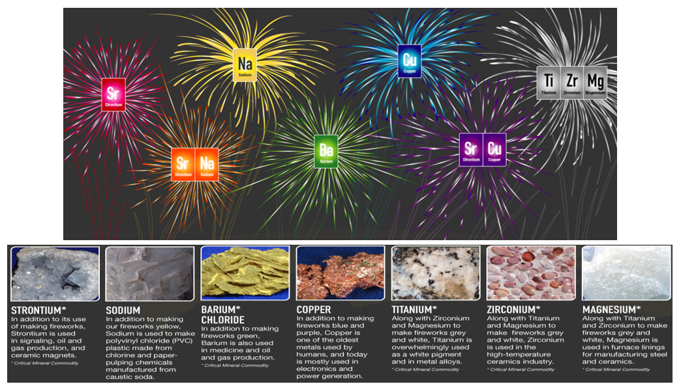Figure 4 Firework Chemistry

3.4 UWTSD Colours
From Figure 5 it can be seen that the colours of the UWTSD crest are yellow, blue, and black. This pushed the team to look at fireworks containing these colours and how the increase in Sodium (yellow) and Copper(blue) would affect the cost of the display and the effect on the environment. Lanceworks where also considered to create a sign spelling out “UWTSD”.
Figure 5 UWTSD Crest

4.1 Team Meeting 2
Figure 6 below, shows the minutes from the second team meeting:
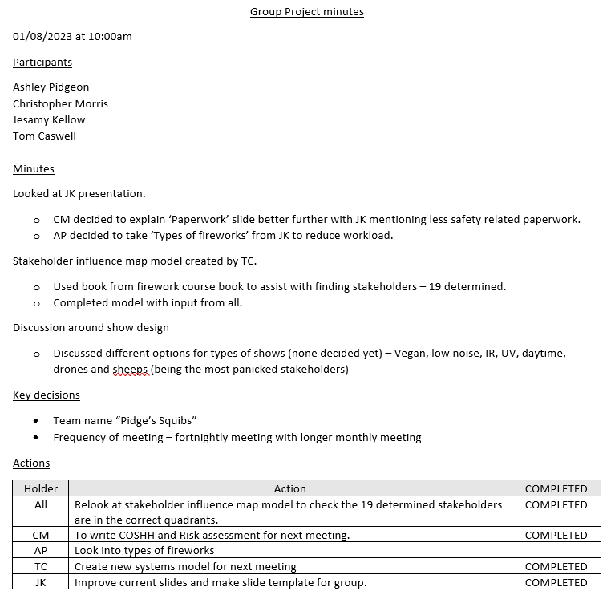Figure 6 Minutes from Second Team Meeting
One of the key points from this meeting was the decision for the author to take on the task of researching “Types of Fireworks” to ease the workload on other members of the team. The key decisions were to consider changing the team’s name to “Pidge’s Squibs” and to increase the frequency of the meetings to fortnightly.
The discussion about display design in this meeting mainly focussed on the point in the brief that stated that the environmental effects were to be considered and documented including such things but not limited to disposal, site contamination and air pollution. The course of the discussion went towards the possibility of using vegan fireworks, low noise fireworks, daytime fireworks including drones, the use of infrared and ultraviolet light and the effect firework displays have on animals.

5.1 Systems Engineering
To aid in the decision-making process the use of systems engineering tools were deployed to show where the focus should be for the display. The first tool used was a stakeholders influence map and reiterating the importance of left shifting.

5.2 Stakeholder Influence Map
A stakeholder influence map is described in an article by Tristancho as “a visual process charting each of the stakeholders for your project, product, or anything with stakeholders to show who can influence the work you’ll be doing. Stakeholders can be your client, project owner or even end-users and are anyone who has a vested interest in the project. Using a stakeholder map allows a project manager to understand how each stakeholder is involved with the project and, therefore, how to respond to them” [6].
The team decided to use a stakeholder influence map to help answer the questions of why and how? Each stakeholder effects how the display will be formed and delivered. The areas it will help answer are to form the map are:
Why?
- Identifies where requirements come from.
- Identifies in what way each stakeholder needs to be engaged with.
- Who can be mostly ignored and who can be focused on.
How?
- Identify any groups who are influential or impacted by the fireworks display.
- Score them based on level influence or the extent to which they can persuade others in decision making.
- Score them based on impact of change or the ability to bring a change or result to the event.

The team used this information to form the stakeholder influence map in Figure 7 below:
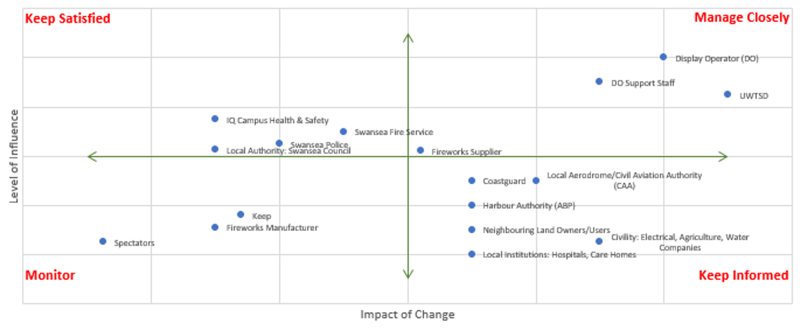Figure 7 Stakeholder Influence Map

From this it allowed the stakeholders to be grouped into Mange Closely, Keep Satisfied, Keep Informed, Monitor and Ignore, of which can be seen in Figure 8.
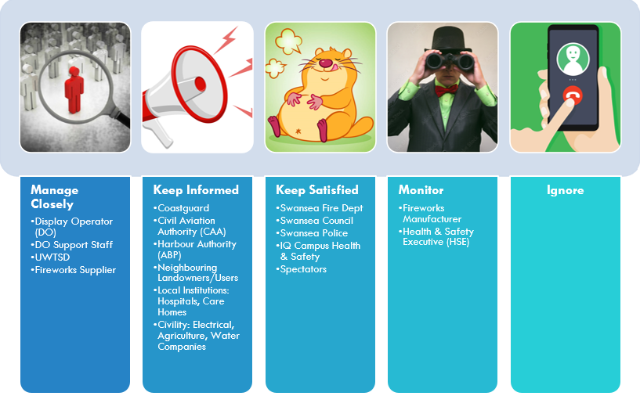Figure 8 Stakeholder Groups
Although it was initially concluded that the spectators could be ignored as they have little input it how the display acts out, it was decided that moving the spectators to “Keep Satisfied” as one of the main focuses of the fireworks display is entertainment. By utilising left shifting and reviewing the groups decisions, it allowed for more clarity in focus for the display.

5.3 Left Shifting
In systems engineering, left shifting is described in a paper by Emes, Smith and James as “during the design stages and early production stages momentum builds until effort reaches a peak, the concept of shifting the effort profile in a project so that the peak occurs earlier than would otherwise have been the case and so shifting left” [7]. Going through to the design and delivery of the display, employing left shifting, is key in saving effort, time, and money.

5.4 Holistic Requirements Model
The next systems engineering tool that the team used was Holistic Requirements Model which is described in a report by Burge as “a systems approach to the classification of system requirements and it provides a consistent analysis framework that can be used when interpreting, clarifying and deducing system requirements from a set of customer/stakeholder requirements. The Holistic Requirements Model is so-called because it provides a complete and consistent model for classifying and organizing any set of requirements of a system. Furthermore, it is only truly understandable as a whole, and isolated consideration of the component requirement types is ephemeral.” [8].
The model comprises three basic requirement types:
- Operational
- Functional
- Non-Functional

With a further sub-classification of the Non-Functional Requirements set:
- Non-Functional Performance
- Non-Functional System
- Non-Functional Implementations
Using this information, the team created the model seen in Figure 9.
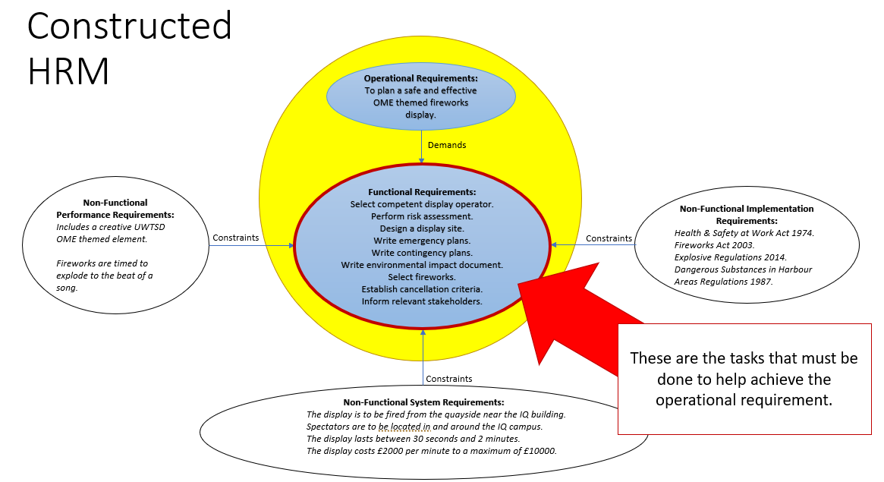Figure 9 Holistic Requirements Model
From this model, it guided the team on the next actions to take to accomplish a successful fireworks display.
6.1 Types of Fireworks and Firework Effects
The author was required by the team to explore the different types of fireworks and the different effects that fireworks generate. Understanding these different types and effects allowed for the team to decide which fireworks to use in the display.
Firework types are described in many ways from multiple sources such as ADR 2023 [1], and commercial firework distributers such as Jake’s Fireworks [9]. Fireworks can be broken down into two groups, aerial “Any firework item that shoot flaming balls into the air, such as a cake or mortar” [9] and static “Or ground items are any item that is lit on the ground and does not shoot objects into the sky such as fountains or Catherine wheels” [9].
The static fireworks considered by the team were:
- Catherine Wheels
“A wheel is a stationary device that spins and creates a circular ring of fire and sparks.” [9]
- Fountains
“A ground device that emits showers of sparks several feet in the air.” [9]
- Waterfalls
- Lanceworks

And the aerial fireworks considered were:
- Cakes and Barrages
“Sometimes referred to as "repeaters" or "multi-shot batteries", a cake is an item that has a single fuse which fire a collection of single shot devices sequentially. Cakes can have a variety of intricate aerial effects, including spinners, fish, flower bouquets, comets, crossettes, and other elements.” [9]
- Comets
“A type of star that leaves a trail of sparks as it flies through the air”. [9]
- Mines
“An aerial device that shoot stars into the sky in an upward spray pattern.” [9]
- Shells
“A shell is an aerial item that is fired into the sky. It generally consists of a fuse, a lift bag, and a paper ball filled with stars and burst media. The fuse lights the lift bag on the bottom of the shell propelling it into the sky. At the same time, an internal time fuse is triggered and at the right time the paper shell bursts with all of its stars lit. The type of stars contained inside the shell determines the effect the shell produces in the sky.” [9]
- Roman Candles
“A paper tube filled with composition that shoots flaming balls out one end of the tube. Most roman candles have five or more balls.” [9]
- Rockets
“A rocket is a tube-like pyrotechnic device made out of a paper tube that propels itself into the air in order to fly. There are many different kinds of rockets, including skyrockets, bottle rockets, and missiles.” [9]

Further descriptions were gained from the Explosive Regulations 2014 [2]:
Catherine Wheel
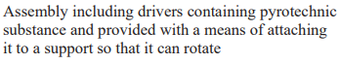
Mines
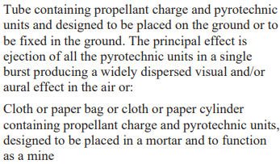
Rockets
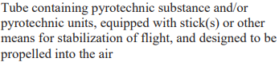
Roman Candle
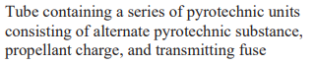
Shell
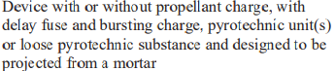
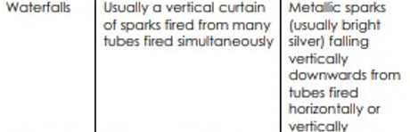
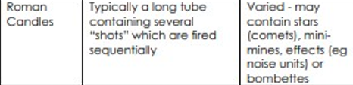
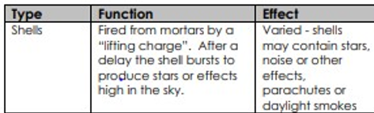
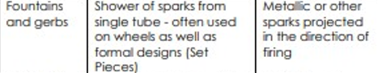
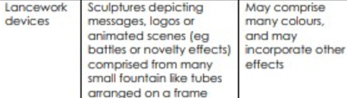
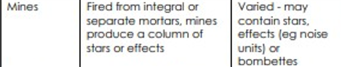
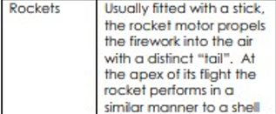
And ADR2023 [1] provides more descriptions as seen in Figure 10:
Figure 10 ADR Firework Type Definitions
Figure 11 shows the effects different fireworks can make:
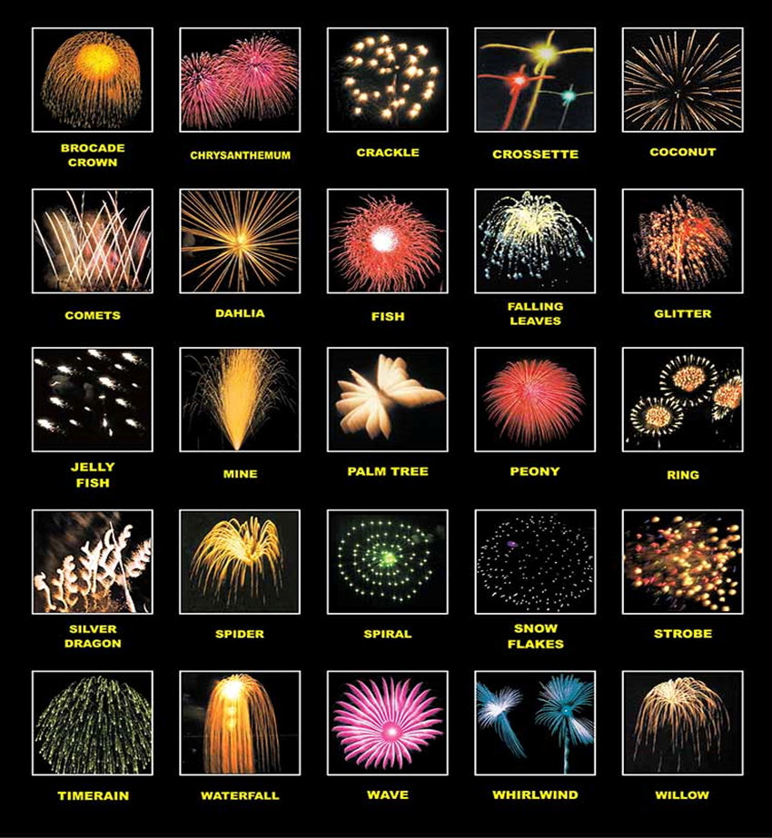Figure 11 Firework Effects
The team considered using multiply effects but chose not to use Waterfalls as they require extra precautions that were unaffordable for the display. This was also the reason for not using Lanceworks.

6.2 Firework Categories
The Pyrotechnic (Safety) Regulations 2010 puts fireworks in to four categories. Categories 1 to 3 covers fireworks that present a lower risk and are commercially available to the public at certain times of the year. Category 4 fireworks are stated as “Only to be used by persons with specialist knowledge.” [3]
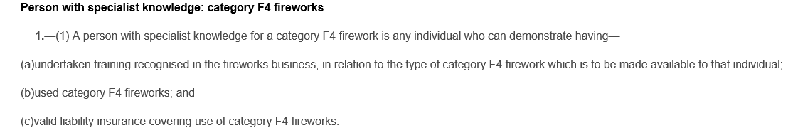
Figure 12 Category 4 Fireworks
The team is deemed to be a professional company with suitable training, experience, and insurance.

6.3 Environmental Impact
The team conducted an Environmental Impact Assessment to address the concerns of chemicals, noise pollution and issues arising from the fallout. This assessment can be seen in Figure 35 and is summarised as :
- Low amounts of combustible products released into the environment.
- Hazardous post combustible products dispersed over a wide area and not concentrated.
- Detectable amounts of perchlorate in the environment from studies show that the levels are not high enough to pose a concern to environmental or human health.
- This firework display being a one-off occurrence.
- Ensure that the competent Display Officer is competent and operating fireworks according to their instructions.
- That the use of a competent display officer and engaging with Swansea police accordingly will minimise the event of malicious usage of the fireworks.
- A contingency plan will be created in the event of disorder at the event that may lead to malicious usage of the fireworks.
- Notice to all neighbours and local institutions will be given of the event so that pets can be given a chance to isolate from the event if it will be a problem for them.
- Specific mention: The event will not be held near any pig farms due to the higher sensitivity of pigs to loud noises.
These considerations were important to the team going forward in the creation of the firework display process.

6.4 Alternates to Traditional Fireworks
As a consideration to the environment and an attempt to be more socially and ethically responsible the team researched vegan fireworks, low noise fireworks, daytime fireworks including drones, the use of infrared and ultraviolet light and the effect firework displays have on animals. The author chose to focus on the question, can fireworks be vegan?
In articles by Barrs and Halstead it is shown by changing the ingredients in the design of fireworks such as changing stearic acid derived from plants instead of animals allows for vegetarian friendly fireworks. However, due to this fact it can be determined that as well as due to the light and noise of most fireworks, it is incredibly difficult to have vegan fireworks. The reason being that the noise created causes disruption to bee's returning to hives, migrating birds and distress to domestic animals. This is supported by The Vegan Society description of veganism as "including all forms of exploitation of, and cruelty to, animals for food, clothing or any other purpose." [10] [11].
Campaigns such as “The Forever Dogs” have also been formed to ban traditional fireworks, as can be seen in the Poster in Figure 13 [10].
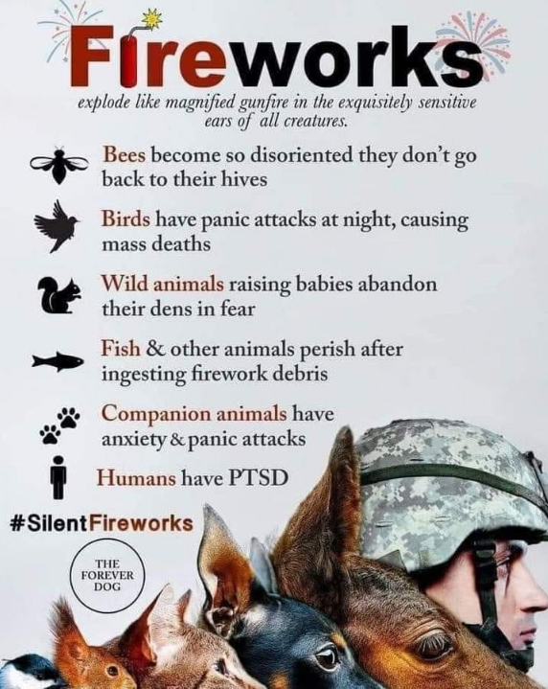
Figure 13 The Forever Dog Poster

7.1 Team Meetings 3 to 6
The next meetings held by the team were conducted regularly and showed the progression of each team member culminating in the creation of the simulation of the team’s firework display and the formation of the team’s presentation. These meetings allowed the team to effectively communicate any problems or issues they were having as well as giving a platform for the collaboration of the team’s ideas. The minutes of the meetings can be seen in Figures 36 to 39 in the Appendix. The team also set questions to ask for a successful display to which all had to be answered yes. These were:
- Can the operator provide evidence of competence?
  - E.g., British Pyrotechnic Association (BPA) qualifications.
- What training and experience does the operator have? Is there any evidence of formal training?
- Does the operator have insurance cover?
- Does the operator agree to observe the safety recommendation in this publication?
- Can the operator provide a list of displays he/she has fired in the past, together with the name of each display organiser?
- Can the organisers of these displays confirm there were no safety problems involving fireworks?
- Is the source of supply of fireworks for the display a reputable company?
- Has the operator asked to see the proposed site, or asked for details of it, before giving a quotation?
- Has the operator taken the initiative in discussing responsibilities?

8.1 Risk Assessment
The next stage in the team’s progression in putting together the fireworks display was to create a risk assessment. The British safety Council states that “Risk assessments are a primary management tool in ensuring the health and safety of everyone. Although many may not be aware that they are a legal requirement.” [12]. As it is a legal requirement, a risk assessment seen in Figure 14 for the firework display was created to take into account, manage, but not limited to, the following hazards:
- Explosives(Fireworks)
- Adverse Weather
- Fire
- Crowd Control
- Security
- Vehicle Movement
- Uneven Ground
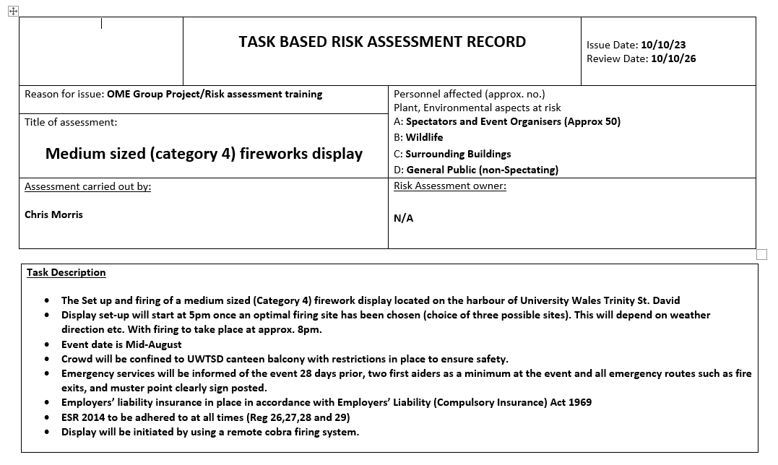
Figure 14 Firework Risk Assessment
Figure 15 shows Regulation 6 of the Explosive Regulations 2014 [2] that reinforces the need to carry out risk assessments.
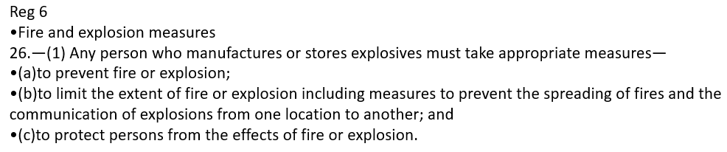
Figure 15 Regulation 6 of The Explosive Regulations 2014

8.2 Trials
The team considered various trials that could be conducted on fireworks to prove the manufactures stated performance, however the test considered most relevant was a height test in a real-world environment. This allowed for accurate data to be used in simulations and better accuracy in display planning. Figure 16 shows how the team set up the height trial to gather data.
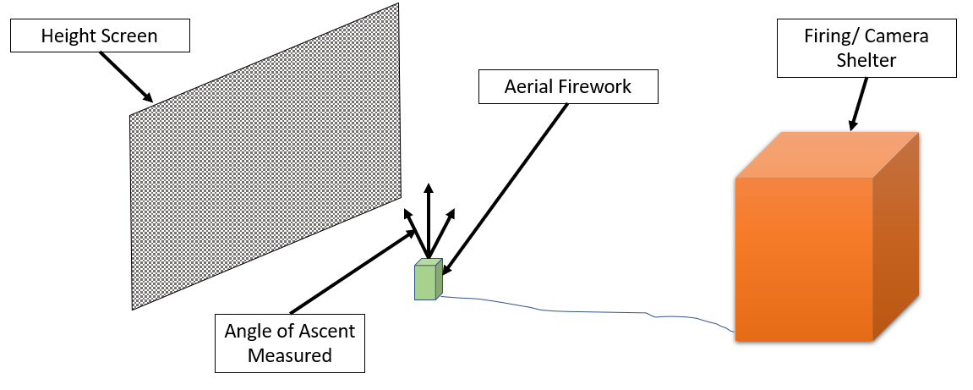
Figure 16 Height Trial

8.3 ShellCalc
The team used the data collected from the height trial to load into a software program called ShellCalc. This software program was used by the team to determine the trajectory of the largest shell used with the average wind speed and direction inputted, which resulted in showing the likely direction of the debris fallout after launch. Figure 17 shows an aerial shot of the desired display site and the results of the ShellCalc simulation with the predicted weather for the day of the display.
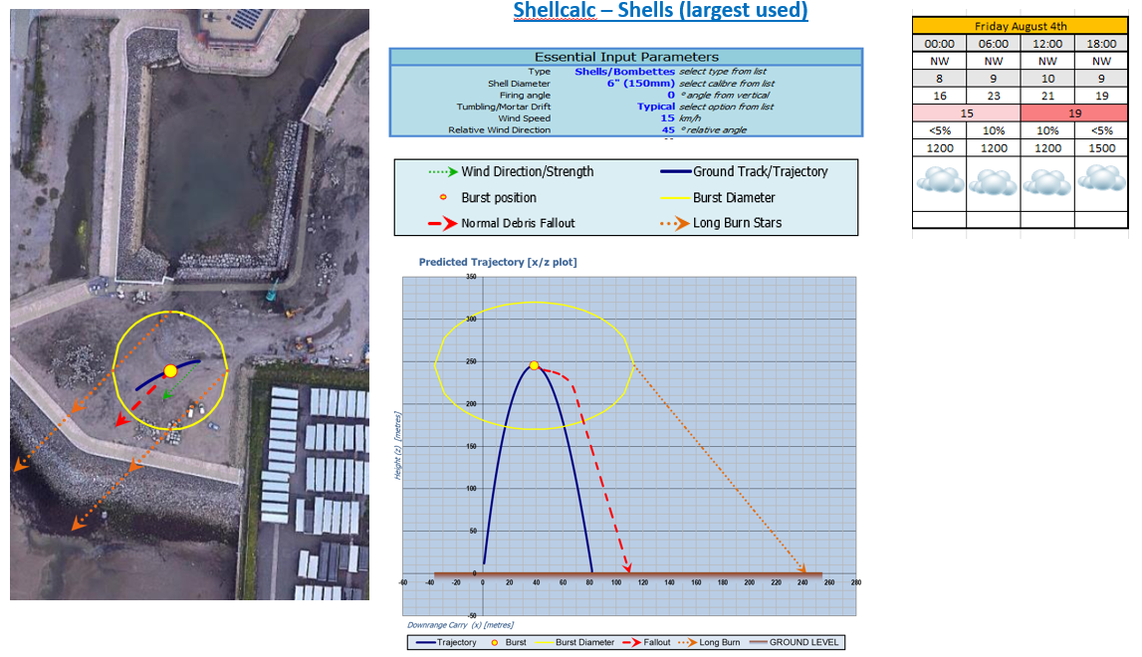
Figure 17 ShellCalc

8.4 Site Layout
With the information gained so far, the team decided on the preferred site for the display, how the site will be laid out and alternative sites if problems arose due to adverse weather conditions. Figure 18 shows the desired site for the fireworks display as it is optimal for spectators.
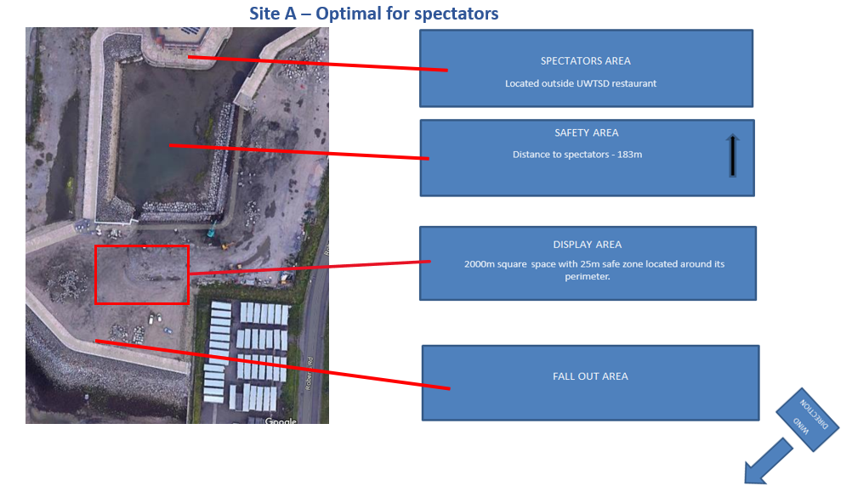
Figure 18 Display Site A
Figure 19 shows the display firing area layout which prioritizes safety for spectators and the team.
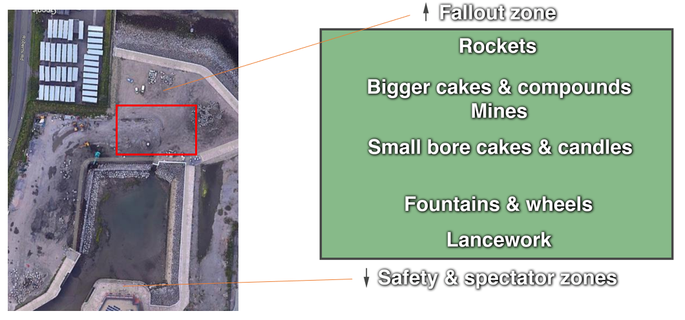
Figure 19 Display Site Layout
The team set criteria that if meet, determined which site would be used. If everything was green and good to go after 17.00 , Site A would be used. If a Northerly wind Site B (Figure 20) would be used and if a wind speed higher than 45 kph were present, Site C (Figure 21) would be used. In both these situations, moving to these sites would have to occur before 17.00.
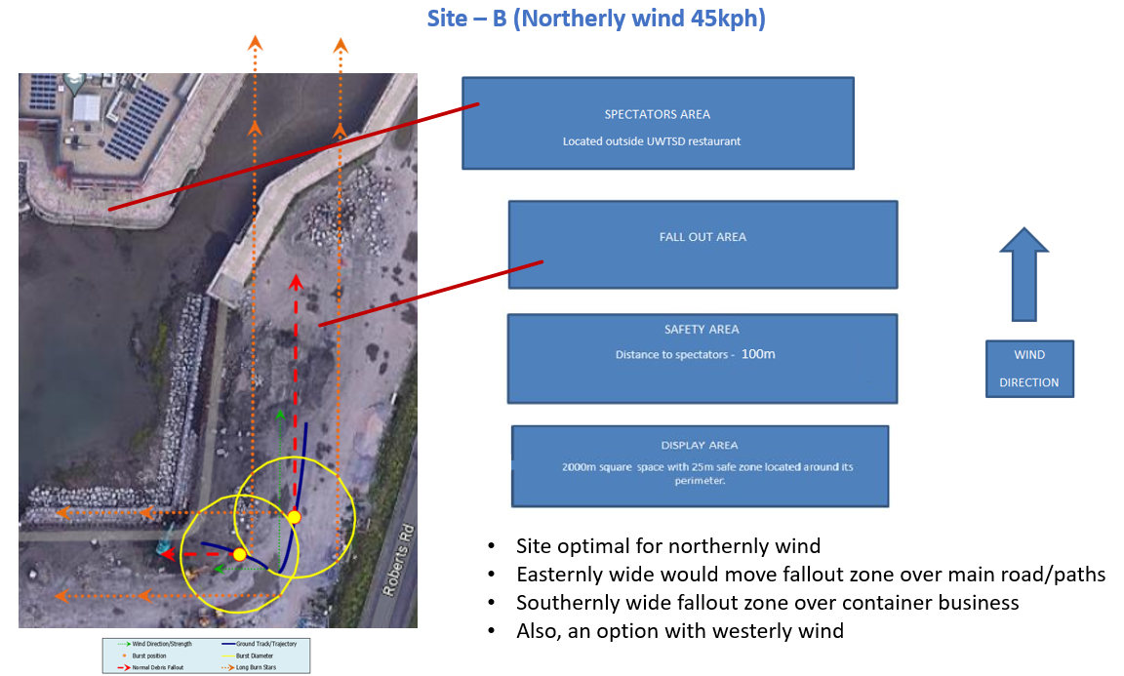
Figure 20 Site B
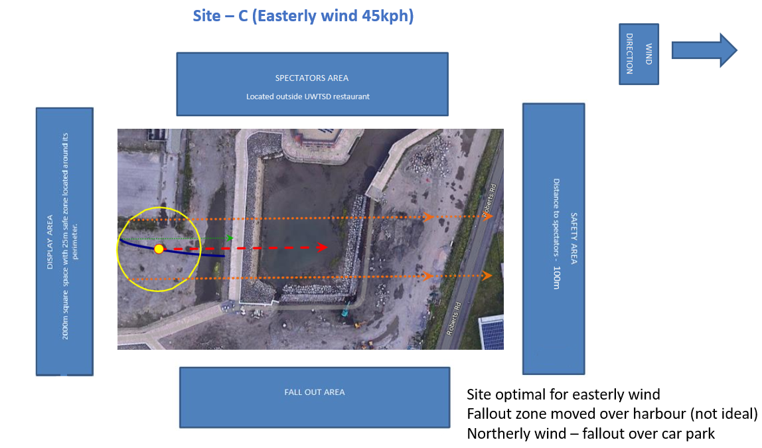
Figure 21 Site C

8.5 Contingency and Emergency Plans
The team created easy to use flow charts for contingency and emergency plans to cover the following scenarios:
- Misfire
- Dud
- Uncontrolled detonation
- Fire
- Fallout Injuries
- Spectators breaking into restricted areas.
- Disorderly behaviour by spectators
Examples can be seen in Figure 22.
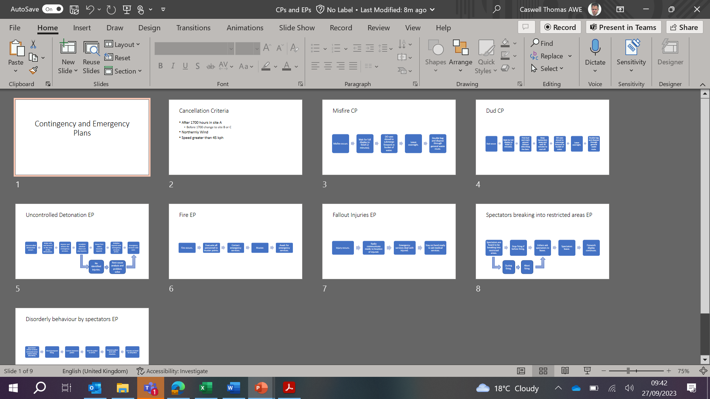
Figure 22 Contingency and Emergency Plans
Along with this local roads needed to be controlled during the event with local residents and businesses informed of our actions (Figure 23). A full case study was also sent to the local council to get an event permit.
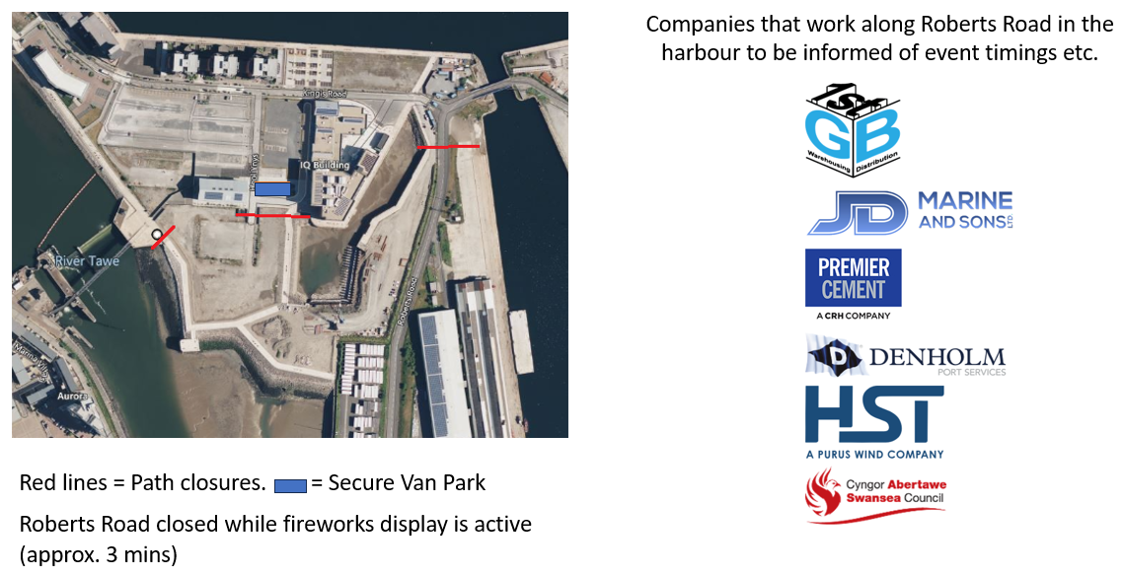
Figure 23 Information for local residents and businesses

9.1 The Display Simulation
The team used the information gathered so far to create the fireworks display, with the intent to keep the cost bellow £10,000 at a duration of 3 minutes. To aid in visualising this, the team used a software program called FWsim. The team also decided to create a pyro-musical display to aid in the entertainment value of the display.
The selection of the music to accompany the display was deliberated thoroughly but the decision was made to link the song’s lyrics and have a tangible link to the theme of OME. This resulted in the team choosing the song “Boom boom boom boom!!” by the Vengaboys [13]. As previously mentioned, the colours of the fireworks used were blue and yellow and special attention was made to the rhythm of the music, to synchronise the beat to when the fireworks burst.
Figures 24 to 28 show examples taken from FWsim of the team’s firework display. Figure 24 shows the teams decision to use the UWTSD colours of yellow and blue. Figure 25 shows the link to AWE as the team choose to use fireworks that produced an effect similar to atoms. Figure 26 shows the yellow shells that synced with every time the word “boom” was sung. Figure 27 shows the teams choice of a heart every time the word “fun” was sung and finally Figure 28 shows the filler comets and mines used in the team’s display.
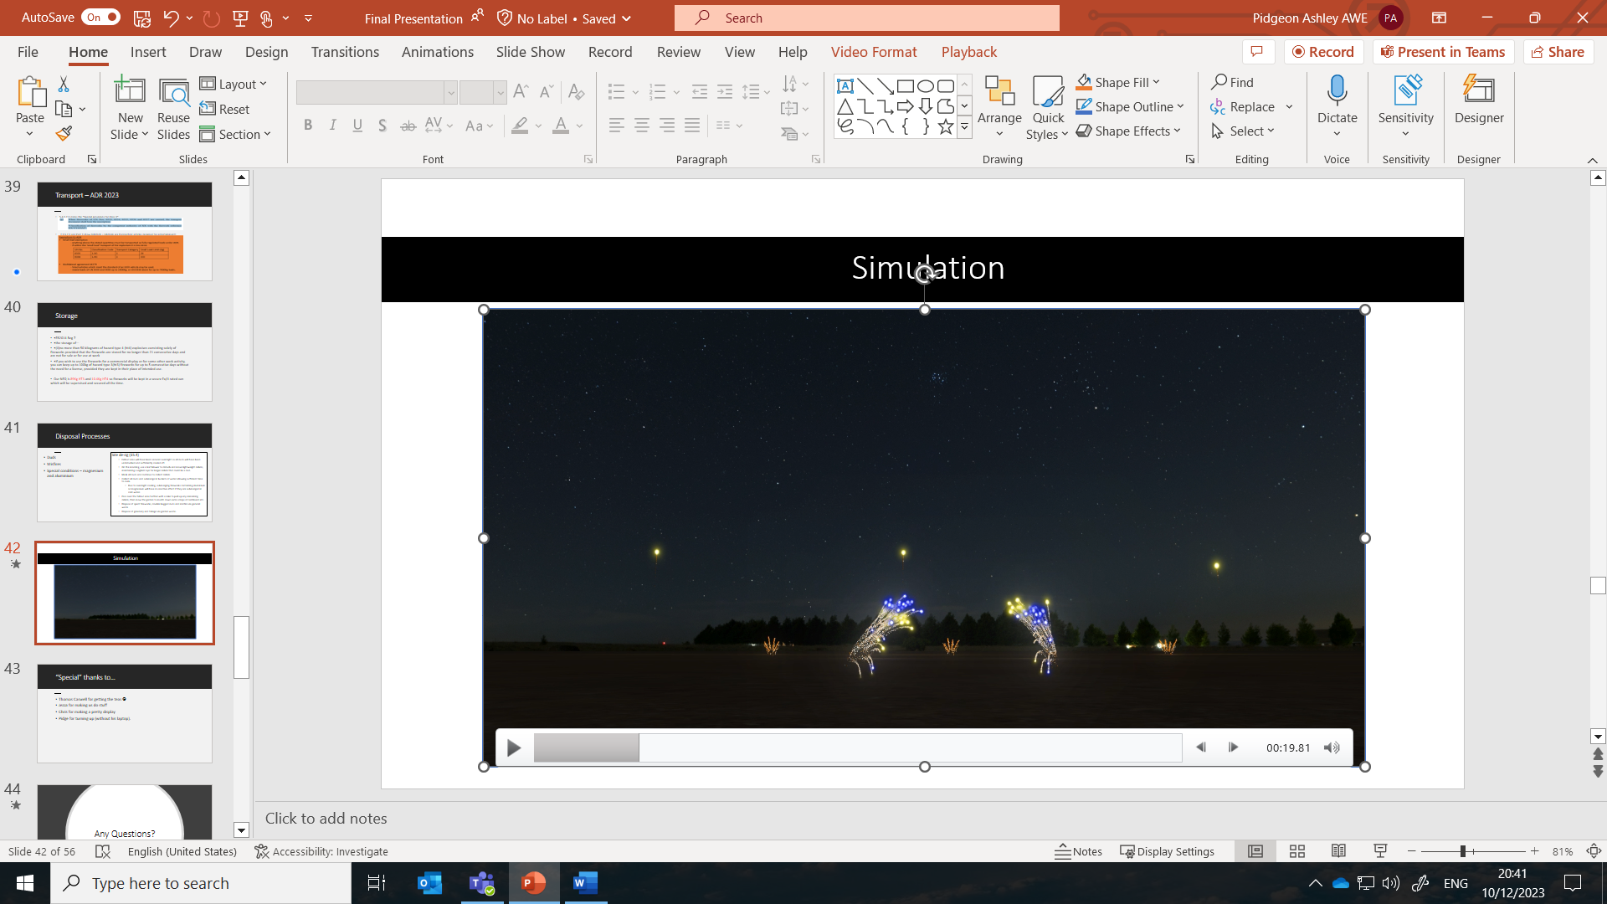
Figure 24 Blue and Yellow Fountains
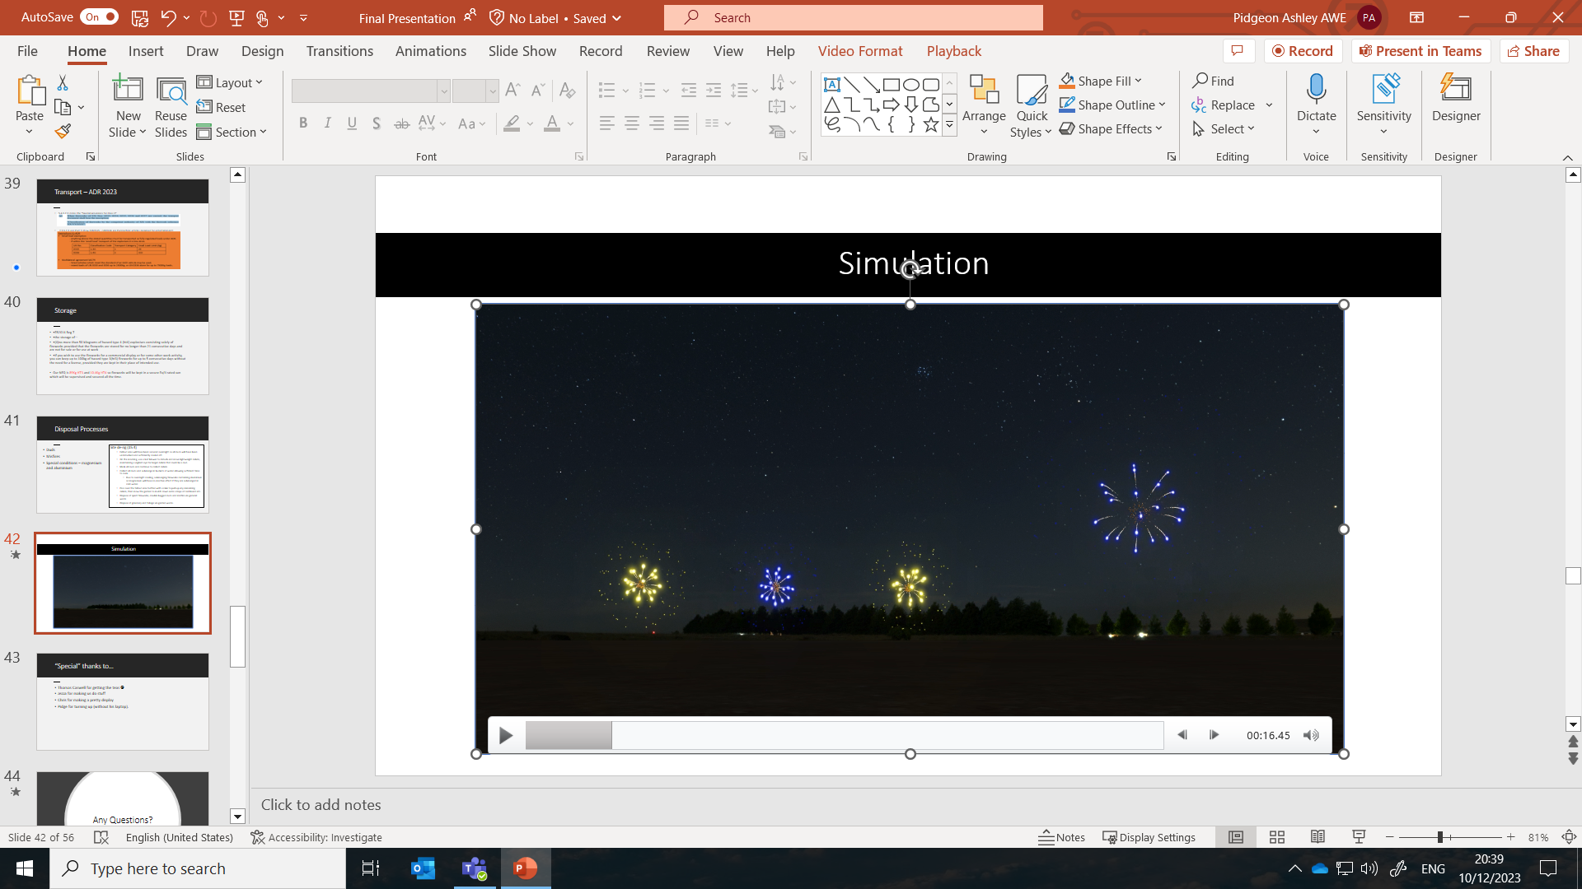
Figure 25 Blue and Yellow Atom Shells with Ring Effect
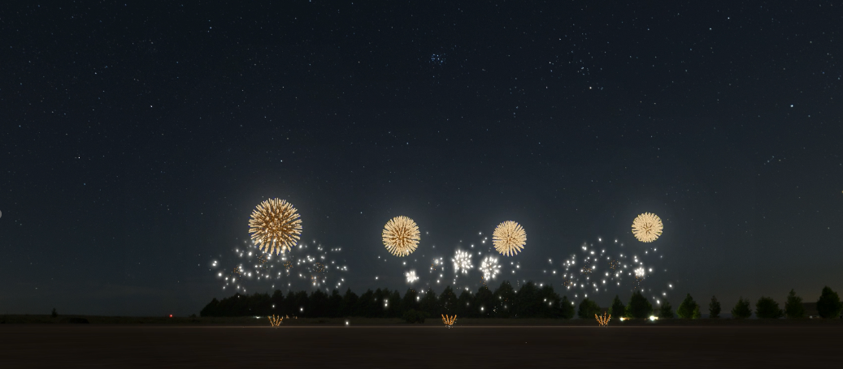
Figure 26 Yellow Shells
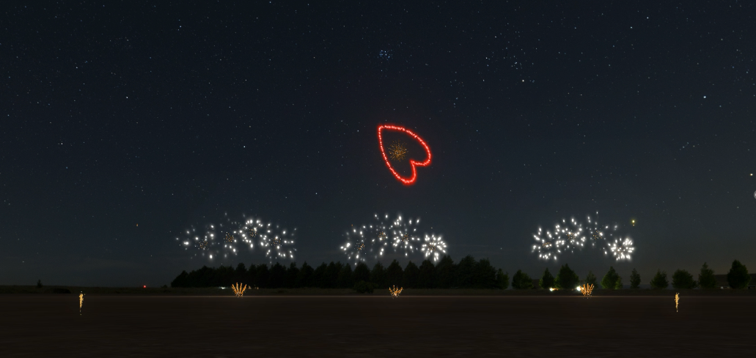
Figure 27 Heart Shell with Ring Effect
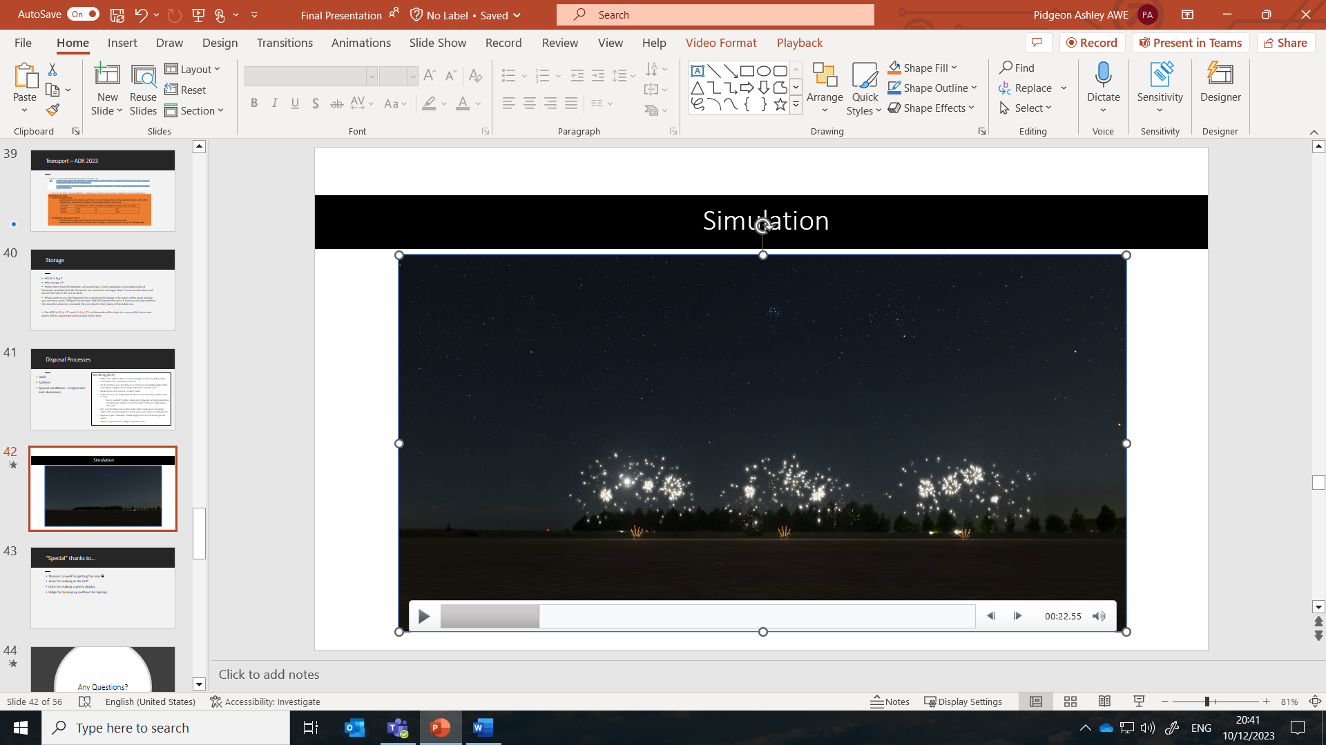
Figure 28 Yellow Comets and Mines

9.2 Firework Display Purchase Order
With the completed firework display simulation, the team was able to create a list of the fireworks that would need to be purchased for the display. Figure 29 shows the team order which totalled £9534.64, within the £10,000 limit.
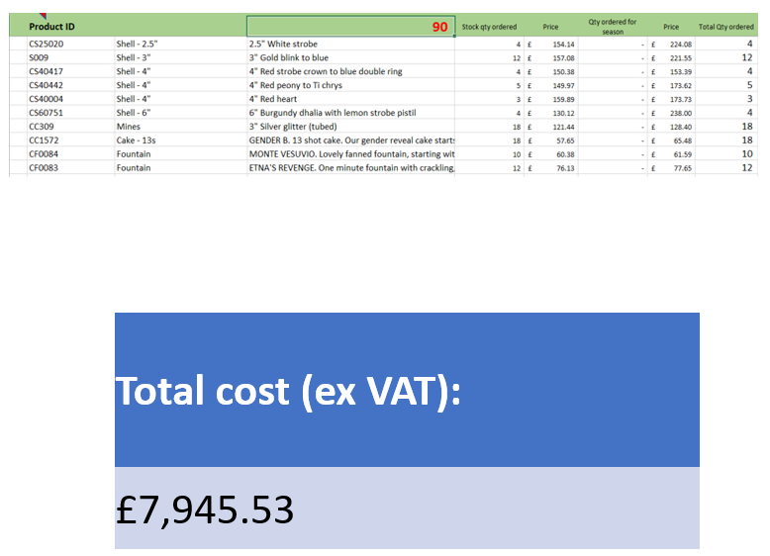
Figure 29 Firework Purchase Order

9.3 Display Layout and Equipment
The next step in the process was for thew team to create a layout for the display site. Figure 30 shows the site plan created by the team and Figure 31 shows the Cobra Unit module and Quick Match used to electrically set off the fireworks in the display. The team choose to use this equipment as this was decided to be the safety option.
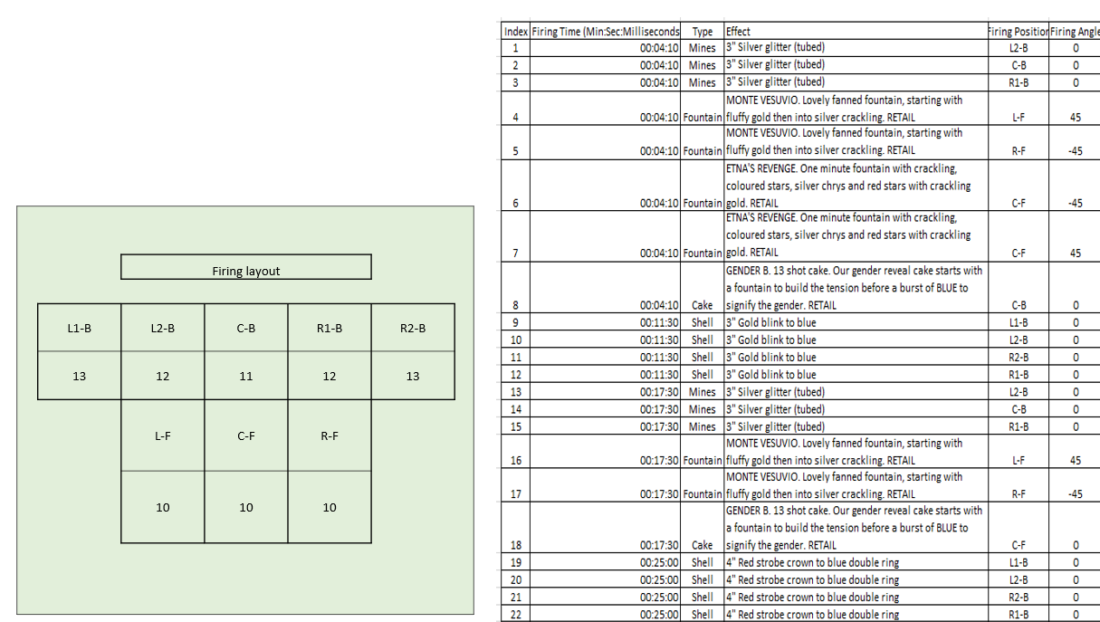
Figure 30 Firing Site Layout
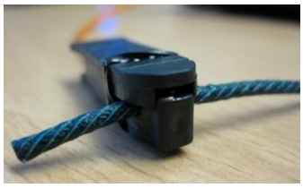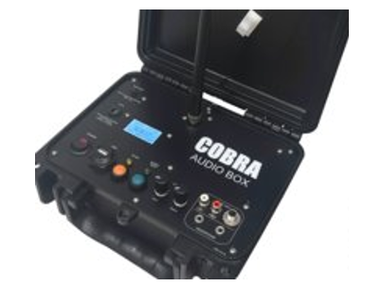
Figure 31 Quick Match and Cobra Module

9.4 Transport
To get the fireworks to the display site, the team had to consider the transportation requirements of the fireworks. The United Kingdom transport by road of dangerous goods follows the treaty set in ADR 2023 [1] that must legally be followed. Accord relatif au transport international des marchandises Dangereuses par Route 2023 or European Agreement concerning the International Carriage of Dangerous Goods by Road 2023 (ADR 2023) puts dangerous goods into nine different classes of which fireworks fall in Class 1, Explosives. ADR 2023 is split into sections of which 2.2.1.1.7.5 to 2.2.1.1.7.5 refers to the assignment of fireworks to divisions due to their United Nations Number and their Compatibility group. A compatibility group assigns articles to groups according to how they behave together in event of fire or unintended event like being crushed [1]. This can be seen in Figure 32.
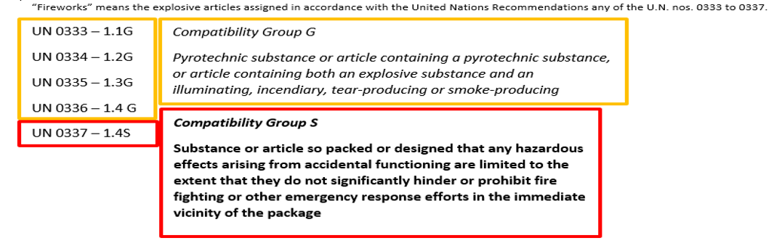
Figure 32 ADR 2023 UN Groups
Figure 33 shows section 5.4.1.2.1 which states the special provisions for Class 1 Fireworks and section 7.5.5.2.1 with the exemptions to ADR.
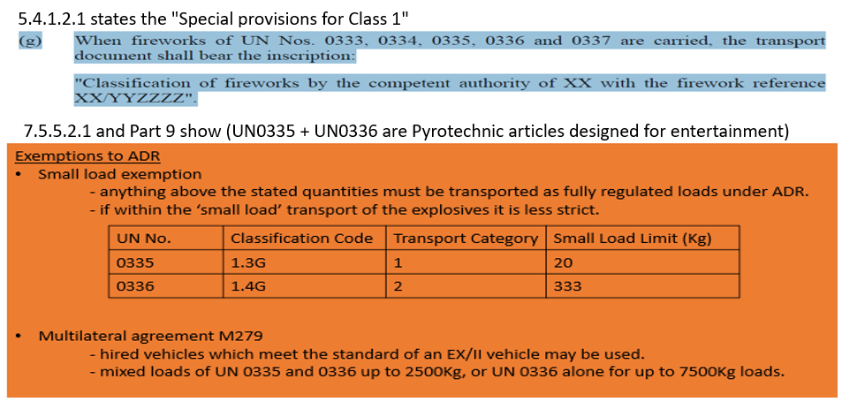
Figure 33 Section 5.4.1.2.1 and 7.5.5.2.1 of ADR2023
The team complied with the regulations as the total load of the display was 99.4Kg.

9.5 Storage
Storage of fireworks in the UK is governed by the Explosive Regulations 2014 of which regulation 7 [2] states that:
“The storage of—
•(ii)no more than 50 kilograms of hazard type 4 (HT4) explosives consisting solely of fireworks provided that the fireworks are stored for no longer than 21 consecutive days and are not for sale or for use at work
•If you wish to use the fireworks for a commercial display or for some other work activity, you can keep up to 100kg of hazard type 3(HT3) fireworks for up to 5 consecutive days without the need for a license, provided they are kept in their place of intended use.” [2].
The Net Explosive Quantity of the display consisted of 89Kg HT3 and 10.4Kg HT4, this allowed for the display fireworks to be stored in a secure EX/II rated vehicle that was parked in the secure van location seen in Figure 23. If the event were to be cancelled, all fireworks would be moved to a secure storage facility.

9.6 Misfire/Dud Procedure
Figure 34 shows the steps of the clean up operation post display and how the team dealt with misfired and dud fireworks.
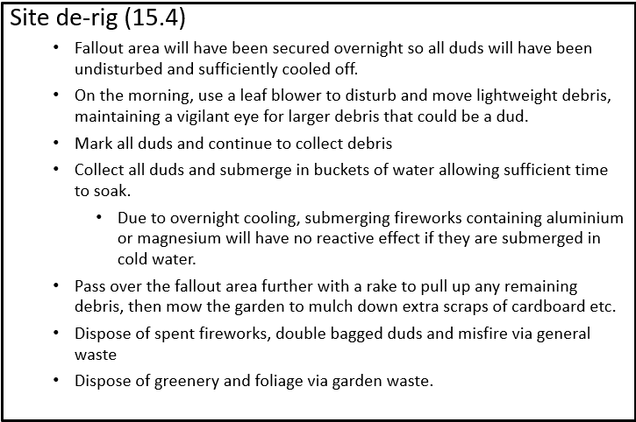
Figure 34 Clean Up Operation List

10.1 Conclusions and Observations
In conclusion the AWE Home Team provided a 3-minute firework display with a theme that represented OME, the university and education with the fireworks being fired from the quayside near the IQ building to an audience in the IQ campus. The display came within the £10000 budget and complied with all legal limitations and regulations for safety and logistics as well as all ‘Fall-Out’ (airborne display debris) being assessed, and any associated safety issues addressed. Environmental effects were considered and documented including such things but not limited to disposal, site contamination and air pollution.
It can be observed that for future firework displays improvement could be made on time management, increase in team members and better attention to detail. For example, ensuring all firework effects are timed correctly and in the correct orientation to the crowd. An increased budget would all be of benefit to deliver a more rounded display.

11.1 Appendix

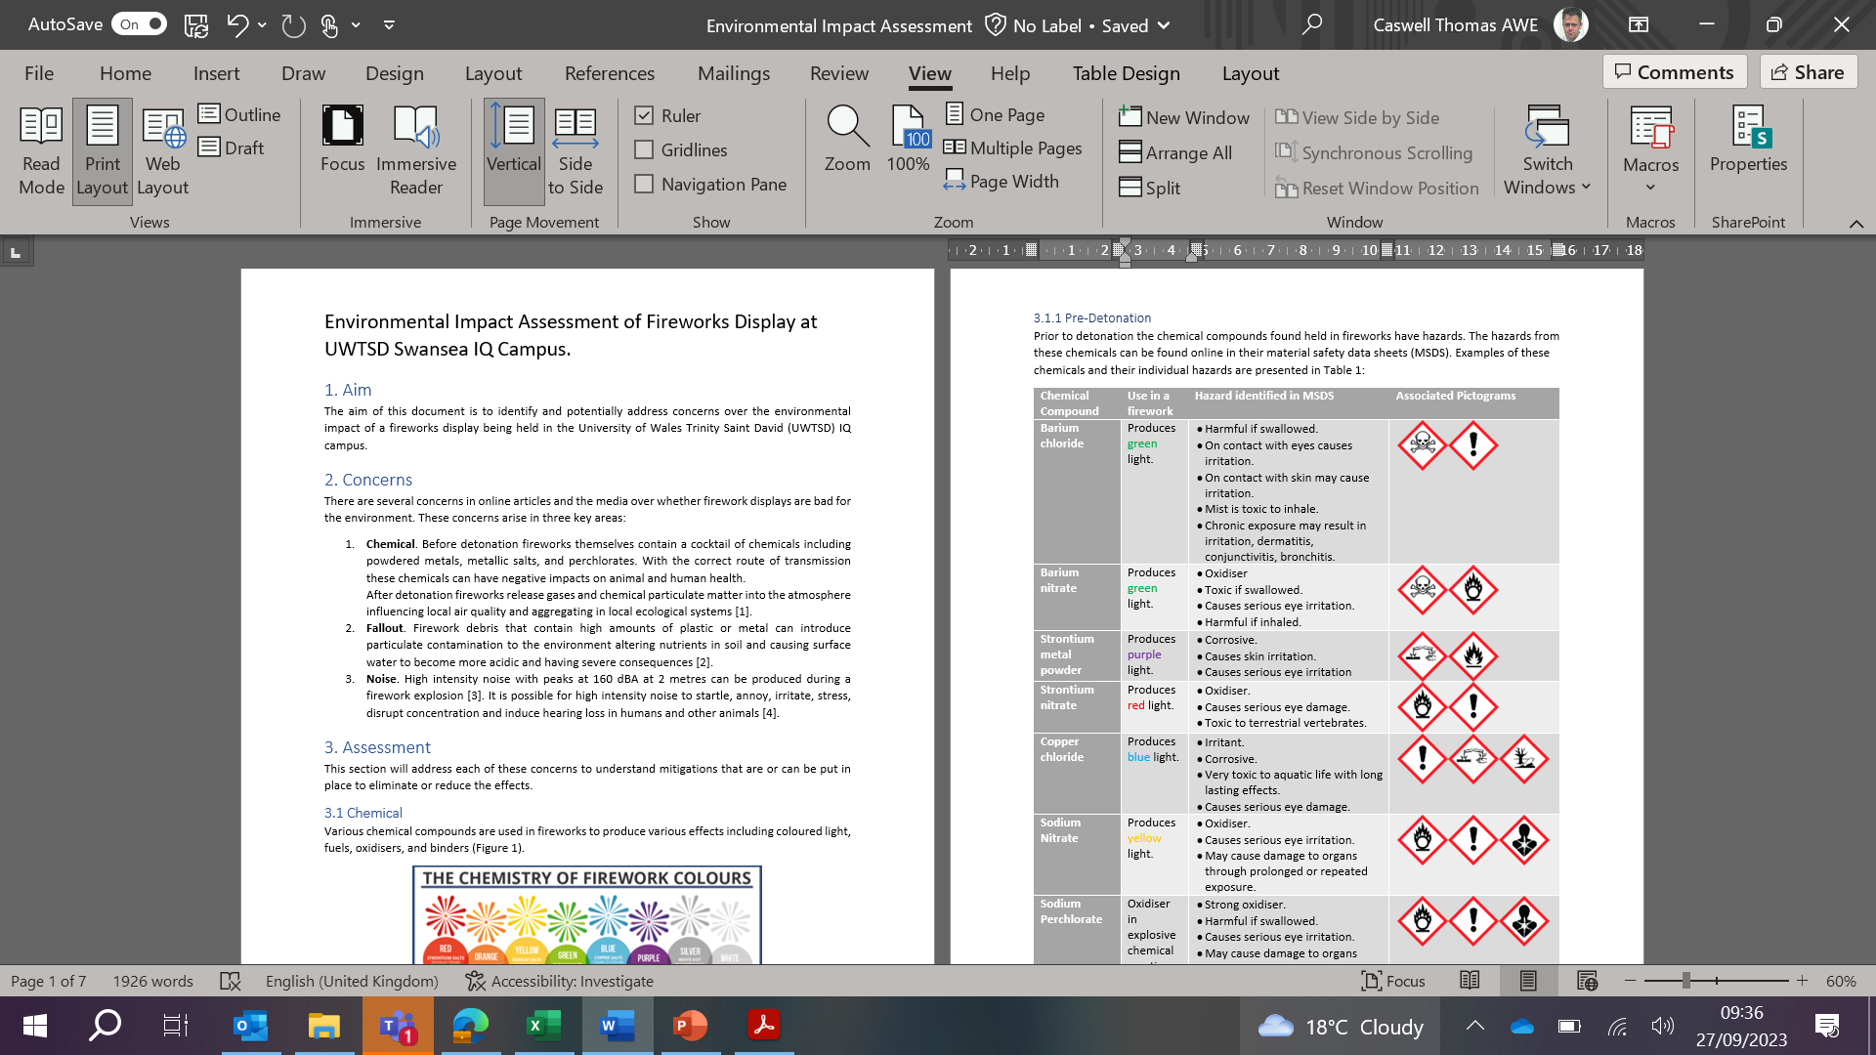
Figure 35 Environmental Impact Assessment

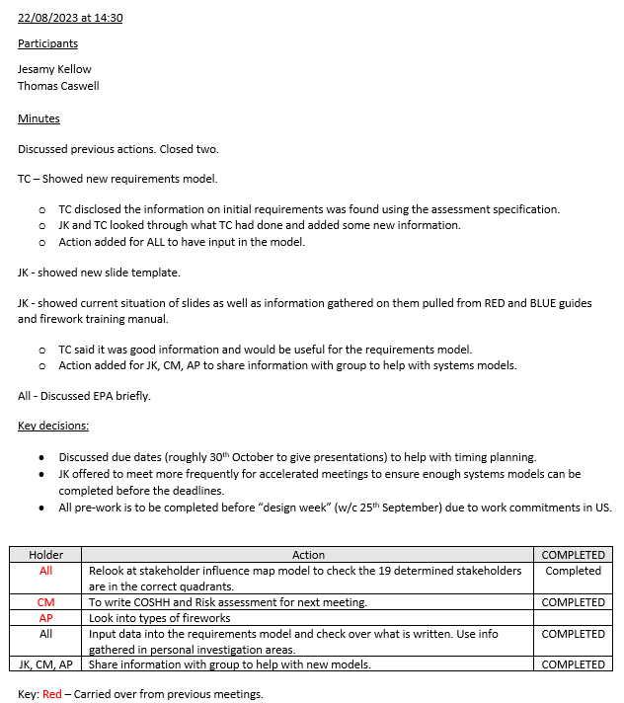
Figure 36 Team Meeting 3
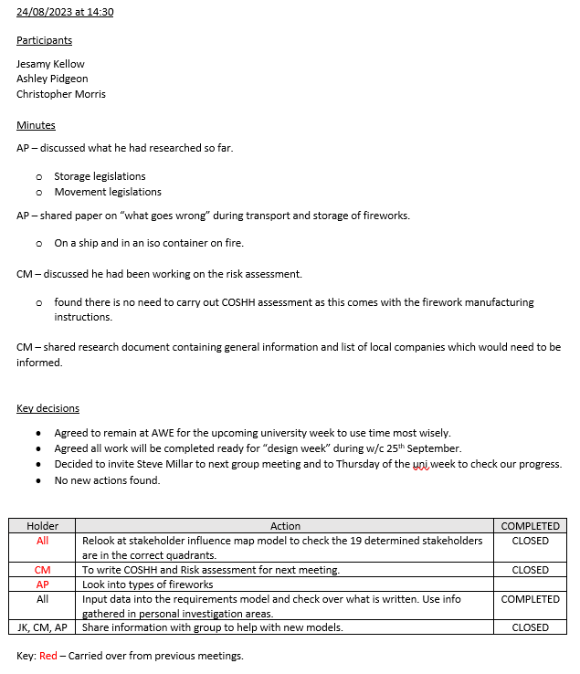
Figure 37 Team Meeting 4

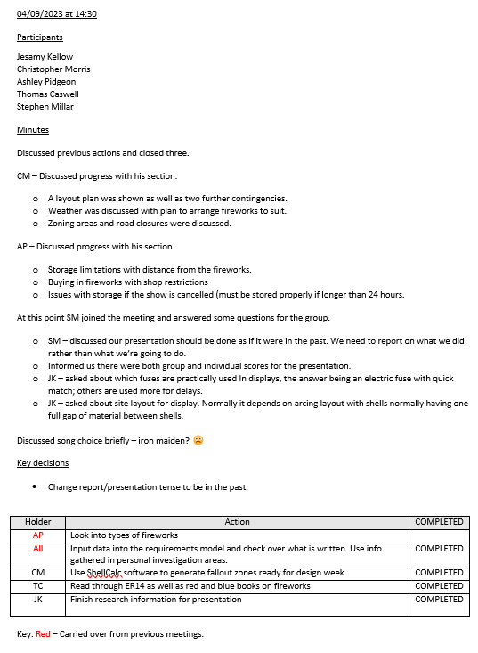
Figure 38 Team Meeting 5

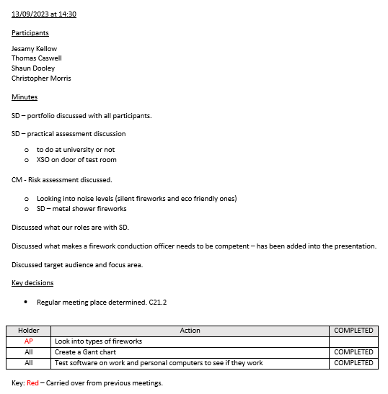
Figure 39 Team Meeting 6

12.1 References

[1] | United Nations, ADR 2023, Gineva: United Nations, 2022.
[2] | The Secretary of State, “The Explosive Regulations 2014,” 2014. [Online]. Available: https://www.legislation.gov.uk/uksi/2014/1638/made. [Accessed 2023].
[3] | The Secretary of State, “The Pyrotechnic (Safety) Regulations 2010,” 2010. [Online]. Available: https://www.legislation.gov.uk/uksi/2010/1554/part/1/made. [Accessed 2023].
[4] | Ontario Science Centre, “The Science of Fireworks,” Government of Ontario, 2023. [Online]. Available: https://www.ontariosciencecentre.ca/science-at-home/diy-science-fun/the-science-of-fireworks. [Accessed 2023].
[5] | S. Collison, “The chemistry of fireworks,” 4 November 2019. [Online]. Available: https://www.open.edu/openlearn/science-maths-technology/science/the-chemistry-fireworks. [Accessed 2023].
[6] | C. Tristancho, “Stakeholder Mapping 101: A Quick Guide to Stakeholder Maps,” 10 May 2023. [Online]. Available: https://www.projectmanager.com/blog/stakeholder-mapping-guide#:~:text=A%20stakeholder%20map%20is%20a%20visual%2C%20four-quadrant%20influence-interest,stakeholder%20matrix%2C%20power%20interest%20grid%20or%20stakeholder%20chart.. [Accessed 2023].
[7] | P. A. S. a. D. A. J. Dr Michael Emes, “‘Left Shift’ vs The Time Value of Money: Unravelling the business case for systems engineering,” INCOSE, Dorking, 2007.
[8] | D. S. Burge, “The Systems engineering Tool Box,” Burge Hughes Walsh, Rugby, 2006.
[9] | Jake's Fireworks, “Fireworks Types and Definitions,” 2023. [Online]. Available: https://www.jakesfireworks.com/fireworks-types-and-definitions. [Accessed 2023].
[10 | S. Barrs, “Are fireworks vegan-friendly? A case for a ban on fireworks,” 25 October 2021. [Online]. Available: https://theveganreview.com/are-fireworks-vegan-friendly/. [Accessed 2023].
[11] | A. Halstead, “Are fireworks vegan? Should they go out with a bang?,” 03 November 2022. [Online]. Available: https://www.v-landuk.com/article/are-fireworks-vegan-should-they-go-out-with-a-bang. [Accessed 2023].
[12 | British Safety Council, “Risk assessments: what they are, why they're important and how to complete them,” 2023. [Online]. Available: https://www.britsafe.org/training-and-learning/informational-resources/risk-assessments-what-they-are-why-they-re-important-and-how-to-complete-them. [Accessed 2023].
[13 | Vengaboys, Writer, Boom boom boom boom. [Performance]. Breakin', 1998.

