

Student Name: Janki Patel
Student ID: 2520611

Programme: MSc Cybersecurity and Digital Forensics
Module: ACCA7028 Data Security, Governance and Compliance

Assignment Title: Design of an Integrated Data Security, Governance, and Compliance Framework for AeroLink Logistics
Word Counts: 2,923 words

Lecturer's Name: Dr. Ayman El Hajjar

Abstract
The rapid development of cloud computing, Internet of things (IoT), and artificial intelligence (AI) technologies has enhanced the efficiency levels of companies but at the same time resulted in an increase in cybersecurity threats. AeroLink Logistics (ALL) is a multinational logistics company that makes use of cloud computing services, IoT devices, and outsourced IT. However, ALL has been experiencing the issues of data breaches, poor governance, and lack of compliance with the regulatory requirements. In this report, the existing security frameworks, namely, NIST CSF 2.0, ISO/IEC 27001:2022, COBIT 2019, and ITIL 4 will be evaluated in order to determine their suitability to address the problems of ALL. As a result of the literature review and the analysis of the case, a security, governance, and compliance framework is proposed. The framework includes the aspects of governance, risk management, cloud security, access management, vendor management, incident response, and business continuity.

Table of Contents

Abstract 2
1 Introduction 4
2. Literature Review 4
2.1 Cybersecurity Governance 5
2.2 NIST Cybersecurity Framework (CSF) 2.0 5
2.3 ISO/IEC 27001:2022 6
2.4 COBIT 2019 7
2.5 GDPR and Regulatory Compliance 7
2.6 Critical Comparison of Frameworks 7
3. Proposed Integrated Data Security, Governance, and Compliance Framework 9
3.1 Framework Components 10
3.2 Expected Benefits 10
3.3 Security Guidelines and Practices 12
3.4 Protection Mechanisms and Access Controls 12
3.5 Vendor Management and Service Level Agreements (SLAs) 13
3.6 Contingency and Business Continuity Planning 14
4. Critical Discussion 14
5. Conclusion 15
6. Reference 17

1 Introduction
Adoption of cloud computing, IoT, AI, and IT outsourcing technologies has made the business more efficient and effective as well as helped businesses take good decisions. However, with the adoption of all these technologies, the risks associated with cybersecurity have increased including data breach, unauthorized access, third-party risks, and compliance risks. With the interconnectivity of organizations because of technological advancements, it is important that organizations also adopt data security and compliance programs.
AeroLink Logistics (ALL), a multinational organization engaged in logistics and supply chain management, is facing the above-discussed challenge as a result of the adoption of cloud computing, IoT, AI, and IT outsourcing technologies. Even though ALL has adopted all the above-discussed technologies, there have been security incidents related to customers’ shipments and PII data. In addition, lack of security and compliance programs has increased risks for ALL.
The objective of this research paper is the analysis of internationally accepted frameworks of security including NIST Cybersecurity Framework (CSF) 2.0, ISO/IEC 27001:2022, COBIT 2019, and ITIL 4 with the goal of identifying their strengths and relevance to the current case study. On the basis of the analysis of the four mentioned frameworks of security, the integrated framework of security and governance for data security, governance, and compliance will be suggested in order to enhance governance, risk management, compliance, and digital transformation securely [1], [9], [10], [11].

2. Literature Review
The growing popularity of cloud computing, Internet of Things (IoT), artificial intelligence (AI) and IT services outsourcing contributes to the growing complexity of cyber security risk management. The current situation calls for the development of a framework which will not only be able to protect the company’s information assets, but also to foster governance and compliance. Frameworks which have been proposed so far include such initiatives as NIST CSF 2.0, ISO/IEC 27001:2022, COBIT 2019 and ITIL 4. According to some latest research findings, none of the mentioned frameworks is able to meet all the requirements of organisations in terms of security, governance and compliance.

2.1 Cybersecurity Governance
However, it should be mentioned that cybersecurity governance is a field of strategic leadership aimed at aligning information security with the organization goals and providing accountability, risk management, and compliance. As the latest research shows, many organizations focus their attention solely on the technical aspects of cybersecurity and neglect governance and organizational culture, which results in the ineffective implementation of the cybersecurity program. According to Handri et al., in order to ensure the effective utilization of the cybersecurity governance framework, such factors as governance, risk management, incident management, security technology, and organizational culture should be taken into account. Nevertheless, it is also important to take care of the technical and human sides of cybersecurity.

The same approach may be used when adapting and revising the cybersecurity governance framework. It is absolutely crucial because it will enable one to deal with new threats and technologies and make proactive decisions [6].

2.2 NIST Cybersecurity Framework (CSF) 2.0
CSF 2.0 by NIST Cybersecurity Framework provides an adaptable and risk-based approach in managing cyber risks in organizations varying in sizes and industries. The framework is organized in six core functions: Govern, Identify, Protect, Detect, Respond, and Recover. The addition of the Govern function in CSF 2.0 helps to improve corporate oversight as a result of the integration of cybersecurity governance, enterprise risk management, and strategic decision making process. NIST CSF differs from prescriptive standards, as it focuses on the outcome of cybersecurity, and allows organizations to choose their controls according to their requirements [1].
It is highly recommended for using in such organizations as AeroLink Logistics because it can be used in cloud environment, supply chain risk management, and cybersecurity continuous improvement. However, NIST CSF cannot provide a framework for developing ISMS. Therefore, it is advantageous to combine it with other frameworks [1].
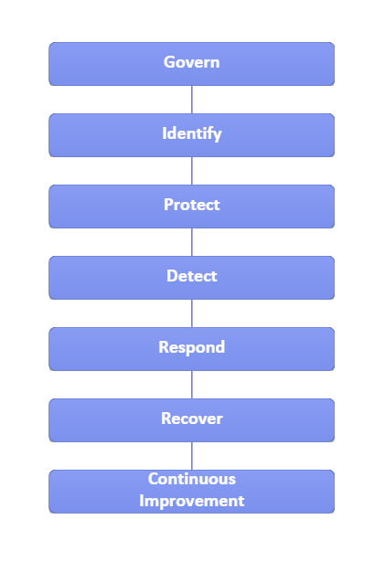
Figure 1: NIST Cybersecurity Framework (CSF) 2.0 Operational Lifecycle

2.3 ISO/IEC 27001:2022
ISO/IEC 27001:2022 is an internationally recognized standard for the management and maintenance of an Information Security Management System (ISMS). The standard uses a risk-based approach whereby the organization is able to address information security risks using policies, procedures, and security controls. Continuous improvement and continuous monitoring are two other characteristics of the standard since the security controls will remain effective despite changes in risk. Some scholars have stated that the adoption of ISO/IEC 27001 creates regulatory compliance through governance structures and security roles [9].
Even though the ISO/IEC 27001 provides a comprehensive security management guideline, some scholars have stated that governance frameworks, together with ISO/IEC 27001, are needed by organizations [2], [8].

2.4 COBIT 2019
Enterprise IT governance is considered by COBIT 2019 in conjunction with information technology and its alignment with business objectives. The focus of COBIT 2019 is on governance, performance management, stakeholders' value, and risk optimization. It allows for establishing appropriate responsibility and decision-making within an organization. Contemporary research has shown that COBIT is capable of promoting governance maturity in organizations due to increased control, audit, and alignment [10].
Figure 2: Mapping Security Frameworks to AeroLink Logistics Security Challenges

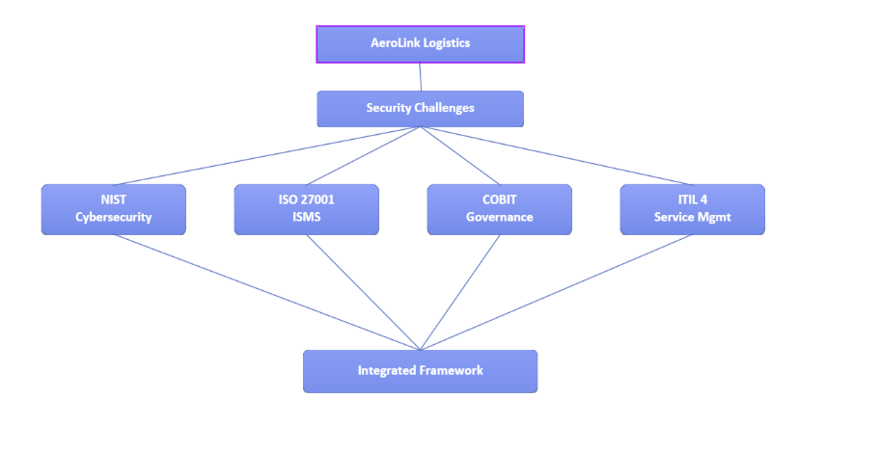

While ISO/IEC 27001 focuses on security controls in the context of the management process, COBIT offers more generic recommendations concerning the governance framework [8]. Nevertheless, its realization cannot occur without being integrated with security frameworks [8].

2.5 GDPR and Regulatory Compliance
The Data Protection General Regulation (GDPR) defines rules concerning data protection and corporate accountability. According to some recent researches, some problems arise in the process of GDPR implementation. Those include organizational change, governance issues, implementation challenges, and coordination of information governance [5], [12]. Implementation of GDPR would be more effective if it was integrated into enterprise architecture governance.

2.6 Critical Comparison of Frameworks
All of the frameworks mentioned above consider various aspects regarding cybersecurity. The NIST CSF 2.0 framework guarantees proper cybersecurity and effective risk management, the ISO/IEC 27001 provides the opportunity to develop an excellent ISMS, the COBIT 2019 framework is useful for organizational governance, and finally the GDPR framework ensures regulatory compliance for personal data. Every framework has its advantages, but according to recent research, modern organizations achieve better results by using several frameworks at once [2], [3], [8].

Table 1: Comparative Analysis of Security Frameworks for AeroLink Logistics
Risk | Likelihood | Impact | Risk Level | Recommended Control
Cloud Misconfiguration | High | High | Critical | NIST CSF + ISO 27001
IoT Device Compromise | High | High | Critical | NIST CSF + Network Segmentation
Customer PII Breach | Medium | Very High | Critical | GDPR + ISO 27001
Third-Party Vendor Attack | High | High | Critical | COBIT + Vendor Risk Management
Remote Access Attack | High | High | Critical | Zero Trust + MFA
AI Model Misuse | Medium | Medium | Moderate | AI Governance + ISO 42001
Ransomware | Medium | Very High | High | Backup Strategy + Incident Response

3. Proposed Integrated Data Security, Governance, and Compliance Framework
In light of the literature review and security problems emerging in the organisation in the case study of AeroLink Logistics, the following strategy for developing the Integrated Data Security, Governance and Compliance Framework is proposed. The integrated framework is developed using the best elements of the other frameworks, specifically, NIST CSF 2.0, ISO/IEC 27001:2022, COBIT 2019, ITIL 4 and GDPR. The suggested framework will help the company address the problems associated with cloud computing, Internet-of-Things-enabled logistics, artificial intelligence analytics, outsourcing and telecommuting within the company.
Even though the adoption of a single framework might not be enough, the suggested framework will help the company develop strategic governance and information security management as well as enhance cybersecurity operations and ensure compliance with regulations. The framework will be useful in risk assessment and improving the organization to safeguard it against any potential cyber security issues. As recent studies show, the use of several frameworks will cover more issues compared to using one framework. [2], [3], [8].

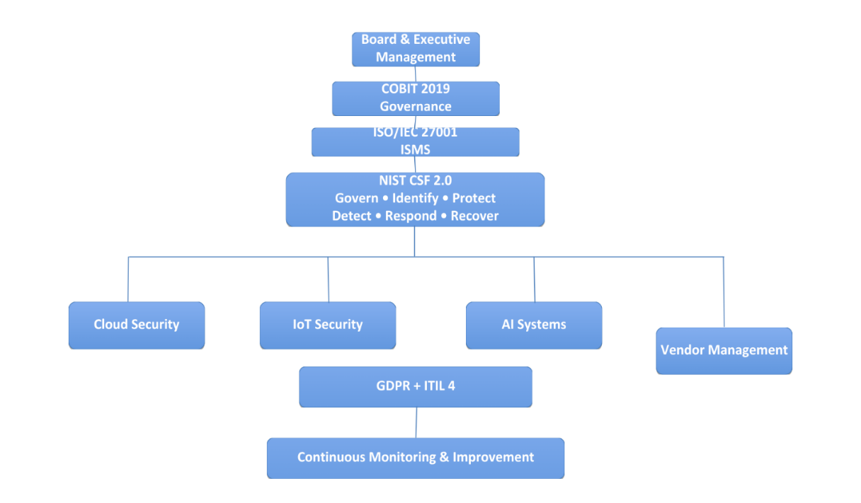
Figure 3: Proposed AeroLink Logistics' Integrated Data Security, Governance, and Compliance Framework

3.1 Framework Components
The given framework consists of five complementary layers:
- Governance Layer (COBIT 2019)
The COBIT 2019 framework creates the governance structure which aligns cybersecurity goals with the organization’s objectives. It identifies organizational duties, aids executive decision-making, and creates accountability for risk management and security performance. In this way, cybersecurity is integrated into enterprise governance and not just limited to information technology [10].
- Security Management Layer (ISO/IEC 27001:2022)
The ISO/IEC 27001 offers an Information Security Management System (ISMS) which may be used for managing security risks in a systematic way. It has security policies, processes, and controls which may be used for protecting the organization’s information assets. [9].
- Operational Cybersecurity Layer (NIST CSF 2.0)
These functions are Governing, Identifying, Protecting, Detecting, Responding, and Recovering. These functions would assist the AeroLink Logistics in identifying any possible cyber security threats, protecting themselves from such threats, detecting the threat, responding to the threat, and recovering from such security threats. [1].
- Service Management Layer (ITIL 4)
This would include activities like incident management, change management, service continuity, and continual service improvement in ITIL 4, which guarantees that cybersecurity is an integral part of the activities of IT services [11].
- Compliance Layer (GDPR)
GDPR provides the legal basis for safeguarding personally identifiable information (PII). The inclusion of GDPR in the framework facilitates legal data processing, accountability, and privacy protection while minimizing regulatory risks related to customer data [12].

3.2 Expected Benefits
Advantages of adopting the above framework are as follows in case of AeroLink Logistics:
- Effective management and governance of cyber security.
- Better protection of information related to customers and operations.
- Conformity with international standards of security.
- Management of security threats in clouds and third parties.
- Improved incident and continuity management.
- Continuous assessment of cyber security.
The above framework acts as a reliable framework for security, governance and conformity regarding digital transformation and deficiencies in the case of AeroLink Logistics.

Table 2: Risk Assessment Matrix for AeroLink Logistics
Framework | Primary Focus | Strengths | Limitations | Relevance to AeroLink Logistics
NIST CSF 2.0 | Cybersecurity risk management | Flexible, risk-based, supports cloud, supply chain and incident response | Does not provide a complete ISMS | Protects cloud infrastructure, IoT devices and improves incident response.
ISO/IEC 27001:2022 | Information Security Management System (ISMS) | Comprehensive security controls, continuous improvement, certification | Limited enterprise governance guidance | Establishes security policies, risk assessment and information security management.
COBIT 2019 | Enterprise IT Governance | Strategic alignment, governance, accountability and performance management | Less technical than security frameworks | Supports executive governance, decision-making and risk management.
ITIL 4 | IT Service Management | Incident, change and service management | Limited cybersecurity guidance | Improves service continuity and operational processes.
GDPR | Data Protection & Privacy | Protects personal data and regulatory compliance | Focuses mainly on privacy | Ensures compliance for customer PII and accountability.

3.3 Security Guidelines and Practices
A policy and procedure set must be established to ensure security controls implementation consistently at AeroLink Logistics. Amongst other policies, the following security policies should be developed: the enterprise Information Security Policy; access control policy; password policy; data classification policy; acceptable use policy; incident response policy; remote working policy; cloud security policy; and vendor management policy. It is crucial to ensure that the security policies are ISO/IEC 27001:2022 compliant and updated regularly based on organizational risks, legal requirements, and technological changes. In addition, standard operating procedures will be developed to inform employees about incident reporting, handling of sensitive data, and cybersecurity incidents [9].

3.4 Protection Mechanisms and Access Controls
To safeguard the organization’s assets and customer data, it would be necessary to have multiple layers of security controls using the concepts of defense-in-depth and Zero Trust Architecture at AeroLink Logistics. It would be recommended to implement Multi-Factor Authentication (MFA) for all remote users and Role-Based Access Control (RBAC) for ensuring that only those systems and data which are necessary for the job performed by the employees can be accessed. Encryption of data both in-use and in transit, for customer shipment information, as well as personally identifiable information (PII), needs to be considered. Network segmentation of critical cloud services, IoT devices, and AI platforms need to be implemented for limiting the lateral movements during a cyber-attack. Some of the measures that can be implemented include security monitoring, EDR, vulnerability assessment, and SIEM. The above mentioned security measures would fit under the operation security function of NIST CSF 2.0 and also cater to the risk-based controls required by ISO/IEC 27001 [1], [9].

3.5 Vendor Management and Service Level Agreements (SLAs)
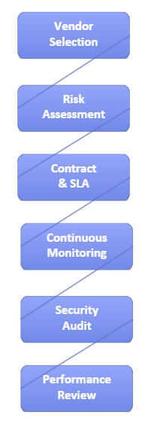
Figure 4: Vendor Risk Management Lifecycle for Outsourced Cloud Services

Considering the fact that 88% of AeroLink Logistics’ IT infrastructure is outsourced via IaaS and SaaS providers, the third-party governance is among the main aspects in the suggested solution. Vendor’s management will begin with risk assessment during the choice of the provider and will continue with the security audits and vendor performance monitoring. Particularly, such aspects as the security responsibilities, availability, reporting period for the incidents, data ownership, criteria of data encryption, data backup responsibilities and compliance have to be described in the SLA. The vendors have to perform the security audits independently and comply with the international ISO/IEC 27001 standard [9,10].

3.6 Contingency and Business Continuity Planning
The business continuity planning process will guarantee that the logistics operations would continue their functioning regardless of the potential attacks, failures and natural disasters that might take place. It should be noted that in order to address the issue, the proposed approach will be the creation of the Business Continuity Plan (BCP) and Disaster Recovery Plan (DRP) that will cover all the information about priorities, communications, recovery and objectives. The offline and online backups and regular testing of disaster recovery procedures need to be carried out in order to determine the efficiency of recovery process. It is important to define the responsibilities of the incident response team in order to control the processes of containment, eradication and recovery. [1], [11].

4. Critical Discussion
However, the fast changes in the field of digitalization have led to the change in the organizational model as well as increase in the risk of cyber security issues. With the advancement in the technology like cloud computing, AI, IoT, and remote working technologies there have been new risks which cannot be dealt with traditional organizational methods and cybersecurity models. Hence, it becomes necessary for the organizations to constantly evaluate their security models as well as their regulatory procedures to counter the upcoming security risks.
Organizations have moved beyond their traditional organizational model for IT services because of the advances in cloud computing. In the case study of AeroLink Logistics, the organization is using cloud computing to provide its IT services [1], [10].
The same goes for new problems related to governance that appeared in connection with AI technologies – decision automation, data privacy, model integrity and regulatory compliance. Recent research suggests that the existing cybersecurity framework should be constantly improved in order to handle AI-related risks and integrate the new technologies safely [2], [8]. The necessity of employing such governance frameworks that evolve along with the evolution of technologies rather than employing purely security measures can be seen in that fact.
The use of IoT devices enlarges the organization's attack surface further, as there are thousands of connected endpoints that need to be continuously monitored and configured. In addition, GDPR and other regulations continue to evolve in their efforts to tackle privacy concerns. Therefore, organizations need to constantly review their data governance and management practices. Compliance with GDPR is not only a technical issue but also a matter of good governance [5], [12].
Aside from the compliance issues, the firms should take into account the ethical dimension of data security and technologies. The ethical concerns here involve the application of artificial intelligence in decision making, a tremendous amount of data collected and continuously monitored by firms, along with their employees and customers. In other words, in this case a firm should embed the ethical concerns within its governance framework in relation to collecting and using data, employing artificial intelligence and cybersecurity without violating individuals' rights and protecting the firm itself at the same time.
As a consequence, organizations require a governance framework that will enable them to perform risk assessment, compliance assessment, training of employees and policies reviews on a regular basis. In this way, firms like AeroLink Logistics will be able to overcome cybersecurity challenges successfully [1], [6], [10].

5. Conclusion
The significance of information security is rising with the use of cloud computing, IoT, artificial intelligence systems, and outsourced IT services. The AeroLink Logistics case study demonstrates that ineffective governance, cybersecurity operations, risk management, and compliance create vulnerability of organisations to cyber threats [1], [9], [10].
Five information security frameworks were examined in this report: NIST CSF 2.0, ISO/IEC 27001:2022, COBIT 2019, ITIL 4, and GDPR. The purpose of the analysis was to find out whether there are any frameworks which would be able to overcome the security problems of AeroLink Logistics. It was revealed that each framework possesses some significant features; nevertheless, no framework can cover all aspects of governance, cybersecurity operations, information security management, and cloud computing environments [1], [2], [9], [10], [11], [12].
From the aforementioned results, an "Integrated Data Security, Governance & Compliance Framework" has been proposed. Based on the strengths of various world-renowned frameworks, the proposed framework is designed to assist in improving governance, increasing information security, ensuring compliance, and risk management on an ongoing basis. The framework deals with issues such as cloud security, AI governance, vendor risk management, incident response, and business continuity; therefore, it will be relevant for the activities of AeroLink Logistics [1], [2], [8], [9], [10].
Continuous improvement will be necessary to ensure proper cybersecurity. Companies that continually improve governance, security, and compliance will be better prepared for emerging technologies and risks [1], [6], [9], [10].

6. References
[1] National Institute of Standards and Technology (NIST), The NIST Cybersecurity Framework (CSF) 2.0, NIST CSWP 29, Gaithersburg, MD, USA, Feb. 2024.
[2] D. Xu, D. Liu, R. Nowrozy, T. R. McIntosh, T. Susnjak, T. Liu, P. Watters, and M. N. Halgamuge, “From COBIT to ISO 42001: Evaluating cybersecurity frameworks for opportunities, risks, and regulatory compliance in commercializing large language models,” Computers & Security, vol. 144, Art. no. 103964, 2024.
[3] M. Schmidt, R. Bruzgienė, P. Smyrli, S. Andreou, A. Lopata, and Š. Grigaliūnas, “Holistic Information Security Management and Compliance Framework,” Electronics, vol. 13, no. 19, Art. no. 3955, 2024.
[4] A. Tarigan, D. I. Sensuse, and E. Y. Handri, “Developing an Agile Cybersecurity Framework With Organizational Culture Approach Using Q Methodology,” IEEE Access, vol. 12, pp. 108835–108850, 2024.
[5] M. M. Spinola, G. H. de Magalhães, and N. A. Zaguir, “Challenges and Enablers for GDPR Compliance: Systematic Literature Review and Future Research Directions,” IEEE Access, vol. 12, pp. 81608–81630, 2024.
[6] M. S. I. M. T. Islam, M. A. Rahman, and S. Kabir, “A Dynamic and Adaptive Cybersecurity Governance Framework,” Standards, vol. 3, no. 3, 2023.
[7] R. R. Sani, D. M. A. Pratama, and V. Y. A. Putri, “How Can FLOSS Support COBIT 2019? Mapping Open-Source Solutions to COBIT Governance Objectives,” Procedia Computer Science, vol. 227, pp. 470–479, 2023.
[8] H. A. Alghamdi, “Developing Cybersecurity Strategies: Towards an Integrated Approach Based on COBIT and ISO 27000,” Standards, vol. 5, no. 1, 2025.
[9] International Organization for Standardization, ISO/IEC 27001:2022 – Information Security, Cybersecurity and Privacy Protection – Information Security Management Systems – Requirements, Geneva, Switzerland: ISO, 2022.
[10] ISACA, COBIT 2019 Framework: Governance and Management Objectives, Schaumburg, IL, USA: ISACA, 2019.
[11] AXELOS, ITIL® Foundation: ITIL 4 Edition, Norwich, U.K.: TSO, 2019.
[12] European Parliament and Council of the European Union, Regulation (EU) 2016/679 (General Data Protection Regulation), Official Journal of the European Union, 2016.

