Questions and Guidelines for Assessment Component 1


Changemakers: Creativity and Value Creation
Professions (BMHP5014)

Component 1: Online portfolio of set exercises

Student name: Adriana Rodrigues Bissoli
Student number: 2337158
Lecturer’s name: Laila Surani
Date: 15th April 2026

Table of Contents
Introduction 3
Task 1 – Defining Key Concepts in Practice. 4
1- Innovation 4
2- Creativity 4
3- Value Creation 4
4- Change 4
Task 2 - Mind Map. 5
Explanation. 5
Task 3 - Self-Reflection of Group Activity. 6
Description and Feelings 6
Evaluation and Analysis 6
Conclusion and Action Plan 6
Task 5 - Research Task to Staff Stress. 8
Task 6 - Exploring Digital Innovation in Health and Social Care. 9
1. Benefit of Wearable Health Technologies. 9
2. Electronic Health Records (EHRs) Improving Communication. 9
3. Digital Technology Supporting Preventative Care. 9
Task 7 - Understanding the NHS Leadership Framework. 10
(NHS Leadership Framework Analysis and Reflection) 10
Task 8 – Self-Reflection Journal Entry. 11
References………………………………………………………………………………………………………………………………………12

Introduction

This assignment examines the key concepts of innovation, creativity, value creation, and change within health and social care. It defines each concept and connects them to relevant theories and frameworks to show their importance in enhancing service delivery, improving patient outcomes, and increasing organisational efficiency.
Examples from the real world are given to show how these concepts are put into practice and how they lead to significant advancements and system transformation.

Task 1 – Defining Key Concepts in Practice.

1- Innovation

Involves developing and using new ideas, processes, or technologies to improve outcomes. In healthcare, it is essential for tackling ongoing issues like limited resources and growing patient demand. Everett Rogers’ Diffusion of Innovation Theory explains how new ideas spread within organizations and are gradually accepted over time (Rogers, 2003).
A clear example is the introduction of virtual wards during the COVID-19 pandemic, which enabled patients to receive hospital-level care at home. This approach helped reduce pressure on hospital beds while improving access to care.

2- Creativity

Refers to the ability to innovation and helpful ideas to solve problems or improve existing practices. Teresa Amabile’s Componential Theory of Creativity suggests that creativity emerges when individuals combine their knowledge, skills, and motivation effectively (Amabile, 1996). In health and social care, creativity is particularly important for addressing complex and unpredictable challenges.
existing practices. Teresa Amabile’s Componential Theory of Creativity suggests that creativity emerges when individuals combine their knowledge, skills, and motivation effectively (Amabile, 1996). In health and social care, creativity is particularly important for addressing complex and unpredictable challenges.
For example, peer support networks for individuals with mental health conditions have been developed as a creative way to improve patient engagement and recovery outcomes.

3- Value Creation
In healthcare focuses on achieving better patient outcomes while making efficient use of available resources. Michael Porter explains that value is created when improvements in patient outcomes are achieved relative to the cost of delivering care (Porter, 2010).
One example is the use of telehealth services, which allow patients with long-term conditions to receive care remotely, reducing unnecessary hospital visits while maintaining quality and continuity of care.

4- Change

Refers to the process of leaving behind ways of working to improved methods or practices. Kurt Lewin’s Change Management Model outlines three key stages unfreezing current practices, implementing change, and refreezing to ensure the changes are sustained (Burnes, 2017).
A good example is the implementation of electronic health records in hospitals, which required careful planning and support to help staff adapt and use the system effectively.
I think in these concepts are essential in health and social care because they support continuous improvement in service delivery, patient outcomes, and organisational performance. Understanding and applying them enables healthcare professionals to encourage innovation, think creatively, and deliver greater value within the system.

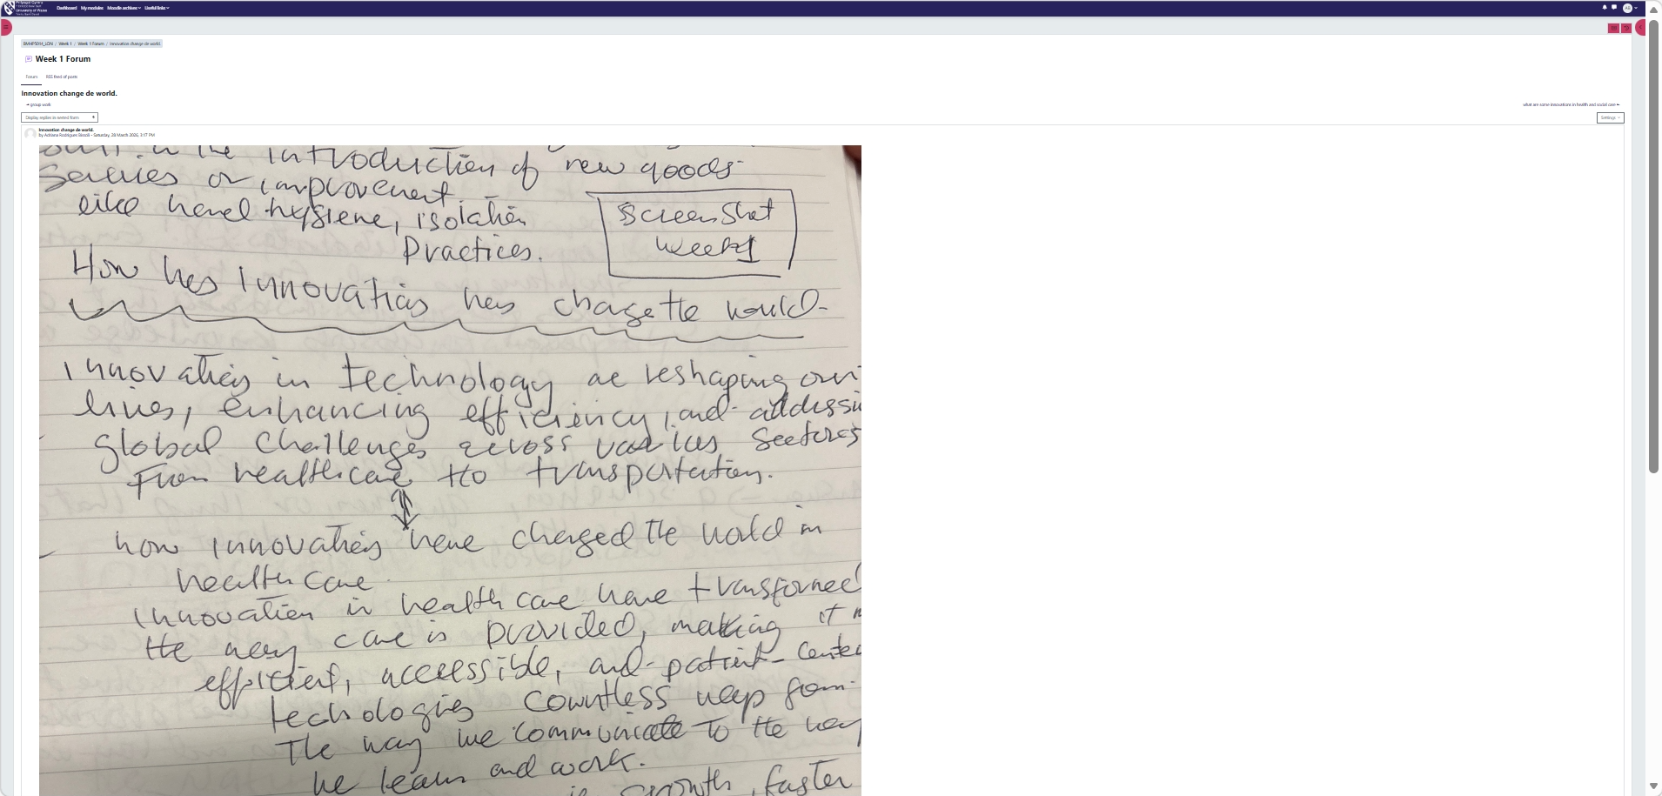

Task 2 - Mind Map.

Mind Map Structure (Systems Thinking View)
[STAFF BURNOUT]
|
-------------------------------------------------
| | |
[CAUSES] [IMPACTS] [SOLUTIONS]
| | |
- Chronic understaffing - Reduced care quality - Workload management
- Emotional labour - Increased errors - WHO Healthy Workplace
- Admin burden - Staff turnover Framework
- Work-life imbalance - Loss of continuity - Peer support networks
- Patient safety risks - Wellbeing audits
- Financial strain Feedback loops connect impacts and cause e.g., turnover intensifies understaffing.

Explanation.

Staff burnout marked by emotional exhaustion, depersonalisation, and reduced professional effectiveness poses a serious threat to both patient outcomes and organisational stability. It often arises from interconnected pressures such as chronic understaffing (NHS England, 2023), sustained emotional labour, and excessive administrative demands. These pressures generate system-wide consequences, diminished care quality contributes to higher clinical error rates (West et al., 2020), while increased staff turnover further worsens workforce shortages.
Vulnerable populations, particularly older adults requiring consistent relationships, are disproportionately affected.
Applying a systems thinking perspective (Meadows, 2008), highlights how these factors interact in reinforcing cycles. Without strategic intervention, burnout can become self-perpetuating. Sustainable solutions must therefore target root causes through structured workload management, peer support initiatives (Perlo et al., 2017), and implementation of the WHO Healthy Workplace Framework to improve organisational culture and workflow design holistically rather than superficially.

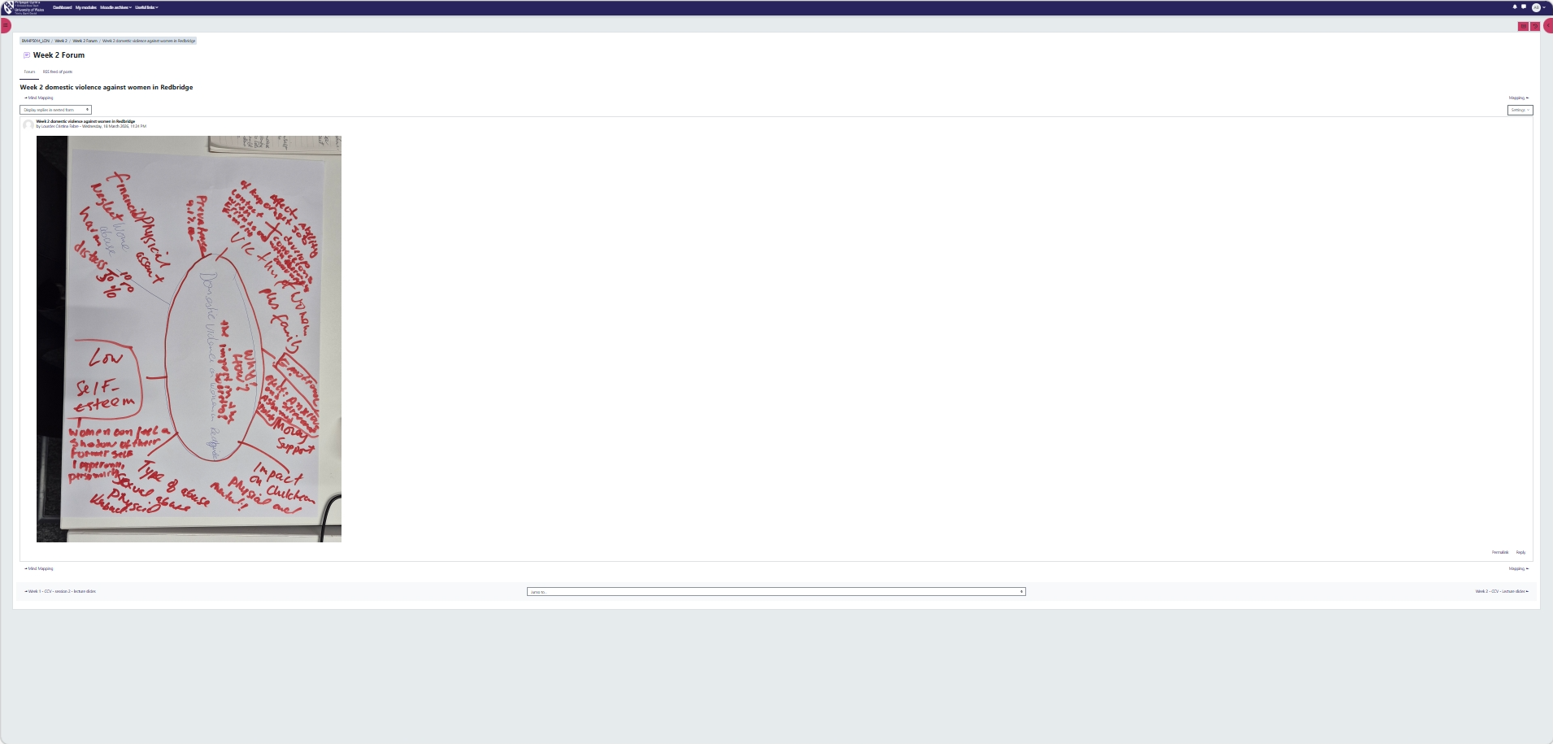

Task 3 Self-Reflection: Convergent and Divergent Thinking Activity (Gibbs’ Reflective Cycle).

Description and Feelings
During a group activity focused on reducing hospital waiting times, our team used both divergent and convergent thinking to generate and refine ideas. In the early stage, we applied divergent thinking to brainstorm a wide range of possible solutions, including highly creative suggestions such as using AI-supported triage systems.
At first, I felt slightly hesitant to contribute because the process was very open-ended and unstructured. However, as the discussion progressed and we moved into the convergent phase where ideas were evaluated and narrowed down based on feasibility
I felt more confident and comfortable participating in the decision-making process.
Evaluation and Analysis
Divergent thinking is coming up with several concepts and considering multiple choices encouraging creativity and open discussion.
In contrast, convergent thinking focuses on analysing options and selecting the most practical solution (Scirp.org, 2024). I realised that my natural preference is for convergent thinking, as I found the initial brainstorming stage challenging.
When the group struggled to decide between two proposals, I suggested evaluating them using criteria such as cost, time, and potential impact. This structured approach helped the group reach a clearer decision and move forward.
Conclusion and Action Plan
This experience highlighted that relying too heavily on analytical thinking can limit creativity in the early stages of problem solving. Effective teamwork requires balancing both divergent and convergent thinking, as well as actively listening to other perspectives.
In future group activities, I plan to use techniques such as Yes, and to build on other’s ideas during brainstorming (Osborn, 1953). I would also recommend introducing simple voting or scoring methods earlier in the convergent stage to help teams evaluate ideas more efficiently.
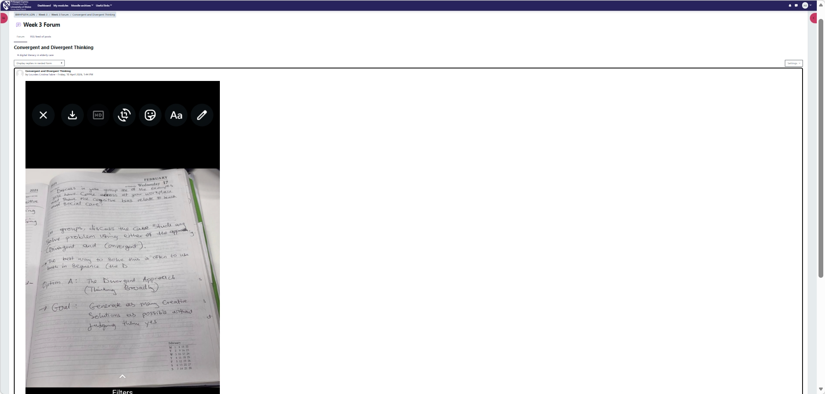

Task 4 – Case Study Analysis of a UK Innovation.

Virtual wards were introduced as a practical response to increasing hospital pressures, extended waiting times, and ongoing bed shortages within the NHS. Rather than admitting patients to hospital, this model enables individuals to receive hospital-level care in their own homes through remote monitoring technology and coordinated multidisciplinary support.
NHS England emphasises that virtual wards can safely deliver acute care in community settings, improving patient experience while reducing hospital admissions and shortening lengths of stay.
Creativity was fundamental to this development.
The model thoughtfully integrates digital monitoring devices, in-person home visits, and structured care pathways into a cohesive system. Instead of replacing clinical judgement, technology enhances it by allowing continuous, real-time oversight and earlier intervention when concerns arise.
This approach reflects Rogers’ Diffusion of Innovation Theory, as uptake increased once healthcare professionals and patients recognised the model’s usefulness, accessibility, and clear benefits.
Value has been created at several levels.
Patients often report feeling more comfortable and independent at home, while unpaid carers benefit from clearer communication and stronger support networks, as highlighted in a recent qualitative evaluation commissioned by NHS England (2025). At a system level, virtual wards help ease pressure on inpatient capacity and enable earlier discharge. Emerging evidence also indicates improvements in clinical outcomes and patient satisfaction, with reduced admissions and shorter hospital stays reported in parliamentary research briefings.
Looking ahead, virtual wards show strong potential for expansion across conditions such as frailty, respiratory disease, and cardiac care. Exploring how similar home-based, digitally supported models could better support people with long-term or complex social care needs represents a promising next step in integrated care development (England, 2024).

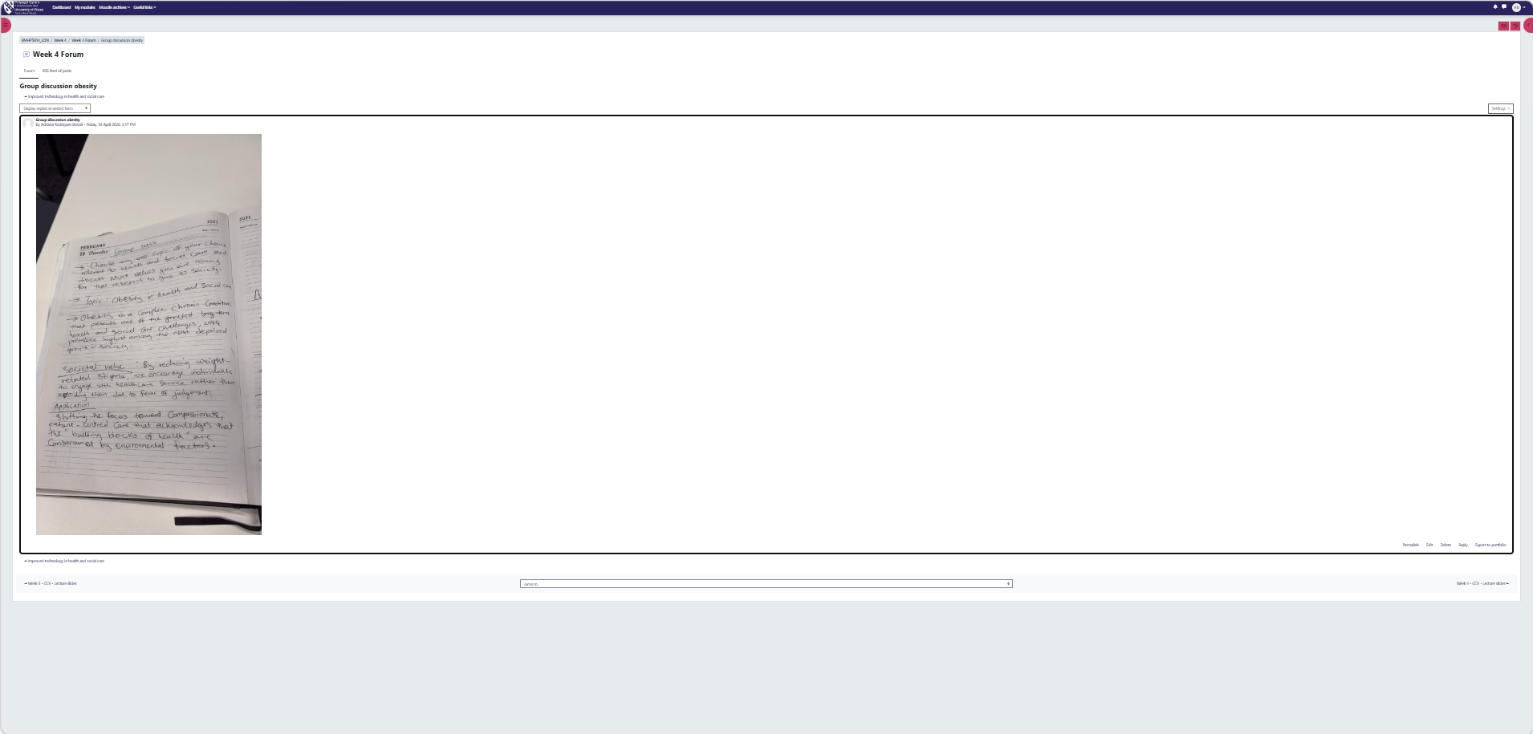

Task 5 - Research Task to Staff Stress.

The issue explored in this task is staff stress in healthcare, with a focus on its causes and wider impact.
Research by Michael West et al. (2016) identifies high workloads, limited autonomy, and a lack of support as key contributors to stress among healthcare professionals. These pressures often result in burnout, which negatively affects both staff performance and the quality of patient care. The study draws on Christina Maslach’s Burnout Theory, which highlights emotional exhaustion, depersonalisation, and a reduced sense of personal achievement as core features of burnout.
This helped develop an understanding of how workplace structure and organisational culture influence staff wellbeing.
Similarly, Tait Shanafelt et al. (2015) highlight factors such as heavy administrative demands and poor work life balance. However, they also emphasise the impact of limited recognition and weak leadership in increasing stress levels.
This perspective reflects Systems Theory, which suggests that stress arises from the interaction between individual, team, and organisational factors. This article reinforced the idea that stress in healthcare is complex and requires a holistic approach.
Overall, both studies agree on the importance of workload and organisational support, although they differ slightly in their focus on leadership and recognition. In practice, staff stress can lead to absenteeism, increased errors, and lower patient satisfaction, highlighting the importance of effective interventions.
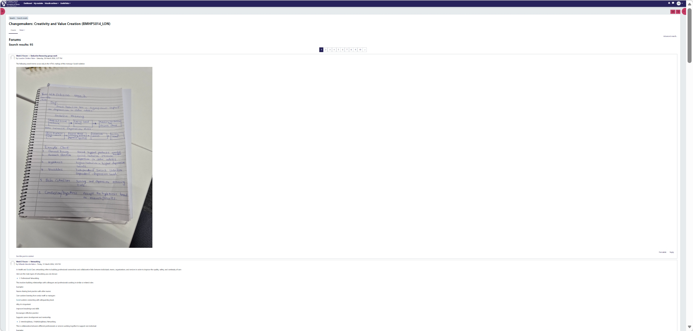

Task 6 - Exploring Digital Innovation in Health and Social Care.

1. Benefit of Wearable Health Technologies.
Wearable health technologies, such as smartwatches, play an important role in supporting the management of long-term conditions by allowing continuous health monitoring and early intervention.
Devices like the Apple Watch can measure heart rate, blood oxygen levels, and physical activity, giving both patients and healthcare professionals access to real-time health data. This enables quicker responses and more informed adjustments to treatment plans, helping to reduce the risk of complications.
Research by Perez et al. (2019) found that wearable devices were effective in detecting irregular heart rhythms in patients with atrial fibrillation, leading to improved outcomes. The Technology Acceptance Model (Davis, 1989) suggests that patients are more likely to use these devices when they find them useful and easy to operate, which supports their overall effectiveness.
2. Electronic Health Records (EHRs) Improving Communication.
Electronic Health Records (EHRs) improve communication and teamwork among healthcare professionals by storing patient information in a single, accessible system.
This is particularly beneficial when patients move between different services, such as from primary care to specialist treatment, as it ensures that all providers have access to up-to-date medical histories. As a result, unnecessary duplication of tests can be avoided, and continuity of care is strengthened.
A study by Julia Adler-Milstein et al. (2014) found that EHRs contribute to better care coordination and a reduction in clinical errors. According to the Technology Acceptance Model, healthcare professionals are more likely to adopt EHR systems when they perceive them as useful and easy to integrate into their daily routines, ultimately improving efficiency and collaboration.
3. Digital Technology Supporting Preventative Care.
Digital technologies are increasingly important in supporting preventative care and promoting healthier lifestyles.
Mobile applications such as MyFitnessPal allow users to monitor their diet, physical activity, and weight, offering personalised feedback to encourage positive behaviour changes.
For example, these tools could be used in public health initiatives targeting individuals at risk of conditions like diabetes, helping to promote regular exercise and better nutrition.
Research by Robyn Whittaker et al. (2019) shows that digital interventions can increase engagement in preventative health behaviours. The Technology Acceptance Model further explains that individuals are more likely to use such tools when they find them accessible and beneficial, making digital technology an effective approach to long-term disease prevention (Department of Health and Social Care, 2022).



Task 7 - Understanding the NHS Leadership Framework.

(NHS Leadership Framework Analysis and Reflection)

1. Summary of NHS Leadership Framework the NHS provides a structured approach to developing leadership capabilities across all levels of health and social care.
It identifies seven core domains inspiring shared purpose, leading with care, evaluating information, connecting our service, sharing the vision, developing capability, and influencing for results. These domains outline the behaviours and skills needed to drive improvement in patient care and organizational performance (NHS Leadership Academy, 2013).
The framework is particularly important as it helps create consistent leadership standards, fosters innovation, and improves service delivery in complex healthcare environments.
Research by West et al. (2015) demonstrates that effective leadership directly correlates with better patient outcomes, higher staff satisfaction, and more efficient resource use. By providing clear expectations for leadership development, the framework supports the NHS Long Term Plan's objectives of delivering sustainable, high-quality care.
2. Application of Inspiring Shared Purpose the leadership behaviour of inspiring shared purpose can significantly enhance creativity in healthcare settings.
A leader might apply this by articulating a compelling vision for patient-centred innovation, such as implementing digital health solutions to improve chronic disease management.
According to Bass and Avolio's (1994) transformational leadership theory, this approach motivates teams by connecting daily work to meaningful outcomes.
For example, when introducing virtual wards, effective leaders framed the initiative around the shared goal of keeping patients safely at home while maintaining clinical excellence. This created psychological safety for staff to propose creative solutions, leading to improved patient experiences and reduced hospital admissions (NHS England, 2024).
Reflective Journal Entry my understanding of healthcare innovation has evolved from viewing it as purely technological to recognizing its systemic and cultural dimensions. Studying Rogers' (2003) Diffusion of Innovation theory helped me appreciate the social processes behind adopting new ideas. Case studies like NHS Test Beds demonstrated how creativity emerges from frontline staff when given proper support. This learning has reshaped my career aspirations I now aim to become a leader who fosters psychological safety and cross disciplinary collaboration to drive meaningful improvements. I've realized that sustainable innovation requires both technical solutions and the leadership skills to implement them effectively across complex system.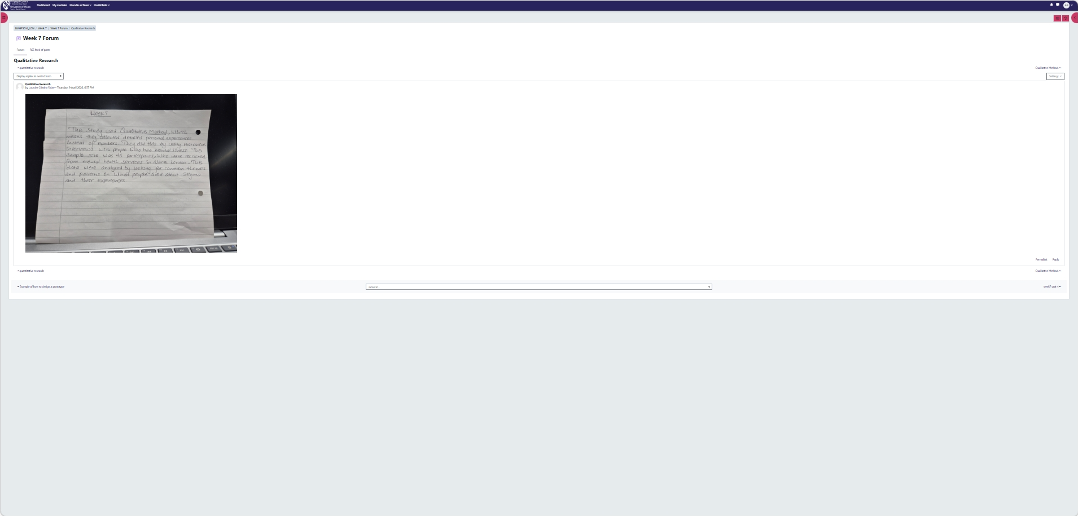

Task 8 – Self-Reflection Journal Entry.

This module has significantly changed how I think about creativity and innovation in healthcare.
At the beginning, I mainly associated innovation with advanced technologies like AI and diagnostic tools. However, through activities such as examining NHS Test Beds and virtual wards, I came to understand that innovation also includes improving processes, shifting organisational culture, and empowering frontline staff to contribute ideas.
One concept that stood out to me was Rogers’ Diffusion of Innovation Theory, which highlighted how important communication, support, and social influence are in successfully adopting new practices.
A key idea I will carry forward is the value of transformational leadership in encouraging creativity. Leaders who create a shared sense of purpose and a psychologically safe environment make it easier for teams to explore and implement new ideas.
In my future career, I hope to apply these lessons by supporting teamwork and promoting pilot initiatives, such as remote monitoring in community care, to improve patient-centred services.

References

Amabile, T.M. (1996) Creativity in Context. Boulder, CO: Westview Press.
Baregheh, A., Rowley, J. and Sambrook, S. (2009) ‘Towards a multidisciplinary definition of innovation’, Management Decision, 47(8), pp. 1323–1339.

Burnes, B. (2017). MANAGING CHANGE BERNARD BURNES SEVENTH EDITION NOW IN ITS 25 TH YEAR. [online] Available at: https://api.pageplace.de/preview/DT0400.9781292156071_A30401762/preview-9781292156071_A30401762.pdf.

‌Hayes, J. (2022) The Theory and Practice of Change Management. 7th edn. London: Bloomsbury Academic.

Porter, M.E. (2010) ‘What is value in health care?’, New England Journal of Medicine, 363(26), pp. 2477–2481.
Rogers, E.M. (2003) Diffusion of Innovations. 5th edn. New York: Free Press.
Topol, E.J. (2019) ‘High-performance medicine: the convergence of human and artificial intelligence’, Nature Medicine, 25(1), pp. 44–56.

Meadows, D.H. (2008) Thinking in Systems: A Primer. London: Earthscan.
NHS England (2023) NHS Workforce Statistics. Available at: [URL] Perlo, J. et al. (2017) IHI Framework for Improving Joy in Work. Cambridge, MA: IHI.

West, M., Bailey, S. and Williams, E. (2020). The Courage of Compassion: Supporting Nurses and Midwives to Deliver High-Quality Care. [online] The King’s Fund. Available at: https://www.kingsfund.org.uk/insight-and-analysis/reports/courage-compassion-supporting-nurses-midwives.

WHO (2010) Healthy Workplace Framework. Geneva: World Health Organization.
England, N. (2024). NHS England» Virtual wards operational framework. [online] England.nhs.uk. Available at: https://www.england.nhs.uk/long-read/virtual-wards-operational-framework/?kuid=5f48a5e4-4809-4c92-9edd-3020f39e0c70-1765152785&kref=KPvnuaLpVIXc&utm_source=copilot.com [Accessed 1 Mar. 2026].
‌
Ravalier, J.M., McVicar, A. and Boichat, C. (2020). Work stress in NHS employees: A mixed-methods study. International Journal of Environmental Research and Public Health, [online] 17(18), pp.1–13. doi:https://doi.org/10.3390/ijerph17186464.

Butler, S. (2025). Understanding burnout in nurses: identification and coping strategies - British Journal of Nursing. [online] British Journal of Nursing. Available at: https://www.britishjournalofnursing.com/content/professional/understanding-burnout-in-nurses-identification-and-coping-strategies. (Accessed 1 Mar. 2026).

Bickerdike, L. et al. (2017) ‘Social prescribing: less rhetoric and more reality’, British Journal of General Practice, 67(662), pp. 435–436.
Davis, F. D. (1989) ‘Perceived Usefulness, Perceived Ease of Use, and User Acceptance of Information Technology’, MIS Quarterly, 13(3), pp. 319–340.
De Lusignan, S. et al. (2019) ‘Impact of Summary Care Records on emergency admissions’, Health Informatics Journal, 25(3), pp. 617–631.

Scirp.org. (2024). Cropley, A. (2006). In Praise of Convergent Thinking. Creativity Research Journal, 18, 391-404. - References - Scientific Research Publishing. [online] Available at: https://www.scirp.org/reference/referencespapers?referenceid=3820227 [Accessed 11 Mar. 2026].
‌

Osborn, A.F. (1953) Applied Imagination: Principles and Procedures of Creative Thinking. New York: Charles Scribner’s Sons.

Scirp.org. (2020). West, M. Bailey, S. and Williams, E. (2020) The Courage of Compassion Supporting Nurses and Midwives to Deliver High-Quality Care. Kings Fund, London. - References - Scientific Research Publishing. [online] Available at: https://www.scirp.org/reference/referencespapers?referenceid=3106131.
‌
Bass, B.M. & Avolio, B.J. (1994) Improving Organizational Effectiveness Through Transformational Leadership

NHS England (2024). What is a virtual ward? [online] www.england.nhs.uk. Available at: https://www.england.nhs.uk/virtual-wards/what-is-a-virtual-ward/.

NHS Leadership Academy (2013). Healthcare Leadership Model: the Nine Dimensions of Leadership Behaviour. [online] NHS Leadership Academy. Available at: https://www.leadershipacademy.nhs.uk/wp-content/uploads/2014/10/NHSLeadership-LeadershipModel-colour.pdf.
Rogers, E.M. (2003). Diffusion of Innovations, 5th Edition. [online] Google Books. Simon and Schuster. Available at: https://books.google.co.uk/books/about/Diffusion_of_Innovations_5th_Edition.html?id=9U1K5LjUOwEC&redir_esc=y.
Department of Health and Social Care (2022). A Plan for Digital Health and Social Care. [online] GOV.UK. Available at: https://www.gov.uk/government/publications/a-plan-for-digital-health-and-social-care/a-plan-for-digital-health-and-social-care.
‌

‌

‌

