 (Everstock Development Ltd, 2023)

Kings Road Health and Safety Report

Callum Griffiths | ACBA4023 | 15/05/2025

Contents
Introduction 2
Building Safety Act 2
Health and Safety Legislation 3
Barriers To Health and Safety Management 4
CDM Regulations 5
Risk Assessment 6
References 7

Introduction
UWTSD Constriction are planning to build a block of flats on Kings Road in Swansea. The flats will be 4-6 storeys, but no overall height is given. This report will look into the Building Safety Act and its possible impacts on the project. It will also look at health and safety legislation which is most applicable to the scenario and how potential barriers can be overcome in the scenario. It will delve into CDM regulation before finishing with a risk assessment for the type of scenario discussed.

Building Safety Act
The Building Safety Act 2022 (BSA) is a piece of legislation brought in to improve building safety to all buildings but particularly in buildings over 18 meters or seven storeys high which are deemed high risk. This was introduced following the Grenfell Tragedy which resulted in the deaths of 72 people. The act came into effect on the 1st of April 2023.
The impact of the BSA on this project will be minimal at this stage due to the planned apartment block being 4-6 storeys, however, below is some general information on the BSA to improve familiarity with the legislation.
In Wales, the Building Safety (Wales) Bill is scheduled for introduction in 2025. This bill has some differences to the BSA. These reforms will apply to all multi-occupied residential buildings, not just those 18 metres and over, meaning the changes go further than the original scope of the Building Safety Act.
In Wales, all residential buildings over 11 metres now have a clear pathway for addressing fire safety issues arising from their construction, extending beyond concerns about unsafe cladding. The Building Safety Programme takes a whole-building approach, considering both internal and external fire safety risks, and prioritising the safety of residents (GOV Wales, 2024).
The BSA as a piece of legislation has improved accountability. For high risk buildings, an accountable person or organisation must be appointed if over 18 meters. Whoever is appointed is then responsible moving forward for repairing any common parts of the building as well as ensuring any fire and structural safety is being maintained. As well as this, the accountable person or organisation must register the new building and receive a completion certificate before any of the apartments are lived in (GOV.UK, 2024b).
As mentioned previously, high risk buildings will need to be registered. These must now be registered with the Building Safety Regulator (BSR) unlike before where the developer had the choice of choosing their own regulator. A BSR oversees compliance and have the ability to stop construction on site if the project is not complying with the legislation. Developers also have to apply to a BSR for building control approval before any construction work starts and once building work has been completed. This will have an impact on the project and must be considered before and after completion (GOV.UK, 2024a).
The BSA has also introduced the requirement for a ‘Golden Thread’ of information. According to ICE, the ‘Golden Thread’ is the term used to describe the information and documents that must be collated and stored in order to safely occupy, manage and operate a Higher-Risk Building (HRB) throughout its lifecycle. This must be in place before the work has been started and must include information from the design stage. This information must also be available for the emergency services so they can respond if required. Contact details, floor plans and details of firefighting equipment must be available in the secure information box (Institution of Civil Engineers, 2024).

Health and Safety Legislation
There are several legislations which are applicable for this type of construction work. The first legislation to discuss is the ‘Health and Safety at Work etc Act 1974’. This is the primary piece of legislation covering occupation health and safety in Great Britain. It sets out general duties which employers have towards their staff and the members of public, employees have to themselves, and certain self-employed people have towards themselves and others (HSE, 2020).
Another piece of legislation which is suitable for this project is ‘The Work at Height Regulations 2005’. The purpose of this act is to prevent death and injury which can be caused by a fall from height. Employers and those responsible for any work at height must ensure that the work is properly planned, appropriately supervised, and carried out by competent individuals. This also involves selecting the correct equipment for working at height. For low-risk, straightforward tasks, less detailed planning may be sufficient. Before any work begins, employers and those in control must assess the associated risks. Employees also have a duty of care for their own health and safety, as well as that of others who may be affected by their actions. They must also co-operate with their employer to help meet health and safety obligations and requirements (HSE, 2019b).
The next legislation to consider is the ‘Manual Handling Operations Regulations 1992’. The Manual Handling Regulations explain the steps that must be taken to prevent and manage risks from hazardous manual handling. First, employers should try to avoid hazardous manual handling wherever possible. If it can't be avoided, they must assess the risk of injury and then take action to reduce it as much as they can. Workers also have responsibilities. They need to follow any safety procedures, use equipment properly, cooperate with their employer on health and safety issues, report any changes or new risks they notice, and make sure they don't put others in danger (Health and Safety Executive, 2020).
Another legislation is the ‘Control of Substances Hazardous to Health Regulations’. By law you must adequately control exposure to materials in the workplace that cause ill health. According to HSE, these substances might include dusts, gases, or fumes that are breathed in, or liquids, gels, and powders that come into contact with the skin or eyes. Harmful micro-organisms could also be present, which may cause infections, allergic reactions, or have toxic effects. Dangerous substances can be found in a wide range of materials, such as paints, cleaning products, flour dust, solder fumes, blood, or waste (HSE, 2019a). Exposure to the hazards can be prevented or reduced by finding out what the health hazards are, running risk assessments and providing measures to limit harm to health.
The final legislation to look at is the Personal Protective Equipment (PPE) at Work Regulation 2022. Under the old legislation, the duty was solely on the employer to provide PPE to employees who may be at risk. Under the 2022 legislation, this duty is extended to limb workers for example flexible workers that are not on full time contracts. Under the legislation, employers must give free PPE to all workers, including temporary and self-employed staff. The PPE must fit properly, be in good condition, and be suitable for the work. Employers also need to provide proper training, so workers know how to use the PPE correctly. PPE should be checked regularly and replaced if it gets damaged or worn out (Work Safe UK, 2025).

Barriers To Health and Safety Management
As with any construction project, there will be potential barriers to help the project meet effective health and safety management. There needs to be a strong, clear and straightforward health and safety procedure with regular check-ups.
One potential barrier to effective health and safety is human factors. For health and safety to work effectively in the workplace, there must be a clear effort from all employees from top to bottom. A lack of communication, risk taking behaviours, poor attitudes towards health and safety are just a few examples of human issues that can hinder health and safety. To overcome this scenario, training and awareness has to be raised to increase skills and change attitudes. Regular site meetings and clear roles can help with communication issues. Site inspections can be introduced to help workers comply with the requirements as well as ongoing health and safety training. As well as employees, management must be committed to overcome barriers. A lack of enforcement for the rules will potentially let that attitude drip down to the workers which will put everyone at risk. Pressure to complete the project by certain dates will put stress on workers and must not be at the detriment to the safety of staff members (International Workplace, 2024).
Another barrier to effective health and safety in the workplace is the complexity of the project and the demands on site. This project in particular is working at height which is a barrier. The working at height legislation previously discussed with need to be adhered too. Physical work at such a height can be dangerous as well as the surrounding environments like weather, temperature and lighting. Thinking skills like attention, memory, and problem-solving are very important for staying safe in busy and complicated workplaces like this project will be. Jobs that need a lot of focus, like using heavy machinery or handling important systems, can easily lead to mistakes if workers are overloaded or bored. Giving workers a good balance of tasks, using things like task rotation and regular breaks, can help them stay alert and do their jobs properly (International Workplace, 2024).

CDM Regulations
The Construction (Design and Management) Regulations 2015 aims to improve health, safety and welfare through a construction project and effects a number of different parties involved. Starting with the client who must make sure their project is suitably managed, ensuring the health and safety of all who might be affected by the work like staff members and members of the general public. The client must also employ a suitable principal designer and principal contractor (HSE, 2015a).
The principal designer is responsible for planning and managing health and safety in the pre-construction phase. Designers must also work together to remove any foreseeable health and safety risks where possible. If risks can't be completely removed, they should take steps to reduce or control them (HSE, 2015c).
The principal contractor similarly is responsible for health and safety issues during the construction phase so must have suitable skills for the role. The principal contractor is responsible for planning and monitoring the entire construction phase. They should prepare a construction phase plan before construction begins and make sure it is regularly assessed throughout the construction phase. They should make sure there are suitable facilities available from the start of the project and regularly consult and engage with workers regarding their health and safety (Health and Safety Executive, 2015).
Another party involved is the worker. A worker is classed as anyone who is working for or under the control of a contractor on a construction site. This includes people like plumbers, electricians, scaffolders, painters, labourers, and supervisors such as foremen and chargehands. Workers play an important role in managing health and safety and should be actively involved. They must only do construction work if they have the right skills, knowledge, training, and experience, or if they are given proper training and supervision to work safely. Workers should also learn about the health and safety risks on each site and understand how these risks are managed. It is important that they always follow site rules and procedures (Health and Safety Executive, 2015).
As well as principal designers and contractors, projects will also have designers and contractors that will report to the principal designers and contractors if some are appointed. Designers and contractors have to consider any information provided by the client and eliminate any health and safety risks. The designer will have to provide design information to the principal designer (Health and Safety Executive, 2015). The contractors will have to coordinate their work with others on the project team and comply with instructions given by the principal designer and contractor (HSE, 2015b).

Risk Assessment
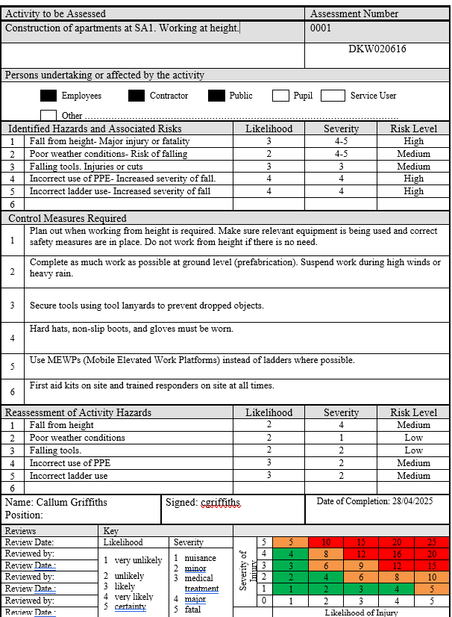

References
Everstock Development Ltd (2023). Block of 104 ‘affordable’ flats set to be built in Swansea’s SA1. Wales Online. Available at: https://www.walesonline.co.uk/news/wales-news/swansea-property-affordable-housing-sa1-28120201 [Accessed 28 Apr. 2025].
GOV Wales (2024). Written Statement: Building Safety in Wales (20 September 2024) | GOV.WALES. [online] GOV.WALES. Available at: https://www.gov.wales/written-statement-building-safety-wales-2 [Accessed 28 Apr. 2025].
GOV.UK (2024a). The Building Safety Regulator is now the Building Control Authority for higher-risk buildings in England - Making Buildings Safer. [online] Making Buildings Safer. Available at: https://buildingsafety.campaign.gov.uk/building-safety-regulator-making-buildings-safer/building-safety-regulator-news/building-safety-regulator-is-now-the-building-control-authority/ [Accessed 27 Apr. 2025].
GOV.UK (2024b). The Role and Responsibilities of Accountable Persons and Principal Accountable Persons - Making Buildings Safer. [online] Making Buildings Safer. Available at: https://buildingsafety.campaign.gov.uk/building-safety-regulator-making-buildings-safer/roles-and-responsibilities-for-high-rise-residential-buildings/role-of-accountable-persons-for-high-rise-residential-buildings/ [Accessed 27 Apr. 2025].
Health and Safety Executive (2015a). Construction - Construction workers: roles and responsibilities CDM 2015. [online] Hse.gov.uk. Available at: https://www.hse.gov.uk/construction/cdm/2015/workers.htm [Accessed 27 Apr. 2025].
Health and Safety Executive (2015b). Construction - Designers: roles and responsibilities CDM 2015. [online] Hse.gov.uk. Available at: https://www.hse.gov.uk/construction/cdm/2015/designers.htm [Accessed 27 Apr. 2025].
Health and Safety Executive (2015c). Construction - Principal contractors: roles and responsibilities CDM 2015. [online] Hse.gov.uk. Available at: https://www.hse.gov.uk/construction/cdm/2015/principal-contractors.htm [Accessed 27 Apr. 2025].
Health and Safety Executive (2020). Health and Safety Executive Manual handling at work A brief guide. [online] Available at: https://www.hse.gov.uk/pubns/INDG143.pdf [Accessed 27 Apr. 2025].
HSE (2015a). Construction - Construction Design and Management Regulations 2015. [online] Hse.gov.uk. Available at: https://www.hse.gov.uk/construction/cdm/2015/index.htm [Accessed 15 May 2025].
HSE (2015b). Construction - Contractors: roles and responsibilities CDM 2015. [online] Hse.gov.uk. Available at: https://www.hse.gov.uk/construction/cdm/2015/contractors.htm [Accessed 27 Apr. 2025].
HSE (2015c). Construction - Principal designers: roles and responsibilities CDM 2015. [online] Hse.gov.uk. Available at: https://www.hse.gov.uk/construction/cdm/2015/principal-designers.htm [Accessed 27 Apr. 2025].
HSE (2019a). COSHH Basics - COSHH. [online] Health and Safety Executive. Available at: https://www.hse.gov.uk/coshh/basics/index.htm [Accessed 27 Apr. 2025].
HSE (2019b). Work at height - The law. [online] Hse.gov.uk. Available at: https://www.hse.gov.uk/work-at-height/the-law.htm [Accessed 27 Apr. 2025].
HSE (2020). Health and Safety at Work Act 1974. [online] Hse.gov.uk. Available at: https://www.hse.gov.uk/legislation/hswa.htm [Accessed 27 Apr. 2025].
Institution of Civil Engineers (2024). The Golden Thread Running through the New Building Safety Act. [online] Institution of Civil Engineers (ICE). Available at: https://www.ice.org.uk/news-views-insights/inside-infrastructure/golden-thread-through-new-building-safety-regime [Accessed 27 Apr. 2025].
International Work Place (2024). Human factors: the impact on health and safety. [online] Internationalworkplace.com. Available at: https://www.internationalworkplace.com/community-zone/news/human-factors-the-impact-on-health-and-safety [Accessed 27 Apr. 2025].
Work Safe UK (2025). Understanding the Personal Protective Equipment at Work Regulations 2022. [online] Worksafe UK. Available at: https://www.worksafe.uk.com/health-and-safety-law/understanding-the-personal-protective-equipment-at-work-regulations-2022/ [Accessed 27 Apr. 2025].

