
Skills for the Workplace
Module Assignment Submission
Student Name: | Phillippa Helen Jones
Student Number: | 2008623
Module No: | BMSK4008
Module Title: | Academic and Research Skills

Statement of Confirmation of Authenticity
By the act of making this submission, the student declares that this is the work of the student named above. The work has not, in whole or in part, been knowingly presented elsewhere for assessment, or where assessment has been built on a previous assessment, this has been identified. Where materials have been used from other sources it has been properly acknowledged. If this statement is untrue, the student acknowledges that an assessment offence has been committed.
Attention is drawn to the plagiarism and unfair practice policies of both the University and of ILM.
Permission for ILM to use this script.
ILM uses learners’ submissions – on an anonymous basis – for assessment standardisation. By submitting, both the centre and the learner agree that ILM may use this script on condition that identifying information is removed. However, if you are unwilling to allow ILM use this script, please refuse by ticking the box: □

Table of Contents
Managing Remotely: Is it the Way Forward? 3
Part 1 3
1.1 Introduction 3
1.2 Research and Findings 3
1.3 Conclusion 3
Part 2 4
Personal Reflection on Managing Remotely 4
2.1 Description 4
2.2 Feelings 5
2.3 Evaluation 5
2.4 Analysis 5
2.5 Conclusion 6
References 7
Appendix 1 8
Appendix 2 9

Managing Remotely: Is it the Way Forward?

Part 1

1.1 Introduction
This report will examine. The topic of working remotely it will show you the pros and cons and the evidence of the finding that was discovered.” while researching about the topic.

1.2 Research and Findings

What was discovered while researching remote working this is what was found that it is about working from home instead of working in an office and you use the internet to talk with your staff or other people who work for the company. Even if they live in another country. Remote working suits a lot of people because its easer for staff with children and people who live in different county’s you can get them all in one place with using the internet like using teams. And if they cannot make a face to face, they can go to the meeting buy using teams and still be there in the meeting. Business these days are using remote working a lot with the covid 19 to still be able to run their company and not lose their business. And to help deal with staff buy manging them remotely they do not have to try and get them all in one place they just do it through the internet and have meetings that way. Being able to remote manage is easier this way so you can keep in close contact with your staff and other people say if they live in different time zones or say a single mum cannot get a babysitter for the kids, she can work from home a lot of companies are finding that their staff are less stressed and find it easier to sort your childcare out better. And they work better not being under so much stress and the company is benefits from it in the long run. Only thing of managing a remote team you need to think about is hiring the right people for your team. And to always be respectful of your staff and there needs and times they can come online so work out a times that suit them all. You must set schedules and it will be hard to track their performance, but it does suit a lot of people. I did a questionnaire with my colleague and my finding was most people liked working from home. but you will find if you give people the trust, they will give you there best. Make you are you are always keeping in contact with your staff and parsing them for all they do for the company and all ways arrange party nights or get togethers once or twice a year for team building and make sure they always feel part of the team. And always make sure you set boundaries and targets for them all and make sure you invest in the right project management software for your team to able to use and that they always get the support from you. Happy staff stay with the company.
B. Z. LARSON
S. R VROMAN
ERIN.E MAKARIUS
(18.3.2021)

Employees Hired Remotely In 2020 Say They are Doing Fine. The Data Says Not Really

Mark C. Perna
Contributor
Careers
I explore Millennials and Gen-Z in careers, education, and the workforce.

Managers, co-workers, and new employees themselves all have a role in connecting new hires to the company culture. The news is full of workers who lost their jobs during the pandemic—but there is surprisingly little about those who were hired and onboarded remotely during that time. How are they doing? According to them, just fine At first glance, a new survey from TINY pulse seems to agree with new employees’ assessment of their own engagement—at least on the surface. A comparison of how 2019 and 2020 new hires rated their overall onboarding experience gave 2020 an edge, about 2% higher than the 2019 data. But there is something else going on beneath the surface. The researchers pulled data from TINY pulse’s employee recognition tool Cheers for Peers, which allows employees to give one another sophisticated, virtual “high fives.” On that platform, peer-to-peer recognition has dropped significantly (34%) for employees who came to the organization during the lockdowns, compared to their 2019 counterparts. This drop remains consistent for every month in the scope of the survey (April through September 2020).
Further, Cheers for Peers allows new hires to tag their Cheers with a predefined company value. The study notes that while the rate of company-value-tagged recognition stayed steady in April and May, it fell significantly for the rest of the year—a 20% decline.

TINY pulse researchers believe that the drop in tagged values corresponds with employees’ decreasing identification with those company values. And it is not a good trend.

Flying under the radar
Unfortunately, it seems all too easy for COVID-era hires to “fly under the radar” and not express their disconnect with co-workers and company values. They may be rating their onboarding experience highly without an accurate basis of comparison for that experience. In a word, they do not know what they missed—or what they are still missing.
Flying under the radar may not be on purpose, but it is a problem, nonetheless. “Many conversations that used to occur organically in the office, don’t happen now because the causal collisions are less frequent,” says researcher Brooks C. Holtom. “Further, valuable non-verbal cues are hard to observe and act credibly on via technology.
“Making life even more difficult for managers is that spotting poor performance can take more time in the remote environment. So, problems may fester and grow worse than if everyone were in the office.”
Flying under the radar will only work for so long. Companies need a better approach.

Managers, tell stories.
Companies can step up their efforts to make their organizational values more visible, beyond just the recruiting and onboarding process. “Storytelling is a powerful way to help employees—and especially newcomers—to learn what is important to the organization and its stakeholders in real terms,” says Holtom.
“Sharing stories of employees who go above and beyond to deliver value for customers will energize those recognized and provide meaningful examples of values in action for newly onboarded employees.”
As a manager, you play a key role in your employees’ connection to the company. So, tell stories.

Co-workers, reach out.
Maybe you are not in a managerial position, but you want to help your newly hired co-workers engage more deeply with the team and company values. Holtom has a word of advice for you, too. “Peers should reach out, ask questions and listen sincerely.”
Reaching out is not rocket science, but in the age of the Zoom fatigue, it may not always be easy. “Reaching out is meaningful precisely because it is hard,” says Holtom. “Sharing pictures, short videos and stories will help bring much-needed context to new employees.”
It is what you would want someone to do for you. So, reach out.

New employees, ask questions.
If you are a newly hired remote employee, you can take ownership of your own growth as a contributing and connected member of the team. “New hires need to ask questions,” advises Holtom. “Keep lists of questions right next to the computer. Some will be tactical and others more strategic. Some will be social. When a supervisor or peer asks, be prepared to share your questions.
“A keen interest in learning how to perform at a high level will be appreciated and rewarded with good answers.”
You owe it to yourself and to the company to engage with the culture and the co-workers who are part of your professional world. So, ask away.

What happens if new employees never make the connection?
Unfortunately, it is all too easy to be anonymous in a remote workforce. Virtual work is not as conducive for social connections as being in the office, where you could bump into anyone over your day.
The anonymity of a remote workforce is more than just a passing problem that will resolve itself when we can all get back to the office. Employees who were onboarded remotely during the pandemic may never fully connect with the company’s core values. And by the time it is safe to return to the office, the new employee is no longer new—and there may be an assumption that they are already embedded in the fabric of the organization, when in fact they may not be.
If employees never made that crucial first connection, there may be a core disconnect from the company that will affect how they relate to co-workers and company values throughout their time there.
What will the outcome be if companies do not grapple with the dropping levels of new-employee engagement? “Low levels of employee engagement are correlated with poor performance and elevated turnover rates,” says Holtom. “During periods of high unemployment, people may not leave an employer. But staying does not guarantee they will deliver value every day or go above and beyond for customers.”
If managers tell compelling stories, co-workers reach out and new employees ask questions, the transition to a fully oriented, onboarded experience will become a lot easier. In the end, it all comes down to empathy. “Put yourself in the shoes (or fuzzy slippers) of the newcomers,” says Holtom. “Be generous. Be patient.
“Support from a supervisor and peers can make the difference between success and failure.”
Follow me on Twitter or LinkedIn. Check out me website or some of my other work here.
Mark C. Perna
I write about unleashing passion, purpose, and performance in younger generations and how that intersects education, career, workforce development, and the new multigenerational workplace. I founded TFS Results, a full-service strategic communications and consulting firm, to coach my clients in maximizing recruitment, engagement, retention, and performance rates. As an international generational expert, I’ve spoken at Harvard University by special invitation and today deliver more than 70 virtual and in-person keynotes every year across North America. Every weekday, I host 'The Perna Syndicate' Alexa Flash Briefing to open the playbook for success, both for young people and their parents, educators, and employers. My work has appeared in numerous national publications and I interview frequently on radio shows, television, and podcasts to discuss the shifting education and employment landscape, generational divides, and viable pathways for today’s young people. I wrote my award-winning bestseller, 'Answering Why: Unleashing Passion, Purpose, and Performance in Younger Generations,' to help educators, employers, and parents understand the Millennial and Z Generations and motivate them to greater performance in all areas of life. Find out more at
MarkCPerna.com.
02/16/2020

GRAPHS AND PIE CHARTS SHOW RESULTS OF QUESTIONNAIRE DONE 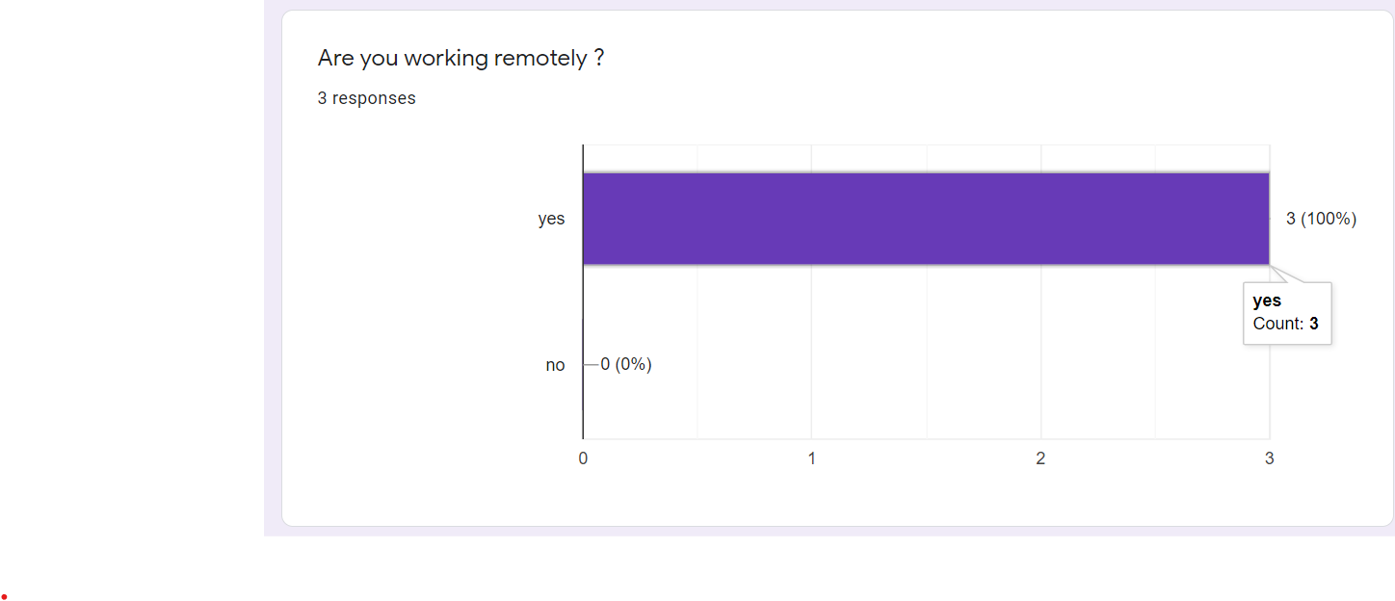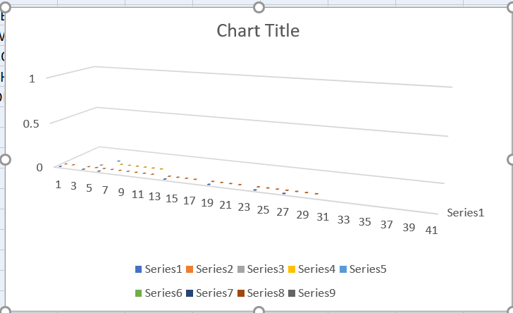
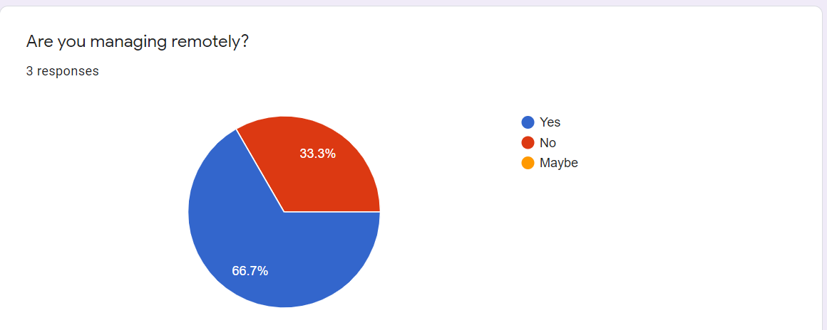

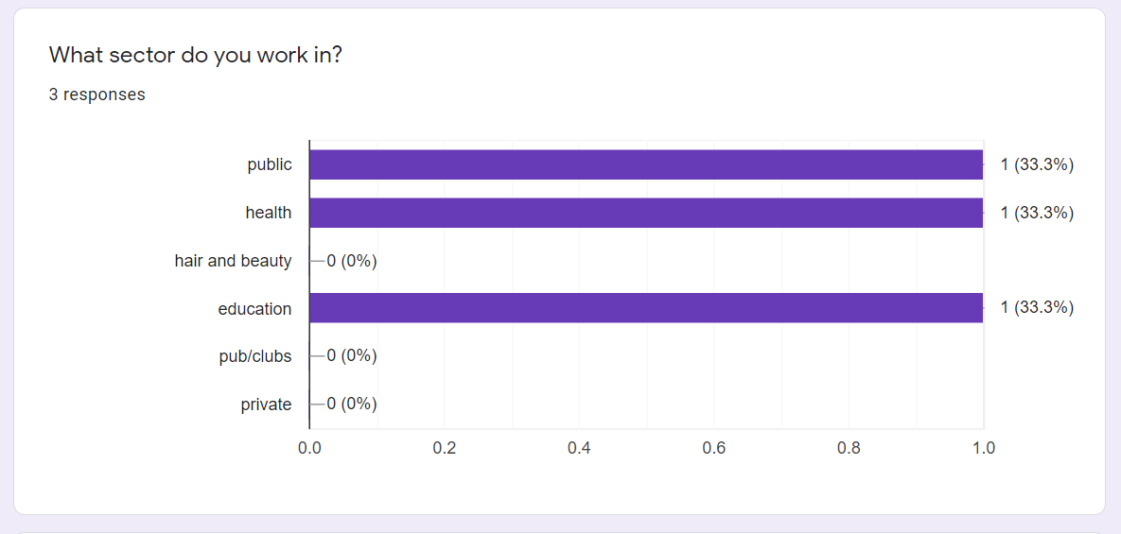
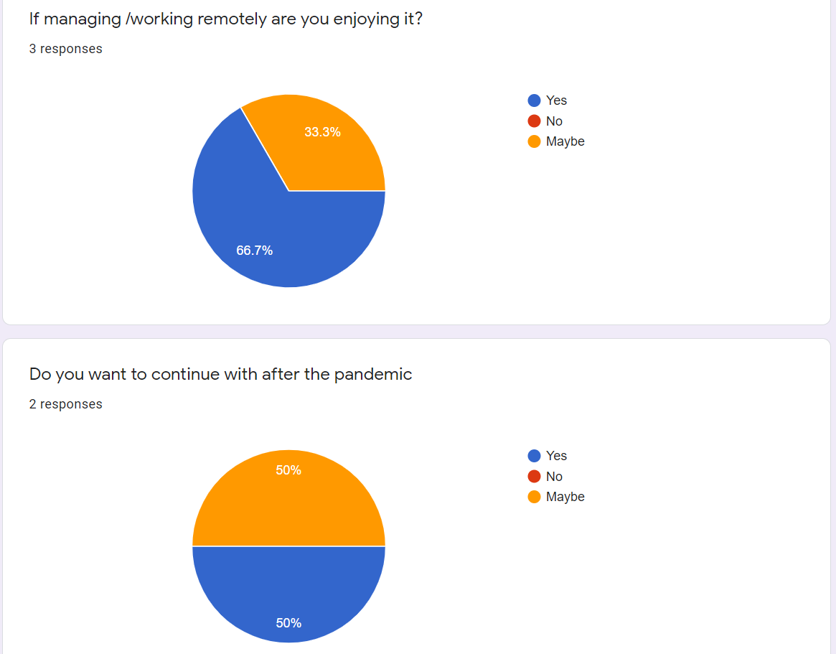
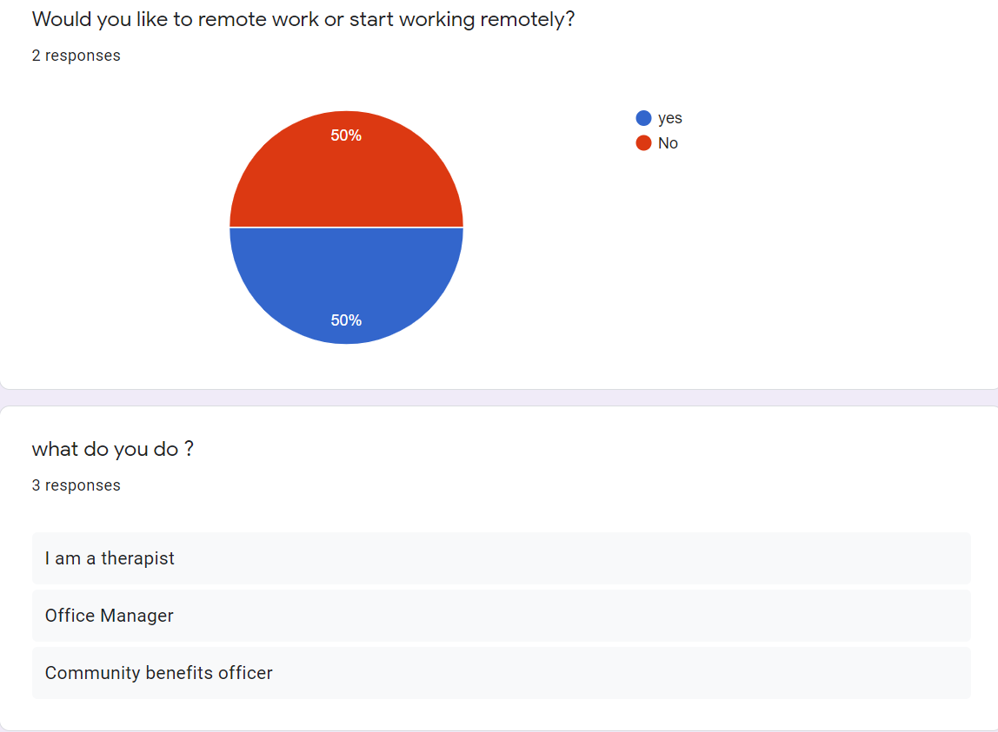

1.3 Conclusion
The research has showed that a lot of people found it hard to work remotely at first but then it started to suit them because they didn’t have to struggle with childcare or getting to the meeting say if they lived in another county, they could still be there by using the internet and teams to keep up to date with their job the owners of the company so in the long run it benefited them and the company And the people who worked for them it was less travel for them to.

Part 2

Personal Reflection on Managing Remotely
My opinion on remote working is that its ok but I find it hard myself because I suffer with learning difficulties, so I prefer the one on one or the face=to=face. I contact. I will not be taking on remote working after the pandemic. I cannot wait to go back to normal.


Gibbs (1988)

2.1 Description

While working on this assignment we learned about working remotely and data/analysing responses from questionnaire. we were tort how to use excel speed sheets and the pyramid and the Gibbs. and how to use forms to design a questionnaire. And collect the data from it. And how to paraphrase articles we have read and put them to our own words after we have read it. and how to manage are time.

2.2 Feelings
My feeling on doing this assignment is that it was hard but good to learn all the new things you would need to do spread sheets and questionnaires and collecting data, information, pyramid. And how to analysis all the information I have found while researching the internet.

2.3 Evaluation
What was good about doing this assignment was learning all the new skills that I can take with me to my job or to the next year in uni.

2.4 Analysis
What sense I made of doing this assignment was I learned a lot about using all these different things I could use for work or university.

2.5 Conclusion
I could have managed my time a bit better and got some help for me to understand a lot better with writing this assignment because my head go's when I do not understand things and my depression and anxiety kicks in.

References
Hittps:/Hbr.Org/2020/03/a-guide-to-managing-your-newly-remote-workers
B, Z, LARSON
S, R, VROMAN
E, E, MAKARIUS (03,2020) hbr.org/2020/03A-guide-to-managing-your-newly-remote-workers/harvrdbusinessreview.
Gibbs, G. (1988) Learning by doing; A guide to teaching and learning methods. London: FEU
MARK C. PERNA (16.FEB.2021) WWW.FORBES.COM/SITE/MARKCPERNA/2021
Marc, c, perna (16,02,2012) www.forbes.com/site/markcperna/2021

Appendix 1
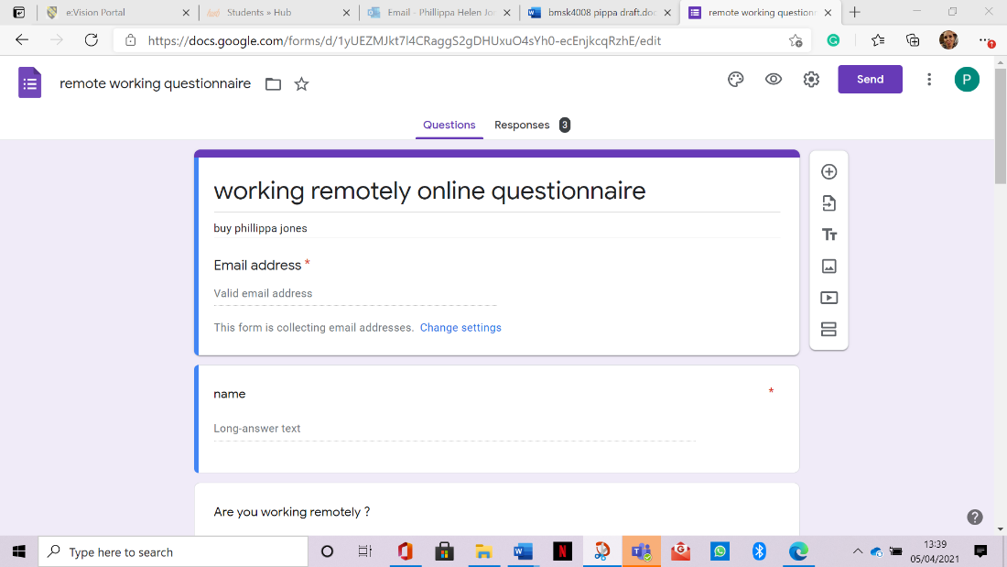

Appendix 2

