University of Wales Trinity Saint David

Wales Institute of Science & Art



Engineering Workshop Research Report
Workshop and Practice (ACHA4011)

Bleddyn Williams
104564
July 2022

Contents
1 Introduction 2
2 Health and Safety Legislation 3
2.1 Health and Safety in the University Workshop 3
2.2 Supervision 3
2.3 Training 3
2.4 Operating Practices 4
2.5 Personal Protective Equipment (PPE) 5
3 Mill and Lathe Operating Procedures 6
3.1 Health and Safety 6
3.2 Machine Compounents 7
3.2.1 Mill 7
3.2.2 Lathe 8
3.3 Machine operations 10
3.3.1 Mill 10
3.3.2 Lathe 10
4 Internal Combustion Engine (ICE) Opertation 12
5 Suspension Calculations 13
6 Validation and Conclusion 13
7 Reference List 14

Introduction
This is a technical report on the Health and Safety legislations, operating principle of a Lathe and Mille machine as well as the general operation of an internal combustion engine. During this report, a reference will be made to the health and safety legislations that, as a student I will encounter and adhere to when operating the machinery on university campus. As well as this, the importance of Personal Protection Equipment (PPE) will be discussed and the types of PPE available within a machine workshop. This is necessary in order to safely operate and machine component parts to be used in an engine for instance. Furthermore, the correct operating procedures or the Mille and Lathe machinery will be reported, and the programming required on these machines to execute the cuts required to machine the desired components. A further discussion will also be made to examine the architecture of three different internal combustion engines, another necessary topic to understand in order to machine suitable parts for operation. The three internal combustion engines that will be discussed are the four stroke ‘Otto’ cycle engine and the two-stroke engine and the rotary ‘Wankle’ engine. Following research into the operation and operating conditions of these engines, an understanding of the conditions and tolerances that must be met when machining components for these engines.

Health and Safety Legislation

Health and Safety in the University Workshop
Health and safety legislation is a set of laws and regulations in place that govern how I as a university student manage health and safety. It is in place to maintain safety of the staff, fellow student and myself.
Before any work is carried put in the workshop, risk assessments must be made while entering the workshop. This is a necessary step to understand and control the possible risks in the workplace. The safe working practices must be followed by all workshop users and enforced by the supervisor on hand.

Supervision
The supervision of an appropriate member of staff is compulsory at the university when operating the machinery, in this case it would be the university technicians. These supervisors must be within sight or hearing range of the ‘competent’ machine operators in order to offer assistance in the case of an emergency. However, if an operator is considered as ‘non-competent’ then further supervision is required by the supervisor to maintain safe practice. The name and picture of authorized supervisors would be displayed on the wall at the entrance to the workshop.

Training
The appropriate training is required to ensure good working practices are being maintained. These are general, machine specific and familiarization. General training which consists of the basic skills and knowledge common to all machines in the workshop. This includes aspects such as good housekeeping of the machines. The machine specific training will consist of the position and location of the machine emergency stops as well as the operation, movement and machine dynamic. Within this training there will be a demonstration of the guards and safety devices on each class of machine. Finally, familiarization training with the machines will be made under close supervision of the appropriate members of staff to ensure the operator gains experience and understanding of the machine operation in order to maintain safe working practice for future use. (UCL, 2022)
Another risk controlling measure is the use of entry control. Each workshop shall be securely closed so long as its reasonably practicable when proper supervision isn’t available. Furthermore, all hazardous equipment such as the mill and lathe machine, secured to prevent unauthorised use. Only following permission for an authorised member of staff can this equipment then be used. As well as this each workshop entrance must display a notice to include:
- Any person looking to use thus workshop must have completed the workshop induction.
- A person must let themselves known to the relevant member of staff in charge
- Fixtures must be inspected for defects before use.
- All machine blades and cutters must be left stationary with the brakes on and power isolated in the off position.
- Machine guards must be properly adjusted and used where provided.
- No person shall use machinery when tired, using medication or under the influence of drugs or alcohol.

Operating Practices
When access is permitted to the workshop, there are general operating practices that must be followed in order to maintain a safe working environment and operation of machinery. (UCL, 2022)
- Eating and drinking is strictly prohibited inside the machine workshops
- Appropriate clothing must be worn, appropriate clothing will be determined by the supervisor in charge.
- Loose clothing such as ties and necklaces are prohibited in the areas where rotary machinery is in use. Long hair must be tied back if the supervisor deems the length hazardous.
- Any spillage if oil or grease must be cleaned up right away. All persons are responsible for good housekeeping inside the workshop.
- Refer to the manual handling guidelines on display on the workshop walls when lifting and carrying objects to maintain visibility and reduce stress to the body.
- Carry out a COSHH (Control of Substances Hazardous to Health) risk assessment before handling any hazardous substances.

Personal Protective Equipment (PPE)
As well as maintaining good operating practices and risk assessment, PPE is mandatory when entering the workshop. PPE in use is dictated by the work/risk assessment. The workshop technicians will provide the appropriate PPE following the workshop induction, it is then the responsibility of the student to bring this PPE to all workshop sessions. An example of the PPE supplied is lad coats, safety glasses and safety boots. This equipment is mandatory at every workshop. Further PPE that will be supplied is barrier cream, ear protection and dust masks, these however will only need to be worn when the supervisor deems it necessary via the risk assessment.

Mill and Lathe Operating Procedures

Health and Safety
When using a Mill and/or Lathe there are pre-operating safety checks, operating safety checks and ending operation procedures.
Pre-operational safety checks
- Locate and ensure familiarity with all machine operations and controls
- Make sure all guards are fitted and operational
- Ensure there are no slip or trip hazards in the workspace
- Ensure the cutter/tool is in good working condition

Operating Safety Checks
- Keep clear of moving/rotating parts
- Reduce overhangs as much as possible and follow correct clamping procedures
- Set the correct speed for the cutting depth and diameter.

Ending operations and cleaning up
- Switch off the machine when the work is complete via the power isolation point
- Remove cutters/tool and store them in a safe place
- Clean up any debris safety, ensure not to handle with bare hands due to a cutting hazard
- Leave the machine and workspace in a clean, safe state.
(WorkSafe, 2021)

Machine Components

Mill
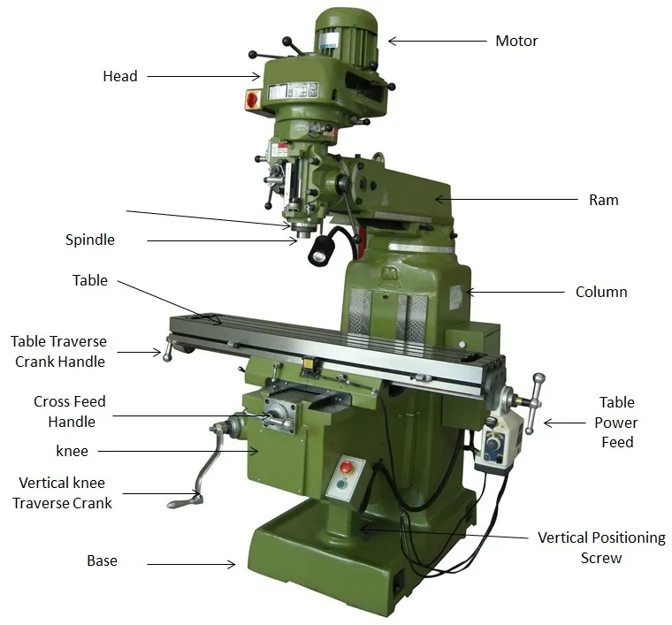
Figure ‎3.1 - Mill Machine (Pankaj Mishtra)

Column and Base
The column and base work as a housing for all other driving members. It is a hollow member consisting of a driving gear as well as an oil repository to lubricate components

Knee
The knee is the first moving part of the Milling machine. While the saddle and table support the casting, the gearing device is included in the knee.

Saddler and Swivel Table
The saddle is located at the knee and supports the table, the saddle slides on the horizontal dovetail. The swivel table, however, is attached to the saddle which moves horizontally in both directions.#

Power feed mechanism
The power feed mechanism is used to control longitudinal, transverse and vertical feeds. The feed selection lever can be used for different desired rates of feed.

Table
The table is a rectangular casting at the top of the saddle. This is used to hold a task or can be used to house task holding devices. This can be moved by the machine or by hand.

Arbor Support
This is a cast with a bearing that supports the outer end of the Arbor. This helps prevent springing of the outer end of the Arbor in a cutting position.
(Engineering Choice, 2020)

Lathe
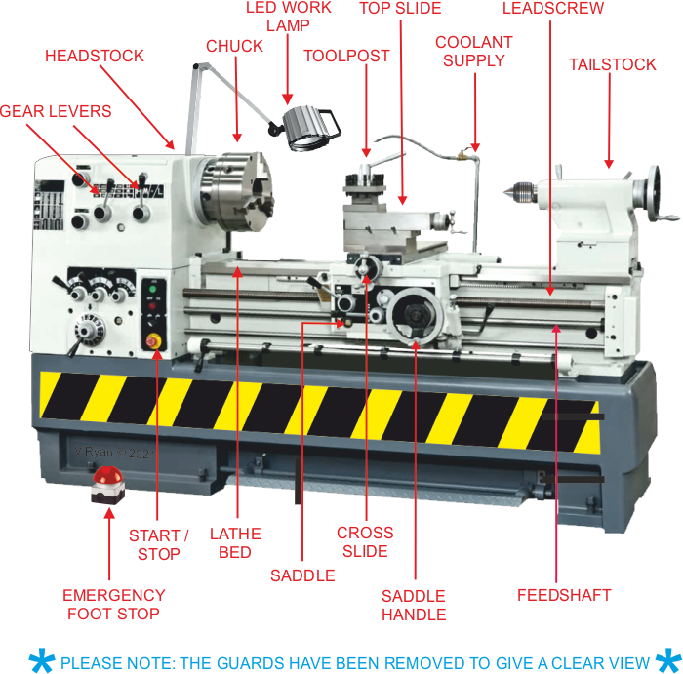
Figure ‎3.2 - Lathe (V. Ryan, 2003)

Headstock
Located on the left side of the Lathe, it has spindles, gears, gear speed controllers, checks and feed controllers.

Tailstock
Located on the right-hand side of the Lathe, this supports the end of the workpiece

Bed
This is the base/main part of the lathe. Here everything is bolted to from the headstock, tailstock, carriage rails etc.

Chuck
This is used to clamp the work piece in place, typically housing a guard over the top of the chuck.

Tool post
This houses the cutting tool; adjustments can be made at the too post to move the cutter out of the way in order to manoeuvre the workpiece before cutting.

Gear levers
These are equipped with different rotation speed of the Lathe, the quicker the speed the greater finish on the work piece.

Saddle handle
This is used to move the cutting tool on a x and z axis, these also contain markers to display length of travel at the cutting tool to aid with accurate cuts

Foot brake
This is an operational brake to be used during to cutting phase to examine the workpiece in between cuts. Good practice is to hover your foot over this brake when operating the Lathe.

Emergency Stop
The emergency stop button is a power isolation location that will cut the power to the Lathe inn the event of an emergency, this should not be used to stop the machine between cuts

On/Off switch
This is another power isolation point; this should always be turned off after the machinist is finished using the Lathe machine
(Market Prospects, 2020)

Machine operations

Mill

Face milling
Face milling is the simplest of milling operations, it is performed by a face milling cutter rotated about an axis perpendicular to the work surface. The depth of the cut is adjusted by rotation the cross-feed screw.

Side milling
This type of milling is used to produce flat vertical surfaces at the side of the workpiece by using a side milling cutter. The depth of the cut is performed by using the vertical feed screw.

Plain milling
This is the most common milling operation; it is used to produce a flat horizontal surface that is parallel to the mounting surface. This is performed by rotating the vertical feed screw to make the cut into the work piece

Angle milling
This is used to perform cuts that are neither parallel or perpendicular to the work surface. This is accomplished by varying the contour of the angle cutter used.

Lathe

Turning
Turning is the removal of material from the outside of a workpiece to obtain one or more finished diameter. This can be accomplished via plain turning, which has equal diameters throughout the workpiece. Stepped turning is another method, where the objective is to have varying diameters that progressively decrease step by step. And finally tapered turning which has two different diameters on each end with a consistent angle between the two.

Facing
This is the machine of the workpiece face to gain a smooth finish. This is accomplished by slowly machining the face of the material at a high rotational speed.

Parting off
This operation involves cutting the workpiece into two parts by using a parting off tool. This is done in the same manner and operation as when facing a tool, only with different apparatus.

Drilling
This is used for making a standard size hole in a workpiece using a drill which is held in the headstock

Boring
Boring is the operation of enlarging a drill hole by using a boring tool, this is fitted onto a boring bar at the headstock of the Lathe.
(Sachin Thorat, 2022)

Internal Combustion Engine (ICE) Operation
The internal combustion engine is designed to convert the chemical energy of fuel ignition into the rotational energy at the geartrain in order to provide rotational force at the wheels and move a vehicle. There are many different approaches to achieve this common goal with some engines opting for 2 strokes, the very common ‘Otto’ cycle engine using 4 strokes as well as the ‘Wankle’ engine employing a more unorthodox 4 stroke setup.

2 stroke engine
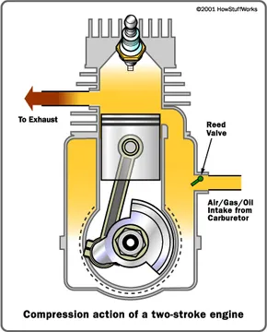
The two stroke is a type of ICE that completes a power cycle in just two strokes. Following the initial turning of the flywheel which rotates the engine via the starter motor, the first stroke (intake & compression) begins. During the cycles of the engine the crankcase houses fuel, air and oil mixture consistently topped up via the inlet port and reed valve (allowing fuel to only flow one way). As the piston travels from to bottom dead centre (BDC) to top dead centre (TDC) an opening via the transfer port allows fuel to enter the combustion chamber. This is followed by the piston compressing the fuel mixture and closing off the exhaust port at the top of the cylinder chamber, achieving compression as a result. Following this 1st stroke ignition occurs beginning the 2nd stroke of the engine (Power & Exhaust). As the piston is forced down the bore this in turn rotates the crankshaft connected to the piston via the connecting rod, providing power via rotational energy. As this piston travels down the bore, it passes below the transfer port which simultaneously allows the next cycle of fuel mixture above the piston into the combustion chamber. As a result, this mixture purges the combustion chamber of the exhaust gasses and forces them out through the exhaust system, completing the second stroke and cycle of the 2-stroke engine. A consideration must also be made that this engine has poor emission standards due to the inefficient injection system as well as the oil burn contact due to the engines lubricating agent having to be added to the fuel mixture. This resulting in a burning of oil as well as fuel.

‘Otto’ 4 stroke engine
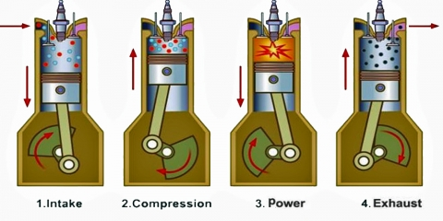
This engine compassion is the most common of the three engines in automotive and racing applications. This is due to the level of control available in regard to lubrication, fuel injection as well as longevity. This engine has 4 strokes as opposed to two and instead of inlet and exhaust ports, uses valves to control the flow of gasses/fuel mixture in and out of the combustion chamber. During the first 180° of the 720° engine rotation as the piston travels from TDC to BDC, a Stoichiometric ratio of fuel is injected into the chamber via the opening of the inlet valve. During the second 180° of engine rotation with both valves closed the piston compresses the volume of the cylinder containing the fuel mixture into the combustion chamber as it reaches TDC. A few degrees following TDC a spark is created at the spark plug located in the most efficient location of the combustion chamber to ignite the fuel and force the piston down the bore via a controlled burn. This is called the power stroke as established when discussing the two-stroke engine. Once again, the Piston will now travel from BDC to TDC beginning the final, exhaust stroke. With the exhaust port open and piston travelling up the bore, the burnt exhaust gasses are forced out of the exhaust chamber, this is also aided on some engines with the premature opening of the inlet valve to scavenge the exhaust gasses using fresh air/fuel mixture. This engine can be set up with multiple cylinders to balance out the power and torque achieve during the non [power strokes of each cylinder.

‘Wankle’ Rotary engine
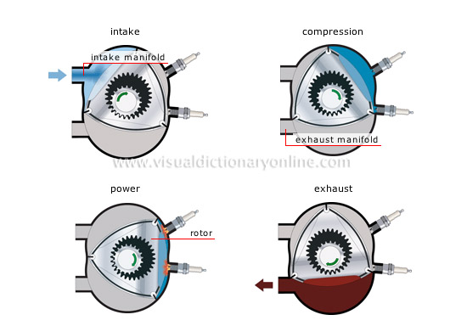
This is a more unorthodox and my personal favourite interpretation of the ICE engine is the rotary ‘wankle’ engine. An engine similar to those found on some older single propeller planes this engine combines many principles of the two stroke and four stroke engine. While this engine has the inlet and output ports similar to the two-stroke engine and the enclosed housing of the four strokes, it achieves a power stroke every 120° of rotation on its eccentric shaft (Three per cycle). This engine uses a curved triangular shaped rotor with apex seals at the corners, creating three potential chambers for combustion inside the housing. It also used a toothed gearing instead of a connecting rod to the crankshaft. This engine achieve its conversion of chemical energy to rotation energy by closing off the exhaust port as it passes the intake manifold, allowing air/fuel mixture into the combustion chamber. It then rotates another 120° compressing the fuel mixture into the right-hand side of the housing, which is then ignited by the spark plugs shortly after, leading to the power stroke. And finally, the engine completes the 360° rotation by passing the exhaust manifold allowing the exhaust gasses to escape the chamber. This cycle happens three times during a full rotation leading to this power stroke every 120° of engine rotation.

Conclusion
In conclusion due to the greater number of power strokes available with the Rotary ‘Wankle’ engine this would be a great choice to access a more consistent torque and power curve due to less travel on inertia alone. However, the Rotary engine suffers from greater reliability issues than the 4-stroke cycle engine as well as a less sustainability coefficient in regard to fuel emissions. Therefore, the 4-stroke cycle ‘Otto’ engine is the greater engine compassion.

Reference List
UCL 2022 - https://www.ucl.ac.uk/safety-services/policies/2020/oct/workshop-safety
Engineering Choice, 2020 - https://www.engineeringchoice.com/milling-machine/
Market Prospects - https://www.market-prospects.com/articles/the-parts-of-lathe-machine
V. Ryan, 2003 - https://technologystudent.com/equip1/mlathe1.htm

Safety Operating Procedures, Milling Machine – www.worksafe.tas.gov.au
Panjak Mishra - https://www.mechanicalbooster.com/2016/12/what-is-milling-machine-operation-parts-types.html
Sachin Thorat - https://learnmech.com/lathe-operations-explained/

