
PSYchology in Health and social care
Why Psychology is relevant in our Health and Social care practice?

27 March 2023
Nazreen Akhtar 2128933
DR Hayley Trower
LCHS4006_BIRM
Contents
Introduction 1
Piaget’s Theory of Cognitive Development 1
Erikson’s Theory 2
Social Identity Theory 3
Conclusion 4
References 5

Psychology in Health and Social Care

Why psychology is relevant in our Health and Social Care practice?

Introduction

In this written report I will be discussing several theories that are used within the health and social care departments. I have chosen to evaluate Piaget’s, Erikson’s, and Social Identity theories. I will be identifying the theorists and providing practical ways in which each theory may support a health and social care professional. Additionally, I will be explaining whether I agree or disagree with the statement “A health and social care professional who understands psychological theories of lifespan development and behaviour can be more effective in their role than a health and social care professional who doesn’t understand these theories.” Finally, will be concluding this report by summarising the important points I have made and the relevance of psychology to a health and social care professional.

Piaget’s Theory of Cognitive Development

Jean Piaget discovered and developed the theory of Cognitive Development. Piaget identifies himself as an epistemologist which is a branch of psychology this is concerned with nature and the limits of human knowledge. He suggested that children have a different thought process than adults and that they should group the knowledge they learn by their experiences into schemas (Cherry, 2023). Jean Piaget discovered four stages of Cognitive Development through his observations of children of different ages. The stages include the Sensorimotor stage (0-2 years old), Preoperational stage (2-7 years old), Concrete operational stage (7-11 years old) and Formal operational stage (11 years old through adulthood).
The first stage, Sensorimotor Stage states that children learn about the environment they are in through their motor activities and senses. This stage has six substages where children’s behaviour moves from being reflex driven to more abstract. These substages are uses of reflexes, primary circular reactions, secondary circular reactions, coordination of secondary schemes, tertiary circular reactions, and mental combinations. At the end of this stage, children begin to use mental abstractions. The Preoperational Stage indicates that children begin to use mental representations and less psychical appearance of people or objects. An example of this is children engaging in pretend play. In this stage, children start to understand categorisation which is classifying items based on similarities or differences, numbers, and quantities. The Concrete Operational stage is where children can problem solves as they can view different perspectives. This stage involves children struggling with problems with conversations. Finally, in the Formal Operational stage, children contain thoughts about abstract concepts and aren’t limited to a person, situation, or time. They can think about hypothetical scenarios and different possibilities (Alicia Nortje, 2023).
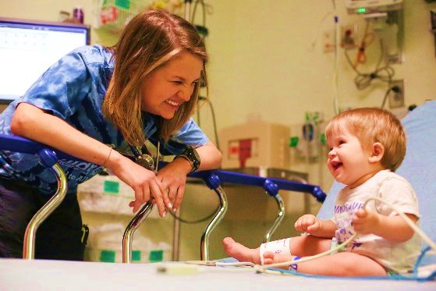
Jeans Piaget’s theory of Cognitive Development is important for health and social care professionals as it provides time with insights into the cognitive process during childhood. It helps professionals identify what actions and words need to be taken into consideration for different-aged children. It also develops professionals understanding of social environments and complex human behaviours that influence their patients' lives and problems. Piaget theory guides professionals with their sense of purpose, control, and direction. The theory also assists them in planning and finding ways to interact with specific aged patients. (Brearley 2022).
(Oliviero, 2016)

Erikson’s Theory
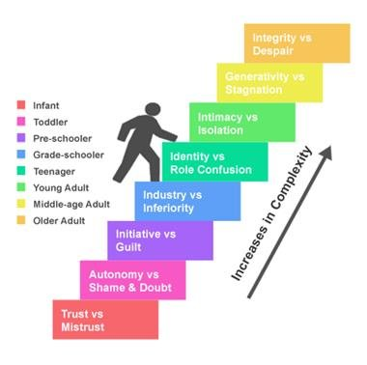
Erikson discovered the psychosocial theory of Human Development. Erikson was a Neo-Freudian psychologist who revisited the central tents of Freudian theory and adds his own beliefs and ideas. Erikson’s theory contains 8 stages of Psychosocial Development At each stage, he states people face a crisis that needs to be successfully resolved to develop the psychological quality central to each stage (Cherry. K, 2023).
Trust vs Mistrust is the first stage of Erikson’s theory. This stage occurs during birth and the age of one and a half years (Cherry. K, 2023). The stage illiterates that trust development is based on the dependability of the child’s caregivers. Successful development of trust will encourage the truest ad safety for a child. However, if the caregiver doesn’t provide the right care for the child the child will then lose trust in them which can result in fear (Cherry, 2022). The second stage is Autonomy vs Shame and Doubt, this stage takes place during early childhood and focuses on developing personal control. Erikson states that children begin to gain independence at this stage and can perform basic actions on their own, Children are also able to make simple decisions, and caregivers can help develop a sense of autonomy by allowing them to have a little amount of control. Initiative vs Guilt is the third stage of this theory. This stage takes place when a child is between the ages of 3 to 6 years old. Children in this stage assert their control and power by directing place and social interactions. Stage four is named Industry vs Inferiority; this stage takes place when a child is between the ages of 5 to 11 years old. In this stage, children develop s sense of pride in their accomplishments and abilities through social interactions. The next stage is Identity vs Confusion, which states the development of personal identity and how it can influence children’s behaviour for the rest of their lives. During teenage years people begin to be more independent and develop a sense of self. At the Intimacy vs Isolation stage young adults for love relationships. Success resulted in strong relationships however failure can equal loneliness. Generativity vs Stagnation is the seventh stage, and it involves adults having to create and nurture things that will be with them through the rest of their lives. For example, having children is a positive change. Finally, stage eight is Integrity vs Despair, and it involves old, aged people reflecting on their life and feeling a sense of fulfilment or regret (Cherry, 2022).
(Google, 2023)
Erikson’s theory is important for professionals in health and society as they should understand the developmental tasks of a person under their care. An example of this is if a nurse is caring for an infant, and knowing they must contain trust, they must make sure that they complete every task the infant needs. When treating the elderly, a nurse who understands that the choice between despair and ego integrity is a developmental responsibility can help the patient in discovering integrity in reflecting on their lives.

Social Identity Theory

Henri Tajfel, who was a social psychologist discovered the theory of social identity with his colleagues. Social identity is a person’s sense of whom they identify as in their group membership. Tajfel stated that groups such as social classes, football teams and families to which people belong are an important part of self-esteem and pride. Tajfel and Turner proposed 3 social identity theory stages.

Social Categorization is the first stage, this states that people categorize objects to understand and identify them, and similar people categorize one another to understand the social environment. If we assign people to a specific group, it can indicate knowledge about the people. The theory states that people define behaviours by references to the norm of groups they belong to, an individual can belong to many different groups. Social Identification is the second stage as people adopt the identity of the group, they have categorised themselves as belonging to. For example, if you categorise yourself as a nurse the chances are that you will adopt the identity of a nurse and begin to act in a certain manner you believe a nurse acts. Furthermore, a person’s identification with a specific group will include an emotional significance and their self-esteem will be one with the group. Social Comparison is the final stage of this theory, after the process of categorisation within a group and the development of identity with the group, the theory states that people begin to compare themselves with other groups. Once groups identify themselves as rivals and competitors, they are then forced to compete for the members to maintain their self-esteem and belonging (McLeod, 2023).
(ARC, 2023)

The theory of Social Identity is important in health and social care as being clear and confident about identity improves professionals’ contribution to other professions. Containing a strong and positive professional identity can be more resilient to stress (Wiles, 2017). In health and social care, environmental professionals should know this theory as it can practice boundaries and can limit confusion practically in multidisciplinary teams. Containing a lack of knowledge of this theory as a profession within the department can impact the values and opinions of their patients (Matthews, 2019).

Conclusion

In conclusion, all three theories by Piaget, Erikson and Tajfel discussed in this report identify the importance of psychology in health and social care. Piaget’s theory of cognitive development summarises that children’s intelligence changes as they grow and that they need to develop a mental model of their surroundings. Erikson’s theory on the other hand suggests that people advance through the stages of development based on their social interactions and their crises impact how they react to their surroundings. Finally, Tajfel’s theory summarises that people receive respect from a group they strongly connect with and people can categorise themselves and others in a specific group based on their identities. Overall, the relevance of psychology in health and social care practice is that it can explore ways of limiting the risk of illness through behavioural changes and can encourage healthy habits. I agree with the statement “A health and social care professional who understands psychological theories of lifespan development and behaviour can be more effective in their role than a health and social care professional who doesn’t understand these theories.” as if professionals know the theories they can perform better and can communicate with their patients and colleagues more successfully.

References
- Alicia Nortje, P.D. (2023) Piaget's stages: 4 stages of Cognitive Development & Theory, PositivePsychology.com. Available at: https://positivepsychology.com/piaget-stages-theory/ (Accessed: March 25, 2023).
- Cherry, K. (2023) Jean Piaget's life and contributions to psychology, very well Mind. Available at: https://www.verywellmind.com/jean-piaget-biography-1896-1980-2795549 (Accessed: March 25, 2023).
- Brearley, M. (2022) Jean Piaget profile, Online Learning College. Available at: https://online-learning-college.com/knowledge-hub/education/jean-piaget-profile/#:~:text=This%20theory%20is%20significant%20because,merely%20a%20guardian%20of%20knowledge. (Accessed: March 25, 2023).
- Cherry, K. (2023) How Erik Erikson's identity crisis shaped his theories, very well Mind. Very well Mind. Available at: https://www.verywellmind.com/erik-erikson-biography-1902-1994-2795538#:~:text=Erikson%20was%20a%20neo%2DFreudian,a%20series%20of%20eight%20stages. (Accessed: March 25, 2023).
- Cherry, K. (2022) Understanding Erikson's stages of psychosocial development, very well Mind. Very well Mind. Available at: https://www.verywellmind.com/erik-eriksons-stages-of-psychosocial-development-2795740#:~:text=Why%20Was%20Erikson's%20Theory%20Important,at%20each%20point%20in%20development. (Accessed: March 25, 2023).
- McLeod, S. (2023) Social Identity theory: Definition, history, examples, & facts, Simply Psychology. Available at: https://simplypsychology.org/social-identity-theory.html (Accessed: March 25, 2023).
- Wiles, F. (2017) What is professional identity and how do social workers acquire it? Open Research Online. Routledge Academic. Available at: http://oro.open.ac.uk/49261/#:~:text=Being%20clear%20and%20confident%20about,social%20workers'%20resilience%20to%20stress. (Accessed: March 25, 2023).
- Matthews, J., Bialocerkowski, A. and Molineux, M. (2019) Professional identity measures for student health professionals – A systematic review of Psychometric Properties - BMC Medical Education, BioMed Central. BioMed Central. Available at: https://bmcmededuc.biomedcentral.com/articles/10.1186/s12909-019-1660-5#:~:text=In%20a%20health%20setting%2C%20professional,in%20multidisciplinary%20teams%20%5B5%5D. (Accessed: March 25, 2023).

