Managing Guest Service Operations

Table of Contents
Assessment 1 1
1. Understanding the Placement Experience 1
2. Key Learnings from the hotel departments 3
3. Analysing practical tasks 4
4. Practical applications and deployment 5
5. Skills for Professional Practice 6
Reference 7

List of Figures
Figure 1: Gibbs Reflective Model 1
Figure 2: Skills for Professional Practice 6

Assessment 1

1. Understanding the Placement Experience
Placement refers to the methods of working and gaining professional experience for a specific period which is a part of the assessment of a student’s degree (Rutherford, 2015). It is also treated as an extra-curricular activity in which the students can learn the theoretical knowledge in their hands. The main objective of placement is to provide career guidance and a picture of professional activities to the students (Heyes, 2017). Besides, it aims to provide the knowledge of recruitment process and gives an idea of which skills are needed for the workplace and what employers want from graduate students. As a result, the students can understand the real world and make them able to compete with others to get a particular job.
It is said that experience is the best learning as people are more eager to learn while working in practice (Bardi, 2010). In this situation, the Gibbs model is referred to understanding one’s practical experiences in learning. The model enables the individual to understand what has been done and the way to improve in the future.
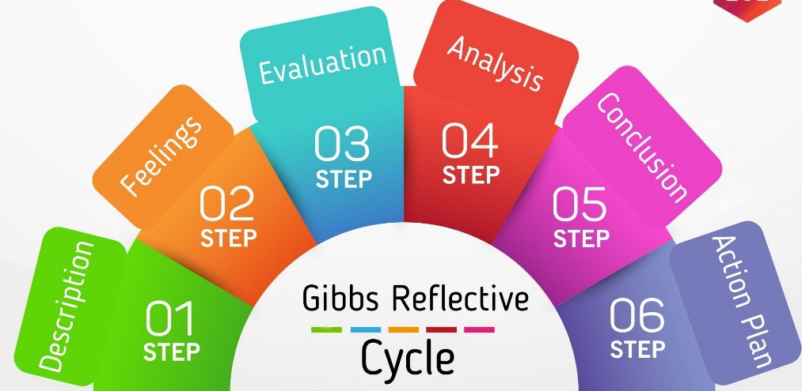
Figure 1: Gibbs Reflective Model
Source: (Haag, 2014)
In the first stage which is in the description stage, the individuals are referred to question the situation and how the environment is (Vallen & Vallen, 2018). In the second stage which is in feelings stage, the person’s thoughts and feelings are measured. In the next stage, the feelings and thoughts are evaluated to understand which factors have worked and which have not. After analysing and evaluating, a conclusion on the situation and the events can be drawn upon and in the last stage, action plans are taken to find out the gaps and think about how to fulfil them. Being one of the biggest resident hotels, Marriott county hall provides a huge segment of workplace experiences to its employees. While working here, it enabled me to go through a training session that has provided me to understand the role of working in food and beverage and kitchen essentials which is one of the major crucial parts of a hotel.

2. Key Learnings from the hotel departments
Working in a food and beverage and kitchen essential department refers to being focused on the customer’s preferences and the changing demand (ASET, 2017). Besides, it is necessary to protect the customers from illness and injury occurring through food consumption. When a hotel ensures food safety for individual customers, the image of that hotel enhances, and that makes its competitive advantage.
The training session on food and beverage has guided me to understand the level of nutrition to maintain as people from different parts of the world visit this hotel and focus on the quality of the meal. Besides, in the very first few weeks, I have learned to deal with the customers while they check in and provide necessary information which has enabled me to enhance my relationships with the customers.

3. Analysing practical tasks
While working in food and beverage and kitchen assessment in Marriott county hall, it was crucial to maintain the quality and safety, and hygiene of the foods (Mutua, 2021). Besides, understanding each individual’s preferences and limitations was another most considered factor.
The first week in the Marriott country hall
It was a pleasure for me to get a chance to work in Marriott county hall as a placement experience. In the very first week, my job was to understand the corporate culture and the languages the employees prefer, and how to meet and greet the customers. Understanding the facilities and the job of the departments was necessary to get a clear view of the whole organization. But getting a training session in food and beverage was one of the areas of my interest after understanding the impact of serving a little bit of wrong food to the customers as it became fatal for a customer when unknowingly an allergic food was served to him.
Four weeks in Marriott county hall
Ensuring food safety is much more important at present as food enables a person to give a full potential outcome in the working sector and others. Highly encouraged by the manager to get training on food and beverage and work in this section has made to go through different cases about what to serve and when to serve. Besides, ensuring the nutrition level in each food is a must. Providing a guideline to the customers of Marriott about their daily food consumption and maintaining the level of nutrition is one of the core functions. Besides, prior asking and knowing about allergic or other issues with food and any beverage and ensuring the proper sugar level which does not harm any customer is one of the core factors to focus on. My training session focused on how diversified the food chain can become or how the presentation of foods can be changed to enhance the thirst and eagerness to consume.
Last week in Marriott County hall
I have contributed to designing and presentation of the food which enhances the appetite. I focused on using vegetables most since these are not harmful and easy to consume. Besides, children are not that much interested in consuming vegetables and it affects their growth. Therefore, my main focus was to ensure that the children find interest in consuming vegetables through its presentation.

4. Practical applications and deployment
Placement experience can be used in a future career which boosts the courage of the students and enable them to be more confident and understand the culture easily (Tewari, 2016). Besides, while working, the students can find out any problem easily and understand the core concepts.
As my focus was on ensuring food safety and making the children eager to consume vegetables which are necessary for their growth and health, I can apply the solutions in the present life also through understanding the preferences and the nutrition level learned from the training session in Marriott. Changes in the presentation and changing the shapes of a vegetable item is a fruitful strategies to attract the children in making them interested to consume.
Besides, the organization can change the presentation of the vegetables and connect them with other elements including caramel, and sugar coating or change the shapes while preparing a specific meal for the children considering the nutrition level to be perfect.

5. Skills for Professional Practice
As working in a hotel needs a collaborative approach to complete any task since all the departments and sections are related to each other, it is necessary to be engaged in team working and have better communication skills through which the ideas can be shared with others (Sheal, 2016). I have developed the following skills which are necessary for professional practice:

Figure 2: Skills for Professional Practice
Source: (Meathrew, 2017)
Self-development is one of the core skills to establish since if one is not ready enough to complete any task and has no confidence in his own getting the job done, the workplace can be a difficult place for him/her (LEFEVER, 2015). I have learned how to deal with the customers alone and it has made me more confident with understanding my task and explaining those to the customers. Team working is necessary as all the departments are interdependent and it is one of the easiest ways to learn from others (Andriushchenko, 2022). Task management refers to the completion of a given task in an effective way which implies the expertise and knowledge level of an employee in the related field. Understanding key issues and finding out the solutions in placement experience make a student find out the complex issues in professional life also which will make me understand the core functions of the organization and bring solutions to that.

Reference
Andriushchenko, Ia.E. (2022) ‘Current trends and world experience of professional training of hotel business specialists’, Modern Economics, 31(1), pp. 6–11.
ASET (2017) ‘A good practice guide for placement and other work-based learning opportunities in higher education – good practice for placements guides – volume 2’, Education + Training, 52(4).
Bardi, J. (2010) ‘Hotel Front Office Management’, Hotel Accommodation Management, pp. 57–69.
Haag, E. (2014) Internship guide: Work placements step by step. 10th edn. The Hague: Eleven international publishing.
Heyes, A. (2017) ‘An empirical examination of the acceptance behaviour of hotel front office systems: An Extended Technology Acceptance Model’, Tourism Management, 29(3), pp. 500–513.
LEFEVER, M. (2015) ‘Hiring hospitality faculty: Erudition and experience’, The Cornell Hotel and Restaurant Administration Quarterly, 36(4), pp. 93–96.
Marriott (2023) Welcome to London Marriott Hotel County Hall, 5 Star Hotel near London Eye | London Marriott Hotel County Hall. Available at: https://www.marriott.com/en-us/hotels/lonch-london-marriott-hotel-county-hall/overview/ (Accessed: 28 May 2023).
Meathrew, P. (2017) ‘HRM in practice in the hotel industry’, Human Resource Management in the Hotel Industry, pp. 105–133.
Mutua, A. (2021) ‘Role of food management systems on food safety in hotels’, Journal of Food Sciences, 2(1), pp. 37–50.
Rutherford, D.G. (2015) Hotel Management and Operations. 15th edn. New York, NY u.a: Van Nostrand Reinhold.
Sheal, J. (2016) ‘Skills for practice and continuing professional development’, Social Work: Introducing Professional Practice, pp. 176–203.
Tewari, J.R. (2016) Hotel Front Office: Operations and Management. New Delhi, India: Oxford University Press.
Vallen, G.K. and Vallen, J.J. (2018) Check-in check-out: Managing hotel operations. 12th edn. Boston: Pearson.

