Developing a Bespoke Inventory Management System Using an Action Research and Phenomenological Approach

By
Brandon Stevens
Supervisor: Andrew Green
Second Marker: Jeanette Adams
Total Word Count – 3532
Content Word Count – 2741

Contents
1. Statement of the Problem 2
1.1 Introduction 2
1.2 Stock Management 2
1.2.2 Types of Stock Management Systems 3
1.3 Current Stock Management Systems Available 4
1.3.1 ABC Inventory 4
1.3.2 SMART Inventory Manager 5
1.4 Evolution of Inventory Management Systems (IMS) 7
2 Client Analysis 8
3 Legal and Security 8
4 Delivery Platform 8
6 Aims and Objectives 9
6.1 Aim 9
6.2 Objectives 9
7 Research Methodologies 10
7.1 Philosophy 10
7.2 Approach 10
7.3 Strategy 10
7.4 Time Horizon 10
7.5 Data Collection 10
8. Resources 11
8.1 Hardware 11
8.2 Software 11
9 Project Timeline 11
Bibliography 13

Statement of the Problem

1.1 Introduction
The major project will consist of developing a web-based stock management system for a local kickboxing school. Operating a small shop within their gym, they sell various items like t-shirts, shorts, gum shields, gloves, pads, and other sports apparel and equipment. Currently, they rely on a manual paper-based system for inventory tracking, and they do not have a schedule outlining when stock should be counted. As a result, they typically do not have a full understanding of what they have in stock, this has led to sudden stock shortages and confusion in the past.
While their existing management system does as much as it can, it demands a significant amount of time and is suboptimal for managing their stock. The school has been dismissive of the idea of using digital systems due to current systems being confusion and bloated with unnecessary features. However, they are not entirely opposed to using digital systems or technology to help run the business, as they make great use of social media to promote the school.
The school’s hesitation stems from the fact that many pre-established management systems come with an array of features that the owners at the school neither desire nor understand. Furthermore, they encounter challenges with the user interface on many of these systems, finding them confusing and not user-friendly.
The stock management system that will be developed for the school will be simple and only include features that the school specifically wants. Additionally, it will be very user friendly for less tech savvy people along with those that generally struggle with using a touch screen.
The problem that is trying to be solved in this project is the lack of a web-based stock-management system that is simple enough for individuals with limited tech proficiency and, at the same time, accessible to those with specific disabilities.

1.2 Stock Management
Stock management is a process that involves the storage, tracking, ordering, and quantity of products within a business. [1]
Key tasks within this process can include monitoring stock levels, replenishing inventory, arranging stock, and doing inspections for potential damage on new stock deliveries. Efficient stock management holds significant importance, as it fine-tunes the balance between supply and demand, a crucial principle in business operations. Furthermore, it ensures the organization of a business's products, particularly beneficial in cases where the inventory comprises a multitude of items. [2]

1.2.1 Stock Management Systems
A stock management system is a software designed to monitor stock levels, sales, and oversee warehouse and delivery processes. This system automates stock counting and updates which increases accuracy and saves time through digitization. Additionally, it offers valuable insights for businesses and warehouse staff such as helping determine optimal times for new stock orders, flag up any stock issues, and identifying top-selling products. [3]
Key features of a stock management system include asset and product tracking, stock optimization, service management, establishing reorder points, and product identification. The software also provides information on current market trends and conditions, enabling businesses to adapt, capitalize on new sales opportunities, and make informed changes.[4]

1.2.2 Types of Stock Management Systems
There are various types of stock management systems available, a business would have to determine which system would work best for them. The size, industry, and specific requirements of the business will determine which system they use. [5]
The manual system stands as the simplest of all SMSs. It involves physically counting the stock by hand and documenting the numbers either on paper or in a digital spreadsheet. This approach is effective for small businesses as it incurs no additional cost, and their typically modest inventories do not require a complex technical system. This is the current system that the client uses. [6]
The perpetual system utilizes Point of Sale (POS) systems and online tracking tools to maintain a real-time inventory record. While it incurs higher costs compared to manual stock counting, it offers a continuously updated representation of stock levels, eliminating the human error associated with manual counting. Notably, the perpetual system is adaptable and suitable for businesses of any size. [7, 8]
A periodic system requires conducting physical stock counts at designated intervals instead of tracking on a constant daily basis. The interval that stock is counted could be weekly, monthly, or annually. [7, 8]

1.3 Current Stock Management Systems Available

1.3.1 ABC Inventory
ABC inventory is a manual inventory management system for small and mid-sized businesses. It uses barcode scanning to keep track of the stock levels and sales. It is designed to handle all aspects of inventory management with features for tracking each step of the inventory life cycle, from the point stock is purchased to when it is sold to a customer. ABC Inventory’s modular organization gives the user a great deal of flexibility to adapt the software to their specific needs. [9]
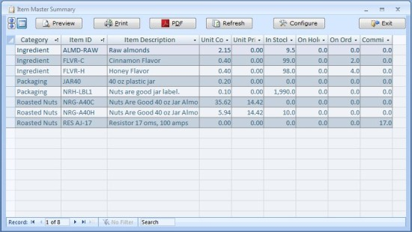
Below is a screenshot of the ABC Inventory user interface. This has been shown to the client who has expressed some concerns about the design. The first issues mentioned were related to color and readability. In UI design, contrast refers to the difference between lightness and saturation of different colors. [10] There must be a clear contrast between the text color and what is behind it for it to be easily readable, [11] in the case of ABC Inventory they have chosen blue and grey for the cell colors but also blue for the text. There is little contrast between these colors and thus it is difficult for them to read. The client practically struggled to read the cell circled red below.

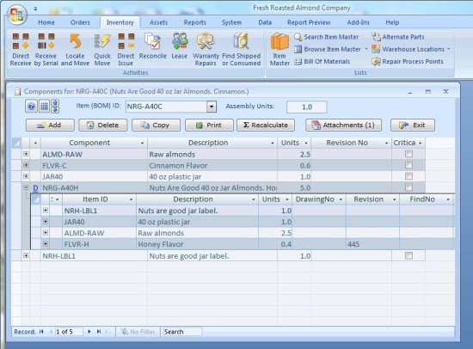
Here is another screenshot from the ABC Inventory UI. When shown to the user they found the green section easy to comprehend, however the ribbon at the top overwhelmed the client slightly. They did not understand what any of the features did and they again struggled to read the text due to the poorly contrasted colors.

1.3.2 SMART Inventory Manager
SMART Inventory Manage (SIM) is a manual inventory management system that makes use of barcode scanning to track inventory levels. [12] SIM offers fundamental inventory management features, including data sorting and exportation, personalized feature configuration, barcode printing, and strategic planning for future stock movements. Notably, SIM seamlessly integrates with Excel spreadsheets, allowing for data to be easily exported and imported.
The client downloaded SIM onto their PC for testing without any assistance, wanting to explore its usability on their own. They found the software to be an improvement over ABC Inventory, although they encountered some issues. Included below is a screenshot of the main inventory section, showcasing the display of all stock records.
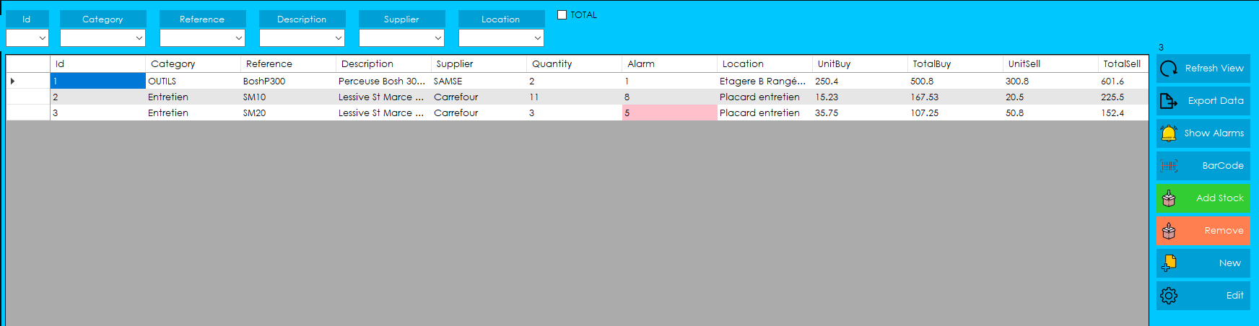The client found the process of adding new stock levels to be unintuitive. After pressing the add stock button, this pop up below appeared. To the client it seemed that they would have to manually enter the stock item details just to adjust their level. The client ran into the same issue when trying to reduce the stock level.
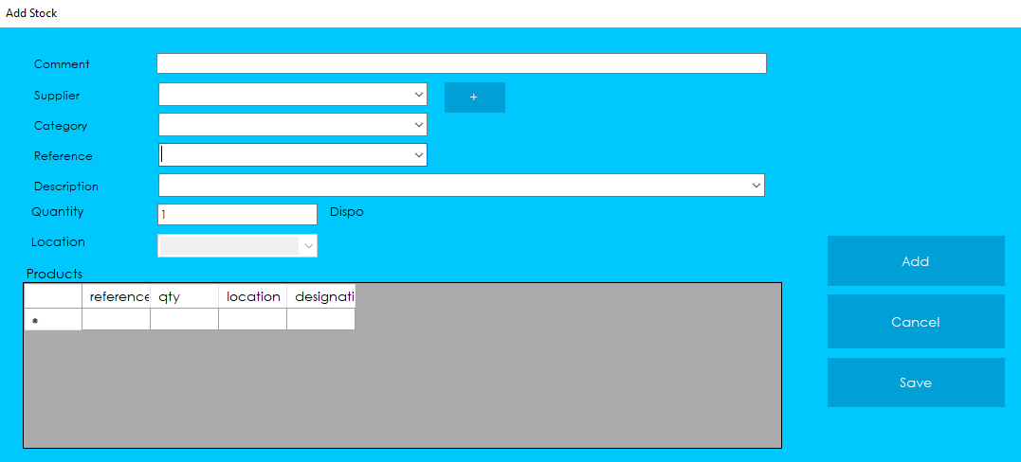
A technical fault that the client found with the software was whenever they tried to cancel the creation of a new item a pop-up box would appear, likely asking them if they were certain they wanted to complete the action. The issue is that the text is not in English. The language has been set to English and this is the only time the error occurred. The client was not impressed by this basic error.
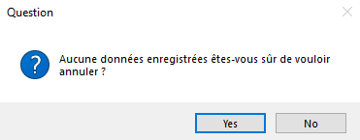

Below is a screenshot of the configuration page, this is where users can modify parameters. When the client found this page, they were very confused and did not understand how to do anything on it.
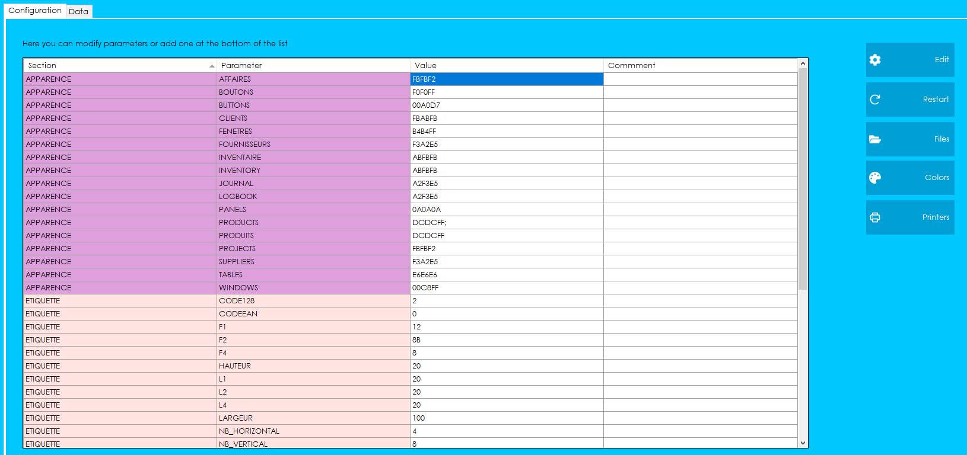

1.4 Evolution of Inventory Management Systems (IMS)
The first piece of IMS software was a material requirement planning (MRP) system. The system functioned as a material controller that tries to keep an adequate number of materials in stock in case they are needed. [13]
The next evolution of stock management came in the form of bar code scanning. Although bar codes had existed since the 1930s, they were first used in a commercial setting on an IMS in 1974. [14, 15] Barcodes proved to be so effective that they are still widely used today to keep track of physical stock. These early IMS’s were only used by large businesses who could afford them, however towards the end of the 1970s personal computers became available for purchase by individuals and businesses, they were still expensive. It was not until the 1990s that personal computers became more common in households. [16, 17]
With PCs becoming more affordable and powerful software such as Excel is being released. It suddenly became very easy for businesses to track their stock. [18]
The next evolution of inventory tracking came in the form of Radio Frequency Identification (RFID). RFID is a type of wireless communication technology that captures data. [19] The technology uses RFID tags and readers to transfer the data. [20]

2 Client Analysis
The client is the owner of a kickboxing school. They have a permanent physical store at the school, this is where all the stock is stored and where most sales are generated. They also set up shop stalls at competitions where they take their products and sell them to fighters and coaches from other kickboxing schools.

3 Legal and Security
Many businesses handle personal and corporate data, often of a sensitive and confidential nature. Governments have implemented various laws and regulations to ensure the appropriate and responsible use of such data by businesses.
Each country has their own data protection laws, the UK’s one is their implementation of GDPR. It is called The Data Protection Act 2018 (DPA). DPA is an extensive set of rules that any organization that collects personal data must adhere to. [21]
The client will be storing their supplier’s and customer’s personal details, both of which count as sensitive information and are protected under the DPA. [22, 23]
The system will make use of a HTML form to input data into the database. There are serious risks to using this system without the proper protection put in place first. [24] Some security issues with HTML forms include cross-site scripting (XSS), SQL injection (SQLi), and form spoofing. [24, 25]
The PHP language will be used to handle sending the data from the form into the database. There are similar issues with security to HTML forms such as SQL injections, another concern is database connection security. [26] There are best practices and techniques that developers use to write more robust and secure PHP code. There are also frameworks such as Laravel that have built-in security features. [27]

4 Delivery Platform
The inventory management system will be a web-based application. Web-based apps are integrated into a website, which serves as the front end and user interface. A user can access and interact with the app on any device with a browser and an internet connection. [28]
A web-based application meets the desired needs of the kickboxing school as there will be scenarios where the app will need to be accessed and interacted with by more than one person at a time, and from different locations. Additionally, the app will need to be responsive so it can work on a phone and 24-inch monitor screen. Responsive design is the seamless adjustment of the user interface to varying screen sizes or different devices. Features and layout elements may undergo modifications or repositioning to accommodate the specific dimensions of the screen, thereby guaranteeing a consistent and user-friendly experience no matter the screen size. [29]
Furthermore, possibly future desirable features will be easier to implement on a web app when compared to a desktop-based system.
The application will utilize a database, enabling the enforcement of data integrity rules to maintain accurate and consistent information. This approach will help prevent errors and inconsistencies, providing the client with reliable stock details.
Although the system will not primarily serve as an e-commerce site, having it built as a database system allows for the potential implementation of e-commerce functionality into the application in the future. [30]
5 Conclusion
Following discussions with the client and understanding their requirements, it has been concluded that an electronic manual system is the most suitable solution. This decision was made since the client is already accustomed to manual paper-based methods for adding and viewing stock. The electronic manual system offers familiarity in these fundamental processes. Moreover, it provides the client with the flexibility to access and manage stock from any location, eliminating the inconvenience of searching for physical stock records scattered across different papers and locations. Additionally, the system can be customized to send reorder notifications to the client and maintain readily accessible supplier details.

6 Aims and Objectives

6.1 Aim
Investigate current inventory management systems and develop a bespoke system that is user-friendly, responsive, and has specific features outlined by the client.

6.2 Objectives
Stages of the project.
- Conduct research into stock management, review current systems available, and investigate different types of management systems.
- Determine the desired features and type of system for the client.
- Design a user interface that matches the client’s requirements.
- Develop the inventory management system.
- Test the system by creating, deleting, and updating stock records. Test the application’s responsiveness and usability on different sized devices.
- Evaluate the usability, user friendliness, and functionality of the app by collecting feedback from the client.

7 Research Methodologies

7.1 Philosophy
A phenomenology approach will be used. It is a qualitative research method that studies the previous experiences that people have and provides the researcher with insight into how people understand those experiences. The project will make good use of this method as it will be necessary to understand the clients' previous experiences with current inventory systems. [31]

7.2 Approach
The inductive approach involves collecting data relevant to research projects prior to making a hypothesis or conclusion. The researcher starts with specific observations and recognizing patterns, and from there they pull a general conclusion. This approach counts as a qualitive research method which is appropriate for the project because the app is bespoke and specifically designed to the client’s needs. So qualitative methods such as an interview will need to be conducted with the client to tailor the app for their needs. [32, 33]
Research for this project will consist of finding out what factors make user interfaces and online systems unapproachable and intimating for the people like the client. The client has limited technology experience and suffers from Carpal Tunnel Syndrome which makes using touchscreens difficult. The data gathered will help determine the aims and objectives.

7.3 Strategy

Action research is a highly interactive method that aims to investigate and solve an issue simultaneously. This method is appropriate for the project because it emphasizes the research participants and researcher working together. Collaboration is required to ensure the application meets the client’s needs. [34]

7.4 Time Horizon
The cross-sectional time horizon research design collects data from participants at a single moment in time. It provides a researcher with a snapshot of the participants from a specific moment in time. This method works well as the client’s opinions and desires will only need to be collected once. [35]

7.5 Data Collection
The data collection in this project will be gathered using interviews which is a qualitative research method. Interviews will be conducted with the kickboxing school to determine specific features they want in the system, necessary usability requirements, and design choices. [36]
The reason for interviews is because they allow for branching questions with rich information being exchanged. It is also a cost-effective method that can be conducted face to face and over the phone, which will be beneficial as physical meetings with the client may not always be possible. [37]

8. Resources

8.1 Hardware
The inventory system will be developed using a college and home PC.
The system will be able to run from two devices, the client’s Samsung Galaxy S20 smartphone and a Dell OptiPlex computer which is permanently located at the kickboxing school. Both devices are more than powerful enough to support the use of the app.

8.2 Software
The inventory system will be developed using Visual Studio Code. Xampp and PhpMyAdmin will be used to manage the database and connecting to it.
The computer at the kickboxing school runs the most up to date version of Windows 10. The client’s phone uses the latest version of the Android operating system.

9 Project Timeline

9.1 Work Breakdown Structure
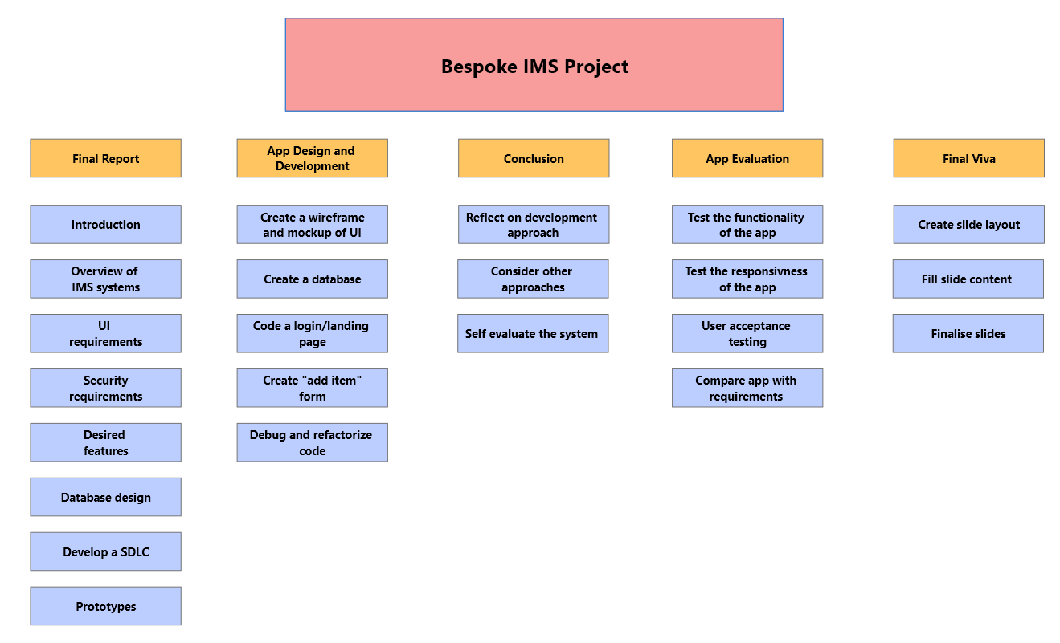

9.2 Gantt Chart
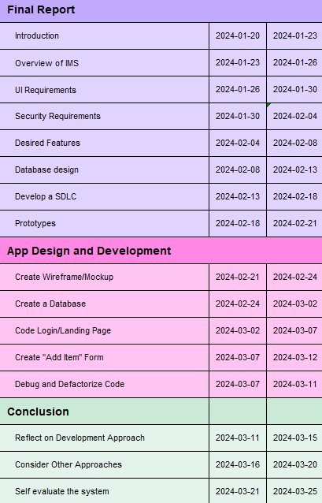

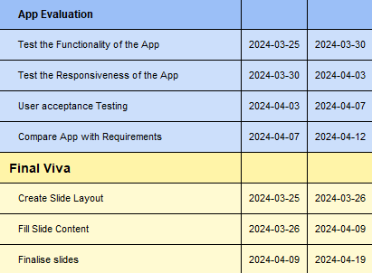



10 Bibliography
- Xero. What is Stock Management [Internet]. Available from: https://www.xero.com/uk/glossary/stock-management/
- Deveshwar A, Modi D. Inventory Management Delivering Profits through Stock Management [Internet]. 2013. Available from: https://citeseerx.ist.psu.edu/document?repid=rep1&type=pdf&doi=50d4e7cc540baa457291c0e0532803406a74fdad
- Corporation M. Stock Management System Basics | Microsoft Dynamics 365 [Internet]. dynamics.microsoft.com. Available from: https://dynamics.microsoft.com/en-au/field-service/inventory-management-system/
- Roughan G. The 19 Best Inventory Management Software Features to Look For [Internet]. Unleashed Software. 2021. Available from: https://www.unleashedsoftware.com/blog/the-19-best-inventory-management-software-features-to-look-for
- Jenkins A. What Is Inventory Management? Benefits, Types, & Techniques [Internet]. Oracle NetSuite. 2020. Available from: https://www.netsuite.com/portal/resource/articles/inventory-management/inventory-management.shtml
- Manual vs. Automated Inventory Management [Internet]. Sortly. 2022. Available from: https://www.sortly.com/blog/manual-vs-automated-inventory-management/#:~:text=What%20is%20a%20manual%20inventory
- Davies R. 4 Types of Inventory Management Systems for Businesses [Internet]. The Motley Fool. 2022. Available from: https://www.fool.com/the-ascent/small-business/inventory-management/articles/inventory-management-types/
- Stock management - What is stock management? | SumUp Invoices [Internet]. SumUp - a better way to get paid. Available from: https://www.sumup.com/en-gb/invoices/dictionary/stock-management/
- Free ABC Inventory Software Features [Internet]. Almyta.com. 2014. Available from: http://www.almyta.com/abc_inventory_software.asp
- Dewra H. Contrasting for Clarity: The Importance of Contrast in UX Design [Internet]. Medium. 2023. Available from: https://bootcamp.uxdesign.cc/contrasting-for-clarity-the-importance-of-contrast-in-ux-design-68c5e2e9494a
- How does typography color affect readability? [Internet]. ordergroup.co. [cited 2023 Dec 8]. Available from: https://ordergroup.co/en-gb/blog/how-does-typography-color-affect-readability/#:~:text=Color%20Contrast%20and%20Readability
- SIM Inventory Management Software [Internet]. smart-inventory-manager.com. Available from: https://smart-inventory-manager.com/
- Rizad H, Tawi L, Ahmad AR, Baskaran S. The Effectiveness of MRP System to Forecast the Accuracy Inventory Requirement. International Journal of Engineering & Technology. 2018. Available from: https://www.researchgate.net/publication/332681868_The_Effectiveness_of_MRP_System_to_Forecast_the_Accuracy_Inventory_Requirement
- Weightman G. The History of the Bar Code [Internet]. Smithsonian. Smithsonian.com; 2015. Available from: https://www.smithsonianmag.com/innovation/history-bar-code-180956704/
- ‌Alfred R. June 26, 1974: Supermarket Scanner Rings Up Historic Pack of Gum [Internet]. Wired. [cited 2023 Dec 20]. Available from: https://www.wired.com/2008/06/june-26-1974-supermarket-scanner-rings-up-historic-pack-of-gum/
- ‌1970s - Early 1980s | Selling the Computer Revolution | Computer History Museum [Internet]. www.computerhistory.org. [cited 2023 Dec 20]. Available from: https://www.computerhistory.org/brochures/1970s-early1980s/#:~:text=Technological%20innovations%20such%20as%20the
- ‌1.Dive Into the Past and Learn When Computers First Became Popular [Internet]. ignite digital . 2023. Available from: https://ignitedigital.com/resources/blog/search-engine-marketing-sem/dive-into-the-past-and-learn-when-computers-first-became-popular/#:~:text=It%20wasn't%20until%20the%201990s%20that%20they%20became%20common,Powerful%20processors
- Migrator. Stock control systems - keeping track using computer software [Internet]. nibusinessinfo.co.uk. 2000. Available from: https://www.nibusinessinfo.co.uk/content/stock-control-systems-keeping-track-using-computer-software
- ‌Chetouane F. An Overview on RFID Technology Instruction and Application. IFAC-PapersOnLine [Internet]. 2015;48(3):382–7. Available from: https://www.sciencedirect.com/science/article/pii/S240589631500350X
- (PDF) An introduction to RFID technology [Internet]. ResearchGate. Available from: https://www.researchgate.net/publication/3437143_An_introduction_to_RFID_technology
- ‌What is the Data Protection Act? | Experian Business [Internet]. www.experian.co.uk. Available from: https://www.experian.co.uk/business/glossary/data-protection-act/#:~:text=The%20Data%20Protection%20Act%20(DPA
- Business-to-business marketing [Internet]. ico.org.uk. 2023 [cited 2023 Dec 20]. Available from: https://ico.org.uk/for-organisations/direct-marketing-and-privacy-and-electronic-communications/business-to-business-marketing/#:~:text=If%20you%20can%20identify%20an
- GDPR’s Most Frequently Asked Questions: Are Work Email Addresses and Business Contact Information Considered “Personal Data?” [Internet]. Lexology. 2018. Available from: https://www.lexology.com/library/detail.aspx?g=54c7ace6-51e6-4ede-9433-1e8b83e45ef2#:~:text=Personal%20data%20is%20defined%20by
- Mueller JP. Security for Web Developers: Using JavaScript, HTML, and CSS [Internet]. Google Books. “O’Reilly Media, Inc.”; 2015 [cited 2023 Dec 20]. Available from: https://books.google.co.uk/books?hl=en&lr=&id=9ZTlCgAAQBAJ&oi=fnd&pg=PR2&dq=html+forms+security+issues&ots=SHN_-pXHpt&sig=mrnDG3DKuBpxPGcvNnnINcjXUgw&redir_esc=y#v=onepage&q=html%20forms%20security%20issues&f=false
- What are the most common security risks of HTML forms and how can you avoid them? [Internet]. www.linkedin.com. [cited 2023 Dec 20]. Available from: https://www.linkedin.com/advice/0/what-most-common-security-risks-html-forms-how-can-cfv5c
- Shiflett C. Essential PHP Security: A Guide to Building Secure Web Applications [Internet]. Google Books. “O’Reilly Media, Inc.”; 2005 [cited 2023 Dec 20]. Available from: https://books.google.co.uk/books?hl=en&lr=&id=HuDy3EYTK1YC&oi=fnd&pg=PT7&dq=security+issues+with+php+to+enter+data+into+db&ots=DJv34Hz07y&sig=MfwHDXJ1hxr9L-6MjExUsMeC5iY&redir_esc=y#v=onepage&q=security%20issues%20with%20php%20to%20enter%20data%20into%20db&f=false
- Nirav. Best Laravel Security Features to Safeguard Your Application [Internet]. KrishaWeb. 2023 [cited 2023 Dec 20]. Available from: https://www.krishaweb.com/blog/best-laravel-security-features/#:~:text=Laravel%20offers%20built%2Din%20protection
- Magic Web Solutions [Internet]. Magic Web Solutions. 2019. Available from: https://www.magicwebsolutions.co.uk/blog/the-benefits-of-web-based-applications.htm
- What is Responsive Design? [Internet]. The Interaction Design Foundation. Available from: https://www.interaction-design.org/literature/topics/responsive-design
- Database Driven Websites [Internet]. Database Management. [cited 2023 Dec 20]. Available from: https://databasemanagement.fandom.com/wiki/Database_Driven_Websites#:~:text=Also%2C%20instead%20of%20making%20multiple
- Delve. What is Phenomenological Research Design? [Internet]. Delve. 2022. Available from: https://delvetool.com/blog/phenomenology#:~:text=Phenomenological%20research%20is%20a%20qualitative
- Sheppard V. 1.6 Inductive Approaches to Research. pressbooksbccampusca [Internet]. 2020 Apr 6; Available from: https://pressbooks.bccampus.ca/jibcresearchmethods/chapter/1-6-inductive-approaches-to-research/#:~:text=An%20inductive%20approach%20to%20research
- Dudovskiy J. Research Approach - Research-Methodology [Internet]. Research-Methodology. 2015. Available from: https://research-methodology.net/research-methodology/research-approach/
- George T. What Is Action Research? | Definition & Examples [Internet]. Scribbr. 2023. Available from: https://www.scribbr.co.uk/research-methods/action-research-cycle/
- 1.Melnikovas A. Towards an Explicit Research Methodology: Adapting Research Onion Model for Futures Studies. 2018. Available from: https://jfsdigital.org/wp-content/uploads/2019/01/03-Melnikovas-Onion-Research-Model.pdf
- Tenny S, Brannan GD, Brannan JM, Sharts-Hopko NC. Qualitative Study [Internet]. Nih.gov. StatPearls Publishing; 2021. Available from: https://www.ncbi.nlm.nih.gov/books/NBK470395/#:~:text=Qualitative%20research%20uses%20several%20techniques
- DeBose K. Research Guides: Research Methods Guide: Interview Research [Internet]. guides.lib.vt.edu. 2018. Available from: https://guides.lib.vt.edu/researchmethods/interviews#:~:text=Interviews%20are%20most%20effective%20for

