

BSc (Hons) Professional Police Practice

LEVEL 4 - 40 Credits

CONTINGENCY REGULATIONS MARCH 2020
In light of the current COVID-19 situation the university, along with all HEIs, have put in place contingency plans for student assessments, learning and progression. These have been done at a senior level and in line with the QAA and endorsed by the College of Policing.

As a result, the two workbooks that would have been completed as part of your course are now combined into one.

Workbook title: Competency Based Workbook (1 & 2 combined - PCDA)

(SOUTH WALES POLICE, GWENT POLICE AND UWTSD)

Learner name: PC 6574 Dylan Griffiths

Learner’s University Registration Number: 1910669

FACULTY OF BUSINESS AND MANAGEMENT
PUBLIC SERVICE PROGRAMME

Module title: Professional Police Practice 1 and 2 (PCDA)
Module title: Policing in the Workplace 2 (PCDA)

Workbook Guidance

Please read these notes carefully; they provide essential information.

What is the workbook for?

The purpose of this workbook is to enable learners to demonstrate and provide evidence of how they meet the learning outcomes set by the College of Policing, for the BSc programme. Essentially, you are being asked to outline your experiential learning based upon your theoretical understanding in a range of operational situations.

Area of Professional Practice covered, (called elements in your module descriptor):

Workbook1 and Workbook2 combined cover these areas:

- Wellbeing and Resilience
- Communication Skills
- Managing Conflict
- Valuing Difference and Inclusion
- Criminal Justice
- Decision making, discretion
- Conducting Investigations
- Criminal Justice (Managing offenders)
- Vulnerability and risk
- Understanding the police constable role
- Conducting investigations (Interviewing suspects)
- Public protection

You may wish to use the same incidents as you’ve outlined in the Occupational Competence Portfolio.

How should the workbook be presented?

Blank electronic copies can be found on Moodle of this workbook. You must submit this document electronically therefore it is important that you save your work regularly and upload the final typed version through Turnitin on Moodle.

Word count policy can be found in chapter 7 of the Academic Quality under section 7.7 (this applies to presenting work above and under the specified word count).
(https://www.uwtsd.ac.uk/media/uwtsd-website/content-assets/documents/academic-office/aqh-chapters/chapters---en/Chapter_07_Assessment_Taught_Programmes_Pages_72-79-UPDATED-05-11-2019.pdf)

Reflective practice is a core aspect for your workbooks and although there is a variety of useful resources on Moodle, there is one particular book, that is specifically based on reflective practice in policing, here is a link to one chapter from Selina Copley’s Reflective Practice for Policing Students:
https://moodle.uwtsd.ac.uk/pluginfile.php/298870/mod_resource/content/1/Reflective%20Practice%20for%20Policing%20Students%20-%20Selina%20Copley%20Chapter5.pdf

How is the workbook assessed?

Advice and support about the completion of this workbook will be provided by university staff as part of your initial training day. Your tutor constable and in-force training staff will not be involved in assessing or marking your workbook after it has been submitted.

Dates of workbook submission will be made available during the initial training day and posted on Moodle.

Once submitted your workbook will be assessed and marked independently.

Confidentiality

It is important that no individual can be identified either directly or indirectly from the information in the workbook. Therefore, you must:

- adhere to guidance in the Student Handbook about unfair practice and plagiarism;
- not identify individuals including witnesses, victims or offenders by name;
- not write information that enables any individual to be identified indirectly through the description you provide. This includes references to names, colleagues, places (including hospitals, schools, town, villages, streets) specific incidents which were high profile and could be identified due to past publicity, other professionals or any other personal information including medical or other conditions;
- take personal responsibility for adhering to confidentiality rules.
- not include any dates of any incidents or anything that specifically identifies an actual incident.

NOTE

Your workbook will be submitted electronically via Turnitin on Moodle. Guidance on this is in the Student Handbook.

Remember that the workbook is YOUR responsibility you must not rely on the assessor or anyone else to pick up any confidentiality breaches as this is your work and you must accept full responsibility for confidentiality. Meeting all the confidentiality requirements is very important.

Dyslexia and other special circumstances

If you have any condition that you feel may affect your ability to deal with any part of the programme, please see the Student Handbook for further guidance. The University has a Student Services Unit that may be able to help but it is the learner’s individual responsibility to contact them.

Guidance:

- Your workbook must contain the items specified in the table below (clearly identified and in the order given);
- You should use this particular document to insert your text / answer within each section of this workbook;
- You should upload your completed document as a saved pdf file of this workbook. If this is not possible then a Worddoc file is acceptable. Do not send a scanned file from a photocopier, an apple.dot file or a Microsoft publisher file as Turnitin will not be able to assess them despite you being able to upload them.

Contents:

Workbook | Area of Professional Practice | Word count
Task 1 | Wellbeing and Resilience | 500
Task 2 | Communication Skills, Managing Conflict, Valuing Difference and Inclusion | 1500
Task 3 | Criminal Justice, Valuing difference and inclusion | 1500
Task 4 | Decision making and discretion, Conducting Investigations and Criminal Justice (Managing offenders) | 1500
Task 5 | Vulnerability and risk, understanding the police constable role, communication skills, decision making and discretion, public protection. | 1500
 | Bibliography
 | Development Plan | This plan and signed OPP is equivalent to 1000 words
 | Confirmation of the completion of your Occupational Competency Portfolio (OCP) | This plan and signed OPP is equivalent to 1000 words
 | Confirmation of Confidentiality and Plagiarism

Task 1

Relevant areas of the National Policing Curriculum:
Wellbeing and Resilience

Guidance:

Focussing on your initial 6 months of learning and/or your tutorship, reflect on the coping strategies you have applied to develop resilience and minimise stress when adapting to your role as a constable within the workplace (e.g. nature of the work, organisational culture, shift pattern, pressures of work and joining a new team).

500 words (+/- 10%: include your actual word count at the end of each section)

ANSWER:

The first 6 months of my employment and training with south wales police have been an emotional rollercoaster and I have detailed below how I found my initial experience and how I coped with the changes.
I will talk about how I used professor coopers stress busting guide to help me get through the stress.

The decision to join the police force was not exactly an easy one as I was previously employed within HM Prison service where I notched up a career spanning over 17 years.
My service took me on a journey from landing officer to a specialist role within a small team that’s main task was dealing with the most serious of incidents throughout the prison service on a daily basis, due to dealing with the most horrendous incidents and individuals that would only feature in peoples nightmares I built up the feeling of invincibility and somewhat arrogance.

Joining the job
The first day of joining there was 90 students of all ages and backgrounds herded into their designated classrooms with everyone on edge and silence only being broken by the sound of idle nervous chit chat.
It was at that point that I first felt this unfamiliar feeling that was alien to my body that I can later pinpoint as stress.

I no longer had an invisible suit of armour that I had built up over my previous career and I felt vulnerable,
I went home and told my partner I need help as I was struggling to settle into this unfamiliar world of power points and exams,

I researched relief for stress and I found an interesting guide on the WWW.NHS.UK website under mental health and wellbeing written by Professor Cooper

Cooper, NHS UK (2020)

The guide gives 10 stress busters broken down into challenges that I should partake and it will have a positive outcome in the way I feel.
The categories are as follows

- Be active
- Take control
- Connect with people
- Have some ‘me time’
- Challenge yourself
- Avoid unhealthy habits
- Help other people
- Work smarter not harder
- Try to be positive
- Accept the things you can’t change

I implemented these tips into my daily routine by going for daily walks during dinner breaks and after work, trying to engage with everyone I came across even if it was a polite hello or good day,
I also changed my diet to eating one plant based meal a day and drink just water while at work.

After a few weeks on implementing these 10 changes to my lifestyle I started to feel the benefits physically and mentally and started to have a positive outlook on life.

I set a few personal goals of getting fitter, losing weight and the one I have found most important is taking time to speak to people and showing interest in how they are.

At the pass out parade I stood tall with a feeling of achievement as I had hit every one of my goals and recognised the journey and transformation that I had endured.

Word count 516
Task 2

Relevant areas of the National Policing Curriculum:
Communication Skills, Managing Conflict, Valuing Difference and Inclusion

You must choose a policing incident involving conflict in which you played a significant role with an offender/service user/victim and reflect on what happened.

Give a brief description of the incident including social and legislative contexts and any relevant cultural, ethnicity and language issues.

Review the fundamental elements of effective communication used (verbal, non-verbal, active listening skills, open and closed questions, building rapport and negotiation skills).

Describe the process for determining whether the use of force was necessary in a conflict situation (including any theories or models underpinning the causes of conflict within policing interventions – e.g. Betari’s Box, The Drama triangle, Emotional versus rational brain) and provide a reflection on the outcome of the incident.

Your reflection must illustrate your understanding and application of core principles of ethics, equality, diversity and human rights, as well as any relevant Code of Practice considerations, culturally sensitive practice and language preference.

1500 words (+/- 10%: include your actual word count at the end of each section)

ANSWER:

The task I am about to write about details an arrest of a male who was wanted on recall to prison following a previous arrest and charge earlier that week.
Due to data protection I shall use no names and I will refer to him throughout as the suspect also the place names will appear like this #######.

My first dealing with the suspect was earlier in the week when I was on mobile patrol in a marked police vehicle when I was contacted by the CCTV operator that covers the town of ####### and he informed me that he had just seen two males walking along the bypass road carrying a bladed article.

Instantly my body started to alter due to the adrenaline and as described by DR Debrah Sullivan who wrote an article in the Healthline times that “it is known as the fight or flight hormone” due to it being released in response to a stressful, exciting, dangerous or threatening situation,

The adrenaline helps your body react more quickly by the heart beating faster increasing the blood flow to the brain and large muscles that stimulates sugar to make fuel
Sullivan,Healthline(2018)

When approaching the suspect

I went through a dynamic rick assessment as I had intelligence from the CCTV operator that he was in possession of a bladed article.

In my head I was going through the Police NDM (National decision making model) Bryant,R (2020) Blackstones policing for students p80.

The NDM breaks down into sections the risk and threat that you are faced with and what powers covers what action you take,
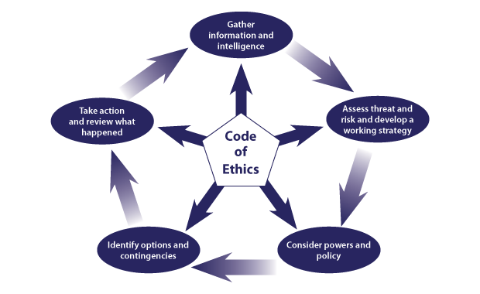

Due to intelligence that the suspect was carrying a bladed article in public place I approached him at a safe distance, I tested his compliance by firstly asking him to stop,
I then asked him to put his hands behind his back with his knuckles touching, the suspect did this so I then moved in with my protective stance and placed the suspect in handcuffs to the rear possession where I locked them off and checked for tightness.

I told the male the grounds for the search and that he was being detained under section one of the police and criminal evidence act 1984 (PACE 1984).

I then conducted the search in accordance with PACE but it had a negative result and I couldn’t locate the knife on the person,
I radioed the CCTV operator directly and asked them to replay the footage of the male just before I had turned up, after a few moments the operator got back to me and stated that it looked like the suspect had thrown the knife into some long grass when he could see the police vehicle approaching.

As I now had positive information from the CCTV operator I conducted an area search where I found a black handled kitchen knife lying in the long grass.

I took out my Samsung device and photographed the knife in situ, and then put a fresh set of gloves on and seized the knife as an exhibit where I then put it in a sharps tube then bag and documented the time, place and description of the exhibit.

I then returned to suspect who was still being detained and asked if he had any defence to why he had a bladed article in Public, the suspect replied by stating he had never seen it before”.
I then arrested and cautioned him under section 139 of the criminal justice act 1988 for suspicion of having with him in a public place any article which has a blade or is sharply pointed.

The necessity for the arrest was to allow the prompt and effective investigation, and to prevent the person causing physical injury (to him/herself or any other person).
The suspect made no reply to the caution and was taken to the local custody suite where his detention was authorised.

The second encounter with the suspect was six days later.

I was tasked with searching for and arresting a male who was wanted on recall to prison,
The reason that I was given this arrest enquiry that I knew what the male looked like as it was the suspect who I arrested for a knife incident six days prior.

After numerous negative searches of different properties I was given a new address where he was suspected to be hiding at.

Before attending the new address I asked for a second unit to assist me to cover the rear of the property as I had heard that the subject would do anything to stop going back to prison.

When arriving at the property I discovered that it was a large two story flat that was above a food take away restaurant.
I had a quick look around to see if there was any potential escape routes or signs of the occupants being there,

I could see the top window was open and a TV was playing in the background, I knocked the front door of the property and waited several minutes before the door was answered,

When the door opened I spoke with the occupant who was the suspect’s father, I asked him if he had heard from his son in the past few days, the dad looked flustered and red in the face and stated that he had not seen or heard from his son for the past few days.

Due to the fact that I had intelligence and the father’s actions I asked if I could come inside and have a look for myself, the dad agreed so officers entered the flat and started to conduct a search for the suspect.

All rooms were searched without a positive result and some officers went back down the stairs to speak with the suspect’s father,
I however was not satisfied and carried on searching the empty top floor of the flat, I could see that the rooms had just been freshly painted but there was a small black mark on the banister, I thought this was odd so I investigated further.

I looked up and could see there was an attic hatch and it looked like it had been disturbed as there was a cobweb broken and hanging down, I then had suspicion that somebody had used the banister to climb on and into the attic.

I went back into one of the rooms that had recently been decorated as I had recalled seeing a step ladder in there, I bought the ladder onto the landing and climbed it and pushed the attic hatch open, on looking inside I could see that the whole attic had been insulated and it was flat apart from the far corner where I looked like the insolation was rolled into a ball.

I got my issued torch out of its pouch and directed the torch beam at the ball of insulation, I could see that there was somebody hiding under it, I ordered them to get up and come down the ladder,

All of a sudden the person got up from under the insolation and I instantly identified the male as the person that I had arrested a few days previous for carrying a bladed article in public.

The suspect jumped up and went into a violent rage screaming that he was not going back to jail and he would slice his own throat, knowing the potential that he may be carrying a knife I instantly started to engage with him in accordance to conflict management where I started to speak more softly in an attempt for the suspect to image me and lower the tone of his voice.

This did not work and the suspect continued to be actively resistant, He started to make threats that if anyone was to come any closer he would assault them,
I then engaged with him by using the Betari’s box method that shows how my attitude and behaviour will affect the attitude behaviour of the suspect.
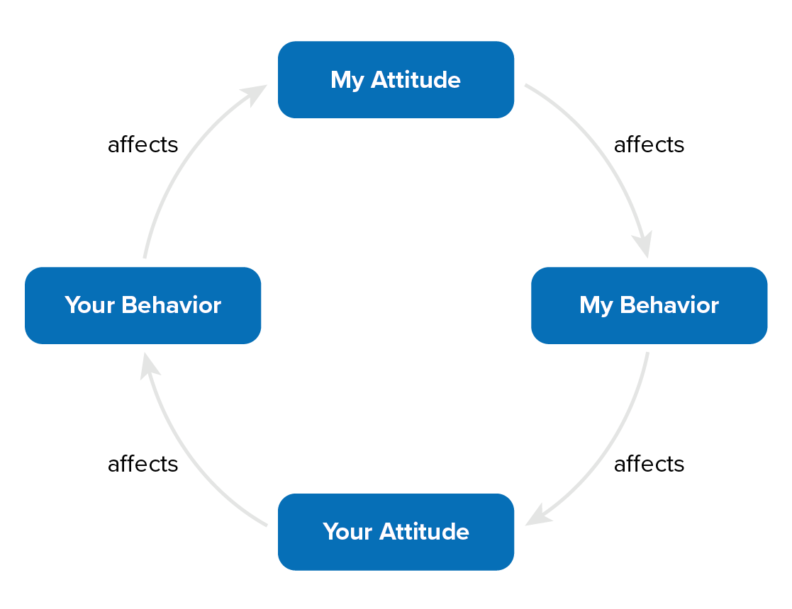
(Bryant, R and Bryant, S, 2020)

I remained calm and spoke with the suspect and told him that he was to get down from the attic as he was wanted on warrant,
He refused and stated that he wouldn’t but was going to be tidy as he recognised me from dealing with him six days previous and I treated him with decency and respect,

The suspect then asked if he got down could he make a call to his partner, I agreed to this request as I feel that taking somebody’s liberty away is a powerful thing and it should be treated in the suspect’s best interests

A phone call may only be a small thing for some people but as the suspect was going back to prison this was a traumatic time for him I honoured my word facilitated a call to his partner.

The suspect finished an emotional call to his partner and then was conveyed compliantly to custody where his detention was authorised.

I have no doubt that if I hadn’t used the tools available to me i.e. Betaris box, where my attitude can affect their behaviour and the National decision making model, combined with natural confidence both incidents could have had a very different outcome where somebody could have got hurt.

Total word count for Task 2 is 1541

Task 3

Relevant areas of the National Policing Curriculum:
Criminal Justice, Valuing difference and inclusion

You must choose a policing incident in which you played a significant role with an offender/service user/victim and reflect on what happened.

Give a brief description of a relevant incident including social and legislative contexts and any relevant cultural, ethnicity and language issues.

Explain and reflect on your responsibilities and procedures in line with the relevant Codes of Practice to support victims and witnesses through the criminal justice system.

Illustrate how policing values were engaged, as well as any other considerations including culturally sensitive practice and language preference.

1500 words (+/- 10%: include your actual word count at the end of each section)

ANSWER:

Throughout this task I shall not use real names and refer to the person as the suspect, also place names with the hash tag symbol e.g. ########, I should also mention that there will be slight changes throughout the task due to confidentiality.
The task I am writing about is when I responded to a drink drive accident and how the lack of English from the suspect made it difficult to engage with him at the road side but what I found most difficult is the fear he had against the police force.

Later on I was to find out that the police force from the suspect’s birth country did not act with the professionalism or standards that British police do and in accordance with the police and criminal evidence act 1984 (PACE).

I was out on Mobile patrol in full uniform and in a marked police vehicle when I heard a call over the police radio asking if there was any available units that could attend a grade 1 immediate response and make their way to ######## roundabout as there was a report of an Road traffic collision (RTC) involving a possible Drunk in charge of a motor vehicle (DIC)
.
I keyed up on my personal radio and attached myself and my colleague to the call and asked if there was any other information available
The call handler replied by stating the reporting person (RP) was a lone female and did not want to stop as she did not feel comfortable but stated there were 2 x males and the younger one with the longer hair was the driver”.

I replied to the public service operator asking to show myself and my colleague code 5 and made our way to the location of the incident.

On the way I was running things through my head by not just dealing with the possible suspect but also thinking about the management of the collision by using the “CLEAR” initiative that the college of policing teach on how to deal with traffic collisions,

C – Collision
L – Lead
E – Evaluate
A – ACT
R – Re-Open

The abbreviation breaks down how you must attend the collision and take lead of the incident where you evaluate the incident, take action and reopen the road.

Bryant,R (2020) Blackstones policing for students p461.

On arriving I could see a small car crashed into a tree and fluids spilling onto the floor, I then noticed two males staggering a few metres behind it on the road, my instant reaction and concern was one for the safety of these two males

I positioned the police vehicle as per policy and went to speak with the males and assess if they needed any medical assistance.

I went straight to the suspected driver while my colleague went to the other male, as I started to engage with him it was clear that he didn’t understand a word of English and seemed overly frightened of my presence.

I asked him to follow me off the road and sit in the police vehicle so I could assess him for any injuries, the male did not understand so I physically had to guide him over to the vehicle, I started off by asking him his name and if he had any injuries, the male just stared at me blank.

I then tried introducing myself and then changed to ask his name, this seemed to work as the make gave me his first name, I asked how he spelled it so I could start to conduct my inquiries and he couldn’t do this so I then went on to ask about his injuries.

I started to point to parts on his body and gave the thumbs up or down signs and this technique seemed to work as he actioned that he was fine and had no injuries.

The male looked frightened and wanted to leave the scene and made numerous attempts to run away, Due to this I placed him in handcuffs and detained him to prevent escape,
The using of force on a person is justified and is part of a constables duties as long as it is necessary and proportionate and reasonable in the circumstances, this is outlined under the police code of ethics and can be found under
College of policing July 2014 Code of ethics

The male had a strong aroma of intoxicating liquor coming from his breath so I had reason to believe he was Drunk in charge of a motor vehicle (DIC), I conducted a search of the person where fund a set of car keys in his right pocket, I asked if he was driving and made the sign of a steering wheel, The male nodded yes.

I could see that my colleague was progressing his investigations with a lot more ease as the person he had detained could speak broken but good English, once it was established that the male I had was the driver the passenger was released from his handcuffs and I then asked him to act as an interpreter so I could communicate with my detained male and offer some comfort as he looked frightened.

Talking via the third party interpreter I explained the process of what was happening and he needed to provide a sample of breath for analysis, again via the third party interpreter I asked the compulsory questions and the male agreed and blew into the breathalyser machine, after a few moments of analysis the machine gave a fail and showed that the suspect had blown seventy five (75micrograms per 100 millilitres of breath).

In 1967 the road safety act made drink driving illegal in the uk and the limit is now set at 35 micrograms per 100 millilitres of breath,

As the suspect blew over the legal limit I cautioned him under section 5 of the road traffic act 1988

As I went to put the arrested suspect into the back of the van he became hysterical and frightened and physically resisted.

The passenger who was helping with the language barrier then informed me that the detained male was begging not to be arrested and was frightened saying that we will take him away and beat him,

The passenger said the police force from their home nation have a reputation of being corrupt and give out punishment style beatings.

I then remembered an article I read Professor Mr Albert Mehrabian who detailed the rule that successful communication is made up of three parts, the words you use, the tone of your voice and your body language.

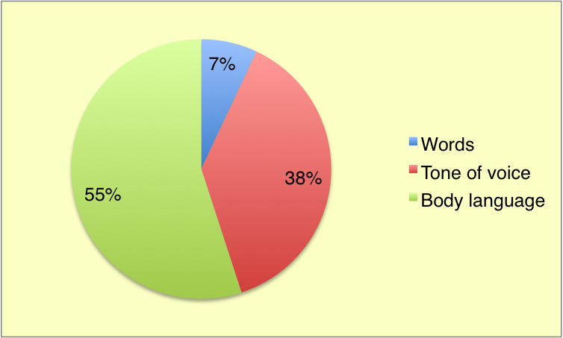

Professor Mehrabian 1939

I turned to the suspect and in a calm voice said softly I will look after you and the Detained male seemed to relate to my calmness and nodded.

I conveyed the detained male to the custody suite in the rear of the marked police vehicle where I sat in the rear facing seats and kept on engaging with the male through the glass to reassure him and offer support.

Once at custody I stayed with the male while my colleague gave a brief handover to the custody sergeant and I stayed with the detained male and give some more reassurance.

I escorted the suspect to the booth and pointed to a poster on the wall that had writing in different languages with nationality flags next to them,
The suspect pointed out a flag of his birth country,

The sergeant rang language line which is a uk language translation service agency that provides call operator service that can speak both English and the language of the detained person.

Once the detained male was engaging with the operator from language line he seemed more settled and was less nervous, he was then booked into custody and the next process was explained to him where he would have to provide two more samples of breath on the analysis machine, the male then went into the room where the call was transferred and the translation continued,

The male provided two more breath samples that both were over the prescribed limit so the lowest one was taken attached to the case file.

The male was charged to court for driving on a public road whilst over the prescribed limit of alcohol.

Throughout this incident I found the communication barrier difficult due to the fact the suspect spoke a different language and very little English.
The most disturbing and serious factor was that the suspect had a genuine fear of the police force as he related the “POLICE” badge to the police force of his birth country.

The passenger explained that the police are known to be corrupt in his birth country where money often exchanges hand as a bribe and punishment style beatings are given out to offenders.

All the tools that were available and the process that the British police have in place helped with reassuring and providing support to the arrested person.

Having your liberty taken away from you is a very unnatural and highly stressful time and police constables should always remember this when making arrests and provide as much support they can.

Word count for task 3 1521

Task 4

Relevant areas of the National Policing Curriculum:
Decision making and discretion, Conducting Investigations and Criminal Justice (Managing offenders)

You must choose a policing incident in which you played a significant role with an offender/service user/victim and reflect on what happened.

Give a brief description of the situation including social and legislative contexts and any relevant cultural, ethnicity and language issues. Reflect on how you applied the National Decision Model (NDM) to assist in resolving this incident. Consider the role of discretion in the decision-making process.

Explain your responsibilities with regards to the provision of the CPIA when conducting this investigation including when managing the offender and suspects and recording and retaining significant information.

Illustrate how policing values were engaged particularly through an analysis of the potential impact of bias on the decision-making process.

1500 words (+/- 10%: include your actual word count at the end of each section)

ANSWER:

Throughout this task I shall be writing about an incident of shoplifting that I was involved in where I explored different types and disposal methods and crime outcomes by using the national decision making process known as the NDM.
I will also explain unconscious bias and how it can affect police officers conducting duties.
I also outline how I used my discretion during the investigation so I did no criminalise the suspect who was a first time offender.
Throughout the task I shall not be using names, places or dates due to confidentiality.

I was on mobile patrol in a marked police vehicle when I received a call on my police radio asking if I was free to respond to a grade one (immediate response) call to a well-known shopping centre as there had just been a crime of shoplifting where the in store security guard had detained the person and was holding him in the security room.

I answered the call and told the public service centre (PSC) to attach me and show me code five (on route) to the location.

When being attached to a call all the information will show on your mobile device under the app IPATROL, as I was not driving I opened the application up and started to look at the information that was given to me from the call handler,
I noticed that the call handler had not linked the suspects name to the incident so I could not look at his previous incidents or warning markers.

On the way in the car I was unfortunately picturing the suspect as being a drug user who had an extensive history of offending wearing unwashed dirty clothes and under the influence of alcohol or drugs this is known as unconscious bias.

Unconscious bias is where a person stereotypes about certain groups of people from outside their own conscious awareness, as a police constable this could affect how you deal with members of the public and incidents that you attend.

On arrival at the store I called up on my police radio and told the public service centre that I had arrived so could they put me as code six, I was directed to the security room by a store member and when the door opened I could see a security member wearing the stores logo and a second gentleman who was well dressed in smart casual wear who I assumed was the store manager.

I introduced myself to the security guard and asked where the suspect was, he turned and pointed to the well-dressed man who I assumed was the store manager, and this is when I realised that I had an episode of being unconscious bias.



Once I was over the initial shock that I had allowed myself to be clouded by my unconscious bias I introduced myself to the well-dressed man and started to obtain some details.

Part of the initial account is to ask the suspects name and address and date of birth and enter the details given into the IPATROL application on my handheld device to see if there was any warning markers or previous intelligence that would help with my decision making process.

Once the information loaded up I noticed that the suspect was not known to the police and his only occurrence recorded was when he was a witness to a road traffic collision a few years ago.

The security guard gave me a quick brief that he was working in the CCTV room at the store when he could see the suspect acting suspiciously by the stationary isle, the camera was then zoomed in and he witnessed the suspect place down the front of his trousers a USB memory stick and a pack of record cards.

The male then had one last look around and then left the store where he was intercepted and bought back to the holding room.

As I now had some information from the guard and I was aware that a crime had been committed under section one of the Theft act 1968 I went to speak with the suspect and see if he could give a lawful excuse or reasons to while he stole these items.

I started to engage with the suspect who had now become very tearful and apologetic and asked him why he stole the items and what his intentions was to do with them.

He stated that he is a student from the local university studding Architecture and has recently lost his mother, he was struggling to cope with the stress of the course and was struggling financially as he was previously receiving help from his mother to pay for items.

The suspect also described that he needed the record cards to make flash memory cards as he had to resist an exam he recently failed, He said he was hoping to sell the USB memory stack to a student in his halls so he could have some quick money to buy some food.

I now knew that I had hit all the points to prove in the definition of the theft act

Theft
Section 1 Theft act 1968
“A Person is guilty of theft if he dishonestly appropriates property belonging to another with the intention of permanently depriving the other of it”.

In my head I was going through the national decision making process where I knew I had different powers and approaches to deal with the suspect and what the long term affect would be if he was arrested and criminalised the suspect.

Included in my decision making I was thinking the suspects chance of reoffending and his overall chance in life if he was to have a criminal record,
I also included the chance of him not gaining his qualifications from his university and if that would have a knock on effect.
I knew what powers that the police constable has to use at his discretion and what crime the suspect had committed.

Below is the National decision making model that the police use and how the cycle works.
(College of Policing, 2020)

I was now happy that I had explored the National decision making model and made my decision of how to investigate and deal with this crime.

I asked the store guard to contact the store manager and ask him to attend our location as I wanted to find out the stores policy on shoplifters, after a few minutes the manager arrived and introduced himself.

I asked what the stores policy was on shoplifters and he said that they take a strong stance and want to see positive action taken, I then explained that the suspect was going through hard times and is totally out of character as this was his first offence and that the long term affects he could have if he was criminalised.

I then explained a process called restorative justice (RJ) and how it gets the victim and offender together where they talk openly about the crime and an apology is offered and assurance that it wouldn’t happen again is given, It is also recorded on the police system and a signature from both parties is required.

The store manager agreed to this crime disposal method so I sat both the store manager and the suspect down and started to engage in a formal RJ process, The suspect gave his apology and reasons that he stole items from the shop and the manager gave a few statistics at how much the company loses each year from shoplifting.

After some time of speaking both the store manager and suspect were happy with the outcome and so I obtained a signature and account from both parties on my Electronic pocket note book (EPNB), I explained that under the criminal procedure and investigations act 1996 (CPIA) that the RJ process and video captured of the meeting would be held on the police system but it will not progress any further that could lead to a charge and criminal record.

As I escorted the shoplifter out of the store he thanked me for what I had done and it was a moment of stupidity that would never happened again.

On reflection of this incident am happy with the way I used my police discretion and knowledge of the law to investigate the crime and have the best outcome for all who was involved.

A large part of my decision was that figures show that people who enter the criminal justice system will have a higher chance of reoffending
(Restorative Justice Council, 2013

Word count for task 4 1428

Task 5

Relevant areas of the National Policing Curriculum:
Vulnerability and risk, understanding the police constable role, communication skills, decision making and discretion, public protection.

You must choose a policing incident in which you played a role with an offender/service user/victim and reflect on what happened.

Give a brief description of the incident including social and legislative contexts and any relevant cultural, ethnicity and language issues.

Review the fundamental elements of effective communication used (verbal, non-verbal, active listening skills, open and closed questions, building rapport and negotiation skills).

Explain your considerations in relation to vulnerability and your responsibilities for safeguarding individuals involved. Outline the police role in managing these factors to reduce risk. (Consider the personal vulnerabilities of the individuals involved, including situational/environmental factors that can result in risk or harm).

Your reflection must illustrate your understanding and application of core principles of ethics, equality, diversity and human rights, as well as any relevant Code of Practice considerations, culturally sensitive practice and language preference.

1500 words (+/- 10%: include your actual word count at the end of each section)

ANSWER:

This task I shall be writing about an incident that I attended that involved an ex solider who was feeling suicidal as his ex-partner stopped him from seeing his children.
My writings will explore suicidal figures in males and how I engaged with him through active listening that helped me build a rapport and a safe end to the incident.

I shall also write about how I used a partnership charity in a crisis to offer support to an adult at risk

This task is something I relate to as I was a serving member of the British Army who have lost military friends through suicide.

I was on duty in full uniform and in a marked police vehicle when I received a call from the Public service centre (PSC) asking me to attend a grade one (immediate response) call as the had been a call from a member of public saying that they had seen a Facebook post from their friend saying “I have nothing to live for and have a drink for me boys”.

I asked the PSC operator if they had any more information or warning markers on the subject, they replied that the subject had warning markers for violence, mental health and was an ex member of the British army.

When hearing these warning markers in the van both my colleague and I started to talk and arrange how we were going to approach the incident and as I had served in the Military I said that I would take lead as there was already a connection between myself and the subject.

I am very aware of the suicidal rates and as reported in 2018 three-quarters of the 6,507 suicides registered in the UK were male
(ons.gov.uk)

I was also aware that the government do not record suicide rates in UK armed forces veterans but it has been described by a veteran campaigning for acknowledgement as a hidden epidemic and in the year 2019 he had personally recorded a number of 75 veterans had taken their life.
(James,S metro.co.uk)

On arrival at the registered property I called up the public service centre and told them that I was code six (arrived), I then got out of the van and approached the house of the subject and knocked the door.

After several minutes of knocking and shouting through the letterbox there was no response so I decided to open the side gate and walk around the back to see if I could see into the property or find a way to enter.

As we had clear cause to believe there was a threat to life we could enter the property by using force, I quickly ran back to the van where we had a lock snapping tool that works by clamping a bar to the lock and by moving it in a sideward direction it snaps and allows a metal key to fit into the hole where the barrel was.

Now that my colleague and I had gained entry to the property I shouted “POLICE IS ANYONE THERE”
I did not hear a reply but I could hear a muffled sound like sobbing coming from upstairs.

I walked upstairs and could see the subject male standing on a step ladder with green cord around his neck tied off to a beam in the attic holding a photo of two children.

When first trying to engage with the subject he would not look at me and kept on staring at the wall crying uncontrollably, as I was looking around I was conducting a dynamic risk assessment to see if there was a way that I could physically intervene and put an end to the incident.

I looked at my options and decided against physically taking hold of the subject as the rope he was using was a thin military rope widely known as 550 cord and it would dig in and cause damage if the subject jumped from the ladder.

As I explored different options I decided my best approach would be to engage with him and try and use active listening in an attempt to talk him down.

Active listening refers to a pattern of listening that helps keep you engaged in conversation by using paraphrasing and saying back what was said to show that you are listening.
(Cunncic,A wellmind 2020)

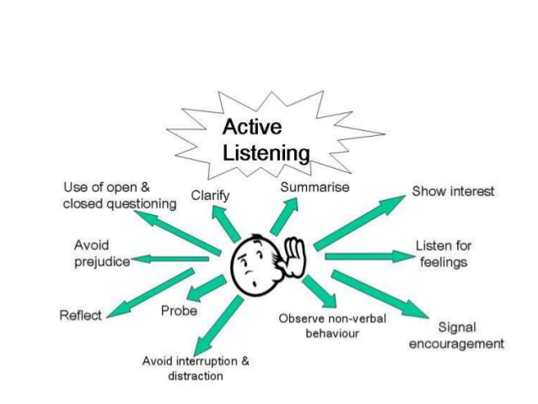
(Image Dr Ruhal)

By using some of these skills highlighted I managed to break down the barriers and start engaging with the male, He said that he had recently left the army following his last tour of duty as he wanted to be with his children and long term partner more.

He had only been out a few months and was struggling to cope with the integration into back civilian life and this was affecting his relationship with his partner, after a few months of arguments his partner left taking his children with her.

The subject was saying that he has lost everything that means something to him and he was better off dead, I kept of giving him value and mentioning his children and how he needed to stay strong for them,

The subject turned to me and aggressively shouted “what do you know”, I then knew that this was the right time to use the active listening skills and change the direction of the conversation.

I pointed to a small HM forces pin badge that I was wearing on my utility vest that was issued to all soldiers on leaving the forces and said “look at that” I know what struggles you are going through and they don’t last forever.

I instantly had the suspect’s attention and I had identified some common ground to explore, firstly I spoke of what regiment he was in and what tours he had been on, this opened the conversation and we started to talk about mutual experiences that had happened while we were away on operations and I even had some chuckles from the subject when he was activating the memory receptors in his brain.

I felt that I was at the stage where I diverted the conversation back to the rope around his neck and asked him to remove it so we could sit in some comfort and continue having a chat, The male agreed and removed the improvised noose from his neck and climbed down the ladder where we went into the front room and sat on the sofas and started back with the conversation.

The suspect was still very tearful and started to speak of his children and how much he missed them and he couldn’t believe that his ex-partner stopped him seeing them,
Again I found myself on common ground and told him of my experience of family courts and the detailed process that he has to complete to get the case in front of a family court where a judge will appoint a cafcas officer who will provide expert child-focused advice and support to safeguard children and make sure their voices are heard in family courts.

This gave the subject hope and he asked if he could take some notes of the pointers I had given, to me this was a good sign as he was already looking to the future.

I was aware that the call was a concern for safety and we were moments away from the subject actually carrying out his suicide attempt and the serious concern and support that he needed, I was also aware of the power a police constable has under section 136 Mental Health Act 1983 where he can remove a person to a place of safety.

Unfortunately I could not use section 136 as the subject was in his own home and not a public place, I then remembered whilst I was in my initial police training we received a lecture from a military veteran who had set up a support charity for soldiers who were struggling with civilian life and gave a card with his contact details on.

I rang the number on the card and explained who I was and luckily he remembered me as we spoke for some length after the lecture, I told him of the incident and the subject’s background and he offered to come to the address and offer support.

Around 40 minutes later the charity veteran arrived where he was introduced to the subject, and after some back and forth conversations he took the subject to the local hospital where he was assessed by a mental health crisis team.

When I arrived back at the police station I completed my updates along with a Public protection notification (PPN) referral under both categories of Adult at risk and domestic,
I highlighted that the subject was suffering with interrogation into civilian life and this had a knock on affect with his relationship, the PPN will be shared with all relevant agencies where he will be discussed and a plan put in place on how they can help him.

Word count task 5 1498 words

Development Plan; (equivalent to 500 words, note that this is not the actual number of words you need to use in completing the table. The ‘equivalence word count’ reflects the thought and research you put into it.).

As part of your reflective process, please use this table to aid you in identifying the next steps for development. (To be completed at the end of workbook completion).

Identified area for development | How it will be achieved | Who can provide support? | Timeline
I feel that I need to spend more time learning how to create custody files and uploading the pre-cons from the PNC computer | To sit with the more senior colleagues on my shift and ask those to show me slow time. Also I will learn this on my hub attachment | Sargent’s and more senior police constables, The hub staff as they do this daily | I would like to set myself a six month timeline to complete this as it is so important I don’t want to rush it and make mistakes.
I would like to see and understand what happens to the PPNs that I submit and all the background support staff and learn their roles | Have an attachment to the public protection team and see how PPNs are risk assessed. | My Sargent and the public protection team | I would set a 3 month timeline as this I think this is very important side of policing
I feel my English and computer skills need some attention, I left school early and joined the army where I served 4 years and then joined the prison service where I worked for 17 years. This is the first job where I need to use computers | The University tasks and workbook help as it makes me use computer skills and conducting research. | I have used the internet to self-teach myself and speak to colleagues when needing advice. | This is something that I will always want to develop and will continue to work hard to better myself, I cant set a timeline on this as it is personal development.

Reference page
Your reference page should only include sources referenced within the workbook using the Harvard referencing system. Information about referencing in written assignments and how to avoid plagiarism can be found on Moodle. It is important that you are aware of the importance of ensuring that the work submitted is your original work.
Only one reference page required that covers all your workbook task.
Note that a reference page contains only the sources you have cited. We are not requiring a bibliography for this workbook which would cover all sources you researched but may, or may not have cited in your work.

National Decision Model College of Policing, (2020), Available at: <https://www.app.college.police.uk/app-content/national-decision-model/the-national-decision-model/?highlight=Ndm?s=Ndm> (Accessed on 11th August 2020)

Criminal Procedure Investigation Act (CPIA) College of Policing. (2020). 1996Available at:<https://www.app.college.police.uk/app-content/investigations/introduction/>. (Accessed on 11th August 2020)

Betari’s Box Mind tools. (2017). : Linking Attitude and Behaviour. Available at: https://www.mindtools.com/pages/article/newCS_82.htm. (Accessed on 11th August 2020)

10 stress busters Cooper, NHS https://www.nhsinform.scot/healthy-living/mental-wellbeing/stress/10-stress-busters (Accessed on 08th August 2020)

DR Sullivan Adrenaline affects https://www.healthline.com/health/adrenaline-rush (Accessed on 01st August 2020)

Bryant, R, & Bryant, S. (2019). Blackstone’s Handbook for Policing Students 2020 (14th ed) Oxford University Press, USA. (Accessed daily)

Suicidehttps://www.ons.gov.uk/peoplepopulationandcommunity/birthsdeathsandmarriages/deaths/bulletins/suicidesintheunitedkingdom/2018registrations> (Accessed on 11th August 2020)

Professor Mehrabian tones of voice <http://joyfulpublicspeaking.blogspot.com/2010/09/if-mehrabian-myth-was-true.html> Accessed on 11th August 2020)

Unconscious bias https://www.grandrapids.org/blog/diversity/unconscious-bias-workplace/ Accessed on 11th August 2020)

Active listening https://alissameeks.wordpress.com/category/uncategorized/page/2/ Accessed on 11th August 2020)

SuicidesVeteran<https://metro.co.uk/2019/05/14/veteran-suicide-hidden-epidemic-government-ignoring-9525180/>

CONFIDENTIALITY and PLAGIARISM – to be completed by the learner

All information provided in this workbook complies with the guidance on confidentiality. I confirm that all work is my original work and has not been copied. Plagiarism is taken very seriously by the University and the programme.

Electronic signature accepted, either pasted in as a ‘picture’, or simply typing your name.

Signed: _ Dylan Griffiths _ (Learner

Date: _ _11/08/2020 _ _

Recognition and confirmation of the progress on the Occupational Competency Portfolio (OCP).

By signing below you are acknowledging your on going progress on O.C.P.
This is recognised by the University as work that is fully supporting this submission and in signing it will be equivalent to 500 words, contributing to your overall word count.

I confirm that I am progressing with the Occupational Competency Portfolio (O.C.P.) in accordance to the regulations.

Signed: _ _Dylan Griffiths _ _ (Learner)

Date: _ _11/08/2020 _ _

Electronic signature accepted, either pasted in as a ‘picture’, or simply typing your name.

