Skills for the Workplace
Module Assignment Submission
Student Name: | Javit Yahsi
Student Number: | 1712742
Module No: | BMSK4003
Module Title: | Digital Skills and Research Methods
Submission Tittle | Effective Communication quantitative survey
Lecturer Name: | Anupam Mazumdar
Counted word: | 1801

Table of Contents
Introduction 3
Literature review 3
Research methodology 5
Questionnaire 5
Findings 8
Conclusion 9
References 10

Introduction

The purpose of this report is to find out how satisfied employees are with communication in the workplace by using quantitative research methods. Communication constantly ranks among the most important skills that employers look for in candidates however communication also comes high in the list of skills lacking in organisations. Picardi, (2001).

The primary research will consist of 5 closed ended questions about how satisfied employees are with communication at their place of work. The sample size will consist of 12 employees from a total population of 60 staff all working at Emel shipping ltd and situated in their UK and Cyprus offices, all participants will remain anonymous. Graphs will be used to show survey results, observation and analysis of the results will be presented in this report.

Literature review

Communication is the transmitting of information from one person to another, this can be verbal, written, visual or nonverbal. Face to face verbal communication is still the most effective form of Communication as it allows for instant response and provides the opportunity to gauge body language and nonverbal signals that may not be communicated via other forms of communication. Communication may involve sending the message however unless the message is received and understood as intended by the sender it cannot be considered communication. Many factors can distort the sending and receiving of messages, this is described as noise in the Shannon and weaver model of communication published in 1949, example shown in the figure below.

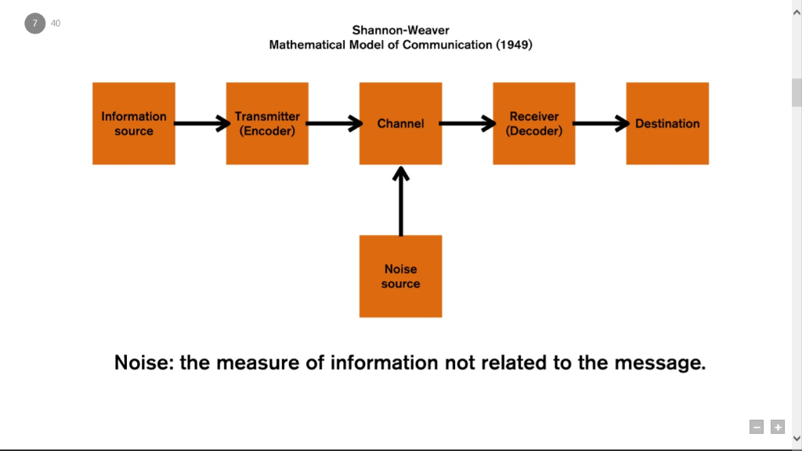

Figure1. Seren moon (2016) Shannon and Weaver model of communication 1949
Failure to communicate or communicating inadequately is detrimental to the success of a company. Poor communication hinders positive development, decreases productivity, makes the organisation less competitive and lowers moral. A survey conducted by office team found that 14% of each working week was lost due to poor communication, that equates to 7 weeks per year. Peter Giuliano chairman of Executive communications group has stated that poor communication from managers is especially damaging as it causes anger, low morale, fear confusion and doubt. (Picardi, 2001)

There are numerous ways that effective communication can be improved within the workplace, the sender may be sending the message however it is the receiver that decodes the message therefore it is vital that the message is received as intended. Past experiences, frame of mind, the mood of the receiver, references and relationships can all distort how the message is received therefore constant feedback is essential, managers need to ensure that they proactively seek feedback in order to ensure the message has been understood as intended. (Picardi, 2001)

Sending messages by speaking or witting are part of verbal communication shared between people, during this process new information and views are shared within the organisation. For successful dialogue to take place certain principles should be followed such as meeting and bonding often to improve relationships, motivated individuals should be engaged, and procedures put in place that are adhered to. Confidentiality is vital and the process should not be rushed, focusing on understanding should be prioritised over trying to get to the end product. Verbal communication is rich in information and allows emotions to be communicated and instant feedback to be sent or received. Written communication may be more effective for messages that require more detail or are of a technical nature. (Guo,K,L. Sanchez,Y. 2005)

Computer generated or electronic communication has been revolutionised with the advent of emails, it is a quick efficient form of sending messages and allows for communication with single or multiple recipients. Emails allow for easy coordination of work and sending clearly defined messages. There may be certain drawbacks when using emails such as it does not allow for the conveying of emotions and could cause certain messages to be misinterpreted or misunderstood. Information overload could affect the output of work and hasty, rude responses may be more common when compared to the traditional methods of written communication that allowed time to cool down and reflect before replying. It is important to know which methods and channels to use when sending messages so that communication is correctly understood and received as intended by the sender. (Guo,K,L. Sanchez,Y. 2005)

It is very important that managers are aware of barriers that can hinder successful communication environmental and social barriers such as relationships, values, beliefs, body language, tone of message and past references can all effect communication and how the message is sent or received. Considering and understanding these these barriers can vastly improve the likelihood of effective communication in the workplace. (Morgan, 2017)

Research methodology

Quantitative research methods will be used in this questionnaire to collect primary data regarding employee satisfaction of communication in the workplace. The questionnaire will consist of 5 closed ended questions on the topic of effective communication in the workplace, a sample size of 12 staff from a population of 60 will participate in the survey. All participants are employees of Emel shipping ltd and work in their London and Cyprus offices. The data collected used to aid the researcher to interpret the results. Participants are both male and female from a wide range of age groups, and have varying religious beliefs.

For content validity to be achieved all questions were constructed based on effective communication in the workplace. The literature review was used as a framework for designing the questions. Bar graphs will be used to highlight the results of each question and a brief summary of the results will be noted below each graph.

Questionnaire

Employee satisfaction survey of effective communication in the workplace

Question 1.

Over 70% of participants did not believe that managers effectively communicated at work. Under 20% of staff questioned thought that managers communicated effectively.

Minimum | Maximum | Median | Mean
1 | 7 | 2 | 3

Question 2.

Over 90% of participants questioned agreed or strongly agreed that Poor communication was a factor in lowering the morale of staff and decreasing productivity at work. Less than 10% thought that poor communication had an effect on morale or productivity.

Minimum | Maximum | Median | Mean
1 | 6 | 5 | 4

Question 3.

75% of employees surveyed agreed that they would like more proactive feedback and agreed that it would benefit effective communication between managers and staff at work. Under 10% of staff were in disagreement that proactive feedback would make any difference in communicating effectively.

Minimum | Maximum | Median | Mean
1 | 5 | 3 | 3

Question 4.

Over 80% of staff questioned believe that poor communication has negatively affected the quality and productivity of their work with Less than 10% believing it had no effect.

Minimum | Maximum | Median | Mean
1 | 6 | 2.5 | 3

Question 5.

Over 90% of staff surveyed believe that verbal, non-verbal and electronic means of communication could be better utilised at work. There were no participants that believed these forms of communication could not be better utilised.10% of participants stating they did not know if these forms of communication could be better utilised.

Minimum | Maximum | Median | Mean
1 | 8 | 3 | 4

Findings

The results of the survey suggest that the majority of the participants thought that communication within the company was lacking or could be improved. The answers also suggest that work output and performance had been negatively affected at some point due to lack of effective communication by managers. Almost all participants surveyed Agreed or strongly agreed that verbal, non-verbal and electronic forms of communication could be more effectively utilised. Over 90% surveyed answered that morale and productivity were adversely affected due to poor communication. Employees seem to be dissatisfied with communication from managers overall.

A survey of over 3,000 businesses conducted by the British chamber of commerce in 2014 and also published by the BBC Oct 2014 found that 9 out of 10 businesses felt school leavers were not ready for employment and more than half of businesses stating that school levers and graduates alike did not have even the most basic skills of communication. Businesses believed that governments both past and present had not adequately prepared students for working life. Businesses stated they needed young people with strong communication and team working skills. (BBC, 2014).

Although the primary sources used to conduct this survey were from a single company (Emel shipping ltd), with a relatively small sample size and population it has produced very similar results to the comprehensive survey conducted by the British chamber of commerce in regards to perceptions of effective communication at work. The findings of both this survey and the survey conducted by the British chamber of commerce of over 3,000 businesses suggests that although Communication is acknowledged to be very important and ranks among the top of the most wanted skills within corporations it seems to be a skill that is lacking or not used effectively.

Conclusion

Time after time communication is shown to be one of the top skills required by employers and yet surveys and research shows that it is one of the skills most lacking in the workplace. People often assume talking alone constitutes communication without considering that listening is just as important and that many external and environmental factors can distort and hinder effective communication. Managers should ensure that they are being listened to and that they actively listen to promote effective communication.
Having clear ideas of what the message is and being aware of the receivers needs, attitude and how they will be affected by the message will aid effective communication. It is the sender’s responsibility to gain feedback and ensure that the message is received as intended, only when a message is received as intended can it be considered communication. Numerous external factors affect how a message is received therefore feedback is one of the most important methods of gauging if effective communication has taken place. Managers need to be aware that speaking and delegating alone does not constitute communication and that feedback should be sought wherever possible.
Communication is a vital skill in any corporation and can negatively or positively influence relationships, staff morale, efficiency, quality of work, productivity and allows resources to be used properly. One of the biggest hindrances of communication is to assume that the receiver has understood the message without considering the factors that can distort the message. Social barriers, personal references, relationships, the medium used and tone of message need to be considered for effective communication to take place. Implementing and bearing in mind all the external and environmental factors while seeking feedback and engaging in active listening could immensely benefit managers to communicate.
Focusing on teaching and developing communication skills to school age children may have benefits in the medium to long term by producing a workforce already equipped with one of the most important and sought-after skills in businesses. This will require effort and investment by government and a willingness of business to work with schools and give young graduates a chance in employment.

References

BBC (2014) Young people lack workplace skills
https://www.bbc.co.uk/news/business-29454002 (Accessed: 01/01/2019)

Guo,K,L. Sanchez,Y (2005) Workplace communication [online] Available at: http://www.dphu.org/uploads/attachements/books/books_4741_0.pdf (Accessed: 13/12/2018)

Morgan,P (2017) The business student’s guide to study and employability, UK, Sage

Picardi,R,P. (2001) skills of workplace communication, Connecticut, Quorum books

Seren Moon, Shannon and weaver model of communication, (2016) [Online] Available at: https://gdblogs.shu.ac.uk/b3023893/2014/10/15/shannon-weaver-model-of-communication/ (Accessed 12/12/2018)

