

Portfolio
Module: Changemaker: Creativity and Value Creation
Module Code: BMHP5014_BRIM

Name: Uzma Amir Said
Student ID: 2426983

Task 1 – Concept Map
Create a concept map that outlines the relationship between creativity, value creation, and health and social care improvement. Within the concept map explain how these concepts interact in a health and social care context (250 words).
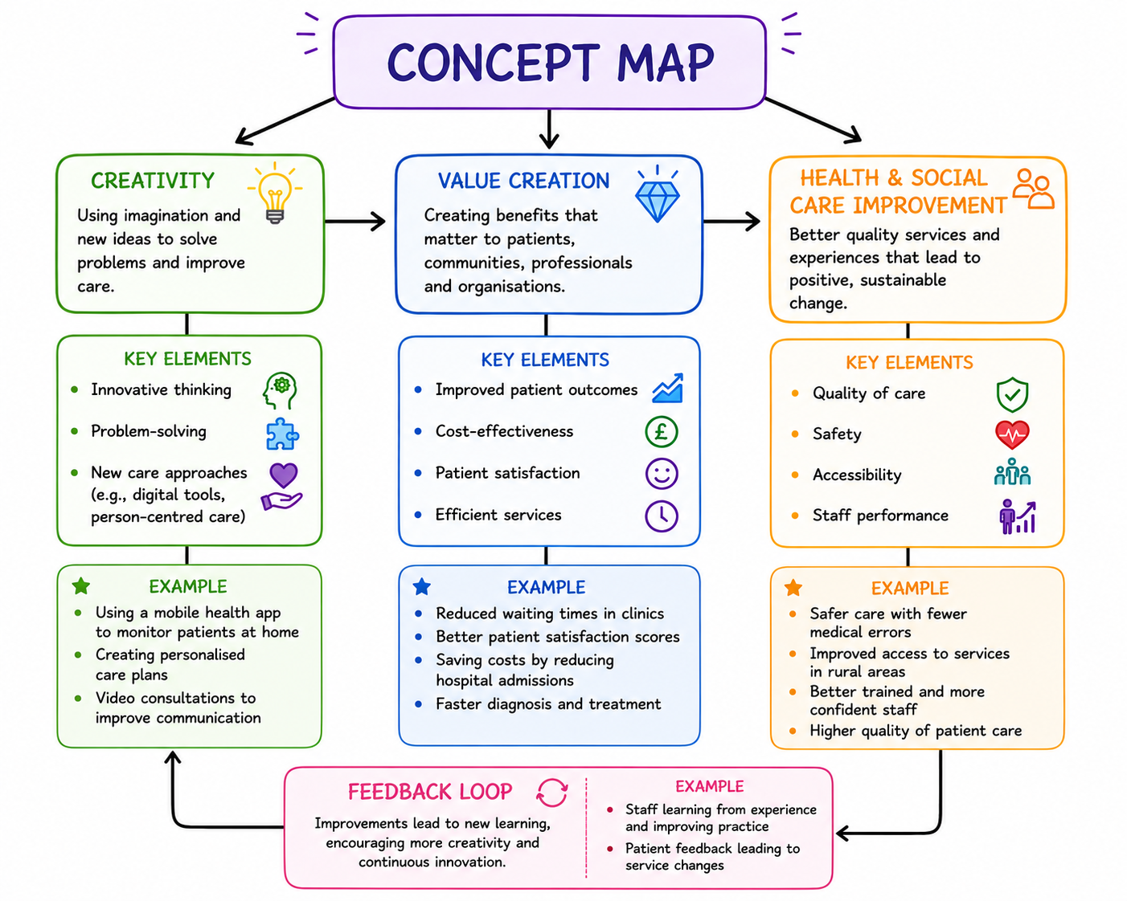
The concept map shows how creativity, value creation, and improvement all connect in health and social care. Margaret Boden (1994) defines creativity as thinking of new ideas and better ways to solve problems (cited Carlile and Jordan, 2012). In care settings, creativity could be using new technology, improving communication, or finding more person-centred ways to support patients.
When creative ideas are used, they help to create value. In health and social care, value is not just about money; it also means improving people’s experiences, making services more efficient, and helping patients achieve better outcomes (Porter, 2012). For example, a new way of organising appointments might reduce waiting times and make patients feel more satisfied with the services.
Value creation then leads to improvements in health and social care services. This includes better quality care, increased safety, easier access to services, and improved staff performance. When services improve, patients receive better support, and overall health outcomes improve.
There is also a continuous cycle between these ideas. When services improve, staff feel more confident and open to try new ideas, which encourages more creativity. This leads to even more value and further improvements.
In simple terms, creativity helps generate value, value leads to improvements, and improvements encourage more creativity. All three work together to make health and social care services better, more effective and more focused on patients' needs.

Task 2 - Self-Reflection of Group Activity
Complete a self-Reflection on the Convergent/Divergent paperclip thinking class activity using a reflective model (250 words, 1 source)

Self-Reflection on the Convergent and Divergent Paperclip Thinking Activity (Gibbs’ Reflective Cycle)
I used Gibbs' Reflective Cycle (1988) to reflect on the paperclip thinking activity. I missed the class when the activity was first completed. Last week, my lecturer asked another student and me, who had also missed the session, to complete it together.
The activity involved discussing the different ways we had used paperclips in real life and thinking of other possible uses. We shared our ideas and completed the task quite quickly. I felt comfortable throughout the activity because there was no pressure, confusion, or judgment. We were both happy to share our thoughts and listen to each other's ideas.
One thing I enjoyed was hearing about some uses for paperclips I had never thought of before. Even though a paperclip is a simple object, the activity showed me that people can think about it in very different ways. Listening to another person's ideas helped me see things from a different perspective and made the discussion more interesting.
The activity helped me understand the difference between convergent and divergent thinking. Divergent thinking involved coming up with as many ideas as possible, while convergent thinking involved focusing on the ideas that were the most practical or useful (Cropley, 2006). Although the task was simple, it showed me how discussing ideas with others can help expand my thinking.
Overall, I found the activity enjoyable and easy to take part in. In future group activities, I will continue to share my ideas and listen to others because this helps me learn new ways of thinking and problem-solving.

Task 3 - Case Study of a UK innovation
Write a concise case study analysis of an innovative project or initiative within the NHS or UK social care. Focus on how creativity was used to drive change and the value it created for patients or service users (400 words, 2 sources).
Case Study Analysis: NHS Virtual Wards
One new and creative idea in the NHS is something called Virtual Wards. These allow patients who would usually need to stay in the hospital to receive the same level of care while staying at home. This is done using digital technology, remote monitoring devices, and regular contact with healthcare professionals. The use of virtual wards grew a lot after the COVID-19 pandemic and has now become an important part of NHS care. By 2023, NHS England had already expanded virtual wards to support over 11,000 “virtual beds” across the country, with plans to scale up significantly in the coming years (Htn.co.uk, 2023).
The main idea behind virtual wards is to rethink how hospital care is delivered. Instead of keeping all patients in hospital, the NHS can monitor them at home using equipment like blood pressure monitors and pulse oximeters, as well as digital apps. Healthcare staff can check patients' readings remotely, speak with patients via video calls, and arrange home visits when needed. This makes care more flexible and focused on the patient.
For patients, this approach brings many benefits. Most people feel more comfortable recovering at home, where they are surrounded by family and in a familiar environment. This can reduce stress and help them feel more independent. Studies also show that virtual wards can lead to similar or even better health outcomes than traditional hospital stays, especially for older patients, with some programmes reporting a 20% reduction in avoidable hospital admissions (Norman, Bennett and Vardy, 2023). Many patients also report higher satisfaction because they feel more involved in their own care (Norman et al., 2023).
Virtual wards are also helpful for the NHS. They reduce the number of hospital admissions and allow some patients to leave the hospital earlier, which frees up beds for those who need them most. This helps hospitals manage their workload better and use resources more efficiently. According to NHS England, virtual wards support faster treatment while avoiding unnecessary hospital stays (NHS England, 2024).
Even though there are still challenges such as staffing, digital access, and deciding which patients are suitable, virtual wards show how technology and new thinking can improve healthcare. They do not always require completely new services, but instead, they can improve existing ones by redesigning how care is delivered. Overall, virtual wards are a strong example of innovation in the NHS, improving patient experience, supporting recovery, and making healthcare more efficient.

Task 4 - Research Task
Identify a current issue in health and social care (e.g. e.g., mental health stigma, access to care for vulnerable populations). Find two pieces of academic research (journal articles) that explain the reason for this problem. Paraphrase the findings of each article (300 words, 2 sources).
Access to Healthcare for Vulnerable People
Access to healthcare for vulnerable populations is a major issue in health and social care. In the UK, people who are older, from low-income backgrounds, refugees, or ethnic minority groups often struggle more to get timely and fair healthcare. Research shows that this problem is not caused by one single factor, but by a mix of social, economic, and system-related barriers.
Article 1: Inequalities in access to adult mental health services in the UK (Lowther-Payne et al., 2023).
Lowther-Payne et al. (2023) found that many people do not get equal access to mental health services in the UK. One reason is stigma. Some people feel embarrassed or afraid to ask for help. Others do not trust health services or feel they will not be understood. The study also shows that services are not equal in all areas. Some places have long waiting lists, and some have very limited services. This creates unfair differences depending on where people live. The research also explains that practical problems such as transportation, time constraints, and digital access issues make it harder for some people to attend appointments (Lowther-Payne et al., 2023). Overall, the study shows that both personal worries and system problems make access unfair for some groups.
Article 2: Conducting a critical interpretive synthesis of the literature on access to healthcare by vulnerable groups (Dixon-Woods et al., 2006).
Dixon-Woods et al. (2006) also explain that disadvantaged groups often delay using healthcare. Some people feel their health problems are “not serious enough” to see a doctor. This idea is known as “candidacy,” meaning people decide if they deserve care or not. The study also highlights real-life barriers such as the cost of travel, lack of transport, and difficulty understanding how to use healthcare systems. Because of these problems, many people only seek help when their condition becomes serious. This leads to higher use of emergency services instead of early treatment (Dixon-Woods et al., 2018).
Both studies show that access problems come from stigma, poor service availability, and everyday barriers. These issues make healthcare harder to reach for vulnerable people.

Task 5 - Podcast
Record a two-minute Podcast introducing your idea for component 2 using https://www.rev.com/onlinevoicerecorder The MP3 audio must be downloaded and embedded as a file (see guidance video on how to do this here: https://www.youtube.com/watch?v=D21isId0agw) or an accessible OneDrive link if using a chromebook (make accessibility – anybody) before inserting into your portfolio. Check the accessibility of the link before submitting.

Task 6 - NHS Leadership Framework Analysis
Write a short summary (200 words) explaining the key components of the NHS Leadership Framework. Then, choose one component and describe (150 words) how a leader might use it to encourage creativity and improve care in the NHS (2 sources).

The NHS Leadership Framework - Summary
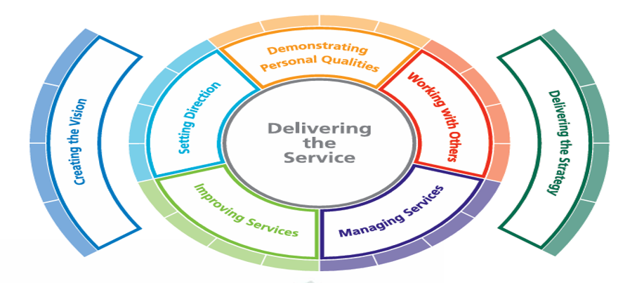
(NHS Leadership Academy, 2011).

The NHS Leadership Framework explains the main skills and behaviours needed for good leaders in the NHS. At the centre is Delivering the Service, which means focusing on safe, high-quality patient care. Around this are the key areas that support good leadership.
Creating the Vision is about explaining future goals simply so everyone understands. Setting Direction means planning goals and showing staff where the service is going. Delivering the Strategy is turning plans into real actions in the workplace. Improving Services focuses on finding better ways to do things, making care safer and more effective. Managing Services is about organising staff, resources, and time properly so services run smoothly. Working with Others means building good teamwork between staff, patients, and other organisations. Demonstrating Personal Qualities includes honesty, respect, and responsibility in leadership roles.
All these parts work together to support good decision-making and better patient care. The framework helps leaders understand what is expected of them and how they can improve healthcare services. It also encourages a positive workplace culture where staff feel supported, and patients receive high-quality care.
Improve Service
The “Improving Services” component helps leaders look for better and more creative ways to deliver care. A leader can use this by encouraging staff to share ideas and suggest improvements without fear of being judged. For example, in a hospital ward, a leader might ask nurses and support workers to suggest small changes that can reduce waiting times or improve patient comfort. They can also support team meetings where staff discuss problems and test new ideas in a safe way.
This approach builds creativity because staff feel involved and valued. When people work together and think openly, they are more likely to find simple but effective solutions. It can also improve patient care by making services faster, safer, and more organised.
Research shows that good leadership and staff involvement can improve innovation in healthcare settings (NHS Leadership Academy, 2011). The King’s Fund also highlights that supportive leadership encourages improvement and better service quality (The King’s Fund, 2020).

Task 7 - Self-Reflection Journal Entry
Write a short journal entry about what you learned in this module. Focus on how your understanding of creativity and value creation withing H&SC has changed and how it has informed your professional practice (200 words).
What Have I learned from this Module?
In this module, I have learned a lot about creativity and value creation in Health and Social Care (H&SC). Before, I thought creativity only meant being artistic or doing something new and different. Now I understand that creativity in H&SC is also about solving problems in simple and practical ways that improve people’s lives.
I also learned that value creation is not just about delivering services, but about how those services make a real difference to individuals. For example, small changes in care planning, communication, or support methods can greatly improve a service user’s independence, dignity, and wellbeing.
This understanding has changed how I think about my future professional practice. I now realise that, as a support worker or practitioner, I should always seek better ways to meet individual needs, even when resources are limited. Creativity can include listening carefully to service users, adapting care approaches, and working well with other professionals.
It has also made me more confident in suggesting ideas and being open-minded in teamwork. I understand that good care is not only about following routines, but also about thinking creatively to create real value for people.
Overall, this module has helped me see health and social care as a field in which creativity is essential to providing high-quality, person-centred care.

Reference List

Boden, M.A. (1994) The creative mind: myths and mechanisms. Routledge.
Carlile, O. and Jordan, A. (2012) Approaches to creativity in education. Routledge.
Carlile, O. and Jordan, A. (2012). Approaches to creativity: a guide for teachers. Berkshire: Open University Press.
Cropley, A.J. (2006) ‘In praise of convergent thinking’, Creativity Research Journal, 18(3), pp. 391–404. https://doi.org/10.1207/s15326934crj1803_13. (Accessed: 18 June 2026).
Dixon-Woods, M., Cavers, D., Agarwal, S., Annandale, E., Arthur, A., Harvey, J., Hsu, R., Katbamna, S., Olsen, R., Smith, L., Riley, R. and Sutton, A.J. (2006). Conducting a critical interpretive synthesis of the literature on access to healthcare by vulnerable groups. BMC Medical Research Methodology, 6(1). doi: https://doi.org/10.1186/1471-2288-6-35. (Accessed: 9 June 2026).
Gibbs, G. (1988). Learning by Doing: A Guide to Teaching and Learning Methods. Oxford Polytechnic.
Htn.co.uk. (2023). Four ICBs currently meeting NHSE’s virtual wards target for end of 2023 – HTN Health Tech News. [online] Available at: https://htn.co.uk/2023/11/08/three-icbs-currently-meeting-nhses-virtual-wards-target-for-end-of-2023/ [Accessed 28 Jun. 2026].
Lowther-Payne, H.J., Ushakova, A., Beckwith, A., Liberty, C., Edge, R. and Lobban, F. (2023). Understanding Inequalities in Access to Adult Mental Health Services in the UK: a Systematic Mapping Review. BMC Health Services Research, [online] 23(1). Available at: https://bmchealthservres.biomedcentral.com/articles/10.1186/s12913-023-10030-8. (Accessed: 7 June 2026).
NHS England (2024) Case studies: Virtual wards. Available at: https://www.england.nhs.uk/virtual-wards/case-studies/ (Accessed: 2 June 2026).
NHS Leadership Academy (2013) Healthcare Leadership Model. Available at: https://www.leadershipacademy.nhs.uk/resources/healthcare-leadership-model/ (Accessed: 28 June 2026).
Norman, G., Bennett, P. and Vardy, E.R.L.C. (2023). Virtual wards: a rapid evidence synthesis and implications for the care of older people. Age and Ageing, 52(1). https://doi.org/10.1093/ageing/afac319. (Accessed: 16 June 2026).
The King’s Fund (n.d.) Leadership and management. Available at: https://www.kingsfund.org.uk/topics/leadership (Accessed: 28 June 2026).

