Name: Hannah Harris
Student Number: P147431
Course: Illustration
Title: A look at contemporary German illustration and if there are any differences with Welsh arts and crafts.
Word Count: 1820
Tutor: Louise Burston

A look at contemporary German illustration and if there are any differences with Welsh arts and crafts.
In my dissertation I plan on looking and comparing the many art forms in both Wales and Germany and whether there are any similarities between the two. As someone who has grown up with both German and Welsh influences in Wales I want to explore the German differences and how that effects the art movement in different ways. I plan on looking at what and if the culture effects the type pf art that is created and mediums used. I want to also know if storylines and themes are affected by the lives lived in different countries.
Thinkers:
Dylan Thomas – A Welsh writer and poet known for pieces such as ‘A Childs Christmas in Wales’
Hermann Hesse – A German Writer, poet and painter
Johann Wolfgang Von Goethe – A German Writer and poet
Glyn Jones – Welsh Novelist and poet
Welsh artists:
Kyffin Williams
Shani Rhys James
Richard Wilson
Ernest Zobole

German Artists:
Gerhard Richter
Anslem Kiefer
Ernst Ludwig Kirchner
Otto Dix

Key Images:
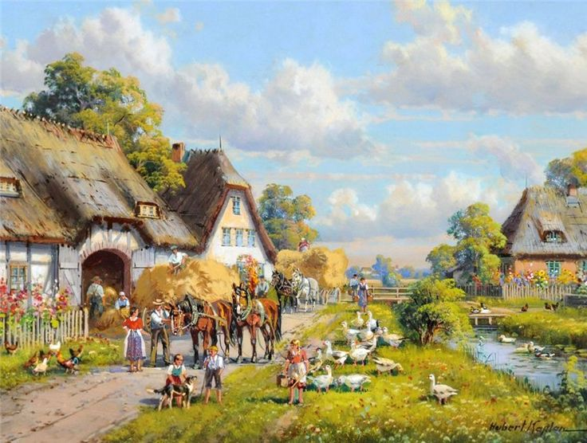
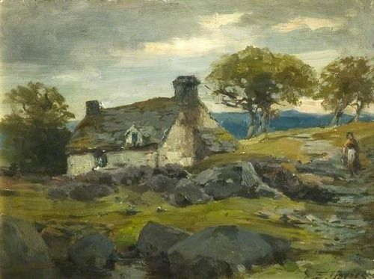

Welsh Cottage crested in oils by Edward Davies Huber Kaplan a German artist
Keywords:
Storytelling
Culture
Mythology
Storytelling:
Storytelling is most commonly done throughout the use of words to describe something that is either factual, for instance the history of a country or its people, to something that is complete fantasy like the Grimm’s tales. It’s something that is popular amongst all cultures and ages and has never died out. Each culture holds its own stories, with most having been influenced by the way they lived their lives and what is relative to them. Some stories have also travelled across countries and are well known by most, for instance the stories of Rapunzel, The little Mermaid and Cinderella. Some stories are passed down from generation to generation and some are made into physical copies like novels and short stories. Whereas the Germans have the most popular Brothers Grimm the Welsh have many lesser known tales that are mainly kept alive by education and family members. These stories are not only kept alive with words but illustrations to help narrate the story itself and help give life to the characters and themes. I want to explore whether there are any similarities between Wales and Germany and what it is about the stories that stay consistently through generations and influences the arts. One of the most famous German pair of writers are The Brothers Grimm, their stories are most commonly used by Disney however they portray the sweeter more cheerful version, where the originals are far darker and less child friendly. What about the change in culture effected the stories and why do we favour the nicer versions to something darker. These stories have been translated into many languages and have created some of the most well know tales today. On the other end there are the Welsh tales that until recently have stayed in their original language of welsh. What about the welsh stories and the way the welsh live has affected how many know to stories compared to the German brothers Grimm. The Welsh, like the tales of brothers Grimm hold many dark themes and unhappy endings. It’s important to look at storytelling in the dissertation as it helps to understand what is relative to each country and how the way they have lived has affected the way they wrote and create art.

References I plan on using:
The Original Folk and Fairy tales of the Brothers Grimm: The Complete First Edition The Fairy Tales of Hermann Hesse Romantic Fairy Tales: Goethe, Tieck, Foque and Brentano Welsh Fairy Tales by William Elliot Griffis Celtic Tails: Fairy Tales and stories of Enchantment from Ireland ,Scotland and Wales
Cultural:
Culture is a way of identifying a particular group of people. It’s a way of being able to see the differences in how people from other countries live and why. Culture defines who we are through many ways such as the arts, literature and music and these things can be affected through history, landscape and language. These things are different throughout each country and can change throughout different areas for instance south and east Germany, this can be anything from the way they use the same language to the food that they eat. It is important to explore the culture of both Germany and Wales throughput my dissertation because it is the background of peoples lives that are most commonly shown throughout their art. It is while looking at the pieces that sometimes leads us to understand the culture better and the differences between us and them. It helps illustrate things that we might not see or even know about. There are similarities between the two countries for instance that farm life is clearly present throughout both but the way they are perceived is different. In welsh paintings there is less colour and more darkness with there being less detail throughout the piece, whereas the Germans have more of a colourful detailed piece, making it appear happier and more cheerful. I want to know if it’s the culture of the two countries that effects the type of materials and why. There is also the similarity in that they share a traditional dress that is only worn for celebrating a traditional holiday or event. It displays the history of an old way of living and reminds them of where they came from. Whereas the Germans tend to wear it more frequently throughout events such as the Oktoberfest, Wales only wear theirs once a year during St David’s day and is most commonly worn by children rather than of all ages in Germany. Culture is what shapes who we are and without it art would have no meaning.
References I plan on using:
The Cambridge Companion To Modern German Culture (Cambridge Companion To Culture) The Complete Picture Of Culture By Gebhard Deißler The Little Book Of Welsh Culture By Mark Rees A History Of Wales By John Davies
Mythology:
Myths are things that are generally untrue but believed by some and kept alive with stories and objects such as cups, bridges and statues. This allows some part of the story to feel true as there is a physical object that can be viewed. The word itself means false story, but this doesn’t stop the myths continuing and being passed down through generations. Myths typically reflect the culture of the place they are formed from and I want to look into if there are any similar themes between the myths of Germany and Wales. They tend to create meaning for certain things in our lives, like how the seasons became to be or how certain traditional events got their name. Religion and cultural beliefs make a huge impact on the myths of different areas. Myths tend to contain god-like beings and placed in settings that always seem to be of a distant past. Each one contains an unimaginable event and I want to look into what makes the stories so interesting and why after all these years they have managed to continue. In Wales one of the most common myths, is how the welsh Valentine’s day of Dydd Santes Dwynwen came to be. It’s a tragic story of how a woman was forced into marriage with a man she did not love, despite having a lover and due to this became a celibate nun who gave luck to couples around the world. Religion comes into play with the German legend of The Changeling, a story of a woman whose child was swapped with the devil. Luckily the woman is warned of the swap and manages to get her child back in the end unharmed. This is one of the few stories that contains a happy ending, but within the Welsh legends there are far more unhappy then happy endings. Throughout my welsh education, I was told many welsh myths as it was a massive part of the culture and language. Many of the tales are only in the welsh language and so it is harder for the English speakers to find translations. I want to know if like the welsh, the Germans teach it as part of their cultural education and if not then why. Myths in wales are what create a lot of foundations for the poetry, artwork, novels and I plan to investigate how culture effects the themes, characters and setting of the myths as many contain well known and popular areas of the country. I want to see if any myths are modified or changed throughout history and if any have remained the same.
References I plan on using:
Mythology, Madness and Laughter: Subjectivity in German Idealism By Markus Gabriel Selected Folktales/ Ausgewälte Märchen Welsh Legends And Myths By Graham Watkins Welsh Folk-Lore: A Collectio Of The Folk Tales And Legends Of North Wales; Being The Prize Essay Of The National Eisteddfod 1887 (Classic Reprint) By Elias Owen

How the key words have led me to my question:
These key words have led me to my question of, “A look at contemporary German illustration and if there are any differences with Welsh arts and crafts” because of the influence it has had on my own art throughout my degree. I have been surrounded by both cultures throughout my childhood and have at times tried to show this through my art. I want to discover the reasons behind some of the legends and the impact that culture has had on other artists and what it is about each country that effects the arts. Being someone of both a German and Welsh heritage growing up in wales, I have grown familiar with Welsh tails and art but throughout this dissertation I hope to uncover the German legends and culture that sets it apart from Wales. I am aware of some differences and similarities, but I want to explore in more depth the impact it has had on the way others view the countries. My aim is to uncover the importance art has had on each country and how where you come from is an important part of how you create art.

Sub questions:
How does culture effect the themes shown in German and Welsh art?
Does the culture effect the materials used to create art in different countries?
Does storytelling have an impact on the art of both Germany and Wales?
Is Mythology present throughout the art of both Wales and Germany?
Are there many cultural differences between Wales and Germany?
Are there differences between the themes and characters present in Welsh and German myths?
Do certain areas in each country effect the art produced?
How does illustration help to bring both German and Welsh stories to life?
Can you tell the differences in culture throughout the art in Germany and Wales?
Is one country more popular than the other when it come to the arts?

