M4X01500 Computer Systems Assignment: Virtual Machines

Student: Ross Shaddick - 1803900

1. Introduction
The aim of this assignment is to create a four virtual machine simulated network, using servers and installation of operating systems then interconnecting them via IP addressing.

- Creation of Virtual PCs.

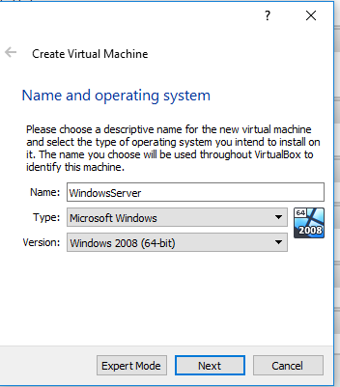

The first task was to create a Windows Server 2008 R2 VM. This comprises the typical steps of building a physical PC such as provisions for RAM, HDD, NICs, and Operating Systems.

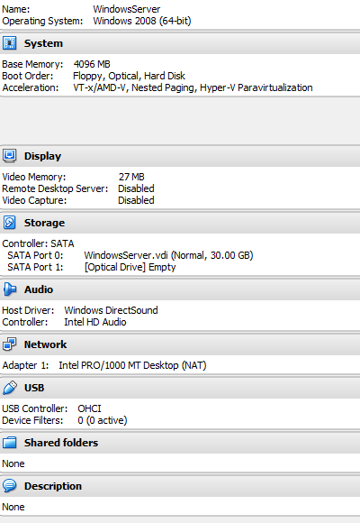

This capture shows vital resource provisions for Server 1. Note that the following parameters were set for Server 1:

- RAM: 4096MB
- HDD: 30GB
- VIDEO MEMORY, VT-x Hyperthreading, Nested Paging-disabled and Network Settings were all set accordingly.
This process was then followed for Client 1 creation, with the only exceptions being:
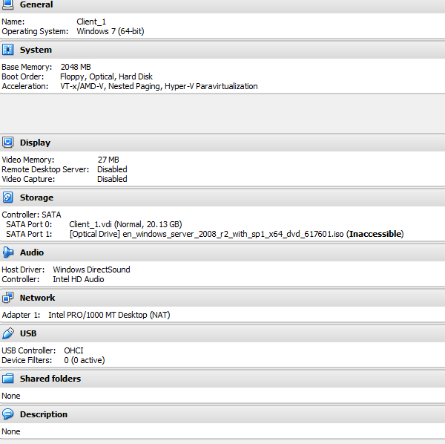

Client machines do not require the resource demands of that of the Server Operating system, therefore HDD was set lower (20GB) and RAM (set to 2048 Windows 7 Minimum RAM/HDD requirements are set (2GB RAM and 16GB HDD respectively). As this is a low demand Client, these resources are fine and provide good practice use of Type 2 Hypervisors as we are not taking more from the physical host than what we need.
  - Installation of Windows Server 2008R2 (64 Bit)

There are some pre-requisite steps to take when installing an operating system on a virtual machine in Oracle Virtualbox. Operating systems can be installed via physical media (e.g. DVD) or via a suitable ISO image and here the latter option is utilised.

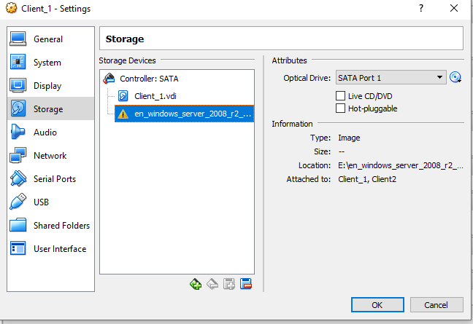
The Storage option provides a means of accessing install media (the Operating System install files) here a ISO file for Windows Server has been used. The cd icon allows selection of suitable ISO when clicked.
It is also necessary to set the Boot order/priority in order for the correct boot sequence to allow the PC to look at the media that has been installed. Here the Optical drive is set as first option to allow the new system to locate Operating system media install files.

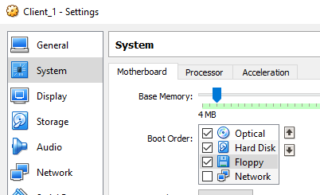

  - Installation of Windows 7 (64-Bit)

This is the exact same procedure as in the steps taken to install Windows server 2008 R2

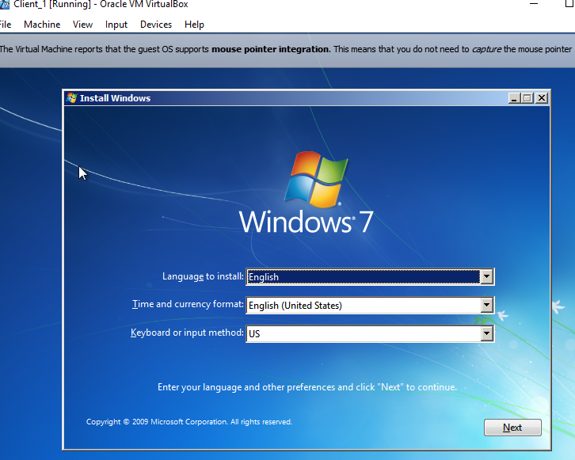

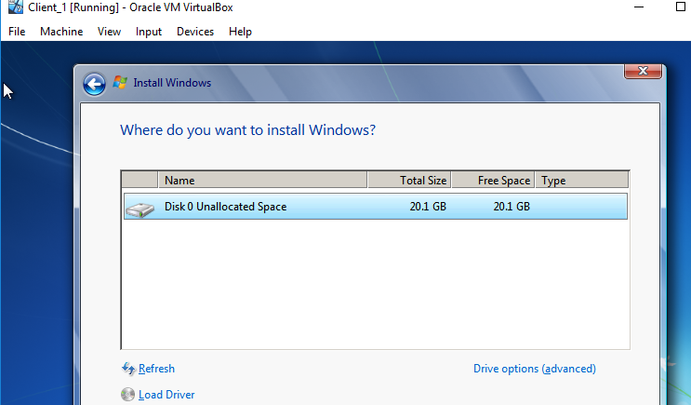

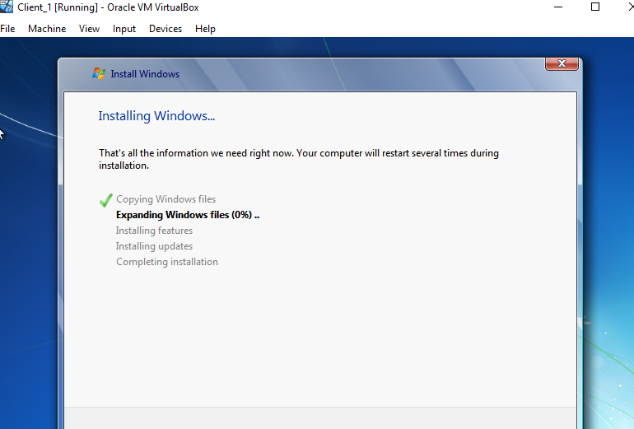

- Network Design for VM Simulation
VSwitch Creation in VirtualBox:
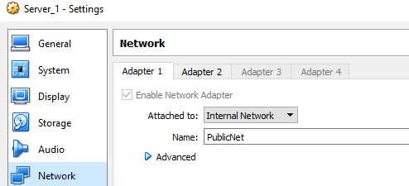

Shown above, is the creation of VSwitch PublicNet on Server 1

Here shown is the creation of another connection to VSwitch PublicNet on Server 2

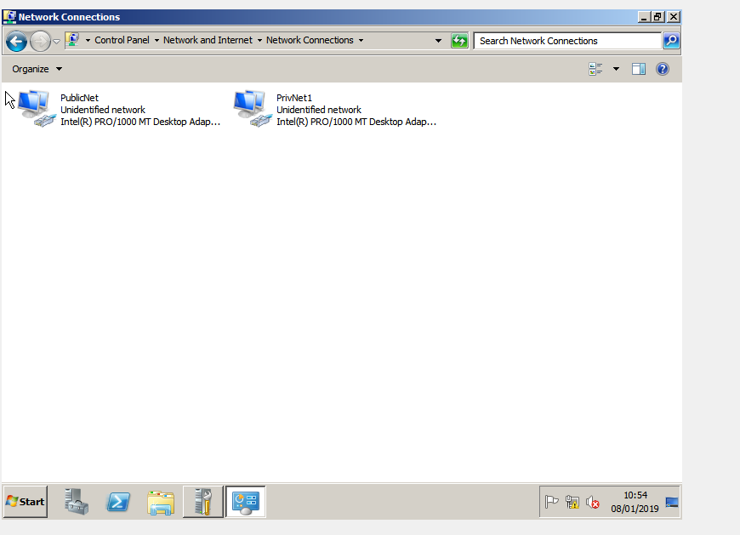

There are two IP networks on Server 1: Server1 is attached to VSwitch PublicNet on 192.168.1.100

It is attached to PrivNet1 VSwitch on 192.168.100.1

Server 2 VSwitch Creation
Here are snippets from the PC console command line for host; Client 1 IP configuration and ‘pinging’ 192.168.101.1

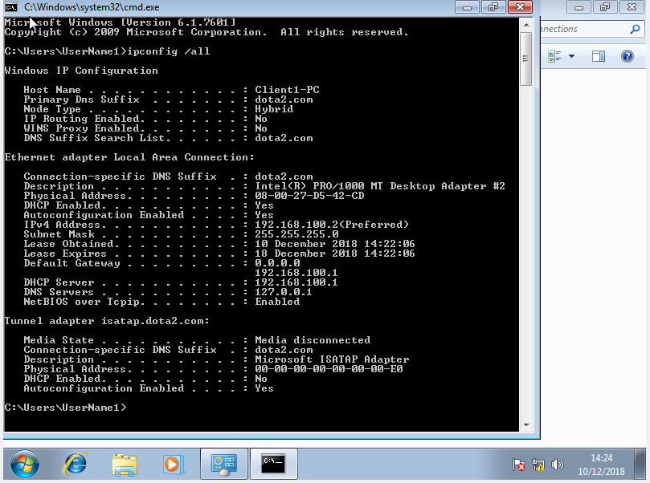

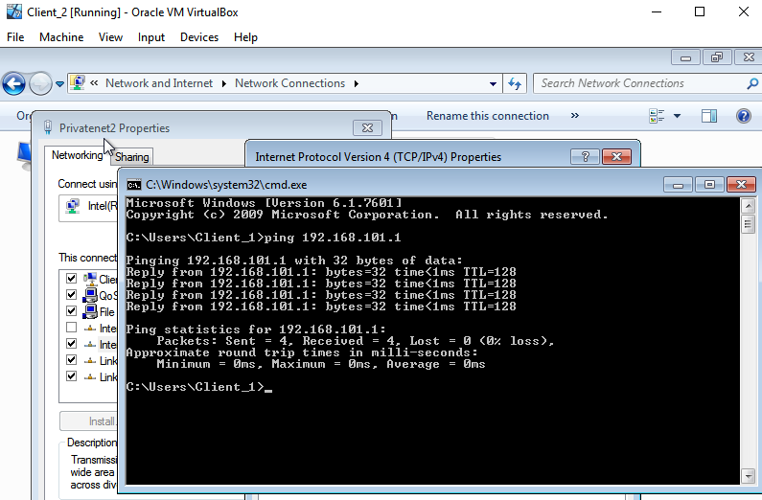

- Set up of a Primary Domain Controller and DNS

Here shown is one of the servers as a primary domain controller and DNS

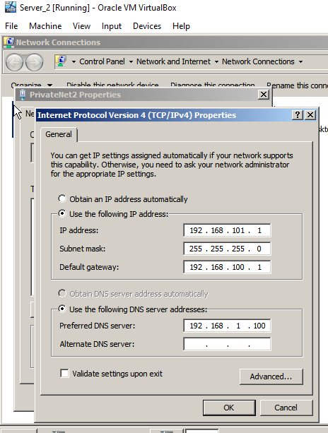

And one of the client PC’s that has joined the domain

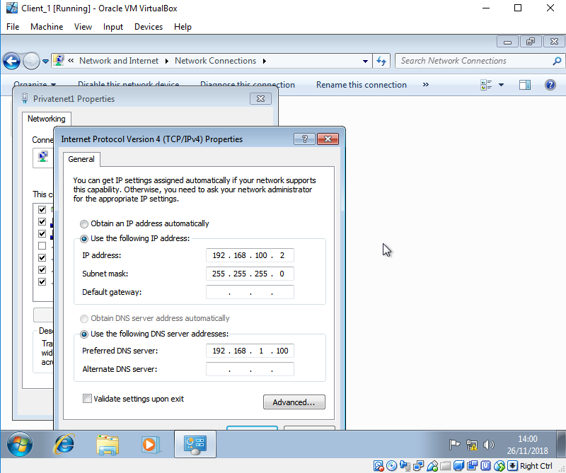

- Creation of a DHCP server

Here is the running of a DHCP server

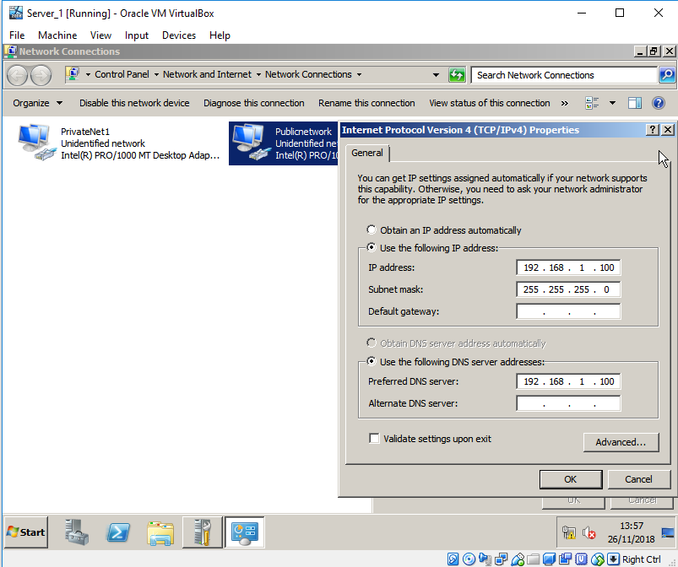

Here the Client 1 has acquired it’s IP address automatically from the server

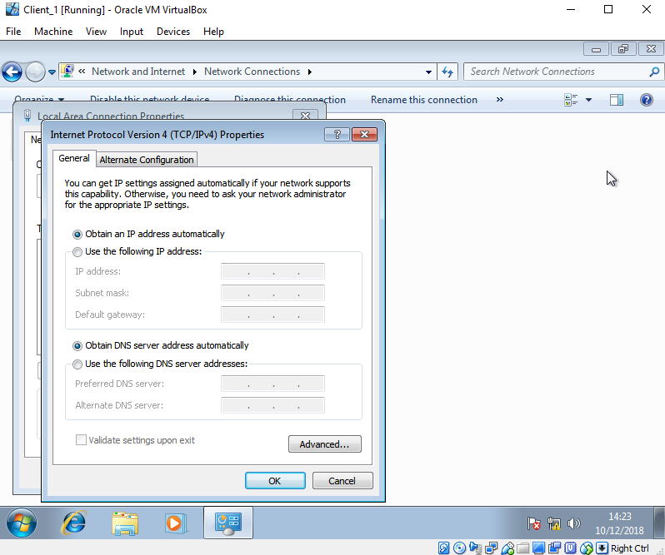

This concludes my assignment.

