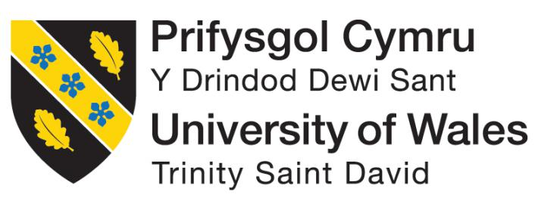

Name:

Student Number: 1602152

Program Name: Doctor of Business Administration

Module Title: Visions for the Future – Theoretical Perspectives on Management

Module Code: LCDB7006

Module Lecturer: Dr John Lang

Student E-mail Address: 1602152@student.uwtsd.ac.uk
Abstract
The purpose of this assignment report is to develop an exact and detailed theoretical understanding of management theories and practice. The paper particularly focused on change management, and British Airways (BA) was taken as an analysis object in order to carry out in-depth research and analysis of change management theories and creative thinking of future change management practice. The report includes four major elements are respectively: creativity, evaluation, analysis, and application. There were mainly five change management theories were critically discussed in the literature review section. A creative reflection (theory combination and model creation) of what other companies can use for their future organizational change management and how to efficiently minimize chaos, potential risks and conflicts are presented at the end of the paper.
Key Words: Change management, critical analysis, creative thinking

Table of Contents
Introduction 4
Review of BA Change Management 4
Literature Review 7
Kurt Lewin’s 'unfreezing' change management model 7
The strength of Lewin's change model 9
The weakness of Lewin's change model 9
The conclusion 10
Mckinsey 7s Model 10
Steps of implementing 7s model 11
Strength of 7s model 12
The weakness of the 7s model 12
The conclusion 12
Nudge Theory 12
The method of Nudge theory 13
The strength of the nudge theory 14
The weakness of the nudge theory 14
The conclusion 15
The ADKAR Model 15
The method of ADKAR 16
The Strength of ADKAR 16
The weakness of ADKAR 16
The conclusion 16
Bridges’ Transition Model 16
The Strength of Bridges’ transition model 17
The weakness of Bridges’ transition model 17
The conclusion 17
Gap of Literature (knowledge) 18
Employees' trends and types of reaction during the change process 18
Change of culture and mindset 18
Creative Thinking: Think Outside the Box- from Creativity to Innovation and then to Changes 18
Critical and Creative Thinking: Theory (Model) Combination and Creation 19
Model Creation: 'rugby transition' model. 22
Different types of reaction 22
Dig the true reason and needs: Five- Why method and Maslow theories 26
Strategic implementation 27
Conclusion 30
Reference 31

Introduction
It has been commonly believed that it is very difficult for large enterprises to make organizational changes. However, due to the rapidly changing world and fast growing technologies, large sized enterprises (particularly international or multi-national companies) have to continually plan and prepare for strategic changes in order to be adaptable for any internal and external or national and global changes.
Jack Ma, the CEO of Alibaba, used to mention that in the current world, small companies are actually easier to survive and have a greater chance to live longer than huge companies when encountering global risks, because they are smaller, they are easier to adapt to changes, they are flexible and can take a shorter time to reorganize, reframe or even restructure in order to quickly follow the latest trends. Thus, large-sized enterprises such as Alibaba have been being challenged every day.
As a result, strategic change management is crucial for enterprises because effective and efficient change management could help a company which is planning and implementing organisational changes to minimize potential risks, shorten the change time and even reduce uncertainties and resistance.
British Airways (BA) is a typical case for change management. This paper takes the BA as an analysis object to critically analyse the planning and implementing change management and creatively rethink what could be improved and how to improve the effectiveness and efficiency of change management in order to enhance the flexibility and adaptability in the future change management.

Review of BA Change Management
British Airways is the European third-biggest airline and the largest one of Great Britain. It is also the world's leading airlines. During the financial crisis, from 2007 to 2008, its profit increased by 3.1percent. However, in 2008, the financial crisis had heavily affected all over the world the British Airways started to undergo the serious economic recession, therefore it was necessary and pressing to make changes in order to survive through the tough period.
If organisations perform unacceptably or have to face serious risks such as the financial crisis, they will have to consider change management. Change management implies that the enterprise has realise the negative outcomes of serious managerial issues because making changes could be normally one of the most difficult challenges of business life and if companies are unable to implement effectively and efficiently, then it may occur worse outcomes or situations. If organisations perform unacceptably or have to face serious risks such as the financial crisis, they will have to consider change management. Change management implies that the enterprise has realise the negative outcomes of serious managerial issues because making changes could be normally one of the most difficult challenges of business life and if companies are unable to implement effectively and efficiently, then it may occur worse outcomes or situations. Change management means the process of diagnosing and correcting errors of organisations' business strategy and operation, rethinking future goals which the company expects to achieve and how it could be reached, implementing the change and fixing the new state into the organisation. The change management may pay attention to a series of factors such as technologies, cultures, strategies, structures, system, and employees. There are mainly three types of recognition if changes are required: proactive recognition, reactive recognition, and crisis recognition (Mészáros, 2008).
BA official website shows that it made about 875 million Pounds of profits in 2008 but it made about 401 million Pounds loss in 2009(Milmo, 2009). Afterward, British Airways realized that serious change management was necessary. The causes and the consideration for BA's change are as follow:
- The impacts of the financial crisis, including the Eurozone crisis and the subprime crisis.
- Changes in airline markets- increased competitors from low-cost airlines lead to stronger market competitions.
- Managerial issues– the resistance from the company's internal labour market.
According to Lewin's change model (1947), change management can be seen as a series of systematic and complex processes, which mainly includes three steps:
Unfreezing: in this step, a company diagnoses and discover the current issues, and then help its related stakeholders to understand the situations and the reasons for applying changes and plan suitable and effective strategies.
Movement (also commonly known as change): A company usually can provide certain relevant education or training in order to enable making changes more smoothly, and generate more positive consequences.
Refreezing: this is the last step of changing process. Normally, a company can compensate for negative outcomes and reinforcing positive outcomes.
By reviewing the BA situation, it is clear that British Airways encountered certain difficulties at the 'unfreezing' step because instead of implementing planned systematic changes, BA suddenly and directly started with an entire cost-reduction process and did not fully identify the issues and their causes. With this series of decisions and implementations, the BA undoubtedly faced big unexpected chaos in its changing process. It reduced the number of working staff and the bonus of the current staying employees but did not effectively prepare its employees for the changes. Therefore, the motivation and morale of BA's employees were missing badly. The BA should have informed its staff about the current situations and why the previous systems need to be changed, in other words, British Airways should have paid more attention to conduct the unfreezing process. Obviously, in every situation, the beginning of any changes is usually the most difficult stage to step out, and BA failed the change management at the beginning because of overlooking the 'unfreezing' process and starting with the downsizing strategies. All those unexpected and sudden happenings eventually led to employees' revolt; the management level could provide employees with more time to understand, prepare and carefully think about their state in order to enable them to be more cooperative.
The second stage of the change management process is the 'change' step. Even though there were downsizing the airline did positive changes, too. It competed with low-cost airlines by reducing the price of the flight tickets and extending the services to supported the company to keep the existing customers (passengers) and to maintain brand loyalty. Additionally, it paid special attention to customer satisfaction and flight punctuality moreover provided more emergency coaching and training for its employees.
The same as many other companies' changing process, the staff did not realize the potential advantages or future benefit of the new changes. Thus, they put their own benefit before the companies' interests. It is quite difficult to make changes in such environments or circumstance, hence British Airways should have paid extra attention to communication with employees and should have provided them with more information and longer time to prepare them to accept changes.
Lastly, they had to refreeze the changes. After the 'changing' step, the next state should be stabilized and the outcomes should also be handled. Therefore, the negative impacts have to be compensated and the positive outcomes should be maintained and built into the daily work or operation of the company. As a result, this is a very significant step in change management because any inappropriate issues may cause employees' unsatisfaction with the coming state. As a result, employees may need to be integrated into the new conditions and after it could come to the new changes. And then, the achieved missions could be celebrated, which can be more effectively motivate staff and make them stay cooperative.
Summarizing the BA change management, it can be considered that the change management of British Airways was successful in general because BA eventually survived from the financial crisis and it operates even more successfully nowadays. Despite the success, BA did not manage its changing process effectively and efficiently, and it can be found by the walk-outs in 2009 and 2010. Those issues should not have been addressed so inadequate and hostile by the management personnel and should have tried to avoid the complex legal procedures and in this case, the entire process would not have taken as much time.
Finally, Willie Walsh, the CEO of British Airways indicated that after knowing that the operating costs will need to be saved:
“Everyone knows that British Airways is in financial difficulty. Many of my colleagues understand this. Our pilots have agreed a pay cut. Our engineers have agreed more efficient ways of working. A third of our managers have accepted voluntary redundancy. And nearly 7,000 colleagues volunteered for salary reductions because they wanted to help this great British company in a time of dire need” (WALSH, Willie, 2009).

Literature Review

'If you know the enemy and know yourself, you need not fear the result of a hundred battles'.
― Sun Tzu, The Art of War

About 2,500 years ago, Mr. Sun Tzu wrote a classic book of military strategies according to Chinese military thought and warfare. Since that time, almost every level of the military has used the teaching on Sun Tzu to warfare and with time goes by, civilization has transformed those strategic thoughts to the use of business, politics in daily lives. And nowadays, the <Art of War> should be a strategic book which can be applied to gain advantages, strength, and profits of opponents and competitors in the markets or business meeting rooms.
As for the organisational change management, it can be seen as a battlefield without bleeding blood. If management makes changes successfully, there is a step closer to the achievement of the future vision. And if they fail to lead the organisations to change smoothly, the success and victory may never arrive in the future.
Refer to British Airways, it did not successfully and smoothly overhaul its entire company by implementing changes. “Before King (one of the senior management of British Airways) began announcing layoffs, he tried to explain the reasons to BA staff in order to prepare employees for the upcoming changes. Without King's transparent information, BA was more likely to suffer from stronger staff backlash and resistance as well as negative outcomes around the entire layoff process. Hence, suitable models or strategies could pave the way for British Airways to earn $284 million in profit (the top one in the airline industry) within over 10 years of the changes.
As a result, regarding change management, the term of 'know yourself' implies how clearly the management understand the changing theories; how many alternatives (theories and models) are available for management to use; how creative and innovative the changing process is and so on. There are mainly five change management related theories and models reviewed in the following sections, respectively are: the Lewin’s theory, 7 S model, Nudge theory, ADKAR, and Bridge’s transition model.

Kurt Lewin’s 'unfreezing' change management model
Kurt Lewin’s ‘three-stage changing model’ (unfreezing, changing, refreezing) has been considered as the fundamental and classic approach to managing the change process. However, Lewin's change model has also been disparaged by other researchers for over-simplifying the changing process. Of course, what has remained undoubtedly is the foundational significance of Lewin's change model.
Figure 1: Lewin’s ‘three-stage changing model’
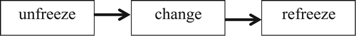
Source: https://journals.sagepub.com/doi/10.1177/0018726715577707#articleCitationDownloadContainer
In recent years, some scholars have criticised Lewin's change model for advancing an overly simplistic change management process. For instance, Kanter et al. (1992: 10) claimed that ‘Lewin’s model quaintly linear and static conception – the companies as ice cubes – may be so wildly inappropriate that it could be very difficult to see why it has not only survived but prospered’. Child (2005: 293) indicated that Lewin’s rigid point of views of ‘refreezing’ may be quite inappropriate in the modern complex workplaces that require high flexibility and adaptability. Moreover, Clegg et al. (2005: 376) discussed the way in which Lewin’s ‘simplex linkage of unfreezing, move (change), and refreezing (which have become) the standard template for the most of changing process, is just a re-addition of a types of mechanistic philosophy behind ‘Taylor’s (1911) concepts of scientific management process’. In recent years, some scholars have criticised Lewin's change model for advancing an overly simplistic change management process. For instance, Kanter et al. (1992: 10) claimed that ‘Lewin’s model quaintly linear and static conception – the companies as ice cubes – may be so wildly inappropriate that it could be very difficult to see why it has not only survived but prospered’. Child (2005: 293) indicated that Lewin’s rigid point of views of ‘refreezing’ may be quite inappropriate in the modern complex workplaces that require high flexibility and adaptability. Moreover, Clegg et al. (2005: 376) discussed the way in which Lewin’s ‘simplex linkage of unfreezing, move (change), and refreezing (which have become) the standard template for the most of changing process, is just a re-addition of a types of mechanistic philosophy behind ‘Taylor’s (1911) concepts of scientific management process’. Yet some other researchers have leaped to Lewin’s defence, and claiming that 'Lewin's three-step changing process model' may tend to be partial or one-sided.
People claimed that Lewin's model could represent only a quarter of his canon and may need to be understood in concert with the rest of pillars (other 3 pillars) of his entire changing model. The other 3 elements of Lewin's models are respectively: field theories; group dynamic and action research (Burnes, 2004a, 2004b). However, even people who are trying to correct misinterpretations or improve Lewin’s other change management related perspectives, couch these within a belief in the foundational importance of his three-step changing process model'(Dent and Goldberg, 1999). Obviously, ‘Lewin’s changing model’ has provided a foundation for future organizational change management procedure and development techniques’ as well as action research (Wren, 1994: 279).
Through the analysis of the formation and form of 'Lewin's change model' people could observe how it has grown-up and developed from a brief aside, to a very effective and helpful fragment to support other companies’ emerging ideas, to a fundamental underpinning, to a way of change could be considered, to an overly simplistic model that people have advanced beyond; from something that one may observe in many social groups, to useful tools for other consultants or third-party agents to instigate, manage resistance and make any changing process smoothly and successfully (Cummings et.al, 2016).
Figure 2: Steps of Lewin’s model
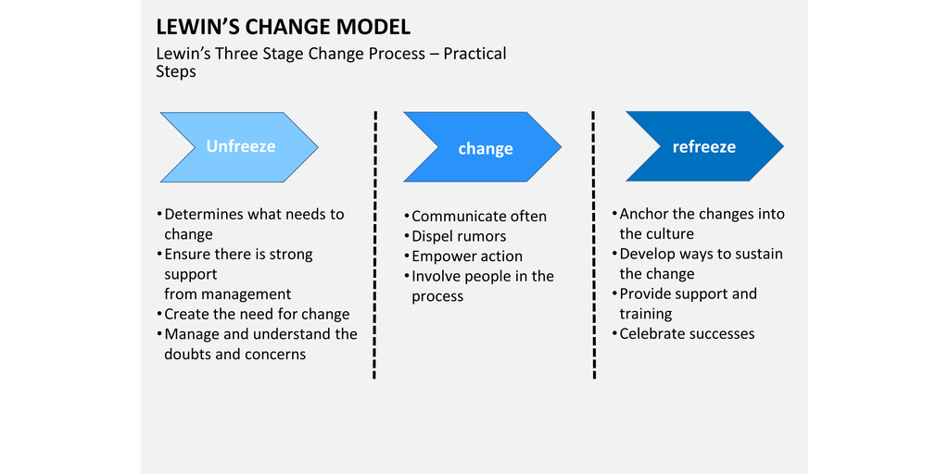
Source: https://www.process.st/change-management-models/

The strength of Lewin's change model
Lewin’s change management model could be very useful when organisations need to drastically make changes in order to succeed. It can also excel at uncovering potential issues which may be taken for granted since organisations must analyse all aspects of whatever they are changing.
As a result, if organisations are conducting certain business process reframing, reengineering or restructure or clearly know that they should shake up certain ingrained mistakes, Lewin’s three-stage change model could be highly recommended.

The weakness of Lewin's change model
Based on the scale of the unfreezing procedure, Lewin’s 'changing model' may be slightly more formidable or time-consuming to enact. However, it is not necessarily a serious issue(because the changes highlighted are normally massive or obvious and highly likely need a larger time cost anyway), and it does imply that applying the Lewin's change model for anything less than an overhaul and in-depth analysis may be not very worthwhile.
In addition, Lewin’s model also requests a lot of deal of care to be taken beyond the base instructions to assist all team members and think over their emotions throughout the entire changing process and turmoil.
Moreover, a massive change runs potential risks of alienating staff and team members, because their workflow, working conditions and environments and so on may be drastically different than before. Therefore, organisations will have to take extra care when bringing employees on board (making changes) and keeping up people's enthusiasm during the 'refreezing process'.

The conclusion
If a company understands that it's business needs improvement or in-depth analysis, Lewin’s model could be a marvellous way to begin with.
By digging up the roots of the suitable application and completely renovating processes or any other conditions where needed, organisations could adjust their businesses in critical periods in their lifespan. Understanding and unfreezing organisations' own businesses with this model could show organisations' management what they have to focus on and change and highlight how to enable teams to adapt to new changes.
As for large multi-national, international or global companies, they could try to simplify or avoid to use “unfreezing process” to change every small and simple issue or mistake because it may take a long time and much effort. And if a company is not careful the disruption of changing process may alienate its staff.

Mckinsey 7s Model
Since the very beginning, the Mckinsey 7s model has been broadly applied by practitioners and researchers and remains a very preferable strategic planning tool. It tried to present emphasis the 'Soft Ss' on strategic human resource management, rather than the traditional mass production tangibles of infrastructures, capitals or devices, as an important thing to enhance organizations' business performance. The purpose of using the 7s model is to identify how 7 components of an organisation: Structure, Strategy, Skills, Staff, Style, Systems, and Shared values, are combined together to maximize effectiveness and efficiency in an organisation. One of the key points of the 7s model could be that every element is interconnected and changes in any areas require additional changes in the other areas for it to function more efficiently and effectively.
The 7s model is normally used in many different situations and it could be very useful if the organizational design encounters issues or risks. The framework is commonly used for addressing the issues below:
• Facilitating organizational changes.
• Helping to implement new strategies.
• Identifying how different factors could change in the future.
• Facilitating the mergers of organisations.

Figure 3: Mckinsey 7s model:
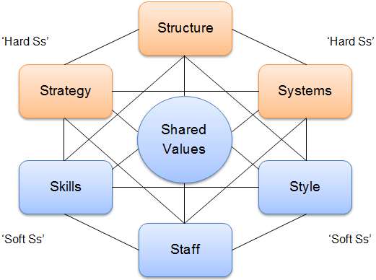
Source: https://www.google.com/search?q=7s+model&rlz=1C1CHBF_en-GBGB818GB818&source=lnms&tbm=isch&sa=X&ved=0ahUKEwj587uQpvHhAhXOVhUIHb8BB1IQ_AUIDigB&biw=1600&bih=758#imgrc=XrItAo9KdzSKzM:
The figure above shows the linkage between seven factors in the 7s model and differentiates them into ‘Hard Ss’ (strategy, structure and system) and ‘Soft Ss’(skill, staff, style and shared value). The shape of this 7s model illustrates the interconnectedness of the areas.

Steps of implementing 7s model
According to Ravanfar (2015), There are mainly five steps for implementing the 7s model:
Step 1: Identify the areas that are not effectively aligned. In the first stage, an organization's object is normally to check all of the 7s areas and determine if they have been effectively linked with each other. Usually, organizations need already be aware of how 7 factors can be aligned in the organizations. If there are gaps or conflicts between certain matrix structure of 7s model, changes in strategies or structures may be strongly required.
Step 2: Discover the most suitable organizational designs With support from senior management. In the second step, is to explore what effective organization designs companies should achieve. By understanding the expected alignment, organisations could set their expected objectives and make an action plan much efficient. Thus, this step may be not as straightforward as determining how 7 elements are currently lined in organizations for some reasons. First of all, organisations should discover the most optimal alignment, which may be not yet known at the moment, therefore, it will require more than just collecting data and answering the questions. Secondly, there are no predetermined and fixed organization designs that companies can use, so, a series of benchmarking and research may be needed in order to discover how other similar companies coped with organization changes.
Step 3: Make decisions of what and where changes can be made. This stage is actually about organisations' action planning, which is going to detail the elements organisations need to realign and the way of doing that. If organisations find that structures and management styles may be not aligned well with companies values or cultures, they need to decide how to reframe the relationships and senior management also need to pay attention to adjusting their management styles so the organisations may perform more effectively.
Step 4. Making essential changes. The implementation of changes is the most crucial step in all processes, analysis, and plans, and only the successfully implemented changes can generate positive outcomes. In consequence, organisations need to discover the most suitable employees that are the best suited to support and implement the planned changes.
Step 5. Continually reviewing the 7s elements. The 7 factors: ‘Hard Ss’ (strategy, structure, and system) and ‘Soft Ss’(skill, staff, style, and shared value) are very dynamic and keep changing all the time. A tiny change in one area can cause additional impacts on the rest of the factors and request making new and different organizational designs. Hence, continuously review of all areas can be extremely crucial for completing and maintaining changes.

Strength of 7s model
The 7s model can help organisations to find the weaknesses and highlight the factors that request more attention when making changes. Moreover, it can also help organisations to ensure that all aspects could support the others, and providing formidable action plans and decisions which are both incredibly strong and yet adaptable to any more further changes.

The weakness of the 7s model
Unless organisations operating small businesses with very only a few employees, the McKinsey 7s model may be unlikely to efficiently carry out alone or in a short time horizon. Organisations could be difficult to get the required knowledge to review all elements and therefore additional time, cost or resources need to be dedicated to support the overviews and assess any viable changes.

The conclusion
The 7s model can be very suitable for organisations which eager to know how they could change for the greater enhancement. By creating detailed overviews of how effective, efficient, coherent and flexible the various factors of organisations are, organisations could then go on to deeply understand their current situations and plan changes to address the issues.

Nudge Theory
Nudge theory – the science behind subtly bringing people into the ‘correct’ decisions – is anywhere, as long as people wake up to it. It is normally propagated by businesses and departments of governments, though people can also adapt it to their own needs or expectations. And Britain invented, developed and perfected the theory(Burt, 2019).
Nudge theory might be slightly odd because it actually is just a theory and there is no fixed and standard change management frame to be had, but instead, a tactic and mindset which are used to structure organisational changes in a more smooth, efficient and effective manner.
The basic rationale of the nudge theory is that “nudging” changes along may be more effective than trying to enforce or push it in the traditional sense. Thus, instead of informing staff about what to do and how to make changes, companies guide and pave the way for employees to choose to do so by their own wish. And the key is to know how to show those nudges.
There are certain highlighted core aspects of nudges: being indirect, subtle, educational, open-ended, understandable, supportive, selective, and able to have further discussion. On the other hand, as for a set model, the frame is quite vague, because it is more like a tool to utilize within other more structured change frames or systems.

The method of Nudge theory
Based on the nudge theory, there are mainly seven elements of nudging changes:
- Clearly define your changes
- Consider changes from your employees’ point of view
- Use evidence to show the best option
- Present the change as a choice
- Listen to feedback
- Limit obstacles
- Keep the momentum up with short-term wins
In fact, it is obvious that all points of nudge theory are easy to understand, but it is important to emphasise certain points which could cause bigger impacts. 'Present the change as a choice': in maintaining with the passive essence of this theory, even though every evidence a company has collected, it cannot just directly force or push the changes on its teams or related stakeholders and justify with its findings. This may lead to employees' resistance or resentment to both the changing process and the company because no-one else can easily have a say in the matter.
Keep the momentum up with short-term wins: as long as certain related progress has been completed on the deployment of changes, companies should ensure that it is firmly kept. To fulfil this it is helpful to plan a series of short-term milestones or objectives which a company could celebrate upon achieving– at the very least it can keep new practices moving forward until becoming the normal routine and part of daily operation.
Figure 4: Nudge theory
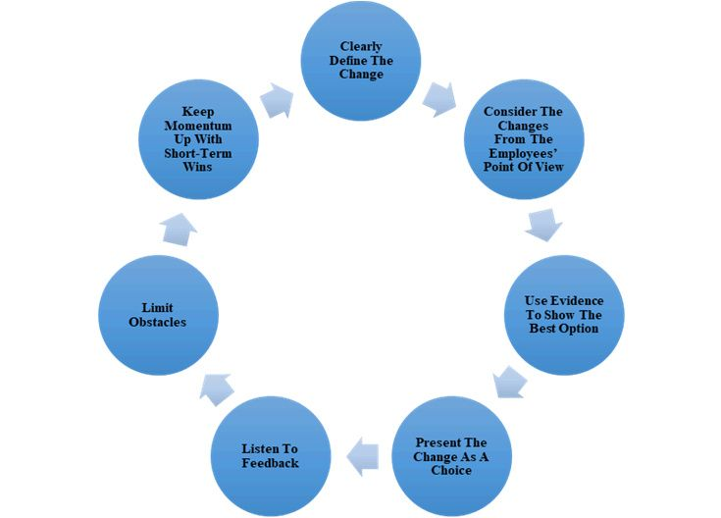
Source: https://www.google.com/search?q=nudge+theory&rlz=1C1CHBF_en-GBGB818GB818&source=lnms&tbm=isch&sa=X&ved=0ahUKEwj9z9Pdr_vhAhXkRBUIHYVuAfkQ_AUIDigB&biw=1600&bih=758#imgrc=PPG4OUmAesu2gM:

The strength of the nudge theory
It can help employees to realise the importance of problems and let them choose the solutions in order to motivate them to support the changes or solve the issues. Providing them with choices and also can facilitate a stronger bond with the company and its business, which could extend into higher staff loyalty and a lower staff turnover rate.
Additionally, the Nudge theory could also cover the gaps other change management models or theories leave open – it can deal with changes on the employees' perspectives and pays attention to motivating employees to adapt to changes. This will make nudge theory at least a very useful complement to more formal approaches.

The weakness of the nudge theory
By itself, it may not provide a model capable of planning, controlling, implementing, and maintaining changes. As a result, that is why it serves best as just a supplement. Furthermore, because it needs to be applied alongside other methods, the additional time, efforts and costs invested in providing attractive choices for employees are incredible and impractical for large-sized organisations.
It may also potentially increase the uncertainty and decrease the predictability. While a company improves the landscape for its changes, the choice (or a variation thereof) eventually will lie with change related employees, which could make uncertain outcomes.

The conclusion
Nudge theory may be seen as an odd concept, but with a detailed plan, a company could turn its employees to the most loyal supporters. However, the lack of particular, actionable guidance, combined with the cost and longer time, this theory needs some other well-structured frameworks or models. So, companies could have not only particular action plans but also a larger amount of supporters from their employees.

The ADKAR Model
The ADKAR model was defined by Jeff Hiatt (founder of Prosci) in 2003. It is a bottom-up pattern which pays attention to the people behind changes. And this model takes less sequential frameworks but sets more objectives to reach (Mulder, 2013).
By paying attention to the following five factors, the ADKAR model could be applied to effectively plan out changes on both management (or organizational) and individual level:
- Awareness (of the needs to changes)
- Desire (to get involved and support changes)
- Knowledge (of how to make changes)
- Ability (to implement necessary skills and actions)
- Reinforcement (to sustain newly made changes)
Figure 5: ADKAR model
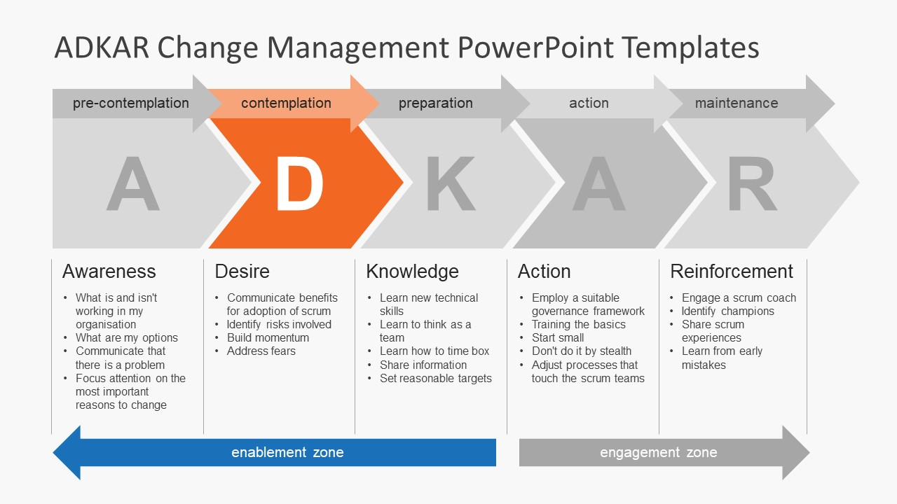
Source: https://www.google.com/search?rlz=1C1CHBF_en-GBGB818GB818&q=adkar+model&tbm=isch&source=univ&sa=X&ved=2ahUKEwiJ27X16_3hAhXFSxUIHSqXBroQsAR6BAgJEAE&biw=1600&bih=758#imgrc=8dd4vNeNqXz2mM:

The method of ADKAR
It is easy to understand each element of the ADKAR model, but points of ‘awareness’ and ‘desire’ are important to emphasize because people’s minds and culture are the most difficult part of changes.

Awareness
The awareness factor is all about ensuring that people understand the needs for changes. This can be finished much as organisations expect – by communicating with every related employee and/or management level, introducing the current situations or issues, and how organisations make changes could improve or solve the situations or issues.
The major difficulty may be pitching changes to other people, and therefore companies cannot just straightforward to list changes and then firmly push people happily accept changes. Instead, management should justify new changes by using clear evidence to drive the points home.

Desire
Promoting the desire to changes may be the hardest part of the ADKAR model because a company needs to consider both the emotional and logical aspects of its employees at the same time. As with other change management theories or frameworks, one of the best ways to develop people desire is to show the benefits and advantages of the change relevant to the participants.

The Strength of ADKAR
ADKAR is a bottom-up method which pays special attention to employees in order to accelerate the rate at which changes are reliably deployed. And the flexibility from ADKAR can also enable companies to deploy incremental changes because small frequent changes may cause fewer impacts, and could be planned out to achieve bigger shifts over several ADKAR cycles.

The weakness of ADKAR
ADKAR has a lack of what it comes to large-scale alterations. It heavily rely on the style of the ADKAR model being bottom-up because any macro management can be either taken for granted or just simply ignored.

The conclusion
ADKAR can be an effective model for reducing additional complicated setups and getting straight to the points with how to change related staff’s reactions.
However, this may be severely lacking in terms of high-level plans. As a result, if a company does not have planned changes in mind then it may be best to analyse and conduct changes with other models (such as the McKinsey model) first.

Bridges’ Transition Model
William Bridges (1991) defined this model as a transition rather than changes. Although this model is sometimes seen as an unnecessary stage, this small element can alter the entire process that change management is progressed.
The Bridge's transaction model includes three steps and all employees will be guided through for the changes to be successful:
- Ending, losing, and letting go
- The neutral zone
- The new beginning
In this model, changes happen to people and could be felt intrusive. People are normally pushed to involve although they may be want to make changes. Thus, this could make Bridges’ transition model become one of guiding employees through the emotions and reactions they could encounter when dealing with changes.
Figure 6: The Bridge's transaction model
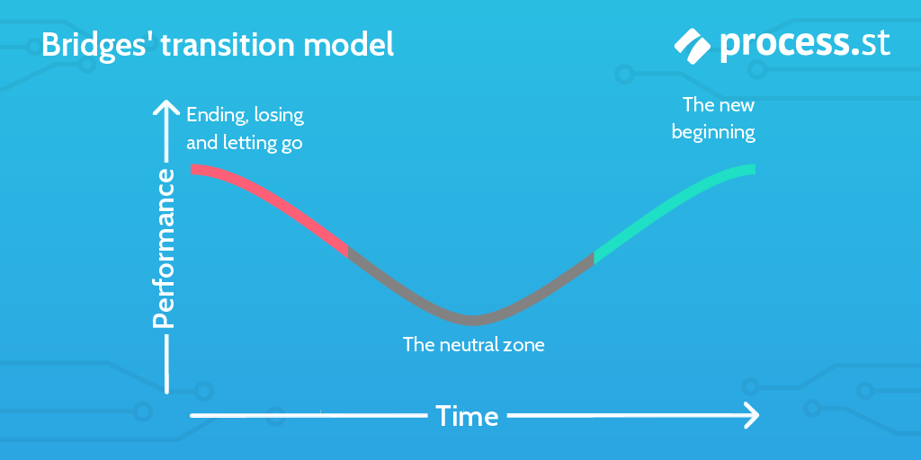
Source: https://www.process.st/change-management-models/

The Strength of Bridges’ transition model
It can fulfil the gaps between rank-and-file staff and management level. It can also take very personal approaches to support people to adapt to new changes by considering their feelings, emotions, and reactions. Furthermore, the consideration for employees as people could also inherently facilitate staff loyalty and better work performance, making people feel stronger relationships with their work.

The weakness of Bridges’ transition model
This model does not contain actionable steps and no planned timeline and conditions for moving from a stage to other stages. It tends to be like once again more of change or transaction guidelines and checklists to help manage staff than step-by-step guidance on implementing changes.

The conclusion
This model can be very helpful for guiding employees through a period of slow improvement (change). However, it has a lack of the heavy management aspects that large-scale changes (or organisation) require
Hence, this model is more suitable to apply to major core employees in order to make sure that changes are successful with the core participants in facilitating it. Beside, Bridges’ model is helpful for foreseeing the general outcomes of changes in employees' emotions (and productivity).

Gap of Literature (knowledge)
Based on the five change management theories and models above and other theories and models such as Kotter’s theory, Kübler-Ross’ change curve, and the Satir change management model, there are two significant missing areas (literature gaps) that may seriously affect the change management. As follow:

Employees' trends and types of reaction during the change process
The first gap of literature (knowledge) is the types and trends of change participants. When people (employees) facing changes, not everyone is willing to change, and also not everyone refuses to accept new changes, so, how many types of reaction from change participants? And how to deal with each type of reaction in order to carry out new changing process more smoothly and successfully, effectively and efficiently? There is no specific theory or model deeply discuss this area because most of theories and models are from the perspective of either overall companies' strategic level or individual's personal thought (and viewpoints).

Change of culture and mindset
The second gap of literature (knowledge) is about how to enable most people to accept new culture and change their minds quickly.
The gaps of knowledge are addressed in the section of model creation.

Creative Thinking: Think Outside the Box- from Creativity to Innovation and then to Changes
‘We cannot solve our problems with the same thinking we used when we created them.’
--- Albert Einstein
Changes are ongoing in organisations as brand new ways of replacing, reshaping and overlapping traditional frameworks, structures, and systems. New environments or workplaces are sought where individuals could offer their creativity and where brilliant ideas could be cultivated and promoted into future innovations that will transform organisations and result in the productions of new merchandise and the delivery of new services. Changes, creativity and innovations are representing significant parts to organisations operating in the 21st. Century.
Technology and information are advancing faster all the time. And the world has been changing at a surprisingly fast pace. Actually, the pace of changes is going to continue to accelerate so dramatically that organisations have to re-invent the world by any opportunities.
Opportunities and potentials in the current world people are creating are endless and unlimited for those creative and innovative individuals that not only can adapt to and make new changes but can also dedicate in dynamic processes. Hence, creativity and Innovations are the major elements of organisational success. Changes are the inevitable results of this innovative and creative processes.
Normally, people begin with creativity. People invent or create brand new notions or opinions. It is fabulous to free imaginations and let it go wild. Whether people utilize improvisation, divergent thinking, or aleatory techniques and so on, the methods applied can be up to inventors. Definitely, creative and innovative ideas and opinions are only the raw materials for innovations and changes. And every idea does not by itself guarantee desired changes and transformation. The figure below illustrates the path of making desired changes.
Figure 7: the path to desired change

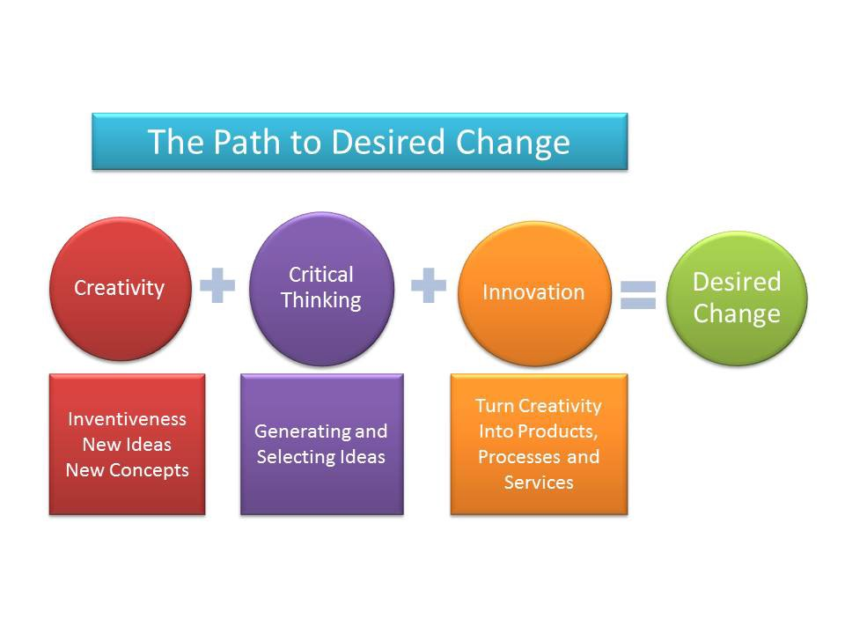
Source: https://medium.com/@jules000120/from-creativity-to-innovation-to-change-f24e5f115591

Critical and Creative Thinking: Theory (Model) Combination and Creation
‘The problem is never how to get new, innovative thoughts into your mind, but how to get old ones out’
--- Dee Hock
According to the critical literature review above, it is clearly obvious that all theories and model of change management have their own strengths and weaknesses, advantages and disadvantages. Therefore, when conducting a change process, the top management of organisations should clearly understand all the available options, tools and alternatives (models and theories) first. And then, select and apply the most suitable models based on the exact circumstances. Moreover, the change makers also need to aware that it might be easy to make new policies or launch new structures but will be very difficult to change cultures and people's mindsets. So, if organisations take a month to change structures or policies, they may take a year to change organisational culture and employees' minds. Hence, change makers or management need to always prepare for uncertainties and get ready to deal with difficult situations especially with those stubborn employees (including senior staff or even managers) who strongly refuse to change and follow the new systems. Thus, in order to make change smoothly and successfully, effectively and efficiently, using or following only one single theory or model may be not capable enough to achieve ultimate goals. As a result, the changemakers of organisations (companies) are strongly advised to use as broad and comprehensive methods and models as possible.
For instance, British Airways mainly followed the Lewin's model but it did not effectively raise employees' awareness to understand and accept new changes. Thus, BA had to spend extra tremendous time and efforts to deal with unnecessary issues which could be avoided. This means that Kurt Lewin's change model and the ADKAR change model could be embedded in each other and support each other.
So, if organisations are conducting certain business process reframing, reengineering or restructure or clearly know that they should shake up certain ingrained mistakes, Lewin’s change management model could be very useful particularly when organisations need to drastically make changes in order to succeed. However, it requires longer time and more efforts to achieve and it is also more tend to be top-to-bottom implementation, so, this model might not take care of all employees' feelings and emotions. Therefore, the changemakers may need to consider to combine the ADKAR model and Bridges’ Transition Model together with Lewin's model because the ADKAR is a bottom-up method which focuses more on employees' awareness and desires meanwhile the Bridges’ Transition Model fulfils the gaps between rank-and-file staff and management level. It can also take very personal approaches to support people to adapt to new changes by considering their feelings, emotions, and reactions.
While combining Lewin's model, ADKAR and Bridges’ Transition models, the changemakers could also ask the following questions based on the Mckinsey's 7s model:
Strategy:
What are the vision, mission, and goals?
What are the plans and strategies to achieve them?
How can strategies adapt to the current circumstance and future changes?
Structure:
Where to make changes? (partially: certain departments, or fully: the entire company's structure)
How can teams and departments be managed or organized with the new changes?
How can people be conducted and passed down?
How do employees communicate and how often does communication occur?
System:
Which is the core system needs to change the most or urgently (HR, finance, marketing, or strategy department)?
How is the system or process used?
How to keep the system updated (ensure it is up to date)?
How useful and accurate the system would be?
How to track and evaluate the results of the system?
Who can access to the system, and who is responsible for it?
Shared value:
What are the core culture and values?
Are the new change at odds with the company's value or culture?
How to strengthen the value in practice?
Style:
How are your departments and teams managed?
How active is this management/leadership?
Are these new management styles effective, and to what extent?
Does it promote stronger competition or collaboration?
Staff:
What duties or vacancies do they fill?
What new skills and knowledge can they bring?
Does the company lack a specific skill set?
Skill:
Do people have the required skills to complete their jobs to the expected quality?
How important is the missing skill?
What is the most valuable skill which benefits the organisation?
How to evaluate skills?
What are the organisations perceived as doing successfully, and what skills does that reflect on?
Definitely, the combination of theories (models) above is just one of the creative and innovative concepts and examples. And companies will need to create new different model combinations according to their own particular issues and situations.

Model Creation: 'rugby transition' model.
Innovation is not only about new products or services, but also Changing minds and Behaviours.
In order to address the two gaps of knowledge in the literature review section, the author( student) of this assignment report created a new model for managing changes, named 'rugby transition' model.

Different types of reaction
Regardless of sectors and industries, as long as a company carries out a change program, there will be always mainly three types (groups) of people who react differently:
The first type of people can be called 'change supporters'. This group of people who would accept the senior management' decision to follow the change process because they are also willing to change, and they will support the new change.
The second type of people can be called' change protesters'. They bring strong resistance to the change makers or management because they refuse to change and they just want to remain the current situation.
The third type of people can be called 'change observers'. Normally, the majority of people are in this group. And they neither support the change nor refuse to change because they just observe the changing process, and they are hesitating.
The allocation of all these three groups of change participants are illustrated as follow, please see the figure below:

Figure 8: The ‘Rugby’ transition model

Change Protesters
They refuse to change
Satisfy with current situation
Create obstacles and resistance to changemakers
Change Supporters
They also want to change
Support the senior management to change
Obey the decision and follow the procedure

Change Observers
(the majority )
They are waiting for the final winner of the changing process
They are hesitating
They have no decisions and ideas about what to do next
They do not care

Source: The author
Making change successfully needs people's support, the more the better. So, according to the figure and model above, changemakers need to focus more on dealing with the change protesters, changing their reactions, minds, and behaviours. Importantly, once the change protesters have changed their minds and behaviours to support the change, most of the change observers are highly likely to be influenced to follow the trend and support the change process automatically.
However, before implementing the transition procedure, the changemakers or management need to clearly understand all the three types of change participants. Such as:
Why do they behave in that way?
What are their major concern and consideration?
What are their true reason and needs?
What are they expecting in the end?
In order to make a better understanding of these questions above, the 'Toyota 5 Why's methods and Maslow hierarchy theory is used to support the analysis.

Dig the true reason and needs: Five- Why method and Maslow theories
For example: firstly, regarding the change supporters:
Why do they support the company's change?
Because they are also willing to change.
Why do they also want to change?
Because the company has encountered serious problems and the profitability has reduced(or market shrunk, competitive advantage decreased, or losing customers, etc.).
Why the change is necessary and urgent?
Because there will be potential safety and health risks, or the company's financial loss and increase of liabilities and so on.
Why do they think that those issues will affect them?
Because their current job positions may be removed, their bonus and incentives may be reduced or cancelled, they may not have a better opportunity to get a promotion and so on.
Hence, the major concern and consideration, as well as the true reason (needs) for supporting the company's change are about getting actual future benefits in terms of healthier work environment, safer working condition, more personal rewards, better job security, higher promotion, and better recognition.

Secondly, regarding the change observers:
Scenario 1: they are hesitating
Why are they hesitating?
Because they are waiting for the final winner of the changing process.
Why are they waiting for the final winner of the changing process?
Because they do not want to make the enemy, and they want to keep good relationships with the people who finally win.
Why do they want to keep good relationships with the people who finally win?
Because the final winner could bring more benefits to them.
Why could the final winner bring more benefits to them?
Because the change observers expect to minimize the effect on their personal benefits during the entire change process and gain the potential opportunity of maximizing their personal benefits after the change.
Scenario 2: they do not care
Why don't they care about the company’s change?
Because the new change does not make much difference to them. So, making new changes or retaining the current situation are both okay for them.
Why does the new change not make much difference to them?
Because after the organisational change, they will still work in the same job positions and places, and receive the same amount of salary (same financial& non-financial rewards).
As a result, the major concerns, considerations and the true reasons (needs) behind change observers are about getting potential opportunities in terms of gaining more benefits.

Lastly, regarding the change protesters:
Why do they create obstacles and resistance to the company's future change?
Because they do not want to take responsibility and risk.
Why don't they want to take responsibility and risk?
Because they are afraid that future changes may affect their duties and benefits (rank, position, salary etc).
Why are they afraid that future changes may affect their benefits?
Because they are only familiar and satisfied with their current duties and benefits and situation.
As a result, the major concerns, considerations and the true reasons (needs) behind change protesters are about keeping their vested benefits in the current situation.

Strategic implementation
After clearly and deeply understanding the true reason behind these three types of reactions from the company's change process, then the management can utilize different strategies to deal with these three groups of people in order to transit their minds and change their behaviours.
Based on the 'five-whys' analysis above, the true reasons for all the three types of reactions(of change participants) during the changing process are all about personal needs: actual future benefits, potential opportunities to future benefits, and vested benefits. So, Maslow's hierarchy needs theory is applied to address these issues.
As for the 'change supporters': they are standing on the changemakers' side. The ultimate goals of all senior management or the changemakers are to bring the company to a higher stage, solve the existing problems, maximize the profit, and enhance the competitive advantages and so on. Therefore, the changemakers could draw a great future blueprint and share with change supporters in order to ensure they all can truly feel that the company's future vision will match their expectations and the new change will fulfil their personal needs (actual future benefits in terms of: safety, health, money, relationship, recognition, love, career promotion etc. ). So, the shared value (from the 7-S model) and awareness, desire (from the ADKAR model) can be applied together in this stage. Additionally, this can also enhance the change supporters' loyalty and then this group of people can be deployed in change observers and protesters in order to influence, lead and manage them to change minds and accept the new change.
As for the 'change observers': they are in the middle and they can support the new change only when they feel it is the right time. So, change managers should show potential opportunities for gaining more personal benefits, and let them know that there will be huge potential and improvement in the future only if they support the management throughout the changing process. Moreover, they can be influenced. If change supporters show the greater chance to win protesters, the change observers would be willing to stand on the supporters' side.
The points below of nudge theory are applicable to this group of change participants:
• Use evidence to show the best option
• Present the change as a choice
As for the 'change protesters': they are the extreme. They could negatively affect the other change participants and ruined the change progress. Therefore, continuous communication is a must. Also, a number of theories and models are applicable to this group. Include:
'Unfreezing' (Lewin's model)
'Shared values' (7 S model)
'Awareness, Desire, and action' (ADKAR model)
(Nudge theory)
• Clearly define your changes
• Consider changes from your employees’ point of view
• Use evidence to show the best option
• Present the change as a choice
• Listen to feedback
• Limit obstacles
• Keep the momentum up with short-term wins
There may be some protesters change their minds and support the change after implementing those theories and models, but certain people may be still stubborn and resist the change. So, the next step is to minimize the impact of those stubborn protesters, therefore, they can be assigned with less important projects. Then, slowly and gradually isolate them and separate them from the company's change program.
Figure 11: The procedure of dealing with change protesters
Isolate
Communicate
Influence
Replace

Source: The author
Finally, the extremely stubborn change protesters can be replaced. So, 'Threat of substitute products' (Porter's 5 Forces) and Staff, Skill (7- S model) can be combined and used for the employee replacement procedure. The change managers will just need to change 'Threat of substitute products' to 'Threat of substitute staff’. Please see below:
Figure 12: Use of combined 'Porter's 5 forces' and '7- S model' to replace the extreme change protesters
7- S Model
‘Staff’ and ‘Skill’
Are they the only staff have such skills?
If so, how long it takes to find or train alternative staff (substitutes)?
How much is the cost?
Porter’s 5 Forces
'Threat of substitute staff’
Is it possible to replace them?
Any other alternatives (substitutes)?
What are the outcomes?
More positive or negative?
Combine together

- Train other staff or change supporters with such skills
- Recruit new staff who already have such skills
If change protesters have higher positions in the company:
- Promote change supporters to the positions.
- Provide opportunities to change observers, and let them know that if they support the change, they will be promoted to the positions.

Source: The author
As for the acceptance of new culture, the change supporters can influence the change observers to change minds, behaviours, and accept the new culture. Furthermore, the company should also actively recruit new well-qualified employees and directly cultivate them with the new culture or value. Thus, the next generation of staff could directly enable their behaviours to follow the new culture.
Also, the company needs to make massive suitable propaganda of new culture and ensure that it can be understood by all the employees. As what Adolf Hitler said: 'all propaganda has to be popular and has to accommodate itself to the comprehension of the least intelligent of those whom it seeks to reach'. (Ps: only quote his saying and idea for academic purposes.)

Conclusion
I, may out of your sight; but you, never out of my mind.
--- Singapore Navy
The paradigm has shifted, the world is accelerating, the science fiction of yesterday is rapidly becoming the science fiction of right now. How do organisations withstand the tectonic shift in the world around them? How does a society thrive and a company to make changes where the world economy is undergoing constant disruption? How do people continue to learn when information is moving at the speed of light? There are always conceptions that are ahead of the people's sights are building the tools for tomorrow. How can the organisation of today make changes to grow and thrive in order to become the place people want to work and live in tomorrow? Creating sustainable, manageable and achievable changes is a challenge.
Theories and models have no souls but humans have. So, people need to give different souls to different theories and models in order to keep them being useful and adaptable for different situations. And creativity and Innovation are the key factors in organizational success. Changes are the inevitable results of any innovative or creative processes.
Despite the use of change management theories and models may be overwhelming at the beginning, having appropriate frameworks to deploy changes could help changemakers reliably deploy change programs. More importantly, considering employees’ reaction is an essential segment, because it is hard to predict when the very people powering the company will take issues with significant actions.
Instead, taking advantages of certain change management models above could provide change's path to success the best possibility of improving change participants' behaviours.
In the 21st-century, creativity and innovation are getting more and more important due to rapid and unpredictably changing global business environments. The reality nowadays dictates that only those organisations that embrace creative and innovative change management will gain sustainable competitive advantages in the global markets.
For change management: ‘My vision for the future, may out of your current cognition; but the future change of the world, never out of my creativity and innovation’.--- the author

Reference
Ágnes Mészáros, 2008. Case study of the change management of British Airways after the economic crisis of 2008.
Burnes B (2004a) Kurt Lewin and the planned approach to change: A re-appraisal. Journal of Management Studies 41(6): 977–1002.
Burnes B (2004b) Kurt Lewin and complexity theories: Back to the future? Journal of Change Management 4(4): 309–325.
Burt, E., 2019. Long reads Nudge theory can help change your employees' behaviour (without them even realising). CIPD. [Access 28 Mar 2019].
Child J (2005) Organization: Contemporary Principles and Practice. Oxford: Blackwell.
Clegg SR, Kornberger M and Pitsis T (2005) Managing & Organizations: An Introduction to Theory and Practice. London: SAGE.
Cummings, S., Bridgman, T. and Brown, K. G. (2016) ‘Unfreezing change as three steps: Rethinking Kurt Lewin’s legacy for change management’, Human Relations, 69(1), pp. 33–60.
Dent EN and Goldberg SG (1999) Challenging ‘resistance to change’. The Journal of Applied Behavioural Science 35(1): 25–41.
Kanter RM, Stein B and Jick T (1992) The Challenge of Organizational Change. New York: The Free Press.
Lewin K (1947a) Frontiers in group dynamics: Concept, method and reality in social science; equilibrium and social change. Human Relations 1(1): 5–41.
Milmo D, 2009. British Airways makes record loss of £292m.
Mulder, P. (2013). ADKAR model by Jeff Hiatt. Retrieved [insert date] from ToolsHero: https://www.toolshero.com/change-management/adkar-model/
Ravanfar, M., (2015). Analyzing Organizational Structure Based on 7s Model of Mckinsey. Global Journal of Management and Business Research: A Administration and Management. 15(10).
Walsh, W., 2009. I can't let this union drag us to destruction, says BA boss.
Wren D (1994) The Evolution of Management Thought, 4th edn. New York: John Wiley & Sons.

