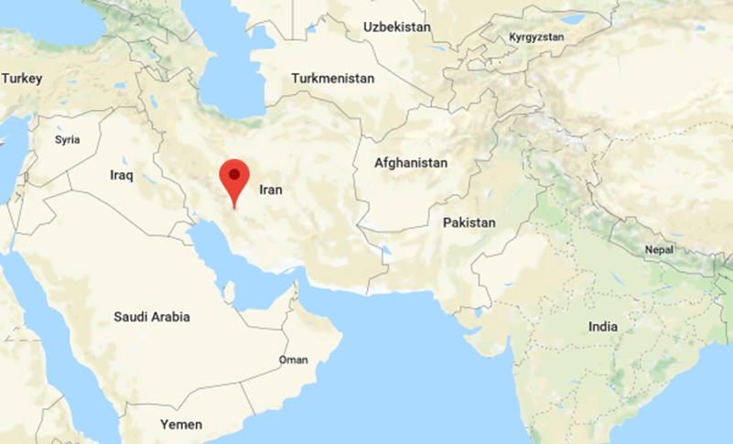
Iran
Iran is the seventeenth largest country in the world in terms of territory, with around eighty one million citizens. It borders many significant resource rich countries and trade routes, notably Iraq and Saudi Arabia.
Producing more than 3.8 million barrels of crude oil in 2017, Iran is the fifth largest producer of oil in the world and has the fourth and second largest proved crude oil and natural gas reserves respectively, constituting 10 percent of the worlds proven oil reserves and 15 percent of its gas reserves according to the EIA. As a founding member of OPEC, Iran has substantial influence both in the Middle East and globally.
fig 1

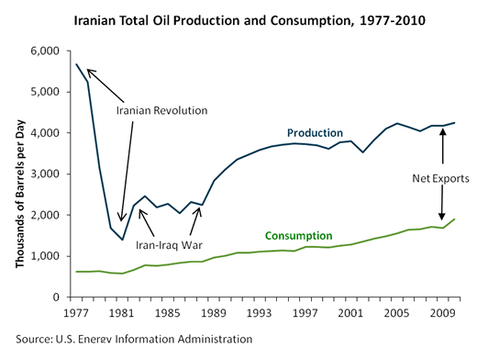

Iran has a transition economy and a relatively large public sector, however between 2005 and 2009 Iran privatised $63 billion worth of government equity in state-owned firms, according to the head of Iran's Privatization Organization. Around 60% of the economy is centrally planned, and it is dominated by oil and gas production. 2017 data from OPEC shows that Iran has proven crude oil reserves of around 155,600 million barrels and was producing 4.271M bbl/d as of August 2018.
Iran is an Islamic Republic, a Muslim majority country with 90-95% of citizens identifying under the Shia branch of Islam. Religion is an important factor in terms of understanding the context of relations between many Middle Eastern countries; a good example being the tensions between Iran and the majority Sunni Saudi Arabia. Iran and Saudi have each accused the other of backing various forms of terrorism, and it has been suggested that the two countries are engaged in proxy warfare; a Middle Eastern cold war, motivated by intertwined politics and religion. Each tends to back opposing forces which align with their respective ideological viewpoints during conflicts and civil wars in nearby nations, which serves to express and add to the tension between the nations.

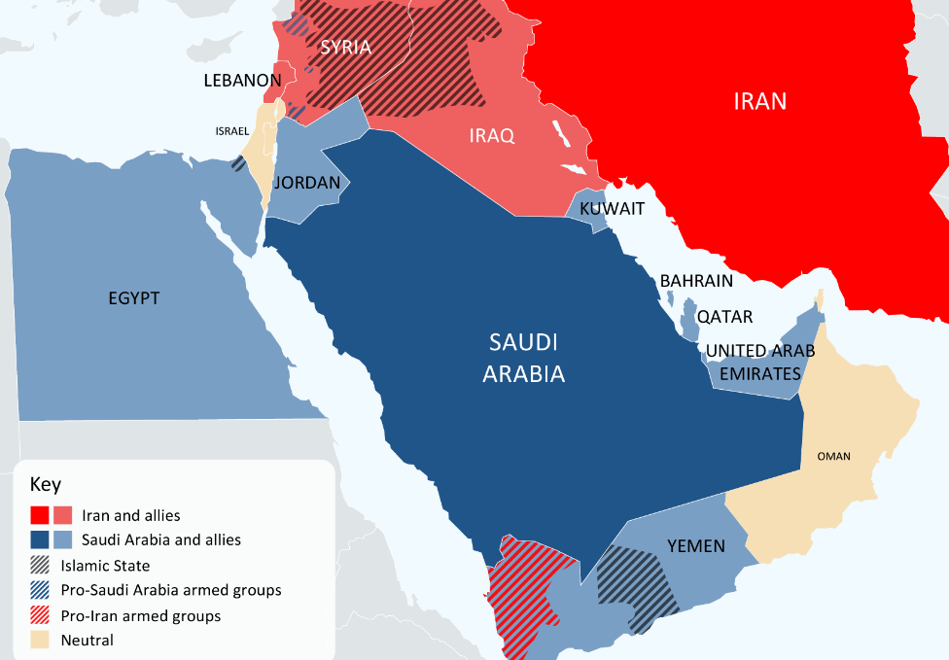
Since the fall of Saddam Hussein in 2003, Iran-Iraq relations have improved considerably and the countries are now considered allies. In the seven years between 2003 and 2010 the two countries are said to have signed and agreed over 100 economic agreements and treaties.
Iran and the United States have had a strained relationship since just after the Iranian Revolution in 1979, and have had no formal diplomatic relationship since. In 2018, the supreme leader of Iran announced a ban on formal contact with America on Iranian state television.
Bonyad (Persian for ‘foundation’) are charitable trusts which play a significant role in Iran's economy, controlling an estimated 20% of Iran's GDP. As tax exempt religious organisations with significant economic influence, accountable only to Ali Khamenei (the supreme leader of Iran), they appear to represent a significant potential source of corruption within the country’s economy as “key players in the political economic landscape of Iran” (Bjorvatn, K. 2007 p.13).
Iran's economy has recently taken a hit from a wave of US sanctions that came to effect in the summer of 2018 and as a result almost half of its imports and exports have halted with an estimate of around 600,000 barrels of oil being cut. Further sanctions have been imposed. This could have serious effects on not only the economy of Iran but many of its export destinations. Iran ships the majority of its oil to China and India, each receiving over 500,000 barrels of oil per day as of 2015. The Indian Economic Times suggest that China is the only buyer of Iranian oil likely to stand strong against US sanctions which may have implications for China’s relations with other countries who have agreed to the sanctions.
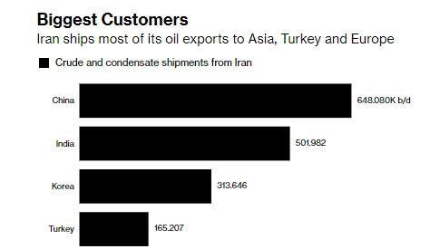
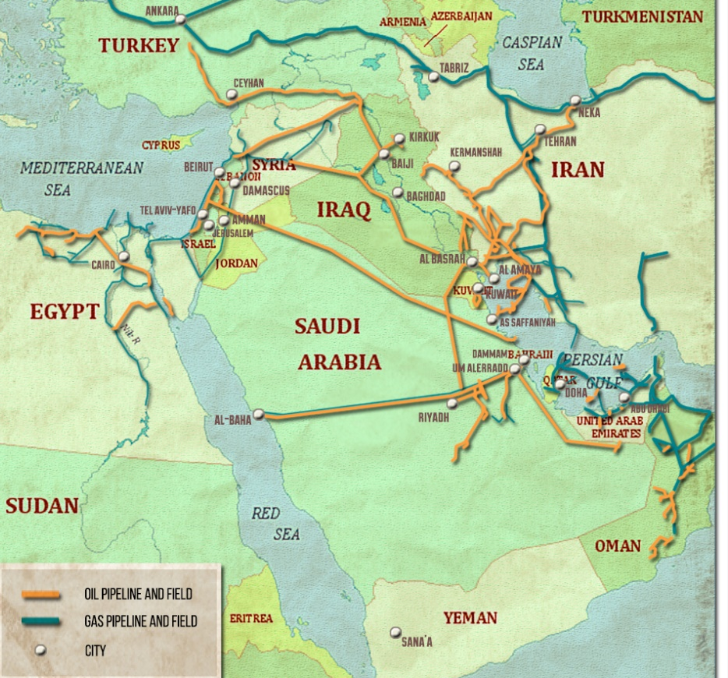
Iran’s geography alone, notwithstanding the political climate of the region, serve to make it a military and economic focal point of the world. Bordering the Persian Gulf and strait of Hormuz and sitting as it does with Europe and Africa to the West and Asia and Russia to the East, surrounded by oil-rich neighbours and warzones alike, Iran’s geopolitical sphere is one which seems complexly entangled in terms of both territorial and energy security. Multiple oil and gas pipelines run belowground, and oil tankers coming from Gulf States must pass along the county’s shores and through its waters. The Fifth Fleet of the US navy are positioned strategically along its coastline in attempt to ensure and oversee the smooth flow of oil from the region.
One issue for Iran’s energy production is its inefficiency; energy consumption in Iran is almost 7 times the global average, but it has been estimated that at least 18.5% of electricity generated in Iran never makes it to the market due to technological issues and systematic inefficiencies.
Iran’s largest energy security challenge currently seems to be the sanctions upon its oil exports and the geopolitical tensions between the country and its resource competitors and ideological rivals, from ISIS to the United States. The most prescient issue in terms of natural resources seems to be international relations and the effects of sanctions on Iran’s economy, however The Council on Foreign Relations and recent reports by the IMF suggest that although Iran’s economy has taken a hit from the sanctions and that they have accentuated already present issues, it is sufficiently diverse to withstand the shocks. Although largely based on oil and natural gas, Iran also boasts the Tehran stock exchange, a variety of other extractive resource based industries, and relatively large reserves.

Bibliography
Crude Oil, "Who Was Buying Iranian Oil And What Happens Next? | Oilprice.Com", Oilprice.Com <https://oilprice.com/Energy/Crude-Oil/Who-Was-Buying-Iranian-Oil-And-What-Happens-Next.html> [Accessed 8 December 2018].
Bjorvatn, K. and Selvik, K. "Destructive Competition: Factionalism And Rent-Seeking In Iran", World Development, 36.11 (2008), 2314-2324 <https://doi.org/10.1016/j.worlddev.2007.11.002>.
F. Gregory Gause III, Beyond Sectarianism: The New Middle East Cold War - BROOKINGS DOHA CENTER ANALYSIS PAPER, 11th edn, 2014 <https://www.brookings.edu/wp-content/uploads/2016/06/English-PDF-1.pdf>
"How Sanctions Affect Iran’s Economy", Council On Foreign Relations, 2018 <https://www.cfr.org/interview/how-sanctions-affect-irans-economy> [Accessed 7 December 2018].
"Iran - U.S. Energy Information Administration (EIA)", Eia.Gov, 2018 <http://www.eia.gov/countries/cab.cfm?fips=IR> [Accessed 7 December 2018].https://commons.wikimedia.org/w/index.php?curid=18721717
"Iran Privatizes $63Bn Of State Assets", Web.Archive.Org, 2018 <https://web.archive.org/web/20120325125521/http://previous.presstv.com/detail.aspx?id=112444&sectionid=351020102> [Accessed 7 December 2018].
"Iran Daily - Domestic Economy - 02/01/07", Web.Archive.Org, 2018 <https://web.archive.org/web/20070930183642/http://www.iran-daily.com/1385/2771/html/economy.htm> [Accessed 7 December 2018].
"Iran Crude Oil Production (Monthly, Barrels Per Day)", Ycharts.Com, <https://ycharts.com/indicators/iran_crude_oil_production> [Accessed 8 December 2018].
"Iran's Khamenei Bans Holding Direct Talks With United States: TV", U.S., 2018 <https://www.reuters.com/article/us-iran-usa/irans-khamenei-bans-holding-direct-talks-with-united-states-tv-idUSKBN1KY14A> [Accessed 8 December 2018].
Mackey, S. The Iranians: Persia, Islam, And The Soul Of A Nation (New York: Dutton, 1996), p. 370.
"Middle East :: Iran — The World Factbook - Central Intelligence Agency", Cia.Gov, 2018 <https://www.cia.gov/library/publications/resources/the-world-factbook/geos/ir.html> [Accessed 8 December 2018].
Molavi, A. The Soul Of Iran (New York: W.W. Norton, 2005), p.176.
"OPEC: Iran", Opec.Org, 2018. <https://www.opec.org/opec_web/en/about_us/163.htm> [Accessed 6 December 2018].
"OPEC : OPEC Statute", Opec.Org, 2018 <https://www.opec.org/opec_web/en/publications/345.htm> [Accessed 7 December 2018].
Production of Crude Oil including Lease Condensate (2016) U.S. Energy Information Administration.
"Presstv - 'Iran, Iraq Have Signed 100 Economic Agreements'", Web.Archive.Org, 2016 <https://web.archive.org/web/20160407205532/http://edition.presstv.ir/detail/117500.html> [Accessed 7 December 2018].
"Public Information Notice: IMF Executive Board Concludes 2011 Article IV Consultation With The Islamic Republic Of Iran", IMF, 2011 <https://www.imf.org/en/News/Articles/2015/09/28/04/53/pn11107> [Accessed 8 December 2018].
"Saudi Arabia Accuses Iran Of ‘Deception’ And Supporting Terrorism", English.Alarabiya.Net, 2017 <https://english.alarabiya.net/en/News/gulf/2017/05/17/Saudi-Arabia-accuses-Iran-of-deception-and-supporting-terrorism.html> [Accessed 7 December 2018].
"The Geopolitics Of Oil And Gas Pipelines In The Middle East | Mondialisation - Centre De Recherche Sur La Mondialisation", Mondialisation.Ca, 2018 <https://www.mondialisation.ca/the-geopolitics-of-oil-and-gas-pipelines-in-the-middle-east/5492595> [Accessed 8 December 2018].
"The Red24 Report, Iran-Saudi Arabia", My.Worldaware.Com, 2018 <https://my.worldaware.com/members/intelligence/newsletters_security_briefings/iran_saudiarabia_regional_instabilty_22042016.php> [Accessed 8 December 2018].
"US Sanctions On Iran Oil Will Hurt India More Than You Think", The Economic Times, 2018 <https://economictimes.indiatimes.com/markets/commodities/views/us-sanctions-on-iran-oil-will-hurt-india-more-than-you-think/articleshow/65374517.cms> [Accessed 7 December 2018].

"OPEC: Iran", Opec.Org, 2018. <https://www.opec.org/opec_web/en/about_us/163.htm> [Accessed 6 December 2018].
"Production of Crude Oil including Lease Condensate (2016) U.S. Energy Information Administration.
"Iran - International - Analysis - U.S. Energy Information Administration (EIA)", Eia.Gov, 2018 <https://www.eia.gov/beta/international/analysis.php?iso=IRN> [Accessed 8 December 2018].
"OPEC: OPEC Statute", Opec.Org, 2018 <https://www.opec.org/opec_web/en/publications/345.htm> [Accessed 7 December 2018].
"Iran - U.S. Energy Information Administration (EIA)", Eia.Gov, 2018 <http://www.eia.gov/countries/cab.cfm?fips=IR> [Accessed 7 December 2018].https://commons.wikimedia.org/w/index.php?curid=18721717
"Iran Privatizes $63Bn Of State Assets", Web.Archive.Org, 2018 <https://web.archive.org/web/20120325125521/http://previous.presstv.com/detail.aspx?id=112444&sectionid=351020102> [Accessed 7 December 2018].
"OPEC: Iran", Opec.Org, 2018. <https://www.opec.org/opec_web/en/about_us/163.htm> [Accessed 6 December 2018].
"Iran Crude Oil Production (Monthly, Barrels Per Day)", Ycharts.Com, <https://ycharts.com/indicators/iran_crude_oil_production> [Accessed 8 December 2018].
"Middle East :: Iran — The World Factbook - Central Intelligence Agency", Cia.Gov, 2018 <https://www.cia.gov/library/publications/resources/the-world-factbook/geos/ir.html> [Accessed 8 December 2018].
"Saudi Arabia Accuses Iran Of ‘Deception’ And Supporting Terrorism", English.Alarabiya.Net, 2017 <https://english.alarabiya.net/en/News/gulf/2017/05/17/Saudi-Arabia-accuses-Iran-of-deception-and-supporting-terrorism.html> [Accessed 7 December 2018].
F. Gregory Gause III, Beyond Sectarianism: The New Middle East Cold War - BROOKINGS DOHA CENTER ANALYSIS PAPER, 11th edn, 2014 <https://www.brookings.edu/wp-content/uploads/2016/06/English-PDF-1.pdf>
"The Red24 Report, Iran-Saudi Arabia", My.Worldaware.Com, 2018 <https://my.worldaware.com/members/intelligence/newsletters_security_briefings/iran_saudiarabia_regional_instabilty_22042016.php> [Accessed 8 December 2018].
"Presstv - 'Iran, Iraq Have Signed 100 Economic Agreements'", Web.Archive.Org, 2016 <https://web.archive.org/web/20160407205532/http://edition.presstv.ir/detail/117500.html> [Accessed 7 December 2018].
"Iran's Khamenei Bans Holding Direct Talks With United States: TV", U.S., 2018 <https://www.reuters.com/article/us-iran-usa/irans-khamenei-bans-holding-direct-talks-with-united-states-tv-idUSKBN1KY14A> [Accessed 8 December 2018].
Afshin Molavi, The Soul Of Iran (New York: W.W. Norton, 2005), p.176.
Sandra Mackey, The Iranians: Persia, Islam, And The Soul Of A Nation (New York: Dutton, 1996), p. 370.
Afshin Molavi, The Soul Of Iran (New York: W.W. Norton, 2005), p.176.
Kjetil Bjorvatn and Kjetil Selvik, "Destructive Competition: Factionalism And Rent-Seeking In Iran", World Development, 36.11 (2008), 2314-2324 <https://doi.org/10.1016/j.worlddev.2007.11.002>.
Crude Oil, "Who Was Buying Iranian Oil And What Happens Next? | Oilprice.Com", Oilprice.Com <https://oilprice.com/Energy/Crude-Oil/Who-Was-Buying-Iranian-Oil-And-What-Happens-Next.html> [Accessed 8 December 2018].
"US Sanctions On Iran Oil Will Hurt India More Than You Think", The Economic Times, 2018 <https://economictimes.indiatimes.com/markets/commodities/views/us-sanctions-on-iran-oil-will-hurt-india-more-than-you-think/articleshow/65374517.cms> [Accessed 7 December 2018].
Crude Oil, "Who Was Buying Iranian Oil And What Happens Next?
"The Geopolitics Of Oil And Gas Pipelines In The Middle East | Mondialisation - Centre De Recherche Sur La Mondialisation", Mondialisation.Ca, 2018 <https://www.mondialisation.ca/the-geopolitics-of-oil-and-gas-pipelines-in-the-middle-east/5492595> [Accessed 8 December 2018].
"Iran Daily - Domestic Economy - 02/01/07", Web.Archive.Org, 2018 <https://web.archive.org/web/20070930183642/http://www.iran-daily.com/1385/2771/html/economy.htm> [Accessed 7 December 2018].
"How Sanctions Affect Iran’s Economy", Council On Foreign Relations, 2018 <https://www.cfr.org/interview/how-sanctions-affect-irans-economy> [Accessed 7 December 2018].
"Public Information Notice: IMF Executive Board Concludes 2011 Article IV Consultation With The Islamic Republic Of Iran", IMF, 2011 <https://www.imf.org/en/News/Articles/2015/09/28/04/53/pn11107> [Accessed 8 December 2018].

