Using wheel load distribution to predict handling balance whilst a car is cornering
BSc Motorsport Engineering

Lee Emery
2017
Lee Emery
P131261
11/20/2017

Contents

Abstract Page 2

Introduction Page 3-4

Literature Review Page 5-10

Calculations Page 11- 13

Conclusion Page 14

References Page 15

Abstract
The aim of this project is to validate the assumption that a vehicles’ handling balance can be predicted by determining wheel load distribution. The motivation behind this project lies with the interest in understanding and potentially even predicting how a vehicle will handle whilst cornering, finding the point at which a vehicle will exceed the limitations of grip. The aims for this project are to find out if;
- The assumption that a vehicles’ handling balance can be predicted by determining wheel load distribution be validated.
- Analytical methods used to calculate wheel load distribution are valid against real live track data.
- If so, can these calculations be used in accordance with live shock-absorber data to find and understand any differences in weight transfer values.
Throughout this project there will be different approaches to obtaining the required data, such as, observation of live-testing, analysis of recorded data, analytical methods and potential simulation testing. If it is found that analytical methods correspond with live data, the next step will be to test an after-market suspension setup with alternate damping rates to observe how this will effect overall wheel load distribution and therefore understand how the vehicle will behave whilst cornering.
The results will give insight into how adjustment of a single parameter of a vehicles suspension setup can have an effect of the overall cornering performance. Given that there are so many adjustments that can be made through various components throughout a vehicles dynamic system, this will allow the project to carry on in many directions whether it be looking into camber/caster angles, anti-roll bar settings, the track of the vehicle or even chassis reinforcements.

Introduction
A vehicles’ ability to handle and manage the power produced by the engine is almost entirely down to the suspension. The term ‘handling’ can be defined as the quality or ability of the vehicle to allow or encourage the driver to make use of the entire available grip, it commonly refers to the ‘directional stability and controllability of a vehicle’. In technical circles the generally refers to the driver-vehicle combination in manoeuvring tasks. When static or travelling at a steady longitudinal velocity the wheel loads across all four corners of the car are equal across the front and rear axle, as the vehicle begins to corner around a right hand turn for example, the wheel loads on the outer wheels will increase as lateral forces act through suspension components, axles and the chassis as the weight is being transferred. Understanding and controlling how suspension characteristics influence wheel loads and the level of grip produced at contact patch of a tyre is arguably at the forefront of engineering research. In recent years suspension technology has improved dramatically, especially with damper design. There are many different types of adjustable independent suspension which are applied to modern day race cars, varying from a simple McPherson strut design to double A arm push/pull rod systems, both of which will be researched and analysed throughout this project.
Recently I observed testing of the universities MCR race car at Pembrey Race Circuit, the car utilises the recently mentioned adjustable double A arm pushrod suspension setup. It is equipped with a data logger which allowed the MCR team to collect live data through Motec i2 software. The car was sent out multiple times with adjustments made to the damping rate and also to the anti-roll bar tension. The aim was to try and produce steady-state cornering data which turned out to be tricky due to ever changing weather conditions, each lap was recorded and saved for later analysis, it was confirmed that some steady-state data was captured. This will allow for comparison between real life data and the theoretical or analytical data which should allow for the project to progress. When carrying out wheel load calculations a number of operational and simplified assumptions need to be made as wheel loads are constantly changing in the real world. The calculation will only be in relation to steady-state conditions, i.e. smooth road, constant longitudinal acceleration, constant gradient and a constant cornering speed. The vehicle itself will also be assumed to be in a steady state, all the variables in the formulas will be in a state of equilibrium. For the purpose of the calculations, all the data used i.e. spring and roll rates are linear, also the basic dimensional data (track, wheelbase, CG height) are constant. The assumption of linearity implies that the principle of superposition is valid, this principle states that the total of a series of effects considered concurrently is identical to the sum of the individual effects. Finally, all calculations will be based on the assumption that the chassis of the vehicle in rigid, if the chassis is flexible, particularly in tension, if there is twist, the accuracy of the calculations will not be valid. The purpose of the investigation is not to obtain a perfectly correct result but to understand how accurate the calculations carried out are and if the results found indicate how the vehicle will behave, in relation to real data. If the validation between wheel load calculations and recorded data turns out to be successful the next step will be to collect more data from a different damper configuration, namely, a Driftworks Control System CS2 coilover. This monotube technology is used by many top level competition drivers due to the high levels of technology, performance and the durability the kit offers. This suspension setup has independent ride height and pre-load adjustment, 16way adjustable monotube damping, pillowball top mounts with camber and castor adjustable fronts, reinforced lower brackets and 9kg / 7kg spring rates feature as standard for general performance driving. As this setup is recognised amongst top motorsport competition drivers it will provide a very reliable source of data for further analysis in this report.

Research Literature
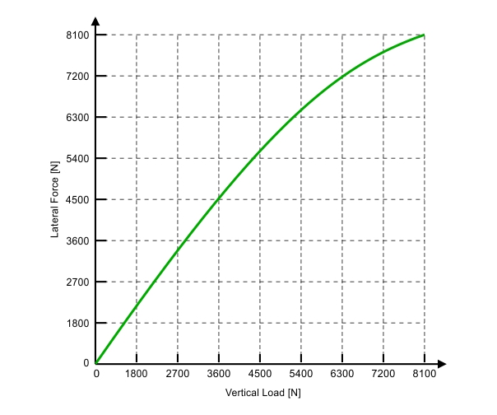
Before proceeding with the project it is important to research what published authors are saying about the significance of load splits on determining the grip level of an axle and hence the handling balance of a car. The term ‘load split’ refers to the difference between two wheel loads. The loads acting on each individual wheel has an extreme importance to understanding and demonstrating the maximum steady-state cornering capability. Adjusting the load splits will have a huge impact on how the vehicle will handle, For example, increasing the load split at the front axle of an understeering car will cause it to understeer more as there is a larger transfer of lateral load which in-turn suggests that a larger vertical load will be acting on the outer wheel, this will cause excessive lateral forces acting on the contact patch which will encourage the tyre to lose grip. Whereas, if the load split is increased at the rear axle of a car it will cause it understeer less. This statement is supported by a book ‘Fundamentals of Vehicle Dynamics’ which states, ‘Increasing vertical load is known categorically to reduce friction coefficient under both wet and dry conditions. That is, as load increases, the peak and slide friction forces do not increase proportionately. Figure 1
Typically, in the vicinity of a tyre’s rated load, both coefficients will decrease on the order of 0.01 for a 10% increase in load.’
Understeer is defined by ‘Multibody Systems Approach to Vehicle Dynamics’ as, strictly the condition in which the slip angle of that of the rear tyres exceeds that of the front tyres, oversteer is strictly the reverse. Figure 1 demonstrates the lateral forces acting on the tyre against the vertical load acting on the tyre for a single slip angle value, the nonlinearity of the line in the graph suggests/supports the statement that as the load on the tyre is increased as the weight is transferred during cornering, the lateral load increases up until a certain point where the tyre begins to lose grip. This is demonstrated on the graph when roughly 3600 newtons of vertical force are applied, the line fails to carry along its linear path. (Gillespie, 1992) (Harty, 2004)
Another factor which has a vast influence on axle grip is the tyre performance characteristics. Tyres’ are the primary source of forces which provide the stability and control of a vehicle. The grip of a vehicle is created by a molecular interaction at the point of contact between the tyre and the road surface. When the wheel is rotating, part of the tyre is always in contact with the road, the molecules at that point will extend until they’re broken. This is where the wheel begins to slip.
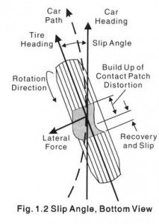
When the maximum coefficient of grip is reached the tyre contact patch begins to slide across the road. The forces generated from this loss of grip are dependent on factors such as quality of tyre, wheel loads and the characteristics of the road surface. It’s necessary to recognise the extent to which the tyre is stuck or sliding as well as the forces which are developed at the area of the contact patch. The acceleration performance of a vehicle is limited by the contact patch forces of the tyre. The slip angle is defined as the angular difference between the direction of which the contact patch is pointing and the direction of the wheel (Figure 2). It is important to remember that a tyres’ slip angle will adjust accordingly to support the lateral forces acting at the contact patch, not the other way round. Figure 2
Every tyre has what is known as a ‘critical slip angle’ this is the slip angle value at which the maximum lateral force is generated.
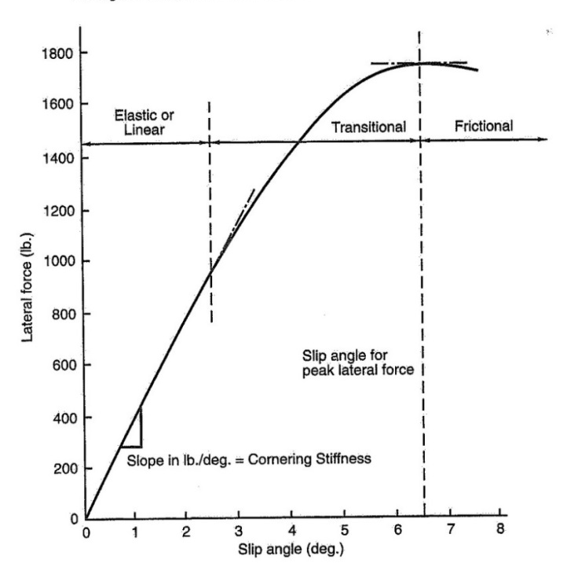
Figure 3 displays a plot showing the lateral force against the slip angle of a given tyre that is exposed to a given vertical load. The data was taken on a flat, dry, simulated road. The graph shows three regions, linear or elastic range, transitional range and finally the frictional range. The elastic or linear range is where the lateral force which is developed from the contact patch deformation is proportional in relation to the amount of slip angle. The transitional range is where the lateral forces and slip angle are no longer linear, this indicates the rear of the contact patch beginning to slide across the road surface. Finally, after the maximum lateral force is reached, any increase in slip angle will not continue to result in a higher lateral force. This is known as the frictional range because from this point the lateral force is only a result of the friction between the tyre and the road surface.
The peak of the curve indicates peak lateral force and may stay at a constant value or may fall off slowly. In dry conditions ‘race tyres generally reach their peak lateral force at slip angles in the vicinity of 3˚-7˚.’ In the wet, the surface of the peak will be lower and the fall-off in lateral force after the peak will be much more rapid. Figure 3
The graph also shows that the cornering stiffness is determined by the gradient of the slope, the value is given in pounds/degrees.
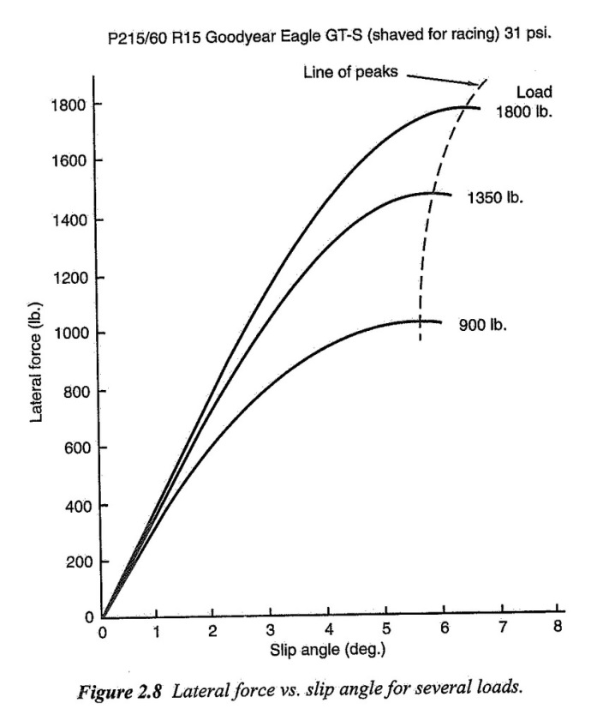
Figure 4 has been taken from ‘Race Car Vehicle Dynamics’, it shows a typical plot of Lateral Force (lbs) against Slip Angle (degrees) for an increasing tyre load. The curve for a 900lb wheel load indicates that a slip angle of just under 6 degrees is created with just 1000lb lateral force acting on the tyre. Compared to a 1800lb wheel load which shows that the same slip angle is created but with a much higher lateral force of just under 1800lb acting through the tyre. Note that these units are imperial as the source is from America.
This graph suggests that without a sufficient load acting on the wheel, the local coefficient of grip is reached a lot earlier and as the slip angle increases, the lateral load reaches it maximum potential.
Figure 4
As the vertical load is increased, the tyre is able to produce a larger lateral force with means that the tyre has more grip. Tyres can develop more lateral force that the vertical load acting on them. (Segers, 2008)
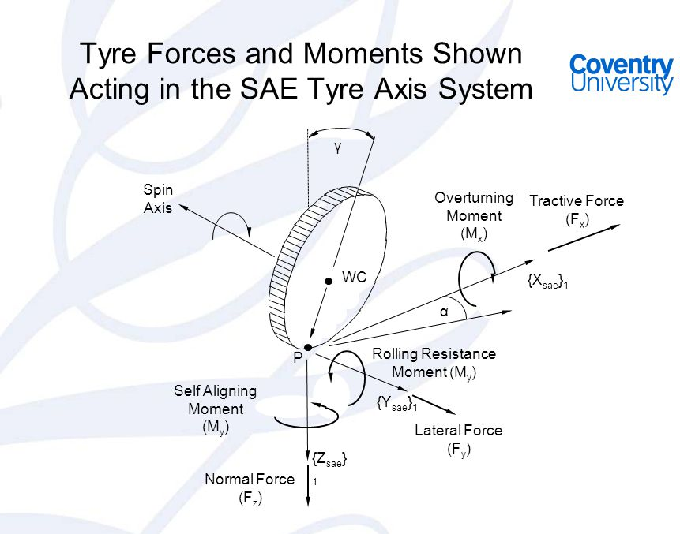
Literature suggests that the lateral force (cornering force) may be thought of as the result of slip angle or slip angle the result of lateral force. ‘A lateral tyre force originates at the centre of the tyre contact with the road, and lies in the horizontal road plane and is perpendicular to the direct in which the wheel is headed, if no inclination or camber exists.’ This is demonstrated in figure 5.
‘Analysis Techniques for Racecar Data Acquisition’ literature states that, ‘The vehicles handling balance is determined by how lateral force at one end of the vehicle develops in comparison to the other end as well as which end of the vehicle reaches the tyres’ maximum lateral force first.’ (Segers, 2008)
Figure 5
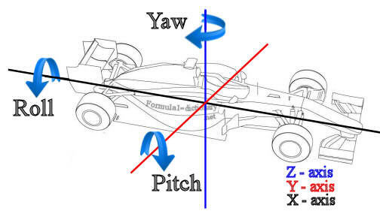
Chassis stiffness also has a huge effect on the achievable load split. The chassis of a vehicle must have adequate torsional stiffness around the ‘x’ axis (Figure 6). If the torsional chassis stiffness is weak, attempts to control lateral load distribution will be confusing at best and impossible at worst. The bending stiffness is generally not as important as torsional stiffness. Static chassis bending will not significantly affect wheel loads or load distribution, secondly, if a chassis has a good torsional stiffness it will also have a sufficient bending stiffness. (Deakin, 2002)
The above statement is supported by an SAE paper ‘Analysis of the influence on dynamics’ which also agrees with the importance of a high torsional stiff chassis, saying that insufficient torsional strength will result in a difficulty to control load transfer distribution. It goes on to say that displacement of suspension attachment points will occur which means any desired control of the movement of the tyres will not be guaranteed. (Milliken, 1995) (Sampo', 2010)
Figure 6
Further research has gone into looking at what factors affect wheel split levels. When a vehicle is in a state of steady-state cornering the main factors effecting weight transfer and wheel loads are;
- The location of the Centre of Gravity.
- The location of Roll Centre
- Wheel size & tyre size
- Camber
- Roll Stiffness distribution
Centre of Gravity location
The location of the centre of gravity has a huge effect on the difference in wheel loads. If the CG is positioned at the centre of the car, the vehicle is known as ‘neutral’ which is best for steady-state cornering. The height of the CG from ground also dictates the amount of roll which will occur, theoretically, the higher the CG, the more roll. ‘Race Car Vehicle Dynamics’ carried out test cases on the front axle of a front-wheel drive sedan with base configuration. The original total CG height was 21” (inches). Graphs created by plotting Reference steer angle (degrees) (x axis) against Axle normalised lateral force (y axis) with respect to different CG heights. The results found suggested that a lower CG height of 19” compared to its original height improved the normalised lateral force and cornering stiffness. (Milliken, 1995)
Location of Roll Centre
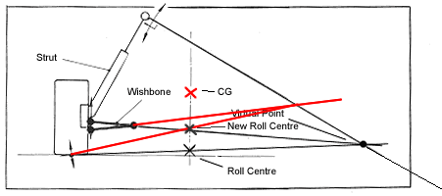
The roll centre is the notional point where the cornering forces in the suspension are reacted to the vehicle chassis. It is the theoretical point at which the chassis rolls. The roll axis is the imaginary line between the front and rear roll centre. SAE defines roll centre as ‘The point in the transverse vertical plane through any part of the wheel centres at which lateral forces may be applied to the sprung mass without producing suspension roll’, which defines it as a height rather than a point, there are no references to lateral location but is mathematically convenient to assume that it is laterally coincident to the centre of gravity. The amount of chassis roll in a cornering car is dependent on the position of the roll axis in relation to the cars centre of gravity, the closer the roll axis is to the CG, the less chassis roll. This will reduce the amount of load being transferred from one wheel to the other. The roll centre is the most under-utilized adjustments on a car as all suspension components rely on chassis roll before they have any effect, roll centre adjustments will have direct and immediate effect on handling. Adjustments can be made by changing the angles of the suspension arms (Figure 7). Image from: https://balancemotorsport.co.uk/suspension-geometry
Figure 7
In Laymans’ terms, the forced based roll centre is an idealised single point where the combined equivalent lateral tyre forces not on the vehicle sprung mass.’ (Mitchell, 2006) (Badiru, 2014)
Wheel & Tyre Size
The cornering stiffness is often dictated by the wheel and tyre aspect ratio and width. Wider tyres will ultimately have more lateral grip as there is more of the rubber molecules in contact with the road surface, the wheel width will allow the tyre to maximize the total available grip. A higher cornering stiffness tyre will require lower slip angle to produce a given amount of lateral force. Lower slip angles mean a lower ‘induced drag’ so less speed is lost when cornering.
(Milliken, 1995)
Camber
Camber is the inward or outward tilt of the wheel in respect to the vertical line going through the centre of the contact patch, (Figure 8). ‘It can be used to balance the car’.
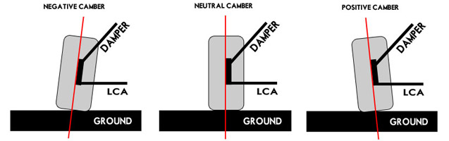
Most vehicles adopt a slightly negative camber. Tis will produce the maximum lateral force on the outside tyres. ‘Camber gain’ is an expression used to understand that the amount of camber will always change due to the roll of the chassis. When a wheel is moved vertically in relation the chassis, negative camber is increased on both the inside and outside wheel. However, when the body rolls, a positive camber is induced on the outside wheel rather than a negative camber.
Figure 8
The amount of positive or negative camber is always being adjusted as the car is in motion, especially as it is corner. As stated earlier in the report, the amount of lateral force being produced at any given time is due to the amount of rubber molecules in contact with the road surface at the contact patch, to optimise the load transfer it is important to understand the correct amount of camber needed, so when the chassis rolls the forces encouraging positive camber do not reduce the contact patch size to the point where lateral force is lost. (Rowley, 2003)
Roll Stiffness Distribution
Roll stiffness distribution is set by the choice of spring used, the stiffness of said spring as well as placement and angle of the spring. The springs are used to support and control the vertical chassis movement as well as resisting the amount of body roll. Ideally, to maximize a cars steady-state cornering the roll stiffness would need to be the same on the front and the rear. In front or rear wheel drive vehicles, the drive breaks down the lateral force capability at the driven end whilst the roll stiffness is biased to the opposite end. The roll stiffness distribution is one of the main factors which determine the load splits of a vehicle. (Milliken, 1995)

Project Calculations
The next step of the report will be to work out the elastic weight transfer at the front and rear of the car. Elastic weight transfer is the force which is reacted in the springs, anti-roll bars and shocks, and is the only one of the three components of total weight transfer that does induce body roll.
This will be done by following the steps below;
- Wheel Rate (Kw)
Front:
$$Kwf=Kwf \left(due to spring\right)+ Kwarf \left(due to ARB\right)$$
Rear:
$$Kwr=Kwr \left(due to spring\right)+ Kwarr (due to ARB)$$

$Kwf-Front wheel rate$ $Kwr-Rear wheel rate$

- Roll Stiffness (Kϕ)
Front:
$Kφf=Tf^{2} x Kwf$/2
Rear:
$Kφr=Tr^{2} x Kwr$/2
Total:
$$Kφt=Kφf+Kφr$$

$Kφf-Front Roll Stiffness$ $Kφt-Total roll Stiffness$
$Kφr-Rear Roll Stiffness$ $Tf-Front Track$
$$Tr-Rear Track$$

- Roll Angle (ϕ)
$Mot=Ms x ay x Hsra$
$$φ=\frac{Mot}{Kφt}$$

$Mot-Overturning Moment$ $Ms-Sprung Mass$
$ay-Lateral acceleration$
$$Hsra-Height of CG sprung mass above roll axis$$

- Elastic weight transfer (WTs) due to sprung mass at each end of the car.

Front:
$$WTsf= \frac{Tf x φ x Kwf }{2}$$

Rear:
$$WTsr= \frac{Tr x φ x Kwr}{2}$$

$$WTsf-Front elastic weight transfer due to sprung mass$$
$$WTsr-Rear elastic weight transfer due to sprung mass$$

Now that the most significant weight transfer has been found, we can proceed to find the total weight transfer by adding two lesser weight transfers to the total already found. As lateral forces are applied at the roll centre directly, geometric weight transfer is transferred through the suspension linkages and doesn’t induce body roll.
- Geometric weight transfer due to sprung mass.
Front:
$$WTsrcf= \frac{Msf x ay x hf}{Tf}$$
Rear:
$$WTsrcr= \frac{Msr x ay x hr}{Tr}$$

$$WTsrcf-Front geometric weight transfer due to sprung mass$$
$$WTsrcr-Rear geometric weight transfer due to sprung mass$$
$hf-Front RC height$ $Msf-Front sprung mass$
$hr-Rear RC height$ $Msr-Rear sprung mass$

- Geometric weight transfer due to unsprung mass.
Front:
$WTusf= \frac{Musf x ay x r}{Tf}$

Rear:
$$WTusr= \frac{Musr x ay x r}{Tr}$$

$$WTusf-Front weight transfer due to the unsprung mass$$
$$WTusr-Rear weight transfer due to the unsprung mass$$
$Musf-Front total unsprung mass$ $r-Rolling radius of tyre$
$$Musr-Rear total unsprung mass$$

- Total Weight Transfer
$$Front=WTsf+WTsrcf+WTusf$$
$$Rear=WTsr+WTsrcr+WTusr$$

Conclusion
After carrying out research into multiple factors which influence axle grip, I believe it is safe to conclude that by determining wheel loads through calculations it is in fact possible to understand and potentially even predict a vehicles handling balance. This statement is also supported by many authors who believe it is possible. The next step for this project will be to carry out the calculations recently mentioned to find a value for individual wheel loads and load splits as the car is cornering, this data will then be compared to the track data which has been obtained from Pembrey test session. Analysis of this data will be carried out using Motec i2 software, static data may also be taken and inputted into Wingeo3 for more comparable data. Even more data may be gathered from simulation test sessions so that there is more data to compare and therefore improve accuracy before proceeding further with the investigation.
Once it has been concluded that analytical calculations can be used to find wheel load distribution values and hence the handling balance of a vehicle, further testing will be carried out to collect data from a Driftworks CS2 coilover. The monotube strut will be fitted to a damper dyno for even more data to be collected, these coilovers have height and preload adjustment as well as 16-way adjustable damping. Further aims for the project will be to apply the calculations used earlier in the report to analyse the effects of different ride heights and damping rates on wheel load distribution.
If all goes to plan and the project thrives, the next step will be to move on to researching and testing other suspension parameters and geometry which effects wheel load distribution. As said before, the inspiration for this project comes from the will to understand how a car behaves, I hope that adequate research into the subject can be applied to my car which in the near future will be put on through drift days on track in the near future.

List of References

Badiru, I. A. (2014). The Three Suspension Roll Centers and their Application to Vehicle Dynamics. USA: SAE International.
Deakin, A. (2002). The Effect of Chassis Stiffness on Race Car Handling Balance. Leeds: SAE International.
Gillespie, T. D. (1992). Fundamentals of Vehicle Dynamics. USA: Library of Congress.
Harty, M. B. (2004). The Multibody Systems Approach to Vehicle Dynamics. Oxford: Elsevier Butterworth-Heinemann .
Milliken, W. F. (1995). Race Car Vehicle Dynamics. USA: Library of Congress.
Mitchell, W. C. (2006). Force-Based Roll Centres and a Improved Kinematic Roll Centres. Mooresville: SAE International.
Rowley, W. J. (2003). Race Car Engineering. Mooresville.
Sampo', E. (2010). Chassis Torsional Stiffness: Analysis of the Influence on Vehicle Dynamics. USA: SAE International.
Segers, J. (2008). Analysis Techniques for Racecar Data Acquisition. Warrendale: SAE.

