Name: Catalina Rosu
Student number: 1917494
Module Title: BMSW4005
Lecturer Name: Joanna Walsh

PROFESSIONAL CAREER DEVELOPMENT

Table of Contents
Introduction 2
Personal reflection 2
Conclusion 10
References 11

Introduction
The Gibbs model of reflection is regarded as a structured debriefing that supports experiential learning. It is designed as continuous cycle representing improvement for recurring experience; however, could be applied for reflecting on standalone experience. The study is aimed at reflecting personal experience on the employability skills for obtaining desired job role in the healthcare industry. In the report, I am going to provide relevant information regarding the skills I possess and the attributes that I need to develop for ensuring sustainable growth in my professional career. I would also highlight my strengths and weakness in the report along with its effect on my personality.

Personal reflection
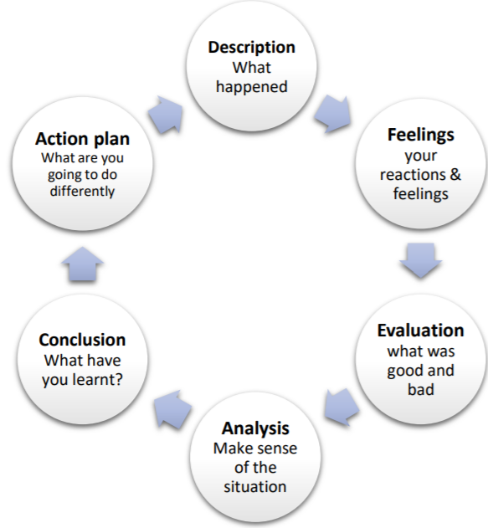
Figure 1: Gibbs cycle of reflection
Source: (My.cumbria 2020)
Description
Dhaliwal et al. (2018) stated that this is the first and foremost stage of the Gibbs model which reflects on the description of entire situation. As reflected, the role play was conducted between me as a student and the interviewer. The session took place for limited frame of time with the view to develop strong discussion on personal skills as well as experience based on healthcare. In the role play, I raised most of the questions to the interviewers to obtain answer which was meant to help me gain specific knowledge regarding the responsibilities of health care assistant in industry as well as the skills that I require to develop in order to ensure sound career growth. Being focussed on the job role of healthcare assistant, I was also asked to describe the skills needed for becoming healthcare assistant and flourishing further in the industry. During the role play I also came across my key weaknesses and strengths related to my career along with its effects. By the help of the interviewer, I also got to know the strategies, which I could develop for overcoming my weakness and improving my strengths further. As a result, I have been strongly able to focus on my skills for developing y career sustainably.
Feelings
As per the views of Arumugam et al. (2017) the feelings phase of the reflective model is concerned with the perspective or opinions of the individual related to the situation. It is helpful for the individual to develop awareness regarding specified topic in the given situation. With respect to the role play, I realised that strong communication and analytical thinking skills might have helped me to continue with the discussion thereby have detailed analysis of the queries raised. Sufficient amount of time could have helped me to ask more questions related to my career to the interviewer that could support me to improve the scope of my career in healthcare setting. However, I felt satisfied with questions raised and response gained in the role play as it is helpful for me to develop my career to a moderate extent. Throughout the situation, I felt strongly focussed towards my career while discussing on the skills and experience related to healthcare. The speaking and listening skills are needed to be developed by me in order to communicate with people effectively in career. Additionally, the analysis on the other skills has made me realise that I need to develop more qualities in order to improve my career like the conflict management and decision making skills. Furthermore, the reflection on my weaknesses and strengths has helped me to develop effective strategies in order to respond positively towards my flaws thereby improve my employability.
Evaluation
The evaluation phase of the model reflects the approaches or the factors in the situation that went well and that not worked well. Holder et al. (2019) argued that it is helpful in deriving productive outcomes from the experience for attaining targeted goals. As per my experience derived from the role play, discussion on how to pursue in career has been a good aspect as it is helpful for me to identify the approaches by the help of which I could focus on my skills and determine my scope of being healthcare assistant in future. However, the discussion on weaknesses and strengths has been worked partially well as it lacked causes behind those which have limited the scope of discussion. Likewise, some other discussion also did not work completely well due to limitation of time allocated for the role play that has also hindered detailed discussion regarding career in healthcare. However, communication on the ways to respond positively towards the weakness has been effective factor in my experience as it might help me to strengthen my professional career. In addition, the discussion on educational and personal skills along with secondary and primary responsibilities has been a positive experience for me in throughout the role play session. Therefore, it might support me to analyse the gaps and importance of each of the factors within my career in healthcare to impress my employer with discharge of suitable duties at different situations thereby ensure sustainable growth. Such experience is helpful for me to improve my personality and at the same time provide focus on the provision of effective services to the care users. Both I and the interviewer made a significant contribution towards the role play. My moderate critical thinking skills and communication skills have helped me to raise relevant queries from interviewer effectively which improved the scope of discussion. Furthermore, the listening skills and calm personality of the interviewer has helped me to obtain the answer of all my queries leading to development in my professional career.
Analysis
As opined by Wight et al. (2016) this phase of the Gibbs reflective cycle is focused on highlighting the personal experience whether it is negative or positive or both from a particular situation. With respect to the role play, I have gained certain positive as well as negative experience, that has helped me to analyse its effect on my career thereby form proper strategies to mitigate risks. The positive experience I gained from the role plays was that I have been able to understand my weaknesses and strengths, which could focus on, for improving my personality in my desired career field. I experienced that I am good at communicating frequently with people; however, I lack proper listening skills, vocabulary, which disrupts me to think towards specific matters critically. I experienced that I get nervous at times while communicating publicly, which reduces confidence of listeners to attend me thereby I need to develop my speaking abilities in public to overcome my weakness. Also experienced that I lack problem-solving or conflict management skills, that is necessary for me to manage issues at workplace. Therefore, I had a positive experience regarding the ways to be followed to develop the skills as it could support me to obtain desired job, perform my tasks effectively thereby ensure better results in my career. Apart from that, I experienced certain negative aspects. Throughout the role play with the interviewer, I was unable to analyse the causes or factors that have developed the issues. Inability to analyse the causes behind the weaknesses faced might disrupt me to undertake an in-depth evaluation of skills lacked that could act as a challenge for me to ensure sustainable professional career growth.
Conclusion
Generally, I have learnt that there are wide range of skills both educations as well as employability, which could help me to focus on both skills in order to attract desired employers and obtain desired job role. As I am focussed to undertake job role of healthcare assistant, I could have to perform critical tasks like maintaining health reports of patients, managing medical team and others. With respect to the analysis, I have come to the conclusion that I need to emphasise on soft employability skills in order to improve my career and obtained desired job role of healthcare assistant. These skills shall support me to undertake my job role, manage issues faced in work while performing in a team thereby obtain a remarkable repute in the eyes of employer and my colleagues in future. Analysis has helped me to acknowledge that strong communication could help in sending messages to the intended audience effectively. Subsequent to my analysis on my positive and negative aspects related to my career, I conclude that I need to form effective strategies related for developing the improving the skills I possess presently and focus on the key qualities, which I lack in order to improve my personality and attract prospective employer from healthcare industry. In the next phase I need to develop action plan for focusing on improvement of decision making abilities, communication, problem-solving competencies and critical thinking skills within stipulated frame of time for attaining targeted goals. It might help me to handle workplace situations effectively as well as ensure sustainable career.
Action plan
With respect to my professional career, I need to develop certain strategies in order to improve skills I lack and qualities I need to improve further for developing my personality. The action plan shall help me to overcome my weaknesses and gain opportunities to develop skills in order to attract desired employers from the healthcare industry.
Areas for improvement | Strategies to develop | Goal | Time plan
Problem-solving skills | I could enrol myself into online courses and workshops concerned with problems solving activities in order to improve the skill. It could also engage in brainstorming activities for building competency of resolving problems. | To resolve problems associated with my career and academics.  Being a prospective healthcare assistant I need to develop qualities to manage conflict amongst medical team members in future. | 2 months
Decision making skills | To develop the skill, I could engage in analytical research and discussion with my co-students on specific matters and try to assess its negative and positive effect in life. It could help me to form decision regarding critical matters successfully.  Also, strong emotional intelligence needs to be developed for ensuring that emotions do not hamper my decisions | I need to develop the skill to form decisions effectively regarding my career. It shall also help me to focus on my academics in order to achieve my goal successfully. | 1 month
Communication skills | Active listening is one of the most key elements to improve communication skills. Therefore, I could participate in public speaking sessions; take up online communication classes in order to strengthen my communication skills. Furthermore, frequent reading of books and thesaurus shall help me to improve my vocabulary. It might attract attention of listeners towards me and help me to convey messages effectively. | I require improving my communication skills for interacting successfully with my colleagues, convey my feelings strongly to the listeners and ensure sustainable growth in my professional career. | 2 months
Critical thinking skills | Continuous analysis of feedback received from my interviewer regarding my skills and weakness and determines its impact on my career could develop my skills of critical thinking. Additionally, I could stand in front of mirror and ask questions frequently from myself regarding my decision to be taken in my life shall help me to critically analyse things, anticipate and manage risk wisely. It could also participate in team-building and active listening; which could help me think analytically. | To have better control of my empathy and learning. By developing the skill, I am also aimed at resolving uncertainties to be met in future based on my professional career. | 3 months
Table 1: Action plan for skills to be developed
Source: (Created by the author)

Conclusion
In confirmation to aforementioned discussion, I conclude that the action plan is helpful for me to develop the skills I lack or require to improve further. It is also effective for me to overcome my weaknesses and strengthen my existing skills in order to ensure development in professional career. It has been concluded that I lack the effective decision making, critical thinking and problem solving skills which are likely to create a negative effect on my professional career and my ability to influence the service users and my colleagues. Furthermore, I need to strengthen the communication skills that could help me to build up my personality as well as encourage managing my team members in my professional career.

References
Arumugam, B., Narayanan, V., Kathiravan, V. and Nagalingam, S., 2017. Reflective writing–how a medical student can reflect?. Journal of Education Technology in Health Sciences, 4(2), pp.47-53.
Dhaliwal, U., Singh, S. and Singh, N., 2018. Reflective student narratives: honing professionalism and empathy. Indian J Med Ethics, 3, pp.9-15.
Holder, N.A.K.A., Sim, Z.L., Foong, C.C. and Pallath, V., 2019. Developing a Reflection Guiding Tool for underperforming medical students: An action research project. Tuning Journal for Higher Education, 7(1), pp.115-163.
My.cumbria, 2020, [online] Available at: <https://my.cumbria.ac.uk/media/MyCumbria/Documents/ReflectiveCycleGibbs.pdf> [Accessed 18 August 2020].
Wight, I., Kellett, J. and Pieters, J., 2016. Practice~ reflection~ learning: work experience in planner education. Planning Practice & Research, 31(5), pp.500-512.

