Upside down essay

Student name: Samantha Hamblet
Student number: 2200174
Module: Research in practice ADAD5004
Program of study: Fine Art: Studio, Site and Context (BA)
Three keywords: beauty standards, double standards and domination
Word count: (excluding title page, quotes, table of contents, list of illustrations and bibliography)
Tutor: Alex Duncan and Holly Slingsby

Table of contents
List of illustrations …………………………………….. pg. 3

Beauty standards ……………………………………... pg. 5

Double standards …………………………………….. pg. 9

Male dominance ……………………………………… pg. 12

Conclusion ……………………………………………. pg.15

Bibliography ………………………………………….. pg. 17
List of illustrations
‌Saville, J. (1993). Plan. [oil on canvas] Available at: https://www.mutualart.com/Artwork/Plan/AF985678C97F2709
[Accessed 31 Mar. 2024] ……………………………………………………pg. 6

Botticelli, S. (1485). The Birth of Venus. [Tempura] Available at: https://www.britannica.com/topic/Birth-of-Venus
[Accessed 1 Apr. 2024] ………………………………………………………pg. 8

‌ Chicago, J. (1979). The dinner party. [mixed media] Available at: https://www.brooklynmuseum.org/exhibitions/dinner_party/
[Accessed 1 Apr. 2024] ………………………………………………………pg. 10

‌Kruger, B. (1989). untitled(your body is a battleground). [ collage] Available at: https://www.artsy.net/article/artsy-editorial-artwork-changed-life-barbara-krugers-untitled-body-battleground
[Accessed 12 Apr. 2024] ……………………………………………………pg. 13

‌

‌

‌

This essay aims to explore into the intricate interplay between three fundamental concepts—beauty standards, double standards, and male dominance—to address a critical question regarding societal norms and their impact on women. Through a comprehensive examination of these concepts and their societal consequence, the complex dynamics that contribute to misogyny in contemporary society will be unveiled. This will be achieved by the investigation into the perspectives of esteemed artists and philosophers, each offering valuable insights into the complex nature of power structures and gender dynamics. The notable figures whose perspectives will be interrogated include Naomi Wolf, whose seminal discourse on beauty standards challenges entrenched notions of femininity; Jenny Saville, whose art disrupts conventional portrayals of the female form and prompts revaluation of societal norms, Sandro Botticelli, whose iconic artworks furnish historical context for the perpetuation of gendered stereotypes, Simone De Beauvoir, who illuminates the systemic inequities confronted by women, Judy Chicago, whose feminist artworks confront historical marginalization and celebrate the achievements of women throughout history, Gerda Lerner, whose inquiries unearth the historical underpinnings of male dominance and patriarchal systems, and Barbara Kruger, whose artistic expressions critique societal norms and challenge the commodification of women's bodies. Through an exploration of these diverse perspectives, a deeper comprehension of the interplay among beauty standards, double standards, and male dominance, and their impact on women's lived experiences, will be attained.

Beauty standards
The concept of beauty standards encompasses the prevailing societal norms and expectations that dictate what is considered physically attractive or desirable. Naomi Wolf's seminal work The Beauty Myth (1990) offers a profound exploration of this phenomenon, illuminating the pervasive impact of societal beauty standards on women's priorities. Wolf's research reveals a startling statistic: thirty-three thousand American women expressed a preference to lose ten to fifteen pounds over achieving any other goal (Wolf, 1990, p. 10), underscoring the immense pressure to conform to beauty ideals. According to Wolf, these standards serve as a tool of control wielded by men to perpetuate patriarchal systems and reinforce gender hierarchies. Furthermore, she argues that the pressure on women to pursue beauty intensified in the aftermath of the second wave of feminism, as a backlash against the progress women have made. This argument suggests that women have been systematically conditioned to prioritize their appearance at the expense of other aspirations. This is evident in the fact that these women have been conditioned to care about their appearance to the extent that they place beauty over any other goal.
An artist engaged in interrogating beauty standards is Jenny Saville. Through her distinctive artistic practice, Saville not only challenges but also deconstructs societal norms surrounding beauty. She achieves this by portraying unconventional, plus-size figures in her artwork, thereby subverting traditional representations of the female form. By deliberately emphasizing the diverse and often marginalized aspects of the female physique, Saville's work serves as a powerful catalyst for viewers to reassess their preconceptions of beauty. Her target audience is particularly significant; she aims to reach women who have been affected by societal beauty standards, inviting them to confront and challenge the narrow definitions of beauty that they may have internalized. Through her bold and unapologetic portrayal of the human body, Saville not only sparks conversations about beauty and body image but also empowers individuals to embrace and celebrate their own unique identities and forms. This is articulated in Saville's own words: “I’m painting women who've been made to think they're big and disgusting, who imagine their thighs go on forever”. (Davies, 2011)

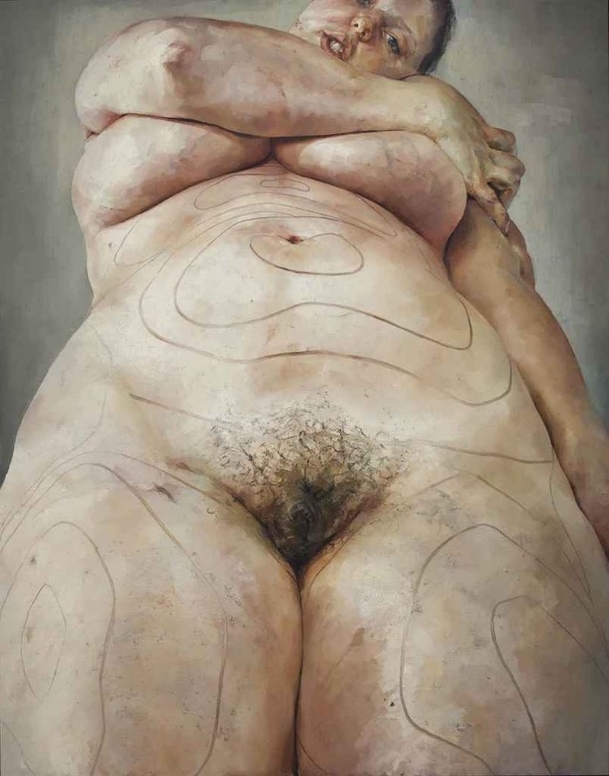

Figure 1

Jenny Saville's Plan (1993) stands as a compelling exploration of beauty standards through the lens of contemporary art. This oil-on-canvas creation presents a close-up view of a nude figure dominating the majority of the canvas. Saville's deliberate use of thick, gestural lines trails over the figure, adding contour to the curves of the body and imbuing a sense of fluidity to the composition. These bold lines not only enhance the figure but also invite viewers to take a closer look at the textured paint and expressive brushwork used by Saville. Through her warm colour palette and dynamic brushstrokes, Saville infuses the body with a sense of movement and vitality, imparting a rawness and realism that challenges conventional notions of beauty. In this composition, Saville prompts reflection on societal expectations surrounding the female body, inviting viewers to reconsider entrenched ideals of beauty and femininity.
In Ways of Seeing, philosopher John Berger delves into the male gaze theory, particularly by analysing representations of women in art and media. Berger contends that the male gaze perpetuates power dynamics between men and women, as men gain power and privilege by objectifying women's bodies. He argues that this perpetuation further solidifies patriarchal inequalities. Similarly, Jenny Saville's work challenges these power dynamics by subverting the male gaze and urging viewers to reconsider preconceptions of women and beauty. By aligning Saville's artistic critique with Berger's analysis, audiences are prompted to confront the ways in which societal beauty standards and gendered power dynamics intersect and perpetuate inequality. “Men look at women. Women watch themselves being looked at”. (Berger,1972)

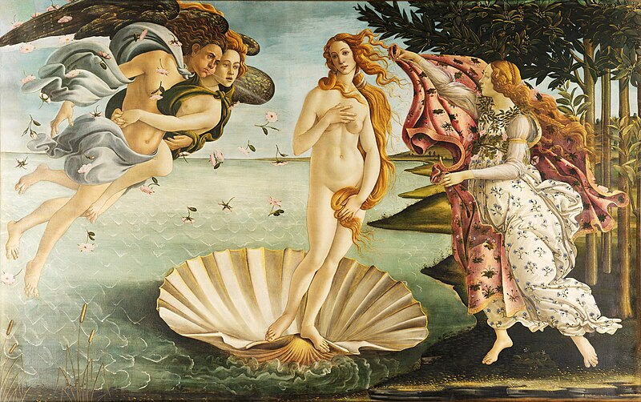 Figure 2

Jenny Saville's work offers a rare perspective on the representation of women, as highlighted in John Berger's analysis of Sandro Botticelli's The Birth of Venus (1485). In Figure 2, Venus stands nude on a shell in the sea, her hands delicately covering her vagina and right breast. The symmetrical composition places Venus at the center, drawing the viewer's gaze directly to her and emphasizing her as the focal point. Botticelli's use of a soft colour palette lends an ethereal quality to the scene, enhancing the beauty of the figure. Berger's critique of the male gaze in this piece underscores how Venus's body proportions conform to beauty standards that perpetuate female objectification in the patriarchy (Burdis, 2019).
During the Renaissance period, significant cultural shifts, such as the invention of the floor-length mirror, prompted women to increasingly consider their appearance from an external perspective (Burke, 2024). Additionally, the popularity of nude portraiture during this time led to women aspiring to emulate unrealistic beauty standards, like the influence of media in modern-day society. This transformative period marked a departure from previous eras, as women gained access to tools like the floor-length mirror, allowing them to scrutinize their appearance with newfound clarity. The allure of idealized beauty portrayed in Renaissance art parallels the contemporary pressure individuals face today to conform to unattainable standards perpetuated by media imagery.
As an artist who identifies as plus-size, exploring beauty standards for individuals with diverse body types resonates deeply with me. Through my artistic practice, I aim to convey the nuanced challenges faced by those whose bodies deviate from conventional norms. Drawing from my own experiences navigating a world that often marginalizes individuals like myself, I channel my artistic expression to shed light on the complexities of societal beauty standards. By depicting plus-size figures in my work, I strive to challenge traditional notions of beauty and foster empathy and understanding for those who, like me, navigate the world in bodies that defy societal expectations.

Double standards
Double standards perpetuate gender inequality by imposing unfair expectations on women compared to men in various aspects of life. By critically examining the impacts of these double standards on women, we can gain insight into the pervasive gender dynamics that uphold systemic misogyny within society. Simone de Beauvoir, a feminist philosopher, extensively addressed double standards for women in her seminal work The Second Sex. De Beauvoir argued that women are subjected to different social and behavioural expectations than men, resulting in limited opportunities for women to fully realize their potential. For instance, she highlighted how women are often harshly judged for expressing their sexuality, while men are celebrated for similar behaviour. This societal judgment against women can lead to internalized shame, increased health risks due to barriers to accessing sexual health care, and strained relationships characterized by unequal power dynamics. By acknowledging and challenging these double standards, we can work towards creating a more equitable society for all genders.



Figure 3

Judy Chicago's The Dinner Party (1974-1979) is an art piece that tackles the double standards faced by women throughout history. Featuring a large triangular table adorned with plates and runners that doubles as an abstract portrait representing 39 significant women, the artwork symbolically highlights the lives and achievements of women who have been historically erased or marginalized. Divided into thematic wings representing different time periods, from prehistory to the women's rights movement, the piece critiques societal restrictions on women's agency and sexuality, while calling for greater gender equality and representation. Chicago's realization of the male-dominated nature of the art world during her time at the University of California in the 1960s is expressed in her statement “It was the prevailing attitude in the 1960s that women had no history” (Sayej,2017). This assertion underscores the pervasive belief that women's contributions were systematically overlooked and dismissed. By bringing attention to these overlooked women, Chicago challenges the double standards that have long constrained women's visibility and recognition in both art and society.
In figure 3, Chicago includes a place setting dedicated to Christina of Sweden, who ruled from 1632 to 1654. Christina's refusal to conform to traditional gender norms, exemplified by her steadfast refusal to marry despite societal expectations (Fish, 2017), positions her as a important figure in the fight for women's rights during her era. Her bold defiance of societal expectations not only challenged the status quo but also paved the way for future generations of women to assert their agency. Through this portrayal, Chicago celebrates Christina's resilience and courage, elevating her from the shadows of historical erasure and ensuring that her legacy endures in the collective consciousness.

Male-Dominance
The concept of male dominance theory emerged in the twentieth century to describe the unequal power dynamics between men and women (www.sciencedirect.com, n.d.). Philosopher Gerda Lerner, in her book The Creation of Patriarchy (1986), contends that male dominance is a socially constructed phenomenon rather than a natural aspect of society. She delves into the historical origins of male dominance, highlighting influences such as agriculture, women's reproductive rights, religious and cultural beliefs, and labour practices. These factors have contributed to patriarchal systems by consolidating male control over resources, regulating women's bodies, and perpetuating gender hierarchies.
Understanding the history of women is imperative, as historical narratives have traditionally been shaped by male perspectives, neglecting the experiences of women (Lane, 2023). Lerner seeks to unveil the perception of women within male-dominated societies and challenge the prevailing pattern of patriarchal history.

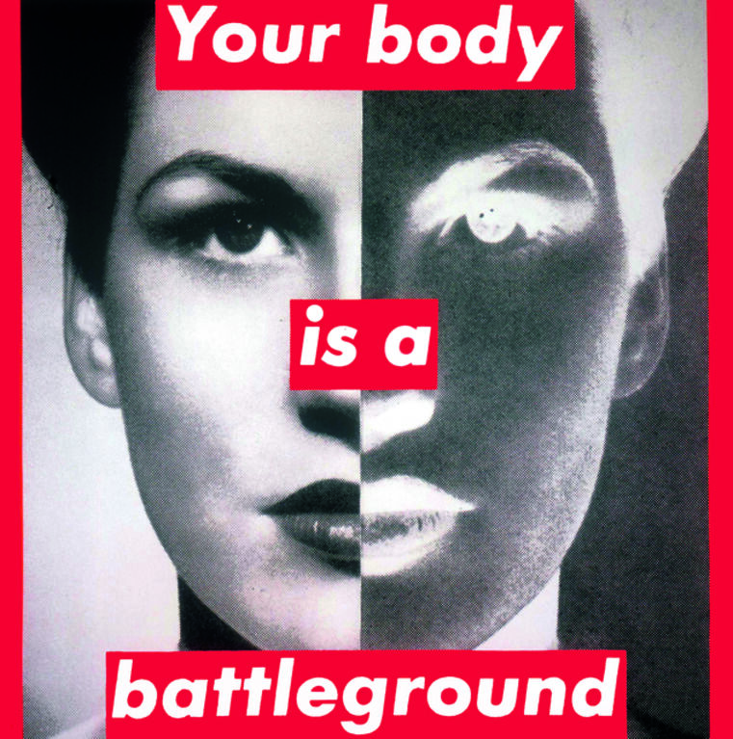

Figure 4

Barbara Kruger's Untitled (Your Body Is a Battleground) (1989) is a poignant exploration of the male dominance theory. This artwork features a close-up photograph of a woman's face overlaid with the bold text "Your Body Is a Battleground" dominating the composition to immediately draw viewers' attention. The confrontational message challenges societal standards imposed on women's bodies by men, inviting reflection on issues of gender inequality and bodily autonomy. Presented in black and white, the image intensifies the impact of the red and white text, emphasizing the urgency of the message. Kruger's statement, "Think you can do whatever you want with your body? Think again" (Kruger, 1999, pg. 172), underscores the contentious nature of women's bodily autonomy. The metaphorical portrayal of women's bodies as battlegrounds suggests a struggle for agency and control, echoing broader debates surrounding laws and policies regarding women's reproductive rights. In the United States, where Kruger was based at the time, access to abortion services was available following legalization in the 1970s (Planned Parenthood, 2022). However, this access was challenged by the U.S. government's decision to cease funding family planning programs that included abortion services (HISTORY, 2023), reflecting the ongoing tension between women's rights and patriarchal structures. Kruger's artwork serves as a critique of the objectification and control of women's bodies within society, highlighting the enduring struggle for bodily autonomy in the face of male dominance.

Conclusion

In conclusion, this essay has shed light on the interplay between beauty standards, double standards, and male dominance and how they have a profound impact on women's lives and experiences within society. By researching in depth of the perspectives offered by a diverse array of artists and philosophers, valuable insights into power dynamics in society have been uncovered due to each viewpoint enriching the comprehension of what fuels misogyny in society.
Upon exploration of these key concepts, beauty standards, double standards and male dominance, I have evaluated through analysis of the artists Jenny Saville, Judy Chicago and Barbara Kruger. I have come to the revelation that there is a significant interconnection between them. Jenny Savile explores the effects of beauty standards on women, Judy Chicago explores the erasure of women in history and Barbara Kruger investigates how a woman’s bodily autonomy is a battleground. These interconnect because they reflect a social outlook on misogyny and male dominance and how these issues are factors in a patriarchal society.
Naomi Wolf shed light on societal beauty standards as a tool to control the female anatomy and that compares to Jenny Saville’s exploration into body image. This exploration was furthered by researching the philosophy of John Berger, specifically his recognition of the male gaze. Botticelli The Birth of Venus was a useful historical artefact within my analysis of the male gaze theory, to confirm that theory from historical standpoint. Simone De Beauvoir explores the limited opportunities that exist for women under a patriarchy which had similarities to Judy Chicago’s The last dinner party. Gerda Lerner helped further my exploration into Barbara Krugers work by creating a perspective that explains unequal power dynamics. By shedding light on the works of these artists and philiophers I have analysed these words in greater depth and my analysis has led me to this proposed dissertational question: ‘How are women disadvantaged in contemporary society? Research into a mixed media array of artistic disciplinaries and a variation of philosophical concepts to support this exploration’.

Bibliography

Berger, J. (1972). Ways of Seeing. London: British Broadcasting Corporation and Penguin Books.

Burdis, S. (2019). Beauty and Myth | The Birth of Venus by Sandro Botticelli. [online] HeadStuff. Available at: https://headstuff.org/culture/visual-arts/the-birth-of-venus-botticelli/.

Burke, J. (2024). How to Be a Renaissance Woman. Simon and Schuster.

Davies, H. (2011). Interview: This is Jenny, and this is her Plan: Men paint female. [online] The Independent. Available at: https://www.independent.co.uk/life-style/interview-this-is-jenny-and-this-is-her-plan-men-paint-female-beauty-in-stereotypes-jenny-saville-paints-it-the-way-it-is-and-charles-saatchi-is-paying-her-to-keep-doing-it-1426296.html.
De Beauvoir, S. (1949). The Second Sex. London: Vintage Classics.

fish (2017). Queen Christina of Sweden – Defying gender roles in the 17th Century. [online] Newcastle’s Foote. Available at: https://www.newcastlesfoote.co.uk/queen-christina-of-sweden-defying-gender-roles-in-the-17th-century/#:~:text=In%20fact%2C%20Christina%20despised%20all%20things%20feminine%20and [Accessed 9 Apr. 2024].

HISTORY. (2023). Reproductive Rights in the US: Timeline. [online] Available at: https://www.history.com/news/reproductive-rights-timeline#early-20th-century-planned-parenthood-launches.

Kruger, B., Goldstein, A., Deutsche, R., Los, A. and Museum, W. (1999). Barbara Kruger. Los Angeles, Ca: Museum Of Contemporary Art; Cambridge, Mass.

Lane, T.T. (2023). On The Creation of Patriarchy by Gerda Lerner. [online] Medium. Available at: https://thethinkinglane.medium.com/on-the-creation-of-patriarchy-by-gerda-lerner-b3966d510af1.

Planned Parenthood. (2022). Historical Abortion Law Timeline: 1850 to Today. [online] Available at: https://www.plannedparenthoodaction.org/issues/abortion/abortion-central-history-reproductive-health-care-america/historical-abortion-law-timeline-1850-today.

Sayej, N. (2017). Judy Chicago: ‘In the 1960s, I was the only visible woman artist’. The Guardian. [online] 20 Oct. Available at: https://www.theguardian.com/artanddesign/2017/oct/20/judy-chicago-the-dinner-party-history-in-the-making.

Wolf, N. (1990). The Beauty Myth: How Images of Beauty Are Used against Women. London: Vintage Classic.

www.sciencedirect.com. (n.d.). Male Dominance - an overview | ScienceDirect Topics. [online] Available at: https://www.sciencedirect.com/topics/social-sciences/male-dominance.

‌

‌

