

Programme: BA International Hotel Management
Module: Food & Beverage Operations
Module code: BMIH4002
Assignment Title: Assignment 2 Menu Engineering (Practical Task)

Student name: Muhammed Khademul Basar
Student ID number: 2211999

Part 1: Restaurant Concept
Hotel Trinity is a very common name among the hotel companies in hospitality industry. It is famous for its wide range of services to different types of customer bases according to their needs. It provides premium quality services to its businessmen and other professional customers. It also provides services to the people who would like enjoy the services of a hotel at a reasonable or competitive price. Mary Daly, the current head of the company, is widely acclaimed for his good leadership and strategic qualities (Trinity Groups, 2022). The hotel has very organised and well-trained management teams across different hotels that controls the operation of those hotel. But compared to other larger competitors, it is yet to capture larger customer base and serve them. It is generally considered as a 4-star hotel service. Hotel Trinity owns many hotels in countries like the USA, Ireland and the UK. Trinity hotel is famous for its comfortable and stylish service quality (Aron, 2021). Moreover, it places itself into important places such as near-by airport, in city centres or business hubs, busy areas etc. to make the service easily available to their target customers‌ (Quek, 2011).
Hotel Trinity, as a part of increasing the customer attraction, arranges special menu packages for targeting different festivals. For the upcoming Valentine’s Day, it has also designed such a menu to capture more and more customers.
Target audience- The target customers of Hotel Trinity are customers who want to experience high-end services and have the financial capability to afford them. For Valentine’s Day’s special menu, the target customers are also affluent customer bases such as leisure travellers, newlywed couples or people who wants enjoy the special occasions well. The company’s marketing team targets them and wants to deliver their message to them very well. These target customers are of different ages and cultural and ethnic backgrounds.
Reasoning behind the menu choice- Festivals like Valentine’s Day are very special to lots of people. It gives them the opportunity to bring their loved peoples or relatives closer and create a strong bond of love, care and friendship (Yost et all., 2021). Hotel Trinity and its management team understand these things and that’s why they try to satisfy their customers by serving their special needs at that time.

Part 2- Menu Design

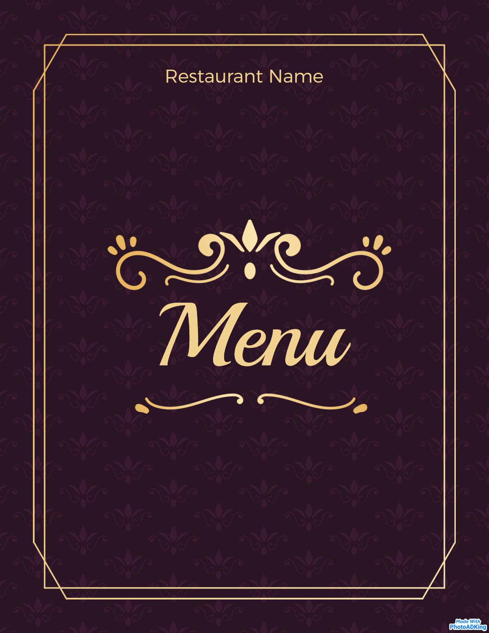

Trinity Hotel, 75 High street, Birmingham, B1 2AB, UK
Tel: 01454378797. Web: trinitybirmingham.com

Open:7 days from 5:30 PM to 11 PM PM

Valentine’s Day **Special Menu**
February 14, 2023

Hotel Trinity
Heads up: Dear Customers, we request you to inform us in advance if you have problems of allergies. Some of our dishes contains allergens

Valentine’s Special (for 2 people) 49.99 (Choose 1 dish from each section)
Starter
Tasty Vegetarian Fajitas (Tasty and healthy fajitas with special fajitas sauce, tortilla, loads of veggies tastes like heaven, 800kcl)
Shrimp Stir Fry (Gluten-free and free of dairy products, this recipe is prepared with different vegetables and fresh shrimps, 1000kcl) GF
Sheet Pan Nachos (Ground beef, onion, olive oil, tortilla, beans, salsa etc. makes a must to try out, 500kcl)
Veggie Burgers (Caramelised roasted vegetables with epic flavours placed on the middle with a combinatination of egg gives you meat like taste, 750kcl) Veg
Main Course
Garlic Honey Shrimp (Perfect combination of juicy shrimp, glazy garlic and honey, 550kcl)
Tomato and Corn Cheesy Pastry Bites (Highly delicious and filled with different flavours of cheese, onion, olive oil, tomato and masalas, 700kcl) Veg
Seared Tuna (Seared tuna with some veggies and masalas are served quickly, 1000kcl)
Chickpea Curry with Basmati Rice (Gluten-free recipe with the royal taste of coconut milk and warm spices, 800kcl)
BBQ Tofu (Perfectly prepared tofu recipe with different sauces and spices makes it irresistible, 900kcl)
Veggie Chilli (Completely vegan dish prepared with beans, quinoa, and a hint of adobo sauce makes it a perfect dish, 500kcl) Veg

Hotel Trinity
Sweet Desserts
Vegan Chocolate banana ice cream (Tasty and flavourful with banana, almond milk and cocoa powder, 500kcl)
Baked cheese cake (With the taste of cream cheese, butter, egg, biscuits etc. You can change it to lemon cheesecake for £2.50, 400kcl)
Vegan Chocolate banana ice cream (Tasty and flavourful with banana, almond milk and cocoa powder, 550kcl)
Baked cheese cake (With the taste of cream cheese, butter, egg, biscuits etc. You can change it to lemon cheesecake for £2.50, 600kcl)
Vanilla Bean Apple Pie (Combination of vanilla bean, brown sugar, cinnamon and granny smith apples makes each bite tastier, 550kcl)
Banana Pound Cake (Banana based cake with simple but tasty recipe, 500kcl)

Beverages
Soft Drinks:
Apple and Orange Fresh juice 250 ml 7.95
Lemonade, Coke and Dite Coke. 250ml. 4.50
Red wine:

Kleine Zalze Shiraz Cabernet Sauvignon 175 ml 6.50. 75Cl 35.95

White wine :

La Vieille Ferme White Wine, France 175 ml 6.95 75 Cl 35.95

Sparkling Wine:

Moet & Chandon Brut Imperial Non Vintage Champagne, France 75Cl 105.95

Reference
‌ Quek, M., (2011). Comparative historical analysis of four UK hotel companies, 1979‐2004. International Journal of Contemporary Hospitality Management, 23(2), pp.147-173.
Aron, M., (2021). Trinity International’s expansion continues with representation in Singapore. [online] Available at: https://www.trinityllp.com/trinity-internationals-expansion-continues-with-representation-in-singapore-2/ [Accessed 24 May 2023]
Trinity Groups. (2022). About Us. [online] Available at: https://trinityhotelgroups.com/about-us [Accessed 24 May 2023].
Yost, E., Zhang, T. and Qi, R., (2021). The power of engagement: Understanding active social media engagement and the impact on sales in the hospitality industry. Journal of Hospitality and Tourism Management, 46, pp.83-95.

