

LEVEL 6

SEMESTER 1&2

MODULE CODE: SHSs6089
ADVANCED TRAINING METHODS
aSSESSMENT TYPE: Practical/Report
Assessment/Component: 2

COMPONENT WEIGHTING: 50 %

WORD COUNT: 2500

MODULE TUTOR: GERAINT FORSTER

Assignment 2 Implementing an advanced training method with a client

Scenario

In order to complete this assignment, you are required to work with a client who has specific exercise-related goals. In order to work towards achieving these goals, you are required to integrate one of the advanced training methodologies studied in this unit into their training programme and utilise technology in some way to complement the training. (note: this must be a DIFFERENT training methodology to the one used in assignment 1).

Task
Having integrated the advanced training method into the training of at least one of your clients, write an evaluative report outlining the effectiveness of the training method in achieving the desired goals, and the usefulness of technology in monitoring progress.

Include the following in the report:
- A profile of the client(s) including results of any testing conducted
- A rationale for the inclusion of this particular advanced training method in the training programme of the client(s)
- A summary of the training programme prescribed to the client(s)
- Details and evaluation of any technology used within the programme
- A critical evaluation of the effectiveness of your intervention, using evidence-based research to support your opinions.

SUBMISSION DETAILS: via turnitin on 8th March 2019

School of Sport, Health & Outdoor Education

Assessment Feedback Sheet

Student No./Name:
Module: Advanced Training Methods
Module Code: SHSS6089

Personal Evaluation – to support your academic progress please complete the section below BEFORE submitting your work.
What do you consider to be the best aspects of this work?
Which aspects do you consider could have been improved in this piece of work?
What have you found most satisfying whilst undertaking this submission?
ASSESSMENT CRITERIA | Learning  Outcomes |  | GRADE
 |  |  | Poor  0-25% | Unsatisfactory  26-39% |  | Satisfactory  40 – 49% | Good  50 – 59% | Very Good  60 – 69% | Excellent  70 – 85% |  | Exceptional  86– 100% |  | %
Rationale for use of training method | 1,2 |  |  |  |  |  |  |  |  |  |  |  | 20
Programme design following best practice | 2 |  |  |  |  |  |  |  |  |  |  |  | 20
Critical evaluation of effectiveness of training method | 1,2 |  |  |  |  |  |  |  |  |  |  |  | 35
Evaluation of use of technology for monitoring and enhancement | 1,3 |  |  |  |  |  |  |  |  |  |  |  | 15
Engagement with the process and professionalism | 2 |  |  |  |  |  |  |  |  |  |  |  | 10
It is expected that students will present work that is proof read and follows the School Reference Guide and Assessment Checklist. Therefore a range of 0 – 10 marks will be deducted for non-completion of any of the points on the checklist below.
TUTOR COMMENTS:

Submission date: 8/03/19 |  | Return date:  (at least within 4 weeks) |  |  | Tutor: Geraint Forster |  |  |  |  | Mark:

Client Training Programme

Client Profile
Age: 21
Weight: 75Kg
Height: 170cm
BMI:25.9 (see appendix 1.0)

The client had moderate experience in strength training and being in a gym environment. The client has previously been in rugby training camps which have been at a semi-professional level therefore has had to follow training programmes and strength sessions. The understanding of the key lifts is good, and the client demonstrated a good understanding of the technique involved with each lift when asked in a verbal conversation. The client made it known to me prior to the programme starting that they were competent and understood training terminology such as sets and reps and how to monitor the intensity of their sessions using the RPE charts.

Aim

The clients aim was to increase their bench press 1 rep max, the client was tested prior to the programme beginning. The clients one rep max before the programme begun was 80KG and the clients aim was to increase his bench press max to 90KG.

From speaking with the client, the client told me that he was comfortable with the beginning portion of the bench press but the main issue and trouble spot was getting past the sticking point of the bench press (towards the end of the press).

Intervention applied
The programme incorporated variable resistance training into his programme which will help the client to get past this sticking point (Anderson, Sforzo and Sigg, 2008). There are 2 different ways in which variable resistance training can be added into a programme, it can either be added by using chains or resistance bands.
Using chains which add weight gradually through the movement it allows a greater weight to be added in more biomechanical advantageous positions (Nijem et al., 2016). Using chains during the bench press movement allows for an increase in the concentric phase of the lift to allow for greater weight towards the end of the movement therefore increases the power output of the lift (Baker and Newton, 2009) see figure 1.0 below produced by Walker, (2016). The Figure explains the strength curve witness when using chains as a variable resistance method. The solid line is a standard bench press which shows that as the joint angle increases the force of the press directly increases. The straight dashed line shows the standard eccentric portion of the bench press. The dashed bell shape on the graph shows the bench press with the addition of chains, this explains that as the weight increases towards the top of the lift that is where the most force is generated but as the chains have been added the downward eccentric portion of the lift is proportional the concentric phase of the lift

Figure 1.0: Figure Shows The Ascending and Descending Portion of a Standard Bench Press Compared with the Addition of Chains to the Lift (Bell-shape) (Walker, 2016)
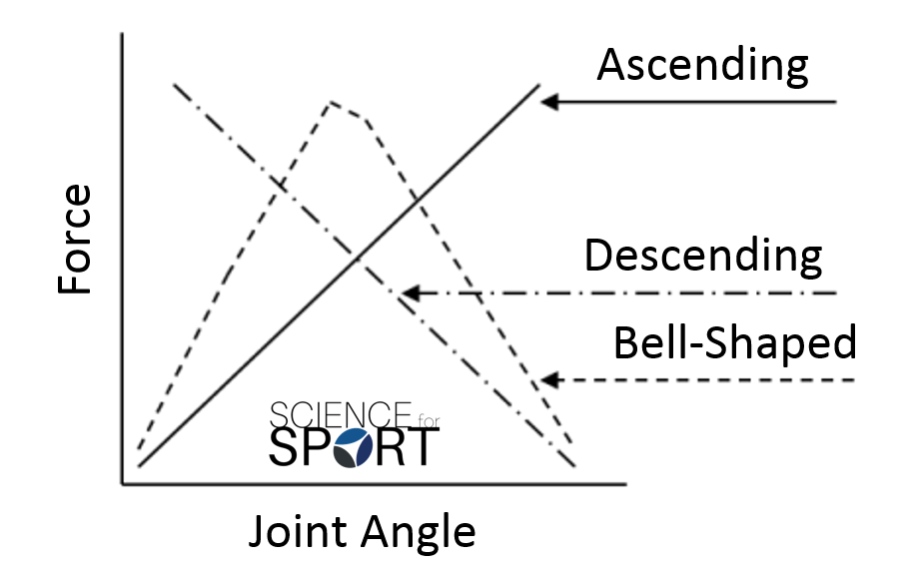

One of the key reasons to use chains during a resistance training session especially the use of chains during the bench press movement is to reduce the amount of deceleration that occurs and the reduction in force in the later phases of movement like the bench press. The chains are there to improve this later phase and allow the force production towards the end of the movement to increase (Swinton et al., 2011). A study conducted by McCurdy et al (2009) suggested that there was no difference between the short-term improvements when comparing chain resistance training and tradition plate loaded training. This study only tested the participants using the chains or standard bench pressing protocol and did not compare the 2 methods against each other. The research paper could have also added them together using both plates loaded training with a slight incorporation of chain training to force the body to adapt and grow by overcoming any physiological constraints (Shoepe et al., 2011)

The other method of variable resistance training that could be incorporated into the client sessions is the use of resistance bands. Resistance bands are similar to chains in relation to adding resistance to a movement but a key difference in the use of bands is that they can also reduce the weight to help with the movement. In the client’s sessions thy will be using the resistance bands for both of these reasons to increase and decrease the resistance of the movement.

Elastic variable training displays a curvilinear length-load relationship whereas chains display a simple linear motion which is easier to control (Mcmaster, Cronin and McGuigan, 2010) figure 2.0 below compares the relationship between chains and elastic bands.
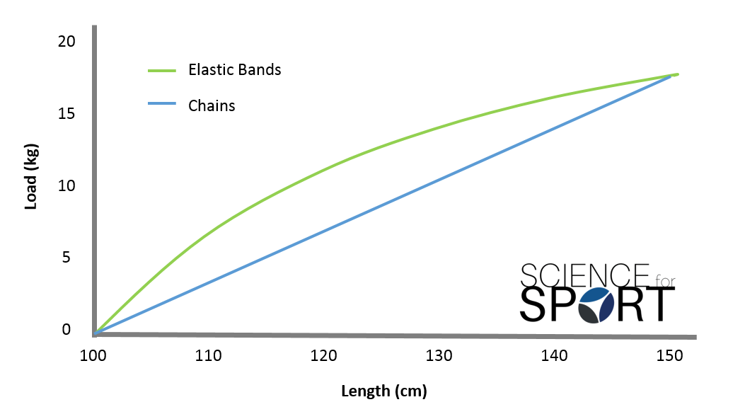
Figure 2.0: A graph to show the relationship between elastic bands and chains (Walker, 2016)

Elastic variable training has been shown to improve strength over a 7-week training programme in both the bench press movement and back squat. The study was conducted on 10 recreationally resistance trained subjects, 4 women and 6 men with the mean age of 21.3 years of age ± 1.5 Years. Baseline testing was performed over 2 separate days with 2 sets of 3 repetitions being performed over each condition. Testing was conducted at 60% of 85% of 1 rep max. In addition, 2 elastic band loading conditions were tested (B1 and B2). B1 was approximately 80% of the resistance provided by free weights. B2 was approximately 65% of the resistance generated by free weights. (Wallace, Winchester and McGuigan, 2006). Anderson et al. (2008) reported that the cross-sectional area of the muscles had not developed or grown due to the use of elastic training therefore it is suggested that the improvement could be linked to neural adaptations within the body. Using elastic bands as an addition to free weight training alone can improve the mechanical disadvantages at the sticking point of an athlete (Soria-Gila et al., 2015), this is the area that my client said he believed he failed his max 1 rep max in this portion of the lift. By training using the bands as a resistive force but using an overall lower weight it will enable the neural adaptations to take place and improve the overall bench press mechanics and speed although in contrast the bands can be used assertively to help the bar to be lifted through the movement therefore also improving the clients ability to get passed the sticking point.

Through this training programme the client had incorporated the bands into their sessions as it may have improved the clients bench press ability where he needed it which is towards and through the sticking point. The bands that were used in this programme were a set of 4 Intey resistance bands purchased from Amazon (Appendix 2.0), the bands come as a set of 4 ranging from a resistance of 15-125lb which will be utilised in the sessions.

The programme

The programme that the client followed was predominantly an upper body strength improvement programme. The client under took testing prior to the programme beginning, the programme was then reviewed after 3 weeks to see if there had been any improvements in his bench press one rep max. if any changes were required to be made, they had been made accordingly if not changes were needed the programme continued through to the end of the 6 week programme where a final testing phase was conducted to see if the client hit their goal of a 90KG one rep max. The programme started with 3 sessions per week and increased after the 4th week to 4 sessions a week.
Kraemer and Ratamess, (2004) stated that ‘’the adaptive process of the body will only respond if continually required to exert a greater magnitude of force to meet higher physiological demands’’
Kraemer and Ratamess, (2004) also suggested in their study that the systematic increase in the demands placed upon the body is necessary for further improvement the client will only be training weekdays as he has work commitments over the weekend

Included in the programme were standard chest development movement such as bench pressing, dumbbell pressing, cable flyes etc. But also, some sessions will be designed to improve the muscular ability of the client upper arms like triceps and biceps as well as some back sessions which will improve the stability of the bench press (Austin and Mann, 2012). Some of the sessions included aspects of shoulder mobility movements which were usually incorporated into the warm up to avoid injury to the rotator cuff and stability muscles in the shoulder (Kolber et al., 2010) this allowed the client to training harder with less risk of shoulder injury and also allow the client to improve their bench press capabilities.

Examples of Sessions

Heavy Loaded Session

Warm up

- 5 Minute Cycle- Resistance 10
- Band Pull Aparts- 2x10 – Blue Bands
- Dumbbell rotations- 2x10 – 5KG Dumbbells
- Lateral raises- 2x15 – 4KG Dumbbells

Main Session

- Bench press 5x5 - 90% 1RM (Simenz, Dugan and Ebben, 2005)
- Dumbbell Press 5x6
- Incline Smiths press 3x10
- Hammer Chest Press 4x8 - (Drop Set on last set)
- Cable flyes -> Press ups – 3xFailure

Cool Down

- Upper body stretch out
- 1 Mile walk out on Treadmill

High Rep Session and Triceps With Shoulder Mobility

Warm up

- 5 Minute Cycle- Resistance 10
- Band Pull Aparts- 2x10 –
- Dumbbell rotations- 2x10 –
- Dumbbell Lateral raises- 2x15

Main Session

- Shoulder rotations with PVC pipe (Slow and Controlled 5 second count) – 3x12
- Prone Press with PVC pipe (Slow and Controlled 5 second count) – 3x12
- Seated Frontal rotate and press PVC pipe (Slow control 5 second count)- 3x12
- Incline Barbell press (70% Max) -> tricep pushdown– 4x12
- Skull Crushers -> Machine press – 4x10
- Decline Dumbbell Press - 4x10
- Plate Press -> Dumbbell flyes – 4x10

Cool Down

- Upper body stretch out
- 1 Mile walk out on Treadmill

Back and Bicep strength Session

Warm up

- 5 Minute Cycle- Resistance 10
- Band Pull Aparts- 2x10 –
- Dumbbell rotations- 2x10 –
- Dumbbell Lateral raises- 2x15

Main Session

- Bent over Barbell rows - 4x8
- Low to high Hammer Strength neutral grip rows – 4x8
- Lat Pulldown – 4x8
- Seated wide grip rows -> Cable pull aparts – 3x10
- One hand low to high puller rows -> Bicep Curl – 4x10
- Hammer curls – 3x8
- Seated supinated curls – 3x10
- One arm cable curls -> Rope curls – 3x12- Failure on final set
Cool Down

- Upper body stretch out
- 1 Mile walk out on Treadmill

Heavy Loaded Session (Bands Included)

Warm up

- 5 Minute Cycle- Resistance 10
- Band Pull Aparts- 2x10 – Blue Bands
- Dumbbell rotations- 2x10 – 5KG Dumbbells
- Lateral raises- 2x15 – 4KG Dumbbells

Main Session

- Bench press 5x5- 95% 1RM (Band assisted)
- Dumbbell Press 4x8 Band resistance (Drop set last set to just push against band resistance)
- Incline Smiths press 3x10 (Speed/Power Band resistance)
- Hammer Chest Press 4x8 - (Drop Set on last set)
- Banded press -> Press ups – 3xFailure

Cool Down

- Upper body partner stretch
- 5 Minute cycle – Resistance 6

Programme Outline

Week 1

Day | Monday | Tuesday | Wednesday | Thursday | Friday
Session | Heavy Loaded session (Low rep High Weight) | REST | Shoulder Mobility warm up with high rep chest session + Triceps | REST | Back strength session + Biceps

Review: Week 1 was a good start to the programme, from receiving feedback from the client he seems to think the programme got off to a “good start”. The first session of the client said that he did struggle with the first heavy session as it was a bit more intense than he is used to. Moving onto week 2 the session will stay the same and the same structure as this will benefit the client by easing him into the programme

Week 2

Day | Monday | Tuesday | Wednesday | Thursday | Friday
Session | Heavy Loaded session (Low rep High Weight) |  | Shoulder Mobility warm up with high rep chest session + Triceps |  | Back strength session + Biceps

Review: Following into week 2 of the programme the client expressed he feels the mobility session on the Wednesday helped him to release a slight shoulder pain that he had been experiences. From doing this he said he could go into the session with less pain.

Week 3

Day | Monday | Tuesday | Wednesday | Thursday | Friday
Session | Shoulder Mobility warm up with high rep chest session + Triceps |  | Back strength session + Biceps |  | Heavy Loaded session (Low rep High Weight)

Review: Going into week 3 the programme changed up to stop the client getting bored and allows the programme to not get tedious. The mid programme testing will be conducted Monday before the session and be incorporated into the client’s high rep session.

Week 4

Day | Monday | Tuesday | Wednesday | Thursday | Friday
Session | Shoulder Mobility warm up  Mid programme testing  Into a high rep chest session + Triceps |  | Back strength session + Biceps  (Bands Included) |  | Heavy Loaded session (Low rep High Weight)

Review: The mid programme testing went well the client managed to bench 85Kg for one rep with no external assistance. Although the client has improved their bench press max towards their goal but are still struggling with the “sticking point” issue hence the reason the bands had been incorporated into the sessions to try and allow the client to overcome this issue. Next week in the programme the client will use chains as well to see if this improves his bench press ability

Week 5

Day | Monday | Tuesday | Wednesday | Thursday | Friday
Session | Back strength session + Biceps | Heavy Loaded session (Low rep High Weight)  (Chains Included) |  | Shoulder Mobility warm up with high rep chest session + Triceps | Heavy Loaded session (Low rep High Weight)

Review: The programme increased in sessions this week to push the client harder over the next 2 weeks. Although this week the client incorporated chains into his session he did not like them. I asked why and he said he preferred the banded session as he felt he got more from the session and that the session was more productive.

Week 6

Day | Monday | Tuesday | Wednesday | Thursday | Friday
Session | Back strength session + Biceps | Heavy Loaded session (Low rep High Weight) |  | Shoulder Mobility warm up with high rep chest session + Triceps | Heavy Loaded session (Low rep High Weight bands included)

Review: The final week of testing was the best week to date; the sessions all went well and the client said that they feel they made massive improvement over this week. The final testing session will occur the Monday allowing sufficient rest time over the weekend so he can come to testing refreshed.

Final Testing

After the programme had completed the client was given the weekend to rest and he was advised to take on high protein meals and protein supplements to aid with muscle repair (Schoenfeld, Aragon and Krieger, 2013) and to stay away from any intensive exercise to allow an optimised testing phase and protocol on the Monday.

The testing was conducted at the same time and in the same environment and the client achieved a bench press max of 92.5KG. the reason that the client pushed over the 90KG mark was because he expressed to me that he felt he could go higher in weight we initially raised the weight to 91.5KG and he managed the press, after giving a 4 minute rest period the client stated that he believed he could achieve higher therefore Reacher the press of 92.5KG.

Evaluation

Looking at the final testing results of the programme It can be concluded that the programme did benefit the client definitively over the programme as the client improved from a 1 rep max of 80KG to 92.5KG. If we take a closer look at the results from the beginning of the testing through the mid programme testing and final testing. It can be seen that an improvement of 5KG was made over the first 3 weeks but from the mid testing to the final testing there was a further 7.5KG improve in the client one rep max. This could be as a result of the implementation of the resistance bands into the sessions. The client did feel that the resistance bands improved the sessions and also the quality of the sessions that they participated in. The programme concurs with the research provided by Soria-Gila et al (2015) that resistance bands improve the ability to move and push through the sticking point of the bench press, if the programme was to be run again it would need to be for a longer duration. This is because I feel the client would benefit greater with more use of the resistance bands because the client still had some trouble pushing through the sticking point in the final testing. Next time the programme is run the sessions will need to change more throughout the programme because the client did say towards the end that the sessions become tedious and slightly repetitive.

To evaluate the use of resistance bands in the programme they were a successful intervention to be put into the programme and the client agreed with this statement. Although the bands helped to improve the clients one rep max the results could also be as a result of the muscle efficiency in the bench press movement.

Clients Review

The client reviewed the sessions and enjoyed the programme overall, he said that the sessions had been run professionally and that the trainer was professional and competent with training methods used throughout the programme. The client said the sessions were challenging and that after each session he felt like he had achieved another step on his fitness journey to hit the 90KG bench press. He mentioned at the end of the programme that he was to use his words “Over the moon” with the results he had seen over a short period of time.

References

Anderson, C., Sforzo, G. and Sigg, J. (2008). The Effects of Combining Elastic and Free Weight Resistance on Strength and Power in Athletes. Journal of Strength and Conditioning Research, 22(2), pp.567-574.

Austin, D. and Mann, B. (2012). Powerlifting. Champaign, Ill.: Human Kinetics.

Baker, D. and Newton, R. (2009). Effect of Kinetically Altering a Repetition via the Use of Chain Resistance on Velocity During the Bench Press. Journal of Strength and Conditioning Research, 23(7), pp.1941-1946.

Kolber, M., Beekhuizen, K., Cheng, M. and Hellman, M. (2010). Shoulder Injuries Attributed to Resistance Training: A Brief Review. Journal of Strength and Conditioning Research, 24(6), pp.1696-1704.

Kraemer, W. and Ratamess, N. (2004). Fundamentals of Resistance Training: Progression and Exercise Prescription. Medicine & Science in Sports & Exercise, 36(4), pp.674-688.

McCurdy, K., Langford, G., Ernest, J., Jenkerson, D. and Doscher, M. (2009). Comparison of Chain- and Plate-Loaded Bench Press Training on Strength, Joint Pain, and Muscle Soreness in Division II Baseball Players. Journal of Strength and Conditioning Research, 23(1), pp.187-195.

Mcmaster, D., Cronin, J. and McGuigan, M. (2010). Quantification of Rubber and Chain-Based Resistance Modes. Journal of Strength and Conditioning Research, 24(8), pp.2056-2064.

Nijem, R., Coburn, J., Brown, L., Lynn, S. and Ciccone, A. (2016). Electromyographic and Force Plate Analysis of the Deadlift Performed With and Without Chains. Journal of Strength and Conditioning Research, 30(5), pp.1177-1182.

Schoenfeld, B., Aragon, A. and Krieger, J. (2013). The effect of protein timing on muscle strength and hypertrophy: a meta-analysis. Journal of the International Society of Sports Nutrition, 10(1).

Shoepe, T., Ramirez, D., Rovetti, R., Kohler, D. and Almstedt, H. (2011). The Effects of 24 weeks of Resistance Training with Simultaneous Elastic and Free Weight Loading on Muscular Performance of Novice Lifters. Journal of Human Kinetics, 29(1), pp.93-106.

Simenz, C., Dugan, C. and Ebben, W. (2005). Strength and Conditioning Practices of National Basketball Association Strength and Conditioning Coaches. The Journal of Strength and Conditioning Research, 19(3), pp.495-504.

Soria-Gila, M., Chirosa, I., Bautista, I., Baena, S. and Chirosa, L. (2015). Effects of Variable Resistance Training on Maximal Strength. Journal of Strength and Conditioning Research, 29(11), pp.3260-3270.

Swinton, P., Stewart, A., Keogh, J., Agouris, I. and Lloyd, R. (2011). Kinematic and Kinetic Analysis of Maximal Velocity Deadlifts Performed With and Without the Inclusion of Chain Resistance. Journal of Strength and Conditioning Research, 25(11), pp.3163-3174.

Walker, O. (2016). Chain-Resistance Training | Science for Sport. [online] Science for Sport. Available at: https://www.scienceforsport.com/chain-resistance-training/#toggle-id-1 [Accessed 19 Mar. 2019].

Wallace, B., Winchester, J. and McGuigan, M. (2006). Effects of Elastic Bands on Force and Power Characteristics During the Back Squat Exercise. The Journal of Strength and Conditioning Research, 20(2), p.268.

Appendices

Appendix 1.0: BMI Results for Client

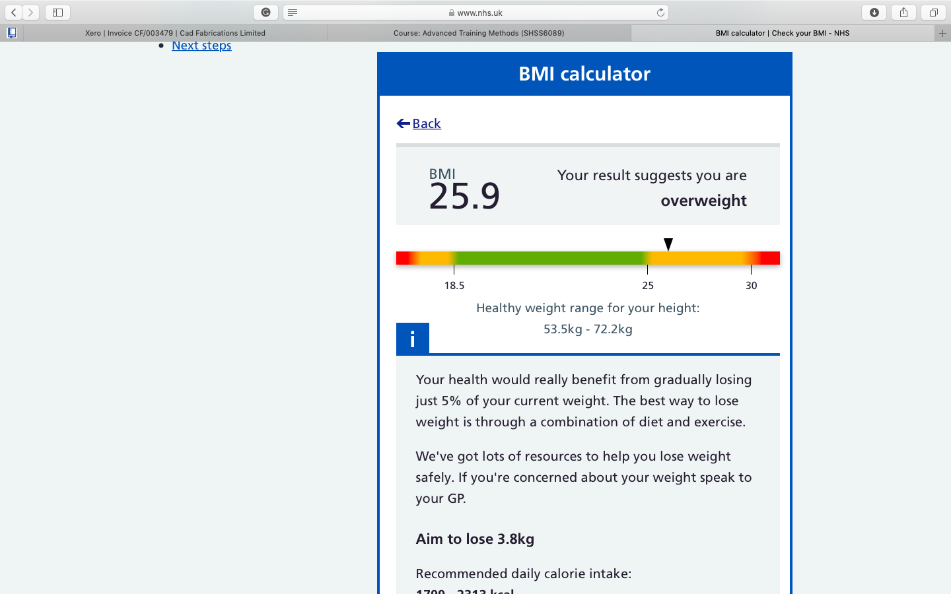

Appendix 2: Resistance bands purchased from amazon



