Contents
1. The Principles of Virtualisation 3
1.1 Definition 3
1.2 Core Principles 3
A. Abstraction 3
B. Isolation 3
C. Resource Sharing 3
D. Encapsulation 3
E. Portability (Live Migration) 3
Example: Virtualisation of Shared Hardware 3
Benefits 4
2. The Fundamentals and Advantages of Containerization: An Illustration of a Dockerfile Definition 4
2.1 Transportable Isolation 5
2.2 Image-Based Implementation 5
2.3 Dependency Packaging 5
2.4 Cross-Environment Portability 5
2.5 Scalability with Microservices 6
Advantages of Containerization 6
Figure: Docker file to Build an Image 7
3. Images and Publishing 8
3.1 Understanding Docker Images 8
3.2 Publishing Docker Images 8
4. Explanation of Container Volumes 10
Use Cases 10
5. Definition of Container Networking 13
Part: 02 19
Cloud Computing Concepts: Load Balancing, Scalability, and Application Gateways 19
1. Application Example Demonstrating All Three Concepts 19
1.1 Load Balancing 19
1.2 Scalability 19
1.3 Application Gateways 20
2. Complementary Nature of Load Balancing and Scalability 20
3. Advantages of Integrating All Three Technologies 21
4. Motivators for the Growth of Cloud Computing (Cost, Flexibility, etc.) 21
4.1 Cost-Effectiveness 21
4.2 Flexibility & Rapid Deployment 21
4.3 Disaster Recovery & Reliability 21
4.4 Global Reach 21
5. Containerization versus Serverless Functions 22
5.1 Serverless Functions 22
5.2 Containerization 22
5.3 Comparison of Driving Forces 22
References 23

Part 01:

1. The Principles of Virtualisation

1.1 Definition
Virtualization is a technology that permits numerous autonomous operating systems—known as virtual machines (VMs)—to run simultaneously on a single physical machine. This is achieved through a software layer called a hypervisor, which manages and allocates hardware resources to each VM while maintaining isolation between them [1].

1.2 Core Principles

A. Abstraction

The hypervisor abstracts the underlying physical hardware and presents each VM with its own virtual CPU, memory, storage and network interface. Through this abstraction, VMs operate independently of the physical hardware configuration, enabling a high degree of flexibility and hardware independence [2].

B. Isolation
Each VM runs in complete isolation from the others. A failure, crash or security breach within one VM does not affect other VMs or the host system. This isolation ensures security, stability and controlled resource access across virtualised environments [1], [3].

C. Resource Sharing
Multiple VMs share the same physical hardware resources dynamically. Idle resources can be reassigned to busy VMs, resulting in efficient utilisation of server hardware, improved scalability and reduced operational cost. This principle underpins server consolidation in cloud infrastructures [2], [4].

D. Encapsulation
A VM exists as a collection of files—including virtual disk images and configuration data. This encapsulation makes VMs portable, easy to back up, clone and restore, supporting disaster recovery and simplified system management [1], [5].

E. Portability (Live Migration)
Virtual machines can be moved between physical hosts with minimal or no downtime, a process known as live migration. Portability supports load balancing, maintenance and high availability without service interruption [3] [5].

Example: Virtualisation of Shared Hardware
A single high-performance server with:
• 32 CPU cores
• 128 GB RAM
• 2 TB SSD
can run 10 virtual machines, each configured with:
• 4 vCPUs
• 12 GB RAM
• 200 GB storage
Instead of purchasing 10 separate physical servers, the organisation can host multiple virtual servers on shared hardware through a hypervisor. This approach enables efficient resource sharing and workload isolation [5], [6].

Benefits
- Lower cost: Fewer physical servers are required, reducing hardware and operational expenses [5].
- Better utilisation: Resource abstraction and dynamic allocation improve hardware efficiency [6].
- Easier management: Centralised administration, snapshots, and standardised deployments simplify management [7].

2. The Fundamentals and Advantages of Containerization: An Illustration of a Dockerfile Definition
Containerization creates a lightweight, portable, and isolated environment known as a container, which bundles an application with all its dependencies. Containers, unlike virtual machines, share the host operating system (OS) kernel, making them notably more efficient in terms of performance and start up time.

2.1 Transportable Isolation
Containers run isolated user-space processes while sharing the host OS kernel. This enables strong separation of applications while greatly reducing overhead compared to virtual machines. Containers typically start within milliseconds due to their lightweight architecture [8].
- Minimal resource consumption
- Rapid startup time (milliseconds)

2.2 Image-Based Implementation
Applications are packaged into immutable container images. These images ensure predictable and consistent deployments across environments, reducing configuration drift and improving reliability [10].
- Uniform deployments
- Repeatable infrastructure behaviour

2.3 Dependency Packaging
Each image contains all the necessary runtime components, such as libraries, executables, and configurations this avoids the usual issue of "works on my machine," which provides environment consistency for development, testing, and production.[9].
- Images include all libraries, code, and runtime
- Removes environment-related execution problems

2.4 Cross-Environment Portability
A container image can run on:
- A developer workstation
- Any cloud platform supporting Docker or Kubernetes
- On-premise servers
Because the container format is standardized, applications become highly portable across heterogeneous infrastructure

2.5 Scalability with Microservices
Containers are well-suited to small service architecture. Every service function in its own container, enabling independent deployment and scaling. This design improves fault isolation and supports modern, distributed applications
- Each microservice operates independently
- Services can scale individually

Advantages of Containerization
Advantage | Explanation
Speed | Containers start in milliseconds or seconds, enabling rapid scaling [8].
Efficiency | Containers consume significantly fewer resources than VMs due to OS-level virtualization [9].
Consistency | The same image runs uniformly across environments [10].
Flexibility | Well-suited for Kubernetes auto-scaling and orchestration [11].
Isolation | Issues in one container don't affect others.  [12].
Streamlined CI/CD | Supports automated builds, testing, and deployments, simplifying DevOps pipelines [10].

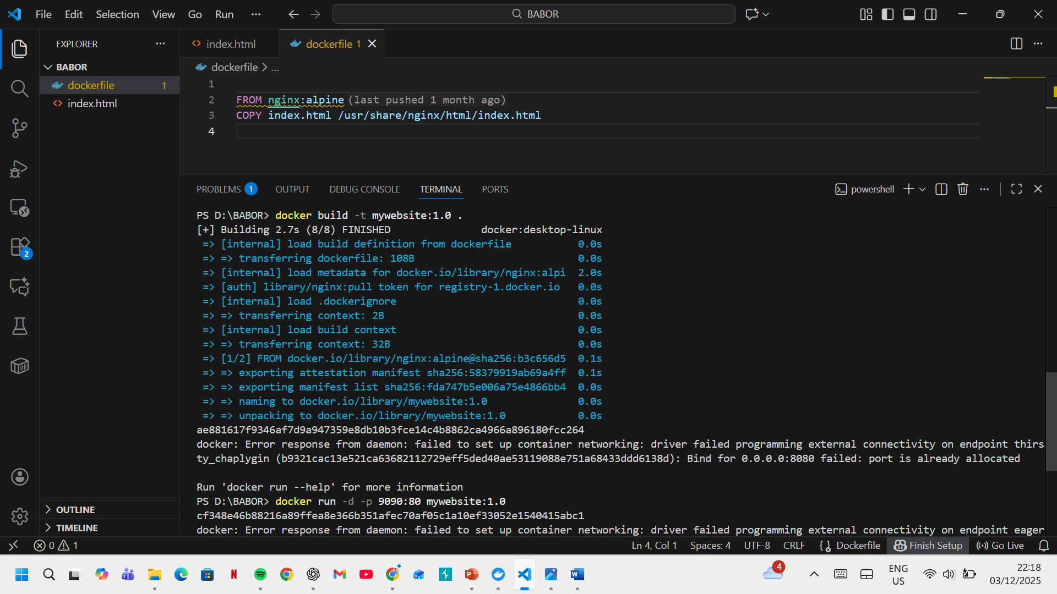

Figure: Docker file to Build an Image

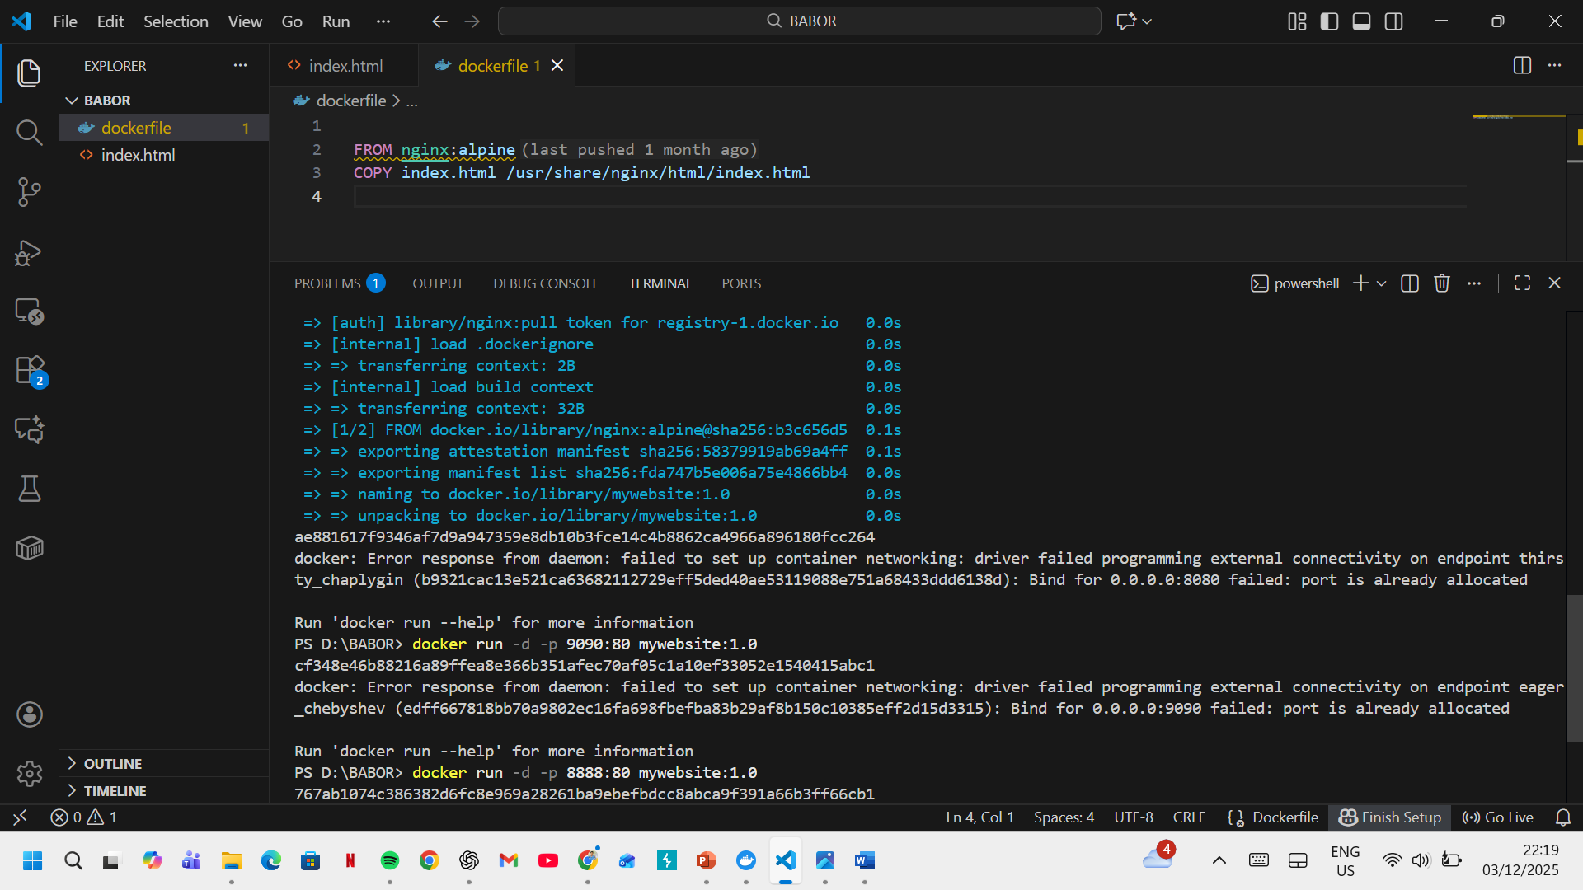

3. Images and Publishing

3.1 Understanding Docker Images
A Docker image is a packaged application that contains the application code, runtime environment, system tools, libraries, and dependencies required for execution. Images are built from layered file systems, making them lightweight, modular, and easy to distribute across environments [13], [14]. Because each layer is immutable, images support reproducible deployments and efficient storage.

3.2 Publishing Docker Images
"Publishing" an image entails uploading the Docker image to a Docker registry. A registry—such as Docker Hub, Amazon ECR, GitHub Container Registry, or a private company registry—is a centralized storage system for images [15]. Once published, photos can be downloaded ("pulled") by other users, automated workflows, or production systems, facilitating broad reuse and consistent publication [16].
This strategy is critical for collaborative development, CI/CD workflows, and cloud-native deployment of apps.

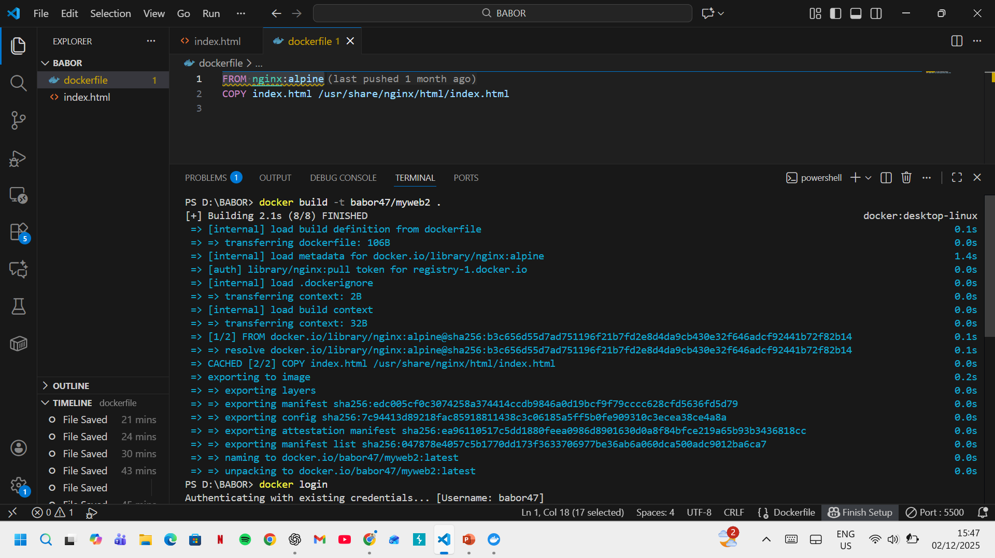

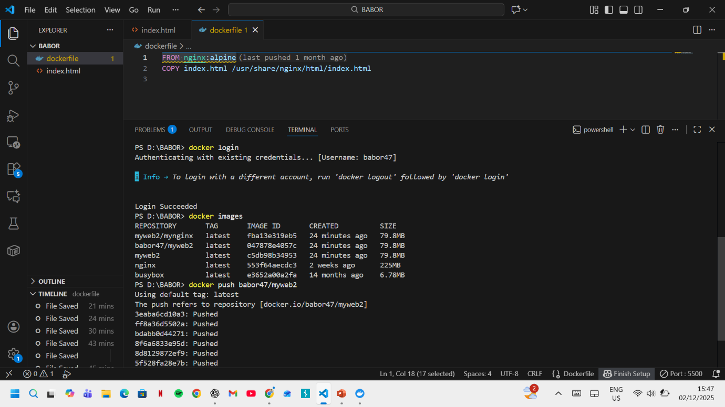
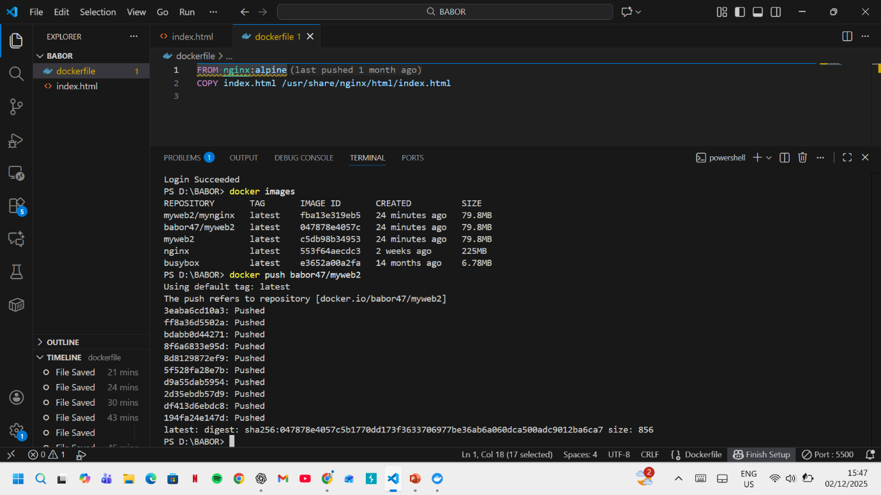

4. Explanation of Container Volumes
Container volumes provide a persistent storage mechanism for Docker containers. Unlike the container’s internal filesystem—which is deleted when the container is stopped, removed, or recreated—volumes store data independently of the container lifecycle [17]. This ensures that critical information is preserved across updates, failures, and deployments.
Volumes are managed by the Docker engine and can be mounted into one or more containers simultaneously. This design supports reliable data sharing, backup processes, and stateful application workloads [18].

Use Cases
Volumes are especially beneficial for applications requiring persistent or shared data, including [19]:
- Databases: storing tables, indexes, and transaction logs
- Application logs: retaining logs for debugging, monitoring, and auditing
- Configuration files and state data: ensuring continuity across container restarts
By separating persistent data from the ephemeral nature of containers, volumes enable more robust, maintainable, and production-ready containerized systems.

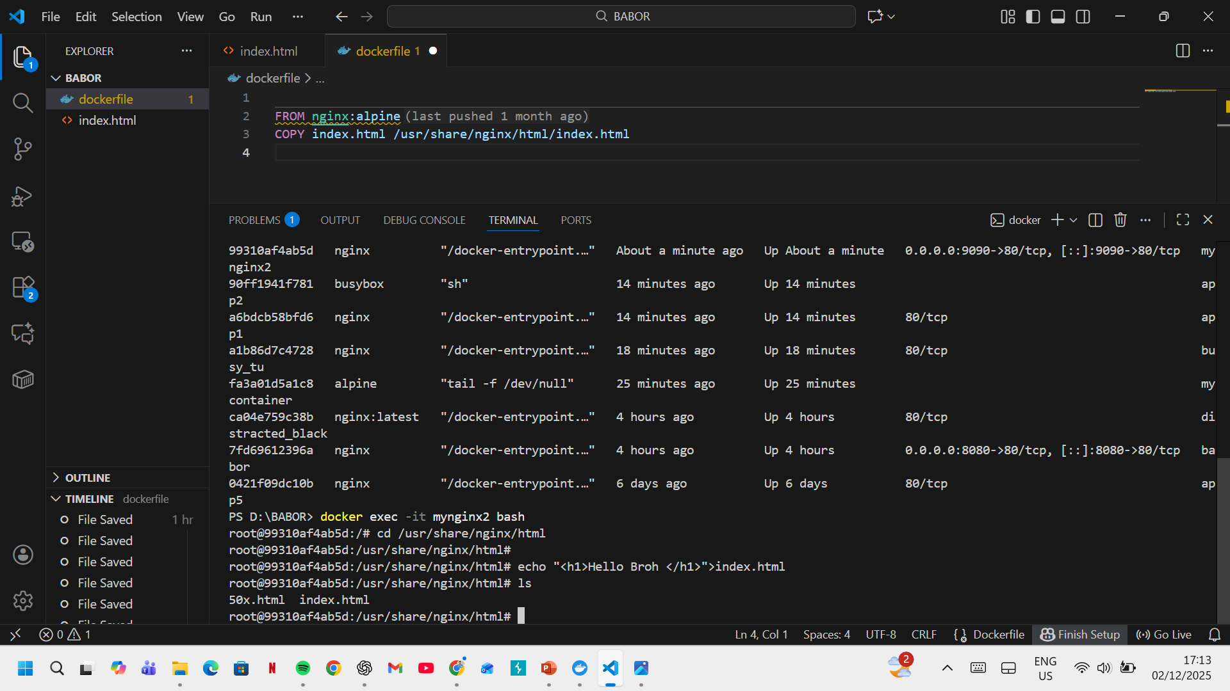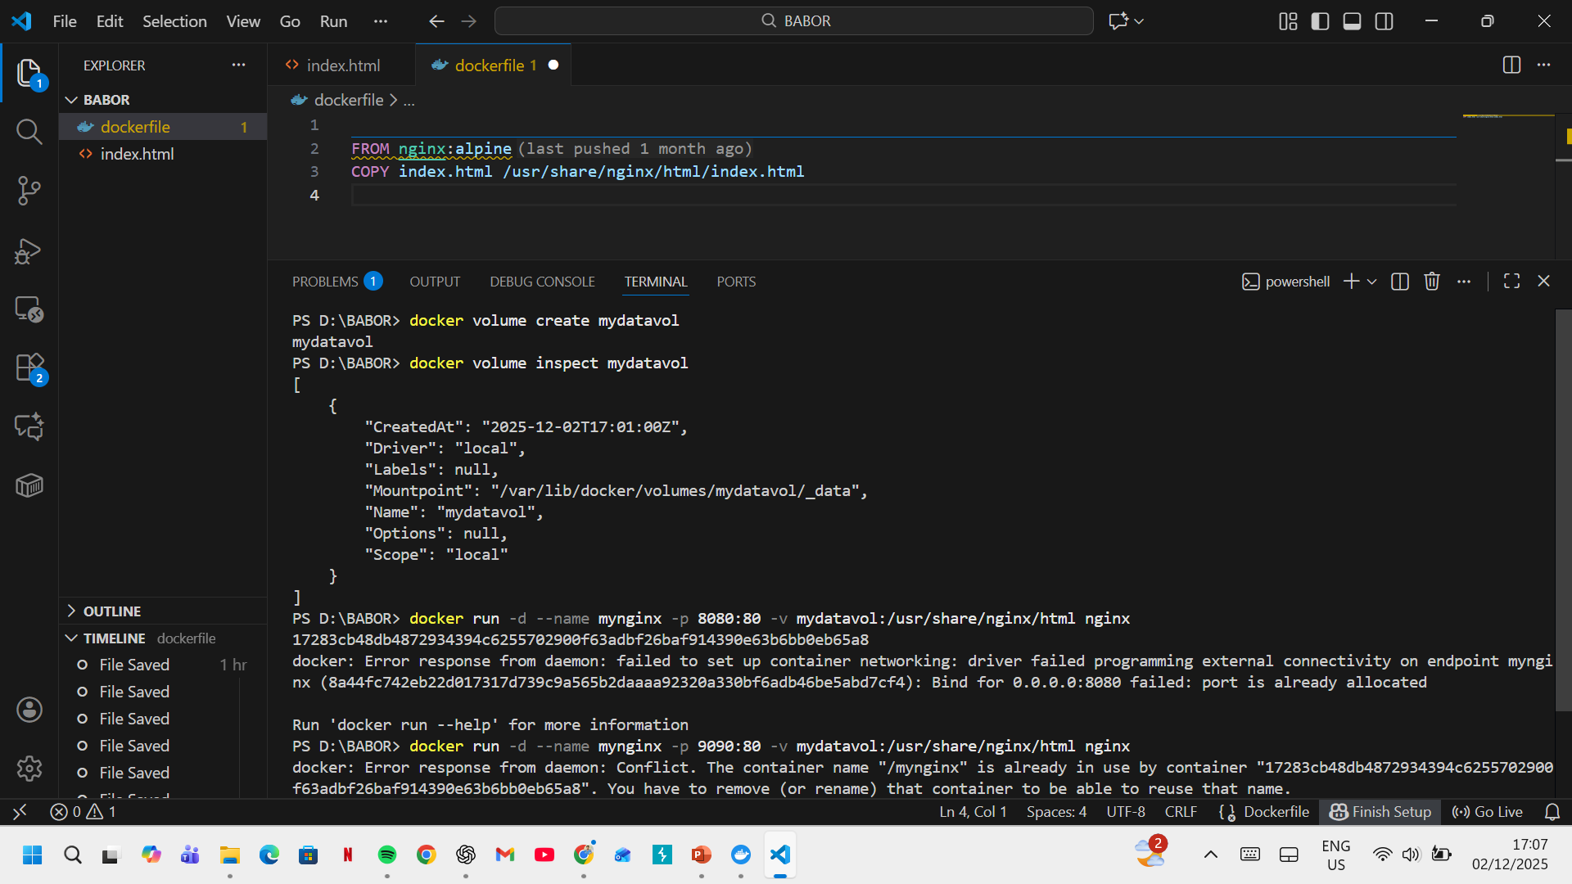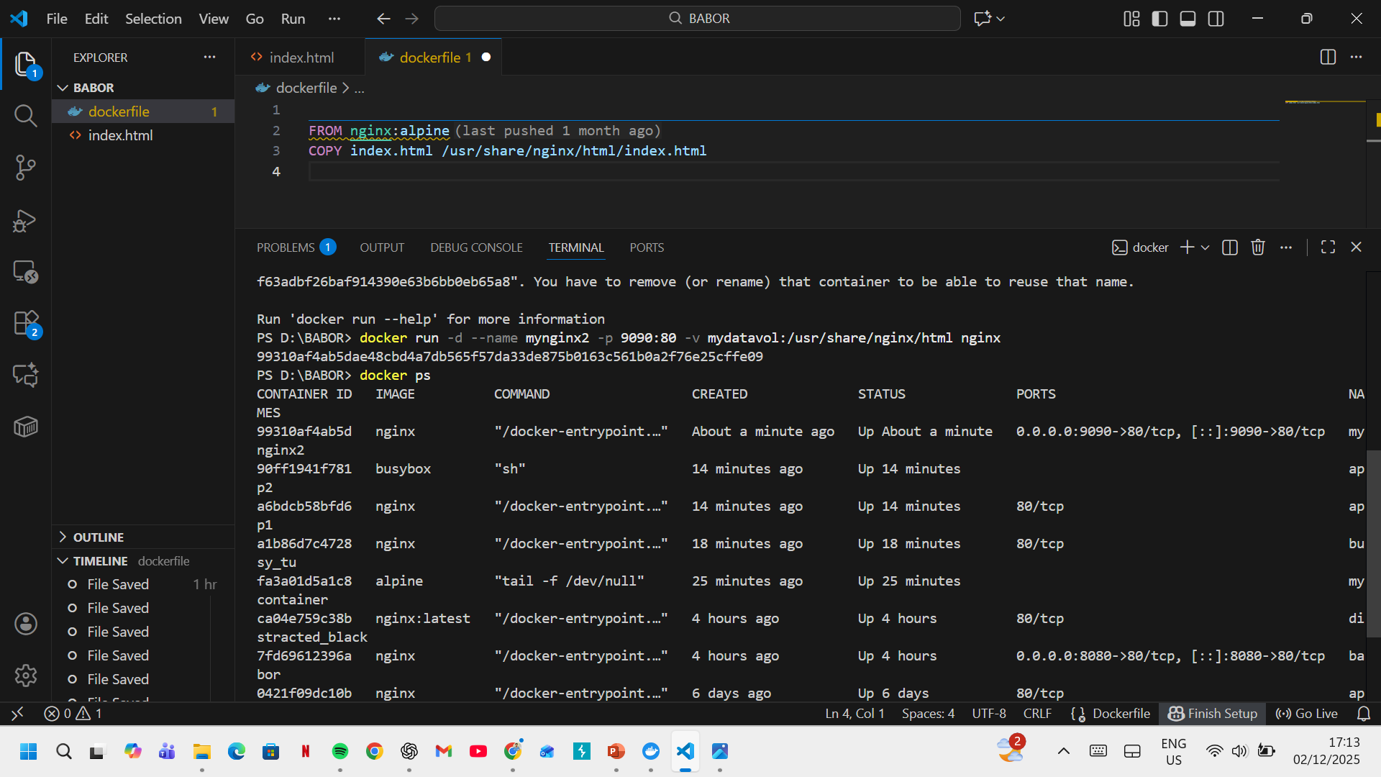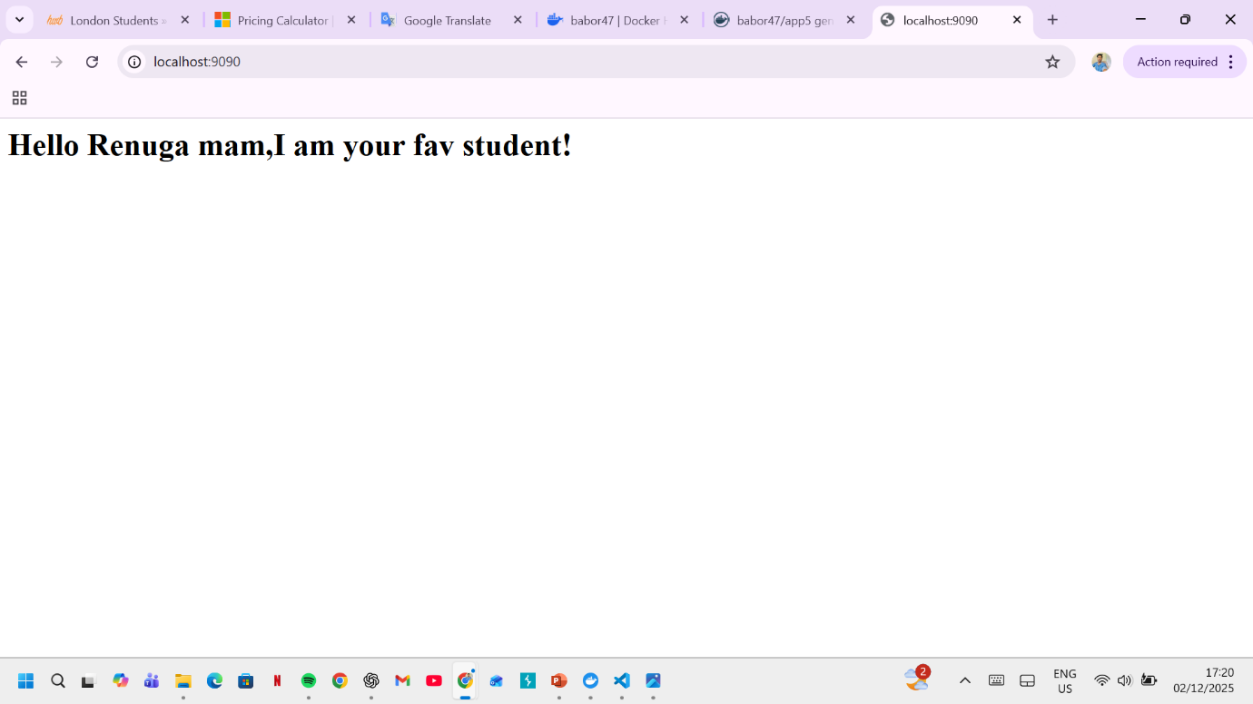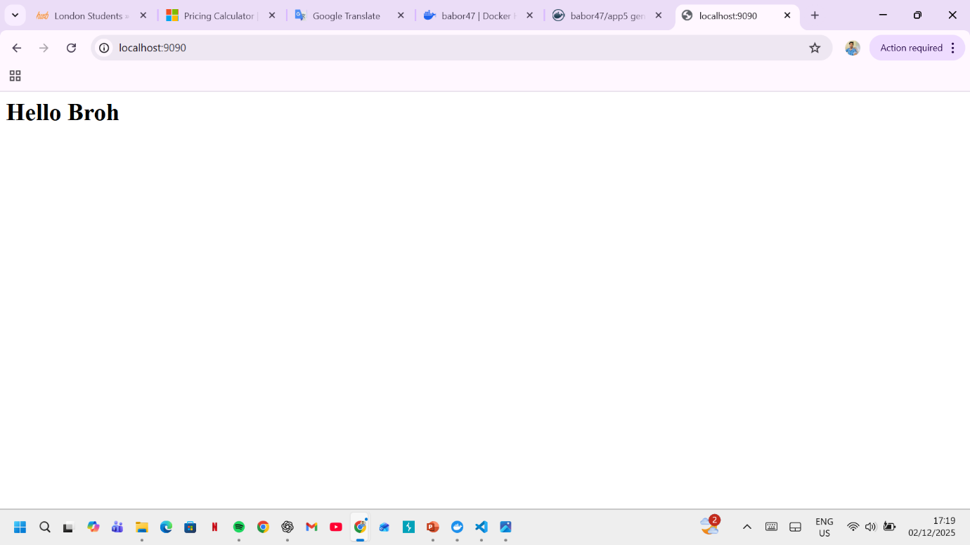

5. Definition of Container Networking
Container networking refers to the set of technologies and mechanisms that allow containers to communicate securely, efficiently, and reliably with each other, as well as with external systems. It enables isolated applications running in separate containers to exchange data through virtual networks, providing connectivity while maintaining secure boundaries [20], [21].
Docker and other container platforms create virtual network interfaces and use software-defined networking (SDN) techniques to manage traffic between containers. Network drivers—such as bridge, host, overlay, and macvlan—enable different communication models depending on deployment requirements [22].
Container networking is essential for distributed applications, microservices architectures, and orchestrated environments such as Kubernetes, where services rely on predictable, stable networking to function correctly [23].

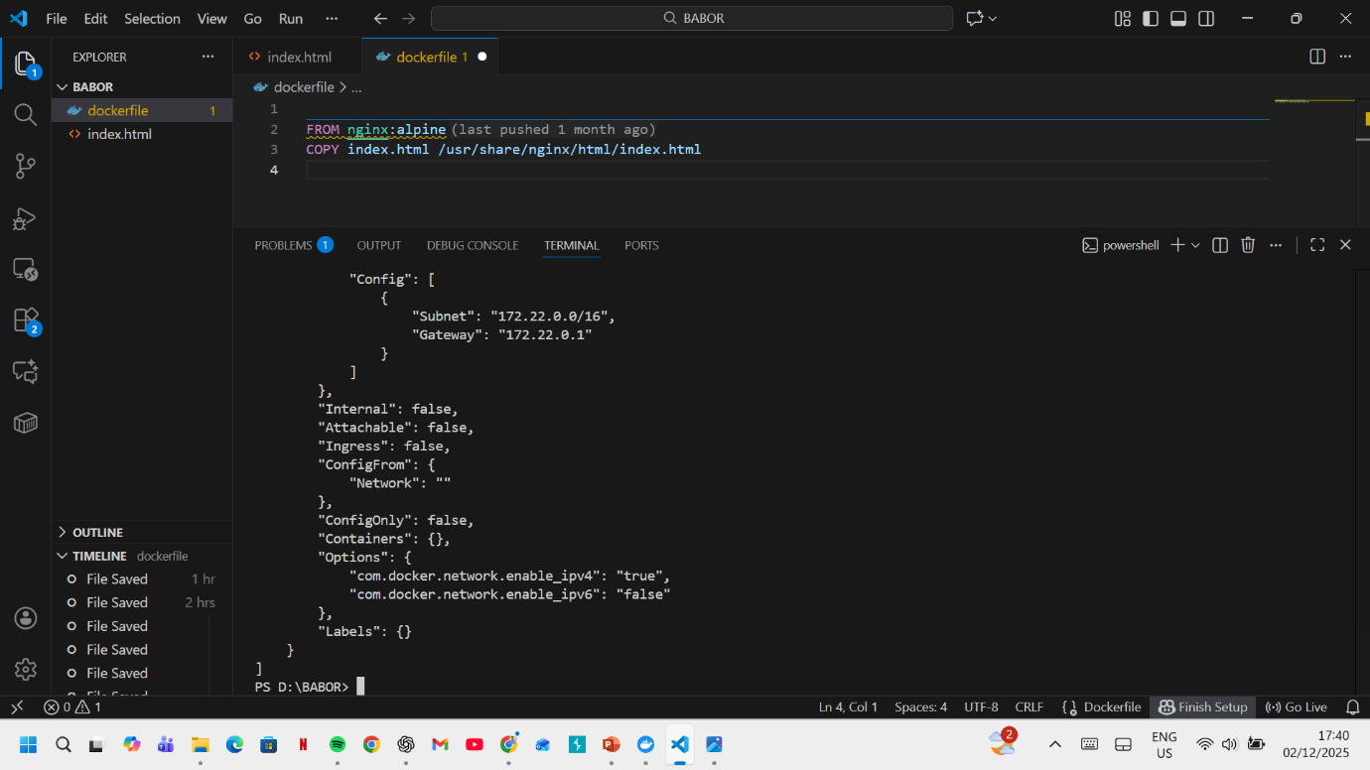
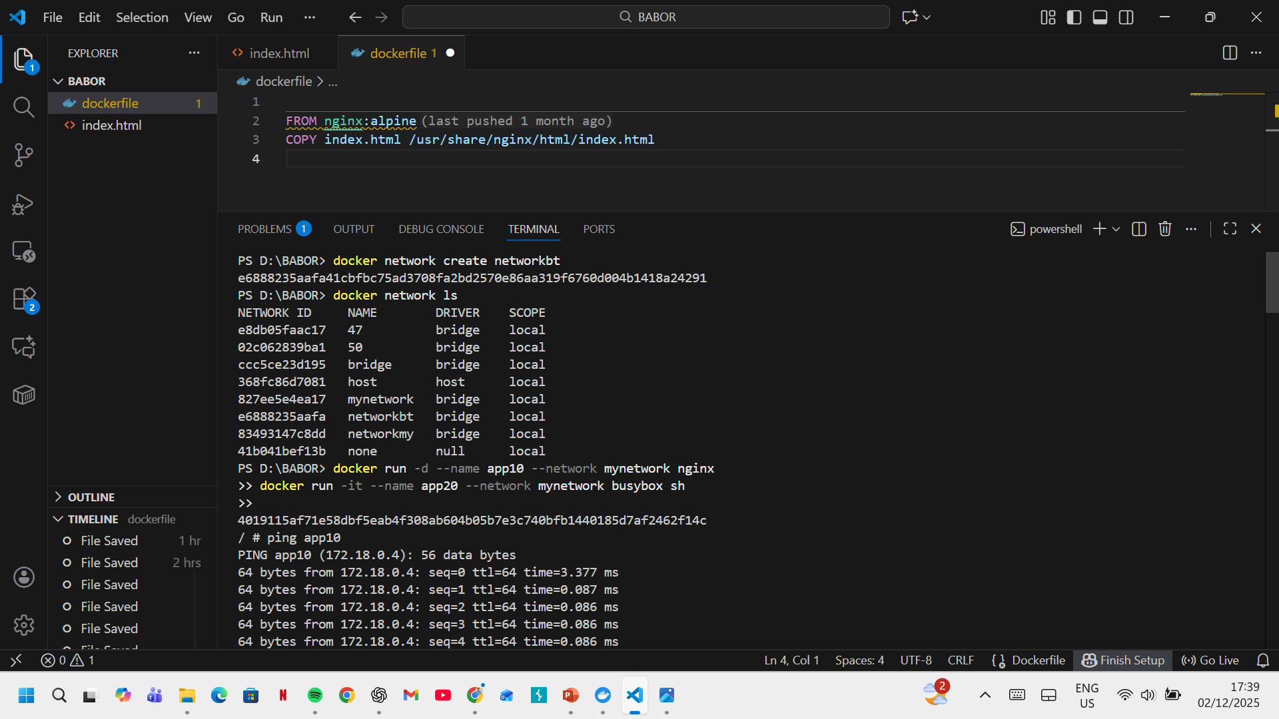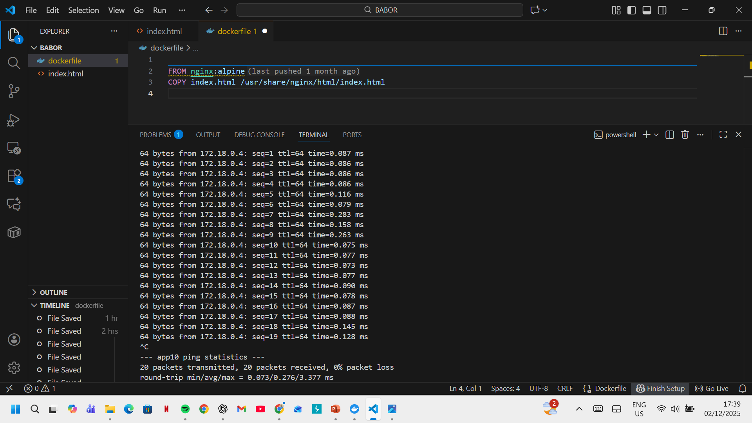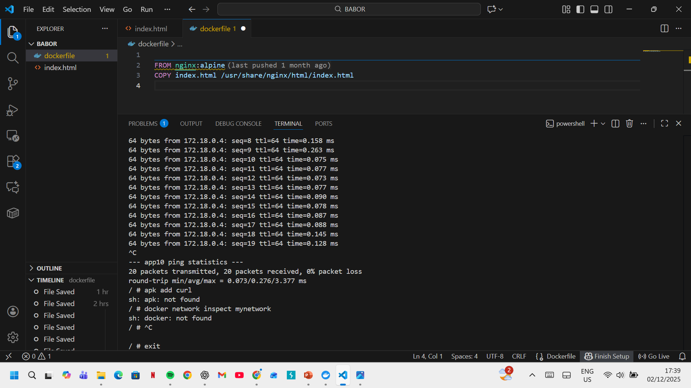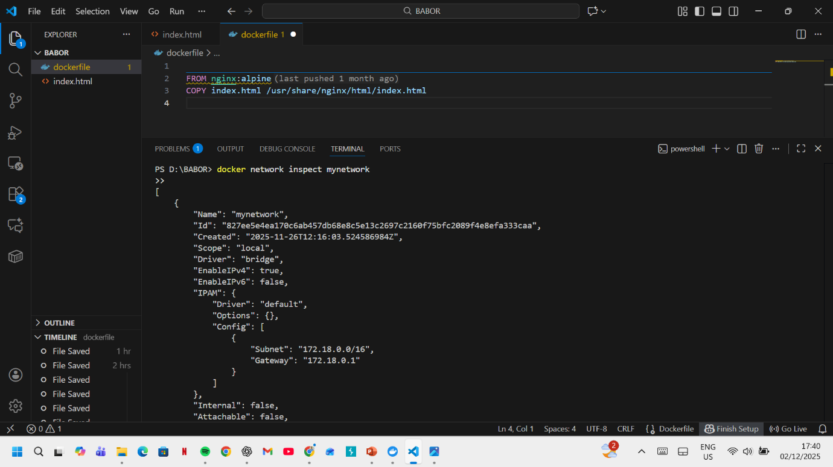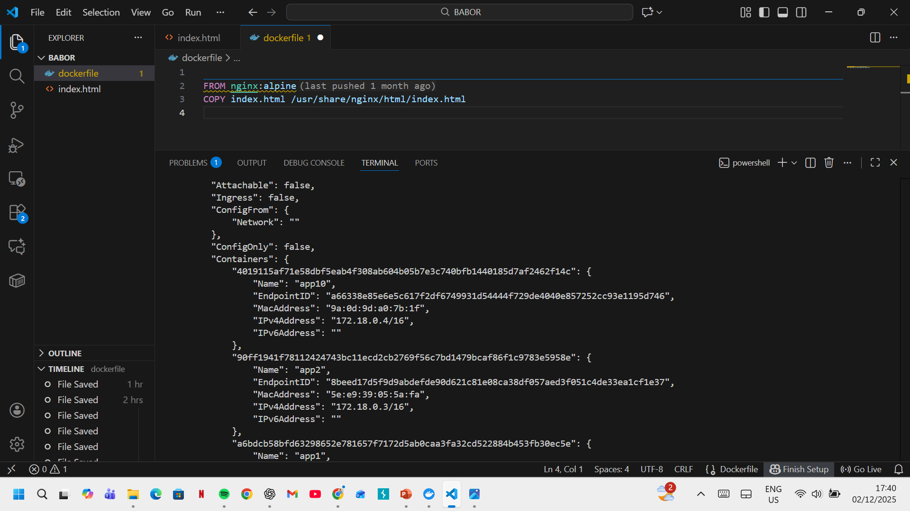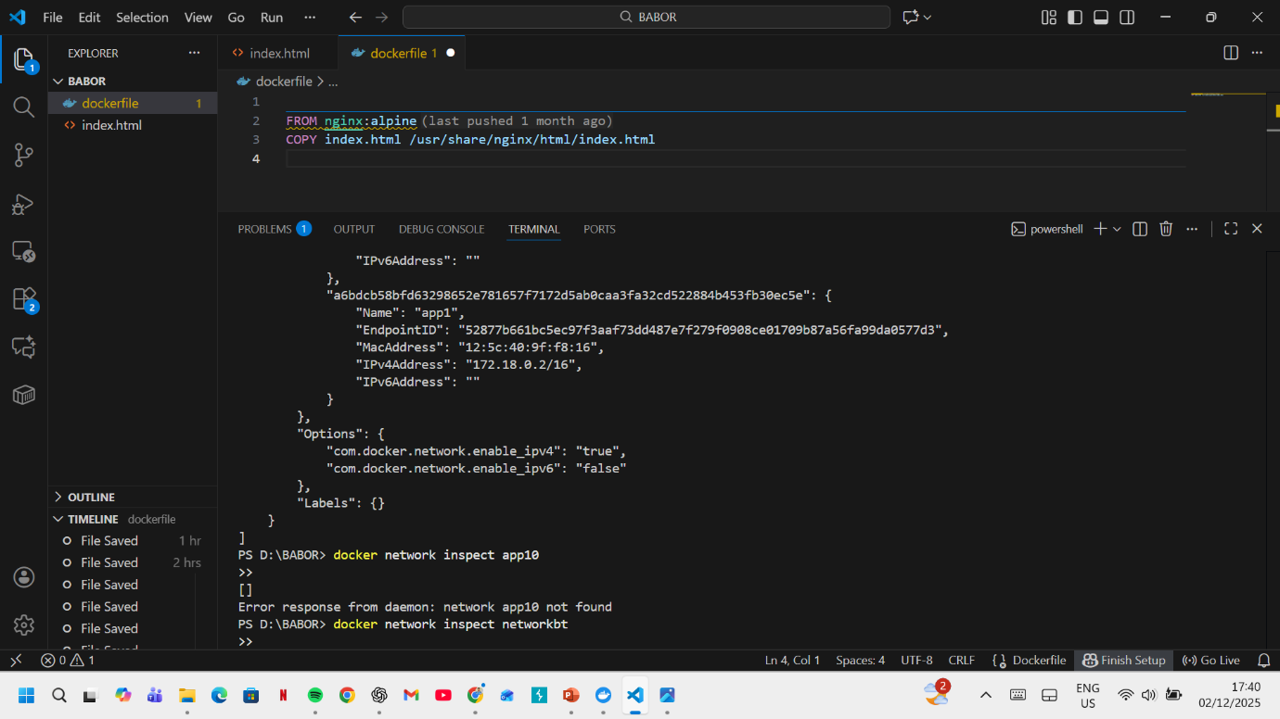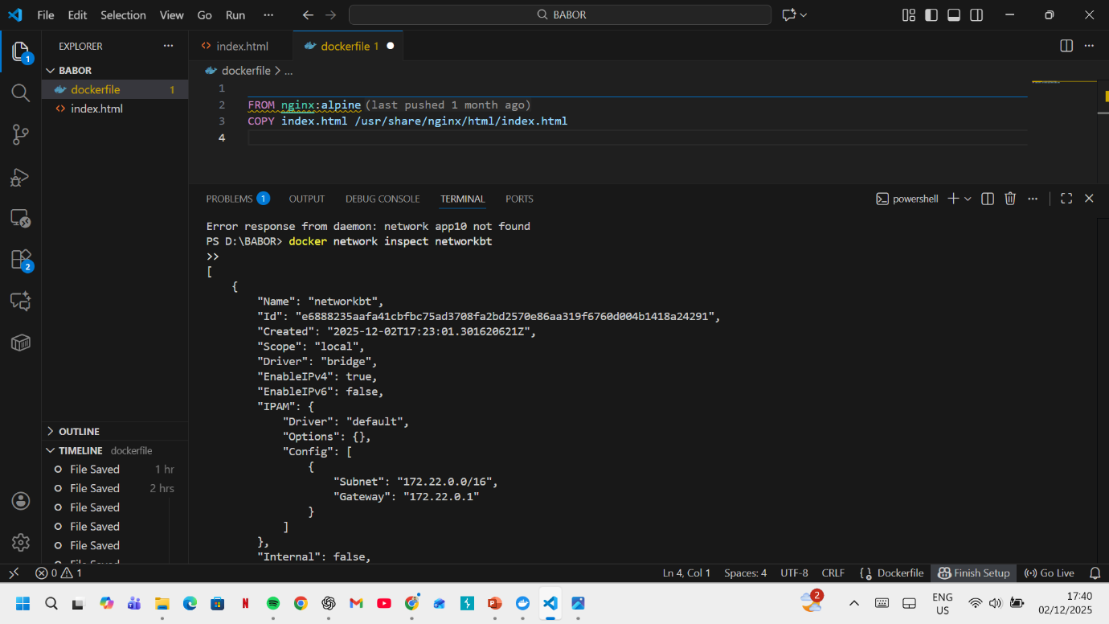

Part: 02

Cloud Computing Concepts: Load Balancing, Scalability, and Application Gateways

1. Application Example Demonstrating All Three Concepts
An e-commerce web application hosted on a major cloud provider AWS, Azure, and Google Cloud are excellent examples of how to mix load balancing, scalability, and application gateways.

1.1 Load Balancing
Load balancing is utilized by cloud providers to evenly distribute incoming traffic between many application instances, therefore improved performance and reliability.
Cloud Provider Methods:
- AWS Elastic Load Balancer (ELB)
  - Automatically distributes HTTP/HTTPS traffic across EC2 instances, containers, or Lambda functions.
  - Performs health checks and reroutes traffic from unhealthy instances. Supports either Application Load Balancers (ALB) and Network Load loads (NLBs) [24].
- Azure Load Balancer
  - Distributes TCP/UDP traffic using Layer 4 forwarding rules.
  - Automatically reroutes traffic around failed instances and supports outbound NAT [25].
Illustrative Step:
Selecting a target group in AWS ALB ensures that only healthy instances receive traffic, demonstrating request filtering and instance monitoring.

1.2 Scalability
Scalability allows the system to expand or contract according to demand.
Cloud Provider Methods:
- AWS Auto Scaling Groups (ASG)
- Auto start or stop EC2 instances using scaling policies prompted by memory, CPU usage, or request metrics.
  - Horizontal scaling adds/removes instances; vertical scaling changes instance sizes [26].
- Azure Virtual Machine Scale Sets (VMSS)
  - Automatically manages identical VMs and adjusts capacity according to load [27].
Illustrative Step:
Implementing a scale-out policy (e.g., add a new instance if CPU > 70% for 5 minutes) directly demonstrates reactive scalability.

1.3 Application Gateways
Application gateways provide Layer 7 routing, security, and intelligent traffic management.
Cloud Provider Methods:
- AWS ALB + AWS WAF
  - Routes traffic based on hostname, headers, or paths.
  - Can route /payment to one microservice and /images to another.
  - Provides protection against SQL injection and XSS [28].
- Azure Application Gateway
  - Supports URL-based routing, SSL termination, session affinity, and Web Application Firewall.
  - Directs user traffic to different back-end pools using application logic [29].
Illustrative Step:
Configuring path-based routing rules in Azure Application Gateway demonstrates intelligent microservice routing.

2. Complementary Nature of Load Balancing and Scalability
Load balancing and scalability work together to create a robust and efficient cloud service:
Load Balancing:
- Distributes traffic evenly to prevent overload.
- Ensures high availability via health checks [24].
Scalability:
- Adds instances to meet increasing demand.
- Maintains performance automatically [26].
Why They Complement Each Other:
- Without scaling, a load balancer distributes traffic over a fixed set of servers, which may still be overloaded.
- Without load balancing, newly scaled instances cannot effectively handle traffic.
Combined Benefit:
Enables higher throughput, resilience, cost optimization, and zero-downtime growth.

3. Advantages of Integrating All Three Technologies
- Combining load balancing, flexibility, and software gateways yields:
- High Availability: Only healthy instances receive traffic.
- High Performance: Scaling increases capacity as demand rises.
- Security & Intelligent Routing: Gateways provide WAF protection and smart routing [28].
- Cost Efficiency: Scaling down reduces expenses during low-demand periods.
- Smooth User Experience: End-users receive consistent response times even during peak loads.
This combination provides a secure, resilient, and scalable cloud application.

4. Motivators for the Growth of Cloud Computing (Cost, Flexibility, etc.)

4.1 Cost-Effectiveness
- Pay-as-you-go pricing reduces capital expenses.
- Eliminates the need to maintain physical servers.
- Auto-scaling lowers costs during low traffic periods [30].

4.2 Flexibility & Rapid Deployment
- Applications can be deployed globally within minutes.
- Managed services (databases, AI, analytics) accelerate development.
- Developers can focus on innovation rather than hardware [31].

4.3 Disaster Recovery & Reliability
- Multi-zone redundancy ensures reliability.
- Automatic failover and backup systems protect against data loss [30].

4.4 Global Reach
- Distributed data centre ensure low-latency access worldwide [31].

5. Containerization versus Serverless Functions
Serverless computing platforms, such as AWS Lambda, Azure Functions, and Google Cloud Functions, offer a new paradigm for cloud deployment.

5.1 Serverless Functions
- Code executes only in response to events (HTTP requests, file uploads, scheduled tasks).
- Cloud provider manages scaling, load balancing, and high availability.
- Billing is based on execution time and number of requests [32].
Example: A Lambda function triggers only when a file is uploaded to Amazon S3.

5.2 Containerization
- • Packages software and components into portable boxes (e.g., Docker, Kubernetes).
• Offers total control over the OS and environment.
- Well-suited for microservices architectures.
- Requires orchestration tools like Kubernetes, ECS, or AKS [33].

5.3 Comparison of Driving Forces
Factor | Serverless | Containers
Cost | Lower for intermittent workloads [32] | Better for stable, long-running workloads [33]
Flexibility | Limited runtime control, short execution | Full control, highly customizable
Scalability | Automatic, instantaneous | Requires orchestration
Management Overhead | Minimal (no servers) | Moderate to high (clusters, networking)
Performance | Cold-start delays possible | Consistent, predictable
Use Cases | Event-driven tasks, APIs, automation | Long-running tasks, complex microservices

References
- [1] IEEE, Introduction to Virtualization. Available: https://www.ieee.li/pdf/viewgraphs/introduction_to_virtualization.pdf
- [2] G. J. Popek and R. P. Goldberg, “Formal Requirements for Virtualizable Third Generation Architectures,” Communications of the ACM, vol. 17, no. 7, pp. 412–421, 1974.
- [3] A. Kivity et al., “kvm: The Linux Virtual Machine Monitor,” in Proceedings of the Linux Symposium, Ottawa, 2007.
- [4] GeeksforGeeks, Characteristics of Virtualization. Available: https://www.geeksforgeeks.org/characteristics-of-virtualization/
[5] IBM, “What is Virtualization?” IBM Documentation, 2024. [Online]. Available: https://www.ibm.com/topics/virtualization
- [6] Oracle, “Introduction to Virtualization,” Oracle Documentation, 2023. [Online]. Available: https://docs.oracle.com/cd/E20065_01/doc.30/e18549/intro.htm
- [7] Microsoft Azure, “What is virtualization?” Azure Cloud Computing Dictionary, 2024. [Online]. Available: https://azure.microsoft.com/en-us/resources/cloud-computing-dictionary/what-is-virtualization
- [8] Docker Inc., What is a Container?, Docker Documentation, 2024. [Online]. Available:
https://www.docker.com/resources/what-container/
- [9] Red Hat, Containers vs Virtual Machines (VMs), Red Hat Documentation, 2024. [Online]. Available:
https://www.redhat.com/en/topics/containers/containers-vs-vms
- [10] Kubernetes Authors, Understanding Container Images, Kubernetes Documentation, 2024. [Online]. Available:
https://kubernetes.io/docs/concepts/containers/images/
- [11] AWS, Containers on AWS, Amazon Web Services Documentation, 2024. [Online]. Available:
https://aws.amazon.com/containers/
- [12] Google Cloud, Microservices Architecture on Containers, Google Cloud Documentation, 2024. [Online]. Available:
https://cloud.google.com/architecture/microservices
- [13] Docker Inc., Docker Images Overview, Docker Documentation, 2024. [Online]. Available:
- https://docs.docker.com/get-started/docker-overview/#docker-images

- [14] Red Hat, What is a Container Image?, Red Hat Documentation, 2024. [Online]. Available:
- https://www.redhat.com/en/search?search=container%20images
- [15] Docker Inc., Docker Registry, Docker Documentation, 2024. [Online]. Available:
https://docs.docker.com/registry/
- [16] Amazon Web Services, Amazon Elastic Container Registry (ECR), AWS Documentation, 2024. [Online]. Available:
https://aws.amazon.com/ecr/
- [17] Docker Inc., Manage Data in Docker, Docker Documentation, 2024. [Online]. Available:
https://docs.docker.com/storage/
- [18] Red Hat, Container Storage: Volumes and Bind Mounts, Red Hat Documentation, 2024. [Online]. Available:
https://www.redhat.com/en/topics/containers/storage
- [19] Kubernetes Authors, Persistent Storage for Containers, Kubernetes Documentation, 2024. [Online]. Available:
https://kubernetes.io/docs/concepts/storage/
- [20] Docker Inc., Networking Overview, Docker Documentation, 2024. [Online]. Available:
https://docs.docker.com/network/
- [21] Red Hat, Container Networking Explained, Red Hat Documentation, 2024. [Online]. Available:
https://www.redhat.com/en/topics/containers/container-networking
- Docker Inc., Network Drivers, Docker Documentation, 2024. [Online]. Available:
https://docs.docker.com/network/drivers/
- Kubernetes Authors, Cluster Networking, Kubernetes Documentation, 2024. [Online]. Available:
https://kubernetes.io/docs/concepts/cluster-administration/networking/
- Amazon Web Services, “Elastic Load Balancing,” AWS Documentation, 2024. [Online]. Available: https://docs.aws.amazon.com/elasticloadbalancing/latest/userguide/what-is-load-balancing.html
- Microsoft Azure, “Azure Load Balancer Overview,” Azure Docs, 2024. [Online]. Available: https://learn.microsoft.com/en-us/azure/load-balancer/load-balancer-overview
- Amazon Web Services, “Amazon EC2 Auto Scaling,” AWS Documentation, 2024. [Online]. Available: https://docs.aws.amazon.com/autoscaling/ec2/userguide/what-is-amazon-ec2-auto-scaling.html
- Microsoft Azure, “Virtual Machine Scale Sets Overview,” Azure Docs, 2024. [Online]. Available: https://learn.microsoft.com/en-us/azure/virtual-machine-scale-sets/overview
- Amazon Web Services, “AWS WAF and ALB Overview,” AWS Docs, 2024. [Online]. Available: https://docs.aws.amazon.com/waf/latest/developerguide/waf-chapter.html
- Microsoft Azure, “Application Gateway Overview,” Azure Docs, 2024. [Online]. Available: https://learn.microsoft.com/en-us/azure/application-gateway/overview
- Gartner, “Cloud Cost Efficiency and Adoption Drivers,” Gartner Report, 2023.
- Google Cloud, “Global Cloud Infrastructure Overview,” Google Cloud Docs, 2024. [Online]. Available: https://cloud.google.com/about/locations
- Amazon Web Services, “AWS Lambda Developer Guide,” AWS Documentation, 2024. [Online]. Available: https://docs.aws.amazon.com/lambda/latest/dg/welcome.html
- Kubernetes Authors, “Kubernetes Architecture and Concepts,” CNCF Documentation, 2024. [Online]. Available: https://kubernetes.io/docs/concepts/overview/what-is-kubernetes/

